# PHỤ LỤC C

# LƯỢC ĐỒ DỮ LIỆU

# PHỤ LỤC C.1.Lược đồ dữ liệu con người

## C.1.1.Nhóm thông tin cơ bản

* Lược đồ XML cấu trúc dữ liệu thông tin đăng ký cơ bản:

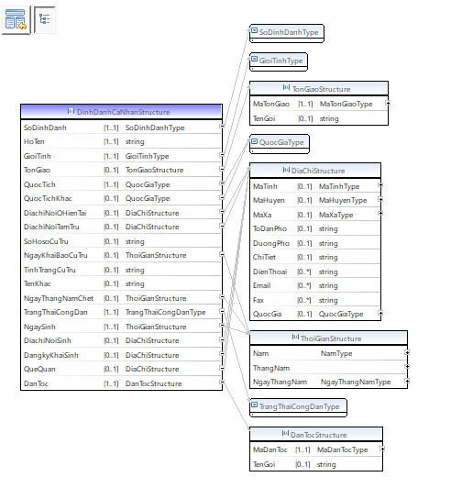

* Lược đồ XML cấu trúc dữ liệu thông tin định danh người nước ngoài:

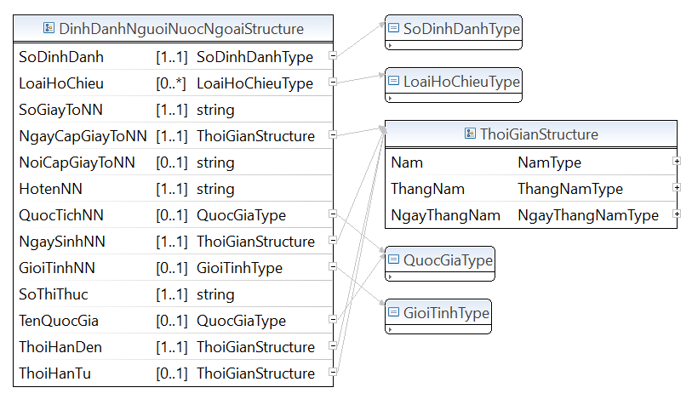

* Lược đồ XML cấu trúc dữ liệu giấy tờ định danh:

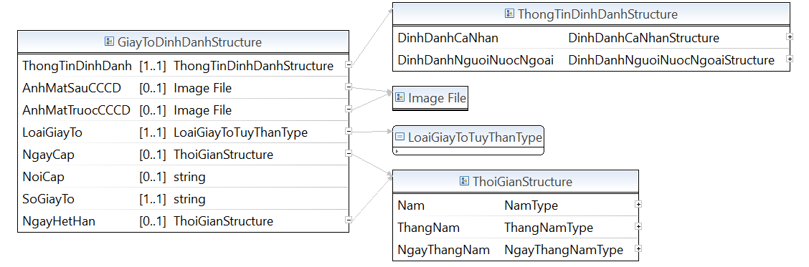

* Lược đồ XML cấu trúc dữ liệu thôi quốc tịch, nhập quốc tịch:

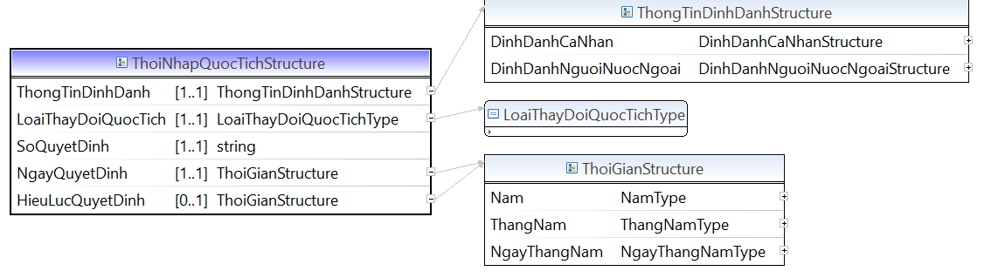

* Lược đồ XML cấu trúc dữ liệu xuất, nhập cảnh:

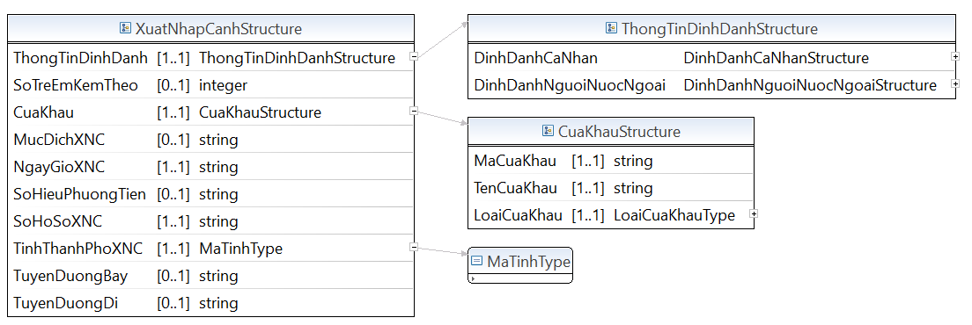

* Lược đồ XML cấu trúc dữ liệu căn cước công dân điện tử:

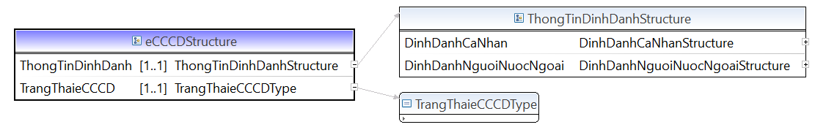

* Lược đồ XML cấu trúc dữ liệu thành viên gia đình, giám hộ:

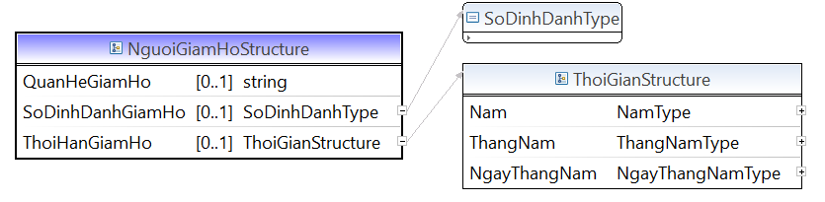

## C1.2.Nhóm thông tin tài sản

* Lược đồ XML cấu trúc dữ liệu tài sản tài chính:

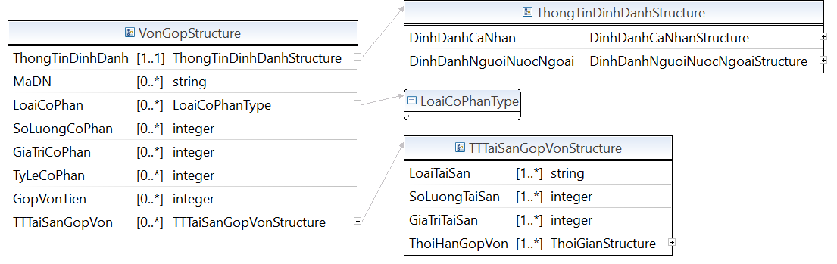

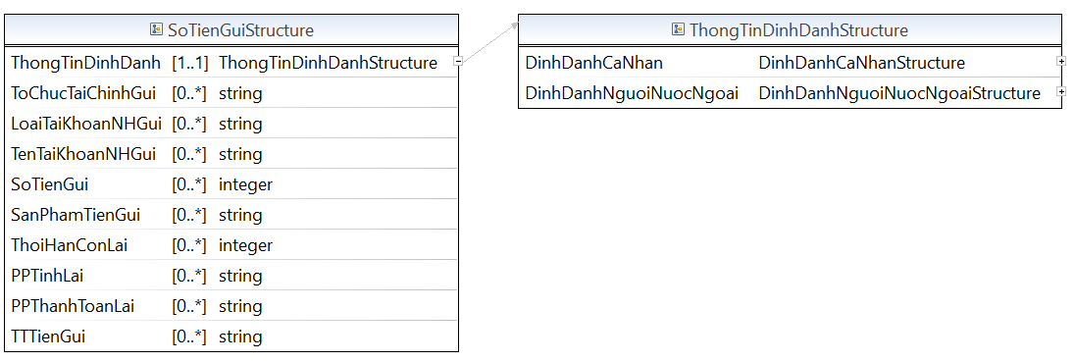

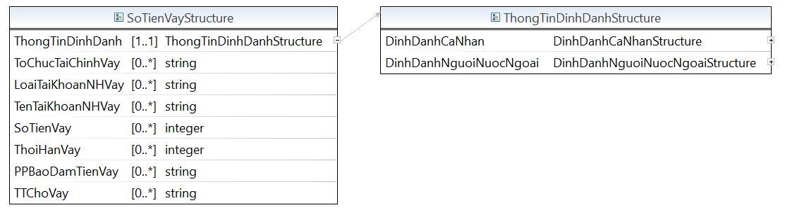

* Lược đồ XML cấu trúc dữ liệu tài sản vật chất:

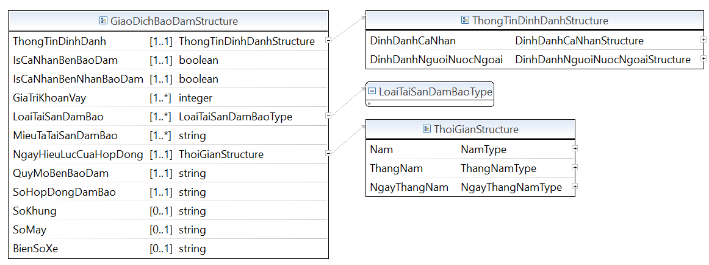

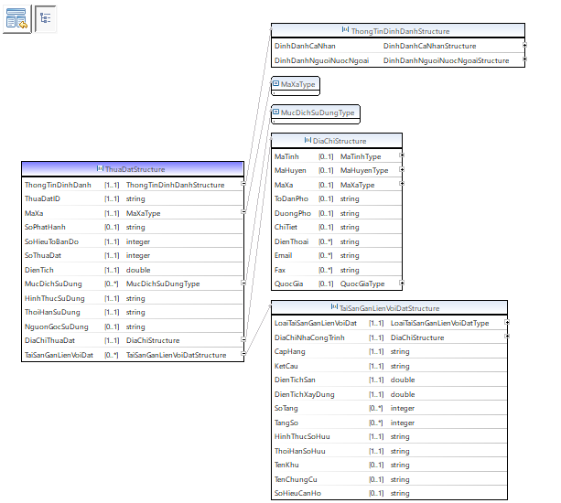

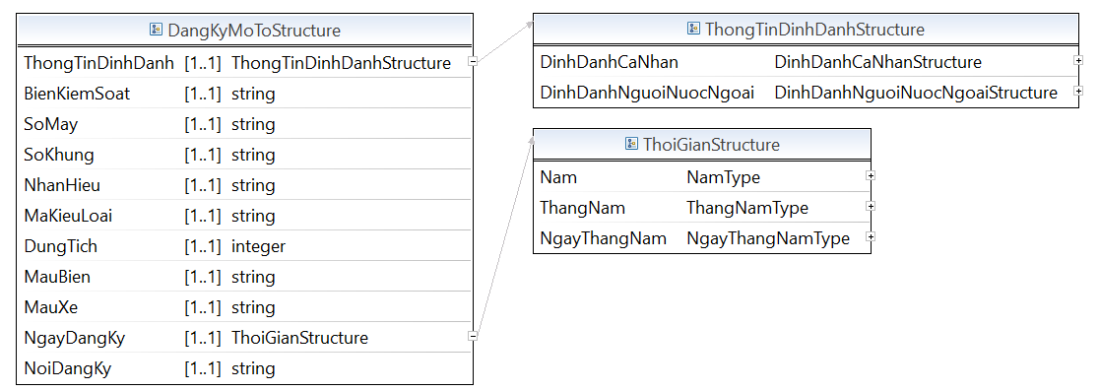

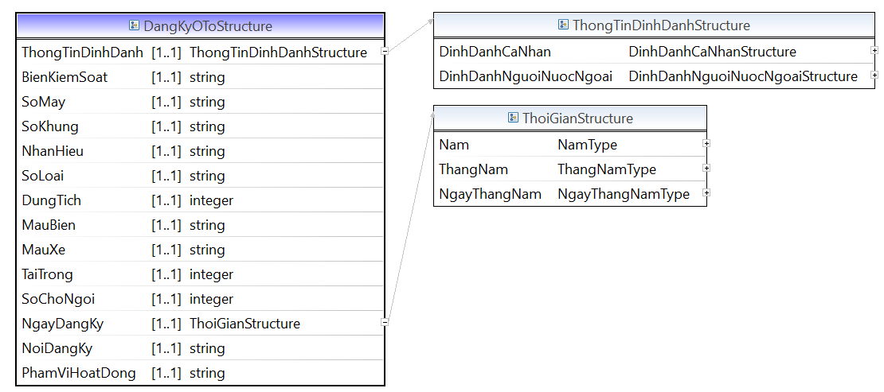

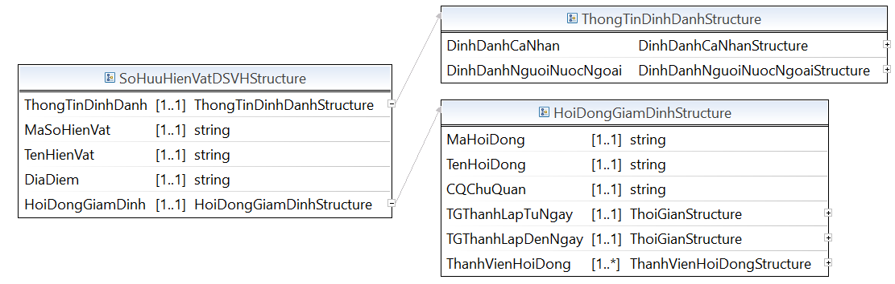

* Lược đồ XML cấu trúc dữ liệu tài sản vô hình:

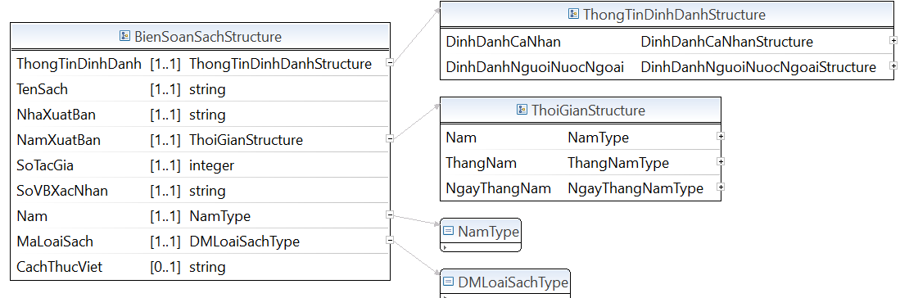

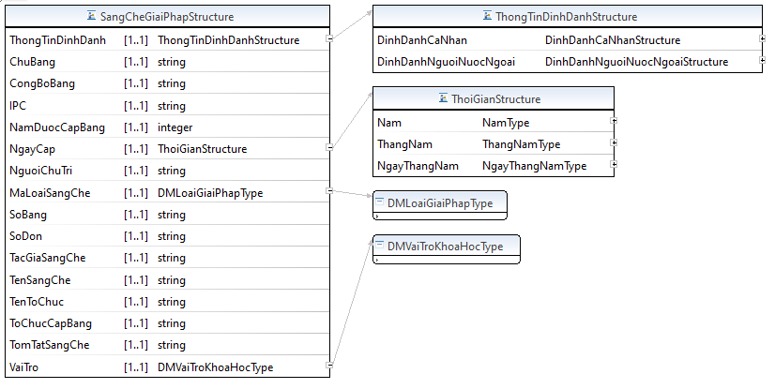

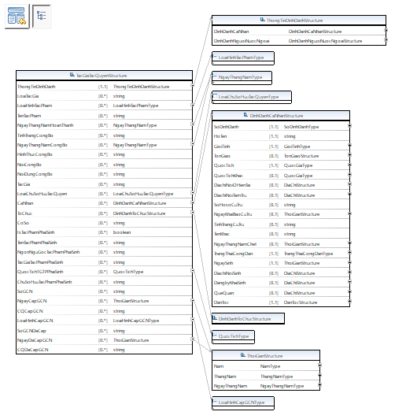

## C1.3.Nhóm an sinh xã hội

* Lược đồ XML cấu trúc dữ liệu cuộc sống cơ bản

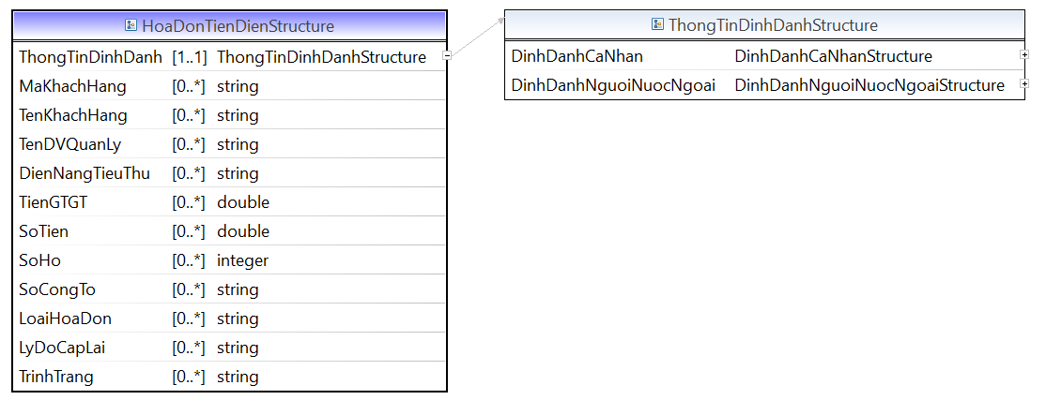

* Lược đồ XML cấu trúc dữ liệu đối tượng người có công:

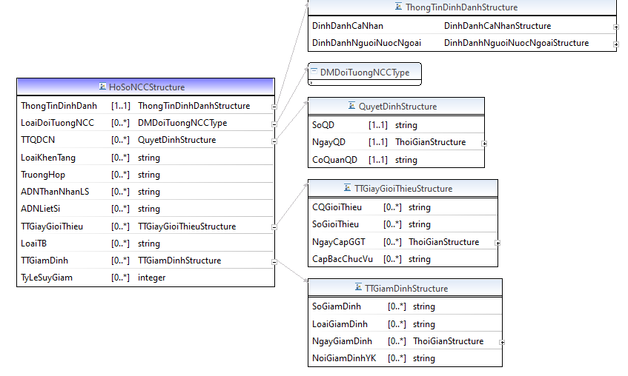

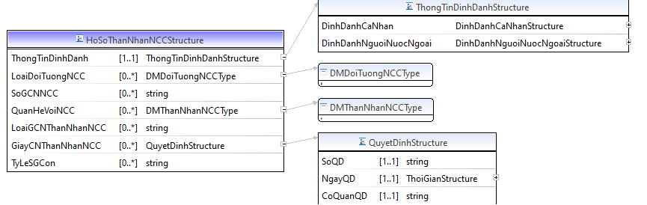

* Lược đồ XML cấu trúc dữ liệu đối tượng nhận trợ giúp xã hội

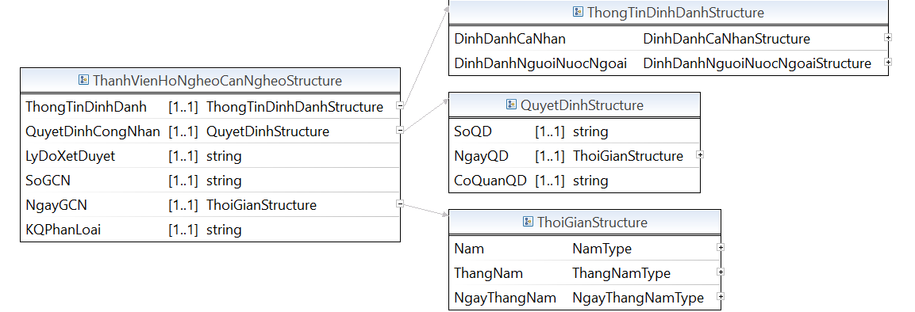

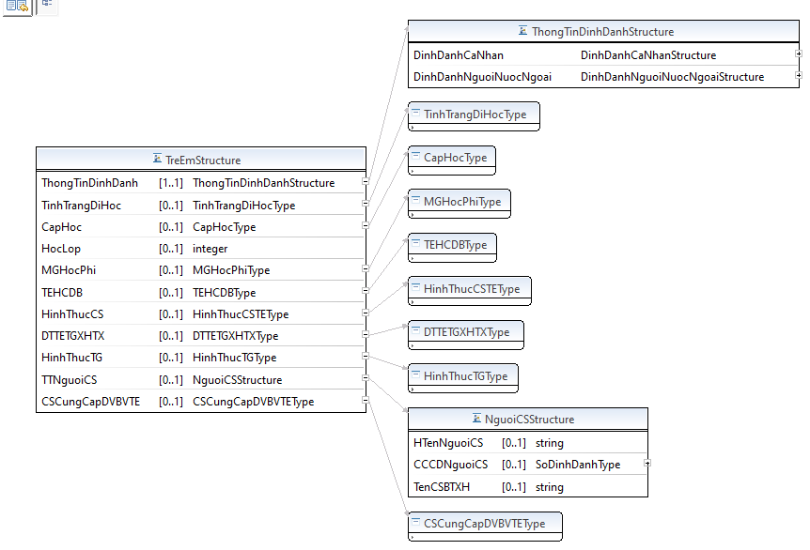

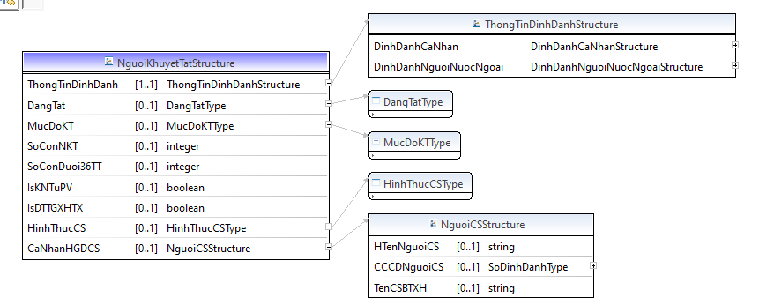

* Lược đồ XML cấu trúc dữ liệu hưởng chính sách xã hội:

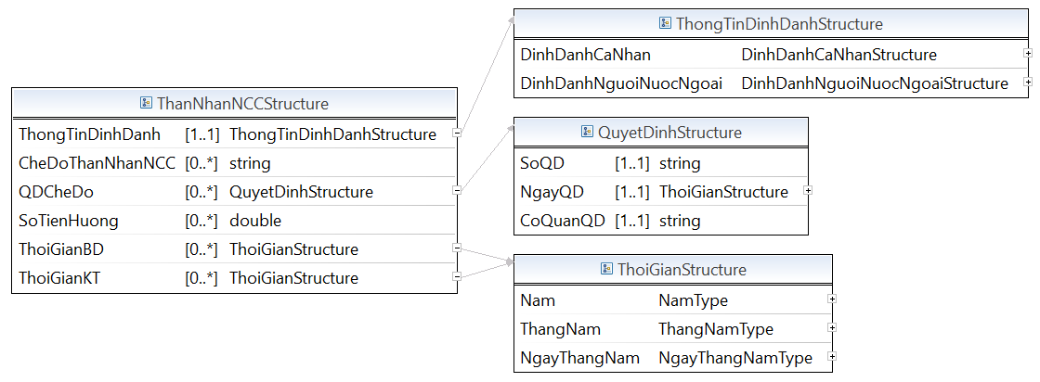

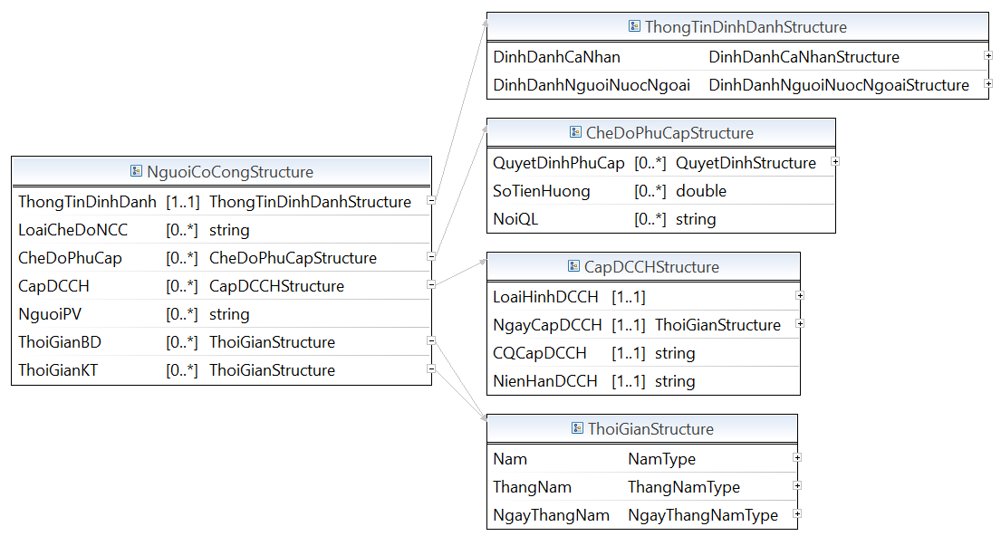

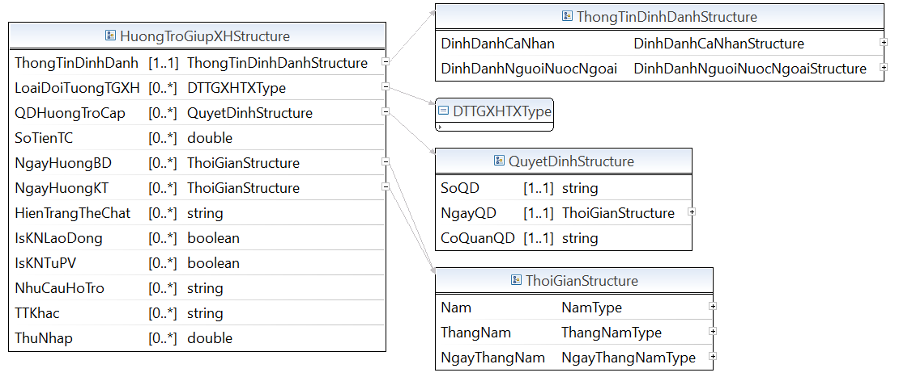

* Lược đồ XML cấu trúc dữ liệu lao động việc làm

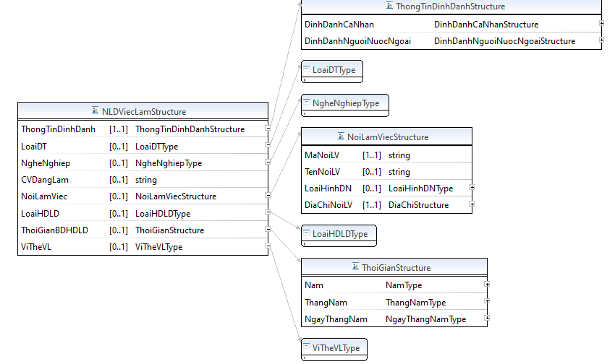

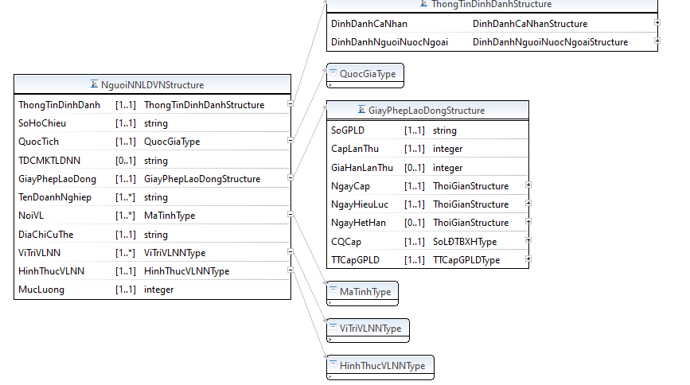

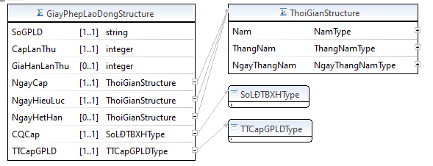

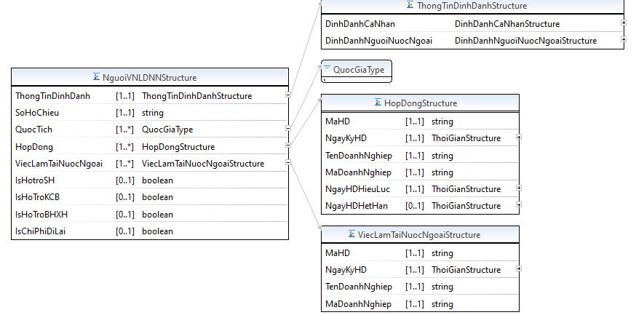

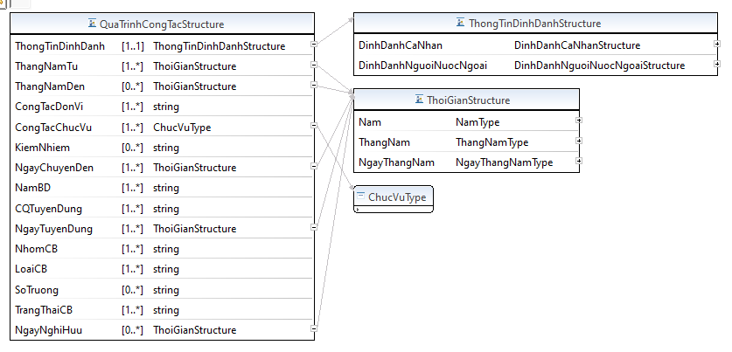

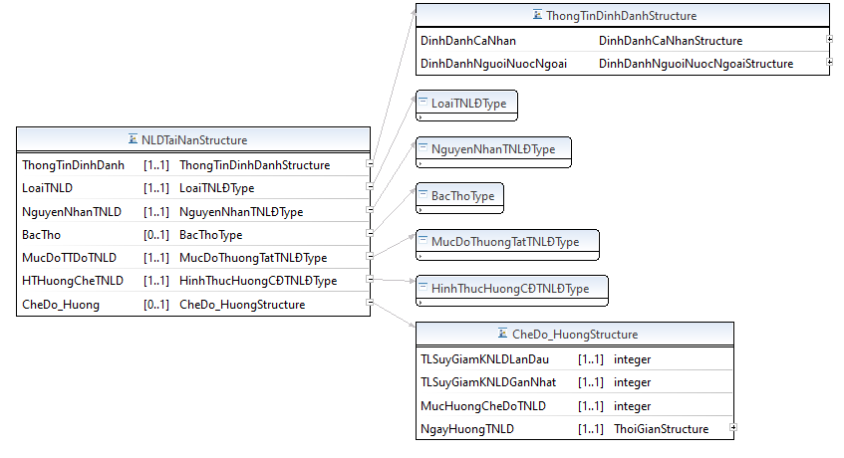

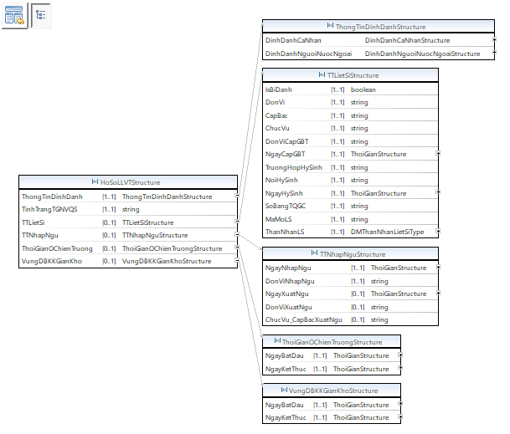

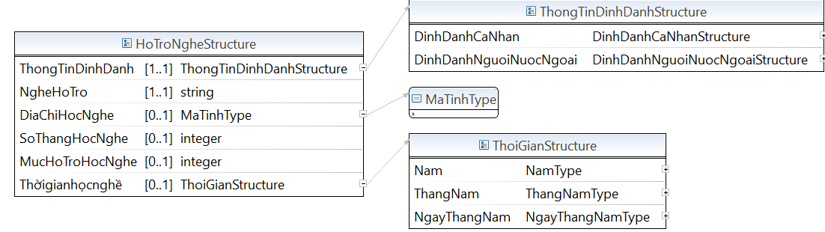

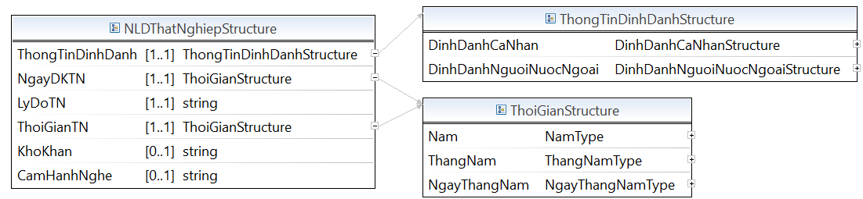

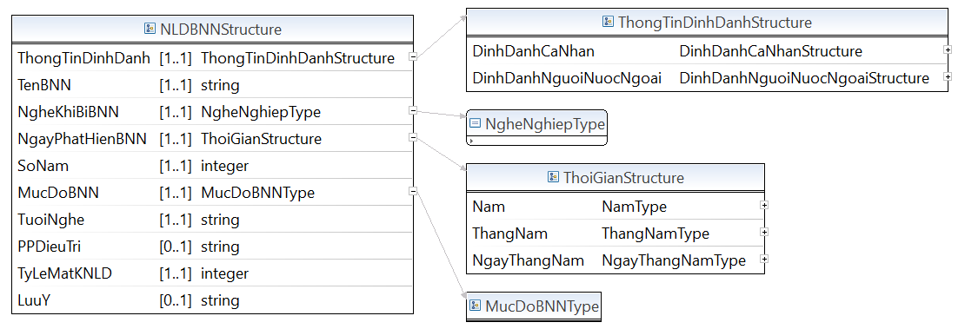

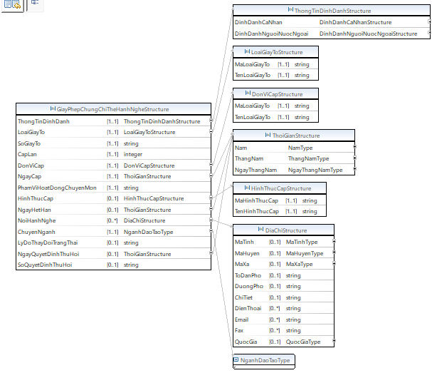

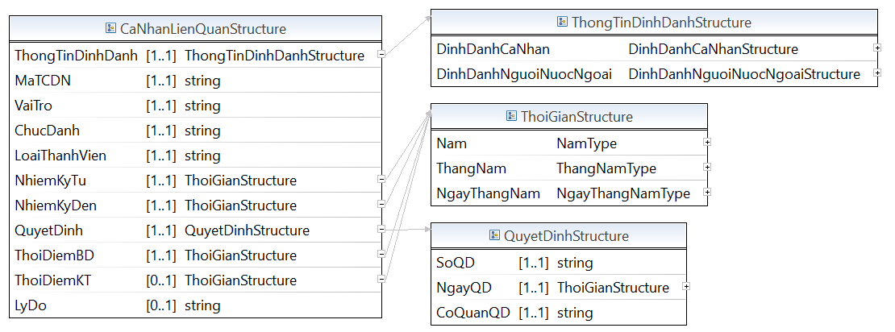

* Lược đồ XML cấu trúc dữ liệu phòng chống tệ nạn xã hội:

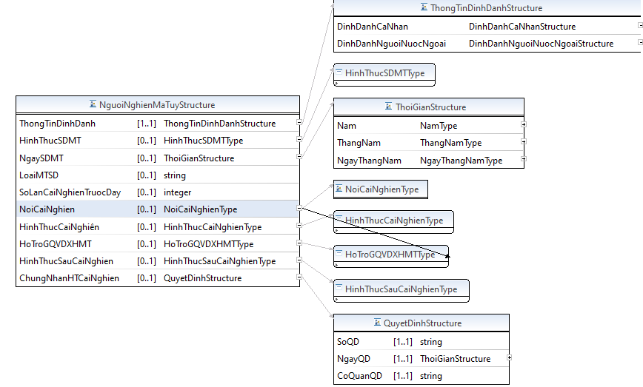

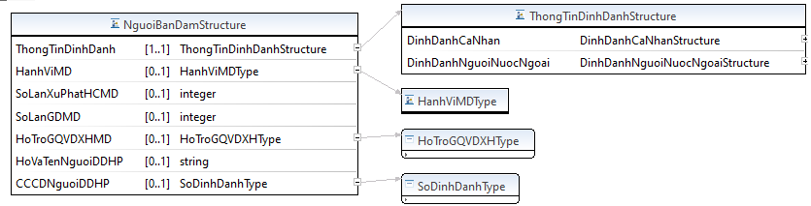

* Lược đồ XML cấu trúc dữ liệu tham gia bảo hiểm xã hội

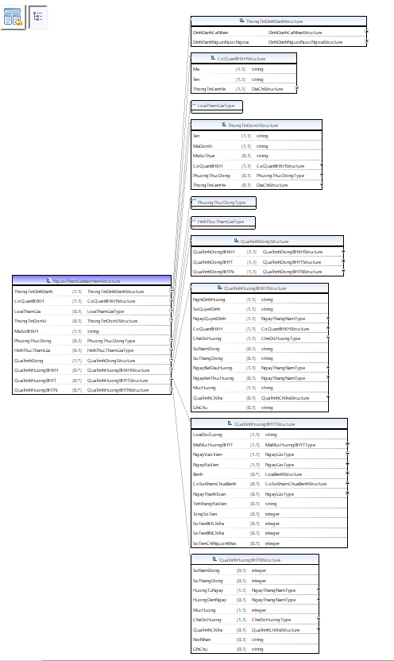

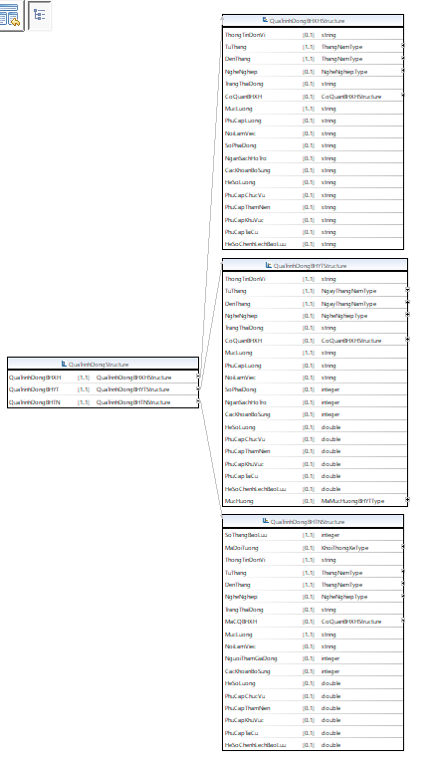

* Lược đồ XML cấu trúc dữ liệu thông tin hưởng bảo hiểm xã hội

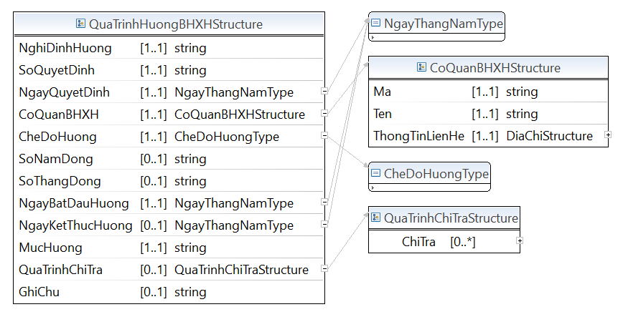

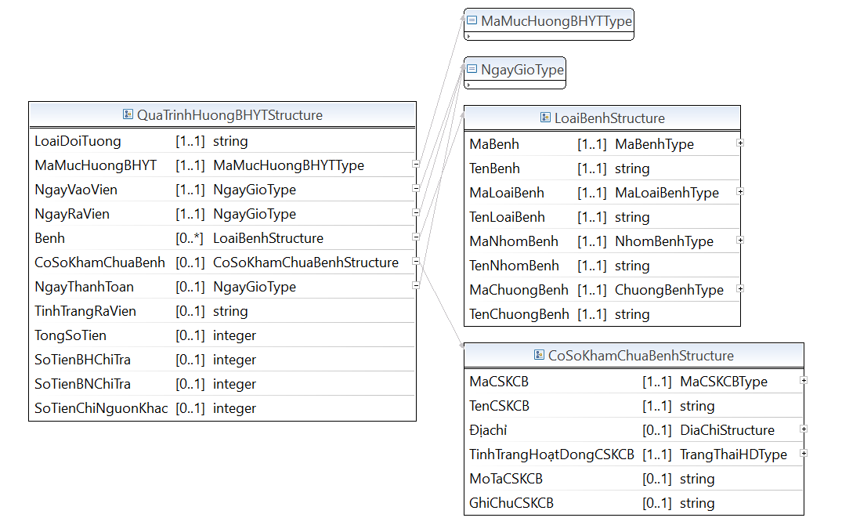

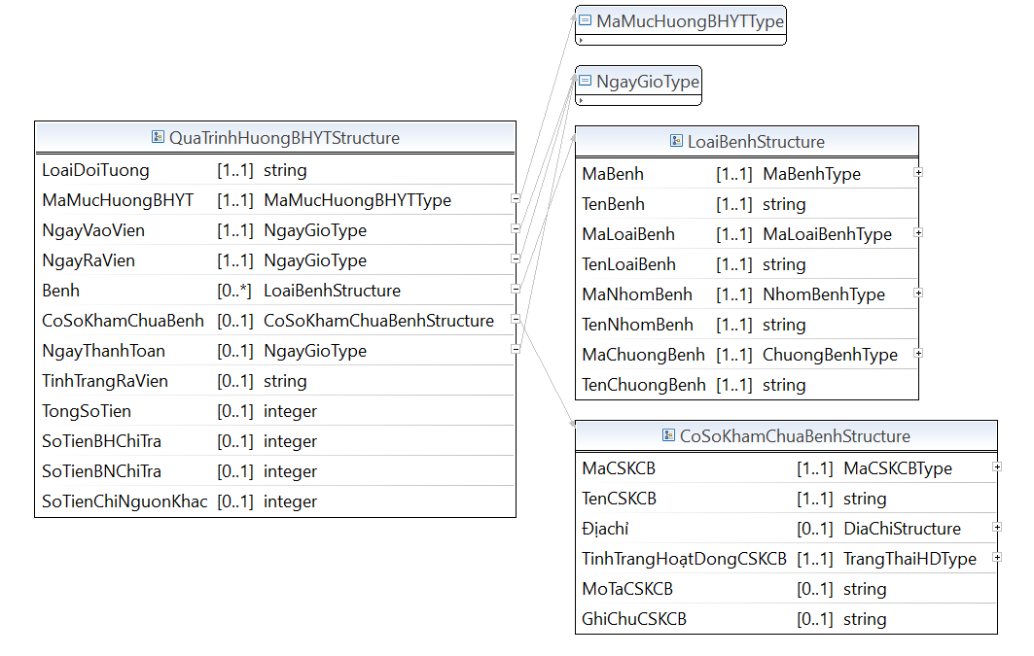

* Lược đồ XML cấu trúc dữ liệu tình trạng bạo lực gia đình

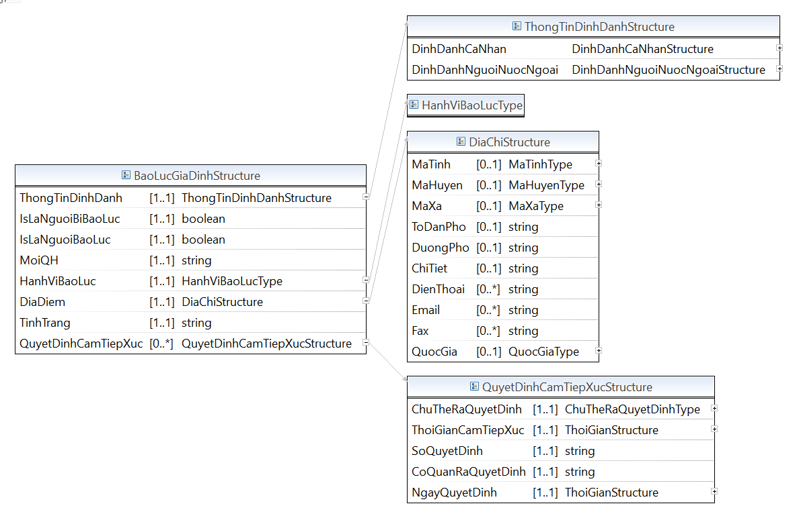

* Lược đồ XML cấu trúc dữ liệu văn hóa thể thao

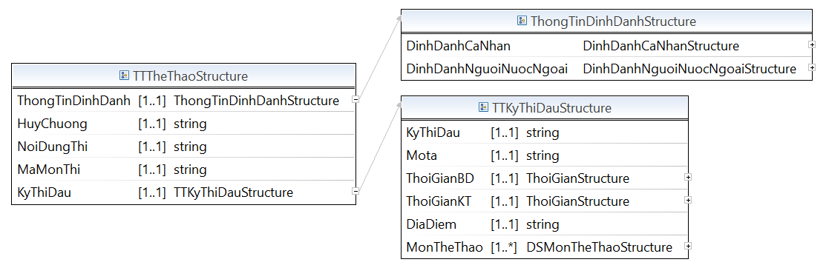

## C1.4. Nhóm thu nhập và thuế

* Lược đồ XML cấu trúc dữ liệu thông tin về thuế

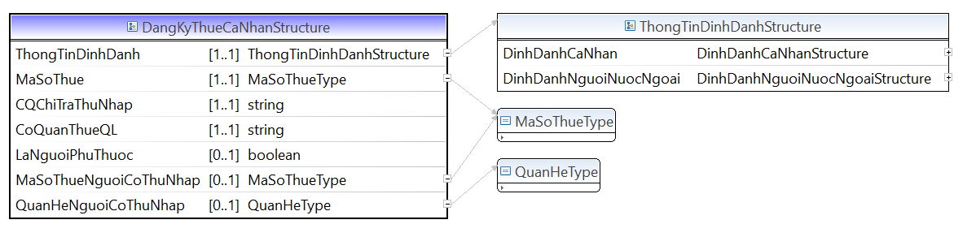

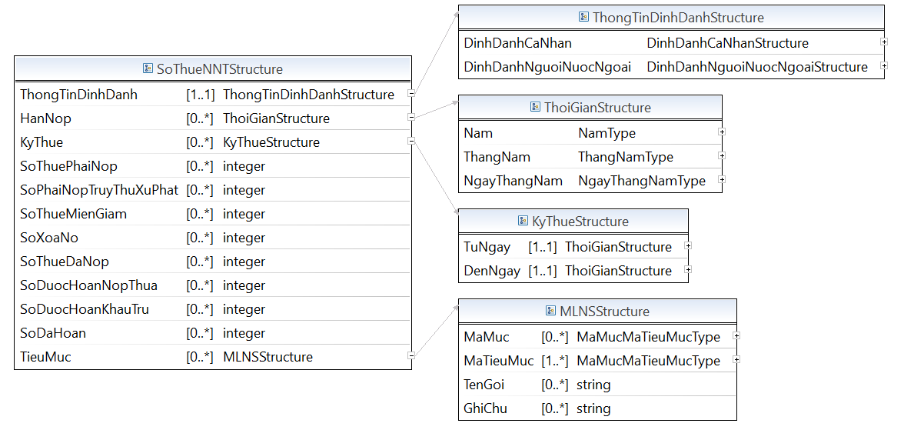

* Lược đồ XML cấu trúc dữ liệu thu nhập từ hoạt động sản xuất kinh doanh

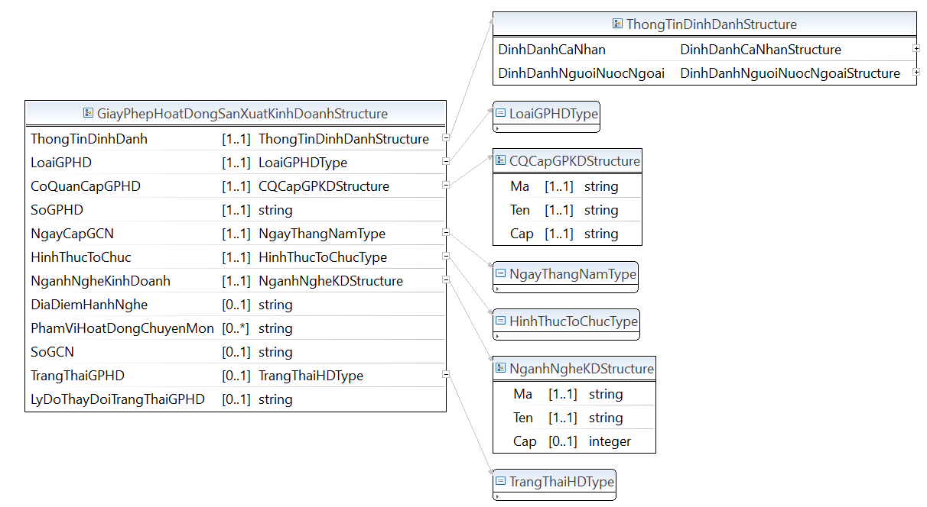

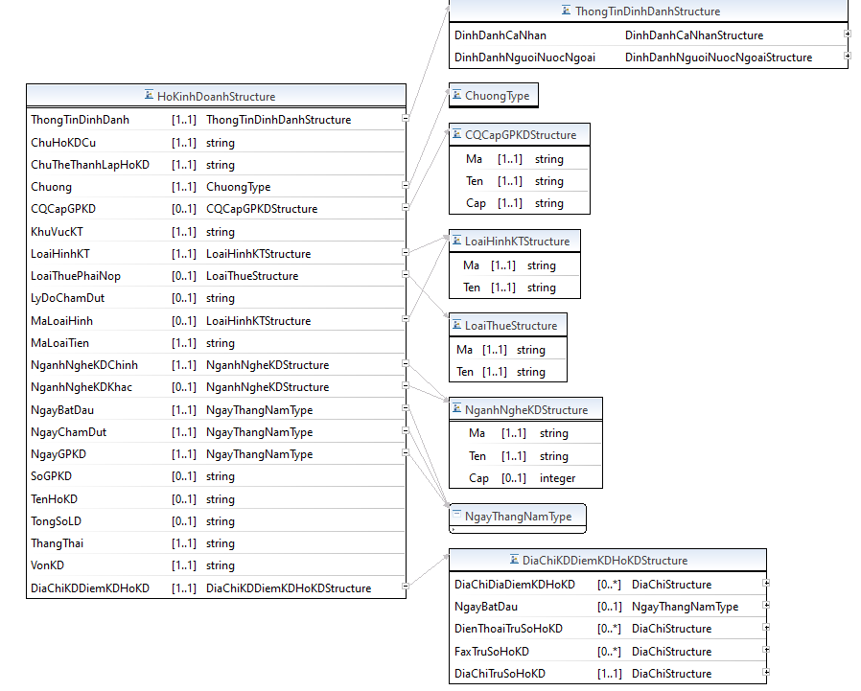

* Lược đồ XML cấu trúc dữ liệu thu nhập từ tiền công, tiền lương

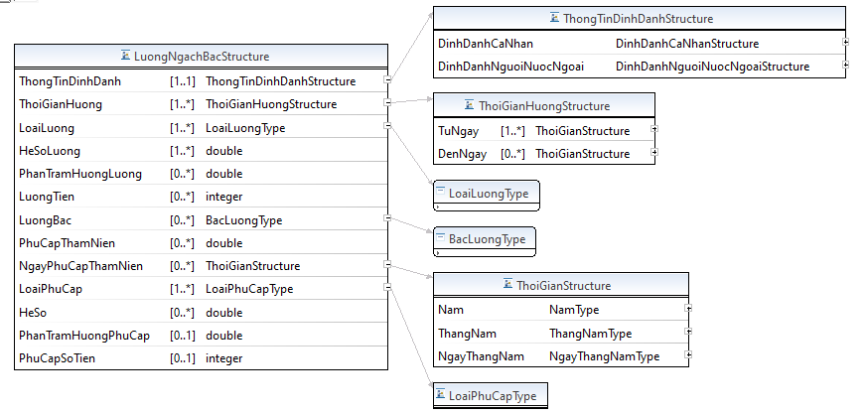

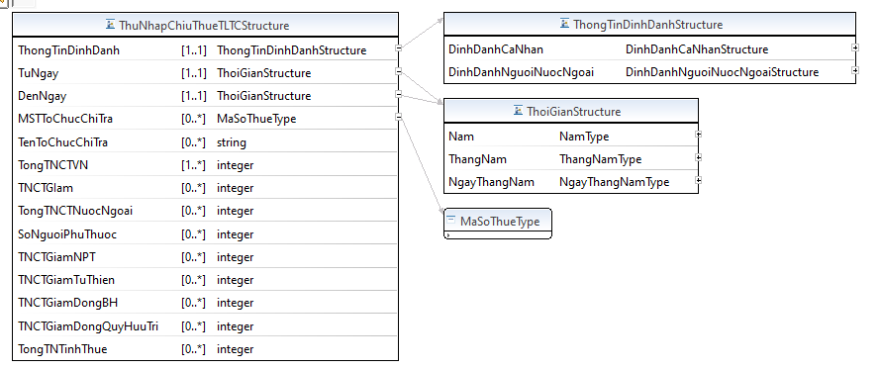

* Lược đồ XML cấu trúc dữ liệu thu nhập khác

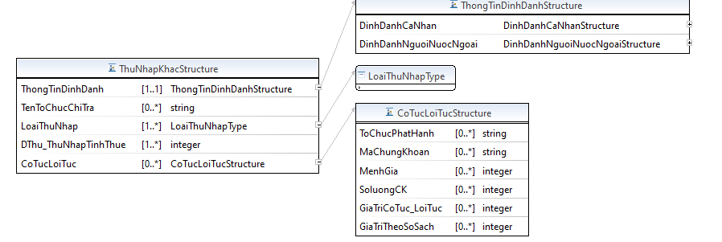

## C1.5.Nhóm năng lực, trình độ

* Lược đồ XML cấu trúc dữ liệu đánh giá chuẩn và kỹ năng

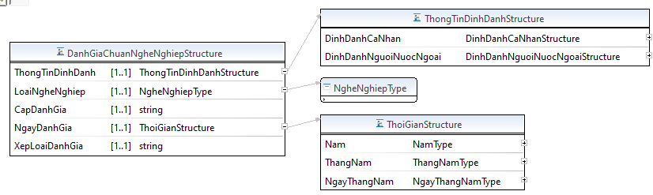

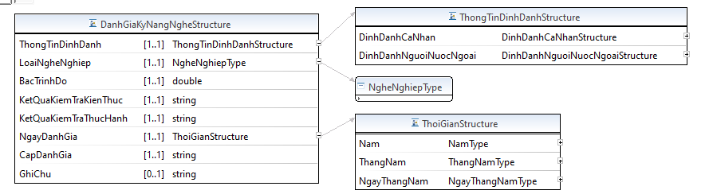

* Lược đồ XML cấu trúc dữ liệu danh hiệu được phong tặng

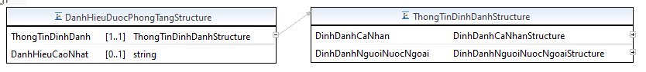

* Lược đồ XML cấu trúc dữ liệu khen thưởng, kỷ luật

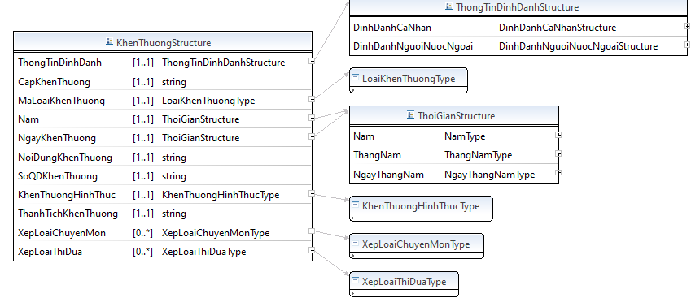

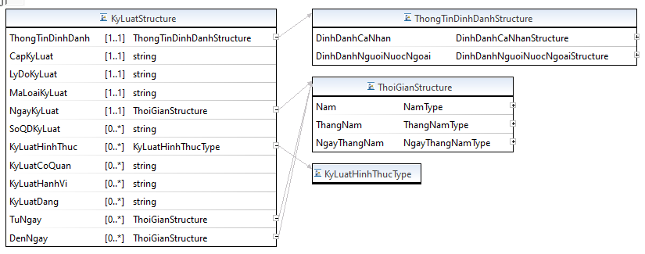

* Lược đồ XML cấu trúc dữ liệu trình độ chung

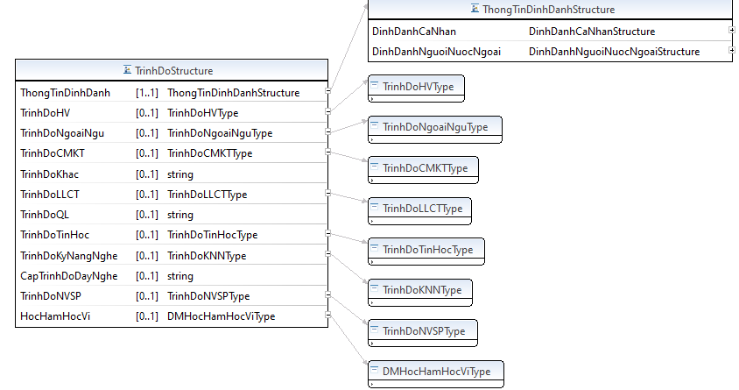

* Lược đồ XML cấu trúc dữ liệu văn bằng, chứng chỉ

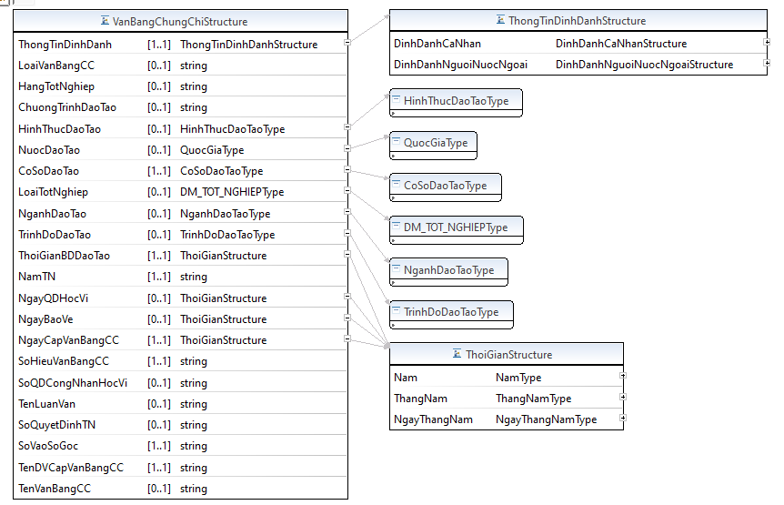

## C1.6.Nhóm giáo dục, nghiên cứu

* Lược đồ XML cấu trúc dữ liệu nghiên cứu khoa học

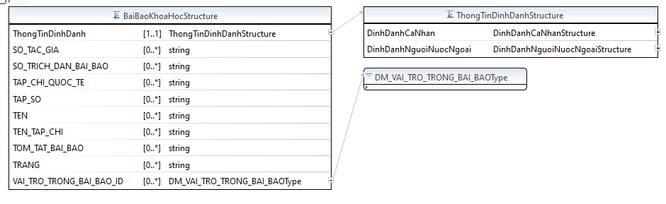

* Lược đồ XML cấu trúc dữ liệu nghiên cứu và phát triển KHCN

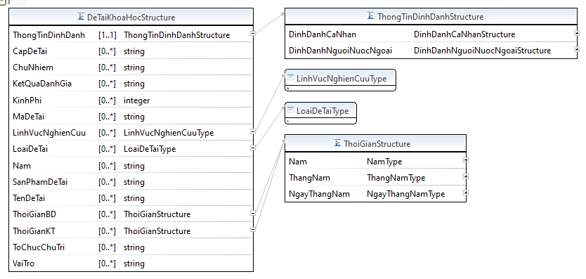

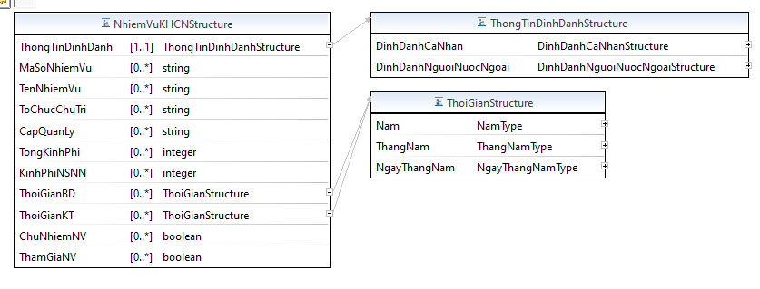

* Lược đồ XML cấu trúc dữ liệu giáo dục, đào tạo

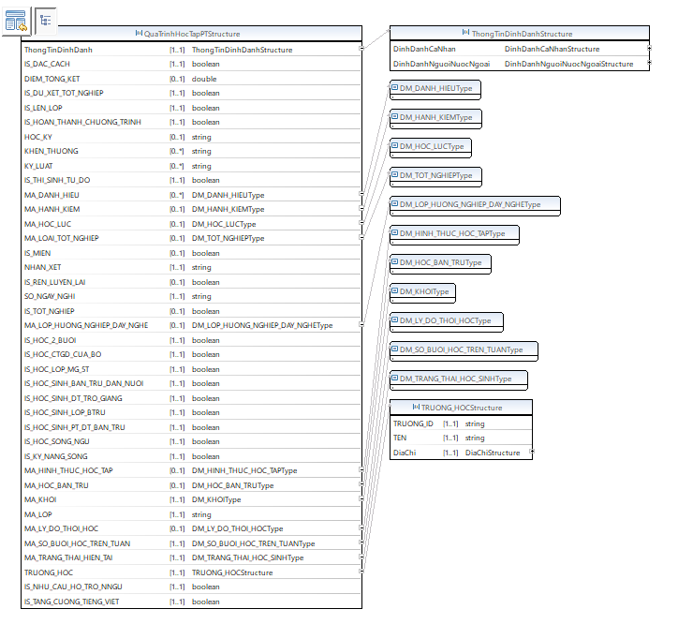

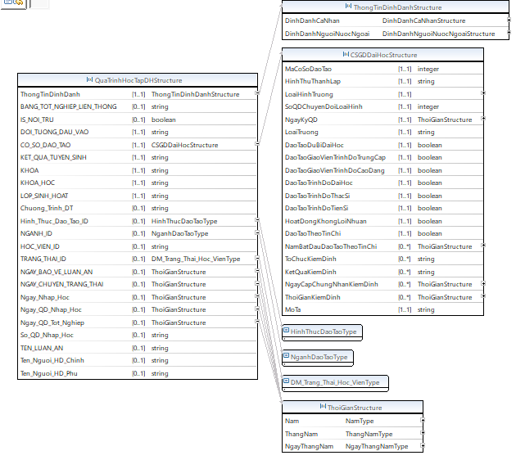

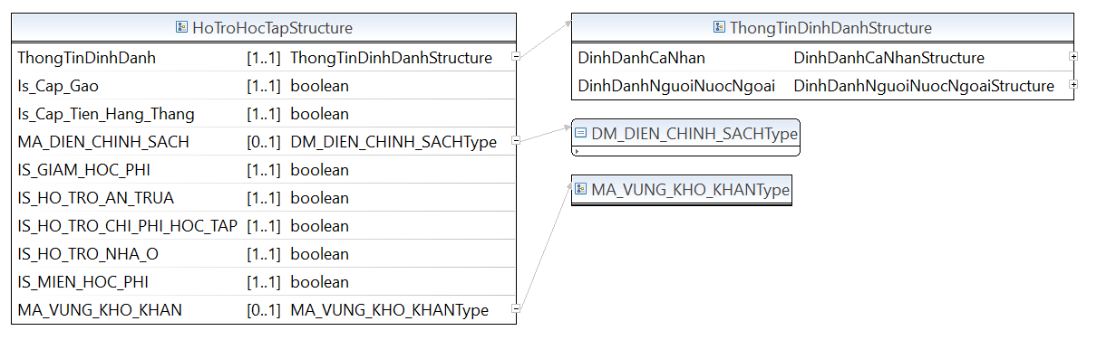

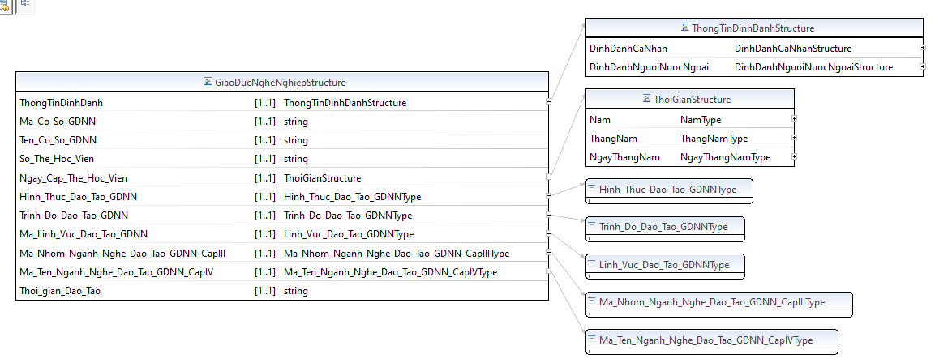

## C.1.7.Nhóm y tế và sức khỏe

* Lược đồ XML cấu trúc dữ liệu thông tin KCB

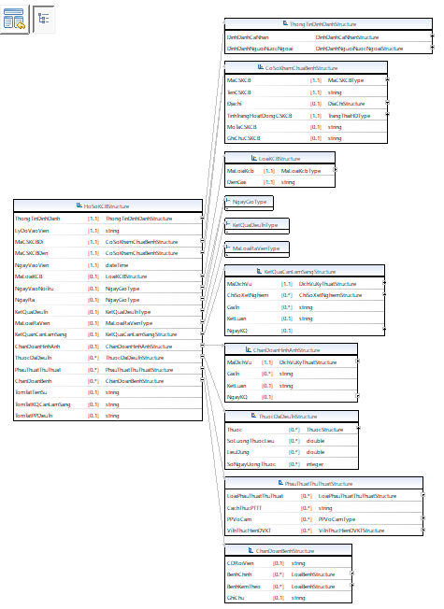

* Lược đồ XML cấu trúc dữ liệu thông tin người bị bệnh mãn tính

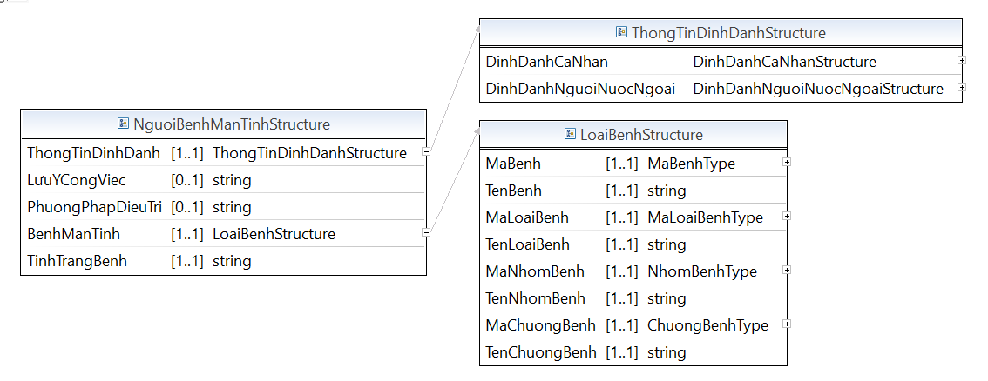

* Lược đồ XML cấu trúc dữ liệu tiêm chủng

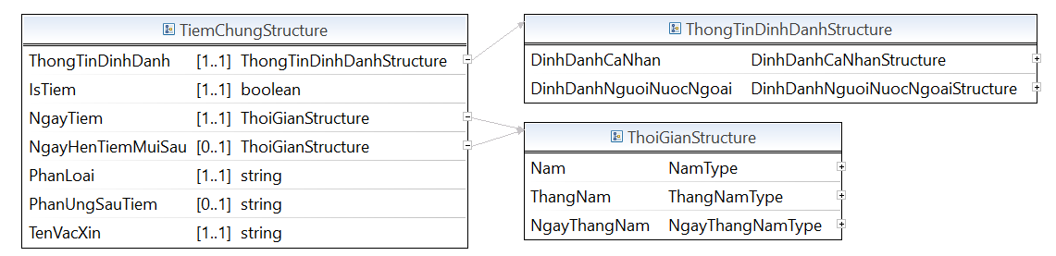

## C.1.8.Nhóm các vấn đề liên quan đến pháp luật

* Lược đồ XML cấu trúc dữ liệu giám sát hành chính

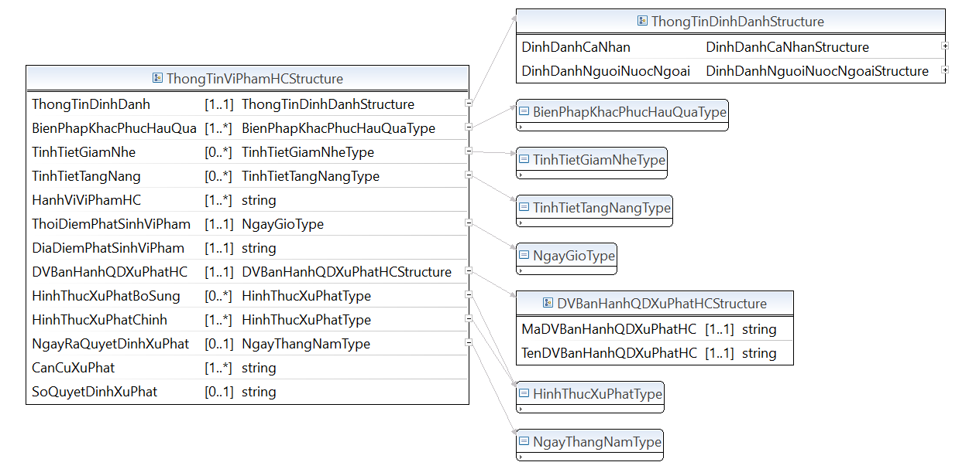

* Lược đồ XML cấu trúc dữ liệu thông tin tư pháp

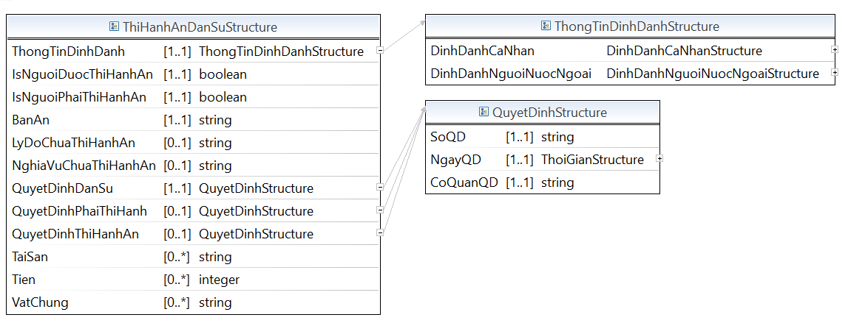

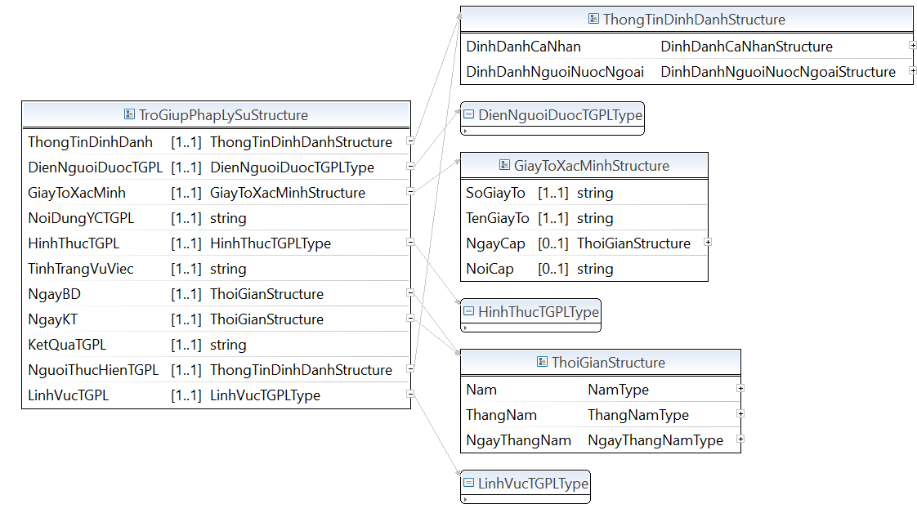

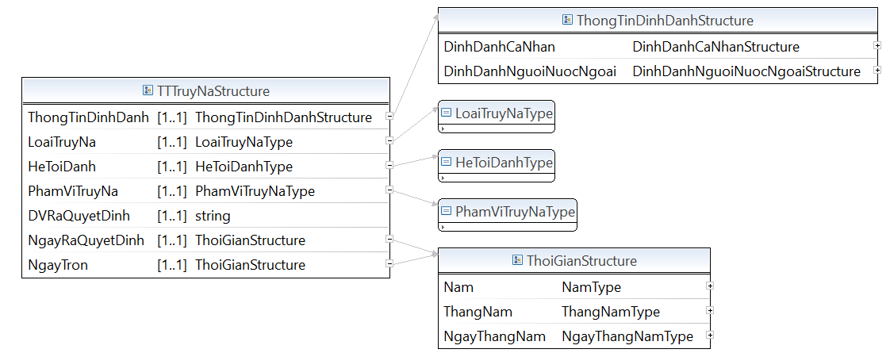

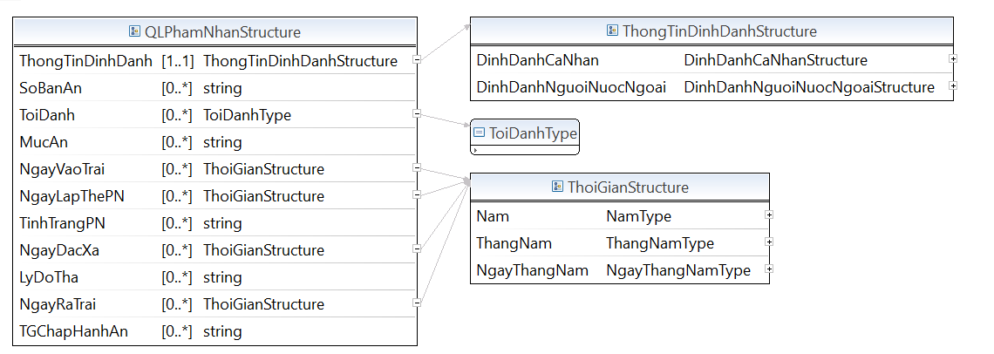

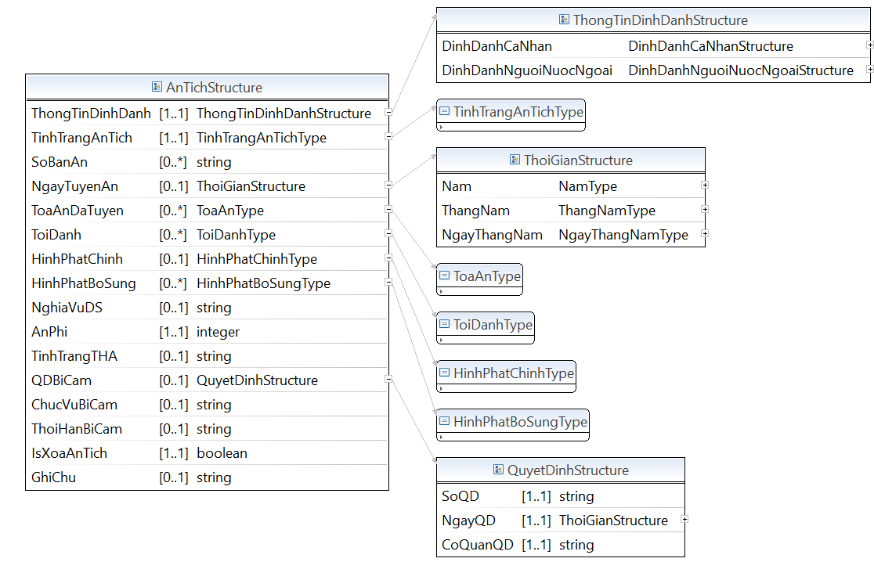

* Lược đồ XML cấu trúc dữ liệu tố tụng

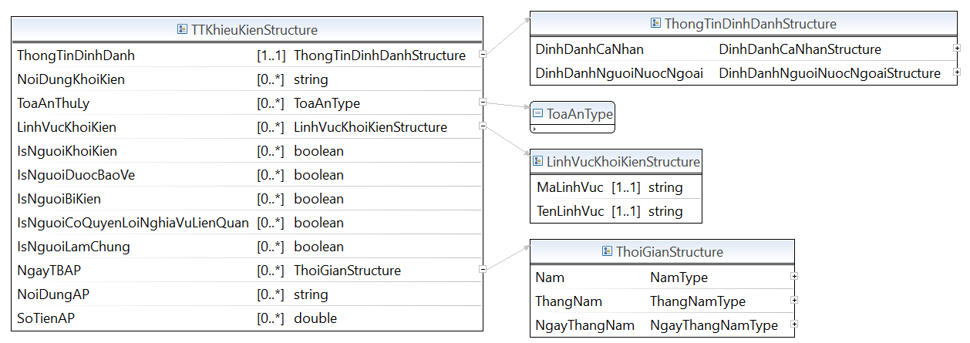

## C.1.9.Nhóm thông tin khác

* Lược đồ XML cấu trúc dữ liệu đặc điểm lịch sử bản thân

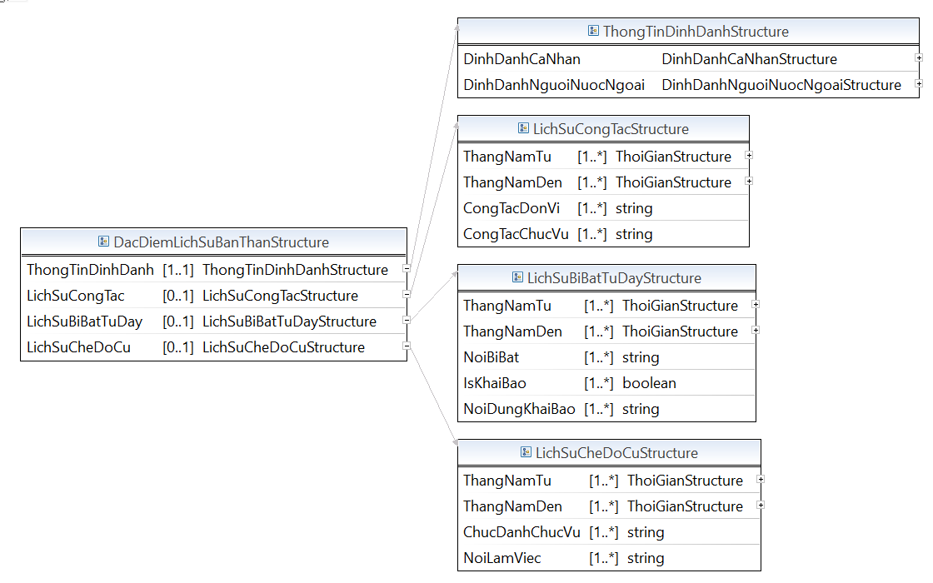

* Lược đồ XML cấu trúc dữ liệu giấy phép lái xe

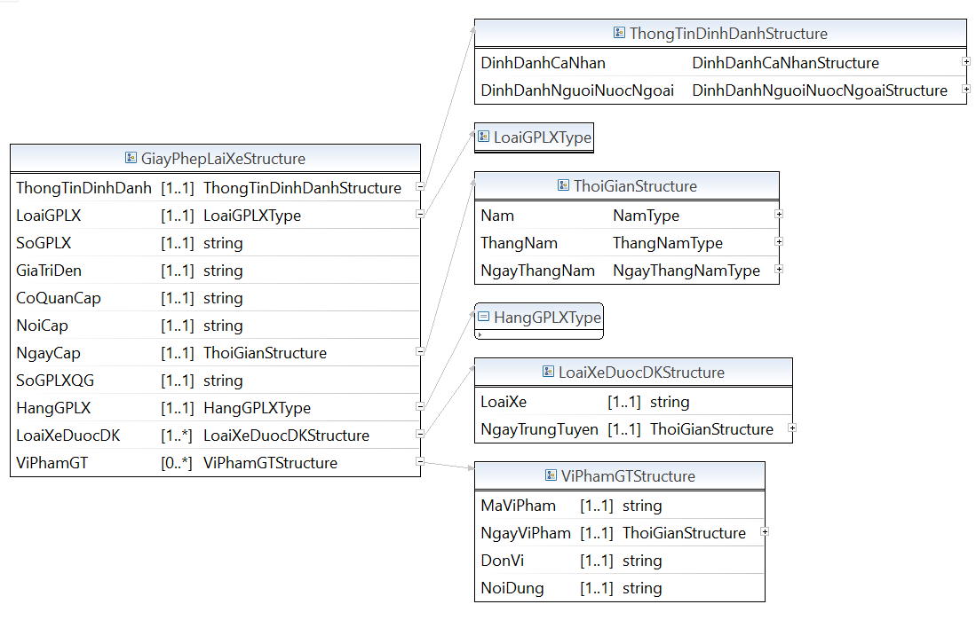

* Lược đồ XML cấu trúc dữ liệu quá trình cư trú:

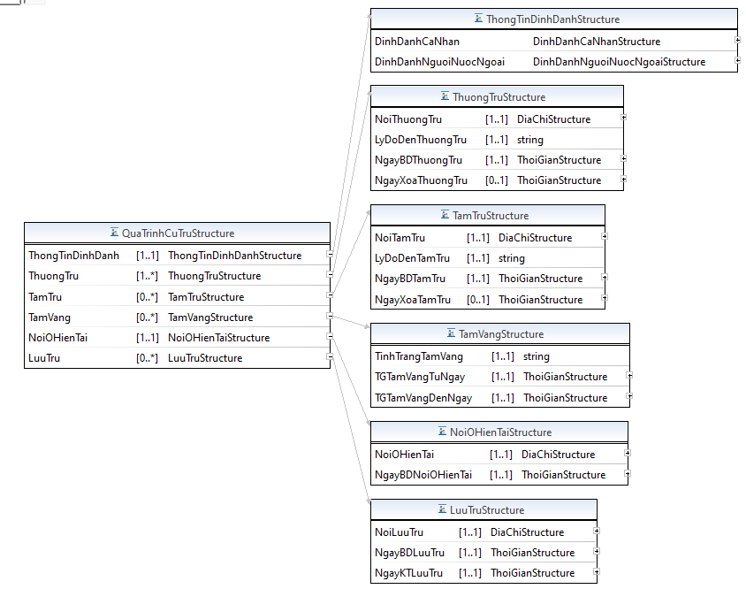

* Lược đồ XML cấu trúc dữ liệu quá trình sinh hoạt Đảng

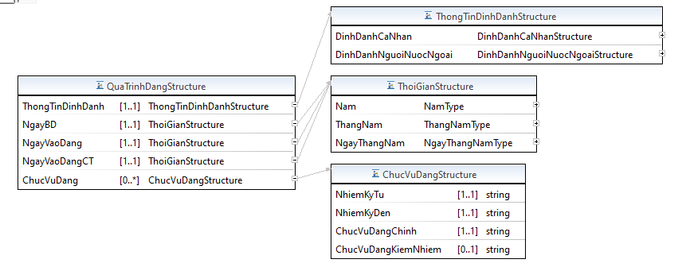

**Mã nguồn lược đồ chứa các cấu trúc thông tin của lược đồ dữ liệu con người (DL_Connguoi.xsd)**

<?xml version=*“1.1”* encoding=*"UTF-8"*?>

<xsd:schema xmlns:xsd=*"http://www.w3.org/2001/XMLSchema"* xmlns:TTDLQG=*"..."* targetNamespace=*"..."* version=*“1.1”* elementFormDefault=*"qualified"*>

<!-- <xsd:include schemaLocation="BaseEnumType.xsd" /> -->

<xsd:annotation>

<xsd:documentation></xsd:documentation>

</xsd:annotation>

<xsd:complexType name=*"DinhDanhCaNhanStructure"*>

<xsd:annotation>

<xsd:documentation>Cấu trúc thông tin đăng ký cơ bản của công dân. Đây là các thuộc tính cần phải có trong tất cả các đối tượng quản lý liên quan đến con người</xsd:documentation>

</xsd:annotation>

<xsd:sequence>

<xsd:element name=*"SoDinhDanh"* type=*"TTDLQG:SoDinhDanhType"* minOccurs=*"1"* maxOccurs=*"1"* />

<xsd:element name=*"HoTen"* type=*"xsd:string"* minOccurs=*"1"* maxOccurs=*"1"* />

<xsd:element name=*"GioiTinh"* type=*"TTDLQG:GioiTinhType"* minOccurs=*"1"* maxOccurs=*"1"* />

<xsd:element name=*"TonGiao"* type=*"TTDLQG:TonGiaoStructure"* minOccurs=*"0"* maxOccurs=*"1"* />

<xsd:element name=*"QuocTich"* type=*"TTDLQG:QuocGiaType"* minOccurs=*"1"* maxOccurs=*"1"* />

<xsd:element name=*"QuocTichKhac"* type=*"TTDLQG:QuocGiaType"* minOccurs=*"0"* maxOccurs=*"1"* />

<xsd:element name=*"DiachiNoiOHienTai"* type=*"TTDLQG:DiaChiStructure"* minOccurs=*"0"* maxOccurs=*"1"* />

<xsd:element name=*"DiachiNoiTamTru"* type=*"TTDLQG:DiaChiStructure"* minOccurs=*"0"* maxOccurs=*"1"* />

<xsd:element name=*"SoHosoCuTru"* type=*"xsd:string"* minOccurs=*"0"* maxOccurs=*"1"* />

<xsd:element name=*"NgayKhaiBaoCuTru"* type=*"TTDLQG:ThoiGianStructure"* minOccurs=*"0"* maxOccurs=*"1"* />

<xsd:element name=*"TinhTrangCuTru"* type=*"xsd:string"* minOccurs=*"0"* maxOccurs=*"1"* />

<xsd:element name=*"TenKhac"* type=*"xsd:string"* minOccurs=*"0"* maxOccurs=*"1"* />

<xsd:element name=*"NgayThangNamChet"* type=*"TTDLQG:ThoiGianStructure"* minOccurs=*"0"* maxOccurs=*"1"* />

<xsd:element name=*"TrangThaiCongDan"* type=*"TTDLQG:TrangThaiCongDanType"* minOccurs=*"1"* maxOccurs=*"1"* />

<xsd:element name=*"NgaySinh"* type=*"TTDLQG:ThoiGianStructure"* minOccurs=*"1"* maxOccurs=*"1"* />

<xsd:element name=*"DiachiNoiSinh"* type=*"TTDLQG:DiaChiStructure"* minOccurs=*"0"* maxOccurs=*"1"* />

<xsd:element name=*"DangkyKhaiSinh"* type=*"TTDLQG:DiaChiStructure"* minOccurs=*"0"* maxOccurs=*"1"* />

<xsd:element name=*"QueQuan"* type=*"TTDLQG:DiaChiStructure"* minOccurs=*"0"* maxOccurs=*"1"* />

<xsd:element name=*"DanToc"* type=*"TTDLQG:DanTocStructure"* minOccurs=*"1"* maxOccurs=*"1"* />

</xsd:sequence>

</xsd:complexType>

<xsd:complexType name=*"DinhDanhNguoiNuocNgoaiStructure"*>

<xsd:annotation>

<xsd:documentation>Cấu trúc thông tin định danh người nước ngoài. Đây là các thuộc tính cần phải có liên quan đến con người là người nước ngoài</xsd:documentation>

</xsd:annotation>

<xsd:sequence>

<xsd:element name=*"SoDinhDanh"* type=*"TTDLQG:SoDinhDanhType"* minOccurs=*"1"* maxOccurs=*"1"* />

<xsd:element name=*"LoaiHoChieu"* type=*"TTDLQG:LoaiHoChieuType"* minOccurs=*"0"* maxOccurs=*"unbounded"* />

<xsd:element name=*"SoGiayToNN"* type=*"xsd:string"* minOccurs=*"1"* maxOccurs=*"1"* />

<xsd:element name=*"NgayCapGiayToNN"* type=*"TTDLQG:ThoiGianStructure"* minOccurs=*"1"* maxOccurs=*"1"* />

<xsd:element name=*"NoiCapGiayToNN"* type=*"xsd:string"* minOccurs=*"0"* maxOccurs=*"1"* />

<xsd:element name=*"HotenNN"* type=*"xsd:string"* minOccurs=*"1"* maxOccurs=*"1"* />

<xsd:element name=*"QuocTichNN"* type=*"TTDLQG:QuocGiaType"* minOccurs=*"0"* maxOccurs=*"1"* />

<xsd:element name=*"NgaySinhNN"* type=*"TTDLQG:ThoiGianStructure"* minOccurs=*"1"* maxOccurs=*"1"* />

<xsd:element name=*"GioiTinhNN"* type=*"TTDLQG:GioiTinh"* minOccurs=*"0"* maxOccurs=*"1"* />

<xsd:element name=*"SoThiThuc"* type=*"xsd:string"* minOccurs=*"1"* maxOccurs=*"1"* />

<xsd:element name=*"TenQuocGia"* type=*"TTDLQG:QuocGiaType"* minOccurs=*"0"* maxOccurs=*"1"* />

<xsd:element name=*"ThoiHanDen"* type=*"TTDLQG:ThoiGianStructure"* minOccurs=*"1"* maxOccurs=*"1"* />

<xsd:element name=*"ThoiHanTu"* type=*"TTDLQG:ThoiGianStructure"* minOccurs=*"0"* maxOccurs=*"1"* />

</xsd:sequence>

</xsd:complexType>

<xsd:complexType name=*"GiayToDinhDanhStructure"*>

<xsd:annotation>

<xsd:documentation>Cấu trúc giấy tờ định danh</xsd:documentation>

</xsd:annotation>

<xsd:sequence>

<xsd:element name=*"ThongTinDinhDanh"* type=*"TTDLQG:ThongTinDinhDanhStructure"* minOccurs=*"1"* maxOccurs=*"1"* />

<xsd:element name=*"AnhMatSauCCCD"* type=*"TTDLQG:base64Binary"* minOccurs=*"0"* maxOccurs=*"1"* />

<xsd:element name=*"AnhMatTruocCCCD"* type=*"TTDLQG:base64Binary"* minOccurs=*"0"* maxOccurs=*"1"* />

<xsd:element name=*"LoaiGiayTo"* type=*"TTDLQG:LoaiGiayToTuyThanType"* minOccurs=*"1"* maxOccurs=*"1"* />

<xsd:element name=*"NgayCap"* type=*"TTDLQG:ThoiGianStructure"* minOccurs=*"0"* maxOccurs=*"1"* />

<xsd:element name=*"NoiCap"* type=*"xsd:string"* minOccurs=*"0"* maxOccurs=*"1"* />

<xsd:element name=*"SoGiayTo"* type=*"xsd:string"* minOccurs=*"1"* maxOccurs=*"1"* />

<xsd:element name=*"NgayHetHan"* type=*"TTDLQG:ThoiGianStructure"* minOccurs=*"0"* maxOccurs=*"1"* />

</xsd:sequence>

</xsd:complexType>

<xsd:complexType name=*"ThongTinNhanDangStructure"*>

<xsd:annotation>

<xsd:documentation>ThongTinNhanDang</xsd:documentation>

</xsd:annotation>

<xsd:sequence>

<xsd:element name=*"AnhChanDung"* type=*"TTDLQG:base64Binary"* minOccurs=*"0"* maxOccurs=*"1"* />

</xsd:sequence>

</xsd:complexType>

<xsd:complexType name=*"ThoiNhapQuocTichStructure"*>

<xsd:annotation>

<xsd:documentation>ThoiNhapQuocTich</xsd:documentation>

</xsd:annotation>

<xsd:sequence>

<xsd:element name=*"ThongTinDinhDanh"* type=*"TTDLQG:ThongTinDinhDanhStructure"* minOccurs=*"1"* maxOccurs=*"1"* />

<xsd:element name=*"LoaiThayDoiQuocTich"* type=*"TTDLQG:LoaiThayDoiQuocTichType"* minOccurs=*"1"* maxOccurs=*"1"* />

<xsd:element name=*"SoQuyetDinh"* type=*"xsd:string"* minOccurs=*"1"* maxOccurs=*"1"* />

<xsd:element name=*"NgayQuyetDinh"* type=*"TTDLQG:ThoiGianStructure"* minOccurs=*"1"* maxOccurs=*"1"* />

<xsd:element name=*"HieuLucQuyetDinh"* type=*"TTDLQG:ThoiGianStructure"* minOccurs=*"0"* maxOccurs=*"1"* />

</xsd:sequence>

</xsd:complexType>

<xsd:complexType name=*"XuatNhapCanhStructure"*>

<xsd:annotation>

<xsd:documentation>Thông tin xuất/Nhập cảnh</xsd:documentation>

</xsd:annotation>

<xsd:sequence>

<xsd:element name=*"ThongTinDinhDanh"* type=*"TTDLQG:ThongTinDinhDanhStructure"* minOccurs=*"1"* maxOccurs=*"1"* />

<xsd:element name=*"SoTreEmKemTheo"* type=*"xsd:integer"* minOccurs=*"0"* maxOccurs=*"1"* />

<xsd:element name=*"CuaKhau"* type=*"TTDLQG:CuaKhau"* minOccurs=*"1"* maxOccurs=*"1"* />

<xsd:element name=*"MucDichXNC"* type=*"xsd:string"* minOccurs=*"0"* maxOccurs=*"1"* />

<xsd:element name=*"NgayGioXNC"* type=*"xsd:string"* minOccurs=*"1"* maxOccurs=*"1"* />

<xsd:element name=*"SoHieuPhuongTien"* type=*"xsd:string"* minOccurs=*"0"* maxOccurs=*"1"* />

<xsd:element name=*"SoHoSoXNC"* type=*"xsd:string"* minOccurs=*"1"* maxOccurs=*"1"* />

<xsd:element name=*"TinhThanhPhoXNC"* type=*"TTDLQG:MaTinhType"* minOccurs=*"1"* maxOccurs=*"1"* />

<xsd:element name=*"TuyenDuongBay"* type=*"xsd:string"* minOccurs=*"0"* maxOccurs=*"1"* />

<xsd:element name=*"TuyenDuongDi"* type=*"xsd:string"* minOccurs=*"0"* maxOccurs=*"1"* />

</xsd:sequence>

</xsd:complexType>

<xsd:complexType name=*"eCCCDStructure"*>

<xsd:annotation>

<xsd:documentation>Căn cước công dân điện tử</xsd:documentation>

</xsd:annotation>

<xsd:sequence>

<xsd:element name=*"ThongTinDinhDanh"* type=*"TTDLQG:ThongTinDinhDanhStructure"* minOccurs=*"1"* maxOccurs=*"1"* />

<xsd:element name=*"TrangThaieCCCD"* type=*"TTDLQG:TrangThaieCCCDType"* minOccurs=*"1"* maxOccurs=*"1"* />

</xsd:sequence>

</xsd:complexType>

<xsd:complexType name=*"CuaKhauStructure"*>

<xsd:annotation>

<xsd:documentation>Cửa khẩu</xsd:documentation>

</xsd:annotation>

<xsd:sequence>

<xsd:element name=*"MaCuaKhau"* type=*"xsd:string"* minOccurs=*"1"* maxOccurs=*"1"* />

<xsd:element name=*"TenCuaKhau"* type=*"xsd:string"* minOccurs=*"1"* maxOccurs=*"1"* />

<xsd:element name=*"LoaiCuaKhau"* type=*"TTDLQG:LoaiCuaKhauType"* minOccurs=*"1"* maxOccurs=*"1"* />

</xsd:sequence>

</xsd:complexType>

<xsd:complexType name=*"NguoiGiamHoStructure"*>

<xsd:annotation>

<xsd:documentation>Thành viên gia đình, giám hộ</xsd:documentation>

</xsd:annotation>

<xsd:sequence>

<xsd:element name=*"QuanHeGiamHo"* type=*"xsd:string"* minOccurs=*"0"* maxOccurs=*"1"* />

<xsd:element name=*"SoDinhDanhGiamHo"* type=*"TTDLQG:SoDinhDanhType"* minOccurs=*"0"* maxOccurs=*"1"* />

<xsd:element name=*"ThoiHanGiamHo"* type=*"TTDLQG:ThoiGianStructure"* minOccurs=*"0"* maxOccurs=*"1"* />

</xsd:sequence>

</xsd:complexType>

<xsd:complexType name=*"ThanhVienHoGiaDinhStructure"*>

<xsd:annotation>

<xsd:documentation>Thành viên hộ gia đình</xsd:documentation>

</xsd:annotation>

<xsd:sequence>

<xsd:element name=*"SoDinhDanhHoGD"* type=*"xsd:string"* minOccurs=*"0"* maxOccurs=*"1"* />

<xsd:element name=*"SoDDChuHo"* type=*"TTDLQG:SoDinhDanhType"* minOccurs=*"0"* maxOccurs=*"1"* />

<xsd:element name=*"QuanHeChuHo"* type=*"xsd:string"* minOccurs=*"0"* maxOccurs=*"1"* />

</xsd:sequence>

</xsd:complexType>

<xsd:complexType name=*"ThongTinHonNhanStructure"*>

<xsd:annotation>

<xsd:documentation>Thông tin kết hôn</xsd:documentation>

</xsd:annotation>

<xsd:sequence>

<xsd:element name=*"ThongTinDinhDanh(S)"* type=*"TTDLQG:ThongTinDinhDanhStructure"* minOccurs=*""* maxOccurs=*""* />

<xsd:element name=*"NgayThayDoiTinhTrangHonNhan"* type=*"TTDLQG:ThoiGianStructure"* minOccurs=*"0"* maxOccurs=*"1"* />

<xsd:element name=*"TinhTrangHonNhan"* type=*"TTDLQG:TinhTrangHonNhanType"* minOccurs=*"1"* maxOccurs=*"1"* />

<xsd:element name=*"NgayDangKyKetHon"* type=*"TTDLQG:ThoiGianStructure"* minOccurs=*"0"* maxOccurs=*"1"* />

<xsd:element name=*"NoiDangKyKetHon"* type=*"xsd:string"* minOccurs=*"0"* maxOccurs=*"1"* />

<xsd:element name=*"NgayLyHon"* type=*"TTDLQG:ThoiGianStructure"* minOccurs=*"0"* maxOccurs=*"1"* />

<xsd:element name=*"SoDinhDanhNguoiKetHon"* type=*"TTDLQG:SoDinhDanhType"* minOccurs=*"1"* maxOccurs=*"1"* />

</xsd:sequence>

</xsd:complexType>

<xsd:complexType name=*"DiaChiLienHeStructure"*>

<xsd:annotation>

<xsd:documentation>Địa chỉ liên hệ</xsd:documentation>

</xsd:annotation>

<xsd:sequence>

<xsd:element name=*"ThongTinDinhDanh"* type=*"TTDLQG:ThongTinDinhDanhStructure"* minOccurs=*"1"* maxOccurs=*"1"* />

<xsd:element name=*"DiaChiLienHe"* type=*"TTDLQG:DiaChiStructure"* minOccurs=*"1"* maxOccurs=*"1"* />

</xsd:sequence>

</xsd:complexType>

<xsd:complexType name=*"DiaChiSoStructure"*>

<xsd:annotation>

<xsd:documentation>Thông tin về địa chỉ</xsd:documentation>

</xsd:annotation>

<xsd:sequence>

<xsd:element name=*"TenDiaDiem"* type=*"xsd:string"* minOccurs=*"0"* maxOccurs=*"1"* />

<xsd:element name=*"PhanLoaiDD"* type=*"TTDLQG:PhanLoaiDiaChiStructure"* minOccurs=*"0"* maxOccurs=*"1"* />

<xsd:element name=*"SoNha"* type=*"xsd:string"* minOccurs=*"0"* maxOccurs=*"1"* />

<xsd:element name=*"TenDuong"* type=*"xsd:string"* minOccurs=*"0"* maxOccurs=*"1"* />

<xsd:element name=*"ThonTo"* type=*"TTDLQG:MaThonToStructure"* minOccurs=*"1"* maxOccurs=*"1"* />

<xsd:element name=*"PhuongXa"* type=*"TTDLQG:MaBCPhuongXaStructure"* minOccurs=*"1"* maxOccurs=*"1"* />

<xsd:element name=*"QuanHuyen"* type=*"TTDLQG:MaBCQuanHuyenStructure"* minOccurs=*"1"* maxOccurs=*"1"* />

<xsd:element name=*"TinhTP"* type=*"TTDLQG:MaBCTinhTPStructure"* minOccurs=*"1"* maxOccurs=*"1"* />

<xsd:element name=*"Geom"* type=*"xsd:string"* minOccurs=*"1"* maxOccurs=*"1"* />

</xsd:sequence>

</xsd:complexType>

<xsd:complexType name=*"DiaChiThuDienTuStructure"*>

<xsd:annotation>

<xsd:documentation>Địa chỉ thư điện tử</xsd:documentation>

</xsd:annotation>

<xsd:sequence>

<xsd:element name=*"ThongTinDinhDanh"* type=*"TTDLQG:ThongTinDinhDanhStructure"* minOccurs=*"1"* maxOccurs=*"1"* />

<xsd:element name=*"DiaChiThuDienTu"* type=*"TTDLQG:DiaChiStructure"* minOccurs=*"0"* maxOccurs=*"unbounded"* />

</xsd:sequence>

</xsd:complexType>

<xsd:complexType name=*"SoDienThoaiStructure"*>

<xsd:annotation>

<xsd:documentation>Số điện thoại</xsd:documentation>

</xsd:annotation>

<xsd:sequence>

<xsd:element name=*"ThongTinDinhDanh"* type=*"TTDLQG:ThongTinDinhDanhStructure"* minOccurs=*"1"* maxOccurs=*"1"* />

<xsd:element name=*"SoDienThoai"* type=*"TTDLQG:DiaChiStructure"* minOccurs=*"0"* maxOccurs=*"unbounded"* />

</xsd:sequence>

</xsd:complexType>

<xsd:complexType name=*"DauHieuSinhLyStructure"*>

<xsd:annotation>

<xsd:documentation>Dấu hiệu sinh lý</xsd:documentation>

</xsd:annotation>

<xsd:sequence>

<xsd:element name=*"ThongTinDinhDanh"* type=*"TTDLQG:ThongTinDinhDanhStructure"* minOccurs=*"1"* maxOccurs=*"1"* />

<xsd:element name=*"NhomMau"* type=*"xsd:string"* minOccurs=*"1"* maxOccurs=*"1"* />

<xsd:element name=*"TienSuBenh"* type=*"TTDLQG:TienSuBenhStructure"* minOccurs=*"0"* maxOccurs=*"unbounded"* />

<xsd:element name=*"KhuyetTat"* type=*"TTDLQG:KhuyetTatStructure"* minOccurs=*"0"* maxOccurs=*"unbounded"* />

</xsd:sequence>

</xsd:complexType>

<xsd:complexType name=*"TTKhaiSinhStructure"*>

<xsd:annotation>

<xsd:documentation>Cấu trúc thông tin khai sinh của công dân</xsd:documentation>

</xsd:annotation>

<xsd:sequence>

<xsd:element name=*"ThongTinDinhDanh"* type=*"TTDLQG:ThongTinDinhDanhStructure"* minOccurs=*"1"* maxOccurs=*"1"* />

<xsd:element name=*"NgayDKKhaiSinh"* type=*"TTDLQG:ThoiGianStructure"* minOccurs=*"1"* maxOccurs=*"1"* />

<xsd:element name=*"TGMangThai"* type=*"xsd:string"* minOccurs=*"1"* maxOccurs=*"1"* />

<xsd:element name=*"GioSinh"* type=*"TTDLQG:NgayGioType"* minOccurs=*"1"* maxOccurs=*"1"* />

<xsd:element name=*"PPSinh"* type=*"xsd:string"* minOccurs=*"1"* maxOccurs=*"1"* />

<xsd:element name=*"CanNang"* type=*"xsd:string"* minOccurs=*"1"* maxOccurs=*"1"* />

<xsd:element name=*"ChieuDai"* type=*"xsd:string"* minOccurs=*"1"* maxOccurs=*"1"* />

<xsd:element name=*"TinhTrangSK"* type=*"xsd:string"* minOccurs=*"1"* maxOccurs=*"1"* />

<xsd:element name=*"ConThuMay"* type=*"xsd:string"* minOccurs=*"1"* maxOccurs=*"1"* />

<xsd:element name=*"SoCon"* type=*"xsd:string"* minOccurs=*"1"* maxOccurs=*"1"* />

<xsd:element name=*"SucKhoeMe"* type=*"xsd:string"* minOccurs=*"1"* maxOccurs=*"1"* />

<xsd:element name=*"VanDeKhac"* type=*"xsd:string"* minOccurs=*"0"* maxOccurs=*"1"* />

<xsd:element name=*"DiTaBamSinh"* type=*"xsd:string"* minOccurs=*"0"* maxOccurs=*"1"* />

<xsd:element name=*"SoDinhDanhMe"* type=*"TTDLQG:SoDinhDanhType"* minOccurs=*"1"* maxOccurs=*"1"* />

</xsd:sequence>

</xsd:complexType>

<xsd:complexType name=*"DangKyKhaiTuStructure"*>

<xsd:annotation>

<xsd:documentation>Mô tả cấu trúc thông tin về đăng ký khai tử</xsd:documentation>

</xsd:annotation>

<xsd:sequence>

<xsd:element name=*"ThongTinDinhDanh"* type=*"TTDLQG:ThongTinDinhDanhStructure"* minOccurs=*"1"* maxOccurs=*"1"* />

<xsd:element name=*"NoiDangKyKhaiTu"* type=*"TTDLQG:NoiDangKyKhaiTuStructure"* minOccurs=*"1"* maxOccurs=*"1"* />

<xsd:element name=*"ThoiGianChet"* type=*"TTDLQG:NgayGioType"* minOccurs=*"1"* maxOccurs=*"1"* />

<xsd:element name=*"NoiChet"* type=*"TTDLQG:DiaChiStructure"* minOccurs=*"1"* maxOccurs=*"1"* />

<xsd:element name=*"NguyenNhanChet"* type=*"TTDLQG:NguyenNhanTuVongType"* minOccurs=*"0"* maxOccurs=*"1"* />

<xsd:element name=*"LoaiGiayToChungMinhViecKhaiTu"* type=*"TTDLQG:LoaiGiayToChungMinhViecKhaiTuStructure"* minOccurs=*"1"* maxOccurs=*"1"* />

<xsd:element name=*"SoGiayToChungMinhViecKhaiTu"* type=*"xsd:string"* minOccurs=*"1"* maxOccurs=*"1"* />

<xsd:element name=*"NoiCapGiayToChungMinhViecKhaiTu"* type=*"xsd:string"* minOccurs=*"1"* maxOccurs=*"1"* />

<xsd:element name=*"NgayCapGiayToChungMinhViecKhaiTu"* type=*"TTDLQG:ThoiGianStructure"* minOccurs=*"1"* maxOccurs=*"1"* />

</xsd:sequence>

</xsd:complexType>

<xsd:complexType name=*"SinhTracHocStructure"*>

<xsd:annotation>

<xsd:documentation>SinhTracHoc</xsd:documentation>

</xsd:annotation>

<xsd:sequence>

<xsd:element name=*"ThongTinDinhDanh"* type=*"TTDLQG:ThongTinDinhDanhStructure"* minOccurs=*"1"* maxOccurs=*"1"* />

<xsd:element name=*"ADN"* type=*"xsd:string"* minOccurs=*"1"* maxOccurs=*"1"* />

<xsd:element name=*"MongMat"* type=*"TTDLQG:base64Binary"* minOccurs=*"1"* maxOccurs=*"1"* />

<xsd:element name=*"AnhChanDung"* type=*"TTDLQG:base64Binary"* minOccurs=*"1"* maxOccurs=*"1"* />

<xsd:element name=*"AnhKhuonMat"* type=*"TTDLQG:base64Binary"* minOccurs=*"1"* maxOccurs=*"1"* />

<xsd:element name=*"VanTay"* type=*"TTDLQG:base64Binary"* minOccurs=*"1"* maxOccurs=*"1"* />

</xsd:sequence>

</xsd:complexType>

<xsd:complexType name=*"TienSuBenhStructure"*>

<xsd:annotation>

<xsd:documentation>Tiền sử bệnh</xsd:documentation>

</xsd:annotation>

<xsd:sequence>

<xsd:element name=*"ThongTinDinhDanh"* type=*"TTDLQG:ThongTinDinhDanhStructure"* minOccurs=*"1"* maxOccurs=*"1"* />

<xsd:element name=*"LoaiDiUng"* type=*"xsd:string"* minOccurs=*"0"* maxOccurs=*"1"* />

<xsd:element name=*"LoaiKhuyetTat"* type=*"xsd:string"* minOccurs=*"0"* maxOccurs=*"1"* />

<xsd:element name=*"BMI"* type=*"xsd:string"* minOccurs=*"0"* maxOccurs=*"1"* />

<xsd:element name=*"ChieuCao"* type=*"xsd:string"* minOccurs=*"0"* maxOccurs=*"1"* />

<xsd:element name=*"CanNang"* type=*"xsd:string"* minOccurs=*"0"* maxOccurs=*"1"* />

<xsd:element name=*"HuyetAp"* type=*"xsd:string"* minOccurs=*"0"* maxOccurs=*"1"* />

<xsd:element name=*"Mach"* type=*"xsd:string"* minOccurs=*"0"* maxOccurs=*"1"* />

<xsd:element name=*"ThiLuc"* type=*"xsd:string"* minOccurs=*"0"* maxOccurs=*"1"* />

<xsd:element name=*"ThinhLuc"* type=*"xsd:string"* minOccurs=*"0"* maxOccurs=*"1"* />

<xsd:element name=*"VongNguc"* type=*"xsd:string"* minOccurs=*"0"* maxOccurs=*"1"* />

<xsd:element name=*"IsUongRuouBia"* type=*"xsd:boolean"* minOccurs=*"1"* maxOccurs=*"1"* />

<xsd:element name=*"SoCocRuou"* type=*"xsd:integer"* minOccurs=*"0"* maxOccurs=*"1"* />

<xsd:element name=*"MoiTruongSong"* type=*"xsd:string"* minOccurs=*"0"* maxOccurs=*"1"* />

<xsd:element name=*"MucDoTiepXuc"* type=*"xsd:string"* minOccurs=*"0"* maxOccurs=*"1"* />

<xsd:element name=*"ThoiGianTiepXuc"* type=*"TTDLQG:ThoiGianStructure"* minOccurs=*"0"* maxOccurs=*"1"* />

</xsd:sequence>

</xsd:complexType>

<xsd:complexType name=*"KhuyetTatStructure"*>

<xsd:annotation>

<xsd:documentation>Mô tả cấu trúc thông tin về bệnh tật/khuyệt tật</xsd:documentation>

</xsd:annotation>

<xsd:sequence>

<xsd:element name=*"ThongTinDinhDanh"* type=*"TTDLQG:ThongTinDinhDanhStructure"* minOccurs=*"1"* maxOccurs=*"1"* />

<xsd:element name=*"DacDiem"* type=*"xsd:string"* minOccurs=*"0"* maxOccurs=*"1"* />

<xsd:element name=*"DangTat"* type=*"xsd:string"* minOccurs=*"0"* maxOccurs=*"1"* />

<xsd:element name=*"MucDo"* type=*"xsd:string"* minOccurs=*"0"* maxOccurs=*"1"* />

<xsd:element name=*"NguyenNhan"* type=*"xsd:string"* minOccurs=*"0"* maxOccurs=*"1"* />

<xsd:element name=*"IsNhomNguoiKhuyetTat"* type=*"xsd:boolean"* minOccurs=*"1"* maxOccurs=*"1"* />

<xsd:element name=*"SoGCNKhuyetTat"* type=*"xsd:string"* minOccurs=*"0"* maxOccurs=*"1"* />

<xsd:element name=*"NgayGCNKhuyetTat"* type=*"TTDLQG:ThoiGianStructure"* minOccurs=*"0"* maxOccurs=*"1"* />

<xsd:element name=*"CQCapGCNKhuyetTat"* type=*"xsd:string"* minOccurs=*"0"* maxOccurs=*"1"* />

</xsd:sequence>

</xsd:complexType>

<xsd:complexType name=*"NoiDangKyKhaiTuStructure"*>

<xsd:annotation>

<xsd:documentation>Cấu trúc thông tin đăng ký khai tử</xsd:documentation>

</xsd:annotation>

<xsd:sequence>

<xsd:element name=*"MaNoiDangKyKhaiTu"* type=*"xsd:string"* minOccurs=*"1"* maxOccurs=*"1"* />

<xsd:element name=*"TenNoiDangKyKhaiTu"* type=*"xsd:string"* minOccurs=*"1"* maxOccurs=*"1"* />

</xsd:sequence>

</xsd:complexType>

<xsd:complexType name=*"LoaiGiayToChungMinhViecKhaiTuStructure"*>

<xsd:annotation>

<xsd:documentation>Loại giấy tờ chứng minh việc khai tử</xsd:documentation>

</xsd:annotation>

<xsd:sequence>

<xsd:element name=*"MaLoai"* type=*"xsd:string"* minOccurs=*"1"* maxOccurs=*"1"* />

<xsd:element name=*"TenLoaiGiayToChungMinhViecKhaiTu"* type=*"xsd:string"* minOccurs=*"1"* maxOccurs=*"1"* />

</xsd:sequence>

</xsd:complexType>

<xsd:complexType name=*"VonGopStructure"*>

<xsd:annotation>

<xsd:documentation>Vốn góp</xsd:documentation>

</xsd:annotation>

<xsd:sequence>

<xsd:element name=*"ThongTinDinhDanh"* type=*"TTDLQG:ThongTinDinhDanhStructure"* minOccurs=*"1"* maxOccurs=*"1"* />

<xsd:element name=*"MaDN"* type=*"TTDLQG:&lt;&lt;Tham chiếu đến cấu trúc về DN&gt;&gt;"* minOccurs=*"0"* maxOccurs=*"unbounded"* />

<xsd:element name=*"LoaiCoPhan"* type=*"TTDLQG:LoaiCoPhanType"* minOccurs=*"0"* maxOccurs=*"unbounded"* />

<xsd:element name=*"SoLuongCoPhan"* type=*"xsd:integer"* minOccurs=*"0"* maxOccurs=*"unbounded"* />

<xsd:element name=*"GiaTriCoPhan"* type=*"xsd:integer"* minOccurs=*"0"* maxOccurs=*"unbounded"* />

<xsd:element name=*"TyLeCoPhan"* type=*"xsd:integer"* minOccurs=*"0"* maxOccurs=*"unbounded"* />

<xsd:element name=*"GopVonTien"* type=*"xsd:integer"* minOccurs=*"0"* maxOccurs=*"unbounded"* />

<xsd:element name=*"TTTaiSanGopVon"* type=*"TTDLQG:TTTaiSanGopVonStructure"* minOccurs=*"0"* maxOccurs=*"unbounded"* />

</xsd:sequence>

</xsd:complexType>

<xsd:complexType name=*"SoTienGuiStructure"*>

<xsd:annotation>

<xsd:documentation>Số tiền gửi</xsd:documentation>

</xsd:annotation>

<xsd:sequence>

<xsd:element name=*"ThongTinDinhDanh"* type=*"TTDLQG:ThongTinDinhDanhStructure"* minOccurs=*"1"* maxOccurs=*"1"* />

<xsd:element name=*"ToChucTaiChinhGui"* type=*"TTDLQG:&lt;&lt;Tham chiếu đến cấu trúc về  DN/Tổ chức&gt;&gt;"* minOccurs=*"0"* maxOccurs=*"unbounded"* />

<xsd:element name=*"LoaiTaiKhoanNHGui"* type=*"xsd:string"* minOccurs=*"0"* maxOccurs=*"unbounded"* />

<xsd:element name=*"TenTaiKhoanNHGui"* type=*"xsd:string"* minOccurs=*"0"* maxOccurs=*"unbounded"* />

<xsd:element name=*"SoTienGui"* type=*"xsd:integer"* minOccurs=*"0"* maxOccurs=*"unbounded"* />

<xsd:element name=*"SanPhamTienGui"* type=*"xsd:string"* minOccurs=*"0"* maxOccurs=*"unbounded"* />

<xsd:element name=*"ThoiHanConLai"* type=*"xsd:integer"* minOccurs=*"0"* maxOccurs=*"unbounded"* />

<xsd:element name=*"PPTinhLai"* type=*"xsd:string"* minOccurs=*"0"* maxOccurs=*"unbounded"* />

<xsd:element name=*"PPThanhToanLai"* type=*"xsd:string"* minOccurs=*"0"* maxOccurs=*"unbounded"* />

<xsd:element name=*"TTTienGui"* type=*"xsd:string"* minOccurs=*"0"* maxOccurs=*"unbounded"* />

</xsd:sequence>

</xsd:complexType>

<xsd:complexType name=*"SoTienVayStructure"*>

<xsd:annotation>

<xsd:documentation>Số tiền vay</xsd:documentation>

</xsd:annotation>

<xsd:sequence>

<xsd:element name=*"ThongTinDinhDanh"* type=*"TTDLQG:ThongTinDinhDanhStructure"* minOccurs=*"1"* maxOccurs=*"1"* />

<xsd:element name=*"ToChucTaiChinhVay"* type=*"TTDLQG:&lt;&lt;Tham chiếu đến cấu trúc về  DN/Tổ chức&gt;&gt;"* minOccurs=*"0"* maxOccurs=*"unbounded"* />

<xsd:element name=*"LoaiTaiKhoanNHVay"* type=*"xsd:string"* minOccurs=*"0"* maxOccurs=*"unbounded"* />

<xsd:element name=*"TenTaiKhoanNHVay"* type=*"xsd:string"* minOccurs=*"0"* maxOccurs=*"unbounded"* />

<xsd:element name=*"SoTienVay"* type=*"xsd:integer"* minOccurs=*"0"* maxOccurs=*"unbounded"* />

<xsd:element name=*"ThoiHanVay"* type=*"xsd:integer"* minOccurs=*"0"* maxOccurs=*"unbounded"* />

<xsd:element name=*"PPBaoDamTienVay"* type=*"xsd:string"* minOccurs=*"0"* maxOccurs=*"unbounded"* />

<xsd:element name=*"TTChoVay"* type=*"xsd:string"* minOccurs=*"0"* maxOccurs=*"unbounded"* />

</xsd:sequence>

</xsd:complexType>

<xsd:complexType name=*"TTTaiSanGopVonStructure"*>

<xsd:annotation>

<xsd:documentation>Mô tả cấu trúc góp vốn bằng tài sản</xsd:documentation>

</xsd:annotation>

<xsd:sequence>

<xsd:element name=*"LoaiTaiSan"* type=*"xsd:string"* minOccurs=*"1"* maxOccurs=*"unbounded"* />

<xsd:element name=*"SoLuongTaiSan"* type=*"xsd:integer"* minOccurs=*"1"* maxOccurs=*"unbounded"* />

<xsd:element name=*"GiaTriTaiSan"* type=*"xsd:integer"* minOccurs=*"1"* maxOccurs=*"unbounded"* />

<xsd:element name=*"ThoiHanGopVon"* type=*"TTDLQG:ThoiGianStructure"* minOccurs=*"1"* maxOccurs=*"unbounded"* />

</xsd:sequence>

</xsd:complexType>

<xsd:complexType name=*"GiaoDichBaoDamStructure"*>

<xsd:annotation>

<xsd:documentation>Mô tả cấu trúc thông tin về đăng ký biện pháp bảo đảm</xsd:documentation>

</xsd:annotation>

<xsd:sequence>

<xsd:element name=*"ThongTinDinhDanh"* type=*"TTDLQG:ThongTinDinhDanhStructure"* minOccurs=*"1"* maxOccurs=*"1"* />

<xsd:element name=*"IsCaNhanBenBaoDam"* type=*"xsd:boolean"* minOccurs=*"1"* maxOccurs=*"1"* />

<xsd:element name=*"IsCaNhanBenNhanBaoDam"* type=*"xsd:boolean"* minOccurs=*"1"* maxOccurs=*"1"* />

<xsd:element name=*"GiaTriKhoanVay"* type=*"xsd:integer"* minOccurs=*"1"* maxOccurs=*"unbounded"* />

<xsd:element name=*"LoaiTaiSanDamBao"* type=*"TTDLQG:LoaiTaiSanDamBaoType"* minOccurs=*"1"* maxOccurs=*"unbounded"* />

<xsd:element name=*"MieuTaTaiSanDamBao"* type=*"xsd:string"* minOccurs=*"1"* maxOccurs=*"unbounded"* />

<xsd:element name=*"NgayHieuLucCuaHopDong"* type=*"TTDLQG:ThoiGianStructure"* minOccurs=*"1"* maxOccurs=*"1"* />

<xsd:element name=*"QuyMoBenBaoDam"* type=*"xsd:string"* minOccurs=*"1"* maxOccurs=*"1"* />

<xsd:element name=*"SoHopDongDamBao"* type=*"xsd:string"* minOccurs=*"1"* maxOccurs=*"1"* />

<xsd:element name=*"SoKhung"* type=*"xsd:string"* minOccurs=*"0"* maxOccurs=*"1"* />

<xsd:element name=*"SoMay"* type=*"xsd:string"* minOccurs=*"0"* maxOccurs=*"1"* />

<xsd:element name=*"BienSoXe"* type=*"xsd:string"* minOccurs=*"0"* maxOccurs=*"1"* />

</xsd:sequence>

</xsd:complexType>

<xsd:complexType name=*"ThuaDatStructure"*>

<xsd:annotation>

<xsd:documentation>Mô tả cấu trúc thông tin về thửa đất</xsd:documentation>

</xsd:annotation>

<xsd:sequence>

<xsd:element name=*"ThongTinDinhDanh"* type=*"TTDLQG:ThongTinDinhDanhStructure"* minOccurs=*"1"* maxOccurs=*"1"* />

<xsd:element name=*"ThuaDatID"* type=*"xsd:string"* minOccurs=*"1"* maxOccurs=*"1"* />

<xsd:element name=*"MaXa"* type=*"TTDLQG:MaXaType"* minOccurs=*"1"* maxOccurs=*"1"* />

<xsd:element name=*"SoPhatHanh"* type=*"xsd:string"* minOccurs=*"0"* maxOccurs=*"1"* />

<xsd:element name=*"SoHieuToBanDo"* type=*"xsd:integer"* minOccurs=*"1"* maxOccurs=*"1"* />

<xsd:element name=*"SoThuaDat"* type=*"xsd:integer"* minOccurs=*"1"* maxOccurs=*"1"* />

<xsd:element name=*"DienTich"* type=*"xsd:double"* minOccurs=*"1"* maxOccurs=*"1"* />

<xsd:element name=*"MucDichSuDung"* type=*"TTDLQG:MucDichSuDungType"* minOccurs=*"0"* maxOccurs=*"unbounded"* />

<xsd:element name=*"HinhThucSuDung"* type=*"xsd:string"* minOccurs=*"1"* maxOccurs=*"1"* />

<xsd:element name=*"ThoiHanSuDung"* type=*"xsd:string"* minOccurs=*"1"* maxOccurs=*"1"* />

<xsd:element name=*"NguonGocSuDung"* type=*"xsd:string"* minOccurs=*"0"* maxOccurs=*"1"* />

<xsd:element name=*"DiaChiThuaDat"* type=*"TTDLQG:DiaChiStructure"* minOccurs=*"1"* maxOccurs=*"1"* />

<xsd:element name=*"TaiSanGanLienVoiDat"* type=*"TTDLQG:TaiSanGanLienVoiDatStructure"* minOccurs=*"0"* maxOccurs=*"unbounded"* />

</xsd:sequence>

</xsd:complexType>

<xsd:complexType name=*"DangKyMoToStructure"*>

<xsd:annotation>

<xsd:documentation>Phương tiện đăng ký là xe mô tô</xsd:documentation>

</xsd:annotation>

<xsd:sequence>

<xsd:element name=*"ThongTinDinhDanh"* type=*"TTDLQG:ThongTinDinhDanhStructure"* minOccurs=*"1"* maxOccurs=*"1"* />

<xsd:element name=*"BienKiemSoat"* type=*"xsd:string"* minOccurs=*"1"* maxOccurs=*"1"* />

<xsd:element name=*"SoMay"* type=*"xsd:string"* minOccurs=*"1"* maxOccurs=*"1"* />

<xsd:element name=*"SoKhung"* type=*"xsd:string"* minOccurs=*"1"* maxOccurs=*"1"* />

<xsd:element name=*"NhanHieu"* type=*"xsd:string"* minOccurs=*"1"* maxOccurs=*"1"* />

<xsd:element name=*"MaKieuLoai"* type=*"xsd:string"* minOccurs=*"1"* maxOccurs=*"1"* />

<xsd:element name=*"DungTich"* type=*"xsd:integer"* minOccurs=*"1"* maxOccurs=*"1"* />

<xsd:element name=*"MauBien"* type=*"xsd:string"* minOccurs=*"1"* maxOccurs=*"1"* />

<xsd:element name=*"MauXe"* type=*"xsd:string"* minOccurs=*"1"* maxOccurs=*"1"* />

<xsd:element name=*"NgayDangKy"* type=*"TTDLQG:ThoiGianStructure"* minOccurs=*"1"* maxOccurs=*"1"* />

<xsd:element name=*"NoiDangKy"* type=*"xsd:string"* minOccurs=*"1"* maxOccurs=*"1"* />

</xsd:sequence>

</xsd:complexType>

<xsd:complexType name=*"DangKyOToStructure"*>

<xsd:annotation>

<xsd:documentation>Phương tiện đăng ký là xe ô tô</xsd:documentation>

</xsd:annotation>

<xsd:sequence>

<xsd:element name=*"ThongTinDinhDanh"* type=*"TTDLQG:ThongTinDinhDanhStructure"* minOccurs=*"1"* maxOccurs=*"1"* />

<xsd:element name=*"BienKiemSoat"* type=*"xsd:string"* minOccurs=*"1"* maxOccurs=*"1"* />

<xsd:element name=*"SoMay"* type=*"xsd:string"* minOccurs=*"1"* maxOccurs=*"1"* />

<xsd:element name=*"SoKhung"* type=*"xsd:string"* minOccurs=*"1"* maxOccurs=*"1"* />

<xsd:element name=*"NhanHieu"* type=*"xsd:string"* minOccurs=*"1"* maxOccurs=*"1"* />

<xsd:element name=*"SoLoai"* type=*"xsd:string"* minOccurs=*"1"* maxOccurs=*"1"* />

<xsd:element name=*"DungTich"* type=*"xsd:integer"* minOccurs=*"1"* maxOccurs=*"1"* />

<xsd:element name=*"MauBien"* type=*"xsd:string"* minOccurs=*"1"* maxOccurs=*"1"* />

<xsd:element name=*"MauXe"* type=*"xsd:string"* minOccurs=*"1"* maxOccurs=*"1"* />

<xsd:element name=*"TaiTrong"* type=*"xsd:integer"* minOccurs=*"1"* maxOccurs=*"1"* />

<xsd:element name=*"SoChoNgoi"* type=*"xsd:integer"* minOccurs=*"1"* maxOccurs=*"1"* />

<xsd:element name=*"NgayDangKy"* type=*"TTDLQG:ThoiGianStructure"* minOccurs=*"1"* maxOccurs=*"1"* />

<xsd:element name=*"NoiDangKy"* type=*"xsd:string"* minOccurs=*"1"* maxOccurs=*"1"* />

<xsd:element name=*"PhamViHoatDong"* type=*"xsd:string"* minOccurs=*"1"* maxOccurs=*"1"* />

</xsd:sequence>

</xsd:complexType>

<xsd:complexType name=*"SoHuuHienVatDSVHStructure"*>

<xsd:annotation>

<xsd:documentation>Thông tin sở hữu hiện vật di sản văn hóa</xsd:documentation>

</xsd:annotation>

<xsd:sequence>

<xsd:element name=*"ThongTinDinhDanh"* type=*"TTDLQG:ThongTinDinhDanhStructure"* minOccurs=*"1"* maxOccurs=*"1"* />

<xsd:element name=*"MaSoHienVat"* type=*"xsd:string"* minOccurs=*"1"* maxOccurs=*"1"* />

<xsd:element name=*"TenHienVat"* type=*"xsd:string"* minOccurs=*"1"* maxOccurs=*"1"* />

<xsd:element name=*"DiaDiem"* type=*"xsd:string"* minOccurs=*"1"* maxOccurs=*"1"* />

<xsd:element name=*"HoiDongGiamDinh"* type=*"TTDLQG:HoiDongGiamDinhStructure"* minOccurs=*"1"* maxOccurs=*"1"* />

</xsd:sequence>

</xsd:complexType>

<xsd:complexType name=*"HoiDongGiamDinhStructure"*>

<xsd:annotation>

<xsd:documentation>Mô tả cấu trúc hội đồng giám định/Chuyên gia giám định</xsd:documentation>

</xsd:annotation>

<xsd:sequence>

<xsd:element name=*"MaHoiDong"* type=*"xsd:string"* minOccurs=*"1"* maxOccurs=*"1"* />

<xsd:element name=*"TenHoiDong"* type=*"xsd:string"* minOccurs=*"1"* maxOccurs=*"1"* />

<xsd:element name=*"CQChuQuan"* type=*"xsd:string"* minOccurs=*"1"* maxOccurs=*"1"* />

<xsd:element name=*"TGThanhLapTuNgay"* type=*"TTDLQG:ThoiGianStructure"* minOccurs=*"1"* maxOccurs=*"1"* />

<xsd:element name=*"TGThanhLapDenNgay"* type=*"TTDLQG:ThoiGianStructure"* minOccurs=*"1"* maxOccurs=*"1"* />

<xsd:element name=*"ThanhVienHoiDong"* type=*"TTDLQG:ThanhVienHoiDongStructure"* minOccurs=*"1"* maxOccurs=*"unbounded"* />

</xsd:sequence>

</xsd:complexType>

<xsd:complexType name=*"ThanhVienHoiDongStructure"*>

<xsd:annotation>

<xsd:documentation>Mô tả thành viên hội đồng</xsd:documentation>

</xsd:annotation>

<xsd:sequence>

<xsd:element name=*"SoDDChuyenGia"* type=*"xsd:integer"* minOccurs=*"1"* maxOccurs=*"unbounded"* />

<xsd:element name=*"VaiTro"* type=*"xsd:string"* minOccurs=*"1"* maxOccurs=*"unbounded"* />

</xsd:sequence>

</xsd:complexType>

<xsd:complexType name=*"LoaiTaiSanDamBaoStructure"*>

<xsd:annotation>

<xsd:documentation>Loại tài sản đảm bảo</xsd:documentation>

</xsd:annotation>

<xsd:sequence>

<xsd:element name=*"MaLoai"* type=*"xsd:string"* minOccurs=*"1"* maxOccurs=*"1"* />

<xsd:element name=*"TenLoaiTaiSanDamBao"* type=*"xsd:string"* minOccurs=*"1"* maxOccurs=*"1"* />

</xsd:sequence>

</xsd:complexType>

<xsd:complexType name=*"TaiSanGanLienVoiDatStructure"*>

<xsd:annotation>

<xsd:documentation>Tài sản gắn liền với đất</xsd:documentation>

</xsd:annotation>

<xsd:sequence>

<xsd:element name=*"LoaiTaiSanGanLienVoiDat"* type=*"TTDLQG:LoaiTaiSanGanLienVoiDatType"* minOccurs=*"1"* maxOccurs=*"1"* />

<xsd:element name=*"DiaChiNhaCongTrinh"* type=*"TTDLQG:DiaChiStructure"* minOccurs=*"1"* maxOccurs=*"1"* />

<xsd:element name=*"CapHang"* type=*"xsd:string"* minOccurs=*"1"* maxOccurs=*"1"* />

<xsd:element name=*"KetCau"* type=*"xsd:string"* minOccurs=*"1"* maxOccurs=*"1"* />

<xsd:element name=*"DienTichSan"* type=*"xsd:double"* minOccurs=*"1"* maxOccurs=*"1"* />

<xsd:element name=*"DienTichXayDung"* type=*"xsd:double"* minOccurs=*"1"* maxOccurs=*"1"* />

<xsd:element name=*"SoTang"* type=*"xsd:integer"* minOccurs=*"0"* maxOccurs=*"unbounded"* />

<xsd:element name=*"TangSo"* type=*"xsd:integer"* minOccurs=*"0"* maxOccurs=*"unbounded"* />

<xsd:element name=*"HinhThucSoHuu"* type=*"xsd:string"* minOccurs=*"1"* maxOccurs=*"1"* />

<xsd:element name=*"ThoiHanSoHuu"* type=*"xsd:string"* minOccurs=*"1"* maxOccurs=*"1"* />

<xsd:element name=*"TenKhu"* type=*"xsd:string"* minOccurs=*"0"* maxOccurs=*"1"* />

<xsd:element name=*"TenChungCu"* type=*"xsd:string"* minOccurs=*"0"* maxOccurs=*"1"* />

<xsd:element name=*"SoHieuCanHo"* type=*"xsd:string"* minOccurs=*"0"* maxOccurs=*"1"* />

</xsd:sequence>

</xsd:complexType>

<xsd:complexType name=*"BienSoanSachStructure"*>

<xsd:annotation>

<xsd:documentation>Biên soạn sách</xsd:documentation>

</xsd:annotation>

<xsd:sequence>

<xsd:element name=*"ThongTinDinhDanh"* type=*"TTDLQG:ThongTinDinhDanhStructure"* minOccurs=*"1"* maxOccurs=*"1"* />

<xsd:element name=*"TenSach"* type=*"xsd:string"* minOccurs=*"1"* maxOccurs=*"1"* />

<xsd:element name=*"NhaXuatBan"* type=*"xsd:string"* minOccurs=*"1"* maxOccurs=*"1"* />

<xsd:element name=*"NamXuatBan"* type=*"TTDLQG:ThoiGianStructure"* minOccurs=*"1"* maxOccurs=*"1"* />

<xsd:element name=*"SoTacGia"* type=*"xsd:integer"* minOccurs=*"1"* maxOccurs=*"1"* />

<xsd:element name=*"SoVBXacNhan"* type=*"xsd:string"* minOccurs=*"1"* maxOccurs=*"1"* />

<xsd:element name=*"Nam"* type=*"TTDLQG:NamType"* minOccurs=*"1"* maxOccurs=*"1"* />

<xsd:element name=*"MaLoaiSach"* type=*"TTDLQG:DMLoaiSachType"* minOccurs=*"1"* maxOccurs=*"1"* />

<xsd:element name=*"CachThucViet"* type=*"xsd:string"* minOccurs=*"0"* maxOccurs=*"1"* />

</xsd:sequence>

</xsd:complexType>

<xsd:complexType name=*"SangCheGiaiPhapStructure"*>

<xsd:annotation>

<xsd:documentation>Sáng chế giải pháp</xsd:documentation>

</xsd:annotation>

<xsd:sequence>

<xsd:element name=*"ThongTinDinhDanh"* type=*"TTDLQG:ThongTinDinhDanhStructure"* minOccurs=*"1"* maxOccurs=*"1"* />

<xsd:element name=*"ChuBang"* type=*"xsd:string"* minOccurs=*"1"* maxOccurs=*"1"* />

<xsd:element name=*"CongBoBang"* type=*"xsd:string"* minOccurs=*"1"* maxOccurs=*"1"* />

<xsd:element name=*"IPC"* type=*"xsd:string"* minOccurs=*"1"* maxOccurs=*"1"* />

<xsd:element name=*"NamDuocCapBang"* type=*"Interger"* minOccurs=*"1"* maxOccurs=*"1"* />

<xsd:element name=*"NgayCap"* type=*"TTDLQG:ThoiGianStructure"* minOccurs=*"1"* maxOccurs=*"1"* />

<xsd:element name=*"NguoiChuTri"* type=*"xsd:string"* minOccurs=*"1"* maxOccurs=*"1"* />

<xsd:element name=*"MaLoaiSangChe"* type=*"TTDLQG:DMLoaiGiaiPhapType"* minOccurs=*"1"* maxOccurs=*"1"* />

<xsd:element name=*"SoBang"* type=*"xsd:string"* minOccurs=*"1"* maxOccurs=*"1"* />

<xsd:element name=*"SoDon"* type=*"xsd:string"* minOccurs=*"1"* maxOccurs=*"1"* />

<xsd:element name=*"TacGiaSangChe"* type=*"xsd:string"* minOccurs=*"1"* maxOccurs=*"1"* />

<xsd:element name=*"TenSangChe"* type=*"xsd:string"* minOccurs=*"1"* maxOccurs=*"1"* />

<xsd:element name=*"TenToChuc"* type=*"xsd:string"* minOccurs=*"1"* maxOccurs=*"1"* />

<xsd:element name=*"ToChucCapBang"* type=*"xsd:string"* minOccurs=*"1"* maxOccurs=*"1"* />

<xsd:element name=*"TomTatSangChe"* type=*"xsd:string"* minOccurs=*"1"* maxOccurs=*"1"* />

<xsd:element name=*"VaiTro"* type=*"TTDLQG:DMVaiTroKhoaHocType"* minOccurs=*"1"* maxOccurs=*"1"* />

</xsd:sequence>

</xsd:complexType>

<xsd:complexType name=*"TacGiaTacQuyenStructure"*>

<xsd:annotation>

<xsd:documentation>Cấu trúc đăng ký quyền tác giả, quyền liên quan</xsd:documentation>

</xsd:annotation>

<xsd:sequence>

<xsd:element name=*"ThongTinDinhDanh"* type=*"TTDLQG:ThongTinDinhDanhStructure"* minOccurs=*"1"* maxOccurs=*"1"* />

<xsd:element name=*"LoaiTacGia"* type=*"xsd:string"* minOccurs=*"0"* maxOccurs=*"unbounded"* />

<xsd:element name=*"LoaiHinhTacPham"* type=*"TTDLQG:LoaiHinhTacPhamType"* minOccurs=*"0"* maxOccurs=*"unbounded"* />

<xsd:element name=*"TenTacPham"* type=*"xsd:string"* minOccurs=*"0"* maxOccurs=*"unbounded"* />

<xsd:element name=*"NgayThangNamHoanThanh"* type=*"TTDLQG:NgayThangNamType"* minOccurs=*"0"* maxOccurs=*"unbounded"* />

<xsd:element name=*"TinhTrangCongBo"* type=*"xsd:string"* minOccurs=*"0"* maxOccurs=*"unbounded"* />

<xsd:element name=*"NgayThangNamCongBo"* type=*"TTDLQG:NgayThangNamType"* minOccurs=*"0"* maxOccurs=*"unbounded"* />

<xsd:element name=*"HinhThucCongBo"* type=*"xsd:string"* minOccurs=*"0"* maxOccurs=*"unbounded"* />

<xsd:element name=*"NoiCongBo"* type=*"xsd:string"* minOccurs=*"0"* maxOccurs=*"unbounded"* />

<xsd:element name=*"NoiDungCongBo"* type=*"xsd:string"* minOccurs=*"0"* maxOccurs=*"unbounded"* />

<xsd:element name=*"TacGia"* type=*"xsd:string"* minOccurs=*"0"* maxOccurs=*"unbounded"* />

<xsd:element name=*"LoaiChuSoHuuTacQuyen"* type=*"TTDLQG:LoaiChuSoHuuTacQuyenType"* minOccurs=*"0"* maxOccurs=*"unbounded"* />

<xsd:element name=*"CaNhan"* type=*"TTDLQG:DinhDanhCaNhanStructure"* minOccurs=*"0"* maxOccurs=*"unbounded"* />

<xsd:element name=*"ToChuc"* type=*"TTDLQG:DinhDanhToChucStructure"* minOccurs=*"0"* maxOccurs=*"unbounded"* />

<xsd:element name=*"CoSo"* type=*"xsd:string"* minOccurs=*"0"* maxOccurs=*"unbounded"* />

<xsd:element name=*"IsTacPhamPhaiSinh"* type=*"xsd:boolean"* minOccurs=*"0"* maxOccurs=*"unbounded"* />

<xsd:element name=*"TenTacPhamPhaiSinh"* type=*"xsd:string"* minOccurs=*"0"* maxOccurs=*"unbounded"* />

<xsd:element name=*"NgonNguGocTacPhamPhaiSinh"* type=*"xsd:string"* minOccurs=*"0"* maxOccurs=*"unbounded"* />

<xsd:element name=*"TacGiaTacPhamPhaiSinh"* type=*"xsd:string"* minOccurs=*"0"* maxOccurs=*"unbounded"* />

<xsd:element name=*"QuocTichTGTPPhaiSinh"* type=*"TTDLQG:QuocTichType"* minOccurs=*"0"* maxOccurs=*"unbounded"* />

<xsd:element name=*"ChuSoHuuTacPhamPhaiSinh"* type=*"xsd:string"* minOccurs=*"0"* maxOccurs=*"unbounded"* />

<xsd:element name=*"SoGCN"* type=*"xsd:string"* minOccurs=*"0"* maxOccurs=*"unbounded"* />

<xsd:element name=*"NgayCapGCN"* type=*"TTDLQG:ThoiGianStructure"* minOccurs=*"0"* maxOccurs=*"unbounded"* />

<xsd:element name=*"CQCapGCN"* type=*"xsd:string"* minOccurs=*"0"* maxOccurs=*"unbounded"* />

<xsd:element name=*"LoaiHinhCapGCN"* type=*"TTDLQG:LoaiHinhCapGCNType"* minOccurs=*"0"* maxOccurs=*"unbounded"* />

<xsd:element name=*"SoGCNDaCap"* type=*"xsd:string"* minOccurs=*"0"* maxOccurs=*"unbounded"* />

<xsd:element name=*"NgayDaCapGCN"* type=*"TTDLQG:ThoiGianStructure"* minOccurs=*"0"* maxOccurs=*"unbounded"* />

<xsd:element name=*"CQDaCapGCN"* type=*"xsd:string"* minOccurs=*"0"* maxOccurs=*"unbounded"* />

</xsd:sequence>

</xsd:complexType>

<xsd:complexType name=*"HoaDonTienDienStructure"*>

<xsd:annotation>

<xsd:documentation>Mô tả cấu trúc hóa đơn tiền điện của khách hang</xsd:documentation>

</xsd:annotation>

<xsd:sequence>

<xsd:element name=*"ThongTinDinhDanh"* type=*"TTDLQG:ThongTinDinhDanhStructure"* minOccurs=*"1"* maxOccurs=*"1"* />

<xsd:element name=*"MaKhachHang"* type=*"xsd:string"* minOccurs=*"0"* maxOccurs=*"unbounded"* />

<xsd:element name=*"TenKhachHang"* type=*"xsd:string"* minOccurs=*"0"* maxOccurs=*"unbounded"* />

<xsd:element name=*"TenDVQuanLy"* type=*"xsd:string"* minOccurs=*"0"* maxOccurs=*"unbounded"* />

<xsd:element name=*"DienNangTieuThu"* type=*"xsd:string"* minOccurs=*"0"* maxOccurs=*"unbounded"* />

<xsd:element name=*"TienGTGT"* type=*"xsd:double"* minOccurs=*"0"* maxOccurs=*"unbounded"* />

<xsd:element name=*"SoTien"* type=*"xsd:double"* minOccurs=*"0"* maxOccurs=*"unbounded"* />

<xsd:element name=*"SoHo"* type=*"xsd:integer"* minOccurs=*"0"* maxOccurs=*"unbounded"* />

<xsd:element name=*"SoCongTo"* type=*"xsd:string"* minOccurs=*"0"* maxOccurs=*"unbounded"* />

<xsd:element name=*"LoaiHoaDon"* type=*"xsd:string"* minOccurs=*"0"* maxOccurs=*"unbounded"* />

<xsd:element name=*"LyDoCapLai"* type=*"xsd:string"* minOccurs=*"0"* maxOccurs=*"unbounded"* />

<xsd:element name=*"TrinhTrang"* type=*"xsd:string"* minOccurs=*"0"* maxOccurs=*"unbounded"* />

</xsd:sequence>

</xsd:complexType>

<xsd:complexType name=*"HoSoNCCStructure"*>

<xsd:annotation>

<xsd:documentation>Hồ sơ người có công</xsd:documentation>

</xsd:annotation>

<xsd:sequence>

<xsd:element name=*"ThongTinDinhDanh"* type=*"TTDLQG:ThongTinDinhDanhStructure"* minOccurs=*"1"* maxOccurs=*"1"* />

<xsd:element name=*"LoaiDoiTuongNCC"* type=*"TTDLQG:DMDoiTuongNCCType"* minOccurs=*"0"* maxOccurs=*"unbounded"* />

<xsd:element name=*"TTQDCN"* type=*"TTDLQG:QuyetDinhStructure"* minOccurs=*"0"* maxOccurs=*"unbounded"* />

<xsd:element name=*"LoaiKhenTang"* type=*"xsd:string"* minOccurs=*"0"* maxOccurs=*"unbounded"* />

<xsd:element name=*"TruongHop"* type=*"xsd:string"* minOccurs=*"0"* maxOccurs=*"unbounded"* />

<xsd:element name=*"ADNThanNhanLS"* type=*"xsd:string"* minOccurs=*"0"* maxOccurs=*"unbounded"* />

<xsd:element name=*"ADNLietSi"* type=*"xsd:string"* minOccurs=*"0"* maxOccurs=*"unbounded"* />

<xsd:element name=*"TTGiayGioiThieu"* type=*"TTDLQG:TTGiayGioiThieuStructure"* minOccurs=*"0"* maxOccurs=*"unbounded"* />

<xsd:element name=*"LoaiTB"* type=*"xsd:string"* minOccurs=*"0"* maxOccurs=*"unbounded"* />

<xsd:element name=*"TTGiamDinh"* type=*"TTDLQG:TTGiamDinhStructure"* minOccurs=*"0"* maxOccurs=*"unbounded"* />

<xsd:element name=*"TyLeSuyGiam"* type=*"xsd:integer"* minOccurs=*"0"* maxOccurs=*"unbounded"* />

</xsd:sequence>

</xsd:complexType>

<xsd:complexType name=*"HoSoThanNhanNCCStructure"*>

<xsd:annotation>

<xsd:documentation>Hồ sơ thân nhân người có công</xsd:documentation>

</xsd:annotation>

<xsd:sequence>

<xsd:element name=*"ThongTinDinhDanh"* type=*"TTDLQG:ThongTinDinhDanhStructure"* minOccurs=*"1"* maxOccurs=*"1"* />

<xsd:element name=*"LoaiDoiTuongNCC"* type=*"TTDLQG:DMDoiTuongNCCType"* minOccurs=*"0"* maxOccurs=*"unbounded"* />

<xsd:element name=*"SoGCNNCC"* type=*"xsd:string"* minOccurs=*"0"* maxOccurs=*"unbounded"* />

<xsd:element name=*"QuanHeVoiNCC"* type=*"TTDLQG:DMThanNhanNCCType"* minOccurs=*"0"* maxOccurs=*"unbounded"* />

<xsd:element name=*"LoaiGCNThanNhanNCC"* type=*"xsd:string"* minOccurs=*"0"* maxOccurs=*"unbounded"* />

<xsd:element name=*"GiayCNThanNhanNCC"* type=*"TTDLQG:QuyetDinhStructure"* minOccurs=*"0"* maxOccurs=*"unbounded"* />

<xsd:element name=*"TyLeSGCon"* type=*"xsd:string"* minOccurs=*"0"* maxOccurs=*"unbounded"* />

</xsd:sequence>

</xsd:complexType>

<xsd:complexType name=*"TTGiayGioiThieuStructure"*>

<xsd:annotation>

<xsd:documentation>Mô tả cấu trúc thông tin về giấy giới thiệu đối với đối tượng NCC là thương binh/bệnh binh</xsd:documentation>

</xsd:annotation>

<xsd:sequence>

<xsd:element name=*"CQGioiThieu"* type=*"xsd:string"* minOccurs=*"0"* maxOccurs=*"unbounded"* />

<xsd:element name=*"SoGioiThieu"* type=*"xsd:string"* minOccurs=*"0"* maxOccurs=*"unbounded"* />

<xsd:element name=*"NgayCapGGT"* type=*"TTDLQG:ThoiGianStructure"* minOccurs=*"0"* maxOccurs=*"unbounded"* />

<xsd:element name=*"CapBacChucVu"* type=*"xsd:string"* minOccurs=*"0"* maxOccurs=*"unbounded"* />

</xsd:sequence>

</xsd:complexType>

<xsd:complexType name=*"TTGiamDinhStructure"*>

<xsd:annotation>

<xsd:documentation>Mô tả cấu trúc thông tin giám định thương tật/bệnh tật đối với thương binh/bệnh binh</xsd:documentation>

</xsd:annotation>

<xsd:sequence>

<xsd:element name=*"SoGiamDinh"* type=*"xsd:string"* minOccurs=*"0"* maxOccurs=*"unbounded"* />

<xsd:element name=*"LoaiGiamDinh"* type=*"xsd:string"* minOccurs=*"0"* maxOccurs=*"unbounded"* />

<xsd:element name=*"NgayGiamDinh"* type=*"TTDLQG:ThoiGianStructure"* minOccurs=*"0"* maxOccurs=*"unbounded"* />

<xsd:element name=*"NoiGiamDinhYK"* type=*"xsd:string"* minOccurs=*"0"* maxOccurs=*"unbounded"* />

</xsd:sequence>

</xsd:complexType>

<xsd:complexType name=*"ThanhVienHoNgheoCanNgheoStructure"*>

<xsd:annotation>

<xsd:documentation>Thông tin thành viên hộ nghèo, cận nghèo</xsd:documentation>

</xsd:annotation>

<xsd:sequence>

<xsd:element name=*"ThongTinDinhDanh"* type=*"TTDLQG:ThongTinDinhDanhStructure"* minOccurs=*"1"* maxOccurs=*"1"* />

<xsd:element name=*"QuyetDinhCongNhan"* type=*"TTDLQG:QuyetDinhStructure"* minOccurs=*"1"* maxOccurs=*"1"* />

<xsd:element name=*"LyDoXetDuyet"* type=*"xsd:string"* minOccurs=*"1"* maxOccurs=*"1"* />

<xsd:element name=*"SoGCN"* type=*"xsd:string"* minOccurs=*"1"* maxOccurs=*"1"* />

<xsd:element name=*"NgayGCN"* type=*"TTDLQG:ThoiGianStructure"* minOccurs=*"1"* maxOccurs=*"1"* />

<xsd:element name=*"KQPhanLoai"* type=*"xsd:string"* minOccurs=*"1"* maxOccurs=*"1"* />

</xsd:sequence>

</xsd:complexType>

<xsd:complexType name=*"TreEmStructure"*>

<xsd:annotation>

<xsd:documentation>Mô tả cấu trúc thông tin về trẻ em và các thông tin về có hoàn cảnh đặc biệt</xsd:documentation>

</xsd:annotation>

<xsd:sequence>

<xsd:element name=*"ThongTinDinhDanh"* type=*"TTDLQG:ThongTinDinhDanhStructure"* minOccurs=*"1"* maxOccurs=*"1"* />

<xsd:element name=*"TinhTrangDiHoc"* type=*"TTDLQG:TinhTrangDiHocType"* minOccurs=*"0"* maxOccurs=*"1"* />

<xsd:element name=*"CapHoc"* type=*"TTDLQG:CapHocType"* minOccurs=*"0"* maxOccurs=*"1"* />

<xsd:element name=*"HocLop"* type=*"xsd:integer"* minOccurs=*"0"* maxOccurs=*"1"* />

<xsd:element name=*"MGHocPhi"* type=*"TTDLQG:MGHocPhiType"* minOccurs=*"0"* maxOccurs=*"1"* />

<xsd:element name=*"TEHCDB"* type=*"TTDLQG:TEHCDBType"* minOccurs=*"0"* maxOccurs=*"1"* />

<xsd:element name=*"HinhThucCS"* type=*"TTDLQG:HinhThucCSTEType"* minOccurs=*"0"* maxOccurs=*"1"* />

<xsd:element name=*"DTTETGXHTX"* type=*"TTDLQG:DTTETGXHTXType"* minOccurs=*"0"* maxOccurs=*"1"* />

<xsd:element name=*"HinhThucTG"* type=*"TTDLQG:HinhThucTGType"* minOccurs=*"0"* maxOccurs=*"1"* />

<xsd:element name=*"TTNguoiCS"* type=*"TTDLQG:NguoiCSStructure"* minOccurs=*"0"* maxOccurs=*"1"* />

<xsd:element name=*"CSCungCapDVBVTE"* type=*"TTDLQG:CSCungCapDVBVTEType"* minOccurs=*"0"* maxOccurs=*"1"* />

</xsd:sequence>

</xsd:complexType>

<xsd:complexType name=*"NguoiKhuyetTatStructure"*>

<xsd:annotation>

<xsd:documentation>- Mô tả cấu trúc thông tin về người khuyết tật</xsd:documentation>

</xsd:annotation>

<xsd:sequence>

<xsd:element name=*"ThongTinDinhDanh"* type=*"TTDLQG:ThongTinDinhDanhStructure"* minOccurs=*"1"* maxOccurs=*"1"* />

<xsd:element name=*"DangTat"* type=*"TTDLQG:DangTatType"* minOccurs=*"0"* maxOccurs=*"1"* />

<xsd:element name=*"MucDoKT"* type=*"TTDLQG:MucDoKTType"* minOccurs=*"0"* maxOccurs=*"1"* />

<xsd:element name=*"SoConNKT"* type=*"xsd:integer"* minOccurs=*"0"* maxOccurs=*"1"* />

<xsd:element name=*"SoConDuoi36TT"* type=*"xsd:integer"* minOccurs=*"0"* maxOccurs=*"1"* />

<xsd:element name=*"IsKNTuPV"* type=*"xsd:boolean"* minOccurs=*"0"* maxOccurs=*"1"* />

<xsd:element name=*"IsDTTGXHTX"* type=*"xsd:boolean"* minOccurs=*"0"* maxOccurs=*"1"* />

<xsd:element name=*"HinhThucCS"* type=*"TTDLQG:HinhThucCSType"* minOccurs=*"0"* maxOccurs=*"1"* />

<xsd:element name=*"CaNhanHGDCS"* type=*"TTDLQG:NguoiCSStructure"* minOccurs=*"0"* maxOccurs=*"1"* />

</xsd:sequence>

</xsd:complexType>

<xsd:complexType name=*"NguoiCSStructure"*>

<xsd:annotation>

<xsd:documentation>-Mô tả cấu trúc thông tin về Người chăm sóc</xsd:documentation>

</xsd:annotation>

<xsd:sequence>

<xsd:element name=*"HTenNguoiCS"* type=*"xsd:string"* minOccurs=*"0"* maxOccurs=*"1"* />

<xsd:element name=*"CCCDNguoiCS"* type=*"TTDLQG:SoDinhDanhType"* minOccurs=*"0"* maxOccurs=*"1"* />

<xsd:element name=*"TenCSBTXH"* type=*"xsd:string"* minOccurs=*"0"* maxOccurs=*"1"* />

</xsd:sequence>

</xsd:complexType>

<xsd:complexType name=*"ThanNhanNCCStructure"*>

<xsd:annotation>

<xsd:documentation>Thông tin hưởng chính sách cho thân nhân người có công</xsd:documentation>

</xsd:annotation>

<xsd:sequence>

<xsd:element name=*"ThongTinDinhDanh"* type=*"TTDLQG:ThongTinDinhDanhStructure"* minOccurs=*"1"* maxOccurs=*"1"* />

<xsd:element name=*"CheDoThanNhanNCC"* type=*"xsd:string"* minOccurs=*"0"* maxOccurs=*"unbounded"* />

<xsd:element name=*"QDCheDo"* type=*"TTDLQG:QuyetDinhStructure"* minOccurs=*"0"* maxOccurs=*"unbounded"* />

<xsd:element name=*"SoTienHuong"* type=*"xsd:double"* minOccurs=*"0"* maxOccurs=*"unbounded"* />

<xsd:element name=*"ThoiGianBD"* type=*"TTDLQG:ThoiGianStructure"* minOccurs=*"0"* maxOccurs=*"unbounded"* />

<xsd:element name=*"ThoiGianKT"* type=*"TTDLQG:ThoiGianStructure"* minOccurs=*"0"* maxOccurs=*"unbounded"* />

</xsd:sequence>

</xsd:complexType>

<xsd:complexType name=*"NguoiCoCongStructure"*>

<xsd:annotation>

<xsd:documentation>Thông tin hưởng chính sách ưu đãi người có công</xsd:documentation>

</xsd:annotation>

<xsd:sequence>

<xsd:element name=*"ThongTinDinhDanh"* type=*"TTDLQG:ThongTinDinhDanhStructure"* minOccurs=*"1"* maxOccurs=*"1"* />

<xsd:element name=*"LoaiCheDoNCC"* type=*"xsd:string"* minOccurs=*"0"* maxOccurs=*"unbounded"* />

<xsd:element name=*"CheDoPhuCap"* type=*"TTDLQG:CheDoPhuCapStructure"* minOccurs=*"0"* maxOccurs=*"unbounded"* />

<xsd:element name=*"CapDCCH"* type=*"TTDLQG:CapDCCHStructure"* minOccurs=*"0"* maxOccurs=*"unbounded"* />

<xsd:element name=*"NguoiPV"* type=*"xsd:string"* minOccurs=*"0"* maxOccurs=*"unbounded"* />

<xsd:element name=*"ThoiGianBD"* type=*"TTDLQG:ThoiGianStructure"* minOccurs=*"0"* maxOccurs=*"unbounded"* />

<xsd:element name=*"ThoiGianKT"* type=*"TTDLQG:ThoiGianStructure"* minOccurs=*"0"* maxOccurs=*"unbounded"* />

</xsd:sequence>

</xsd:complexType>

<xsd:complexType name=*"HuongTroGiupXHStructure"*>

<xsd:annotation>

<xsd:documentation>Hưởng trợ giúp xã hội</xsd:documentation>

</xsd:annotation>

<xsd:sequence>

<xsd:element name=*"ThongTinDinhDanh"* type=*"TTDLQG:ThongTinDinhDanhStructure"* minOccurs=*"1"* maxOccurs=*"1"* />

<xsd:element name=*"LoaiDoiTuongTGXH"* type=*"TTDLQG:DTTGXHTXType"* minOccurs=*"0"* maxOccurs=*"unbounded"* />

<xsd:element name=*"QDHuongTroCap"* type=*"TTDLQG:QuyetDinhStructure"* minOccurs=*"0"* maxOccurs=*"unbounded"* />

<xsd:element name=*"SoTienTC"* type=*"xsd:double"* minOccurs=*"0"* maxOccurs=*"unbounded"* />

<xsd:element name=*"NgayHuongBD"* type=*"TTDLQG:ThoiGianStructure"* minOccurs=*"0"* maxOccurs=*"unbounded"* />

<xsd:element name=*"NgayHuongKT"* type=*"TTDLQG:ThoiGianStructure"* minOccurs=*"0"* maxOccurs=*"unbounded"* />

<xsd:element name=*"HienTrangTheChat"* type=*"xsd:string"* minOccurs=*"0"* maxOccurs=*"unbounded"* />

<xsd:element name=*"IsKNLaoDong"* type=*"xsd:boolean"* minOccurs=*"0"* maxOccurs=*"unbounded"* />

<xsd:element name=*"IsKNTuPV"* type=*"xsd:boolean"* minOccurs=*"0"* maxOccurs=*"unbounded"* />

<xsd:element name=*"NhuCauHoTro"* type=*"xsd:string"* minOccurs=*"0"* maxOccurs=*"unbounded"* />

<xsd:element name=*"TTKhac"* type=*"xsd:string"* minOccurs=*"0"* maxOccurs=*"unbounded"* />

<xsd:element name=*"ThuNhap"* type=*"xsd:double"* minOccurs=*"0"* maxOccurs=*"unbounded"* />

</xsd:sequence>

</xsd:complexType>

<xsd:complexType name=*"CheDoPhuCapStructure"*>

<xsd:annotation>

<xsd:documentation>Chế độ phụ cấp</xsd:documentation>

</xsd:annotation>

<xsd:sequence>

<xsd:element name=*"QuyetDinhPhuCap"* type=*"TTDLQG:QuyetDinhStructure"* minOccurs=*"0"* maxOccurs=*"unbounded"* />

<xsd:element name=*"SoTienHuong"* type=*"xsd:double"* minOccurs=*"0"* maxOccurs=*"unbounded"* />

<xsd:element name=*"NoiQL"* type=*"xsd:string"* minOccurs=*"0"* maxOccurs=*"unbounded"* />

</xsd:sequence>

</xsd:complexType>

<xsd:complexType name=*"CapDCCHStructure"*>

<xsd:annotation>

<xsd:documentation>CapDCCH</xsd:documentation>

</xsd:annotation>

<xsd:sequence>

<xsd:element name=*"LoaiHinhDCCH"* type=*"TTDLQG:DCCHType"* minOccurs=*"1"* maxOccurs=*"1"* />

<xsd:element name=*"NgayCapDCCH"* type=*"TTDLQG:ThoiGianStructure"* minOccurs=*"1"* maxOccurs=*"1"* />

<xsd:element name=*"CQCapDCCH"* type=*"xsd:string"* minOccurs=*"1"* maxOccurs=*"1"* />

<xsd:element name=*"NienHanDCCH"* type=*"xsd:string"* minOccurs=*"1"* maxOccurs=*"1"* />

</xsd:sequence>

</xsd:complexType>

<xsd:complexType name=*"NLDViecLamStructure"*>

<xsd:annotation>

<xsd:documentation>Thông tin về người lao động</xsd:documentation>

</xsd:annotation>

<xsd:sequence>

<xsd:element name=*"ThongTinDinhDanh"* type=*"TTDLQG:ThongTinDinhDanhStructure"* minOccurs=*"1"* maxOccurs=*"1"* />

<xsd:element name=*"LoaiDT"* type=*"TTDLQG:LoaiDTType"* minOccurs=*"0"* maxOccurs=*"1"* />

<xsd:element name=*"NgheNghiep"* type=*"TTDLQG:NgheNghiepType"* minOccurs=*"0"* maxOccurs=*"1"* />

<xsd:element name=*"CVDangLam"* type=*"xsd:string"* minOccurs=*"0"* maxOccurs=*"1"* />

<xsd:element name=*"NoiLamViec"* type=*"TTDLQG:NoiLamViecStructure"* minOccurs=*"0"* maxOccurs=*"1"* />

<xsd:element name=*"LoaiHDLD"* type=*"TTDLQG:LoaiHDLDType"* minOccurs=*"0"* maxOccurs=*"1"* />

<xsd:element name=*"ThoiGianBDHDLD"* type=*"TTDLQG:ThoiGianStructure"* minOccurs=*"0"* maxOccurs=*"1"* />

<xsd:element name=*"ViTheVL"* type=*"TTDLQG:ViTheVLType"* minOccurs=*"0"* maxOccurs=*"1"* />

</xsd:sequence>

</xsd:complexType>

<xsd:complexType name=*"NguoiNNLDVNStructure"*>

<xsd:annotation>

<xsd:documentation>Người lao động nước ngoài làm việc ở Việt Nam</xsd:documentation>

</xsd:annotation>

<xsd:sequence>

<xsd:element name=*"ThongTinDinhDanh"* type=*"TTDLQG:ThongTinDinhDanhStructure"* minOccurs=*"1"* maxOccurs=*"1"* />

<xsd:element name=*"SoHoChieu"* type=*"xsd:string"* minOccurs=*"1"* maxOccurs=*"1"* />

<xsd:element name=*"QuocTich"* type=*"TTDLQG:QuocGiaType"* minOccurs=*"1"* maxOccurs=*"1"* />

<xsd:element name=*"TDCMKTLDNN"* type=*"xsd:string"* minOccurs=*"0"* maxOccurs=*"1"* />

<xsd:element name=*"GiayPhepLaoDong"* type=*"TTDLQG:GiayPhepLaoDongStructure"* minOccurs=*"1"* maxOccurs=*"1"* />

<xsd:element name=*"TenDoanhNghiep"* type=*"xsd:string"* minOccurs=*"1"* maxOccurs=*"unbounded"* />

<xsd:element name=*"NoiVL"* type=*"TTDLQG:MaTinhType"* minOccurs=*"1"* maxOccurs=*"unbounded"* />

<xsd:element name=*"DiaChiCuThe"* type=*"xsd:string"* minOccurs=*"1"* maxOccurs=*"1"* />

<xsd:element name=*"ViTriVLNN"* type=*"TTDLQG:ViTriVLNNType"* minOccurs=*"1"* maxOccurs=*"unbounded"* />

<xsd:element name=*"HinhThucVLNN"* type=*"TTDLQG:HinhThucVLNNType"* minOccurs=*"1"* maxOccurs=*"1"* />

<xsd:element name=*"MucLuong"* type=*"xsd:integer"* minOccurs=*"1"* maxOccurs=*"1"* />

</xsd:sequence>

</xsd:complexType>

<xsd:complexType name=*"GiayPhepLaoDongStructure"*>

<xsd:annotation>

<xsd:documentation>Giấy phép lao động của NLĐ nước ngoài</xsd:documentation>

</xsd:annotation>

<xsd:sequence>

<xsd:element name=*"SoGPLD"* type=*"xsd:string"* minOccurs=*"1"* maxOccurs=*"1"* />

<xsd:element name=*"CapLanThu"* type=*"xsd:integer"* minOccurs=*"1"* maxOccurs=*"1"* />

<xsd:element name=*"GiaHanLanThu"* type=*"xsd:integer"* minOccurs=*"0"* maxOccurs=*"1"* />

<xsd:element name=*"NgayCap"* type=*"TTDLQG:ThoiGianStructure"* minOccurs=*"1"* maxOccurs=*"1"* />

<xsd:element name=*"NgayHieuLuc"* type=*"TTDLQG:ThoiGianStructure"* minOccurs=*"1"* maxOccurs=*"1"* />

<xsd:element name=*"NgayHetHan"* type=*"TTDLQG:ThoiGianStructure"* minOccurs=*"0"* maxOccurs=*"1"* />

<xsd:element name=*"CQCap"* type=*"TTDLQG:SoLĐTBXHType"* minOccurs=*"1"* maxOccurs=*"1"* />

<xsd:element name=*"TTCapGPLD"* type=*"TTDLQG:TTCapGPLDType"* minOccurs=*"1"* maxOccurs=*"1"* />

</xsd:sequence>

</xsd:complexType>

<xsd:complexType name=*"NguoiVNLDNNStructure"*>

<xsd:annotation>

<xsd:documentation>Người lao động đi làm ở nước ngoài</xsd:documentation>

</xsd:annotation>

<xsd:sequence>

<xsd:element name=*"ThongTinDinhDanh"* type=*"TTDLQG:ThongTinDinhDanhStructure"* minOccurs=*"1"* maxOccurs=*"1"* />

<xsd:element name=*"SoHoChieu"* type=*"xsd:string"* minOccurs=*"1"* maxOccurs=*"1"* />

<xsd:element name=*"QuocTich"* type=*"TTDLQG:QuocGiaType"* minOccurs=*"1"* maxOccurs=*"unbounded"* />

<xsd:element name=*"HopDong"* type=*"TTDLQG:HopDongStructure"* minOccurs=*"1"* maxOccurs=*"unbounded"* />

<xsd:element name=*"ViecLamTaiNuocNgoai"* type=*"TTDLQG:ViecLamTaiNuocNgoaiStructure"* minOccurs=*"1"* maxOccurs=*"unbounded"* />

<xsd:element name=*"IsHotroSH"* type=*"xsd:boolean"* minOccurs=*"0"* maxOccurs=*"1"* />

<xsd:element name=*"IsHoTroKCB"* type=*"xsd:boolean"* minOccurs=*"0"* maxOccurs=*"1"* />

<xsd:element name=*"IsHoTroBHXH"* type=*"xsd:boolean"* minOccurs=*"0"* maxOccurs=*"1"* />

<xsd:element name=*"IsChiPhiDiLai"* type=*"xsd:boolean"* minOccurs=*"0"* maxOccurs=*"1"* />

</xsd:sequence>

</xsd:complexType>

<xsd:complexType name=*"QuaTrinhCongTacStructure"*>

<xsd:annotation>

<xsd:documentation>Quá trình công tác</xsd:documentation>

</xsd:annotation>

<xsd:sequence>

<xsd:element name=*"ThongTinDinhDanh"* type=*"TTDLQG:ThongTinDinhDanhStructure"* minOccurs=*"1"* maxOccurs=*"1"* />

<xsd:element name=*"ThangNamTu"* type=*"TTDLQG:ThoiGianStructure"* minOccurs=*"1"* maxOccurs=*"unbounded"* />

<xsd:element name=*"ThangNamDen"* type=*"TTDLQG:ThoiGianStructure"* minOccurs=*"0"* maxOccurs=*"unbounded"* />

<xsd:element name=*"CongTacDonVi"* type=*"xsd:string"* minOccurs=*"1"* maxOccurs=*"unbounded"* />

<xsd:element name=*"CongTacChucVu"* type=*"TTDLQG:ChucVuType"* minOccurs=*"1"* maxOccurs=*"unbounded"* />

<xsd:element name=*"KiemNhiem"* type=*"xsd:string"* minOccurs=*"0"* maxOccurs=*"unbounded"* />

<xsd:element name=*"NgayChuyenDen"* type=*"TTDLQG:ThoiGianStructure"* minOccurs=*"1"* maxOccurs=*"unbounded"* />

<xsd:element name=*"NamBD"* type=*"xsd:string"* minOccurs=*"1"* maxOccurs=*"unbounded"* />

<xsd:element name=*"CQTuyenDung"* type=*"xsd:string"* minOccurs=*"1"* maxOccurs=*"unbounded"* />

<xsd:element name=*"NgayTuyenDung"* type=*"TTDLQG:ThoiGianStructure"* minOccurs=*"1"* maxOccurs=*"unbounded"* />

<xsd:element name=*"NhomCB"* type=*"xsd:string"* minOccurs=*"1"* maxOccurs=*"unbounded"* />

<xsd:element name=*"LoaiCB"* type=*"xsd:string"* minOccurs=*"1"* maxOccurs=*"unbounded"* />

<xsd:element name=*"SoTruong"* type=*"xsd:string"* minOccurs=*"0"* maxOccurs=*"unbounded"* />

<xsd:element name=*"TrangThaiCB"* type=*"xsd:string"* minOccurs=*"1"* maxOccurs=*"unbounded"* />

<xsd:element name=*"NgayNghiHuu"* type=*"TTDLQG:ThoiGianStructure"* minOccurs=*"0"* maxOccurs=*"unbounded"* />

</xsd:sequence>

</xsd:complexType>

<xsd:complexType name=*"NLDTaiNanStructure"*>

<xsd:annotation>

<xsd:documentation>Tai nạn lao động</xsd:documentation>

</xsd:annotation>

<xsd:sequence>

<xsd:element name=*"ThongTinDinhDanh"* type=*"TTDLQG:ThongTinDinhDanhStructure"* minOccurs=*"1"* maxOccurs=*"1"* />

<xsd:element name=*"LoaiTNLD"* type=*"TTDLQG:LoaiTNLĐType"* minOccurs=*"1"* maxOccurs=*"1"* />

<xsd:element name=*"NguyenNhanTNLD"* type=*"TTDLQG:NguyenNhanTNLĐType"* minOccurs=*"1"* maxOccurs=*"1"* />

<xsd:element name=*"BacTho"* type=*"TTDLQG:BacThoType"* minOccurs=*"0"* maxOccurs=*"1"* />

<xsd:element name=*"MucDoTTDoTNLD"* type=*"TTDLQG:MucDoThuongTatTNLĐType"* minOccurs=*"1"* maxOccurs=*"1"* />

<xsd:element name=*"HTHuongCheTNLD"* type=*"TTDLQG:HinhThucHuongCĐTNLĐType"* minOccurs=*"1"* maxOccurs=*"1"* />

<xsd:element name=*"CheDo_Huong"* type=*"TTDLQG:CheDo_HuongStructure"* minOccurs=*"0"* maxOccurs=*"1"* />

</xsd:sequence>

</xsd:complexType>

<xsd:complexType name=*"HoSoLLVTStructure"*>

<xsd:annotation>

<xsd:documentation>cấu trúc thông tin hồ sơ tham gia lực lượng vũ trang</xsd:documentation>

</xsd:annotation>

<xsd:sequence>

<xsd:element name=*"ThongTinDinhDanh"* type=*"TTDLQG:ThongTinDinhDanhStructure"* minOccurs=*"1"* maxOccurs=*"1"* />

<xsd:element name=*"TinhTrangTGNVQS"* type=*"xsd:string"* minOccurs=*"1"* maxOccurs=*"1"* />

<xsd:element name=*"TTLietSi"* type=*"TTDLQG:TTLietSiStructure"* minOccurs=*"0"* maxOccurs=*"1"* />

<xsd:element name=*"TTNhapNgu"* type=*"TTDLQG:TTNhapNguStructure"* minOccurs=*"0"* maxOccurs=*"1"* />

<xsd:element name=*"ThoiGianOChienTruong"* type=*"TTDLQG:ThoiGianOChienTruongStructure"* minOccurs=*"0"* maxOccurs=*"1"* />

<xsd:element name=*"VungDBKKGianKho"* type=*"TTDLQG:VungDBKKGianKhoStructure"* minOccurs=*"0"* maxOccurs=*"1"* />

</xsd:sequence>

</xsd:complexType>

<xsd:complexType name=*"HoTroNgheStructure"*>

<xsd:annotation>

<xsd:documentation>Hỗ trợ nghề</xsd:documentation>

</xsd:annotation>

<xsd:sequence>

<xsd:element name=*"ThongTinDinhDanh"* type=*"TTDLQG:ThongTinDinhDanhStructure"* minOccurs=*"1"* maxOccurs=*"1"* />

<xsd:element name=*"NgheHoTro"* type=*"xsd:string"* minOccurs=*"1"* maxOccurs=*"1"* />

<xsd:element name=*"DiaChiHocNghe"* type=*"TTDLQG:MaTinhType"* minOccurs=*"0"* maxOccurs=*"1"* />

<xsd:element name=*"SoThangHocNghe"* type=*"xsd:integer"* minOccurs=*"0"* maxOccurs=*"1"* />

<xsd:element name=*"MucHoTroHocNghe"* type=*"xsd:integer"* minOccurs=*"0"* maxOccurs=*"1"* />

<xsd:element name=*"Thờigianhọcnghề"* type=*"TTDLQG:ThoiGianStructure"* minOccurs=*"0"* maxOccurs=*"1"* />

</xsd:sequence>

</xsd:complexType>

<xsd:complexType name=*"NLDThatNghiepStructure"*>

<xsd:annotation>

<xsd:documentation>NLDThatNghiep</xsd:documentation>

</xsd:annotation>

<xsd:sequence>

<xsd:element name=*"ThongTinDinhDanh"* type=*"TTDLQG:ThongTinDinhDanhStructure"* minOccurs=*"1"* maxOccurs=*"1"* />

<xsd:element name=*"NgayDKTN"* type=*"TTDLQG:ThoiGianStructure"* minOccurs=*"1"* maxOccurs=*"1"* />

<xsd:element name=*"LyDoTN"* type=*"xsd:string"* minOccurs=*"1"* maxOccurs=*"1"* />

<xsd:element name=*"ThoiGianTN"* type=*"TTDLQG:ThoiGianStructure"* minOccurs=*"1"* maxOccurs=*"1"* />

<xsd:element name=*"KhoKhan"* type=*"xsd:string"* minOccurs=*"0"* maxOccurs=*"1"* />

<xsd:element name=*"CamHanhNghe"* type=*"xsd:string"* minOccurs=*"0"* maxOccurs=*"1"* />

</xsd:sequence>

</xsd:complexType>

<xsd:complexType name=*"NLDBNNStructure"*>

<xsd:annotation>

<xsd:documentation>Bệnh nghề nghiệp</xsd:documentation>

</xsd:annotation>

<xsd:sequence>

<xsd:element name=*"ThongTinDinhDanh"* type=*"TTDLQG:ThongTinDinhDanhStructure"* minOccurs=*"1"* maxOccurs=*"1"* />

<xsd:element name=*"TenBNN"* type=*"xsd:string"* minOccurs=*"1"* maxOccurs=*"1"* />

<xsd:element name=*"NgheKhiBiBNN"* type=*"TTDLQG:NgheNghiepType"* minOccurs=*"1"* maxOccurs=*"1"* />

<xsd:element name=*"NgayPhatHienBNN"* type=*"TTDLQG:ThoiGianStructure"* minOccurs=*"1"* maxOccurs=*"1"* />

<xsd:element name=*"SoNam"* type=*"xsd:integer"* minOccurs=*"1"* maxOccurs=*"1"* />

<xsd:element name=*"MucDoBNN"* type=*"TTDLQG:MucDoBNNType"* minOccurs=*"1"* maxOccurs=*"1"* />

<xsd:element name=*"TuoiNghe"* type=*"xsd:string"* minOccurs=*"1"* maxOccurs=*"1"* />

<xsd:element name=*"PPDieuTri"* type=*"xsd:string"* minOccurs=*"0"* maxOccurs=*"1"* />

<xsd:element name=*"TyLeMatKNLD"* type=*"xsd:integer"* minOccurs=*"1"* maxOccurs=*"1"* />

<xsd:element name=*"LuuY"* type=*"xsd:string"* minOccurs=*"0"* maxOccurs=*"1"* />

</xsd:sequence>

</xsd:complexType>

<xsd:complexType name=*"GiayPhepChungChiTheHanhNgheStructure"*>

<xsd:annotation>

<xsd:documentation>Giấy phép, chứng chỉ, thẻ hành nghề</xsd:documentation>

</xsd:annotation>

<xsd:sequence>

<xsd:element name=*"ThongTinDinhDanh"* type=*"TTDLQG:ThongTinDinhDanhStructure"* minOccurs=*"1"* maxOccurs=*"1"* />

<xsd:element name=*"LoaiGiayTo"* type=*"TTDLQG:LoaiGiayToStructure"* minOccurs=*"1"* maxOccurs=*"1"* />

<xsd:element name=*"SoGiayTo"* type=*"xsd:string"* minOccurs=*"1"* maxOccurs=*"1"* />

<xsd:element name=*"CapLan"* type=*"xsd:integer"* minOccurs=*"1"* maxOccurs=*"1"* />

<xsd:element name=*"DonViCap"* type=*"TTDLQG:DonViCapStructure"* minOccurs=*"1"* maxOccurs=*"1"* />

<xsd:element name=*"NgayCap"* type=*"TTDLQG:ThoiGianStructure"* minOccurs=*"1"* maxOccurs=*"1"* />

<xsd:element name=*"PhamViHoatDongChuyenMon"* type=*"xsd:string"* minOccurs=*"1"* maxOccurs=*"1"* />

<xsd:element name=*"HinhThucCap"* type=*"TTDLQG:HinhThucCapStructure"* minOccurs=*"0"* maxOccurs=*"1"* />

<xsd:element name=*"NgayHetHan"* type=*"TTDLQG:ThoiGianStructure"* minOccurs=*"0"* maxOccurs=*"1"* />

<xsd:element name=*"NoiHanhNghe"* type=*"TTDLQG:DiaChiStructure"* minOccurs=*"0"* maxOccurs=*"unbounded"* />

<xsd:element name=*"ChuyenNganh"* type=*"TTDLQG:NganhDaoTaoType"* minOccurs=*"1"* maxOccurs=*"1"* />

<xsd:element name=*"LyDoThayDoiTrangThai"* type=*"xsd:string"* minOccurs=*"0"* maxOccurs=*"1"* />

<xsd:element name=*"NgayQuyetDinhThuHoi"* type=*"TTDLQG:ThoiGianStructure"* minOccurs=*"0"* maxOccurs=*"1"* />

<xsd:element name=*"SoQuyetDinhThuHoi"* type=*"xsd:string"* minOccurs=*"0"* maxOccurs=*"1"* />

</xsd:sequence>

</xsd:complexType>

<xsd:complexType name=*"CaNhanLienQuanStructure"*>

<xsd:annotation>

<xsd:documentation>Cá nhân có liên quan trong tổ chức, doanh nghiệp</xsd:documentation>

</xsd:annotation>

<xsd:sequence>

<xsd:element name=*"ThongTinDinhDanh"* type=*"TTDLQG:ThongTinDinhDanhStructure"* minOccurs=*"1"* maxOccurs=*"1"* />

<xsd:element name=*"MaTCDN"* type=*"TTDLQG:&lt;&lt;Cấu trúc tổ chức [A1] doanh nghiệp&gt;&gt;"* minOccurs=*"1"* maxOccurs=*"1"* />

<xsd:element name=*"VaiTro"* type=*"xsd:string"* minOccurs=*"1"* maxOccurs=*"1"* />

<xsd:element name=*"ChucDanh"* type=*"xsd:string"* minOccurs=*"1"* maxOccurs=*"1"* />

<xsd:element name=*"LoaiThanhVien"* type=*"xsd:string"* minOccurs=*"1"* maxOccurs=*"1"* />

<xsd:element name=*"NhiemKyTu"* type=*"TTDLQG:ThoiGianStructure"* minOccurs=*"1"* maxOccurs=*"1"* />

<xsd:element name=*"NhiemKyDen"* type=*"TTDLQG:ThoiGianStructure"* minOccurs=*"1"* maxOccurs=*"1"* />

<xsd:element name=*"QuyetDinh"* type=*"TTDLQG:QuyetDinhStructure"* minOccurs=*"1"* maxOccurs=*"1"* />

<xsd:element name=*"ThoiDiemBD"* type=*"TTDLQG:ThoiGianStructure"* minOccurs=*"1"* maxOccurs=*"1"* />

<xsd:element name=*"ThoiDiemKT"* type=*"TTDLQG:ThoiGianStructure"* minOccurs=*"0"* maxOccurs=*"1"* />

<xsd:element name=*"LyDo"* type=*"xsd:string"* minOccurs=*"0"* maxOccurs=*"1"* />

</xsd:sequence>

</xsd:complexType>

<xsd:complexType name=*"TTLietSiStructure"*>

<xsd:annotation>

<xsd:documentation>Cấu trúc thông tin liệt sĩ</xsd:documentation>

</xsd:annotation>

<xsd:sequence>

<xsd:element name=*"IsBiDanh"* type=*"xsd:boolean"* minOccurs=*"1"* maxOccurs=*"1"* />

<xsd:element name=*"DonVi"* type=*"xsd:string"* minOccurs=*"1"* maxOccurs=*"1"* />

<xsd:element name=*"CapBac"* type=*"xsd:string"* minOccurs=*"1"* maxOccurs=*"1"* />

<xsd:element name=*"ChucVu"* type=*"xsd:string"* minOccurs=*"1"* maxOccurs=*"1"* />

<xsd:element name=*"DonViCapGBT"* type=*"xsd:string"* minOccurs=*"1"* maxOccurs=*"1"* />

<xsd:element name=*"NgayCapGBT"* type=*"TTDLQG:ThoiGianStructure"* minOccurs=*"1"* maxOccurs=*"1"* />

<xsd:element name=*"TruongHopHySinh"* type=*"xsd:string"* minOccurs=*"1"* maxOccurs=*"1"* />

<xsd:element name=*"NoiHySinh"* type=*"xsd:string"* minOccurs=*"1"* maxOccurs=*"1"* />

<xsd:element name=*"NgayHySinh"* type=*"TTDLQG:ThoiGianStructure"* minOccurs=*"1"* maxOccurs=*"1"* />

<xsd:element name=*"SoBangTQGC"* type=*"xsd:string"* minOccurs=*"1"* maxOccurs=*"1"* />

<xsd:element name=*"MaMoLS"* type=*"xsd:string"* minOccurs=*"1"* maxOccurs=*"1"* />

<xsd:element name=*"ThanNhanLS"* type=*"TTDLQG:DMThanNhanLietSiType"* minOccurs=*"1"* maxOccurs=*"1"* />

</xsd:sequence>

</xsd:complexType>

<xsd:complexType name=*"TTNhapNguStructure"*>

<xsd:annotation>

<xsd:documentation>Cấu trúc thông tin nhập ngũ</xsd:documentation>

</xsd:annotation>

<xsd:sequence>

<xsd:element name=*"NgayNhapNgu"* type=*"TTDLQG:ThoiGianStructure"* minOccurs=*"1"* maxOccurs=*"1"* />

<xsd:element name=*"DonViNhapNgu"* type=*"xsd:string"* minOccurs=*"1"* maxOccurs=*"1"* />

<xsd:element name=*"NgayXuatNgu"* type=*"TTDLQG:ThoiGianStructure"* minOccurs=*"0"* maxOccurs=*"1"* />

<xsd:element name=*"DonViXuatNgu"* type=*"xsd:string"* minOccurs=*"0"* maxOccurs=*"1"* />

<xsd:element name=*"ChucVu_CapBacXuatNgu"* type=*"xsd:string"* minOccurs=*"0"* maxOccurs=*"1"* />

</xsd:sequence>

</xsd:complexType>

<xsd:complexType name=*"ThoiGianOChienTruongStructure"*>

<xsd:annotation>

<xsd:documentation>cấu trúc thời gian ở chiến trường</xsd:documentation>

</xsd:annotation>

<xsd:sequence>

<xsd:element name=*"NgayBatDau"* type=*"TTDLQG:ThoiGianStructure"* minOccurs=*"1"* maxOccurs=*"1"* />

<xsd:element name=*"NgayKetThuc"* type=*"TTDLQG:ThoiGianStructure"* minOccurs=*"1"* maxOccurs=*"1"* />

</xsd:sequence>

</xsd:complexType>

<xsd:complexType name=*"VungDBKKGianKhoStructure"*>

<xsd:annotation>

<xsd:documentation>cấu trúc thời gian ở vùng đặc biệt khó khan</xsd:documentation>

</xsd:annotation>

<xsd:sequence>

<xsd:element name=*"NgayBatDau"* type=*"TTDLQG:ThoiGianStructure"* minOccurs=*"1"* maxOccurs=*"1"* />

<xsd:element name=*"NgayKetThuc"* type=*"TTDLQG:ThoiGianStructure"* minOccurs=*"1"* maxOccurs=*"1"* />

</xsd:sequence>

</xsd:complexType>

<xsd:complexType name=*"HopDongStructure"*>

<xsd:annotation>

<xsd:documentation>Hợp đồng</xsd:documentation>

</xsd:annotation>

<xsd:sequence>

<xsd:element name=*"MaHD"* type=*"xsd:string"* minOccurs=*"1"* maxOccurs=*"1"* />

<xsd:element name=*"NgayKyHD"* type=*"TTDLQG:ThoiGianStructure"* minOccurs=*"1"* maxOccurs=*"1"* />

<xsd:element name=*"TenDoanhNghiep"* type=*"xsd:string"* minOccurs=*"1"* maxOccurs=*"1"* />

<xsd:element name=*"MaDoanhNghiep"* type=*"xsd:string"* minOccurs=*"1"* maxOccurs=*"1"* />

<xsd:element name=*"NgayHDHieuLuc"* type=*"TTDLQG:ThoiGianStructure"* minOccurs=*"1"* maxOccurs=*"1"* />

<xsd:element name=*"NgayHDHetHan"* type=*"TTDLQG:ThoiGianStructure"* minOccurs=*"0"* maxOccurs=*"1"* />

</xsd:sequence>

</xsd:complexType>

<xsd:complexType name=*"ViecLamTaiNuocNgoaiStructure"*>

<xsd:annotation>

<xsd:documentation>ViecLamTaiNuocNgoai</xsd:documentation>

</xsd:annotation>

<xsd:sequence>

<xsd:element name=*"MaHD"* type=*"xsd:string"* minOccurs=*"1"* maxOccurs=*"1"* />

<xsd:element name=*"NgayKyHD"* type=*"TTDLQG:ThoiGianStructure"* minOccurs=*"1"* maxOccurs=*"1"* />

<xsd:element name=*"TenDoanhNghiep"* type=*"xsd:string"* minOccurs=*"1"* maxOccurs=*"1"* />

<xsd:element name=*"MaDoanhNghiep"* type=*"xsd:string"* minOccurs=*"1"* maxOccurs=*"1"* />

</xsd:sequence>

</xsd:complexType>

<xsd:complexType name=*"CheDo_HuongStructure"*>

<xsd:annotation>

<xsd:documentation>CheDo_Huong</xsd:documentation>

</xsd:annotation>

<xsd:sequence>

<xsd:element name=*"TLSuyGiamKNLDLanDau"* type=*"xsd:integer"* minOccurs=*"1"* maxOccurs=*"1"* />

<xsd:element name=*"TLSuyGiamKNLDGanNhat"* type=*"xsd:integer"* minOccurs=*"1"* maxOccurs=*"1"* />

<xsd:element name=*"MucHuongCheDoTNLD"* type=*"xsd:integer"* minOccurs=*"1"* maxOccurs=*"1"* />

<xsd:element name=*"NgayHuongTNLD"* type=*"TTDLQG:ThoiGianStructure"* minOccurs=*"1"* maxOccurs=*"1"* />

</xsd:sequence>

</xsd:complexType>

<xsd:complexType name=*"NoiLamViecStructure"*>

<xsd:annotation>

<xsd:documentation>Nơi làm việc</xsd:documentation>

</xsd:annotation>

<xsd:sequence>

<xsd:element name=*"MaNoiLV"* type=*"xsd:string"* minOccurs=*"1"* maxOccurs=*"1"* />

<xsd:element name=*"TenNoiLV"* type=*"xsd:string"* minOccurs=*"0"* maxOccurs=*"1"* />

<xsd:element name=*"LoaiHinhDN"* type=*"TTDLQG:LoaiHinhDNType"* minOccurs=*"0"* maxOccurs=*"1"* />

<xsd:element name=*"DiaChiNoiLV"* type=*"TTDLQG:DiaChiStructure"* minOccurs=*"1"* maxOccurs=*"1"* />

</xsd:sequence>

</xsd:complexType>

<xsd:complexType name=*"LoaiGiayToStructure"*>

<xsd:annotation>

<xsd:documentation>Mô tả thông tin loại giấy phép, chứng chỉ, thẻ hành nghề, thông tin bao gồm</xsd:documentation>

</xsd:annotation>

<xsd:sequence>

<xsd:element name=*"MaLoaiGiayTo"* type=*"xsd:string"* minOccurs=*"1"* maxOccurs=*"1"* />

<xsd:element name=*"TenLoaiGiayTo"* type=*"xsd:string"* minOccurs=*"1"* maxOccurs=*"1"* />

</xsd:sequence>

</xsd:complexType>

<xsd:complexType name=*"DonViCapStructure"*>

<xsd:annotation>

<xsd:documentation>Đơn vị cấp</xsd:documentation>

</xsd:annotation>

<xsd:sequence>

<xsd:element name=*"MaLoaiGiayTo"* type=*"xsd:string"* minOccurs=*"1"* maxOccurs=*"1"* />

<xsd:element name=*"TenLoaiGiayTo"* type=*"xsd:string"* minOccurs=*"1"* maxOccurs=*"1"* />

</xsd:sequence>

</xsd:complexType>

<xsd:complexType name=*"HinhThucCapStructure"*>

<xsd:annotation>

<xsd:documentation>Hình thức cấp</xsd:documentation>

</xsd:annotation>

<xsd:sequence>

<xsd:element name=*"MaHinhThucCap"* type=*"xsd:string"* minOccurs=*"1"* maxOccurs=*"1"* />

<xsd:element name=*"TenHinhThucCap"* type=*"xsd:string"* minOccurs=*"1"* maxOccurs=*"1"* />

</xsd:sequence>

</xsd:complexType>

<xsd:complexType name=*"NguoiNghienMaTuyStructure"*>

<xsd:annotation>

<xsd:documentation>Thông tin người nghiện ma túy</xsd:documentation>

</xsd:annotation>

<xsd:sequence>

<xsd:element name=*"ThongTinDinhDanh"* type=*"TTDLQG:ThongTinDinhDanhStructure"* minOccurs=*"1"* maxOccurs=*"1"* />

<xsd:element name=*"HinhThucSDMT"* type=*"TTDLQG:HinhThucSDMTType"* minOccurs=*"0"* maxOccurs=*"1"* />

<xsd:element name=*"NgaySDMT"* type=*"TTDLQG:ThoiGianStructure"* minOccurs=*"0"* maxOccurs=*"1"* />

<xsd:element name=*"LoaiMTSD"* type=*"xsd:string"* minOccurs=*"0"* maxOccurs=*"1"* />

<xsd:element name=*"SoLanCaiNghienTruocDay"* type=*"xsd:integer"* minOccurs=*"0"* maxOccurs=*"1"* />

<xsd:element name=*"NoiCaiNghien"* type=*"TTDLQG:NoiCaiNghienType"* minOccurs=*"0"* maxOccurs=*"1"* />

<xsd:element name=*"HinhThucCaiNghiên"* type=*"TTDLQG:HinhThucCaiNghienType"* minOccurs=*"0"* maxOccurs=*"1"* />

<xsd:element name=*"HoTroGQVDXHMT"* type=*"TTDLQG:HoTroGQVDXHMTType"* minOccurs=*"0"* maxOccurs=*"1"* />

<xsd:element name=*"HinhThucSauCaiNghien"* type=*"TTDLQG:HinhThucSauCaiNghienType"* minOccurs=*"0"* maxOccurs=*"1"* />

<xsd:element name=*"ChungNhanHTCaiNghien"* type=*"TTDLQG:QuyetDinhStructure"* minOccurs=*"0"* maxOccurs=*"1"* />

</xsd:sequence>

</xsd:complexType>

<xsd:complexType name=*"NguoiBanDamStructure"*>

<xsd:annotation>

<xsd:documentation>Thông tin người bán dâm</xsd:documentation>

</xsd:annotation>

<xsd:sequence>

<xsd:element name=*"ThongTinDinhDanh"* type=*"TTDLQG:ThongTinDinhDanhStructure"* minOccurs=*"1"* maxOccurs=*"1"* />

<xsd:element name=*"HanhViMD"* type=*"TTDLQG:HanhViMDType"* minOccurs=*"0"* maxOccurs=*"1"* />

<xsd:element name=*"SoLanXuPhatHCMD"* type=*"xsd:integer"* minOccurs=*"0"* maxOccurs=*"1"* />

<xsd:element name=*"SoLanGDMD"* type=*"xsd:integer"* minOccurs=*"0"* maxOccurs=*"1"* />

<xsd:element name=*"HoTroGQVDXHMD"* type=*"TTDLQG:HoTroGQVDXHType"* minOccurs=*"0"* maxOccurs=*"1"* />

<xsd:element name=*"HoVaTenNguoiDDHP"* type=*"xsd:string"* minOccurs=*"0"* maxOccurs=*"1"* />

<xsd:element name=*"CCCDNguoiDDHP"* type=*"TTDLQG:SoDinhDanhType"* minOccurs=*"0"* maxOccurs=*"1"* />

</xsd:sequence>

</xsd:complexType>

<xsd:complexType name=*"NguoiThamGiaBaoHiemStructure"*>

<xsd:annotation>

<xsd:documentation>cấu trúc thông tin của người tham gia bảo hiểm xã hội:</xsd:documentation>

</xsd:annotation>

<xsd:sequence>

<xsd:element name=*"ThongTinDinhDanh"* type=*"TTDLQG:ThongTinDinhDanhStructure"* minOccurs=*"1"* maxOccurs=*"1"* />

<xsd:element name=*"CoQuanBHXH"* type=*"TTDLQG:CoQuanBHXHStructure"* minOccurs=*"1"* maxOccurs=*"1"* />

<xsd:element name=*"LoaiThamGia"* type=*"TTDLQG:LoaiThamGiaType"* minOccurs=*"0"* maxOccurs=*"1"* />

<xsd:element name=*"ThongTinDonVi"* type=*"TTDLQG:ThongTinDonViStructure"* minOccurs=*"0"* maxOccurs=*"1"* />

<xsd:element name=*"MaSoBHXH"* type=*"xsd:string"* minOccurs=*"1"* maxOccurs=*"1"* />

<xsd:element name=*"PhuongThucDong"* type=*"TTDLQG:PhuongThucDongType"* minOccurs=*"0"* maxOccurs=*"1"* />

<xsd:element name=*"HinhThucThamGia"* type=*"TTDLQG:HinhThucThamGiaType"* minOccurs=*"0"* maxOccurs=*"1"* />

<xsd:element name=*"QuaTrinhDong"* type=*"TTDLQG:QuaTrinhDongStructure"* minOccurs=*"1"* maxOccurs=*"unbounded"* />

<xsd:element name=*"QuaTrinhHuongBHXH"* type=*"TTDLQG:QuaTrinhHuongBHXHStructure"* minOccurs=*"0"* maxOccurs=*"unbounded"* />

<xsd:element name=*"QuaTrinhHuongBHYT"* type=*"TTDLQG:QuaTrinhHuongBHYTStructure"* minOccurs=*"0"* maxOccurs=*"unbounded"* />

<xsd:element name=*"QuaTrinhHuongBHTN"* type=*"TTDLQG:QuaTrinhHuongBHTNStructure"* minOccurs=*"0"* maxOccurs=*"unbounded"* />

</xsd:sequence>

</xsd:complexType>

<xsd:complexType name=*"QuaTrinhDongStructure"*>

<xsd:annotation>

<xsd:documentation>Quá trình đóng BHXH, BHYT, BHTN</xsd:documentation>

</xsd:annotation>

<xsd:sequence>

<xsd:element name=*"QuaTrinhDongBHXH"* type=*"TTDLQG:QuaTrinhDongBHXHStructure"* minOccurs=*"1"* maxOccurs=*"1"* />

<xsd:element name=*"QuaTrinhDongBHYT"* type=*"TTDLQG:QuaTrinhDongBHYTStructure"* minOccurs=*"1"* maxOccurs=*"1"* />

<xsd:element name=*"QuaTrinhDongBHTN"* type=*"TTDLQG:QuaTrinhDongBHTNStructure"* minOccurs=*"1"* maxOccurs=*"1"* />

</xsd:sequence>

</xsd:complexType>

<xsd:complexType name=*"QuaTrinhDongBHXHStructure"*>

<xsd:annotation>

<xsd:documentation>cấu trúc thông tin quá trình đóng của người tham gia bảo hiểm xã hội</xsd:documentation>

</xsd:annotation>

<xsd:sequence>

<xsd:element name=*"ThongTinDonVi"* type=*"xsd:string"* minOccurs=*"0"* maxOccurs=*"1"* />

<xsd:element name=*"TuThang"* type=*"TTDLQG:ThangNamType"* minOccurs=*"1"* maxOccurs=*"1"* />

<xsd:element name=*"DenThang"* type=*"TTDLQG:ThangNamType"* minOccurs=*"1"* maxOccurs=*"1"* />

<xsd:element name=*"NgheNghiep"* type=*"TTDLQG:NgheNghiepType"* minOccurs=*"0"* maxOccurs=*"1"* />

<xsd:element name=*"TrangThaiDong"* type=*"xsd:string"* minOccurs=*"0"* maxOccurs=*"1"* />

<xsd:element name=*"CoQuanBHXH"* type=*"TTDLQG:CoQuanBHXHStructure"* minOccurs=*"0"* maxOccurs=*"1"* />

<xsd:element name=*"MucLuong"* type=*"xsd:string"* minOccurs=*"1"* maxOccurs=*"1"* />

<xsd:element name=*"PhuCapLuong"* type=*"xsd:string"* minOccurs=*"0"* maxOccurs=*"1"* />

<xsd:element name=*"NoiLamViec"* type=*"xsd:string"* minOccurs=*"0"* maxOccurs=*"1"* />

<xsd:element name=*"SoPhaiDong"* type=*"xsd:string"* minOccurs=*"0"* maxOccurs=*"1"* />

<xsd:element name=*"NganSachHoTro"* type=*"xsd:string"* minOccurs=*"0"* maxOccurs=*"1"* />

<xsd:element name=*"CacKhoanBoSung"* type=*"xsd:string"* minOccurs=*"0"* maxOccurs=*"1"* />

<xsd:element name=*"HeSoLuong"* type=*"xsd:string"* minOccurs=*"0"* maxOccurs=*"1"* />

<xsd:element name=*"PhuCapChucVu"* type=*"xsd:string"* minOccurs=*"0"* maxOccurs=*"1"* />

<xsd:element name=*"PhuCapThamNien"* type=*"xsd:string"* minOccurs=*"0"* maxOccurs=*"1"* />

<xsd:element name=*"PhuCapKhuVuc"* type=*"xsd:string"* minOccurs=*"0"* maxOccurs=*"1"* />

<xsd:element name=*"PhuCapTaiCu"* type=*"xsd:string"* minOccurs=*"0"* maxOccurs=*"1"* />

<xsd:element name=*"HeSoChenhLechBaoLuu"* type=*"xsd:string"* minOccurs=*"0"* maxOccurs=*"1"* />

</xsd:sequence>

</xsd:complexType>

<xsd:complexType name=*"QuaTrinhDongBHYTStructure"*>

<xsd:annotation>

<xsd:documentation>cấu trúc thông tin quá trình đóng của người tham gia bảo hiểm y tế</xsd:documentation>

</xsd:annotation>

<xsd:sequence>

<xsd:element name=*"ThongTinDonVi"* type=*"xsd:string"* minOccurs=*"1"* maxOccurs=*"1"* />

<xsd:element name=*"TuThang"* type=*"TTDLQG:NgayThangNamType"* minOccurs=*"1"* maxOccurs=*"1"* />

<xsd:element name=*"DenThang"* type=*"TTDLQG:NgayThangNamType"* minOccurs=*"1"* maxOccurs=*"1"* />

<xsd:element name=*"NgheNghiep"* type=*"TTDLQG:NgheNghiepType"* minOccurs=*"0"* maxOccurs=*"1"* />

<xsd:element name=*"TrangThaiDong"* type=*"xsd:string"* minOccurs=*"0"* maxOccurs=*"1"* />

<xsd:element name=*"CoQuanBHXH"* type=*"TTDLQG:CoQuanBHXHStructure"* minOccurs=*"0"* maxOccurs=*"1"* />

<xsd:element name=*"MucLuong"* type=*"xsd:string"* minOccurs=*"1"* maxOccurs=*"1"* />

<xsd:element name=*"PhuCapLuong"* type=*"xsd:string"* minOccurs=*"0"* maxOccurs=*"1"* />

<xsd:element name=*"NoiLamViec"* type=*"xsd:string"* minOccurs=*"0"* maxOccurs=*"1"* />

<xsd:element name=*"SoPhaiDong"* type=*"xsd:integer"* minOccurs=*"0"* maxOccurs=*"1"* />

<xsd:element name=*"NganSachHoTro"* type=*"xsd:integer"* minOccurs=*"0"* maxOccurs=*"1"* />

<xsd:element name=*"CacKhoanBoSung"* type=*"xsd:integer"* minOccurs=*"0"* maxOccurs=*"1"* />

<xsd:element name=*"HeSoLuong"* type=*"xsd:double"* minOccurs=*"0"* maxOccurs=*"1"* />

<xsd:element name=*"PhuCapChucVu"* type=*"xsd:double"* minOccurs=*"0"* maxOccurs=*"1"* />

<xsd:element name=*"PhuCapThamNien"* type=*"xsd:double"* minOccurs=*"0"* maxOccurs=*"1"* />

<xsd:element name=*"PhuCapKhuVuc"* type=*"xsd:double"* minOccurs=*"0"* maxOccurs=*"1"* />

<xsd:element name=*"PhuCapTaiCu"* type=*"xsd:double"* minOccurs=*"0"* maxOccurs=*"1"* />

<xsd:element name=*"HeSoChenhLechBaoLuu"* type=*"xsd:double"* minOccurs=*"0"* maxOccurs=*"1"* />

<xsd:element name=*"MucHuong"* type=*"TTDLQG:MaMucHuongBHYTType"* minOccurs=*"0"* maxOccurs=*"1"* />

</xsd:sequence>

</xsd:complexType>

<xsd:complexType name=*"QuaTrinhDongBHTNStructure"*>

<xsd:annotation>

<xsd:documentation>cấu trúc thông tin quá trình đóng của người tham gia bảo hiểm tự nguyện</xsd:documentation>

</xsd:annotation>

<xsd:sequence>

<xsd:element name=*"SoThangBaoLuu"* type=*"xsd:integer"* minOccurs=*"1"* maxOccurs=*"1"* />

<xsd:element name=*"MaDoiTuong"* type=*"TTDLQG:KhoiThongKeType"* minOccurs=*"0"* maxOccurs=*"1"* />

<xsd:element name=*"ThongTinDonVi"* type=*"xsd:string"* minOccurs=*"1"* maxOccurs=*"1"* />

<xsd:element name=*"TuThang"* type=*"TTDLQG:ThangNamType"* minOccurs=*"1"* maxOccurs=*"1"* />

<xsd:element name=*"DenThang"* type=*"TTDLQG:ThangNamType"* minOccurs=*"1"* maxOccurs=*"1"* />

<xsd:element name=*"NgheNghiep"* type=*"TTDLQG:NgheNghiepType"* minOccurs=*"0"* maxOccurs=*"1"* />

<xsd:element name=*"TrangThaiDong"* type=*"xsd:string"* minOccurs=*"0"* maxOccurs=*"1"* />

<xsd:element name=*"MaCQBHXH"* type=*"TTDLQG:CoQuanBHXHStructure"* minOccurs=*"0"* maxOccurs=*"1"* />

<xsd:element name=*"MucLuong"* type=*"xsd:string"* minOccurs=*"1"* maxOccurs=*"1"* />

<xsd:element name=*"NoiLamViec"* type=*"xsd:string"* minOccurs=*"0"* maxOccurs=*"1"* />

<xsd:element name=*"NguoiThamGiaDong"* type=*"xsd:integer"* minOccurs=*"0"* maxOccurs=*"1"* />

<xsd:element name=*"CacKhoanBoSung"* type=*"xsd:integer"* minOccurs=*"0"* maxOccurs=*"1"* />

<xsd:element name=*"HeSoLuong"* type=*"xsd:double"* minOccurs=*"0"* maxOccurs=*"1"* />

<xsd:element name=*"PhuCapChucVu"* type=*"xsd:double"* minOccurs=*"0"* maxOccurs=*"1"* />

<xsd:element name=*"PhuCapThamNien"* type=*"xsd:double"* minOccurs=*"0"* maxOccurs=*"1"* />

<xsd:element name=*"PhuCapKhuVuc"* type=*"xsd:double"* minOccurs=*"0"* maxOccurs=*"1"* />

<xsd:element name=*"PhuCapTaiCu"* type=*"xsd:double"* minOccurs=*"0"* maxOccurs=*"1"* />

<xsd:element name=*"HeSoChenhLechBaoLuu"* type=*"xsd:double"* minOccurs=*"0"* maxOccurs=*"1"* />

</xsd:sequence>

</xsd:complexType>

<xsd:complexType name=*"CoQuanBHXHStructure"*>

<xsd:annotation>

<xsd:documentation>Cơ quan BHXH</xsd:documentation>

</xsd:annotation>

<xsd:sequence>

<xsd:element name=*"Ma"* type=*"xsd:string"* minOccurs=*"1"* maxOccurs=*"1"* />

<xsd:element name=*"Ten"* type=*"xsd:string"* minOccurs=*"1"* maxOccurs=*"1"* />

<xsd:element name=*"ThongTinLienHe"* type=*"TTDLQG:DiaChiStructure"* minOccurs=*"1"* maxOccurs=*"1"* />

</xsd:sequence>

</xsd:complexType>

<xsd:complexType name=*"ThongTinDonViStructure"*>

<xsd:annotation>

<xsd:documentation>Thông tin đơn vị</xsd:documentation>

</xsd:annotation>

<xsd:sequence>

<xsd:element name=*"Ten"* type=*"xsd:string"* minOccurs=*"1"* maxOccurs=*"1"* />

<xsd:element name=*"MaDonVi"* type=*"xsd:string"* minOccurs=*"1"* maxOccurs=*"1"* />

<xsd:element name=*"MaSoThue"* type=*"xsd:string"* minOccurs=*"0"* maxOccurs=*"1"* />

<xsd:element name=*"CoQuanBHXH"* type=*"TTDLQG:CoQuanBHXHStructure"* minOccurs=*"1"* maxOccurs=*"1"* />

<xsd:element name=*"PhuongThucDong"* type=*"TTDLQG:PhuongThucDongType"* minOccurs=*"0"* maxOccurs=*"1"* />

<xsd:element name=*"ThongTinLienHe"* type=*"TTDLQG:DiaChiStructure"* minOccurs=*"0"* maxOccurs=*"1"* />

</xsd:sequence>

</xsd:complexType>

<xsd:complexType name=*"QuaTrinhHuongBHXHStructure"*>

<xsd:annotation>

<xsd:documentation>cấu trúc thông tin quá trình hưởng BHXH của người tham gia</xsd:documentation>

</xsd:annotation>

<xsd:sequence>

<xsd:element name=*"NghiDinhHuong"* type=*"xsd:string"* minOccurs=*"1"* maxOccurs=*"1"* />

<xsd:element name=*"SoQuyetDinh"* type=*"xsd:string"* minOccurs=*"1"* maxOccurs=*"1"* />

<xsd:element name=*"NgayQuyetDinh"* type=*"TTDLQG:NgayThangNamType"* minOccurs=*"1"* maxOccurs=*"1"* />

<xsd:element name=*"CoQuanBHXH"* type=*"TTDLQG:CoQuanBHXHStructure"* minOccurs=*"1"* maxOccurs=*"1"* />

<xsd:element name=*"CheDoHuong"* type=*"TTDLQG:CheDoHuongType"* minOccurs=*"1"* maxOccurs=*"1"* />

<xsd:element name=*"SoNamDong"* type=*"xsd:string"* minOccurs=*"0"* maxOccurs=*"1"* />

<xsd:element name=*"SoThangDong"* type=*"xsd:string"* minOccurs=*"0"* maxOccurs=*"1"* />

<xsd:element name=*"NgayBatDauHuong"* type=*"TTDLQG:NgayThangNamType"* minOccurs=*"1"* maxOccurs=*"1"* />

<xsd:element name=*"NgayKetThucHuong"* type=*"TTDLQG:NgayThangNamType"* minOccurs=*"0"* maxOccurs=*"1"* />

<xsd:element name=*"MucHuong"* type=*"xsd:string"* minOccurs=*"1"* maxOccurs=*"1"* />

<xsd:element name=*"QuaTrinhChiTra"* type=*"TTDLQG:QuaTrinhChiTraStructure"* minOccurs=*"0"* maxOccurs=*"1"* />

<xsd:element name=*"GhiChu"* type=*"xsd:string"* minOccurs=*"0"* maxOccurs=*"1"* />

</xsd:sequence>

</xsd:complexType>

<xsd:complexType name=*"QuaTrinhHuongBHYTStructure"*>

<xsd:annotation>

<xsd:documentation>cấu trúc thông tin quá trình hưởng BHYT của người tham gia</xsd:documentation>

</xsd:annotation>

<xsd:sequence>

<xsd:element name=*"LoaiDoiTuong"* type=*"xsd:string"* minOccurs=*"1"* maxOccurs=*"1"* />

<xsd:element name=*"MaMucHuongBHYT"* type=*"TTDLQG:MaMucHuongBHYTType"* minOccurs=*"1"* maxOccurs=*"1"* />

<xsd:element name=*"NgayVaoVien"* type=*"TTDLQG:NgayGioType"* minOccurs=*"1"* maxOccurs=*"1"* />

<xsd:element name=*"NgayRaVien"* type=*"TTDLQG:NgayGioType"* minOccurs=*"1"* maxOccurs=*"1"* />

<xsd:element name=*"Benh"* type=*"TTDLQG:LoaiBenhStructure"* minOccurs=*"0"* maxOccurs=*"unbounded"* />

<xsd:element name=*"CoSoKhamChuaBenh"* type=*"TTDLQG:CoSoKhamChuaBenhStructure"* minOccurs=*"0"* maxOccurs=*"1"* />

<xsd:element name=*"NgayThanhToan"* type=*"TTDLQG:NgayGioType"* minOccurs=*"0"* maxOccurs=*"1"* />

<xsd:element name=*"TinhTrangRaVien"* type=*"xsd:string"* minOccurs=*"0"* maxOccurs=*"1"* />

<xsd:element name=*"TongSoTien"* type=*"xsd:integer"* minOccurs=*"0"* maxOccurs=*"1"* />

<xsd:element name=*"SoTienBHChiTra"* type=*"xsd:integer"* minOccurs=*"0"* maxOccurs=*"1"* />

<xsd:element name=*"SoTienBNChiTra"* type=*"xsd:integer"* minOccurs=*"0"* maxOccurs=*"1"* />

<xsd:element name=*"SoTienChiNguonKhac"* type=*"xsd:integer"* minOccurs=*"0"* maxOccurs=*"1"* />

</xsd:sequence>

</xsd:complexType>

<xsd:complexType name=*"QuaTrinhHuongBHTNStructure"*>

<xsd:annotation>

<xsd:documentation>cấu trúc thông tin quá trình hưởng BHTN của người tham gia</xsd:documentation>

</xsd:annotation>

<xsd:sequence>

<xsd:element name=*"SoNamDong"* type=*"xsd:integer"* minOccurs=*"0"* maxOccurs=*"1"* />

<xsd:element name=*"SoThangDong"* type=*"xsd:integer"* minOccurs=*"0"* maxOccurs=*"1"* />

<xsd:element name=*"HuongTuNgay"* type=*"TTDLQG:NgayThangNamType"* minOccurs=*"1"* maxOccurs=*"1"* />

<xsd:element name=*"HuongDenNgay"* type=*"TTDLQG:NgayThangNamType"* minOccurs=*"0"* maxOccurs=*"1"* />

<xsd:element name=*"MucHuong"* type=*"xsd:integer"* minOccurs=*"1"* maxOccurs=*"1"* />

<xsd:element name=*"CheDoHuong"* type=*"TTDLQG:CheDoHuongType"* minOccurs=*"1"* maxOccurs=*"1"* />

<xsd:element name=*"QuaTrinhChiTra"* type=*"TTDLQG:QuaTrinhChiTraStructure"* minOccurs=*"0"* maxOccurs=*"1"* />

<xsd:element name=*"NoiNhan"* type=*"xsd:string"* minOccurs=*"0"* maxOccurs=*"1"* />

<xsd:element name=*"GhiChu"* type=*"xsd:string"* minOccurs=*"0"* maxOccurs=*"1"* />

</xsd:sequence>

</xsd:complexType>

<xsd:complexType name=*"QuaTrinhChiTraStructure"*>

<xsd:annotation>

<xsd:documentation>Quá trình chi trả</xsd:documentation>

</xsd:annotation>

<xsd:sequence>

<xsd:element name=*"ChiTra"* type=*"TTDLQG:ChiTra"* minOccurs=*"0"* maxOccurs=*"unbounded"* />

</xsd:sequence>

</xsd:complexType>

<xsd:complexType name=*"ChiTraStructure"*>

<xsd:annotation>

<xsd:documentation>Cấu trúc mô tả dữ liệu về mỗi lần chi trả bảo hiểm xã hội hoặc bảo hiểm thất nghiệp</xsd:documentation>

</xsd:annotation>

<xsd:sequence>

<xsd:element name=*"ThangNam"* type=*"TTDLQG:ThangNamType"* minOccurs=*"1"* maxOccurs=*"1"* />

<xsd:element name=*"ThoiDiemChiTra"* type=*"TTDLQG:NgayThangNamType"* minOccurs=*"0"* maxOccurs=*"1"* />

<xsd:element name=*"MucHuong"* type=*"xsd:integer"* minOccurs=*"1"* maxOccurs=*"1"* />

<xsd:element name=*"HinhThucChiTra"* type=*"xsd:string"* minOccurs=*"0"* maxOccurs=*"1"* />

<xsd:element name=*"TrangThai"* type=*"xsd:string"* minOccurs=*"1"* maxOccurs=*"1"* />

</xsd:sequence>

</xsd:complexType>

<xsd:complexType name=*"BaoLucGiaDinhStructure"*>

<xsd:annotation>

<xsd:documentation>Bạo lực gia đình</xsd:documentation>

</xsd:annotation>

<xsd:sequence>

<xsd:element name=*"ThongTinDinhDanh"* type=*"TTDLQG:ThongTinDinhDanhStructure"* minOccurs=*"1"* maxOccurs=*"1"* />

<xsd:element name=*"IsLaNguoiBiBaoLuc"* type=*"xsd:boolean"* minOccurs=*"1"* maxOccurs=*"1"* />

<xsd:element name=*"IsLaNguoiBaoLuc"* type=*"xsd:boolean"* minOccurs=*"1"* maxOccurs=*"1"* />

<xsd:element name=*"MoiQH"* type=*"xsd:string"* minOccurs=*"1"* maxOccurs=*"1"* />

<xsd:element name=*"HanhViBaoLuc"* type=*"TTDLQG:HanhViBaoLucType"* minOccurs=*"1"* maxOccurs=*"1"* />

<xsd:element name=*"DiaDiem"* type=*"TTDLQG:DiaChiStructure"* minOccurs=*"1"* maxOccurs=*"1"* />

<xsd:element name=*"TinhTrang"* type=*"xsd:string"* minOccurs=*"1"* maxOccurs=*"1"* />

<xsd:element name=*"QuyetDinhCamTiepXuc"* type=*"TTDLQG:QuyetDinhCamTiepXucStructure"* minOccurs=*"0"* maxOccurs=*"unbounded"* />

</xsd:sequence>

</xsd:complexType>

<xsd:complexType name=*"QuyetDinhCamTiepXucStructure"*>

<xsd:annotation>

<xsd:documentation>Mô tả cấu trúc quyết định cấm tiếp xúc</xsd:documentation>

</xsd:annotation>

<xsd:sequence>

<xsd:element name=*"ChuTheRaQuyetDinh"* type=*"TTDLQG:ChuTheRaQuyetDinhType"* minOccurs=*"1"* maxOccurs=*"1"* />

<xsd:element name=*"ThoiGianCamTiepXuc"* type=*"TTDLQG:ThoiGianStructure"* minOccurs=*"1"* maxOccurs=*"1"* />

<xsd:element name=*"SoQuyetDinh"* type=*"xsd:string"* minOccurs=*"1"* maxOccurs=*"1"* />

<xsd:element name=*"CoQuanRaQuyetDinh"* type=*"xsd:string"* minOccurs=*"1"* maxOccurs=*"1"* />

<xsd:element name=*"NgayQuyetDinh"* type=*"TTDLQG:ThoiGianStructure"* minOccurs=*"1"* maxOccurs=*"1"* />

</xsd:sequence>

</xsd:complexType>

<xsd:complexType name=*"TTTheThaoStructure"*>

<xsd:annotation>

<xsd:documentation>Thành tích thể thao</xsd:documentation>

</xsd:annotation>

<xsd:sequence>

<xsd:element name=*"ThongTinDinhDanh"* type=*"TTDLQG:ThongTinDinhDanhStructure"* minOccurs=*"1"* maxOccurs=*"1"* />

<xsd:element name=*"HuyChuong"* type=*"xsd:string"* minOccurs=*"1"* maxOccurs=*"1"* />

<xsd:element name=*"NoiDungThi"* type=*"xsd:string"* minOccurs=*"1"* maxOccurs=*"1"* />

<xsd:element name=*"MaMonThi"* type=*"xsd:string"* minOccurs=*"1"* maxOccurs=*"1"* />

<xsd:element name=*"KyThiDau"* type=*"TTDLQG:TTKyThiDauStructure"* minOccurs=*"1"* maxOccurs=*"1"* />

</xsd:sequence>

</xsd:complexType>

<xsd:complexType name=*"TTKyThiDauStructure"*>

<xsd:annotation>

<xsd:documentation>Mô tả cấu trúc của kỳ thi đấu</xsd:documentation>

</xsd:annotation>

<xsd:sequence>

<xsd:element name=*"KyThiDau"* type=*"xsd:string"* minOccurs=*"1"* maxOccurs=*"1"* />

<xsd:element name=*"Mota"* type=*"xsd:string"* minOccurs=*"1"* maxOccurs=*"1"* />

<xsd:element name=*"ThoiGianBD"* type=*"TTDLQG:ThoiGianStructure"* minOccurs=*"1"* maxOccurs=*"1"* />

<xsd:element name=*"ThoiGianKT"* type=*"TTDLQG:ThoiGianStructure"* minOccurs=*"1"* maxOccurs=*"1"* />

<xsd:element name=*"DiaDiem"* type=*"xsd:string"* minOccurs=*"1"* maxOccurs=*"1"* />

<xsd:element name=*"MonTheThao"* type=*"TTDLQG:DSMonTheThaoStructure"* minOccurs=*"1"* maxOccurs=*"unbounded"* />

</xsd:sequence>

</xsd:complexType>

<xsd:complexType name=*"DSMonTheThaoStructure"*>

<xsd:annotation>

<xsd:documentation>Mô tả cấu trúc về danh sách môn thể thao</xsd:documentation>

</xsd:annotation>

<xsd:sequence>

<xsd:element name=*"MaMonTheThao"* type=*"xsd:string"* minOccurs=*"1"* maxOccurs=*"1"* />

<xsd:element name=*"TenMonTheThao"* type=*"xsd:string"* minOccurs=*"1"* maxOccurs=*"1"* />

</xsd:sequence>

</xsd:complexType>

<xsd:complexType name=*"DangKyThueCaNhanStructure"*>

<xsd:annotation>

<xsd:documentation>Đăng ký thuế cho cá nhân</xsd:documentation>

</xsd:annotation>

<xsd:sequence>

<xsd:element name=*"ThongTinDinhDanh"* type=*"TTDLQG:ThongTinDinhDanhStructure"* minOccurs=*"1"* maxOccurs=*"1"* />

<xsd:element name=*"MaSoThue"* type=*"TTDLQG:MaSoThueType"* minOccurs=*"1"* maxOccurs=*"1"* />

<xsd:element name=*"CQChiTraThuNhap"* type=*"xsd:string"* minOccurs=*"1"* maxOccurs=*"1"* />

<xsd:element name=*"CoQuanThueQL"* type=*"xsd:string"* minOccurs=*"1"* maxOccurs=*"1"* />

<xsd:element name=*"LaNguoiPhuThuoc"* type=*"xsd:boolean"* minOccurs=*"0"* maxOccurs=*"1"* />

<xsd:element name=*"MaSoThueNguoiCoThuNhap"* type=*"TTDLQG:MaSoThueType"* minOccurs=*"0"* maxOccurs=*"1"* />

<xsd:element name=*"QuanHeNguoiCoThuNhap"* type=*"TTDLQG:QuanHeType"* minOccurs=*"0"* maxOccurs=*"1"* />

</xsd:sequence>

</xsd:complexType>

<xsd:complexType name=*"SoThueNNTStructure"*>

<xsd:annotation>

<xsd:documentation>Số thuế</xsd:documentation>

</xsd:annotation>

<xsd:sequence>

<xsd:element name=*"ThongTinDinhDanh"* type=*"TTDLQG:ThongTinDinhDanhStructure"* minOccurs=*"1"* maxOccurs=*"1"* />

<xsd:element name=*"HanNop"* type=*"TTDLQG:ThoiGianStructure"* minOccurs=*"0"* maxOccurs=*"unbounded"* />

<xsd:element name=*"KyThue"* type=*"TTDLQG:KyThueStructure"* minOccurs=*"0"* maxOccurs=*"unbounded"* />

<xsd:element name=*"SoThuePhaiNop"* type=*"xsd:integer"* minOccurs=*"0"* maxOccurs=*"unbounded"* />

<xsd:element name=*"SoPhaiNopTruyThuXuPhat"* type=*"xsd:integer"* minOccurs=*"0"* maxOccurs=*"unbounded"* />

<xsd:element name=*"SoThueMienGiam"* type=*"xsd:integer"* minOccurs=*"0"* maxOccurs=*"unbounded"* />

<xsd:element name=*"SoXoaNo"* type=*"xsd:integer"* minOccurs=*"0"* maxOccurs=*"unbounded"* />

<xsd:element name=*"SoThueDaNop"* type=*"xsd:integer"* minOccurs=*"0"* maxOccurs=*"unbounded"* />

<xsd:element name=*"SoDuocHoanNopThua"* type=*"xsd:integer"* minOccurs=*"0"* maxOccurs=*"unbounded"* />

<xsd:element name=*"SoDuocHoanKhauTru"* type=*"xsd:integer"* minOccurs=*"0"* maxOccurs=*"unbounded"* />

<xsd:element name=*"SoDaHoan"* type=*"xsd:integer"* minOccurs=*"0"* maxOccurs=*"unbounded"* />

<xsd:element name=*"TieuMuc"* type=*"TTDLQG:MLNSStructure"* minOccurs=*"0"* maxOccurs=*"unbounded"* />

</xsd:sequence>

</xsd:complexType>

<xsd:complexType name=*"KyThueStructure"*>

<xsd:annotation>

<xsd:documentation>Kỳ thuế</xsd:documentation>

</xsd:annotation>

<xsd:sequence>

<xsd:element name=*"TuNgay"* type=*"TTDLQG:ThoiGianStructure"* minOccurs=*"1"* maxOccurs=*"1"* />

<xsd:element name=*"DenNgay"* type=*"TTDLQG:ThoiGianStructure"* minOccurs=*"1"* maxOccurs=*"1"* />

</xsd:sequence>

</xsd:complexType>

<xsd:complexType name=*"MLNSStructure"*>

<xsd:annotation>

<xsd:documentation>Mô tả cấu trúc thông tin Danh mục Mã mục và mã tiểu mục</xsd:documentation>

</xsd:annotation>

<xsd:sequence>

<xsd:element name=*"MaMuc"* type=*"TTDLQG:MaMucMaTieuMucType"* minOccurs=*"0"* maxOccurs=*"unbounded"* />

<xsd:element name=*"MaTieuMuc"* type=*"TTDLQG:MaMucMaTieuMucType"* minOccurs=*"1"* maxOccurs=*"unbounded"* />

<xsd:element name=*"TenGoi"* type=*"xsd:string"* minOccurs=*"0"* maxOccurs=*"unbounded"* />

<xsd:element name=*"GhiChu"* type=*"xsd:string"* minOccurs=*"0"* maxOccurs=*"unbounded"* />

</xsd:sequence>

</xsd:complexType>

<xsd:complexType name=*"GiayPhepHoatDongSanXuatKinhDoanhStructure"*>

<xsd:annotation>

<xsd:documentation>Giấy phép hoạt động sản xuất, kinh doanh</xsd:documentation>

</xsd:annotation>

<xsd:sequence>

<xsd:element name=*"ThongTinDinhDanh"* type=*"TTDLQG:ThongTinDinhDanhStructure"* minOccurs=*"1"* maxOccurs=*"1"* />

<xsd:element name=*"LoaiGPHD"* type=*"TTDLQG:LoaiGPHDType"* minOccurs=*"1"* maxOccurs=*"1"* />

<xsd:element name=*"CoQuanCapGPHD"* type=*"TTDLQG:CQCapGPKDStructure"* minOccurs=*"1"* maxOccurs=*"1"* />

<xsd:element name=*"SoGPHD"* type=*"xsd:string"* minOccurs=*"1"* maxOccurs=*"1"* />

<xsd:element name=*"NgayCapGCN"* type=*"TTDLQG:NgayThangNamType"* minOccurs=*"1"* maxOccurs=*"1"* />

<xsd:element name=*"HinhThucToChuc"* type=*"TTDLQG:HinhThucToChucType"* minOccurs=*"1"* maxOccurs=*"1"* />

<xsd:element name=*"NganhNgheKinhDoanh"* type=*"TTDLQG:NganhNgheKDStructure"* minOccurs=*"1"* maxOccurs=*"1"* />

<xsd:element name=*"DiaDiemHanhNghe"* type=*"xsd:string"* minOccurs=*"0"* maxOccurs=*"1"* />

<xsd:element name=*"PhamViHoatDongChuyenMon"* type=*"xsd:string"* minOccurs=*"0"* maxOccurs=*"unbounded"* />

<xsd:element name=*"SoGCN"* type=*"xsd:string"* minOccurs=*"0"* maxOccurs=*"1"* />

<xsd:element name=*"TrangThaiGPHD"* type=*"TTDLQG:TrangThaiHDType"* minOccurs=*"0"* maxOccurs=*"1"* />

<xsd:element name=*"LyDoThayDoiTrangThaiGPHD"* type=*"xsd:string"* minOccurs=*"0"* maxOccurs=*"1"* />

</xsd:sequence>

</xsd:complexType>

<xsd:complexType name=*"HoKinhDoanhStructure"*>

<xsd:annotation>

<xsd:documentation>Thông tin hộ kinh doanh</xsd:documentation>

</xsd:annotation>

<xsd:sequence>

<xsd:element name=*"ThongTinDinhDanh"* type=*"TTDLQG:ThongTinDinhDanhStructure"* minOccurs=*"1"* maxOccurs=*"1"* />

<xsd:element name=*"ChuHoKDCu"* type=*"xsd:string"* minOccurs=*"1"* maxOccurs=*"1"* />

<xsd:element name=*"ChuTheThanhLapHoKD"* type=*"xsd:string"* minOccurs=*"1"* maxOccurs=*"1"* />

<xsd:element name=*"Chuong"* type=*"TTDLQG:ChuongStructure"* minOccurs=*"1"* maxOccurs=*"1"* />

<xsd:element name=*"CQCapGPKD"* type=*"TTDLQG:CQCapGPKDStructure"* minOccurs=*"0"* maxOccurs=*"1"* />

<xsd:element name=*"KhuVucKT"* type=*"xsd:string"* minOccurs=*"1"* maxOccurs=*"1"* />

<xsd:element name=*"LoaiHinhKT"* type=*"TTDLQG:LoaiHinhKTStructure"* minOccurs=*"1"* maxOccurs=*"1"* />

<xsd:element name=*"LoaiThuePhaiNop"* type=*"TTDLQG:LoaiThueStructure"* minOccurs=*"0"* maxOccurs=*"1"* />

<xsd:element name=*"LyDoChamDut"* type=*"xsd:string"* minOccurs=*"0"* maxOccurs=*"1"* />

<xsd:element name=*"MaLoaiHinh"* type=*"TTDLQG:LoaiHinhKTStructure"* minOccurs=*"0"* maxOccurs=*"1"* />

<xsd:element name=*"MaLoaiTien"* type=*"xsd:string"* minOccurs=*"1"* maxOccurs=*"1"* />

<xsd:element name=*"NganhNgheKDChinh"* type=*"TTDLQG:NganhNgheKDStructure"* minOccurs=*"1"* maxOccurs=*"1"* />

<xsd:element name=*"NganhNgheKDKhac"* type=*"TTDLQG:NganhNgheKDStructure"* minOccurs=*"0"* maxOccurs=*"1"* />

<xsd:element name=*"NgayBatDau"* type=*"TTDLQG:NgayThangNamType"* minOccurs=*"1"* maxOccurs=*"1"* />

<xsd:element name=*"NgayChamDut"* type=*"TTDLQG:NgayThangNamType"* minOccurs=*"1"* maxOccurs=*"1"* />

<xsd:element name=*"NgayGPKD"* type=*"TTDLQG:NgayThangNamType"* minOccurs=*"1"* maxOccurs=*"1"* />

<xsd:element name=*"SoGPKD"* type=*"xsd:string"* minOccurs=*"0"* maxOccurs=*"1"* />

<xsd:element name=*"TenHoKD"* type=*"xsd:string"* minOccurs=*"0"* maxOccurs=*"1"* />

<xsd:element name=*"TongSoLD"* type=*"xsd:string"* minOccurs=*"0"* maxOccurs=*"1"* />

<xsd:element name=*"ThangThai"* type=*"xsd:string"* minOccurs=*"1"* maxOccurs=*"1"* />

<xsd:element name=*"VonKD"* type=*"xsd:string"* minOccurs=*"1"* maxOccurs=*"1"* />

<xsd:element name=*"DiaChiKDDiemKDHoKD"* type=*"TTDLQG:DiaChiKDDiemKDHoKDStructure"* minOccurs=*"1"* maxOccurs=*"1"* />

</xsd:sequence>

</xsd:complexType>

<xsd:complexType name=*"DiaChiKDDiemKDHoKDStructure"*>

<xsd:annotation>

<xsd:documentation>Đia điểm kinh doanh của hộ KD</xsd:documentation>

</xsd:annotation>

<xsd:sequence>

<xsd:element name=*"DiaChiDiaDiemKDHoKD"* type=*"TTDLQG:DiaChiStructure"* minOccurs=*"0"* maxOccurs=*"unbounded"* />

<xsd:element name=*"NgayBatDau"* type=*"TTDLQG:NgayThangNamType"* minOccurs=*"0"* maxOccurs=*"1"* />

<xsd:element name=*"DienThoaiTruSoHoKD"* type=*"TTDLQG:DiaChiStructure"* minOccurs=*"0"* maxOccurs=*"unbounded"* />

<xsd:element name=*"FaxTruSoHoKD"* type=*"TTDLQG:DiaChiStructure"* minOccurs=*"0"* maxOccurs=*"unbounded"* />

<xsd:element name=*"DiaChiTruSoHoKD"* type=*"TTDLQG:DiaChiStructure"* minOccurs=*"1"* maxOccurs=*"1"* />

</xsd:sequence>

</xsd:complexType>

<xsd:complexType name=*"LuongNgachBacStructure"*>

<xsd:annotation>

<xsd:documentation>Lương, ngạch, bậc lương nhà nước</xsd:documentation>

</xsd:annotation>

<xsd:sequence>

<xsd:element name=*"ThongTinDinhDanh"* type=*"TTDLQG:ThongTinDinhDanhStructure"* minOccurs=*"1"* maxOccurs=*"1"* />

<xsd:element name=*"ThoiGianHuong"* type=*"TTDLQG:ThoiGianHuongStructure"* minOccurs=*"1"* maxOccurs=*"unbounded"* />

<xsd:element name=*"LoaiLuong"* type=*"TTDLQG:LoaiLuongType"* minOccurs=*"1"* maxOccurs=*"unbounded"* />

<xsd:element name=*"HeSoLuong"* type=*"xsd:double"* minOccurs=*"1"* maxOccurs=*"unbounded"* />

<xsd:element name=*"PhanTramHuongLuong"* type=*"xsd:double"* minOccurs=*"0"* maxOccurs=*"unbounded"* />

<xsd:element name=*"LuongTien"* type=*"xsd:integer"* minOccurs=*"0"* maxOccurs=*"unbounded"* />

<xsd:element name=*"LuongBac"* type=*"TTDLQG:BacLuongType"* minOccurs=*"0"* maxOccurs=*"unbounded"* />

<xsd:element name=*"PhuCapThamNien"* type=*"xsd:double"* minOccurs=*"0"* maxOccurs=*"unbounded"* />

<xsd:element name=*"NgayPhuCapThamNien"* type=*"TTDLQG:ThoiGianStructure"* minOccurs=*"0"* maxOccurs=*"unbounded"* />

<xsd:element name=*"LoaiPhuCap"* type=*"TTDLQG:LoaiPhuCapType"* minOccurs=*"1"* maxOccurs=*"unbounded"* />

<xsd:element name=*"HeSo"* type=*"xsd:double"* minOccurs=*"0"* maxOccurs=*"unbounded"* />

<xsd:element name=*"PhanTramHuongPhuCap"* type=*"xsd:double"* minOccurs=*"0"* maxOccurs=*"*"* />

<xsd:element name=*"PhuCapSoTien"* type=*"xsd:integer"* minOccurs=*"0"* maxOccurs=*"*"* />

</xsd:sequence>

</xsd:complexType>

<xsd:complexType name=*"ThuNhapChiuThueTLTCStructure"*>

<xsd:annotation>

<xsd:documentation>Mô tả cấu trúc thông tin về thu nhập và thuế TNCN từ tiền lương tiền công của NNT</xsd:documentation>

</xsd:annotation>

<xsd:sequence>

<xsd:element name=*"ThongTinDinhDanh"* type=*"TTDLQG:ThongTinDinhDanhStructure"* minOccurs=*"1"* maxOccurs=*"1"* />

<xsd:element name=*"TuNgay"* type=*"TTDLQG:ThoiGianStructure"* minOccurs=*"1"* maxOccurs=*"1"* />

<xsd:element name=*"DenNgay"* type=*"TTDLQG:ThoiGianStructure"* minOccurs=*"1"* maxOccurs=*"1"* />

<xsd:element name=*"MSTToChucChiTra"* type=*"TTDLQG:MaSoThueType"* minOccurs=*"0"* maxOccurs=*"unbounded"* />

<xsd:element name=*"TenToChucChiTra"* type=*"xsd:string"* minOccurs=*"0"* maxOccurs=*"unbounded"* />

<xsd:element name=*"TongTNCTVN"* type=*"xsd:integer"* minOccurs=*"1"* maxOccurs=*"unbounded"* />

<xsd:element name=*"TNCTGIam"* type=*"xsd:integer"* minOccurs=*"0"* maxOccurs=*"unbounded"* />

<xsd:element name=*"TongTNCTNuocNgoai"* type=*"xsd:integer"* minOccurs=*"0"* maxOccurs=*"unbounded"* />

<xsd:element name=*"SoNguoiPhuThuoc"* type=*"xsd:integer"* minOccurs=*"0"* maxOccurs=*"unbounded"* />

<xsd:element name=*"TNCTGiamNPT"* type=*"xsd:integer"* minOccurs=*"0"* maxOccurs=*"unbounded"* />

<xsd:element name=*"TNCTGiamTuThien"* type=*"xsd:integer"* minOccurs=*"0"* maxOccurs=*"unbounded"* />

<xsd:element name=*"TNCTGiamDongBH"* type=*"xsd:integer"* minOccurs=*"0"* maxOccurs=*"unbounded"* />

<xsd:element name=*"TNCTGiamDongQuyHuuTri"* type=*"xsd:integer"* minOccurs=*"0"* maxOccurs=*"unbounded"* />

<xsd:element name=*"TongTNTinhThue"* type=*"xsd:integer"* minOccurs=*"0"* maxOccurs=*"unbounded"* />

</xsd:sequence>

</xsd:complexType>

<xsd:complexType name=*"ThoiGianHuongStructure"*>

<xsd:annotation>

<xsd:documentation>Thời gian hưởng</xsd:documentation>

</xsd:annotation>

<xsd:sequence>

<xsd:element name=*"TuNgay"* type=*"TTDLQG:ThoiGianStructure"* minOccurs=*"1"* maxOccurs=*"unbounded"* />

<xsd:element name=*"DenNgay"* type=*"TTDLQG:ThoiGianStructure"* minOccurs=*"0"* maxOccurs=*"unbounded"* />

</xsd:sequence>

</xsd:complexType>

<xsd:complexType name=*"ThuNhapKhacStructure"*>

<xsd:annotation>

<xsd:documentation>Thu nhập khác</xsd:documentation>

</xsd:annotation>

<xsd:sequence>

<xsd:element name=*"ThongTinDinhDanh"* type=*"TTDLQG:ThongTinDinhDanhStructure"* minOccurs=*"1"* maxOccurs=*"1"* />

<xsd:element name=*"TenToChucChiTra"* type=*"xsd:string"* minOccurs=*"0"* maxOccurs=*"unbounded"* />

<xsd:element name=*"LoaiThuNhap"* type=*"TTDLQG:LoaiThuNhapType"* minOccurs=*"1"* maxOccurs=*"unbounded"* />

<xsd:element name=*"DThu_ThuNhapTinhThue"* type=*"xsd:integer"* minOccurs=*"1"* maxOccurs=*"unbounded"* />

<xsd:element name=*"CoTucLoiTuc"* type=*"TTDLQG:CoTucLoiTucStructure"* minOccurs=*"0"* maxOccurs=*"unbounded"* />

</xsd:sequence>

</xsd:complexType>

<xsd:complexType name=*"CoTucLoiTucStructure"*>

<xsd:annotation>

<xsd:documentation>Cổ tức, lợi tức</xsd:documentation>

</xsd:annotation>

<xsd:sequence>

<xsd:element name=*"ToChucPhatHanh"* type=*"xsd:string"* minOccurs=*"0"* maxOccurs=*"unbounded"* />

<xsd:element name=*"MaChungKhoan"* type=*"xsd:string"* minOccurs=*"0"* maxOccurs=*"unbounded"* />

<xsd:element name=*"MenhGia"* type=*"xsd:integer"* minOccurs=*"0"* maxOccurs=*"unbounded"* />

<xsd:element name=*"SoluongCK"* type=*"xsd:integer"* minOccurs=*"0"* maxOccurs=*"unbounded"* />

<xsd:element name=*"GiaTriCoTuc_LoiTuc"* type=*"xsd:integer"* minOccurs=*"0"* maxOccurs=*"unbounded"* />

<xsd:element name=*"GiaTriTheoSoSach"* type=*"xsd:integer"* minOccurs=*"0"* maxOccurs=*"unbounded"* />

</xsd:sequence>

</xsd:complexType>

<xsd:complexType name=*"DanhGiaChuanNgheNghiepStructure"*>

<xsd:annotation>

<xsd:documentation>DanhGiaChuanNgheNghiep</xsd:documentation>

</xsd:annotation>

<xsd:sequence>

<xsd:element name=*"ThongTinDinhDanh"* type=*"TTDLQG:ThongTinDinhDanhStructure"* minOccurs=*"1"* maxOccurs=*"1"* />

<xsd:element name=*"LoaiNgheNghiep"* type=*"TTDLQG:NgheNghiepType"* minOccurs=*"1"* maxOccurs=*"1"* />

<xsd:element name=*"CapDanhGia"* type=*"xsd:string"* minOccurs=*"1"* maxOccurs=*"1"* />

<xsd:element name=*"NgayDanhGia"* type=*"TTDLQG:ThoiGianStructure"* minOccurs=*"1"* maxOccurs=*"1"* />

<xsd:element name=*"XepLoaiDanhGia"* type=*"xsd:string"* minOccurs=*"1"* maxOccurs=*"1"* />

</xsd:sequence>

</xsd:complexType>

<xsd:complexType name=*"DanhGiaKyNangNgheStructure"*>

<xsd:annotation>

<xsd:documentation>DanhGiaKyNangNghe</xsd:documentation>

</xsd:annotation>

<xsd:sequence>

<xsd:element name=*"ThongTinDinhDanh"* type=*"TTDLQG:ThongTinDinhDanhStructure"* minOccurs=*"1"* maxOccurs=*"1"* />

<xsd:element name=*"LoaiNgheNghiep"* type=*"TTDLQG:NgheNghiepType"* minOccurs=*"1"* maxOccurs=*"1"* />

<xsd:element name=*"BacTrinhDo"* type=*"xsd:double"* minOccurs=*"1"* maxOccurs=*"1"* />

<xsd:element name=*"KetQuaKiemTraKienThuc"* type=*"xsd:string"* minOccurs=*"1"* maxOccurs=*"1"* />

<xsd:element name=*"KetQuaKiemTraThucHanh"* type=*"xsd:string"* minOccurs=*"1"* maxOccurs=*"1"* />

<xsd:element name=*"NgayDanhGia"* type=*"TTDLQG:ThoiGianStructure"* minOccurs=*"1"* maxOccurs=*"1"* />

<xsd:element name=*"CapDanhGia"* type=*"xsd:string"* minOccurs=*"1"* maxOccurs=*"1"* />

<xsd:element name=*"GhiChu"* type=*"xsd:string"* minOccurs=*"0"* maxOccurs=*"1"* />

</xsd:sequence>

</xsd:complexType>

<xsd:complexType name=*"DanhHieuDuocPhongTangStructure"*>

<xsd:annotation>

<xsd:documentation>DanhHieuDuocPhongTang</xsd:documentation>

</xsd:annotation>

<xsd:sequence>

<xsd:element name=*"ThongTinDinhDanh"* type=*"TTDLQG:ThongTinDinhDanhStructure"* minOccurs=*"1"* maxOccurs=*"1"* />

<xsd:element name=*"DanhHieuCaoNhat"* type=*"xsd:string"* minOccurs=*"0"* maxOccurs=*"1"* />

</xsd:sequence>

</xsd:complexType>

<xsd:complexType name=*"KhenThuongStructure"*>

<xsd:annotation>

<xsd:documentation>Khen thưởng</xsd:documentation>

</xsd:annotation>

<xsd:sequence>

<xsd:element name=*"ThongTinDinhDanh"* type=*"TTDLQG:ThongTinDinhDanhStructure"* minOccurs=*"1"* maxOccurs=*"1"* />

<xsd:element name=*"CapKhenThuong"* type=*"xsd:string"* minOccurs=*"1"* maxOccurs=*"1"* />

<xsd:element name=*"MaLoaiKhenThuong"* type=*"TTDLQG:LoaiKhenThuongType"* minOccurs=*"1"* maxOccurs=*"1"* />

<xsd:element name=*"Nam"* type=*"TTDLQG:ThoiGianStructure"* minOccurs=*"1"* maxOccurs=*"1"* />

<xsd:element name=*"NgayKhenThuong"* type=*"TTDLQG:ThoiGianStructure"* minOccurs=*"1"* maxOccurs=*"1"* />

<xsd:element name=*"NoiDungKhenThuong"* type=*"xsd:string"* minOccurs=*"1"* maxOccurs=*"1"* />

<xsd:element name=*"SoQDKhenThuong"* type=*"xsd:string"* minOccurs=*"1"* maxOccurs=*"1"* />

<xsd:element name=*"KhenThuongHinhThuc"* type=*"TTDLQG:KhenThuongHinhThucType"* minOccurs=*"1"* maxOccurs=*"1"* />

<xsd:element name=*"ThanhTichKhenThuong"* type=*"xsd:string"* minOccurs=*"1"* maxOccurs=*"1"* />

<xsd:element name=*"XepLoaiChuyenMon"* type=*"TTDLQG:XepLoaiChuyenMonType"* minOccurs=*"0"* maxOccurs=*"unbounded"* />

<xsd:element name=*"XepLoaiThiDua"* type=*"TTDLQG:XepLoaiThiDuaType"* minOccurs=*"0"* maxOccurs=*"unbounded"* />

</xsd:sequence>

</xsd:complexType>

<xsd:complexType name=*"KyLuatStructure"*>

<xsd:annotation>

<xsd:documentation>Kỷ luật</xsd:documentation>

</xsd:annotation>

<xsd:sequence>

<xsd:element name=*"ThongTinDinhDanh"* type=*"TTDLQG:ThongTinDinhDanhStructure"* minOccurs=*"1"* maxOccurs=*"1"* />

<xsd:element name=*"CapKyLuat"* type=*"xsd:string"* minOccurs=*"1"* maxOccurs=*"1"* />

<xsd:element name=*"LyDoKyLuat"* type=*"xsd:string"* minOccurs=*"1"* maxOccurs=*"1"* />

<xsd:element name=*"MaLoaiKyLuat"* type=*"xsd:string"* minOccurs=*"1"* maxOccurs=*"1"* />

<xsd:element name=*"NgayKyLuat"* type=*"TTDLQG:ThoiGianStructure"* minOccurs=*"1"* maxOccurs=*"1"* />

<xsd:element name=*"SoQDKyLuat"* type=*"xsd:string"* minOccurs=*"0"* maxOccurs=*"unbounded"* />

<xsd:element name=*"KyLuatHinhThuc"* type=*"TTDLQG:KyLuatHinhThucType"* minOccurs=*"0"* maxOccurs=*"unbounded"* />

<xsd:element name=*"KyLuatCoQuan"* type=*"xsd:string"* minOccurs=*"0"* maxOccurs=*"unbounded"* />

<xsd:element name=*"KyLuatHanhVi"* type=*"xsd:string"* minOccurs=*"0"* maxOccurs=*"unbounded"* />

<xsd:element name=*"KyLuatDang"* type=*"xsd:string"* minOccurs=*"0"* maxOccurs=*"unbounded"* />

<xsd:element name=*"TuNgay"* type=*"TTDLQG:ThoiGianStructure"* minOccurs=*"0"* maxOccurs=*"unbounded"* />

<xsd:element name=*"DenNgay"* type=*"TTDLQG:ThoiGianStructure"* minOccurs=*"0"* maxOccurs=*"unbounded"* />

</xsd:sequence>

</xsd:complexType>

<xsd:complexType name=*"TrinhDoStructure"*>

<xsd:annotation>

<xsd:documentation>Trình độ</xsd:documentation>

</xsd:annotation>

<xsd:sequence>

<xsd:element name=*"ThongTinDinhDanh"* type=*"TTDLQG:ThongTinDinhDanhStructure"* minOccurs=*"1"* maxOccurs=*"1"* />

<xsd:element name=*"TrinhDoHV"* type=*"TTDLQG:TrinhDoHVType"* minOccurs=*"0"* maxOccurs=*"1"* />

<xsd:element name=*"TrinhDoNgoaiNgu"* type=*"TTDLQG:TrinhDoNgoaiNguType"* minOccurs=*"0"* maxOccurs=*"1"* />

<xsd:element name=*"TrinhDoCMKT"* type=*"TTDLQG:TrinhDoCMKTType"* minOccurs=*"0"* maxOccurs=*"1"* />

<xsd:element name=*"TrinhDoKhac"* type=*"xsd:string"* minOccurs=*"0"* maxOccurs=*"1"* />

<xsd:element name=*"TrinhDoLLCT"* type=*"TTDLQG:TrinhDoLLCTType"* minOccurs=*"0"* maxOccurs=*"1"* />

<xsd:element name=*"TrinhDoQL"* type=*"xsd:string"* minOccurs=*"0"* maxOccurs=*"1"* />

<xsd:element name=*"TrinhDoTinHoc"* type=*"TTDLQG:TrinhDoTinHocType"* minOccurs=*"0"* maxOccurs=*"1"* />

<xsd:element name=*"TrinhDoKyNangNghe"* type=*"TTDLQG:TrinhDoKNNType"* minOccurs=*"0"* maxOccurs=*"1"* />

<xsd:element name=*"CapTrinhDoDayNghe"* type=*"xsd:string"* minOccurs=*"0"* maxOccurs=*"1"* />

<xsd:element name=*"TrinhDoNVSP"* type=*"TTDLQG:TrinhDoNVSPType"* minOccurs=*"0"* maxOccurs=*"1"* />

<xsd:element name=*"HocHamHocVi"* type=*"TTDLQG:DMHocHamHocViType"* minOccurs=*"0"* maxOccurs=*"1"* />

</xsd:sequence>

</xsd:complexType>

<xsd:complexType name=*"VanBangChungChiStructure"*>

<xsd:annotation>

<xsd:documentation>Văn bằng chứng chỉ</xsd:documentation>

</xsd:annotation>

<xsd:sequence>

<xsd:element name=*"ThongTinDinhDanh"* type=*"TTDLQG:ThongTinDinhDanhStructure"* minOccurs=*"1"* maxOccurs=*"1"* />

<xsd:element name=*"LoaiVanBangCC"* type=*"xsd:string"* minOccurs=*"0"* maxOccurs=*"1"* />

<xsd:element name=*"HangTotNghiep"* type=*"xsd:string"* minOccurs=*"0"* maxOccurs=*"1"* />

<xsd:element name=*"ChuongTrinhDaoTao"* type=*"xsd:string"* minOccurs=*"0"* maxOccurs=*"1"* />

<xsd:element name=*"HinhThucDaoTao"* type=*"TTDLQG:HinhThucDaoTaoType"* minOccurs=*"0"* maxOccurs=*"1"* />

<xsd:element name=*"NuocDaoTao"* type=*"TTDLQG:QuocGiaType"* minOccurs=*"0"* maxOccurs=*"1"* />

<xsd:element name=*"CoSoDaoTao"* type=*"TTDLQG:CoSoDaoTaoType"* minOccurs=*"1"* maxOccurs=*"1"* />

<xsd:element name=*"LoaiTotNghiep"* type=*"TTDLQG:DM_TOT_NGHIEPType"* minOccurs=*"0"* maxOccurs=*"1"* />

<xsd:element name=*"NganhDaoTao"* type=*"TTDLQG:NganhDaoTaoType"* minOccurs=*"0"* maxOccurs=*"1"* />

<xsd:element name=*"TrinhDoDaoTao"* type=*"TTDLQG:TrinhDoDaoTaoType"* minOccurs=*"0"* maxOccurs=*"1"* />

<xsd:element name=*"ThoiGianBDDaoTao"* type=*"TTDLQG:ThoiGianStructure"* minOccurs=*"1"* maxOccurs=*"1"* />

<xsd:element name=*"NamTN"* type=*"xsd:string"* minOccurs=*"1"* maxOccurs=*"1"* />

<xsd:element name=*"NgayQDHocVi"* type=*"TTDLQG:ThoiGianStructure"* minOccurs=*"0"* maxOccurs=*"1"* />

<xsd:element name=*"NgayBaoVe"* type=*"TTDLQG:ThoiGianStructure"* minOccurs=*"0"* maxOccurs=*"1"* />

<xsd:element name=*"NgayCapVanBangCC"* type=*"TTDLQG:ThoiGianStructure"* minOccurs=*"1"* maxOccurs=*"1"* />

<xsd:element name=*"SoHieuVanBangCC"* type=*"xsd:string"* minOccurs=*"1"* maxOccurs=*"1"* />

<xsd:element name=*"SoQDCongNhanHocVi"* type=*"xsd:string"* minOccurs=*"0"* maxOccurs=*"1"* />

<xsd:element name=*"TenLuanVan"* type=*"xsd:string"* minOccurs=*"0"* maxOccurs=*"1"* />

<xsd:element name=*"SoQuyetDinhTN"* type=*"xsd:string"* minOccurs=*"0"* maxOccurs=*"1"* />

<xsd:element name=*"SoVaoSoGoc"* type=*"xsd:string"* minOccurs=*"1"* maxOccurs=*"1"* />

<xsd:element name=*"TenDVCapVanBangCC"* type=*"xsd:string"* minOccurs=*"1"* maxOccurs=*"1"* />

<xsd:element name=*"TenVanBangCC"* type=*"xsd:string"* minOccurs=*"0"* maxOccurs=*"1"* />

</xsd:sequence>

</xsd:complexType>

<xsd:complexType name=*"BaiBaoKhoaHocStructure"*>

<xsd:annotation>

<xsd:documentation>Mô tả cấu trúc thông tin Bài báo khoa học đã công bố của giảng viên</xsd:documentation>

</xsd:annotation>

<xsd:sequence>

<xsd:element name=*"ThongTinDinhDanh"* type=*"TTDLQG:ThongTinDinhDanhStructure"* minOccurs=*"1"* maxOccurs=*"1"* />

<xsd:element name=*"SO_TAC_GIA"* type=*"xsd:string"* minOccurs=*"0"* maxOccurs=*"unbounded"* />

<xsd:element name=*"SO_TRICH_DAN_BAI_BAO"* type=*"xsd:string"* minOccurs=*"0"* maxOccurs=*"unbounded"* />

<xsd:element name=*"TAP_CHI_QUOC_TE"* type=*"xsd:string"* minOccurs=*"0"* maxOccurs=*"unbounded"* />

<xsd:element name=*"TAP_SO"* type=*"xsd:string"* minOccurs=*"0"* maxOccurs=*"unbounded"* />

<xsd:element name=*"TEN"* type=*"xsd:string"* minOccurs=*"0"* maxOccurs=*"unbounded"* />

<xsd:element name=*"TEN_TAP_CHI"* type=*"xsd:string"* minOccurs=*"0"* maxOccurs=*"unbounded"* />

<xsd:element name=*"TOM_TAT_BAI_BAO"* type=*"xsd:string"* minOccurs=*"0"* maxOccurs=*"unbounded"* />

<xsd:element name=*"TRANG"* type=*"xsd:string"* minOccurs=*"0"* maxOccurs=*"unbounded"* />

<xsd:element name=*"VAI_TRO_TRONG_BAI_BAO_ID"* type=*"TTDLQG:DM_VAI_TRO_TRONG_BAI_BAOType"* minOccurs=*"0"* maxOccurs=*"unbounded"* />

</xsd:sequence>

</xsd:complexType>

<xsd:complexType name=*"DeTaiKhoaHocStructure"*>

<xsd:annotation>

<xsd:documentation>Đề tài khoa học</xsd:documentation>

</xsd:annotation>

<xsd:sequence>

<xsd:element name=*"ThongTinDinhDanh"* type=*"TTDLQG:ThongTinDinhDanhStructure"* minOccurs=*"1"* maxOccurs=*"1"* />

<xsd:element name=*"CapDeTai"* type=*"xsd:string"* minOccurs=*"0"* maxOccurs=*"unbounded"* />

<xsd:element name=*"ChuNhiem"* type=*"xsd:string"* minOccurs=*"0"* maxOccurs=*"unbounded"* />

<xsd:element name=*"KetQuaDanhGia"* type=*"xsd:string"* minOccurs=*"0"* maxOccurs=*"unbounded"* />

<xsd:element name=*"KinhPhi"* type=*"xsd:integer"* minOccurs=*"0"* maxOccurs=*"unbounded"* />

<xsd:element name=*"MaDeTai"* type=*"xsd:string"* minOccurs=*"0"* maxOccurs=*"unbounded"* />

<xsd:element name=*"LinhVucNghienCuu"* type=*"TTDLQG:LinhVucNghienCuuType"* minOccurs=*"0"* maxOccurs=*"unbounded"* />

<xsd:element name=*"LoaiDeTai"* type=*"TTDLQG:LoaiDeTaiType"* minOccurs=*"0"* maxOccurs=*"unbounded"* />

<xsd:element name=*"Nam"* type=*"xsd:string"* minOccurs=*"0"* maxOccurs=*"unbounded"* />

<xsd:element name=*"SanPhamDeTai"* type=*"xsd:string"* minOccurs=*"0"* maxOccurs=*"unbounded"* />

<xsd:element name=*"TenDeTai"* type=*"xsd:string"* minOccurs=*"0"* maxOccurs=*"unbounded"* />

<xsd:element name=*"ThoiGianBD"* type=*"TTDLQG:ThoiGianStructure"* minOccurs=*"0"* maxOccurs=*"unbounded"* />

<xsd:element name=*"ThoiGianKT"* type=*"TTDLQG:ThoiGianStructure"* minOccurs=*"0"* maxOccurs=*"unbounded"* />

<xsd:element name=*"ToChucChuTri"* type=*"xsd:string"* minOccurs=*"0"* maxOccurs=*"unbounded"* />

<xsd:element name=*"VaiTro"* type=*"xsd:string"* minOccurs=*"0"* maxOccurs=*"unbounded"* />

</xsd:sequence>

</xsd:complexType>

<xsd:complexType name=*"NhiemVuKHCNStructure"*>

<xsd:annotation>

<xsd:documentation>Nhiệm vụ khoa học</xsd:documentation>

</xsd:annotation>

<xsd:sequence>

<xsd:element name=*"ThongTinDinhDanh"* type=*"TTDLQG:ThongTinDinhDanhStructure"* minOccurs=*"1"* maxOccurs=*"1"* />

<xsd:element name=*"MaSoNhiemVu"* type=*"xsd:string"* minOccurs=*"0"* maxOccurs=*"unbounded"* />

<xsd:element name=*"TenNhiemVu"* type=*"xsd:string"* minOccurs=*"0"* maxOccurs=*"unbounded"* />

<xsd:element name=*"ToChucChuTri"* type=*"xsd:string"* minOccurs=*"0"* maxOccurs=*"unbounded"* />

<xsd:element name=*"CapQuanLy"* type=*"xsd:string"* minOccurs=*"0"* maxOccurs=*"unbounded"* />

<xsd:element name=*"TongKinhPhi"* type=*"xsd:integer"* minOccurs=*"0"* maxOccurs=*"unbounded"* />

<xsd:element name=*"KinhPhiNSNN"* type=*"xsd:integer"* minOccurs=*"0"* maxOccurs=*"unbounded"* />

<xsd:element name=*"ThoiGianBD"* type=*"TTDLQG:ThoiGianStructure"* minOccurs=*"0"* maxOccurs=*"unbounded"* />

<xsd:element name=*"ThoiGianKT"* type=*"TTDLQG:ThoiGianStructure"* minOccurs=*"0"* maxOccurs=*"unbounded"* />

<xsd:element name=*"ChuNhiemNV"* type=*"xsd:boolean"* minOccurs=*"0"* maxOccurs=*"unbounded"* />

<xsd:element name=*"ThamGiaNV"* type=*"xsd:boolean"* minOccurs=*"0"* maxOccurs=*"unbounded"* />

</xsd:sequence>

</xsd:complexType>

<xsd:complexType name=*"QuaTrinhHocTapPTStructure"*>

<xsd:annotation>

<xsd:documentation>Quá trình học tập</xsd:documentation>

</xsd:annotation>

<xsd:sequence>

<xsd:element name=*"ThongTinDinhDanh"* type=*"TTDLQG:ThongTinDinhDanhStructure"* minOccurs=*"1"* maxOccurs=*"1"* />

<xsd:element name=*"IS_DAC_CACH"* type=*"xsd:boolean"* minOccurs=*"1"* maxOccurs=*"1"* />

<xsd:element name=*"DIEM_TONG_KET"* type=*"xsd:double"* minOccurs=*"0"* maxOccurs=*"1"* />

<xsd:element name=*"IS_DU_XET_TOT_NGHIEP"* type=*"xsd:boolean"* minOccurs=*"1"* maxOccurs=*"1"* />

<xsd:element name=*"IS_LEN_LOP"* type=*"xsd:boolean"* minOccurs=*"1"* maxOccurs=*"1"* />

<xsd:element name=*"IS_HOAN_THANH_CHUONG_TRINH"* type=*"xsd:boolean"* minOccurs=*"1"* maxOccurs=*"1"* />

<xsd:element name=*"HOC_KY"* type=*"xsd:string"* minOccurs=*"0"* maxOccurs=*"1"* />

<xsd:element name=*"KHEN_THUONG"* type=*"xsd:string"* minOccurs=*"0"* maxOccurs=*"unbounded"* />

<xsd:element name=*"KY_LUAT"* type=*"xsd:string"* minOccurs=*"0"* maxOccurs=*"unbounded"* />

<xsd:element name=*"IS_THI_SINH_TU_DO"* type=*"xsd:boolean"* minOccurs=*"1"* maxOccurs=*"1"* />

<xsd:element name=*"MA_DANH_HIEU"* type=*"TTDLQG:DM_DANH_HIEUType"* minOccurs=*"0"* maxOccurs=*"unbounded"* />

<xsd:element name=*"MA_HANH_KIEM"* type=*"TTDLQG:DM_HANH_KIEMType"* minOccurs=*"0"* maxOccurs=*"1"* />

<xsd:element name=*"MA_HOC_LUC"* type=*"TTDLQG:DM_HOC_LUCType"* minOccurs=*"0"* maxOccurs=*"1"* />

<xsd:element name=*"MA_LOAI_TOT_NGHIEP"* type=*"TTDLQG:DM_TOT_NGHIEPType"* minOccurs=*"0"* maxOccurs=*"1"* />

<xsd:element name=*"IS_MIEN"* type=*"xsd:boolean"* minOccurs=*"0"* maxOccurs=*"1"* />

<xsd:element name=*"NHAN_XET"* type=*"xsd:string"* minOccurs=*"1"* maxOccurs=*"1"* />

<xsd:element name=*"IS_REN_LUYEN_LAI"* type=*"xsd:boolean"* minOccurs=*"0"* maxOccurs=*"1"* />

<xsd:element name=*"SO_NGAY_NGHI"* type=*"xsd:string"* minOccurs=*"1"* maxOccurs=*"1"* />

<xsd:element name=*"IS_TOT_NGHIEP"* type=*"xsd:boolean"* minOccurs=*"0"* maxOccurs=*"1"* />

<xsd:element name=*"MA_LOP_HUONG_NGHIEP_DAY_NGHE"* type=*"TTDLQG:DM_LOP_HUONG_NGHIEP_DAY_NGHEType"* minOccurs=*"0"* maxOccurs=*"1"* />

<xsd:element name=*"IS_HOC_2_BUOI"* type=*"xsd:boolean"* minOccurs=*"1"* maxOccurs=*"1"* />

<xsd:element name=*"IS_HOC_CTGD_CUA_BO"* type=*"xsd:boolean"* minOccurs=*"1"* maxOccurs=*"1"* />

<xsd:element name=*"IS_HOC_LOP_MG_5T"* type=*"xsd:boolean"* minOccurs=*"1"* maxOccurs=*"1"* />

<xsd:element name=*"IS_HOC_SINH_BAN_TRU_DAN_NUOI"* type=*"xsd:boolean"* minOccurs=*"1"* maxOccurs=*"1"* />

<xsd:element name=*"IS_HOC_SINH_DT_TRO_GIANG"* type=*"xsd:boolean"* minOccurs=*"1"* maxOccurs=*"1"* />

<xsd:element name=*"IS_HOC_SINH_LOP_BTRU"* type=*"xsd:boolean"* minOccurs=*"1"* maxOccurs=*"1"* />

<xsd:element name=*"IS_HOC_SINH_PT_DT_BAN_TRU"* type=*"xsd:boolean"* minOccurs=*"1"* maxOccurs=*"1"* />

<xsd:element name=*"IS_HOC_SONG_NGU"* type=*"xsd:boolean"* minOccurs=*"1"* maxOccurs=*"1"* />

<xsd:element name=*"IS_KY_NANG_SONG"* type=*"xsd:boolean"* minOccurs=*"1"* maxOccurs=*"1"* />

<xsd:element name=*"MA_HINH_THUC_HOC_TAP"* type=*"TTDLQG:DM_HINH_THUC_HOC_TAPType"* minOccurs=*"0"* maxOccurs=*"1"* />

<xsd:element name=*"MA_HOC_BAN_TRU"* type=*"TTDLQG:DM_HOC_BAN_TRUType"* minOccurs=*"0"* maxOccurs=*"1"* />

<xsd:element name=*"MA_KHOI"* type=*"TTDLQG:DM_KHOIType"* minOccurs=*"1"* maxOccurs=*"1"* />

<xsd:element name=*"MA_LOP"* type=*"xsd:string"* minOccurs=*"1"* maxOccurs=*"1"* />

<xsd:element name=*"MA_LY_DO_THOI_HOC"* type=*"TTDLQG:DM_LY_DO_THOI_HOCType"* minOccurs=*"0"* maxOccurs=*"1"* />

<xsd:element name=*"MA_SO_BUOI_HOC_TREN_TUAN"* type=*"TTDLQG:DM_SO_BUOI_HOC_TREN_TUANType"* minOccurs=*"1"* maxOccurs=*"1"* />

<xsd:element name=*"MA_TRANG_THAI_HIEN_TAI"* type=*"TTDLQG:DM_TRANG_THAI_HOC_SINHType"* minOccurs=*"1"* maxOccurs=*"1"* />

<xsd:element name=*"TRUONG_HOC"* type=*"TTDLQG:TRUONG_HOCStructure"* minOccurs=*"1"* maxOccurs=*"1"* />

<xsd:element name=*"IS_NHU_CAU_HO_TRO_NNGU"* type=*"xsd:boolean"* minOccurs=*"1"* maxOccurs=*"1"* />

<xsd:element name=*"IS_TANG_CUONG_TIENG_VIET"* type=*"xsd:boolean"* minOccurs=*"1"* maxOccurs=*"1"* />

</xsd:sequence>

</xsd:complexType>

<xsd:complexType name=*"QuaTrinhHocTapDHStructure"*>

<xsd:annotation>

<xsd:documentation>Mô tả cấu trúc thông tin về quá trình học tập nghiên cứu của học viên</xsd:documentation>

</xsd:annotation>

<xsd:sequence>

<xsd:element name=*"ThongTinDinhDanh"* type=*"TTDLQG:ThongTinDinhDanhStructure"* minOccurs=*"1"* maxOccurs=*"1"* />

<xsd:element name=*"BANG_TOT_NGHIEP_LIEN_THONG"* type=*"xsd:string"* minOccurs=*"0"* maxOccurs=*"1"* />

<xsd:element name=*"IS_NOI_TRU"* type=*"xsd:boolean"* minOccurs=*"0"* maxOccurs=*"1"* />

<xsd:element name=*"DOI_TUONG_DAU_VAO"* type=*"xsd:string"* minOccurs=*"1"* maxOccurs=*"1"* />

<xsd:element name=*"CO_SO_DAO_TAO"* type=*"TTDLQG:CSGDDaiHocStructure"* minOccurs=*"1"* maxOccurs=*"1"* />

<xsd:element name=*"KET_QUA_TUYEN_SINH"* type=*"xsd:string"* minOccurs=*"1"* maxOccurs=*"1"* />

<xsd:element name=*"KHOA"* type=*"xsd:string"* minOccurs=*"1"* maxOccurs=*"1"* />

<xsd:element name=*"KHOA_HOC"* type=*"xsd:string"* minOccurs=*"1"* maxOccurs=*"1"* />

<xsd:element name=*"LOP_SINH_HOAT"* type=*"xsd:string"* minOccurs=*"1"* maxOccurs=*"1"* />

<xsd:element name=*"Chuong_Trinh_DT"* type=*"xsd:string"* minOccurs=*"0"* maxOccurs=*"1"* />

<xsd:element name=*"Hinh_Thuc_Dao_Tao_ID"* type=*"TTDLQG:HinhThucDaoTaoType"* minOccurs=*"0"* maxOccurs=*"1"* />

<xsd:element name=*"NGANH_ID"* type=*"TTDLQG:NganhDaoTaoType"* minOccurs=*"0"* maxOccurs=*"1"* />

<xsd:element name=*"HOC_VIEN_ID"* type=*"xsd:string"* minOccurs=*"0"* maxOccurs=*"1"* />

<xsd:element name=*"TRANG_THAI_ID"* type=*"TTDLQG:DM_Trang_Thai_Hoc_VienType"* minOccurs=*"0"* maxOccurs=*"1"* />

<xsd:element name=*"NGAY_BAO_VE_LUAN_AN"* type=*"TTDLQG:ThoiGianStructure"* minOccurs=*"0"* maxOccurs=*"1"* />

<xsd:element name=*"NGAY_CHUYEN_TRANG_THAI"* type=*"TTDLQG:ThoiGianStructure"* minOccurs=*"0"* maxOccurs=*"1"* />

<xsd:element name=*"Ngay_Nhap_Hoc"* type=*"TTDLQG:ThoiGianStructure"* minOccurs=*"0"* maxOccurs=*"1"* />

<xsd:element name=*"Ngay_QD_Nhap_Hoc"* type=*"TTDLQG:ThoiGianStructure"* minOccurs=*"0"* maxOccurs=*"1"* />

<xsd:element name=*"Ngay_QD_Tot_Nghiep"* type=*"TTDLQG:ThoiGianStructure"* minOccurs=*"0"* maxOccurs=*"1"* />

<xsd:element name=*"So_QD_Nhap_Hoc"* type=*"xsd:string"* minOccurs=*"0"* maxOccurs=*"1"* />

<xsd:element name=*"TEN_LUAN_AN"* type=*"xsd:string"* minOccurs=*"0"* maxOccurs=*"1"* />

<xsd:element name=*"Ten_Nguoi_HD_Chinh"* type=*"xsd:string"* minOccurs=*"0"* maxOccurs=*"1"* />

<xsd:element name=*"Ten_Nguoi_HD_Phu"* type=*"xsd:string"* minOccurs=*"0"* maxOccurs=*"1"* />

</xsd:sequence>

</xsd:complexType>

<xsd:complexType name=*"HoTroHocTapStructure"*>

<xsd:annotation>

<xsd:documentation>Hỗ trợ học tập</xsd:documentation>

</xsd:annotation>

<xsd:sequence>

<xsd:element name=*"ThongTinDinhDanh"* type=*"TTDLQG:ThongTinDinhDanhStructure"* minOccurs=*"1"* maxOccurs=*"1"* />

<xsd:element name=*"Is_Cap_Gao"* type=*"xsd:boolean"* minOccurs=*"1"* maxOccurs=*"1"* />

<xsd:element name=*"Is_Cap_Tien_Hang_Thang"* type=*"xsd:boolean"* minOccurs=*"1"* maxOccurs=*"1"* />

<xsd:element name=*"MA_DIEN_CHINH_SACH"* type=*"TTDLQG:DM_DIEN_CHINH_SACHType"* minOccurs=*"0"* maxOccurs=*"1"* />

<xsd:element name=*"IS_GIAM_HOC_PHI"* type=*"xsd:boolean"* minOccurs=*"1"* maxOccurs=*"1"* />

<xsd:element name=*"IS_HO_TRO_AN_TRUA"* type=*"xsd:boolean"* minOccurs=*"1"* maxOccurs=*"1"* />

<xsd:element name=*"IS_HO_TRO_CHI_PHI_HOC_TAP"* type=*"xsd:boolean"* minOccurs=*"1"* maxOccurs=*"1"* />

<xsd:element name=*"IS_HO_TRO_NHA_O"* type=*"xsd:boolean"* minOccurs=*"1"* maxOccurs=*"1"* />

<xsd:element name=*"IS_MIEN_HOC_PHI"* type=*"xsd:boolean"* minOccurs=*"1"* maxOccurs=*"1"* />

<xsd:element name=*"MA_VUNG_KHO_KHAN"* type=*"TTDLQG:DM_VUNG_KHO_KHANType"* minOccurs=*"0"* maxOccurs=*"1"* />

</xsd:sequence>

</xsd:complexType>

<xsd:complexType name=*"GiaoDucNgheNghiepStructure"*>

<xsd:annotation>

<xsd:documentation>Thông tin học sinh, sinh viên, học viên trong các cơ sở GDNN</xsd:documentation>

</xsd:annotation>

<xsd:sequence>

<xsd:element name=*"ThongTinDinhDanh"* type=*"TTDLQG:ThongTinDinhDanhStructure"* minOccurs=*"1"* maxOccurs=*"1"* />

<xsd:element name=*"Ma_Co_So_GDNN"* type=*"xsd:string"* minOccurs=*"1"* maxOccurs=*"1"* />

<xsd:element name=*"Ten_Co_So_GDNN"* type=*"xsd:string"* minOccurs=*"1"* maxOccurs=*"1"* />

<xsd:element name=*"So_The_Hoc_Vien"* type=*"xsd:string"* minOccurs=*"1"* maxOccurs=*"1"* />

<xsd:element name=*"Ngay_Cap_The_Hoc_Vien"* type=*"TTDLQG:ThoiGianStructure"* minOccurs=*"1"* maxOccurs=*"1"* />

<xsd:element name=*"Hinh_Thuc_Dao_Tao_GDNN"* type=*"TTDLQG:Hinh_Thuc_Dao_Tao_GDNNType"* minOccurs=*"1"* maxOccurs=*"1"* />

<xsd:element name=*"Trinh_Do_Dao_Tao_GDNN"* type=*"TTDLQG:Trinh_Do_Dao_Tao_GDNNType"* minOccurs=*"1"* maxOccurs=*"1"* />

<xsd:element name=*"Ma_Linh_Vuc_Dao_Tao_GDNN"* type=*"TTDLQG:Linh_Vuc_Dao_Tao_GDNNType"* minOccurs=*"1"* maxOccurs=*"1"* />

<xsd:element name=*"Ma_Nhom_Nganh_Nghe_Dao_Tao_GDNN_CapIII"* type=*"TTDLQG:Ma_Nhom_Nganh_Nghe_Dao_Tao_GDNN_CapIIIType"* minOccurs=*"1"* maxOccurs=*"1"* />

<xsd:element name=*"Ma_Ten_Nganh_Nghe_Dao_Tao_GDNN_CapIV"* type=*"TTDLQG:Ma_Ten_Nganh_Nghe_Dao_Tao_GDNN_CapIVType"* minOccurs=*"1"* maxOccurs=*"1"* />

<xsd:element name=*"Thoi_gian_Dao_Tao"* type=*"xsd:string"* minOccurs=*"1"* maxOccurs=*"1"* />

</xsd:sequence>

</xsd:complexType>

<xsd:complexType name=*"TRUONG_HOCStructure"*>

<xsd:annotation>

<xsd:documentation>Mô tả cấu trúc trường học</xsd:documentation>

</xsd:annotation>

<xsd:sequence>

<xsd:element name=*"TRUONG_ID"* type=*"xsd:string"* minOccurs=*"1"* maxOccurs=*"1"* />

<xsd:element name=*"TEN"* type=*"xsd:string"* minOccurs=*"1"* maxOccurs=*"1"* />

<xsd:element name=*"DiaChi"* type=*"TTDLQG:DiaChiStructure"* minOccurs=*"1"* maxOccurs=*"1"* />

</xsd:sequence>

</xsd:complexType>

<xsd:complexType name=*"HoSoKCBStructure"*>

<xsd:annotation>

<xsd:documentation>Mô tả cấu trúc thông tin của hồ sơ sức khỏe điện tử của bệnh nhân</xsd:documentation>

</xsd:annotation>

<xsd:sequence>

<xsd:element name=*"ThongTinDinhDanh"* type=*"TTDLQG:ThongTinDinhDanhStructure"* minOccurs=*"1"* maxOccurs=*"1"* />

<xsd:element name=*"LyDoVaoVien"* type=*"xsd:string"* minOccurs=*"1"* maxOccurs=*"1"* />

<xsd:element name=*"MaCSKCBDi"* type=*"TTDLQG:CoSoKhamChuaBenhStructure"* minOccurs=*"1"* maxOccurs=*"1"* />

<xsd:element name=*"MaCSKCBDen"* type=*"TTDLQG:CoSoKhamChuaBenhStructure"* minOccurs=*"1"* maxOccurs=*"1"* />

<xsd:element name=*"NgayVaoVien"* type=*"TTDLQG:NgayType"* minOccurs=*"1"* maxOccurs=*"1"* />

<xsd:element name=*"MaLoaiKCB"* type=*"TTDLQG:LoaiKCBStructure"* minOccurs=*"0"* maxOccurs=*"1"* />

<xsd:element name=*"NgayVaoNoiTru"* type=*"TTDLQG:NgayGioType"* minOccurs=*"0"* maxOccurs=*"1"* />

<xsd:element name=*"NgayRa"* type=*"TTDLQG:NgayGioType"* minOccurs=*"0"* maxOccurs=*"1"* />

<xsd:element name=*"KetQuaDieuTri"* type=*"TTDLQG:KetQuaDieuTriType"* minOccurs=*"0"* maxOccurs=*"1"* />

<xsd:element name=*"MaLoaiRaVien"* type=*"TTDLQG:MaLoaiRaVienType"* minOccurs=*"0"* maxOccurs=*"1"* />

<xsd:element name=*"KetQuanCanLamSang"* type=*"TTDLQG:KetQuanCanLamSangStructure"* minOccurs=*"0"* maxOccurs=*"1"* />

<xsd:element name=*"ChanDoanHinhAnh"* type=*"TTDLQG:ChanDoanHinhAnhStructure"* minOccurs=*"0"* maxOccurs=*"1"* />

<xsd:element name=*"ThuocDaDieuTri"* type=*"TTDLQG:ThuocDaDieuTriStructure"* minOccurs=*"0"* maxOccurs=*"unbounded"* />

<xsd:element name=*"PhauThuatThuThuat"* type=*"TTDLQG:PhauThuatThuThuatStructure"* minOccurs=*"0"* maxOccurs=*"unbounded"* />

<xsd:element name=*"ChanDoanBenh"* type=*"TTDLQG:ChanDoanBenhStructure"* minOccurs=*"0"* maxOccurs=*"unbounded"* />

<xsd:element name=*"TomTatTienSu"* type=*"xsd:string"* minOccurs=*"0"* maxOccurs=*"1"* />

<xsd:element name=*"TomTatKQCanLamSang"* type=*"xsd:string"* minOccurs=*"0"* maxOccurs=*"1"* />

<xsd:element name=*"TomTatPPDieuTri"* type=*"xsd:string"* minOccurs=*"0"* maxOccurs=*"1"* />

</xsd:sequence>

</xsd:complexType>

<xsd:complexType name=*"KetQuaCanLamSangStructure"*>

<xsd:annotation>

<xsd:documentation>Mô tả cấu trúc thông tin của Kết quả cận lâm sàng có giá trị chẩn đoán</xsd:documentation>

</xsd:annotation>

<xsd:sequence>

<xsd:element name=*"MaDichVu"* type=*"TTDLQG:DichVuKyThuatStructure"* minOccurs=*"1"* maxOccurs=*"1"* />

<xsd:element name=*"ChiSoXetNghiem"* type=*"TTDLQG:ChiSoXetNghiemStructure"* minOccurs=*"0"* maxOccurs=*"unbounded"* />

<xsd:element name=*"GiaTri"* type=*"xsd:string"* minOccurs=*"0"* maxOccurs=*"unbounded"* />

<xsd:element name=*"KetLuan"* type=*"xsd:string"* minOccurs=*"0"* maxOccurs=*"1"* />

<xsd:element name=*"NgayKQ"* type=*"TTDLQG:NgayType"* minOccurs=*"0"* maxOccurs=*"1"* />

</xsd:sequence>

</xsd:complexType>

<xsd:complexType name=*"ChanDoanHinhAnhStructure"*>

<xsd:annotation>

<xsd:documentation>Mô tả cấu trúc thông tin của Chẩn đoán hình ảnh thăm dò chức năng</xsd:documentation>

</xsd:annotation>

<xsd:sequence>

<xsd:element name=*"MaDichVu"* type=*"TTDLQG:DichVuKyThuatStructure"* minOccurs=*"1"* maxOccurs=*"1"* />

<xsd:element name=*"GiaTri"* type=*"xsd:string"* minOccurs=*"0"* maxOccurs=*"unbounded"* />

<xsd:element name=*"KetLuan"* type=*"xsd:string"* minOccurs=*"0"* maxOccurs=*"1"* />

<xsd:element name=*"NgayKQ"* type=*"TTDLQG:NgayType"* minOccurs=*"0"* maxOccurs=*"1"* />

</xsd:sequence>

</xsd:complexType>

<xsd:complexType name=*"ThuocDaDieuTriStructure"*>

<xsd:annotation>

<xsd:documentation>Mô tả cấu trúc thông tin của Thuốc đã điều trị</xsd:documentation>

</xsd:annotation>

<xsd:sequence>

<xsd:element name=*"Thuoc"* type=*"TTDLQG:ThuocStructure"* minOccurs=*"0"* maxOccurs=*"unbounded"* />

<xsd:element name=*"SoLuongThuocLieu"* type=*"xsd:double"* minOccurs=*"0"* maxOccurs=*"unbounded"* />

<xsd:element name=*"LieuDung"* type=*"xsd:double"* minOccurs=*"0"* maxOccurs=*"unbounded"* />

<xsd:element name=*"SoNgayUongThuoc"* type=*"xsd:integer"* minOccurs=*"0"* maxOccurs=*"unbounded"* />

</xsd:sequence>

</xsd:complexType>

<xsd:complexType name=*"PhauThuatThuThuatStructure"*>

<xsd:annotation>

<xsd:documentation>Mô tả cấu trúc thông tin của Phẫu thuật thủ thuật</xsd:documentation>

</xsd:annotation>

<xsd:sequence>

<xsd:element name=*"LoaiPhauThuatThuThuat"* type=*"TTDLQG:LoaiPhauThuatThuThuatStructure"* minOccurs=*"0"* maxOccurs=*"unbounded"* />

<xsd:element name=*"CachThucPTTT"* type=*"xsd:string"* minOccurs=*"0"* maxOccurs=*"unbounded"* />

<xsd:element name=*"PPVoCam"* type=*"TTDLQG:PPVoCamType"* minOccurs=*"0"* maxOccurs=*"unbounded"* />

<xsd:element name=*"ViTriThucHienDVKT"* type=*"TTDLQG:ViTriThucHienDVKTStructure"* minOccurs=*"0"* maxOccurs=*"unbounded"* />

</xsd:sequence>

</xsd:complexType>

<xsd:complexType name=*"ChanDoanBenhStructure"*>

<xsd:annotation>

<xsd:documentation>Mô tả cấu trúc thông tin của Chẩn đoán xác định khi ra viện</xsd:documentation>

</xsd:annotation>

<xsd:sequence>

<xsd:element name=*"CDRoiVien"* type=*"xsd:string"* minOccurs=*"0"* maxOccurs=*"1"* />

<xsd:element name=*"BenhChinh"* type=*"TTDLQG:LoaiBenhStructure"* minOccurs=*"0"* maxOccurs=*"unbounded"* />

<xsd:element name=*"BenhKemTheo"* type=*"TTDLQG:LoaiBenhStructure"* minOccurs=*"0"* maxOccurs=*"unbounded"* />

<xsd:element name=*"GhiChu"* type=*"xsd:string"* minOccurs=*"0"* maxOccurs=*"1"* />

</xsd:sequence>

</xsd:complexType>

<xsd:complexType name=*"CoSoKhamChuaBenhStructure"*>

<xsd:annotation>

<xsd:documentation>Cấu trúc mô tả dữ liệu về cơ sở khám chữa bệnh ban đầu được đăng ký với BHXH Việt Nam</xsd:documentation>

</xsd:annotation>

<xsd:sequence>

<xsd:element name=*"MaCSKCB"* type=*"TTDLQG:MaCSKCBType"* minOccurs=*"1"* maxOccurs=*"1"* />

<xsd:element name=*"TenCSKCB"* type=*"xsd:string"* minOccurs=*"1"* maxOccurs=*"1"* />

<xsd:element name=*"Địachỉ"* type=*"TTDLQG:DiaChiStructure"* minOccurs=*"0"* maxOccurs=*"1"* />

<xsd:element name=*"TinhTrangHoạtDongCSKCB"* type=*"TTDLQG:TrangThaiHDType"* minOccurs=*"1"* maxOccurs=*"1"* />

<xsd:element name=*"MoTaCSKCB"* type=*"xsd:string"* minOccurs=*"0"* maxOccurs=*"1"* />

<xsd:element name=*"GhiChuCSKCB"* type=*"xsd:string"* minOccurs=*"0"* maxOccurs=*"1"* />

</xsd:sequence>

</xsd:complexType>

<xsd:complexType name=*"DichVuKyThuatStructure"*>

<xsd:annotation>

<xsd:documentation>Cấu trúc mô tả dữ liệu mã dịch vụ kỹ thuật tương đương</xsd:documentation>

</xsd:annotation>

<xsd:sequence>

<xsd:element name=*"MaDichVuKyThuat"* type=*"TTDLQG:MaDichVuKyThuatType"* minOccurs=*"1"* maxOccurs=*"1"* />

<xsd:element name=*"TenDichVu"* type=*"xsd:string"* minOccurs=*"1"* maxOccurs=*"1"* />

</xsd:sequence>

</xsd:complexType>

<xsd:complexType name=*"LoaiKCBStructure"*>

<xsd:annotation>

<xsd:documentation>Cấu trúc mô tả dữ liệu mã loại hình khám bênh, chữa bệnh</xsd:documentation>

</xsd:annotation>

<xsd:sequence>

<xsd:element name=*"MaLoaiKcb"* type=*"TTDLQG:MaLoaiKcbType"* minOccurs=*"1"* maxOccurs=*"1"* />

<xsd:element name=*"DienGiai"* type=*"xsd:string"* minOccurs=*"1"* maxOccurs=*"1"* />

</xsd:sequence>

</xsd:complexType>

<xsd:complexType name=*"LoaiBenhStructure"*>

<xsd:annotation>

<xsd:documentation>Loại bệnh</xsd:documentation>

</xsd:annotation>

<xsd:sequence>

<xsd:element name=*"MaBenh"* type=*"TTDLQG:MaBenhType"* minOccurs=*"1"* maxOccurs=*"1"* />

<xsd:element name=*"TenBenh"* type=*"xsd:string"* minOccurs=*"1"* maxOccurs=*"1"* />

<xsd:element name=*"MaLoaiBenh"* type=*"TTDLQG:MaLoaiBenhType"* minOccurs=*"1"* maxOccurs=*"1"* />

<xsd:element name=*"TenLoaiBenh"* type=*"xsd:string"* minOccurs=*"1"* maxOccurs=*"1"* />

<xsd:element name=*"MaNhomBenh"* type=*"TTDLQG:NhomBenhType"* minOccurs=*"1"* maxOccurs=*"1"* />

<xsd:element name=*"TenNhomBenh"* type=*"xsd:string"* minOccurs=*"1"* maxOccurs=*"1"* />

<xsd:element name=*"MaChuongBenh"* type=*"TTDLQG:ChuongBenhType"* minOccurs=*"1"* maxOccurs=*"1"* />

<xsd:element name=*"TenChuongBenh"* type=*"xsd:string"* minOccurs=*"1"* maxOccurs=*"1"* />

</xsd:sequence>

</xsd:complexType>

<xsd:complexType name=*"ChiSoXetNghiemStructure"*>

<xsd:annotation>

<xsd:documentation>Cấu trúc mô tả dữ liệu mã xét nghiệm huyết học, hóa sinh, vi sinh, chuẩn đoán hình ảnh và nội soi</xsd:documentation>

</xsd:annotation>

<xsd:sequence>

<xsd:element name=*"MaChiSoXetNghiem"* type=*"TTDLQG:MaChiSoXetNghiemType"* minOccurs=*"1"* maxOccurs=*"1"* />

<xsd:element name=*"TenXetNghiem"* type=*"xsd:string"* minOccurs=*"1"* maxOccurs=*"1"* />

<xsd:element name=*"DVD"* type=*"xsd:string"* minOccurs=*"1"* maxOccurs=*"1"* />

<xsd:element name=*"ChiSo"* type=*"xsd:string"* minOccurs=*"1"* maxOccurs=*"1"* />

<xsd:element name=*"GhiChu"* type=*"xsd:string"* minOccurs=*"1"* maxOccurs=*"1"* />

</xsd:sequence>

</xsd:complexType>

<xsd:complexType name=*"ThuocStructure"*>

<xsd:annotation>

<xsd:documentation>Cấu trúc mô tả dữ liệu mã thuốc</xsd:documentation>

</xsd:annotation>

<xsd:sequence>

<xsd:element name=*"MaThuoc"* type=*"TTDLQG:MaThuocType"* minOccurs=*"1"* maxOccurs=*"1"* />

<xsd:element name=*"TenThuoc"* type=*"xsd:string"* minOccurs=*"1"* maxOccurs=*"1"* />

</xsd:sequence>

</xsd:complexType>

<xsd:complexType name=*"LoaiPhauThuatThuThuatStructure"*>

<xsd:annotation>

<xsd:documentation>Cấu trúc mô tả dữ liệu phân loại phẫu thuật</xsd:documentation>

</xsd:annotation>

<xsd:sequence>

<xsd:element name=*"MaPTTT"* type=*"TTDLQG:MaLoaiPTTTType"* minOccurs=*"1"* maxOccurs=*"1"* />

<xsd:element name=*"TenPTTT"* type=*"xsd:string"* minOccurs=*"1"* maxOccurs=*"1"* />

<xsd:element name=*"LoaiPTTT"* type=*"TTDLQG:LoaiPTTTType"* minOccurs=*"1"* maxOccurs=*"1"* />

</xsd:sequence>

</xsd:complexType>

<xsd:complexType name=*"ViTriThucHienDVKTStructure"*>

<xsd:annotation>

<xsd:documentation>Cấu trúc mô tả dữ liệu mã thuốc</xsd:documentation>

</xsd:annotation>

<xsd:sequence>

<xsd:element name=*"MaViTriThucHienDVKT"* type=*"TTDLQG:MaViTriThucHienDVKTType"* minOccurs=*"1"* maxOccurs=*"1"* />

<xsd:element name=*"TenViTriThucHienDVKT"* type=*"xsd:string"* minOccurs=*"1"* maxOccurs=*"1"* />

</xsd:sequence>

</xsd:complexType>

<xsd:complexType name=*"QuaTrinhHanhNgheKCBStructure"*>

<xsd:annotation>

<xsd:documentation>Cấu trúc mô tả quá trình hành nghề khám bệnh, chữa bệnh của nhân viên y tế</xsd:documentation>

</xsd:annotation>

<xsd:sequence>

<xsd:element name=*"DaoDucNgheNghiep"* type=*"xsd:string"* minOccurs=*"0"* maxOccurs=*"1"* />

<xsd:element name=*"NamTotNghiep"* type=*"xsd:integer"* minOccurs=*"0"* maxOccurs=*"1"* />

<xsd:element name=*"NangLucChuyenMon"* type=*"xsd:string"* minOccurs=*"0"* maxOccurs=*"1"* />

<xsd:element name=*"PhamViHanhNghe"* type=*"xsd:string"* minOccurs=*"0"* maxOccurs=*"1"* />

<xsd:element name=*"CSKCB"* type=*"TTDLQG:CoSoKhamChuaBenhStructure"* minOccurs=*"0"* maxOccurs=*"1"* />

<xsd:element name=*"KhoaPhong"* type=*"TTDLQG:KhoaStructure"* minOccurs=*"0"* maxOccurs=*"1"* />

<xsd:element name=*"ThoiGianHanhNgheTu"* type=*"TTDLQG:ThoiGianStructure"* minOccurs=*"0"* maxOccurs=*"1"* />

<xsd:element name=*"ThoiGianHanhNgheDen"* type=*"TTDLQG:ThoiGianStructure"* minOccurs=*"0"* maxOccurs=*"1"* />

<xsd:element name=*"VanBangChuyenMon"* type=*"TTDLQG:VanBangChungChiStructure"* minOccurs=*"0"* maxOccurs=*"1"* />

<xsd:element name=*"ViTriChuyenMon"* type=*"xsd:string"* minOccurs=*"0"* maxOccurs=*"1"* />

<xsd:element name=*"ChucDanh"* type=*"TTDLQG:NgachChucDanhType"* minOccurs=*"0"* maxOccurs=*"1"* />

</xsd:sequence>

</xsd:complexType>

<xsd:complexType name=*"KhoaStructure"*>

<xsd:annotation>

<xsd:documentation>Cấu trúc mô tả dữ liệu mã khoa</xsd:documentation>

</xsd:annotation>

<xsd:sequence>

<xsd:element name=*"MaKhoa"* type=*"xsd:string"* minOccurs=*"1"* maxOccurs=*"1"* />

<xsd:element name=*"TenKhoa"* type=*"xsd:string"* minOccurs=*"1"* maxOccurs=*"1"* />

<xsd:element name=*"MaCSKCB"* type=*"TTDLQG:CoSoKhamChuaBenhStructure"* minOccurs=*"1"* maxOccurs=*"1"* />

</xsd:sequence>

</xsd:complexType>

<xsd:complexType name=*"NguoiBenhManTinhStructure"*>

<xsd:annotation>

<xsd:documentation>NguoiBenhManTinh</xsd:documentation>

</xsd:annotation>

<xsd:sequence>

<xsd:element name=*"ThongTinDinhDanh"* type=*"TTDLQG:ThongTinDinhDanhStructure"* minOccurs=*"1"* maxOccurs=*"1"* />

<xsd:element name=*"LưuYCongViec"* type=*"xsd:string"* minOccurs=*"0"* maxOccurs=*"1"* />

<xsd:element name=*"PhuongPhapDieuTri"* type=*"xsd:string"* minOccurs=*"0"* maxOccurs=*"1"* />

<xsd:element name=*"BenhManTinh"* type=*"TTDLQG:LoaiBenhStructure"* minOccurs=*"1"* maxOccurs=*"1"* />

<xsd:element name=*"TinhTrangBenh"* type=*"xsd:string"* minOccurs=*"1"* maxOccurs=*"1"* />

</xsd:sequence>

</xsd:complexType>

<xsd:complexType name=*"TiemChungStructure"*>

<xsd:annotation>

<xsd:documentation>Tiêm chủng</xsd:documentation>

</xsd:annotation>

<xsd:sequence>

<xsd:element name=*"ThongTinDinhDanh"* type=*"TTDLQG:ThongTinDinhDanhStructure"* minOccurs=*"1"* maxOccurs=*"1"* />

<xsd:element name=*"IsTiem"* type=*"xsd:boolean"* minOccurs=*"1"* maxOccurs=*"1"* />

<xsd:element name=*"NgayTiem"* type=*"TTDLQG:ThoiGianStructure"* minOccurs=*"1"* maxOccurs=*"1"* />

<xsd:element name=*"NgayHenTiemMuiSau"* type=*"TTDLQG:ThoiGianStructure"* minOccurs=*"0"* maxOccurs=*"1"* />

<xsd:element name=*"PhanLoai"* type=*"xsd:string"* minOccurs=*"1"* maxOccurs=*"1"* />

<xsd:element name=*"PhanUngSauTiem"* type=*"xsd:string"* minOccurs=*"0"* maxOccurs=*"1"* />

<xsd:element name=*"TenVacXin"* type=*"xsd:string"* minOccurs=*"1"* maxOccurs=*"1"* />

</xsd:sequence>

</xsd:complexType>

<xsd:complexType name=*"ThongTinViPhamHCStructure"*>

<xsd:annotation>

<xsd:documentation>Vi phạm hành chính</xsd:documentation>

</xsd:annotation>

<xsd:sequence>

<xsd:element name=*"ThongTinDinhDanh"* type=*"TTDLQG:ThongTinDinhDanhStructure"* minOccurs=*"1"* maxOccurs=*"1"* />

<xsd:element name=*"BienPhapKhacPhucHauQua"* type=*"TTDLQG:BienPhapKhacPhucHauQuaType"* minOccurs=*"1"* maxOccurs=*"unbounded"* />

<xsd:element name=*"TinhTietGiamNhe"* type=*"TTDLQG:TinhTietGiamNheType"* minOccurs=*"0"* maxOccurs=*"unbounded"* />

<xsd:element name=*"TinhTietTangNang"* type=*"TTDLQG:TinhTietTangNangType"* minOccurs=*"0"* maxOccurs=*"unbounded"* />

<xsd:element name=*"HanhViViPhamHC"* type=*"xsd:string"* minOccurs=*"1"* maxOccurs=*"unbounded"* />

<xsd:element name=*"ThoiDiemPhatSinhViPham"* type=*"TTDLQG:NgayGioType"* minOccurs=*"1"* maxOccurs=*"1"* />

<xsd:element name=*"DiaDiemPhatSinhViPham"* type=*"xsd:string"* minOccurs=*"1"* maxOccurs=*"1"* />

<xsd:element name=*"DVBanHanhQDXuPhatHC"* type=*"TTDLQG:DVBanHanhQDXuPhatHCStructure"* minOccurs=*"1"* maxOccurs=*"1"* />

<xsd:element name=*"HinhThucXuPhatBoSung"* type=*"TTDLQG:HinhThucXuPhatType"* minOccurs=*"0"* maxOccurs=*"unbounded"* />

<xsd:element name=*"HinhThucXuPhatChinh"* type=*"TTDLQG:HinhThucXuPhatType"* minOccurs=*"1"* maxOccurs=*"unbounded"* />

<xsd:element name=*"NgayRaQuyetDinhXuPhat"* type=*"TTDLQG:NgayThangNamType"* minOccurs=*"0"* maxOccurs=*"1"* />

<xsd:element name=*"CanCuXuPhat"* type=*"xsd:string"* minOccurs=*"1"* maxOccurs=*"unbounded"* />

<xsd:element name=*"SoQuyetDinhXuPhat"* type=*"xsd:string"* minOccurs=*"0"* maxOccurs=*"1"* />

</xsd:sequence>

</xsd:complexType>

<xsd:complexType name=*"DVBanHanhQDXuPhatHCStructure"*>

<xsd:annotation>

<xsd:documentation>DVBanHanhQDXuPhatHC</xsd:documentation>

</xsd:annotation>

<xsd:sequence>

<xsd:element name=*"MaDVBanHanhQDXuPhatHC"* type=*"xsd:string"* minOccurs=*"1"* maxOccurs=*"1"* />

<xsd:element name=*"TenDVBanHanhQDXuPhatHC"* type=*"xsd:string"* minOccurs=*"1"* maxOccurs=*"1"* />

</xsd:sequence>

</xsd:complexType>

<xsd:complexType name=*"ThiHanhAnDanSuStructure"*>

<xsd:annotation>

<xsd:documentation>cấu trúc thông tin về thị hành án dân sự</xsd:documentation>

</xsd:annotation>

<xsd:sequence>

<xsd:element name=*"ThongTinDinhDanh"* type=*"TTDLQG:ThongTinDinhDanhStructure"* minOccurs=*"1"* maxOccurs=*"1"* />

<xsd:element name=*"IsNguoiDuocThiHanhAn"* type=*"xsd:boolean"* minOccurs=*"1"* maxOccurs=*"1"* />

<xsd:element name=*"IsNguoiPhaiThiHanhAn"* type=*"xsd:boolean"* minOccurs=*"1"* maxOccurs=*"1"* />

<xsd:element name=*"BanAn"* type=*"xsd:string"* minOccurs=*"1"* maxOccurs=*"1"* />

<xsd:element name=*"LyDoChuaThiHanhAn"* type=*"xsd:string"* minOccurs=*"0"* maxOccurs=*"1"* />

<xsd:element name=*"NghiaVuChuaThiHanhAn"* type=*"xsd:string"* minOccurs=*"0"* maxOccurs=*"1"* />

<xsd:element name=*"QuyetDinhDanSu"* type=*"TTDLQG:QuyetDinhStructure"* minOccurs=*"1"* maxOccurs=*"1"* />

<xsd:element name=*"QuyetDinhPhaiThiHanh"* type=*"TTDLQG:QuyetDinhStructure"* minOccurs=*"0"* maxOccurs=*"1"* />

<xsd:element name=*"QuyetDinhThiHanhAn"* type=*"TTDLQG:QuyetDinhStructure"* minOccurs=*"0"* maxOccurs=*"1"* />

<xsd:element name=*"TaiSan"* type=*"xsd:string"* minOccurs=*"0"* maxOccurs=*"unbounded"* />

<xsd:element name=*"Tien"* type=*"xsd:integer"* minOccurs=*"0"* maxOccurs=*"unbounded"* />

<xsd:element name=*"VatChung"* type=*"xsd:string"* minOccurs=*"0"* maxOccurs=*"unbounded"* />

</xsd:sequence>

</xsd:complexType>

<xsd:complexType name=*"TroGiupPhapLySuStructure"*>

<xsd:annotation>

<xsd:documentation>Trợ giúp pháp lý</xsd:documentation>

</xsd:annotation>

<xsd:sequence>

<xsd:element name=*"ThongTinDinhDanh"* type=*"TTDLQG:ThongTinDinhDanhStructure"* minOccurs=*"1"* maxOccurs=*"1"* />

<xsd:element name=*"DienNguoiDuocTGPL"* type=*"TTDLQG:DienNguoiDuocTGPLType"* minOccurs=*"1"* maxOccurs=*"1"* />

<xsd:element name=*"GiayToXacMinh"* type=*"TTDLQG:GiayToXacMinhStructure"* minOccurs=*"1"* maxOccurs=*"1"* />

<xsd:element name=*"NoiDungYCTGPL"* type=*"xsd:string"* minOccurs=*"1"* maxOccurs=*"1"* />

<xsd:element name=*"HinhThucTGPL"* type=*"TTDLQG:HinhThucTGPLType"* minOccurs=*"1"* maxOccurs=*"1"* />

<xsd:element name=*"TinhTrangVuViec"* type=*"xsd:string"* minOccurs=*"1"* maxOccurs=*"1"* />

<xsd:element name=*"NgayBD"* type=*"TTDLQG:ThoiGianStructure"* minOccurs=*"1"* maxOccurs=*"1"* />

<xsd:element name=*"NgayKT"* type=*"TTDLQG:ThoiGianStructure"* minOccurs=*"1"* maxOccurs=*"1"* />

<xsd:element name=*"KetQuaTGPL"* type=*"xsd:string"* minOccurs=*"1"* maxOccurs=*"1"* />

<xsd:element name=*"NguoiThucHienTGPL"* type=*"TTDLQG:ThongTinDinhDanhStructure"* minOccurs=*"1"* maxOccurs=*"1"* />

<xsd:element name=*"LinhVucTGPL"* type=*"TTDLQG:LinhVucTGPLType"* minOccurs=*"1"* maxOccurs=*"1"* />

</xsd:sequence>

</xsd:complexType>

<xsd:complexType name=*"TTTruyNaStructure"*>

<xsd:annotation>

<xsd:documentation>Thông tin truy nã</xsd:documentation>

</xsd:annotation>

<xsd:sequence>

<xsd:element name=*"ThongTinDinhDanh"* type=*"TTDLQG:ThongTinDinhDanhStructure"* minOccurs=*"1"* maxOccurs=*"1"* />

<xsd:element name=*"LoaiTruyNa"* type=*"TTDLQG:LoaiTruyNaType"* minOccurs=*"1"* maxOccurs=*"1"* />

<xsd:element name=*"HeToiDanh"* type=*"TTDLQG:HeToiDanhType"* minOccurs=*"1"* maxOccurs=*"1"* />

<xsd:element name=*"PhamViTruyNa"* type=*"TTDLQG:PhamViTruyNaType"* minOccurs=*"1"* maxOccurs=*"1"* />

<xsd:element name=*"DVRaQuyetDinh"* type=*"xsd:string"* minOccurs=*"1"* maxOccurs=*"1"* />

<xsd:element name=*"NgayRaQuyetDinh"* type=*"TTDLQG:ThoiGianStructure"* minOccurs=*"1"* maxOccurs=*"1"* />

<xsd:element name=*"NgayTron"* type=*"TTDLQG:ThoiGianStructure"* minOccurs=*"1"* maxOccurs=*"1"* />

</xsd:sequence>

</xsd:complexType>

<xsd:complexType name=*"QLPhamNhanStructure"*>

<xsd:annotation>

<xsd:documentation>Quản lý phạm nhân</xsd:documentation>

</xsd:annotation>

<xsd:sequence>

<xsd:element name=*"ThongTinDinhDanh"* type=*"TTDLQG:ThongTinDinhDanhStructure"* minOccurs=*"1"* maxOccurs=*"1"* />

<xsd:element name=*"SoBanAn"* type=*"xsd:string"* minOccurs=*"0"* maxOccurs=*"unbounded"* />

<xsd:element name=*"ToiDanh"* type=*"TTDLQG:ToiDanhType"* minOccurs=*"0"* maxOccurs=*"unbounded"* />

<xsd:element name=*"MucAn"* type=*"xsd:string"* minOccurs=*"0"* maxOccurs=*"unbounded"* />

<xsd:element name=*"NgayVaoTrai"* type=*"TTDLQG:ThoiGianStructure"* minOccurs=*"0"* maxOccurs=*"unbounded"* />

<xsd:element name=*"NgayLapThePN"* type=*"TTDLQG:ThoiGianStructure"* minOccurs=*"0"* maxOccurs=*"unbounded"* />

<xsd:element name=*"TinhTrangPN"* type=*"xsd:string"* minOccurs=*"0"* maxOccurs=*"unbounded"* />

<xsd:element name=*"NgayDacXa"* type=*"TTDLQG:ThoiGianStructure"* minOccurs=*"0"* maxOccurs=*"unbounded"* />

<xsd:element name=*"LyDoTha"* type=*"xsd:string"* minOccurs=*"0"* maxOccurs=*"unbounded"* />

<xsd:element name=*"NgayRaTrai"* type=*"TTDLQG:ThoiGianStructure"* minOccurs=*"0"* maxOccurs=*"unbounded"* />

<xsd:element name=*"TGChapHanhAn"* type=*"xsd:string"* minOccurs=*"0"* maxOccurs=*"unbounded"* />

</xsd:sequence>

</xsd:complexType>

<xsd:complexType name=*"QuyetDinhStructure"*>

<xsd:annotation>

<xsd:documentation>Quyết định</xsd:documentation>

</xsd:annotation>

<xsd:sequence>

<xsd:element name=*"SoQD"* type=*"xsd:string"* minOccurs=*"1"* maxOccurs=*"1"* />

<xsd:element name=*"NgayQD"* type=*"TTDLQG:ThoiGianStructure"* minOccurs=*"1"* maxOccurs=*"1"* />

<xsd:element name=*"CoQuanQD"* type=*"xsd:string"* minOccurs=*"1"* maxOccurs=*"1"* />

</xsd:sequence>

</xsd:complexType>

<xsd:complexType name=*"AnTichStructure"*>

<xsd:annotation>

<xsd:documentation>Án tích</xsd:documentation>

</xsd:annotation>

<xsd:sequence>

<xsd:element name=*"ThongTinDinhDanh"* type=*"TTDLQG:ThongTinDinhDanhStructure"* minOccurs=*"1"* maxOccurs=*"1"* />

<xsd:element name=*"TinhTrangAnTich"* type=*"TTDLQG:TinhTrangAnTichType"* minOccurs=*"1"* maxOccurs=*"1"* />

<xsd:element name=*"SoBanAn"* type=*"xsd:string"* minOccurs=*"0"* maxOccurs=*"unbounded"* />

<xsd:element name=*"NgayTuyenAn"* type=*"TTDLQG:ThoiGianStructure"* minOccurs=*"0"* maxOccurs=*"1"* />

<xsd:element name=*"ToaAnDaTuyen"* type=*"TTDLQG:ToaAnType"* minOccurs=*"0"* maxOccurs=*"unbounded"* />

<xsd:element name=*"ToiDanh"* type=*"TTDLQG:ToiDanhType"* minOccurs=*"0"* maxOccurs=*"unbounded"* />

<xsd:element name=*"HinhPhatChinh"* type=*"TTDLQG:HinhPhatChinhType"* minOccurs=*"0"* maxOccurs=*"1"* />

<xsd:element name=*"HinhPhatBoSung"* type=*"TTDLQG:HinhPhatBoSungType"* minOccurs=*"0"* maxOccurs=*"unbounded"* />

<xsd:element name=*"NghiaVuDS"* type=*"xsd:string"* minOccurs=*"0"* maxOccurs=*"1"* />

<xsd:element name=*"AnPhi"* type=*"xsd:integer"* minOccurs=*"1"* maxOccurs=*"1"* />

<xsd:element name=*"TinhTrangTHA"* type=*"xsd:string"* minOccurs=*"0"* maxOccurs=*"1"* />

<xsd:element name=*"QDBiCam"* type=*"TTDLQG:QuyetDinhStructure"* minOccurs=*"0"* maxOccurs=*"1"* />

<xsd:element name=*"ChucVuBiCam"* type=*"xsd:string"* minOccurs=*"0"* maxOccurs=*"1"* />

<xsd:element name=*"ThoiHanBiCam"* type=*"xsd:string"* minOccurs=*"0"* maxOccurs=*"1"* />

<xsd:element name=*"IsXoaAnTich"* type=*"xsd:boolean"* minOccurs=*"1"* maxOccurs=*"1"* />

<xsd:element name=*"GhiChu"* type=*"xsd:string"* minOccurs=*"0"* maxOccurs=*"1"* />

</xsd:sequence>

</xsd:complexType>

<xsd:complexType name=*"GiayToXacMinhStructure"*>

<xsd:annotation>

<xsd:documentation>Giấy tờ xác minh</xsd:documentation>

</xsd:annotation>

<xsd:sequence>

<xsd:element name=*"SoGiayTo"* type=*"xsd:string"* minOccurs=*"1"* maxOccurs=*"1"* />

<xsd:element name=*"TenGiayTo"* type=*"xsd:string"* minOccurs=*"1"* maxOccurs=*"1"* />

<xsd:element name=*"NgayCap"* type=*"TTDLQG:ThoiGianStructure"* minOccurs=*"0"* maxOccurs=*"1"* />

<xsd:element name=*"NoiCap"* type=*"xsd:string"* minOccurs=*"0"* maxOccurs=*"1"* />

</xsd:sequence>

</xsd:complexType>

<xsd:complexType name=*"TTKhieuKienStructure"*>

<xsd:annotation>

<xsd:documentation>Thông tin khiếu kiện</xsd:documentation>

</xsd:annotation>

<xsd:sequence>

<xsd:element name=*"ThongTinDinhDanh"* type=*"TTDLQG:ThongTinDinhDanhStructure"* minOccurs=*"1"* maxOccurs=*"1"* />

<xsd:element name=*"NoiDungKhoiKien"* type=*"xsd:string"* minOccurs=*"0"* maxOccurs=*"unbounded"* />

<xsd:element name=*"ToaAnThuLy"* type=*"TTDLQG:ToaAnType"* minOccurs=*"0"* maxOccurs=*"unbounded"* />

<xsd:element name=*"LinhVucKhoiKien"* type=*"TTDLQG:LinhVucKhoiKienStructure"* minOccurs=*"0"* maxOccurs=*"unbounded"* />

<xsd:element name=*"IsNguoiKhoiKien"* type=*"xsd:boolean"* minOccurs=*"0"* maxOccurs=*"unbounded"* />

<xsd:element name=*"IsNguoiDuocBaoVe"* type=*"xsd:boolean"* minOccurs=*"0"* maxOccurs=*"unbounded"* />

<xsd:element name=*"IsNguoiBiKien"* type=*"xsd:boolean"* minOccurs=*"0"* maxOccurs=*"unbounded"* />

<xsd:element name=*"IsNguoiCoQuyenLoiNghiaVuLienQuan"* type=*"xsd:boolean"* minOccurs=*"0"* maxOccurs=*"unbounded"* />

<xsd:element name=*"IsNguoiLamChung"* type=*"xsd:boolean"* minOccurs=*"0"* maxOccurs=*"unbounded"* />

<xsd:element name=*"NgayTBAP"* type=*"TTDLQG:ThoiGianStructure"* minOccurs=*"0"* maxOccurs=*"unbounded"* />

<xsd:element name=*"NoiDungAP"* type=*"xsd:string"* minOccurs=*"0"* maxOccurs=*"unbounded"* />

<xsd:element name=*"SoTienAP"* type=*"xsd:double"* minOccurs=*"0"* maxOccurs=*"unbounded"* />

</xsd:sequence>

</xsd:complexType>

<xsd:complexType name=*"LinhVucKhoiKienStructure"*>

<xsd:annotation>

<xsd:documentation>Lĩnh vực khởi kiện</xsd:documentation>

</xsd:annotation>

<xsd:sequence>

<xsd:element name=*"MaLinhVuc"* type=*"xsd:string"* minOccurs=*"1"* maxOccurs=*"1"* />

<xsd:element name=*"TenLinhVuc"* type=*"xsd:string"* minOccurs=*"1"* maxOccurs=*"1"* />

</xsd:sequence>

</xsd:complexType>

<xsd:complexType name=*"DacDiemLichSuBanThanStructure"*>

<xsd:annotation>

<xsd:documentation>Cấu trúc đặc điểm lịch sử bản thân</xsd:documentation>

</xsd:annotation>

<xsd:sequence>

<xsd:element name=*"ThongTinDinhDanh"* type=*"TTDLQG:ThongTinDinhDanhStructure"* minOccurs=*"1"* maxOccurs=*"1"* />

<xsd:element name=*"LichSuCongTac"* type=*"TTDLQG:LichSuCongTacStructure"* minOccurs=*"0"* maxOccurs=*"1"* />

<xsd:element name=*"LichSuBiBatTuDay"* type=*"TTDLQG:LichSuBiBatTuDayStructure"* minOccurs=*"0"* maxOccurs=*"1"* />

<xsd:element name=*"LichSuCheDoCu"* type=*"TTDLQG:LichSuCheDoCuStructure"* minOccurs=*"0"* maxOccurs=*"1"* />

</xsd:sequence>

</xsd:complexType>

<xsd:complexType name=*"LichSuCongTacStructure"*>

<xsd:annotation>

<xsd:documentation>Lịch sử công tác</xsd:documentation>

</xsd:annotation>

<xsd:sequence>

<xsd:element name=*"ThangNamTu"* type=*"TTDLQG:ThoiGianStructure"* minOccurs=*"1"* maxOccurs=*"unbounded"* />

<xsd:element name=*"ThangNamDen"* type=*"TTDLQG:ThoiGianStructure"* minOccurs=*"1"* maxOccurs=*"unbounded"* />

<xsd:element name=*"CongTacDonVi"* type=*"xsd:string"* minOccurs=*"1"* maxOccurs=*"unbounded"* />

<xsd:element name=*"CongTacChucVu"* type=*"xsd:string"* minOccurs=*"1"* maxOccurs=*"unbounded"* />

</xsd:sequence>

</xsd:complexType>

<xsd:complexType name=*"LichSuBiBatTuDayStructure"*>

<xsd:annotation>

<xsd:documentation>Lịch sử bị bắt tù đầy</xsd:documentation>

</xsd:annotation>

<xsd:sequence>

<xsd:element name=*"ThangNamTu"* type=*"TTDLQG:ThoiGianStructure"* minOccurs=*"1"* maxOccurs=*"unbounded"* />

<xsd:element name=*"ThangNamDen"* type=*"TTDLQG:ThoiGianStructure"* minOccurs=*"1"* maxOccurs=*"unbounded"* />

<xsd:element name=*"NoiBiBat"* type=*"xsd:string"* minOccurs=*"1"* maxOccurs=*"unbounded"* />

<xsd:element name=*"IsKhaiBao"* type=*"xsd:boolean"* minOccurs=*"1"* maxOccurs=*"unbounded"* />

<xsd:element name=*"NoiDungKhaiBao"* type=*"xsd:string"* minOccurs=*"1"* maxOccurs=*"unbounded"* />

</xsd:sequence>

</xsd:complexType>

<xsd:complexType name=*"LichSuCheDoCuStructure"*>

<xsd:annotation>

<xsd:documentation>Lịch sử chế độ cũ</xsd:documentation>

</xsd:annotation>

<xsd:sequence>

<xsd:element name=*"ThangNamTu"* type=*"TTDLQG:ThoiGianStructure"* minOccurs=*"1"* maxOccurs=*"unbounded"* />

<xsd:element name=*"ThangNamDen"* type=*"TTDLQG:ThoiGianStructure"* minOccurs=*"1"* maxOccurs=*"unbounded"* />

<xsd:element name=*"ChucDanhChucVu"* type=*"xsd:string"* minOccurs=*"1"* maxOccurs=*"unbounded"* />

<xsd:element name=*"NoiLamViec"* type=*"xsd:string"* minOccurs=*"1"* maxOccurs=*"unbounded"* />

</xsd:sequence>

</xsd:complexType>

<xsd:complexType name=*"GiayPhepLaiXeStructure"*>

<xsd:annotation>

<xsd:documentation>GiayPhepLaiXe</xsd:documentation>

</xsd:annotation>

<xsd:sequence>

<xsd:element name=*"ThongTinDinhDanh"* type=*"TTDLQG:ThongTinDinhDanhStructure"* minOccurs=*"1"* maxOccurs=*"1"* />

<xsd:element name=*"LoaiGPLX"* type=*"TTDLQG:LoaiGPLX"* minOccurs=*"1"* maxOccurs=*"1"* />

<xsd:element name=*"SoGPLX"* type=*"xsd:string"* minOccurs=*"1"* maxOccurs=*"1"* />

<xsd:element name=*"GiaTriDen"* type=*"xsd:string"* minOccurs=*"1"* maxOccurs=*"1"* />

<xsd:element name=*"CoQuanCap"* type=*"xsd:string"* minOccurs=*"1"* maxOccurs=*"1"* />

<xsd:element name=*"NoiCap"* type=*"xsd:string"* minOccurs=*"1"* maxOccurs=*"1"* />

<xsd:element name=*"NgayCap"* type=*"TTDLQG:ThoiGianStructure"* minOccurs=*"1"* maxOccurs=*"1"* />

<xsd:element name=*"SoGPLXQG"* type=*"xsd:string"* minOccurs=*"1"* maxOccurs=*"1"* />

<xsd:element name=*"HangGPLX"* type=*"TTDLQG:HangGPLXType"* minOccurs=*"1"* maxOccurs=*"1"* />

<xsd:element name=*"LoaiXeDuocDK"* type=*"TTDLQG:LoaiXeDuocDKStructure"* minOccurs=*"1"* maxOccurs=*"unbounded"* />

<xsd:element name=*"ViPhamGT"* type=*"TTDLQG:ViPhamGTStructure"* minOccurs=*"0"* maxOccurs=*"unbounded"* />

</xsd:sequence>

</xsd:complexType>

<xsd:complexType name=*"LoaiXeDuocDKStructure"*>

<xsd:annotation>

<xsd:documentation>LoaiXeDuocDK</xsd:documentation>

</xsd:annotation>

<xsd:sequence>

<xsd:element name=*"LoaiXe"* type=*"xsd:string"* minOccurs=*"1"* maxOccurs=*"1"* />

<xsd:element name=*"NgayTrungTuyen"* type=*"TTDLQG:ThoiGianStructure"* minOccurs=*"1"* maxOccurs=*"1"* />

</xsd:sequence>

</xsd:complexType>

<xsd:complexType name=*"ViPhamGTStructure"*>

<xsd:annotation>

<xsd:documentation>ViPhamGT</xsd:documentation>

</xsd:annotation>

<xsd:sequence>

<xsd:element name=*"MaViPham"* type=*"xsd:string"* minOccurs=*"1"* maxOccurs=*"1"* />

<xsd:element name=*"NgayViPham"* type=*"TTDLQG:ThoiGianStructure"* minOccurs=*"1"* maxOccurs=*"1"* />

<xsd:element name=*"DonVi"* type=*"xsd:string"* minOccurs=*"1"* maxOccurs=*"1"* />

<xsd:element name=*"NoiDung"* type=*"xsd:string"* minOccurs=*"1"* maxOccurs=*"1"* />

</xsd:sequence>

</xsd:complexType>

<xsd:complexType name=*"QuaTrinhCuTruStructure"*>

<xsd:annotation>

<xsd:documentation>QuaTrinhCuTru</xsd:documentation>

</xsd:annotation>

<xsd:sequence>

<xsd:element name=*"ThongTinDinhDanh"* type=*"TTDLQG:ThongTinDinhDanhStructure"* minOccurs=*"1"* maxOccurs=*"1"* />

<xsd:element name=*"ThuongTru"* type=*"TTDLQG:ThuongTruStructure"* minOccurs=*"1"* maxOccurs=*"unbounded"* />

<xsd:element name=*"TamTru"* type=*"TTDLQG:TamTruStructure"* minOccurs=*"0"* maxOccurs=*"unbounded"* />

<xsd:element name=*"TamVang"* type=*"TTDLQG:TamVangStructure"* minOccurs=*"0"* maxOccurs=*"unbounded"* />

<xsd:element name=*"NoiOHienTai"* type=*"TTDLQG:NoiOHienTaiStructure"* minOccurs=*"1"* maxOccurs=*"1"* />

<xsd:element name=*"LuuTru"* type=*"TTDLQG:LuuTruStructure"* minOccurs=*"0"* maxOccurs=*"unbounded"* />

</xsd:sequence>

</xsd:complexType>

<xsd:complexType name=*"ThuongTruStructure"*>

<xsd:annotation>

<xsd:documentation>Thường trú</xsd:documentation>

</xsd:annotation>

<xsd:sequence>

<xsd:element name=*"NoiThuongTru"* type=*"TTDLQG:DiaChiStructure"* minOccurs=*"1"* maxOccurs=*"1"* />

<xsd:element name=*"LyDoDenThuongTru"* type=*"xsd:string"* minOccurs=*"1"* maxOccurs=*"1"* />

<xsd:element name=*"NgayBDThuongTru"* type=*"TTDLQG:ThoiGianStructure"* minOccurs=*"1"* maxOccurs=*"1"* />

<xsd:element name=*"NgayXoaThuongTru"* type=*"TTDLQG:ThoiGianStructure"* minOccurs=*"0"* maxOccurs=*"1"* />

</xsd:sequence>

</xsd:complexType>

<xsd:complexType name=*"TamTruStructure"*>

<xsd:annotation>

<xsd:documentation>Tạm trú</xsd:documentation>

</xsd:annotation>

<xsd:sequence>

<xsd:element name=*"NoiTamTru"* type=*"TTDLQG:DiaChiStructure"* minOccurs=*"1"* maxOccurs=*"1"* />

<xsd:element name=*"LyDoDenTamTru"* type=*"xsd:string"* minOccurs=*"1"* maxOccurs=*"1"* />

<xsd:element name=*"NgayBDTamTru"* type=*"TTDLQG:ThoiGianStructure"* minOccurs=*"1"* maxOccurs=*"1"* />

<xsd:element name=*"NgayXoaTamTru"* type=*"TTDLQG:ThoiGianStructure"* minOccurs=*"0"* maxOccurs=*"1"* />

</xsd:sequence>

</xsd:complexType>

<xsd:complexType name=*"TamVangStructure"*>

<xsd:annotation>

<xsd:documentation>Tạm vắng</xsd:documentation>

</xsd:annotation>

<xsd:sequence>

<xsd:element name=*"TinhTrangTamVang"* type=*"xsd:string"* minOccurs=*"1"* maxOccurs=*"1"* />

<xsd:element name=*"TGTamVangTuNgay"* type=*"TTDLQG:ThoiGianStructure"* minOccurs=*"1"* maxOccurs=*"1"* />

<xsd:element name=*"TGTamVangDenNgay"* type=*"TTDLQG:ThoiGianStructure"* minOccurs=*"1"* maxOccurs=*"1"* />

</xsd:sequence>

</xsd:complexType>

<xsd:complexType name=*"NoiOHienTaiStructure"*>

<xsd:annotation>

<xsd:documentation>Nơi ở hiện tại</xsd:documentation>

</xsd:annotation>

<xsd:sequence>

<xsd:element name=*"NoiOHienTai"* type=*"TTDLQG:DiaChiStructure"* minOccurs=*"1"* maxOccurs=*"1"* />

<xsd:element name=*"NgayBDNoiOHienTai"* type=*"TTDLQG:ThoiGianStructure"* minOccurs=*"1"* maxOccurs=*"1"* />

</xsd:sequence>

</xsd:complexType>

<xsd:complexType name=*"LuuTruStructure"*>

<xsd:annotation>

<xsd:documentation>Lưu trú</xsd:documentation>

</xsd:annotation>

<xsd:sequence>

<xsd:element name=*"NoiLuuTru"* type=*"TTDLQG:DiaChiStructure"* minOccurs=*"1"* maxOccurs=*"1"* />

<xsd:element name=*"NgayBDLuuTru"* type=*"TTDLQG:ThoiGianStructure"* minOccurs=*"1"* maxOccurs=*"1"* />

<xsd:element name=*"NgayKTLuuTru"* type=*"TTDLQG:ThoiGianStructure"* minOccurs=*"1"* maxOccurs=*"1"* />

</xsd:sequence>

</xsd:complexType>

<xsd:complexType name=*"QuaTrinhDangStructure"*>

<xsd:annotation>

<xsd:documentation>Cấu trúc quá trình sinh hoạt Đảng của công dân</xsd:documentation>

</xsd:annotation>

<xsd:sequence>

<xsd:element name=*"ThongTinDinhDanh"* type=*"TTDLQG:ThongTinDinhDanhStructure"* minOccurs=*"1"* maxOccurs=*"1"* />

<xsd:element name=*"NgayBD"* type=*"TTDLQG:ThoiGianStructure"* minOccurs=*"1"* maxOccurs=*"1"* />

<xsd:element name=*"NgayVaoDang"* type=*"TTDLQG:ThoiGianStructure"* minOccurs=*"1"* maxOccurs=*"1"* />

<xsd:element name=*"NgayVaoDangCT"* type=*"TTDLQG:ThoiGianStructure"* minOccurs=*"1"* maxOccurs=*"1"* />

<xsd:element name=*"ChucVuDang"* type=*"TTDLQG:ChucVuDangStructure"* minOccurs=*"0"* maxOccurs=*"unbounded"* />

</xsd:sequence>

</xsd:complexType>

<xsd:complexType name=*"ChucVuDangStructure"*>

<xsd:annotation>

<xsd:documentation>Chức vụ đảng</xsd:documentation>

</xsd:annotation>

<xsd:sequence>

<xsd:element name=*"NhiemKyTu"* type=*"xsd:string"* minOccurs=*"1"* maxOccurs=*"1"* />

<xsd:element name=*"NhiemKyDen"* type=*"xsd:string"* minOccurs=*"1"* maxOccurs=*"1"* />

<xsd:element name=*"ChucVuDangChinh"* type=*"xsd:string"* minOccurs=*"1"* maxOccurs=*"1"* />

<xsd:element name=*"ChucVuDangKiemNhiem"* type=*"xsd:string"* minOccurs=*"0"* maxOccurs=*"1"* />

</xsd:sequence>

</xsd:complexType>

<xsd:complexType name=*"ThoiGianStructure"*>

<xsd:annotation>

<xsd:documentation>Mô tả cấu trúc các trường thông tin sử dụng liên quan đến thời gian</xsd:documentation>

</xsd:annotation>

<xsd:sequence>

<xsd:element name=*"Nam"* type=*"TTDLQG:NamType"* minOccurs=*"1 "* maxOccurs=*"1 "* />

<xsd:element name=*"ThangNam"* type=*"TTDLQG:ThangNamType"* minOccurs=*""* maxOccurs=*""* />

<xsd:element name=*"NgayThangNam"* type=*"TTDLQG:NgayThangNamType"* minOccurs=*""* maxOccurs=*""* />

</xsd:sequence>

</xsd:complexType>

<xsd:complexType name=*"DiaChiStructure"*>

<xsd:annotation>

<xsd:documentation>Mô tả cấu trúc dữ liệu địa chỉ</xsd:documentation>

</xsd:annotation>

<xsd:sequence>

<xsd:element name=*"MaTinh"* type=*"TTDLQG:MaTinhType"* minOccurs=*"0"* maxOccurs=*"1"* />

<xsd:element name=*"MaHuyen"* type=*"TTDLQG:MaHuyenType"* minOccurs=*"0"* maxOccurs=*"1"* />

<xsd:element name=*"MaXa"* type=*"TTDLQG:MaXaType"* minOccurs=*"0"* maxOccurs=*"1"* />

<xsd:element name=*"ToDanPho"* type=*"xsd:string"* minOccurs=*"0"* maxOccurs=*"1"* />

<xsd:element name=*"DuongPho"* type=*"xsd:string"* minOccurs=*"0"* maxOccurs=*"1"* />

<xsd:element name=*"ChiTiet"* type=*"xsd:string"* minOccurs=*"0"* maxOccurs=*"1"* />

<xsd:element name=*"DienThoai"* type=*"xsd:string"* minOccurs=*"0"* maxOccurs=*"unbounded"* />

<xsd:element name=*"Email"* type=*"xsd:string"* minOccurs=*"0"* maxOccurs=*"unbounded"* />

<xsd:element name=*"Fax"* type=*"xsd:string"* minOccurs=*"0"* maxOccurs=*"unbounded"* />

<xsd:element name=*"QuocGia"* type=*"TTDLQG:QuocGiaType"* minOccurs=*"0"* maxOccurs=*"1"* />

</xsd:sequence>

</xsd:complexType>

<xsd:simpleType name=*"NgayGioType"*>

<xsd:annotation>

<xsd:documentation>Ngày giờ</xsd:documentation>

</xsd:annotation>

<xsd:restriction base=*"xsd:token"*>

<xsd:enumeration value=*"YYYY-MM-DDThh:mm:ss"*><xsd:annotation><xsd:documentation>xsd:string</xsd:documentation></xsd:annotation></xsd:enumeration>

</xsd:restriction>

</xsd:simpleType>

<xsd:simpleType name=*"NgayThangNamType"*>

<xsd:annotation>

<xsd:documentation>Loại ngày tháng năm</xsd:documentation>

</xsd:annotation>

<xsd:restriction base=*"xsd:token"*>

<xsd:enumeration value=*"mm/dd/yyyy"*><xsd:annotation><xsd:documentation>xsd:string</xsd:documentation></xsd:annotation></xsd:enumeration>

</xsd:restriction>

</xsd:simpleType>

<xsd:simpleType name=*"GioiTinhType"*>

<xsd:annotation>

<xsd:documentation>Giới tính</xsd:documentation>

</xsd:annotation>

<xsd:restriction base=*"xsd:token"*>

<xsd:enumeration value=*"0"*><xsd:annotation><xsd:documentation>xsd:string</xsd:documentation></xsd:annotation></xsd:enumeration>

</xsd:restriction>

</xsd:simpleType>

<xsd:simpleType name=*"SoDinhDanhType"*>

<xsd:annotation>

<xsd:documentation>Số định danh</xsd:documentation>

</xsd:annotation>

<xsd:restriction base=*"xsd:token"*>

<xsd:enumeration value=*"001195123456"*><xsd:annotation><xsd:documentation>xsd:string</xsd:documentation></xsd:annotation></xsd:enumeration>

</xsd:restriction>

</xsd:simpleType>

<xsd:simpleType name=*"TinhTrangAnTichType"*>

<xsd:annotation>

<xsd:documentation>Tình trạng án tích</xsd:documentation>

</xsd:annotation>

<xsd:restriction base=*"xsd:token"*>

<xsd:enumeration value=*"0"*><xsd:annotation><xsd:documentation>xsd:string</xsd:documentation></xsd:annotation></xsd:enumeration>

<xsd:enumeration value=*"1"*><xsd:annotation><xsd:documentation>xsd:string</xsd:documentation></xsd:annotation></xsd:enumeration>

<xsd:enumeration value=*"2"*><xsd:annotation><xsd:documentation>xsd:string</xsd:documentation></xsd:annotation></xsd:enumeration>

</xsd:restriction>

</xsd:simpleType>

<xsd:simpleType name=*"QuocGiaType"*>

<xsd:annotation>

<xsd:documentation>Quốc gia</xsd:documentation>

</xsd:annotation>

<xsd:restriction base=*"xsd:token"*>

<xsd:enumeration value=*"VN"*><xsd:annotation><xsd:documentation>xsd:string</xsd:documentation></xsd:annotation></xsd:enumeration>

<xsd:enumeration value=*"US"*><xsd:annotation><xsd:documentation>xsd:string</xsd:documentation></xsd:annotation></xsd:enumeration>

</xsd:restriction>

</xsd:simpleType>

<xsd:complexType name=*"TonGiaoStructure"*>

<xsd:annotation>

<xsd:documentation>TonGiao</xsd:documentation>

</xsd:annotation>

<xsd:sequence>

<xsd:element name=*"MaTonGiao"* type=*"TTDLQG:MaTonGiaoType"* minOccurs=*"1"* maxOccurs=*"1"* />

<xsd:element name=*"TenGoi"* type=*"xsd:string"* minOccurs=*"0"* maxOccurs=*"1"* />

</xsd:sequence>

</xsd:complexType>

<xsd:simpleType name=*"MaTonGiaoType"*>

<xsd:annotation>

<xsd:documentation>Mã tôn giáo</xsd:documentation>

</xsd:annotation>

<xsd:restriction base=*"xsd:token"*>

<xsd:enumeration value=*"99"*><xsd:annotation><xsd:documentation>xsd:string</xsd:documentation></xsd:annotation></xsd:enumeration>

</xsd:restriction>

</xsd:simpleType>

<xsd:simpleType name=*"LoaiHoChieuType"*>

<xsd:annotation>

<xsd:documentation>Loại hộ chiếu</xsd:documentation>

</xsd:annotation>

<xsd:restriction base=*"xsd:token"*>

<xsd:enumeration value=*"PT"*><xsd:annotation><xsd:documentation>xsd:string</xsd:documentation></xsd:annotation></xsd:enumeration>

</xsd:restriction>

</xsd:simpleType>

<xsd:simpleType name=*"MaTinhType"*>

<xsd:annotation>

<xsd:documentation>Mã tỉnh</xsd:documentation>

</xsd:annotation>

<xsd:restriction base=*"xsd:token"*>

<xsd:enumeration value=*"01"*><xsd:annotation><xsd:documentation>xsd:string</xsd:documentation></xsd:annotation></xsd:enumeration>

<xsd:enumeration value=*"02"*><xsd:annotation><xsd:documentation>xsd:string</xsd:documentation></xsd:annotation></xsd:enumeration>

</xsd:restriction>

</xsd:simpleType>

<xsd:simpleType name=*"MaHuyenType"*>

<xsd:annotation>

<xsd:documentation>Mã huyện</xsd:documentation>

</xsd:annotation>

<xsd:restriction base=*"xsd:token"*>

<xsd:enumeration value=*"001"*><xsd:annotation><xsd:documentation>xsd:string</xsd:documentation></xsd:annotation></xsd:enumeration>

<xsd:enumeration value=*"002"*><xsd:annotation><xsd:documentation>xsd:string</xsd:documentation></xsd:annotation></xsd:enumeration>

</xsd:restriction>

</xsd:simpleType>

<xsd:simpleType name=*"MaXaType"*>

<xsd:annotation>

<xsd:documentation>Mã xã</xsd:documentation>

</xsd:annotation>

<xsd:restriction base=*"xsd:token"*>

<xsd:enumeration value=*"00001"*><xsd:annotation><xsd:documentation>xsd:string</xsd:documentation></xsd:annotation></xsd:enumeration>

<xsd:enumeration value=*"00004"*><xsd:annotation><xsd:documentation>xsd:string</xsd:documentation></xsd:annotation></xsd:enumeration>

</xsd:restriction>

</xsd:simpleType>

<xsd:simpleType name=*"LoaiGiayToTuyThanType"*>

<xsd:annotation>

<xsd:documentation>Loại giấy tờ tùy thân</xsd:documentation>

</xsd:annotation>

<xsd:restriction base=*"xsd:token"*>

<xsd:enumeration value=*"1"*><xsd:annotation><xsd:documentation>xsd:string</xsd:documentation></xsd:annotation></xsd:enumeration>

<xsd:enumeration value=*"2"*><xsd:annotation><xsd:documentation>xsd:string</xsd:documentation></xsd:annotation></xsd:enumeration>

</xsd:restriction>

</xsd:simpleType>

<xsd:simpleType name=*"TrangThaiCongDanType"*>

<xsd:annotation>

<xsd:documentation>Trạng thái công dân</xsd:documentation>

</xsd:annotation>

<xsd:restriction base=*"xsd:token"*>

<xsd:enumeration value=*"1"*><xsd:annotation><xsd:documentation>xsd:string</xsd:documentation></xsd:annotation></xsd:enumeration>

<xsd:enumeration value=*"2"*><xsd:annotation><xsd:documentation>xsd:string</xsd:documentation></xsd:annotation></xsd:enumeration>

</xsd:restriction>

</xsd:simpleType>

<xsd:simpleType name=*"LoaiThayDoiQuocTichType"*>

<xsd:annotation>

<xsd:documentation>Loại thay đổi quyết định</xsd:documentation>

</xsd:annotation>

<xsd:restriction base=*"xsd:token"*>

<xsd:enumeration value=*"1"*><xsd:annotation><xsd:documentation>xsd:string</xsd:documentation></xsd:annotation></xsd:enumeration>

</xsd:restriction>

</xsd:simpleType>

<xsd:complexType name=*"ThongTinDinhDanhStructure"*>

<xsd:annotation>

<xsd:documentation>Thông tin định danh</xsd:documentation>

</xsd:annotation>

<xsd:sequence>

<xsd:element name=*"DinhDanhCaNhan"* type=*"TTDLQG:DinhDanhCaNhanStructure"* minOccurs=*"1 "* maxOccurs=*"1 "* />

<xsd:element name=*"DinhDanhNguoiNuocNgoai"* type=*"TTDLQG:DinhDanhNguoiNuocNgoaiStructure"* minOccurs=*""* maxOccurs=*""* />

</xsd:sequence>

</xsd:complexType>

<xsd:simpleType name=*"TrangThaieCCCDType"*>

<xsd:annotation>

<xsd:documentation>Trạng thái CCCD điện tử</xsd:documentation>

</xsd:annotation>

<xsd:restriction base=*"xsd:token"*>

<xsd:enumeration value=*"1"*><xsd:annotation><xsd:documentation>xsd:string</xsd:documentation></xsd:annotation></xsd:enumeration>

</xsd:restriction>

</xsd:simpleType>

<xsd:complexType name=*"DanTocStructure"*>

<xsd:annotation>

<xsd:documentation>Mô tả thông tin dân tộc</xsd:documentation>

</xsd:annotation>

<xsd:sequence>

<xsd:element name=*"MaDanToc"* type=*"TTDLQG:MaDanTocType"* minOccurs=*"1"* maxOccurs=*"1"* />

<xsd:element name=*"TenGoi"* type=*"xsd:string"* minOccurs=*"0"* maxOccurs=*"1"* />

</xsd:sequence>

</xsd:complexType>

<xsd:simpleType name=*"MaDanTocType"*>

<xsd:annotation>

<xsd:documentation>Mã dân tộc</xsd:documentation>

</xsd:annotation>

<xsd:restriction base=*"xsd:token"*>

<xsd:enumeration value=*"01"*><xsd:annotation><xsd:documentation>xsd:string</xsd:documentation></xsd:annotation></xsd:enumeration>

</xsd:restriction>

</xsd:simpleType>

<xsd:simpleType name=*"NamType"*>

<xsd:annotation>

<xsd:documentation>Năm</xsd:documentation>

</xsd:annotation>

<xsd:restriction base=*"xsd:token"*>

<xsd:enumeration value=*"2023"*><xsd:annotation><xsd:documentation>xsd:string</xsd:documentation></xsd:annotation></xsd:enumeration>

<xsd:enumeration value=*"2024"*><xsd:annotation><xsd:documentation>xsd:string</xsd:documentation></xsd:annotation></xsd:enumeration>

</xsd:restriction>

</xsd:simpleType>

<xsd:simpleType name=*"TinhTrangHonNhanType"*>

<xsd:annotation>

<xsd:documentation>Tình trạng hôn nhân</xsd:documentation>

</xsd:annotation>

<xsd:restriction base=*"xsd:token"*>

<xsd:enumeration value=*"1"*><xsd:annotation><xsd:documentation>xsd:string</xsd:documentation></xsd:annotation></xsd:enumeration>

</xsd:restriction>

</xsd:simpleType>

<xsd:simpleType name=*"LoaiCoPhanType"*>

<xsd:annotation>

<xsd:documentation>Loại cổ phần</xsd:documentation>

</xsd:annotation>

<xsd:restriction base=*"xsd:token"*>

<xsd:enumeration value=*"1"*><xsd:annotation><xsd:documentation>xsd:string</xsd:documentation></xsd:annotation></xsd:enumeration>

</xsd:restriction>

</xsd:simpleType>

<xsd:simpleType name=*"LoaiTaiSanDamBaoType"*>

<xsd:annotation>

<xsd:documentation>Loại tài sản đảm bảo</xsd:documentation>

</xsd:annotation>

<xsd:restriction base=*"xsd:token"*>

<xsd:enumeration value=*"1"*><xsd:annotation><xsd:documentation>xsd:string</xsd:documentation></xsd:annotation></xsd:enumeration>

</xsd:restriction>

</xsd:simpleType>

<xsd:simpleType name=*"MucDichSuDungType"*>

<xsd:annotation>

<xsd:documentation></xsd:documentation>

</xsd:annotation>

<xsd:restriction base=*"xsd:token"*>

<xsd:enumeration value=*"1"*><xsd:annotation><xsd:documentation>xsd:string</xsd:documentation></xsd:annotation></xsd:enumeration>

</xsd:restriction>

</xsd:simpleType>

<xsd:simpleType name=*"LoaiTaiSanGanLienVoiDatType"*>

<xsd:annotation>

<xsd:documentation></xsd:documentation>

</xsd:annotation>

<xsd:restriction base=*"xsd:token"*>

<xsd:enumeration value=*"1"*><xsd:annotation><xsd:documentation>xsd:string</xsd:documentation></xsd:annotation></xsd:enumeration>

</xsd:restriction>

</xsd:simpleType>

<xsd:simpleType name=*"DMLoaiSachType"*>

<xsd:annotation>

<xsd:documentation></xsd:documentation>

</xsd:annotation>

<xsd:restriction base=*"xsd:token"*>

<xsd:enumeration value=*"1"*><xsd:annotation><xsd:documentation>xsd:string</xsd:documentation></xsd:annotation></xsd:enumeration>

</xsd:restriction>

</xsd:simpleType>

<xsd:simpleType name=*"DMLoaiGiaiPhapType"*>

<xsd:annotation>

<xsd:documentation></xsd:documentation>

</xsd:annotation>

<xsd:restriction base=*"xsd:token"*>

<xsd:enumeration value=*"1"*><xsd:annotation><xsd:documentation>xsd:string</xsd:documentation></xsd:annotation></xsd:enumeration>

</xsd:restriction>

</xsd:simpleType>

<xsd:simpleType name=*"LoaiHinhTacPhamType"*>

<xsd:annotation>

<xsd:documentation></xsd:documentation>

</xsd:annotation>

<xsd:restriction base=*"xsd:token"*>

<xsd:enumeration value=*"1"*><xsd:annotation><xsd:documentation>xsd:string</xsd:documentation></xsd:annotation></xsd:enumeration>

</xsd:restriction>

</xsd:simpleType>

<xsd:simpleType name=*"DMVaiTroKhoaHocType"*>

<xsd:annotation>

<xsd:documentation></xsd:documentation>

</xsd:annotation>

<xsd:restriction base=*"xsd:token"*>

<xsd:enumeration value=*"1"*><xsd:annotation><xsd:documentation>xsd:string</xsd:documentation></xsd:annotation></xsd:enumeration>

</xsd:restriction>

</xsd:simpleType>

<xsd:simpleType name=*"LoaiChuSoHuuTacQuyenType"*>

<xsd:annotation>

<xsd:documentation></xsd:documentation>

</xsd:annotation>

<xsd:restriction base=*"xsd:token"*>

<xsd:enumeration value=*"1"*><xsd:annotation><xsd:documentation>xsd:string</xsd:documentation></xsd:annotation></xsd:enumeration>

</xsd:restriction>

</xsd:simpleType>

<xsd:simpleType name=*"QuocTichType"*>

<xsd:annotation>

<xsd:documentation></xsd:documentation>

</xsd:annotation>

<xsd:restriction base=*"xsd:token"*>

<xsd:enumeration value=*"1"*><xsd:annotation><xsd:documentation>xsd:string</xsd:documentation></xsd:annotation></xsd:enumeration>

</xsd:restriction>

</xsd:simpleType>

<xsd:simpleType name=*"LoaiHinhCapGCNType"*>

<xsd:annotation>

<xsd:documentation></xsd:documentation>

</xsd:annotation>

<xsd:restriction base=*"xsd:token"*>

<xsd:enumeration value=*"1"*><xsd:annotation><xsd:documentation>xsd:string</xsd:documentation></xsd:annotation></xsd:enumeration>

</xsd:restriction>

</xsd:simpleType>

<xsd:simpleType name=*"DMDoiTuongNCCType"*>

<xsd:annotation>

<xsd:documentation></xsd:documentation>

</xsd:annotation>

<xsd:restriction base=*"xsd:token"*>

<xsd:enumeration value=*"1"*><xsd:annotation><xsd:documentation>xsd:string</xsd:documentation></xsd:annotation></xsd:enumeration>

</xsd:restriction>

</xsd:simpleType>

<xsd:simpleType name=*"DMThanNhanNCCType"*>

<xsd:annotation>

<xsd:documentation></xsd:documentation>

</xsd:annotation>

<xsd:restriction base=*"xsd:token"*>

<xsd:enumeration value=*"1"*><xsd:annotation><xsd:documentation>xsd:string</xsd:documentation></xsd:annotation></xsd:enumeration>

</xsd:restriction>

</xsd:simpleType>

<xsd:simpleType name=*"TinhTrangDiHocType"*>

<xsd:annotation>

<xsd:documentation></xsd:documentation>

</xsd:annotation>

<xsd:restriction base=*"xsd:token"*>

<xsd:enumeration value=*"1"*><xsd:annotation><xsd:documentation>xsd:string</xsd:documentation></xsd:annotation></xsd:enumeration>

</xsd:restriction>

</xsd:simpleType>

<xsd:simpleType name=*"CapHocType"*>

<xsd:annotation>

<xsd:documentation></xsd:documentation>

</xsd:annotation>

<xsd:restriction base=*"xsd:token"*>

<xsd:enumeration value=*"1"*><xsd:annotation><xsd:documentation>xsd:string</xsd:documentation></xsd:annotation></xsd:enumeration>

</xsd:restriction>

</xsd:simpleType>

<xsd:simpleType name=*"MGHocPhiType"*>

<xsd:annotation>

<xsd:documentation></xsd:documentation>

</xsd:annotation>

<xsd:restriction base=*"xsd:token"*>

<xsd:enumeration value=*"1"*><xsd:annotation><xsd:documentation>xsd:string</xsd:documentation></xsd:annotation></xsd:enumeration>

</xsd:restriction>

</xsd:simpleType>

<xsd:simpleType name=*"TEHCDBType"*>

<xsd:annotation>

<xsd:documentation></xsd:documentation>

</xsd:annotation>

<xsd:restriction base=*"xsd:token"*>

<xsd:enumeration value=*"1"*><xsd:annotation><xsd:documentation>xsd:string</xsd:documentation></xsd:annotation></xsd:enumeration>

</xsd:restriction>

</xsd:simpleType>

<xsd:simpleType name=*"HinhThucCSTEType"*>

<xsd:annotation>

<xsd:documentation></xsd:documentation>

</xsd:annotation>

<xsd:restriction base=*"xsd:token"*>

<xsd:enumeration value=*"1"*><xsd:annotation><xsd:documentation>xsd:string</xsd:documentation></xsd:annotation></xsd:enumeration>

</xsd:restriction>

</xsd:simpleType>

<xsd:simpleType name=*"DTTETGXHTXType"*>

<xsd:annotation>

<xsd:documentation></xsd:documentation>

</xsd:annotation>

<xsd:restriction base=*"xsd:token"*>

<xsd:enumeration value=*"1"*><xsd:annotation><xsd:documentation>xsd:string</xsd:documentation></xsd:annotation></xsd:enumeration>

</xsd:restriction>

</xsd:simpleType>

<xsd:simpleType name=*"HinhThucTGType"*>

<xsd:annotation>

<xsd:documentation></xsd:documentation>

</xsd:annotation>

<xsd:restriction base=*"xsd:token"*>

<xsd:enumeration value=*"1"*><xsd:annotation><xsd:documentation>xsd:string</xsd:documentation></xsd:annotation></xsd:enumeration>

</xsd:restriction>

</xsd:simpleType>

<xsd:simpleType name=*"CSCungCapDVBVTEType"*>

<xsd:annotation>

<xsd:documentation></xsd:documentation>

</xsd:annotation>

<xsd:restriction base=*"xsd:token"*>

<xsd:enumeration value=*"1"*><xsd:annotation><xsd:documentation>xsd:string</xsd:documentation></xsd:annotation></xsd:enumeration>

</xsd:restriction>

</xsd:simpleType>

<xsd:simpleType name=*"MucDoKTType"*>

<xsd:annotation>

<xsd:documentation></xsd:documentation>

</xsd:annotation>

<xsd:restriction base=*"xsd:token"*>

<xsd:enumeration value=*"1"*><xsd:annotation><xsd:documentation>xsd:string</xsd:documentation></xsd:annotation></xsd:enumeration>

</xsd:restriction>

</xsd:simpleType>

<xsd:simpleType name=*"DangTatType"*>

<xsd:annotation>

<xsd:documentation></xsd:documentation>

</xsd:annotation>

<xsd:restriction base=*"xsd:token"*>

<xsd:enumeration value=*"1"*><xsd:annotation><xsd:documentation>xsd:string</xsd:documentation></xsd:annotation></xsd:enumeration>

</xsd:restriction>

</xsd:simpleType>

<xsd:simpleType name=*"HinhThucCSType"*>

<xsd:annotation>

<xsd:documentation></xsd:documentation>

</xsd:annotation>

<xsd:restriction base=*"xsd:token"*>

<xsd:enumeration value=*"1"*><xsd:annotation><xsd:documentation>xsd:string</xsd:documentation></xsd:annotation></xsd:enumeration>

</xsd:restriction>

</xsd:simpleType>

<xsd:simpleType name=*"DTTGXHTXType"*>

<xsd:annotation>

<xsd:documentation></xsd:documentation>

</xsd:annotation>

<xsd:restriction base=*"xsd:token"*>

<xsd:enumeration value=*"1"*><xsd:annotation><xsd:documentation>xsd:string</xsd:documentation></xsd:annotation></xsd:enumeration>

</xsd:restriction>

</xsd:simpleType>

<xsd:simpleType name=*"LoaiDTType"*>

<xsd:annotation>

<xsd:documentation></xsd:documentation>

</xsd:annotation>

<xsd:restriction base=*"xsd:token"*>

<xsd:enumeration value=*"1"*><xsd:annotation><xsd:documentation>xsd:string</xsd:documentation></xsd:annotation></xsd:enumeration>

</xsd:restriction>

</xsd:simpleType>

<xsd:simpleType name=*"NgheNghiepType"*>

<xsd:annotation>

<xsd:documentation></xsd:documentation>

</xsd:annotation>

<xsd:restriction base=*"xsd:token"*>

<xsd:enumeration value=*"1"*><xsd:annotation><xsd:documentation>xsd:string</xsd:documentation></xsd:annotation></xsd:enumeration>

</xsd:restriction>

</xsd:simpleType>

<xsd:simpleType name=*"LoaiHDLDType"*>

<xsd:annotation>

<xsd:documentation></xsd:documentation>

</xsd:annotation>

<xsd:restriction base=*"xsd:token"*>

<xsd:enumeration value=*"1"*><xsd:annotation><xsd:documentation>xsd:string</xsd:documentation></xsd:annotation></xsd:enumeration>

</xsd:restriction>

</xsd:simpleType>

<xsd:simpleType name=*"HinhThucCSType"*>

<xsd:annotation>

<xsd:documentation></xsd:documentation>

</xsd:annotation>

<xsd:restriction base=*"xsd:token"*>

<xsd:enumeration value=*"1"*><xsd:annotation><xsd:documentation>xsd:string</xsd:documentation></xsd:annotation></xsd:enumeration>

</xsd:restriction>

</xsd:simpleType>

<xsd:simpleType name=*"ViTheVLType"*>

<xsd:annotation>

<xsd:documentation></xsd:documentation>

</xsd:annotation>

<xsd:restriction base=*"xsd:token"*>

<xsd:enumeration value=*"1"*><xsd:annotation><xsd:documentation>xsd:string</xsd:documentation></xsd:annotation></xsd:enumeration>

</xsd:restriction>

</xsd:simpleType>

<xsd:simpleType name=*"ViTriVLNNType"*>

<xsd:annotation>

<xsd:documentation></xsd:documentation>

</xsd:annotation>

<xsd:restriction base=*"xsd:token"*>

<xsd:enumeration value=*"1"*><xsd:annotation><xsd:documentation>xsd:string</xsd:documentation></xsd:annotation></xsd:enumeration>

</xsd:restriction>

</xsd:simpleType>

<xsd:simpleType name=*"HinhThucVLNNType"*>

<xsd:annotation>

<xsd:documentation></xsd:documentation>

</xsd:annotation>

<xsd:restriction base=*"xsd:token"*>

<xsd:enumeration value=*"1"*><xsd:annotation><xsd:documentation>xsd:string</xsd:documentation></xsd:annotation></xsd:enumeration>

</xsd:restriction>

</xsd:simpleType>

<xsd:simpleType name=*"SoLĐTBXHType"*>

<xsd:annotation>

<xsd:documentation></xsd:documentation>

</xsd:annotation>

<xsd:restriction base=*"xsd:token"*>

<xsd:enumeration value=*"1"*><xsd:annotation><xsd:documentation>xsd:string</xsd:documentation></xsd:annotation></xsd:enumeration>

</xsd:restriction>

</xsd:simpleType>

<xsd:simpleType name=*"TTCapGPLDType"*>

<xsd:annotation>

<xsd:documentation></xsd:documentation>

</xsd:annotation>

<xsd:restriction base=*"xsd:token"*>

<xsd:enumeration value=*"1"*><xsd:annotation><xsd:documentation>xsd:string</xsd:documentation></xsd:annotation></xsd:enumeration>

</xsd:restriction>

</xsd:simpleType>

<xsd:simpleType name=*"ChucVuType"*>

<xsd:annotation>

<xsd:documentation></xsd:documentation>

</xsd:annotation>

<xsd:restriction base=*"xsd:token"*>

<xsd:enumeration value=*"1"*><xsd:annotation><xsd:documentation>xsd:string</xsd:documentation></xsd:annotation></xsd:enumeration>

</xsd:restriction>

</xsd:simpleType>

<xsd:simpleType name=*"LoaiTNLĐType"*>

<xsd:annotation>

<xsd:documentation></xsd:documentation>

</xsd:annotation>

<xsd:restriction base=*"xsd:token"*>

<xsd:enumeration value=*"1"*><xsd:annotation><xsd:documentation>xsd:string</xsd:documentation></xsd:annotation></xsd:enumeration>

</xsd:restriction>

</xsd:simpleType>

<xsd:simpleType name=*"NguyenNhanTNLĐType"*>

<xsd:annotation>

<xsd:documentation></xsd:documentation>

</xsd:annotation>

<xsd:restriction base=*"xsd:token"*>

<xsd:enumeration value=*"1"*><xsd:annotation><xsd:documentation>xsd:string</xsd:documentation></xsd:annotation></xsd:enumeration>

</xsd:restriction>

</xsd:simpleType>

<xsd:simpleType name=*"BacThoType"*>

<xsd:annotation>

<xsd:documentation></xsd:documentation>

</xsd:annotation>

<xsd:restriction base=*"xsd:token"*>

<xsd:enumeration value=*"1"*><xsd:annotation><xsd:documentation>xsd:string</xsd:documentation></xsd:annotation></xsd:enumeration>

</xsd:restriction>

</xsd:simpleType>

<xsd:simpleType name=*"MucDoThuongTatTNLĐType"*>

<xsd:annotation>

<xsd:documentation></xsd:documentation>

</xsd:annotation>

<xsd:restriction base=*"xsd:token"*>

<xsd:enumeration value=*"1"*><xsd:annotation><xsd:documentation>xsd:string</xsd:documentation></xsd:annotation></xsd:enumeration>

</xsd:restriction>

</xsd:simpleType>

<xsd:simpleType name=*"HinhThucHuongCĐTNLĐType"*>

<xsd:annotation>

<xsd:documentation></xsd:documentation>

</xsd:annotation>

<xsd:restriction base=*"xsd:token"*>

<xsd:enumeration value=*"1"*><xsd:annotation><xsd:documentation>xsd:string</xsd:documentation></xsd:annotation></xsd:enumeration>

</xsd:restriction>

</xsd:simpleType>

<xsd:simpleType name=*"DMThanNhanLietSiType"*>

<xsd:annotation>

<xsd:documentation></xsd:documentation>

</xsd:annotation>

<xsd:restriction base=*"xsd:token"*>

<xsd:enumeration value=*"1"*><xsd:annotation><xsd:documentation>xsd:string</xsd:documentation></xsd:annotation></xsd:enumeration>

</xsd:restriction>

</xsd:simpleType>

<xsd:simpleType name=*"LoaiHinhDNType"*>

<xsd:annotation>

<xsd:documentation></xsd:documentation>

</xsd:annotation>

<xsd:restriction base=*"xsd:token"*>

<xsd:enumeration value=*"1"*><xsd:annotation><xsd:documentation>xsd:string</xsd:documentation></xsd:annotation></xsd:enumeration>

</xsd:restriction>

</xsd:simpleType>

<xsd:simpleType name=*"HinhThucSDMTType"*>

<xsd:annotation>

<xsd:documentation></xsd:documentation>

</xsd:annotation>

<xsd:restriction base=*"xsd:token"*>

<xsd:enumeration value=*"1"*><xsd:annotation><xsd:documentation>xsd:string</xsd:documentation></xsd:annotation></xsd:enumeration>

</xsd:restriction>

</xsd:simpleType>

<xsd:simpleType name=*"HinhThucCaiNghienType"*>

<xsd:annotation>

<xsd:documentation></xsd:documentation>

</xsd:annotation>

<xsd:restriction base=*"xsd:token"*>

<xsd:enumeration value=*"1"*><xsd:annotation><xsd:documentation>xsd:string</xsd:documentation></xsd:annotation></xsd:enumeration>

</xsd:restriction>

</xsd:simpleType>

<xsd:simpleType name=*"HoTroGQVDXHMTType"*>

<xsd:annotation>

<xsd:documentation></xsd:documentation>

</xsd:annotation>

<xsd:restriction base=*"xsd:token"*>

<xsd:enumeration value=*"1"*><xsd:annotation><xsd:documentation>xsd:string</xsd:documentation></xsd:annotation></xsd:enumeration>

</xsd:restriction>

</xsd:simpleType>

<xsd:simpleType name=*"HinhThucSauCaiNghienType"*>

<xsd:annotation>

<xsd:documentation></xsd:documentation>

</xsd:annotation>

<xsd:restriction base=*"xsd:token"*>

<xsd:enumeration value=*"1"*><xsd:annotation><xsd:documentation>xsd:string</xsd:documentation></xsd:annotation></xsd:enumeration>

</xsd:restriction>

</xsd:simpleType>

<xsd:simpleType name=*"HoTroGQVDXHType"*>

<xsd:annotation>

<xsd:documentation></xsd:documentation>

</xsd:annotation>

<xsd:restriction base=*"xsd:token"*>

<xsd:enumeration value=*"1"*><xsd:annotation><xsd:documentation>xsd:string</xsd:documentation></xsd:annotation></xsd:enumeration>

</xsd:restriction>

</xsd:simpleType>

<xsd:simpleType name=*"PhuongThucDongType"*>

<xsd:annotation>

<xsd:documentation></xsd:documentation>

</xsd:annotation>

<xsd:restriction base=*"xsd:token"*>

<xsd:enumeration value=*"1"*><xsd:annotation><xsd:documentation>xsd:string</xsd:documentation></xsd:annotation></xsd:enumeration>

</xsd:restriction>

</xsd:simpleType>

<xsd:simpleType name=*"HinhThucThamGiaType"*>

<xsd:annotation>

<xsd:documentation></xsd:documentation>

</xsd:annotation>

<xsd:restriction base=*"xsd:token"*>

<xsd:enumeration value=*"1"*><xsd:annotation><xsd:documentation>xsd:string</xsd:documentation></xsd:annotation></xsd:enumeration>

</xsd:restriction>

</xsd:simpleType>

<xsd:simpleType name=*"LoaiThamGiaType"*>

<xsd:annotation>

<xsd:documentation></xsd:documentation>

</xsd:annotation>

<xsd:restriction base=*"xsd:token"*>

<xsd:enumeration value=*"1"*><xsd:annotation><xsd:documentation>xsd:string</xsd:documentation></xsd:annotation></xsd:enumeration>

</xsd:restriction>

</xsd:simpleType>

<xsd:simpleType name=*"MaMucHuongBHYTType"*>

<xsd:annotation>

<xsd:documentation></xsd:documentation>

</xsd:annotation>

<xsd:restriction base=*"xsd:token"*>

<xsd:enumeration value=*"1"*><xsd:annotation><xsd:documentation>xsd:string</xsd:documentation></xsd:annotation></xsd:enumeration>

</xsd:restriction>

</xsd:simpleType>

<xsd:simpleType name=*"KhoiThongKeType"*>

<xsd:annotation>

<xsd:documentation></xsd:documentation>

</xsd:annotation>

<xsd:restriction base=*"xsd:token"*>

<xsd:enumeration value=*"1"*><xsd:annotation><xsd:documentation>xsd:string</xsd:documentation></xsd:annotation></xsd:enumeration>

</xsd:restriction>

</xsd:simpleType>

<xsd:simpleType name=*"CheDoHuongType"*>

<xsd:annotation>

<xsd:documentation></xsd:documentation>

</xsd:annotation>

<xsd:restriction base=*"xsd:token"*>

<xsd:enumeration value=*"1"*><xsd:annotation><xsd:documentation>xsd:string</xsd:documentation></xsd:annotation></xsd:enumeration>

</xsd:restriction>

</xsd:simpleType>

<xsd:simpleType name=*"ChuTheRaQuyetDinhType"*>

<xsd:annotation>

<xsd:documentation></xsd:documentation>

</xsd:annotation>

<xsd:restriction base=*"xsd:token"*>

<xsd:enumeration value=*"1"*><xsd:annotation><xsd:documentation>xsd:string</xsd:documentation></xsd:annotation></xsd:enumeration>

</xsd:restriction>

</xsd:simpleType>

<xsd:simpleType name=*"MaSoThueType"*>

<xsd:annotation>

<xsd:documentation></xsd:documentation>

</xsd:annotation>

<xsd:restriction base=*"xsd:token"*>

<xsd:enumeration value=*"1"*><xsd:annotation><xsd:documentation>xsd:string</xsd:documentation></xsd:annotation></xsd:enumeration>

</xsd:restriction>

</xsd:simpleType>

<xsd:simpleType name=*"QuanHeType"*>

<xsd:annotation>

<xsd:documentation></xsd:documentation>

</xsd:annotation>

<xsd:restriction base=*"xsd:token"*>

<xsd:enumeration value=*"1"*><xsd:annotation><xsd:documentation>xsd:string</xsd:documentation></xsd:annotation></xsd:enumeration>

</xsd:restriction>

</xsd:simpleType>

<xsd:simpleType name=*"HinhThucToChucType"*>

<xsd:annotation>

<xsd:documentation></xsd:documentation>

</xsd:annotation>

<xsd:restriction base=*"xsd:token"*>

<xsd:enumeration value=*"1"*><xsd:annotation><xsd:documentation>xsd:string</xsd:documentation></xsd:annotation></xsd:enumeration>

</xsd:restriction>

</xsd:simpleType>

<xsd:simpleType name=*"LoaiGPHDType"*>

<xsd:annotation>

<xsd:documentation></xsd:documentation>

</xsd:annotation>

<xsd:restriction base=*"xsd:token"*>

<xsd:enumeration value=*"1"*><xsd:annotation><xsd:documentation>xsd:string</xsd:documentation></xsd:annotation></xsd:enumeration>

</xsd:restriction>

</xsd:simpleType>

<xsd:simpleType name=*"MaMucMaTieuMucType"*>

<xsd:annotation>

<xsd:documentation></xsd:documentation>

</xsd:annotation>

<xsd:restriction base=*"xsd:token"*>

<xsd:enumeration value=*"1"*><xsd:annotation><xsd:documentation>xsd:string</xsd:documentation></xsd:annotation></xsd:enumeration>

</xsd:restriction>

</xsd:simpleType>

<xsd:simpleType name=*"TrangThaiHDType"*>

<xsd:annotation>

<xsd:documentation></xsd:documentation>

</xsd:annotation>

<xsd:restriction base=*"xsd:token"*>

<xsd:enumeration value=*"1"*><xsd:annotation><xsd:documentation>xsd:string</xsd:documentation></xsd:annotation></xsd:enumeration>

</xsd:restriction>

</xsd:simpleType>

<xsd:complexType name=*"CQCapGPKDStructure"*>

<xsd:annotation>

<xsd:documentation></xsd:documentation>

</xsd:annotation>

<xsd:sequence>

<xsd:element name=*"Ma"* type=*"xsd:string"* minOccurs=*"1"* maxOccurs=*"1"* />

<xsd:element name=*"Ten"* type=*"xsd:string"* minOccurs=*"1"* maxOccurs=*"1"* />

<xsd:element name=*"Cap"* type=*"xsd:string"* minOccurs=*"1"* maxOccurs=*"1"* />

</xsd:sequence>

</xsd:complexType>

<xsd:complexType name=*"NganhNgheKDStructure"*>

<xsd:annotation>

<xsd:documentation></xsd:documentation>

</xsd:annotation>

<xsd:sequence>

<xsd:element name=*"Ma"* type=*"xsd:string"* minOccurs=*"1"* maxOccurs=*"1"* />

<xsd:element name=*"Ten"* type=*"xsd:string"* minOccurs=*"1"* maxOccurs=*"1"* />

<xsd:element name=*"Cap"* type=*"xsd:integer"* minOccurs=*"0"* maxOccurs=*"1"* />

</xsd:sequence>

</xsd:complexType>

<xsd:simpleType name=*"LoaiLuongType"*>

<xsd:annotation>

<xsd:documentation></xsd:documentation>

</xsd:annotation>

<xsd:restriction base=*"xsd:token"*>

<xsd:enumeration value=*"1"*><xsd:annotation><xsd:documentation>xsd:string</xsd:documentation></xsd:annotation></xsd:enumeration>

</xsd:restriction>

</xsd:simpleType>

<xsd:simpleType name=*"BacLuongType"*>

<xsd:annotation>

<xsd:documentation></xsd:documentation>

</xsd:annotation>

<xsd:restriction base=*"xsd:token"*>

<xsd:enumeration value=*"1"*><xsd:annotation><xsd:documentation>xsd:string</xsd:documentation></xsd:annotation></xsd:enumeration>

</xsd:restriction>

</xsd:simpleType>

<xsd:simpleType name=*"LoaiThuNhapType"*>

<xsd:annotation>

<xsd:documentation></xsd:documentation>

</xsd:annotation>

<xsd:restriction base=*"xsd:token"*>

<xsd:enumeration value=*"1"*><xsd:annotation><xsd:documentation>xsd:string</xsd:documentation></xsd:annotation></xsd:enumeration>

</xsd:restriction>

</xsd:simpleType>

<xsd:simpleType name=*"LoaiKhenThuongType"*>

<xsd:annotation>

<xsd:documentation></xsd:documentation>

</xsd:annotation>

<xsd:restriction base=*"xsd:token"*>

<xsd:enumeration value=*"1"*><xsd:annotation><xsd:documentation>xsd:string</xsd:documentation></xsd:annotation></xsd:enumeration>

</xsd:restriction>

</xsd:simpleType>

<xsd:simpleType name=*"KhenThuongHinhThucType"*>

<xsd:annotation>

<xsd:documentation></xsd:documentation>

</xsd:annotation>

<xsd:restriction base=*"xsd:token"*>

<xsd:enumeration value=*"1"*><xsd:annotation><xsd:documentation>xsd:string</xsd:documentation></xsd:annotation></xsd:enumeration>

</xsd:restriction>

</xsd:simpleType>

<xsd:simpleType name=*"XepLoaiChuyenMonType"*>

<xsd:annotation>

<xsd:documentation></xsd:documentation>

</xsd:annotation>

<xsd:restriction base=*"xsd:token"*>

<xsd:enumeration value=*"1"*><xsd:annotation><xsd:documentation>xsd:string</xsd:documentation></xsd:annotation></xsd:enumeration>

</xsd:restriction>

</xsd:simpleType>

<xsd:simpleType name=*"XepLoaiThiDuaType"*>

<xsd:annotation>

<xsd:documentation></xsd:documentation>

</xsd:annotation>

<xsd:restriction base=*"xsd:token"*>

<xsd:enumeration value=*"1"*><xsd:annotation><xsd:documentation>xsd:string</xsd:documentation></xsd:annotation></xsd:enumeration>

</xsd:restriction>

</xsd:simpleType>

<xsd:simpleType name=*"TrinhDoHVType"*>

<xsd:annotation>

<xsd:documentation></xsd:documentation>

</xsd:annotation>

<xsd:restriction base=*"xsd:token"*>

<xsd:enumeration value=*"1"*><xsd:annotation><xsd:documentation>xsd:string</xsd:documentation></xsd:annotation></xsd:enumeration>

</xsd:restriction>

</xsd:simpleType>

<xsd:simpleType name=*"TrinhDoNgoaiNguType"*>

<xsd:annotation>

<xsd:documentation></xsd:documentation>

</xsd:annotation>

<xsd:restriction base=*"xsd:token"*>

<xsd:enumeration value=*"1"*><xsd:annotation><xsd:documentation>xsd:string</xsd:documentation></xsd:annotation></xsd:enumeration>

</xsd:restriction>

</xsd:simpleType>

<xsd:simpleType name=*"TrinhDoCMKTType"*>

<xsd:annotation>

<xsd:documentation></xsd:documentation>

</xsd:annotation>

<xsd:restriction base=*"xsd:token"*>

<xsd:enumeration value=*"1"*><xsd:annotation><xsd:documentation>xsd:string</xsd:documentation></xsd:annotation></xsd:enumeration>

</xsd:restriction>

</xsd:simpleType>

<xsd:simpleType name=*"TrinhDoLLCTType"*>

<xsd:annotation>

<xsd:documentation></xsd:documentation>

</xsd:annotation>

<xsd:restriction base=*"xsd:token"*>

<xsd:enumeration value=*"1"*><xsd:annotation><xsd:documentation>xsd:string</xsd:documentation></xsd:annotation></xsd:enumeration>

</xsd:restriction>

</xsd:simpleType>

<xsd:simpleType name=*"TrinhDoTinHocType"*>

<xsd:annotation>

<xsd:documentation></xsd:documentation>

</xsd:annotation>

<xsd:restriction base=*"xsd:token"*>

<xsd:enumeration value=*"1"*><xsd:annotation><xsd:documentation>xsd:string</xsd:documentation></xsd:annotation></xsd:enumeration>

</xsd:restriction>

</xsd:simpleType>

<xsd:simpleType name=*"TrinhDoKNNType"*>

<xsd:annotation>

<xsd:documentation></xsd:documentation>

</xsd:annotation>

<xsd:restriction base=*"xsd:token"*>

<xsd:enumeration value=*"1"*><xsd:annotation><xsd:documentation>xsd:string</xsd:documentation></xsd:annotation></xsd:enumeration>

</xsd:restriction>

</xsd:simpleType>

<xsd:simpleType name=*"TrinhDoNVSPType"*>

<xsd:annotation>

<xsd:documentation></xsd:documentation>

</xsd:annotation>

<xsd:restriction base=*"xsd:token"*>

<xsd:enumeration value=*"1"*><xsd:annotation><xsd:documentation>xsd:string</xsd:documentation></xsd:annotation></xsd:enumeration>

</xsd:restriction>

</xsd:simpleType>

<xsd:simpleType name=*"HinhThucDaoTaoType"*>

<xsd:annotation>

<xsd:documentation></xsd:documentation>

</xsd:annotation>

<xsd:restriction base=*"xsd:token"*>

<xsd:enumeration value=*"1"*><xsd:annotation><xsd:documentation>xsd:string</xsd:documentation></xsd:annotation></xsd:enumeration>

</xsd:restriction>

</xsd:simpleType>

<xsd:simpleType name=*"DMHocHamHocViType"*>

<xsd:annotation>

<xsd:documentation></xsd:documentation>

</xsd:annotation>

<xsd:restriction base=*"xsd:token"*>

<xsd:enumeration value=*"1"*><xsd:annotation><xsd:documentation>xsd:string</xsd:documentation></xsd:annotation></xsd:enumeration>

</xsd:restriction>

</xsd:simpleType>

<xsd:simpleType name=*"CoSoDaoTaoType"*>

<xsd:annotation>

<xsd:documentation></xsd:documentation>

</xsd:annotation>

<xsd:restriction base=*"xsd:token"*>

<xsd:enumeration value=*"1"*><xsd:annotation><xsd:documentation>xsd:string</xsd:documentation></xsd:annotation></xsd:enumeration>

</xsd:restriction>

</xsd:simpleType>

<xsd:simpleType name=*"DM_TOT_NGHIEPType"*>

<xsd:annotation>

<xsd:documentation></xsd:documentation>

</xsd:annotation>

<xsd:restriction base=*"xsd:token"*>

<xsd:enumeration value=*"1"*><xsd:annotation><xsd:documentation>xsd:string</xsd:documentation></xsd:annotation></xsd:enumeration>

</xsd:restriction>

</xsd:simpleType>

<xsd:simpleType name=*"NganhDaoTaoType"*>

<xsd:annotation>

<xsd:documentation></xsd:documentation>

</xsd:annotation>

<xsd:restriction base=*"xsd:token"*>

<xsd:enumeration value=*"1"*><xsd:annotation><xsd:documentation>xsd:string</xsd:documentation></xsd:annotation></xsd:enumeration>

</xsd:restriction>

</xsd:simpleType>

<xsd:simpleType name=*"TrinhDoDaoTaoType"*>

<xsd:annotation>

<xsd:documentation></xsd:documentation>

</xsd:annotation>

<xsd:restriction base=*"xsd:token"*>

<xsd:enumeration value=*"1"*><xsd:annotation><xsd:documentation>xsd:string</xsd:documentation></xsd:annotation></xsd:enumeration>

</xsd:restriction>

</xsd:simpleType>

<xsd:simpleType name=*"DM_VAI_TRO_TRONG_BAI_BAOType"*>

<xsd:annotation>

<xsd:documentation></xsd:documentation>

</xsd:annotation>

<xsd:restriction base=*"xsd:token"*>

<xsd:enumeration value=*"1"*><xsd:annotation><xsd:documentation>xsd:string</xsd:documentation></xsd:annotation></xsd:enumeration>

</xsd:restriction>

</xsd:simpleType>

<xsd:simpleType name=*"LinhVucNghienCuuType"*>

<xsd:annotation>

<xsd:documentation></xsd:documentation>

</xsd:annotation>

<xsd:restriction base=*"xsd:token"*>

<xsd:enumeration value=*"1"*><xsd:annotation><xsd:documentation>xsd:string</xsd:documentation></xsd:annotation></xsd:enumeration>

</xsd:restriction>

</xsd:simpleType>

<xsd:simpleType name=*"LoaiDeTaiType"*>

<xsd:annotation>

<xsd:documentation></xsd:documentation>

</xsd:annotation>

<xsd:restriction base=*"xsd:token"*>

<xsd:enumeration value=*"1"*><xsd:annotation><xsd:documentation>xsd:string</xsd:documentation></xsd:annotation></xsd:enumeration>

</xsd:restriction>

</xsd:simpleType>

<xsd:simpleType name=*"DM_DANH_HIEUType"*>

<xsd:annotation>

<xsd:documentation></xsd:documentation>

</xsd:annotation>

<xsd:restriction base=*"xsd:token"*>

<xsd:enumeration value=*"1"*><xsd:annotation><xsd:documentation>xsd:string</xsd:documentation></xsd:annotation></xsd:enumeration>

</xsd:restriction>

</xsd:simpleType>

<xsd:simpleType name=*"DM_HANH_KIEMType"*>

<xsd:annotation>

<xsd:documentation></xsd:documentation>

</xsd:annotation>

<xsd:restriction base=*"xsd:token"*>

<xsd:enumeration value=*"1"*><xsd:annotation><xsd:documentation>xsd:string</xsd:documentation></xsd:annotation></xsd:enumeration>

</xsd:restriction>

</xsd:simpleType>

<xsd:simpleType name=*"DM_HOC_LUCType"*>

<xsd:annotation>

<xsd:documentation></xsd:documentation>

</xsd:annotation>

<xsd:restriction base=*"xsd:token"*>

<xsd:enumeration value=*"1"*><xsd:annotation><xsd:documentation>xsd:string</xsd:documentation></xsd:annotation></xsd:enumeration>

</xsd:restriction>

</xsd:simpleType>

<xsd:simpleType name=*"DM_LOP_HUONG_NGHIEP_DAY_NGHEType"*>

<xsd:annotation>

<xsd:documentation></xsd:documentation>

</xsd:annotation>

<xsd:restriction base=*"xsd:token"*>

<xsd:enumeration value=*"1"*><xsd:annotation><xsd:documentation>xsd:string</xsd:documentation></xsd:annotation></xsd:enumeration>

</xsd:restriction>

</xsd:simpleType>

<xsd:simpleType name=*"DM_HINH_THUC_HOC_TAPType"*>

<xsd:annotation>

<xsd:documentation></xsd:documentation>

</xsd:annotation>

<xsd:restriction base=*"xsd:token"*>

<xsd:enumeration value=*"1"*><xsd:annotation><xsd:documentation>xsd:string</xsd:documentation></xsd:annotation></xsd:enumeration>

</xsd:restriction>

</xsd:simpleType>

<xsd:simpleType name=*"DM_HOC_BAN_TRUType"*>

<xsd:annotation>

<xsd:documentation></xsd:documentation>

</xsd:annotation>

<xsd:restriction base=*"xsd:token"*>

<xsd:enumeration value=*"1"*><xsd:annotation><xsd:documentation>xsd:string</xsd:documentation></xsd:annotation></xsd:enumeration>

</xsd:restriction>

</xsd:simpleType>

<xsd:simpleType name=*"DM_KHOIType"*>

<xsd:annotation>

<xsd:documentation></xsd:documentation>

</xsd:annotation>

<xsd:restriction base=*"xsd:token"*>

<xsd:enumeration value=*"1"*><xsd:annotation><xsd:documentation>xsd:string</xsd:documentation></xsd:annotation></xsd:enumeration>

</xsd:restriction>

</xsd:simpleType>

<xsd:simpleType name=*"DM_LY_DO_THOI_HOCType"*>

<xsd:annotation>

<xsd:documentation></xsd:documentation>

</xsd:annotation>

<xsd:restriction base=*"xsd:token"*>

<xsd:enumeration value=*"1"*><xsd:annotation><xsd:documentation>xsd:string</xsd:documentation></xsd:annotation></xsd:enumeration>

</xsd:restriction>

</xsd:simpleType>

<xsd:simpleType name=*"DM_SO_BUOI_HOC_TREN_TUANType"*>

<xsd:annotation>

<xsd:documentation></xsd:documentation>

</xsd:annotation>

<xsd:restriction base=*"xsd:token"*>

<xsd:enumeration value=*"1"*><xsd:annotation><xsd:documentation>xsd:string</xsd:documentation></xsd:annotation></xsd:enumeration>

</xsd:restriction>

</xsd:simpleType>

<xsd:simpleType name=*"DM_TRANG_THAI_HOC_SINHType"*>

<xsd:annotation>

<xsd:documentation></xsd:documentation>

</xsd:annotation>

<xsd:restriction base=*"xsd:token"*>

<xsd:enumeration value=*"1"*><xsd:annotation><xsd:documentation>xsd:string</xsd:documentation></xsd:annotation></xsd:enumeration>

</xsd:restriction>

</xsd:simpleType>

<xsd:simpleType name=*"DM_Trang_Thai_Hoc_VienType"*>

<xsd:annotation>

<xsd:documentation></xsd:documentation>

</xsd:annotation>

<xsd:restriction base=*"xsd:token"*>

<xsd:enumeration value=*"1"*><xsd:annotation><xsd:documentation>xsd:string</xsd:documentation></xsd:annotation></xsd:enumeration>

</xsd:restriction>

</xsd:simpleType>

<xsd:simpleType name=*"DM_DIEN_CHINH_SACHType"*>

<xsd:annotation>

<xsd:documentation></xsd:documentation>

</xsd:annotation>

<xsd:restriction base=*"xsd:token"*>

<xsd:enumeration value=*"1"*><xsd:annotation><xsd:documentation>xsd:string</xsd:documentation></xsd:annotation></xsd:enumeration>

</xsd:restriction>

</xsd:simpleType>

<xsd:simpleType name=*"Hinh_Thuc_Dao_Tao_GDNNType"*>

<xsd:annotation>

<xsd:documentation></xsd:documentation>

</xsd:annotation>

<xsd:restriction base=*"xsd:token"*>

<xsd:enumeration value=*"1"*><xsd:annotation><xsd:documentation>xsd:string</xsd:documentation></xsd:annotation></xsd:enumeration>

</xsd:restriction>

</xsd:simpleType>

<xsd:simpleType name=*"Trinh_Do_Dao_Tao_GDNNType"*>

<xsd:annotation>

<xsd:documentation></xsd:documentation>

</xsd:annotation>

<xsd:restriction base=*"xsd:token"*>

<xsd:enumeration value=*"1"*><xsd:annotation><xsd:documentation>xsd:string</xsd:documentation></xsd:annotation></xsd:enumeration>

</xsd:restriction>

</xsd:simpleType>

<xsd:simpleType name=*"Linh_Vuc_Dao_Tao_GDNNType"*>

<xsd:annotation>

<xsd:documentation></xsd:documentation>

</xsd:annotation>

<xsd:restriction base=*"xsd:token"*>

<xsd:enumeration value=*"1"*><xsd:annotation><xsd:documentation>xsd:string</xsd:documentation></xsd:annotation></xsd:enumeration>

</xsd:restriction>

</xsd:simpleType>

<xsd:simpleType name=*"Ma_Nhom_Nganh_Nghe_Dao_Tao_GDNN_CapIIIType"*>

<xsd:annotation>

<xsd:documentation></xsd:documentation>

</xsd:annotation>

<xsd:restriction base=*"xsd:token"*>

<xsd:enumeration value=*"1"*><xsd:annotation><xsd:documentation>xsd:string</xsd:documentation></xsd:annotation></xsd:enumeration>

</xsd:restriction>

</xsd:simpleType>

<xsd:simpleType name=*"Ma_Ten_Nganh_Nghe_Dao_Tao_GDNN_CapIVType"*>

<xsd:annotation>

<xsd:documentation></xsd:documentation>

</xsd:annotation>

<xsd:restriction base=*"xsd:token"*>

<xsd:enumeration value=*"1"*><xsd:annotation><xsd:documentation>xsd:string</xsd:documentation></xsd:annotation></xsd:enumeration>

</xsd:restriction>

</xsd:simpleType>

<xsd:simpleType name=*"KetQuaDieuTriType"*>

<xsd:annotation>

<xsd:documentation></xsd:documentation>

</xsd:annotation>

<xsd:restriction base=*"xsd:token"*>

<xsd:enumeration value=*"1"*><xsd:annotation><xsd:documentation>xsd:string</xsd:documentation></xsd:annotation></xsd:enumeration>

</xsd:restriction>

</xsd:simpleType>

<xsd:simpleType name=*"MaLoaiRaVienType"*>

<xsd:annotation>

<xsd:documentation></xsd:documentation>

</xsd:annotation>

<xsd:restriction base=*"xsd:token"*>

<xsd:enumeration value=*"1"*><xsd:annotation><xsd:documentation>xsd:string</xsd:documentation></xsd:annotation></xsd:enumeration>

</xsd:restriction>

</xsd:simpleType>

<xsd:simpleType name=*"PPVoCamType"*>

<xsd:annotation>

<xsd:documentation></xsd:documentation>

</xsd:annotation>

<xsd:restriction base=*"xsd:token"*>

<xsd:enumeration value=*"1"*><xsd:annotation><xsd:documentation>xsd:string</xsd:documentation></xsd:annotation></xsd:enumeration>

</xsd:restriction>

</xsd:simpleType>

<xsd:simpleType name=*"MaCSKCBType"*>

<xsd:annotation>

<xsd:documentation></xsd:documentation>

</xsd:annotation>

<xsd:restriction base=*"xsd:token"*>

<xsd:enumeration value=*"1"*><xsd:annotation><xsd:documentation>xsd:string</xsd:documentation></xsd:annotation></xsd:enumeration>

</xsd:restriction>

</xsd:simpleType>

<xsd:simpleType name=*"MaDichVuKyThuatType"*>

<xsd:annotation>

<xsd:documentation></xsd:documentation>

</xsd:annotation>

<xsd:restriction base=*"xsd:token"*>

<xsd:enumeration value=*"1"*><xsd:annotation><xsd:documentation>xsd:string</xsd:documentation></xsd:annotation></xsd:enumeration>

</xsd:restriction>

</xsd:simpleType>

<xsd:simpleType name=*"MaLoaiKcbType"*>

<xsd:annotation>

<xsd:documentation></xsd:documentation>

</xsd:annotation>

<xsd:restriction base=*"xsd:token"*>

<xsd:enumeration value=*"1"*><xsd:annotation><xsd:documentation>xsd:string</xsd:documentation></xsd:annotation></xsd:enumeration>

</xsd:restriction>

</xsd:simpleType>

<xsd:simpleType name=*"MaBenhType"*>

<xsd:annotation>

<xsd:documentation></xsd:documentation>

</xsd:annotation>

<xsd:restriction base=*"xsd:token"*>

<xsd:enumeration value=*"1"*><xsd:annotation><xsd:documentation>xsd:string</xsd:documentation></xsd:annotation></xsd:enumeration>

</xsd:restriction>

</xsd:simpleType>

<xsd:simpleType name=*"MaLoaiBenhType"*>

<xsd:annotation>

<xsd:documentation></xsd:documentation>

</xsd:annotation>

<xsd:restriction base=*"xsd:token"*>

<xsd:enumeration value=*"1"*><xsd:annotation><xsd:documentation>xsd:string</xsd:documentation></xsd:annotation></xsd:enumeration>

</xsd:restriction>

</xsd:simpleType>

<xsd:simpleType name=*"NhomBenhType"*>

<xsd:annotation>

<xsd:documentation></xsd:documentation>

</xsd:annotation>

<xsd:restriction base=*"xsd:token"*>

<xsd:enumeration value=*"1"*><xsd:annotation><xsd:documentation>xsd:string</xsd:documentation></xsd:annotation></xsd:enumeration>

</xsd:restriction>

</xsd:simpleType>

<xsd:simpleType name=*"ChuongBenhType"*>

<xsd:annotation>

<xsd:documentation></xsd:documentation>

</xsd:annotation>

<xsd:restriction base=*"xsd:token"*>

<xsd:enumeration value=*"1"*><xsd:annotation><xsd:documentation>xsd:string</xsd:documentation></xsd:annotation></xsd:enumeration>

</xsd:restriction>

</xsd:simpleType>

<xsd:simpleType name=*"MaChiSoXetNghiemType"*>

<xsd:annotation>

<xsd:documentation></xsd:documentation>

</xsd:annotation>

<xsd:restriction base=*"xsd:token"*>

<xsd:enumeration value=*"1"*><xsd:annotation><xsd:documentation>xsd:string</xsd:documentation></xsd:annotation></xsd:enumeration>

</xsd:restriction>

</xsd:simpleType>

<xsd:simpleType name=*"MaThuocType"*>

<xsd:annotation>

<xsd:documentation></xsd:documentation>

</xsd:annotation>

<xsd:restriction base=*"xsd:token"*>

<xsd:enumeration value=*"1"*><xsd:annotation><xsd:documentation>xsd:string</xsd:documentation></xsd:annotation></xsd:enumeration>

</xsd:restriction>

</xsd:simpleType>

<xsd:simpleType name=*"MaLoaiPTTTType"*>

<xsd:annotation>

<xsd:documentation></xsd:documentation>

</xsd:annotation>

<xsd:restriction base=*"xsd:token"*>

<xsd:enumeration value=*"1"*><xsd:annotation><xsd:documentation>xsd:string</xsd:documentation></xsd:annotation></xsd:enumeration>

</xsd:restriction>

</xsd:simpleType>

<xsd:simpleType name=*"LoaiPTTTType"*>

<xsd:annotation>

<xsd:documentation></xsd:documentation>

</xsd:annotation>

<xsd:restriction base=*"xsd:token"*>

<xsd:enumeration value=*"1"*><xsd:annotation><xsd:documentation>xsd:string</xsd:documentation></xsd:annotation></xsd:enumeration>

</xsd:restriction>

</xsd:simpleType>

<xsd:simpleType name=*"MaViTriThucHienDVKTType"*>

<xsd:annotation>

<xsd:documentation></xsd:documentation>

</xsd:annotation>

<xsd:restriction base=*"xsd:token"*>

<xsd:enumeration value=*"1"*><xsd:annotation><xsd:documentation>xsd:string</xsd:documentation></xsd:annotation></xsd:enumeration>

</xsd:restriction>

</xsd:simpleType>

<xsd:simpleType name=*"NgachChucDanhType"*>

<xsd:annotation>

<xsd:documentation></xsd:documentation>

</xsd:annotation>

<xsd:restriction base=*"xsd:token"*>

<xsd:enumeration value=*"1"*><xsd:annotation><xsd:documentation>xsd:string</xsd:documentation></xsd:annotation></xsd:enumeration>

</xsd:restriction>

</xsd:simpleType>

<xsd:simpleType name=*"BienPhapKhacPhucHauQuaType"*>

<xsd:annotation>

<xsd:documentation></xsd:documentation>

</xsd:annotation>

<xsd:restriction base=*"xsd:token"*>

<xsd:enumeration value=*"1"*><xsd:annotation><xsd:documentation>xsd:string</xsd:documentation></xsd:annotation></xsd:enumeration>

</xsd:restriction>

</xsd:simpleType>

<xsd:simpleType name=*"TinhTietGiamNheType"*>

<xsd:annotation>

<xsd:documentation></xsd:documentation>

</xsd:annotation>

<xsd:restriction base=*"xsd:token"*>

<xsd:enumeration value=*"1"*><xsd:annotation><xsd:documentation>xsd:string</xsd:documentation></xsd:annotation></xsd:enumeration>

</xsd:restriction>

</xsd:simpleType>

<xsd:simpleType name=*"TinhTietTangNangType"*>

<xsd:annotation>

<xsd:documentation></xsd:documentation>

</xsd:annotation>

<xsd:restriction base=*"xsd:token"*>

<xsd:enumeration value=*"1"*><xsd:annotation><xsd:documentation>xsd:string</xsd:documentation></xsd:annotation></xsd:enumeration>

</xsd:restriction>

</xsd:simpleType>

<xsd:simpleType name=*"HinhThucXuPhatType"*>

<xsd:annotation>

<xsd:documentation></xsd:documentation>

</xsd:annotation>

<xsd:restriction base=*"xsd:token"*>

<xsd:enumeration value=*"1"*><xsd:annotation><xsd:documentation>xsd:string</xsd:documentation></xsd:annotation></xsd:enumeration>

</xsd:restriction>

</xsd:simpleType>

<xsd:simpleType name=*"ToaAnType"*>

<xsd:annotation>

<xsd:documentation></xsd:documentation>

</xsd:annotation>

<xsd:restriction base=*"xsd:token"*>

<xsd:enumeration value=*"1"*><xsd:annotation><xsd:documentation>xsd:string</xsd:documentation></xsd:annotation></xsd:enumeration>

</xsd:restriction>

</xsd:simpleType>

<xsd:simpleType name=*"ToiDanhType"*>

<xsd:annotation>

<xsd:documentation></xsd:documentation>

</xsd:annotation>

<xsd:restriction base=*"xsd:token"*>

<xsd:enumeration value=*"1"*><xsd:annotation><xsd:documentation>xsd:string</xsd:documentation></xsd:annotation></xsd:enumeration>

</xsd:restriction>

</xsd:simpleType>

<xsd:simpleType name=*"HinhPhatChinhType"*>

<xsd:annotation>

<xsd:documentation></xsd:documentation>

</xsd:annotation>

<xsd:restriction base=*"xsd:token"*>

<xsd:enumeration value=*"1"*><xsd:annotation><xsd:documentation>xsd:string</xsd:documentation></xsd:annotation></xsd:enumeration>

</xsd:restriction>

</xsd:simpleType>

<xsd:simpleType name=*"HinhPhatBoSungType"*>

<xsd:annotation>

<xsd:documentation></xsd:documentation>

</xsd:annotation>

<xsd:restriction base=*"xsd:token"*>

<xsd:enumeration value=*"1"*><xsd:annotation><xsd:documentation>xsd:string</xsd:documentation></xsd:annotation></xsd:enumeration>

</xsd:restriction>

</xsd:simpleType>

<xsd:simpleType name=*"HangGPLXType"*>

<xsd:annotation>

<xsd:documentation></xsd:documentation>

</xsd:annotation>

<xsd:restriction base=*"xsd:token"*>

<xsd:enumeration value=*"1"*><xsd:annotation><xsd:documentation>xsd:string</xsd:documentation></xsd:annotation></xsd:enumeration>

</xsd:restriction>

</xsd:simpleType>

<xsd:complexType name=*"LoaiHinhKTStructure"*>

<xsd:annotation>

<xsd:documentation>Loại hình kinh tế</xsd:documentation>

</xsd:annotation>

<xsd:sequence>

<xsd:element name=*"Ma"* type=*"xsd:string"* minOccurs=*"1"* maxOccurs=*"1"* />

<xsd:element name=*"Ten"* type=*"xsd:string"* minOccurs=*"1"* maxOccurs=*"1"* />

</xsd:sequence>

</xsd:complexType>

<xsd:complexType name=*"LoaiThueStructure"*>

<xsd:annotation>

<xsd:documentation>Loại thuế</xsd:documentation>

</xsd:annotation>

<xsd:sequence>

<xsd:element name=*"Ma"* type=*"xsd:string"* minOccurs=*"1"* maxOccurs=*"1"* />

<xsd:element name=*"Ten"* type=*"xsd:string"* minOccurs=*"1"* maxOccurs=*"1"* />

</xsd:sequence>

</xsd:complexType>

<xsd:complexType name=*"CSGDDaiHocStructure"*>

<xsd:annotation>

<xsd:documentation>Cơ sở giáo dục đại học</xsd:documentation>

</xsd:annotation>

<xsd:sequence>

<xsd:element name=*"MaCoSoDaoTao"* type=*"xsd:integer"* minOccurs=*"1"* maxOccurs=*"1"* />

<xsd:element name=*"HinhThuThanhLap"* type=*"xsd:string"* minOccurs=*"1"* maxOccurs=*"1"* />

<xsd:element name=*"LoaiHinhTruong"* type=*"TTDLQG:LoaiHinhTruongType"* minOccurs=*"1"* maxOccurs=*"1"* />

<xsd:element name=*"SoQDChuyenDoiLoaiHinh"* type=*"xsd:integer"* minOccurs=*"1"* maxOccurs=*"1"* />

<xsd:element name=*"NgayKyQD"* type=*"TTDLQG:ThoiGianStructure"* minOccurs=*"1"* maxOccurs=*"1"* />

<xsd:element name=*"LoaiTruong"* type=*"xsd:string"* minOccurs=*"1"* maxOccurs=*"1"* />

<xsd:element name=*"DaoTaoDuBiDaiHoc"* type=*"xsd:boolean"* minOccurs=*"1"* maxOccurs=*"1"* />

<xsd:element name=*"DaoTaoGiaoVienTrinhDoTrungCap"* type=*"xsd:boolean"* minOccurs=*"1"* maxOccurs=*"1"* />

<xsd:element name=*"DaoTaoGiaoVienTrinhDoCaoDang"* type=*"xsd:boolean"* minOccurs=*"1"* maxOccurs=*"1"* />

<xsd:element name=*"DaoTaoTrinhDoDaiHoc"* type=*"xsd:boolean"* minOccurs=*"1"* maxOccurs=*"1"* />

<xsd:element name=*"DaoTaoTrinhDoThacSi"* type=*"xsd:boolean"* minOccurs=*"1"* maxOccurs=*"1"* />

<xsd:element name=*"DaoTaoTrinhDoTienSi"* type=*"xsd:boolean"* minOccurs=*"1"* maxOccurs=*"1"* />

<xsd:element name=*"HoatDongKhongLoiNhuan"* type=*"xsd:boolean"* minOccurs=*"1"* maxOccurs=*"1"* />

<xsd:element name=*"DaoTaoTheoTinChi"* type=*"xsd:boolean"* minOccurs=*"1"* maxOccurs=*"1"* />

<xsd:element name=*"NamBatDauDaoTaoTheoTinChi"* type=*"TTDLQG:ThoiGianStructure"* minOccurs=*"0"* maxOccurs=*"unbounded"* />

<xsd:element name=*"ToChucKiemDinh"* type=*"xsd:string"* minOccurs=*"0"* maxOccurs=*"unbounded"* />

<xsd:element name=*"KetQuaKiemDinh"* type=*"xsd:string"* minOccurs=*"0"* maxOccurs=*"unbounded"* />

<xsd:element name=*"NgayCapChungNhanKiemDinh"* type=*"TTDLQG:ThoiGianStructure"* minOccurs=*"0"* maxOccurs=*"unbounded"* />

<xsd:element name=*"ThoiGianKiemDinh"* type=*"TTDLQG:ThoiGianStructure"* minOccurs=*"0"* maxOccurs=*"unbounded"* />

<xsd:element name=*"MoTa"* type=*"xsd:string"* minOccurs=*"1"* maxOccurs=*"1"* />

</xsd:sequence>

</xsd:complexType>

<xsd:simpleType name=*"DienNguoiDuocTGPLType"*>

<xsd:annotation>

<xsd:documentation></xsd:documentation>

</xsd:annotation>

<xsd:restriction base=*"xsd:token"*>

<xsd:enumeration value=*"1"*><xsd:annotation><xsd:documentation>xsd:string</xsd:documentation></xsd:annotation></xsd:enumeration>

</xsd:restriction>

</xsd:simpleType>

<xsd:simpleType name=*"HinhThucTGPLType"*>

<xsd:annotation>

<xsd:documentation></xsd:documentation>

</xsd:annotation>

<xsd:restriction base=*"xsd:token"*>

<xsd:enumeration value=*"1"*><xsd:annotation><xsd:documentation>xsd:string</xsd:documentation></xsd:annotation></xsd:enumeration>

</xsd:restriction>

</xsd:simpleType>

<xsd:simpleType name=*"ToiDanhType"*>

<xsd:annotation>

<xsd:documentation></xsd:documentation>

</xsd:annotation>

<xsd:restriction base=*"xsd:token"*>

<xsd:enumeration value=*"1"*><xsd:annotation><xsd:documentation>xsd:string</xsd:documentation></xsd:annotation></xsd:enumeration>

</xsd:restriction>

</xsd:simpleType>

<xsd:simpleType name=*"LinhVucTGPLType"*>

<xsd:annotation>

<xsd:documentation></xsd:documentation>

</xsd:annotation>

<xsd:restriction base=*"xsd:token"*>

<xsd:enumeration value=*"1"*><xsd:annotation><xsd:documentation>xsd:string</xsd:documentation></xsd:annotation></xsd:enumeration>

</xsd:restriction>

</xsd:simpleType>

<xsd:simpleType name=*"LoaiTruyNaType"*>

<xsd:annotation>

<xsd:documentation></xsd:documentation>

</xsd:annotation>

<xsd:restriction base=*"xsd:token"*>

<xsd:enumeration value=*"1"*><xsd:annotation><xsd:documentation>xsd:string</xsd:documentation></xsd:annotation></xsd:enumeration>

</xsd:restriction>

</xsd:simpleType>

<xsd:simpleType name=*"HeToiDanhType"*>

<xsd:annotation>

<xsd:documentation></xsd:documentation>

</xsd:annotation>

<xsd:restriction base=*"xsd:token"*>

<xsd:enumeration value=*"1"*><xsd:annotation><xsd:documentation>xsd:string</xsd:documentation></xsd:annotation></xsd:enumeration>

</xsd:restriction>

</xsd:simpleType>

<xsd:simpleType name=*"PhamViTruyNaType"*>

<xsd:annotation>

<xsd:documentation></xsd:documentation>

</xsd:annotation>

<xsd:restriction base=*"xsd:token"*>

<xsd:enumeration value=*"1"*><xsd:annotation><xsd:documentation>xsd:string</xsd:documentation></xsd:annotation></xsd:enumeration>

</xsd:restriction>

</xsd:simpleType>

<xsd:simpleType name=*"ToiDanhType"*>

<xsd:annotation>

<xsd:documentation></xsd:documentation>

</xsd:annotation>

<xsd:restriction base=*"xsd:token"*>

<xsd:enumeration value=*"1"*><xsd:annotation><xsd:documentation>xsd:string</xsd:documentation></xsd:annotation></xsd:enumeration>

</xsd:restriction>

</xsd:simpleType>

</xsd:schema>

# PHỤ LỤC C.2.Lược đồ dữ liệu pháp nhân

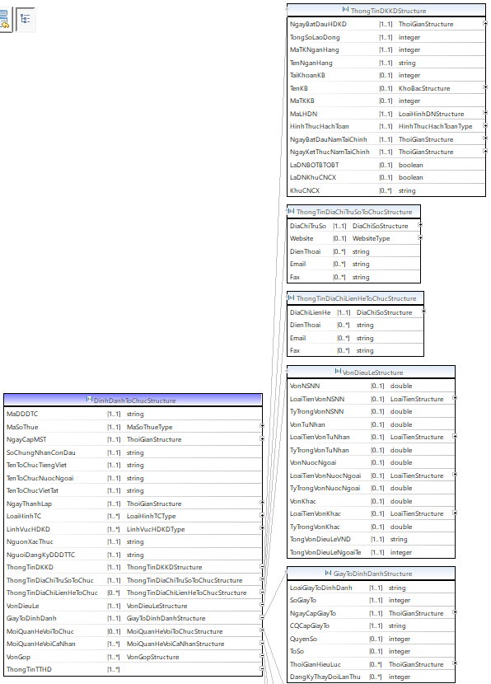

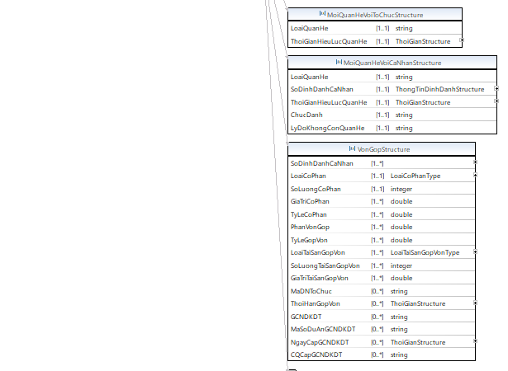

**Hình 3.1 - Lược đồ dữ liệu pháp nhân mô tả cấu trúc dữ liệu của DinhDanhToChuc và các cấu trúc, kiểu dữ liệu liên quan**

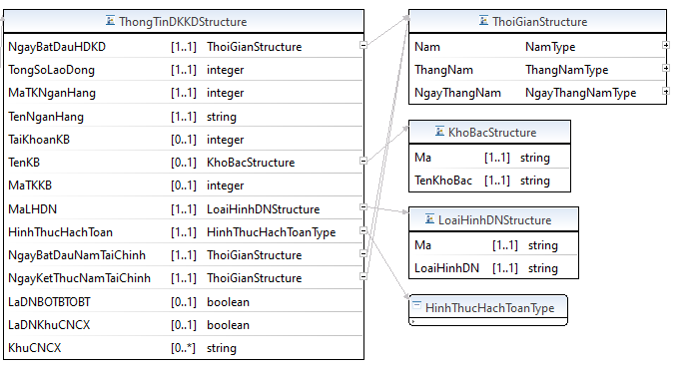

**Hình 3.2 - Lược đồ dữ liệu pháp nhân mô tả cấu trúc dữ liệu của ThongTinDKKD và các cấu trúc, kiểu dữ liệu liên quan**

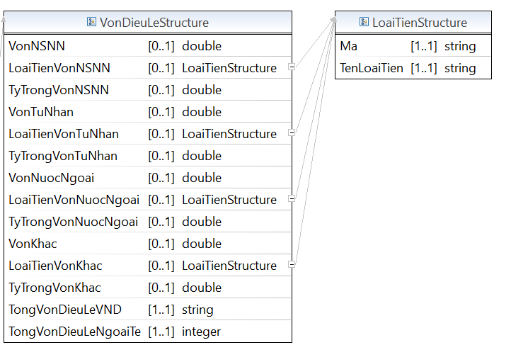

**Hình 3.3 - Lược đồ dữ liệu pháp nhân mô tả cấu trúc dữ liệu của VonDieuLe và các cấu trúc, kiểu dữ liệu liên quan**

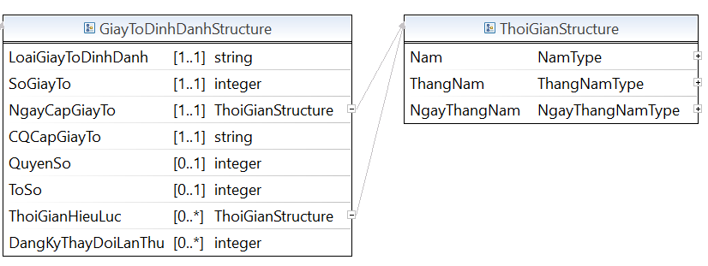

**Hình 3.4 - Lược đồ dữ liệu pháp nhân mô tả cấu trúc dữ liệu của GiayToDinhDanh và các cấu trúc, kiểu dữ liệu liên quan**

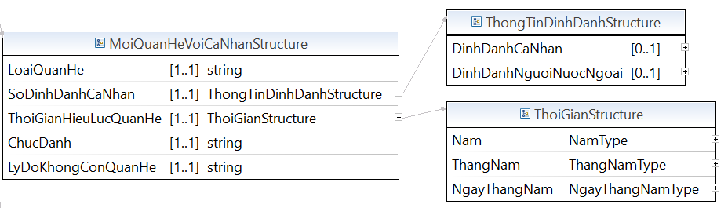

**Hình 3.5 - Lược đồ dữ liệu pháp nhân mô tả cấu trúc dữ liệu của MoiQuanHeVoiCaNhan và các cấu trúc, kiểu dữ liệu liên quan**

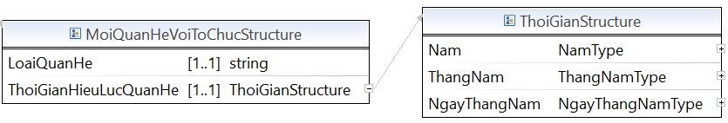

**Hình 3.6 - Lược đồ dữ liệu pháp nhân mô tả cấu trúc dữ liệu của MoiQuanHeVoiToChuc và các cấu trúc, kiểu dữ liệu liên quan**

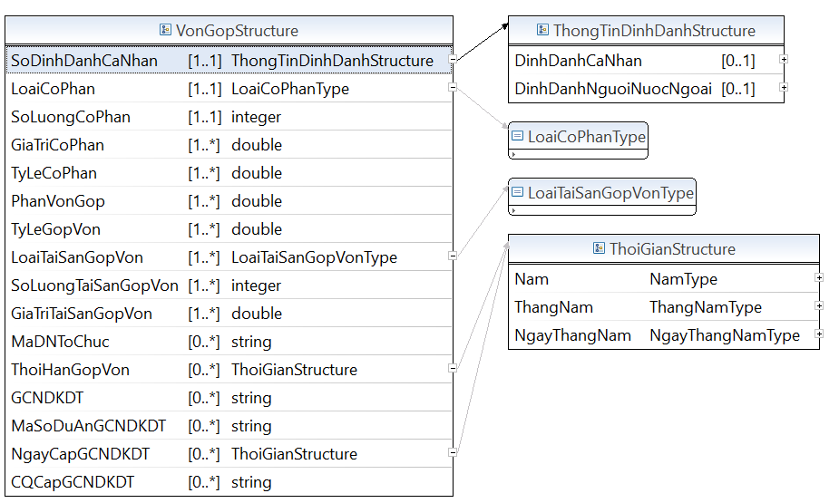

**Hình 3.7 - Lược đồ dữ liệu pháp nhân mô tả cấu trúc dữ liệu của VonGop và các cấu trúc, kiểu dữ liệu liên quan**

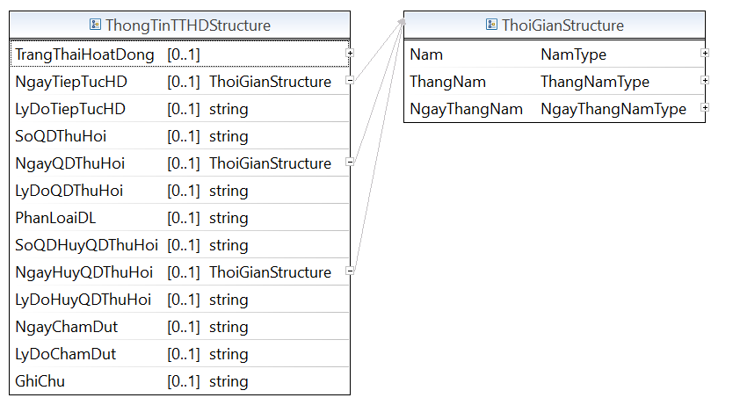

**Hình 3.8 - Lược đồ dữ liệu pháp nhân mô tả cấu trúc dữ liệu của ThongTinTTHD và các cấu trúc, kiểu dữ liệu liên quan**

**Mã nguồn lược đồ chứa các cấu trúc thông tin của lược đồ dữ liệu pháp nhân (PhapNhan_core.xsd)**

<?xml version=*“1.1”* encoding=*"UTF-8"*?>

<xsd:schema xmlns:xsd=*"http://www.w3.org/2001/XMLSchema"* xmlns:TTDLQG=*"..."* targetNamespace=*"..."* version=*“1.1”* elementFormDefault=*"qualified"*>

<!-- <xsd:include schemaLocation="BaseEnumType.xsd" /> -->

<xsd:annotation>

<xsd:documentation></xsd:documentation>

</xsd:annotation>

<xsd:complexType name=*"DinhDanhToChucStructure"*>

<xsd:annotation>

<xsd:documentation>DinhDanhToChucStructure</xsd:documentation>

</xsd:annotation>

<xsd:sequence>

<xsd:element name=*"MaDDDTC"* type=*"xsd:string"* minOccurs=*"1"* maxOccurs=*"1"* />

<xsd:element name=*"MaSoThue"* type=*"TTDLQG:MaSoThueType"* minOccurs=*"1"* maxOccurs=*"1"* />

<xsd:element name=*"NgayCapMST"* type=*"TTDLQG:ThoiGianStructure"* minOccurs=*"1"* maxOccurs=*"1"* />

<xsd:element name=*"SoChungNhanConDau"* type=*"xsd:string"* minOccurs=*"1"* maxOccurs=*"1"* />

<xsd:element name=*"TenToChucTiengViet"* type=*"xsd:string"* minOccurs=*"1"* maxOccurs=*"1"* />

<xsd:element name=*"TenToChucNuocNgoai"* type=*"xsd:string"* minOccurs=*"1"* maxOccurs=*"1"* />

<xsd:element name=*"TenToChucVietTat"* type=*"xsd:string"* minOccurs=*"1"* maxOccurs=*"1"* />

<xsd:element name=*"NgayThanhLap"* type=*"TTDLQG:ThoiGianStructure"* minOccurs=*"1"* maxOccurs=*"1"* />

<xsd:element name=*"LoaiHinhTC"* type=*"TTDLQG:LoaiHinhTCType"* minOccurs=*"1"* maxOccurs=*"unbounded"* />

<xsd:element name=*"LinhVucHDKD"* type=*"TTDLQG:LinhVucHDKDType"* minOccurs=*"1"* maxOccurs=*"unbounded"* />

<xsd:element name=*"NguonXacThuc"* type=*"xsd:string"* minOccurs=*"1"* maxOccurs=*"1"* />

<xsd:element name=*"NguoiDangKyDDDTTC"* type=*"xsd:string"* minOccurs=*"1"* maxOccurs=*"1"* />

<xsd:element name=*"ThongTinDKKD"* type=*"TTDLQG:ThongTinDKKDStructure"* minOccurs=*"1"* maxOccurs=*"1"* />

<xsd:element name=*"ThongTinDiaChiTruSoToChuc"* type=*"TTDLQG:ThongTinDiaChiTruSoToChucStructure"* minOccurs=*"1"* maxOccurs=*"1"* />

<xsd:element name=*"ThongTinDiaChiLienHeToChuc"* type=*"TTDLQG:ThongTinDiaChiLienHeToChucStructure"* minOccurs=*"0"* maxOccurs=*"unbounded"* />

<xsd:element name=*"VonDieuLe"* type=*"TTDLQG:VonDieuLeStructure"* minOccurs=*"1"* maxOccurs=*"1"* />

<xsd:element name=*"GiayToDinhDanh"* type=*"TTDLQG:GiayToDinhDanhStructure"* minOccurs=*"1"* maxOccurs=*"1"* />

<xsd:element name=*"MoiQuanHeVoiToChuc"* type=*"TTDLQG:MoiQuanHeVoiToChucStructure"* minOccurs=*"0"* maxOccurs=*"1"* />

<xsd:element name=*"MoiQuanHeVoiCaNhan"* type=*"TTDLQG:MoiQuanHeVoiCaNhanStructure"* minOccurs=*"1"* maxOccurs=*"unbounded"* />

<xsd:element name=*"VonGop"* type=*"TTDLQG:VonGopStructure"* minOccurs=*"1"* maxOccurs=*"unbounded"* />

<xsd:element name=*"ThongTinTTHD"* type=*"ThongTinTTHDStructure"* minOccurs=*"1"* maxOccurs=*"unbounded"* />

</xsd:sequence>

</xsd:complexType>

<xsd:complexType name=*"ThongTinDKKDStructure"*>

<xsd:annotation>

<xsd:documentation>ThongTinDKKDStructure</xsd:documentation>

</xsd:annotation>

<xsd:sequence>

<xsd:element name=*"NgayBatDauHDKD"* type=*"TTDLQG:ThoiGianStructure"* minOccurs=*"1"* maxOccurs=*"1"* />

<xsd:element name=*"TongSoLaoDong"* type=*"xsd:integer"* minOccurs=*"1"* maxOccurs=*"1"* />

<xsd:element name=*"MaTKNganHang"* type=*"xsd:integer"* minOccurs=*"1"* maxOccurs=*"1"* />

<xsd:element name=*"TenNganHang"* type=*"xsd:string"* minOccurs=*"1"* maxOccurs=*"1"* />

<xsd:element name=*"TaiKhoanKB"* type=*"xsd:integer"* minOccurs=*"0"* maxOccurs=*"1"* />

<xsd:element name=*"TenKB"* type=*"TTDLQG:KhoBacStructure"* minOccurs=*"0"* maxOccurs=*"1"* />

<xsd:element name=*"MaTKKB"* type=*"xsd:integer"* minOccurs=*"0"* maxOccurs=*"1"* />

<xsd:element name=*"MaLHDN"* type=*"TTDLQG:LoaiHinhDNStructure"* minOccurs=*"1"* maxOccurs=*"1"* />

<xsd:element name=*"HinhThucHachToan"* type=*"TTDLQG:HinhThucHachToanType"* minOccurs=*"1"* maxOccurs=*"1"* />

<xsd:element name=*"NgayBatDauNamTaiChinh"* type=*"TTDLQG:ThoiGianStructure"* minOccurs=*"1"* maxOccurs=*"1"* />

<xsd:element name=*"NgayKetThucNamTaiChinh"* type=*"TTDLQG:ThoiGianStructure"* minOccurs=*"1"* maxOccurs=*"1"* />

<xsd:element name=*"LaDNBOTBTOBT"* type=*"xsd:boolean"* minOccurs=*"0"* maxOccurs=*"1"* />

<xsd:element name=*"LaDNKhuCNCX"* type=*"xsd:boolean"* minOccurs=*"0"* maxOccurs=*"1"* />

<xsd:element name=*"KhuCNCX"* type=*"xsd:string"* minOccurs=*"0"* maxOccurs=*"unbounded"* />

</xsd:sequence>

</xsd:complexType>

<xsd:complexType name=*"ThongTinDiaChiTruSoToChucStructure"*>

<xsd:annotation>

<xsd:documentation>ThongTinDiaChiTruSoToChucStructure</xsd:documentation>

</xsd:annotation>

<xsd:sequence>

<xsd:element name=*"DiaChiTruSo"* type=*"TTDLQG:DiaChiSoStructure"* minOccurs=*"1"* maxOccurs=*"1"* />

<xsd:element name=*"Website"* type=*"TTDLQG:WebsiteType"* minOccurs=*"0"* maxOccurs=*"1"* />

<xsd:element name=*"DienThoai"* type=*"xsd:string"* minOccurs=*"0"* maxOccurs=*"unbounded"* />

<xsd:element name=*"Email"* type=*"xsd:string"* minOccurs=*"0"* maxOccurs=*"unbounded"* />

<xsd:element name=*"Fax"* type=*"xsd:string"* minOccurs=*"0"* maxOccurs=*"unbounded"* />

</xsd:sequence>

</xsd:complexType>

<xsd:complexType name=*"ThongTinDiaChiLienHeToChucStructure"*>

<xsd:annotation>

<xsd:documentation>ThongTinDiaChiLienHeToChucStructure</xsd:documentation>

</xsd:annotation>

<xsd:sequence>

<xsd:element name=*"DiaChiLienHe"* type=*"TTDLQG:DiaChiSoStructure"* minOccurs=*"1"* maxOccurs=*"1"* />

<xsd:element name=*"DienThoai"* type=*"xsd:string"* minOccurs=*"0"* maxOccurs=*"unbounded"* />

<xsd:element name=*"Email"* type=*"xsd:string"* minOccurs=*"0"* maxOccurs=*"unbounded"* />

<xsd:element name=*"Fax"* type=*"xsd:string"* minOccurs=*"0"* maxOccurs=*"unbounded"* />

</xsd:sequence>

</xsd:complexType>

<xsd:complexType name=*"VonDieuLeStructure"*>

<xsd:annotation>

<xsd:documentation>VonDieuLeStructure</xsd:documentation>

</xsd:annotation>

<xsd:sequence>

<xsd:element name=*"VonNSNN"* type=*"xsd:double"* minOccurs=*"0"* maxOccurs=*"1"* />

<xsd:element name=*"LoaiTienVonNSNN"* type=*"TTDLQG:LoaiTienStructure"* minOccurs=*"0"* maxOccurs=*"1"* />

<xsd:element name=*"TyTrongVonNSNN"* type=*"xsd:double"* minOccurs=*"0"* maxOccurs=*"1"* />

<xsd:element name=*"VonTuNhan"* type=*"xsd:double"* minOccurs=*"0"* maxOccurs=*"1"* />

<xsd:element name=*"LoaiTienVonTuNhan"* type=*"TTDLQG:LoaiTienStructure"* minOccurs=*"0"* maxOccurs=*"1"* />

<xsd:element name=*"TyTrongVonTuNhan"* type=*"xsd:double"* minOccurs=*"0"* maxOccurs=*"1"* />

<xsd:element name=*"VonNuocNgoai"* type=*"xsd:double"* minOccurs=*"0"* maxOccurs=*"1"* />

<xsd:element name=*"LoaiTienVonNuocNgoai"* type=*"TTDLQG:LoaiTienStructure"* minOccurs=*"0"* maxOccurs=*"1"* />

<xsd:element name=*"TyTrongVonNuocNgoai"* type=*"xsd:double"* minOccurs=*"0"* maxOccurs=*"1"* />

<xsd:element name=*"VonKhac"* type=*"xsd:double"* minOccurs=*"0"* maxOccurs=*"1"* />

<xsd:element name=*"LoaiTienVonKhac"* type=*"TTDLQG:LoaiTienStructure"* minOccurs=*"0"* maxOccurs=*"1"* />

<xsd:element name=*"TyTrongVonKhac"* type=*"xsd:double"* minOccurs=*"0"* maxOccurs=*"1"* />

<xsd:element name=*"TongVonDieuLeVND"* type=*"xsd:string"* minOccurs=*"1"* maxOccurs=*"1"* />

<xsd:element name=*"TongVonDieuLeNgoaiTe"* type=*"xsd:integer"* minOccurs=*"1"* maxOccurs=*"1"* />

</xsd:sequence>

</xsd:complexType>

<xsd:complexType name=*"GiayToDinhDanhTCStructure"*>

<xsd:annotation>

<xsd:documentation>GiayToDinhDanhTCStructure</xsd:documentation>

</xsd:annotation>

<xsd:sequence>

<xsd:element name=*"LoaiGiayToDinhDanh"* type=*"xsd:string"* minOccurs=*"1"* maxOccurs=*"1"* />

<xsd:element name=*"SoGiayTo"* type=*"xsd:integer"* minOccurs=*"1"* maxOccurs=*"1"* />

<xsd:element name=*"NgayCapGiayTo"* type=*"TTDLQG:ThoiGianStructure"* minOccurs=*"1"* maxOccurs=*"1"* />

<xsd:element name=*"CQCapGiayTo"* type=*"xsd:string"* minOccurs=*"1"* maxOccurs=*"1"* />

<xsd:element name=*"QuyenSo"* type=*"xsd:integer"* minOccurs=*"0"* maxOccurs=*"1"* />

<xsd:element name=*"ToSo"* type=*"xsd:integer"* minOccurs=*"0"* maxOccurs=*"1"* />

<xsd:element name=*"ThoiGianHieuLuc"* type=*"TTDLQG:ThoiGianStructure"* minOccurs=*"0"* maxOccurs=*"unbounded"* />

<xsd:element name=*"DangKyThayDoiLanThu"* type=*"xsd:integer"* minOccurs=*"0"* maxOccurs=*"unbounded"* />

</xsd:sequence>

</xsd:complexType>

<xsd:complexType name=*"MoiQuanHeVoiToChucStructure"*>

<xsd:annotation>

<xsd:documentation>MoiQuanHeVoiToChucStructure</xsd:documentation>

</xsd:annotation>

<xsd:sequence>

<xsd:element name=*"LoaiQuanHe"* type=*"xsd:string"* minOccurs=*"1"* maxOccurs=*"1"* />

<xsd:element name=*"ThoiGianHieuLucQuanHe"* type=*"TTDLQG:ThoiGianStructure"* minOccurs=*"1"* maxOccurs=*"1"* />

</xsd:sequence>

</xsd:complexType>

<xsd:complexType name=*"MoiQuanHeVoiCaNhanStructure"*>

<xsd:annotation>

<xsd:documentation>MoiQuanHeVoiCaNhanStructure</xsd:documentation>

</xsd:annotation>

<xsd:sequence>

<xsd:element name=*"LoaiQuanHe"* type=*"xsd:string"* minOccurs=*"1"* maxOccurs=*"1"* />

<xsd:element name=*"SoDinhDanhCaNhan"* type=*"TTDLQG:ThongTinDinhDanhStructure"* minOccurs=*"1"* maxOccurs=*"1"* />

<xsd:element name=*"ThoiGianHieuLucQuanHe"* type=*"TTDLQG:ThoiGianStructure"* minOccurs=*"1"* maxOccurs=*"1"* />

<xsd:element name=*"ChucDanh"* type=*"xsd:string"* minOccurs=*"1"* maxOccurs=*"1"* />

<xsd:element name=*"LyDoKhongConQuanHe"* type=*"xsd:string"* minOccurs=*"1"* maxOccurs=*"1"* />

</xsd:sequence>

</xsd:complexType>

<xsd:complexType name=*"VonGopStructure"*>

<xsd:annotation>

<xsd:documentation>VonGopStructure</xsd:documentation>

</xsd:annotation>

<xsd:sequence>

<xsd:element name=*"SoDinhDanhCaNhan"* type=*"TTDLQG:ThongTinDinhDanhStructure"* minOccurs=*"1"* maxOccurs=*"unbounded"* />

<xsd:element name=*"LoaiCoPhan"* type=*"TTDLQG:LoaiCoPhanType"* minOccurs=*"1"* maxOccurs=*"1"* />

<xsd:element name=*"SoLuongCoPhan"* type=*"xsd:integer"* minOccurs=*"1"* maxOccurs=*"1"* />

<xsd:element name=*"GiaTriCoPhan"* type=*"xsd:double"* minOccurs=*"1"* maxOccurs=*"unbounded"* />

<xsd:element name=*"TyLeCoPhan"* type=*"xsd:double"* minOccurs=*"1"* maxOccurs=*"unbounded"* />

<xsd:element name=*"PhanVonGop"* type=*"xsd:double"* minOccurs=*"1"* maxOccurs=*"unbounded"* />

<xsd:element name=*"TyLeGopVon"* type=*"xsd:double"* minOccurs=*"1"* maxOccurs=*"unbounded"* />

<xsd:element name=*"LoaiTaiSanGopVon"* type=*"TTDLQG:LoaiTaiSanGopVonType"* minOccurs=*"1"* maxOccurs=*"unbounded"* />

<xsd:element name=*"SoLuongTaiSanGopVon"* type=*"xsd:integer"* minOccurs=*"1"* maxOccurs=*"unbounded"* />

<xsd:element name=*"GiaTriTaiSanGopVon"* type=*"xsd:double"* minOccurs=*"1"* maxOccurs=*"unbounded"* />

<xsd:element name=*"MaDNToChuc"* type=*"xsd:string"* minOccurs=*"0"* maxOccurs=*"unbounded"* />

<xsd:element name=*"ThoiHanGopVon"* type=*"TTDLQG:ThoiGianStructure"* minOccurs=*"0"* maxOccurs=*"unbounded"* />

<xsd:element name=*"GCNDKDT"* type=*"xsd:string"* minOccurs=*"0"* maxOccurs=*"unbounded"* />

<xsd:element name=*"MaSoDuAnGCNDKDT"* type=*"xsd:string"* minOccurs=*"0"* maxOccurs=*"unbounded"* />

<xsd:element name=*"NgayCapGCNDKDT"* type=*"TTDLQG:ThoiGianStructure"* minOccurs=*"0"* maxOccurs=*"unbounded"* />

<xsd:element name=*"CQCapGCNDKDT"* type=*"xsd:string"* minOccurs=*"0"* maxOccurs=*"unbounded"* />

</xsd:sequence>

</xsd:complexType>

<xsd:complexType name=*"ThongTinTTHDStructure"*>

<xsd:annotation>

<xsd:documentation>ThongTinTTHDStructure</xsd:documentation>

</xsd:annotation>

<xsd:sequence>

<xsd:element name=*"TrangThaiHoatDong"* type=*"TTDLQG:TrangThaiHoatDongStructrure"* minOccurs=*"1"* maxOccurs=*"1"* />

<xsd:element name=*"NgayTiepTucHD"* type=*"TTDLQG:ThoiGianStructure"* minOccurs=*"0"* maxOccurs=*"1"* />

<xsd:element name=*"LyDoTiepTucHD"* type=*"xsd:string"* minOccurs=*"0"* maxOccurs=*"1"* />

<xsd:element name=*"SoQDThuHoi"* type=*"xsd:string"* minOccurs=*"0"* maxOccurs=*"1"* />

<xsd:element name=*"NgayQDThuHoi"* type=*"TTDLQG:ThoiGianStructure"* minOccurs=*"0"* maxOccurs=*"1"* />

<xsd:element name=*"LyDoQDThuHoi"* type=*"xsd:string"* minOccurs=*"0"* maxOccurs=*"1"* />

<xsd:element name=*"PhanLoaiDL"* type=*"TTDLQG:PhanLoaiDLType"* minOccurs=*"0"* maxOccurs=*"1"* />

<xsd:element name=*"SoQDHuyQDThuHoi"* type=*"xsd:string"* minOccurs=*"0"* maxOccurs=*"1"* />

<xsd:element name=*"NgayHuyQDThuHoi"* type=*"TTDLQG:ThoiGianStructure"* minOccurs=*"0"* maxOccurs=*"1"* />

<xsd:element name=*"LyDoHuyQDThuHoi"* type=*"xsd:string"* minOccurs=*"0"* maxOccurs=*"1"* />

<xsd:element name=*"NgayChamDut"* type=*"xsd:string"* minOccurs=*"0"* maxOccurs=*"1"* />

<xsd:element name=*"LyDoChamDut"* type=*"xsd:string"* minOccurs=*"0"* maxOccurs=*"1"* />

<xsd:element name=*"GhiChu"* type=*"xsd:string"* minOccurs=*"0"* maxOccurs=*"1"* />

</xsd:sequence>

</xsd:complexType>

<xsd:complexType name=*"KhoBacStructure"*>

<xsd:annotation>

<xsd:documentation>KhoBacStructure</xsd:documentation>

</xsd:annotation>

<xsd:sequence>

<xsd:element name=*"Ma"* type=*"xsd:string"* minOccurs=*"1"* maxOccurs=*"1"* />

<xsd:element name=*"TenKhoBac"* type=*"xsd:string"* minOccurs=*"1"* maxOccurs=*"1"* />

</xsd:sequence>

</xsd:complexType>

<xsd:complexType name=*"LoaiHinhDNStructure"*>

<xsd:annotation>

<xsd:documentation>LoaiHinhDNStructure</xsd:documentation>

</xsd:annotation>

<xsd:sequence>

<xsd:element name=*"Ma"* type=*"xsd:string"* minOccurs=*"1"* maxOccurs=*"1"* />

<xsd:element name=*"LoaiHinhDN"* type=*"xsd:string"* minOccurs=*"1"* maxOccurs=*"1"* />

</xsd:sequence>

</xsd:complexType>

<xsd:complexType name=*"LoaiTienStructure"*>

<xsd:annotation>

<xsd:documentation>LoaiTienStructure</xsd:documentation>

</xsd:annotation>

<xsd:sequence>

<xsd:element name=*"Ma"* type=*"xsd:string"* minOccurs=*"1"* maxOccurs=*"1"* />

<xsd:element name=*"TenLoaiTien"* type=*"xsd:string"* minOccurs=*"1"* maxOccurs=*"1"* />

</xsd:sequence>

</xsd:complexType>

<xsd:complexType name=*"TrangThaiHoatDongStructure"*>

<xsd:annotation>

<xsd:documentation>TrangThaiHoatDongStructure</xsd:documentation>

</xsd:annotation>

<xsd:sequence>

<xsd:element name=*"Ma"* type=*"xsd:string"* minOccurs=*"1"* maxOccurs=*"1"* />

<xsd:element name=*"TrangThaiHoatDong"* type=*"xsd:string"* minOccurs=*"1"* maxOccurs=*"1"* />

</xsd:sequence>

</xsd:complexType>

<xsd:complexType name=*"GiayPhepHDSXKDStructure"*>

<xsd:annotation>

<xsd:documentation>GiayPhepHDSXKDStructure</xsd:documentation>

</xsd:annotation>

<xsd:sequence>

<xsd:element name=*"LoaiGPHD"* type=*"xsd:string"* minOccurs=*"1"* maxOccurs=*"1"* />

<xsd:element name=*"CQCapGPHD"* type=*"xsd:string"* minOccurs=*"1"* maxOccurs=*"1"* />

<xsd:element name=*"SoGPHD"* type=*"xsd:string"* minOccurs=*"1"* maxOccurs=*"1"* />

<xsd:element name=*"HinhThucToChuc"* type=*"xsd:string"* minOccurs=*"0"* maxOccurs=*"1"* />

<xsd:element name=*"NganhNgheKD"* type=*"TTDLQG:NganhNgheKDStructure"* minOccurs=*"1"* maxOccurs=*"unbounded"* />

<xsd:element name=*"DiaDiemHanhNghe"* type=*"xsd:string"* minOccurs=*"0"* maxOccurs=*"unbounded"* />

<xsd:element name=*"NgayHieuLuc"* type=*"TTDLQG:ThoiGianStructure"* minOccurs=*"1"* maxOccurs=*"1"* />

<xsd:element name=*"PhamViHDChuyenMon"* type=*"xsd:string"* minOccurs=*"0"* maxOccurs=*"unbounded"* />

<xsd:element name=*"SoGCN"* type=*"TTDLQG:ThoiGianStructure"* minOccurs=*"0"* maxOccurs=*"1"* />

<xsd:element name=*"NgayCapGCN"* type=*"TTDLQG:ThoiGianStructure"* minOccurs=*"0"* maxOccurs=*"1"* />

<xsd:element name=*"TrangThaiGPHD"* type=*"TTDLQG:TrangThaiGPHDType"* minOccurs=*"1"* maxOccurs=*"1"* />

<xsd:element name=*"LyDoThayDoiTrangThaiGPHD"* type=*"xsd:string"* minOccurs=*"0"* maxOccurs=*"1"* />

<xsd:element name=*"MaDDDTC"* type=*"TTDLQG:DinhDanhToChucStructure"* minOccurs=*"1"* maxOccurs=*"1"* />

</xsd:sequence>

</xsd:complexType>

<xsd:complexType name=*"BaoCaoTaiChinhStructure"*>

<xsd:annotation>

<xsd:documentation>BaoCaoTaiChinhStructure</xsd:documentation>

</xsd:annotation>

<xsd:sequence>

<xsd:element name=*"KyBaoCaoTuNgay"* type=*"TTDLQG:ThoiGianStructure"* minOccurs=*"1"* maxOccurs=*"1"* />

<xsd:element name=*"KyBaoCaoDenNgay"* type=*"TTDLQG:ThoiGianStructure"* minOccurs=*"1"* maxOccurs=*"1"* />

<xsd:element name=*"NguonVonChuSoHuu"* type=*"xsd:double"* minOccurs=*"1"* maxOccurs=*"1"* />

<xsd:element name=*"NoPhaiTra"* type=*"xsd:double"* minOccurs=*"0"* maxOccurs=*"1"* />

<xsd:element name=*"TSCoDinhDauTuDH"* type=*"xsd:double"* minOccurs=*"0"* maxOccurs=*"1"* />

<xsd:element name=*"TSLuDongDauTuNH"* type=*"xsd:double"* minOccurs=*"0"* maxOccurs=*"1"* />

<xsd:element name=*"DoanhThuThuanBHCCDV"* type=*"xsd:double"* minOccurs=*"1"* maxOccurs=*"1"* />

<xsd:element name=*"ThuNhapNLD"* type=*"xsd:double"* minOccurs=*"1"* maxOccurs=*"1"* />

<xsd:element name=*"LoiNhuanTruocThue"* type=*"xsd:double"* minOccurs=*"1"* maxOccurs=*"1"* />

<xsd:element name=*"MaDDDTC"* type=*"TTDLQG:DinhDanhToChucStructure"* minOccurs=*"1"* maxOccurs=*"1"* />

</xsd:sequence>

</xsd:complexType>

<xsd:complexType name=*"DongBHXHStructure"*>

<xsd:annotation>

<xsd:documentation>DongBHXHStructure</xsd:documentation>

</xsd:annotation>

<xsd:sequence>

<xsd:element name=*"MaDonVi"* type=*"xsd:string"* minOccurs=*"1"* maxOccurs=*"1"* />

<xsd:element name=*"CoQuanBaoHiem"* type=*"TTDLQG:CoQuanBHXHStructure"* minOccurs=*"1"* maxOccurs=*"1"* />

<xsd:element name=*"PhuongThucDong"* type=*"TTDLQG:PhuongThucDongType"* minOccurs=*"1"* maxOccurs=*"1"* />

<xsd:element name=*"MaDDDTC"* type=*"TTDLQG:DinhDanhToChucStructure"* minOccurs=*"1"* maxOccurs=*"1"* />

</xsd:sequence>

</xsd:complexType>

<xsd:complexType name=*"ChamDongBHXHStructure"*>

<xsd:annotation>

<xsd:documentation>ChamDongBHXHStructure</xsd:documentation>

</xsd:annotation>

<xsd:sequence>

<xsd:element name=*"SoLaoDong"* type=*"xsd:integer"* minOccurs=*"1"* maxOccurs=*"1"* />

<xsd:element name=*"TSTienChamDongBHXH"* type=*"xsd:double"* minOccurs=*"1"* maxOccurs=*"1"* />

<xsd:element name=*"TSTienChamDongDuoi30Ngay"* type=*"xsd:double"* minOccurs=*"1"* maxOccurs=*"1"* />

<xsd:element name=*"LoaiQuyChamDong"* type=*"TTDLQG:LoaiQuyBHType"* minOccurs=*"1"* maxOccurs=*"unbounded"* />

<xsd:element name=*"SoThangChamDong"* type=*"xsd:integer"* minOccurs=*"1"* maxOccurs=*"1"* />

<xsd:element name=*"STChamDong"* type=*"xsd:double"* minOccurs=*"1"* maxOccurs=*"1"* />

<xsd:element name=*"Lai"* type=*"xsd:double"* minOccurs=*"1"* maxOccurs=*"1"* />

<xsd:element name=*"MaDDDTC"* type=*"TTDLQG:DinhDanhToChucStructure"* minOccurs=*"1"* maxOccurs=*"1"* />

</xsd:sequence>

</xsd:complexType>

<xsd:complexType name=*"LaoDongStructure"*>

<xsd:annotation>

<xsd:documentation>LaoDongStructure</xsd:documentation>

</xsd:annotation>

<xsd:sequence>

<xsd:element name=*"TongSoLaoDong"* type=*"xsd:integer"* minOccurs=*"1"* maxOccurs=*"1"* />

<xsd:element name=*"TongSoLaoDongNu"* type=*"xsd:integer"* minOccurs=*"1"* maxOccurs=*"1"* />

<xsd:element name=*"MaDDDTC"* type=*"TTDLQG:DinhDanhToChucStructure"* minOccurs=*"1"* maxOccurs=*"1"* />

</xsd:sequence>

</xsd:complexType>

<xsd:complexType name=*"DangKyThueStructure"*>

<xsd:annotation>

<xsd:documentation>DangKyThueStructure</xsd:documentation>

</xsd:annotation>

<xsd:sequence>

<xsd:element name=*"CQTQuanLy"* type=*"TTDLQG:CoQuanThueType"* minOccurs=*"1"* maxOccurs=*"1"* />

<xsd:element name=*"LoaiNNT"* type=*"TTDLQG:LoaiNNTType"* minOccurs=*"1"* maxOccurs=*"1"* />

<xsd:element name=*"PhuongPhapTinhThue"* type=*"xsd:string"* minOccurs=*"1"* maxOccurs=*"1"* />

<xsd:element name=*"CoHDXNK"* type=*"xsd:boolean"* minOccurs=*"0"* maxOccurs=*"1"* />

<xsd:element name=*"MaDDDTC"* type=*"TTDLQG:DinhDanhToChucStructure"* minOccurs=*"1"* maxOccurs=*"1"* />

</xsd:sequence>

</xsd:complexType>

<xsd:complexType name=*"SoThueStructure"*>

<xsd:annotation>

<xsd:documentation>SoThueStructure</xsd:documentation>

</xsd:annotation>

<xsd:sequence>

<xsd:element name=*"CQTPhatSinhKhoanPhaiNopNNT"* type=*"TTDLQG:CoQuanThueType"* minOccurs=*"1"* maxOccurs=*"1"* />

<xsd:element name=*"Ky"* type=*"xsd:string"* minOccurs=*"1"* maxOccurs=*"1"* />

<xsd:element name=*"PhaiNopTrongKy"* type=*"xsd:double"* minOccurs=*"1"* maxOccurs=*"1"* />

<xsd:element name=*"PhaiNopTheoTTXP"* type=*"xsd:double"* minOccurs=*"0"* maxOccurs=*"1"* />

<xsd:element name=*"MienGiam"* type=*"xsd:double"* minOccurs=*"0"* maxOccurs=*"1"* />

<xsd:element name=*"XoaNo"* type=*"xsd:double"* minOccurs=*"0"* maxOccurs=*"1"* />

<xsd:element name=*"DaNop"* type=*"xsd:double"* minOccurs=*"0"* maxOccurs=*"1"* />

<xsd:element name=*"DuocHoanNopThua"* type=*"xsd:double"* minOccurs=*"0"* maxOccurs=*"1"* />

<xsd:element name=*"DuocHoanKhauTru"* type=*"xsd:double"* minOccurs=*"0"* maxOccurs=*"1"* />

<xsd:element name=*"DaHoan"* type=*"xsd:double"* minOccurs=*"0"* maxOccurs=*"1"* />

<xsd:element name=*"DuCuoiKyPhaiNop"* type=*"xsd:double"* minOccurs=*"0"* maxOccurs=*"1"* />

<xsd:element name=*"DuCuoiKyNTTN"* type=*"xsd:double"* minOccurs=*"0"* maxOccurs=*"1"* />

<xsd:element name=*"DuCuoiKyDuocHoan"* type=*"xsd:double"* minOccurs=*"0"* maxOccurs=*"1"* />

<xsd:element name=*"MaChuong"* type=*"TTDLQG:MaChuongStructure"* minOccurs=*"1"* maxOccurs=*"1"* />

<xsd:element name=*"MaTieuMuc"* type=*"TTDLQG:MaTieuMucStructure"* minOccurs=*"1"* maxOccurs=*"1"* />

<xsd:element name=*"MaDDDTC"* type=*"TTDLQG:DinhDanhToChucStructure"* minOccurs=*"1"* maxOccurs=*"1"* />

</xsd:sequence>

</xsd:complexType>

<xsd:complexType name=*"SoNoThueStructure"*>

<xsd:annotation>

<xsd:documentation>SoNoThueStructure</xsd:documentation>

</xsd:annotation>

<xsd:sequence>

<xsd:element name=*"MaCQTPhatSinhKhoanNo"* type=*"TTDLQG:CoQuanThueType"* minOccurs=*"1"* maxOccurs=*"1"* />

<xsd:element name=*"KyNoTuNgay"* type=*"TTDLQG:ThoiGianStructure"* minOccurs=*"1"* maxOccurs=*"1"* />

<xsd:element name=*"KyNoDenNgay"* type=*"TTDLQG:ThoiGianStructure"* minOccurs=*"1"* maxOccurs=*"1"* />

<xsd:element name=*"Chuong"* type=*"TTDLQG:MaChuongStructure"* minOccurs=*"1"* maxOccurs=*"1"* />

<xsd:element name=*"TieuMuc"* type=*"TTDLQG:MaTieuMucStructure"* minOccurs=*"1"* maxOccurs=*"1"* />

<xsd:element name=*"HanNop"* type=*"TTDLQG:ThoiGianStructure"* minOccurs=*"1"* maxOccurs=*"1"* />

<xsd:element name=*"NguonGoc"* type=*"xsd:string"* minOccurs=*"1"* maxOccurs=*"1"* />

<xsd:element name=*"NoKyTruocChuyenSang"* type=*"xsd:double"* minOccurs=*"0"* maxOccurs=*"1"* />

<xsd:element name=*"NoPSTrongKy"* type=*"xsd:double"* minOccurs=*"0"* maxOccurs=*"1"* />

<xsd:element name=*"ThuDuocTrongThang"* type=*"xsd:double"* minOccurs=*"0"* maxOccurs=*"1"* />

<xsd:element name=*"NoChuyenKySau"* type=*"xsd:double"* minOccurs=*"0"* maxOccurs=*"1"* />

<xsd:element name=*"TKNganSach"* type=*"xsd:string"* minOccurs=*"1"* maxOccurs=*"1"* />

<xsd:element name=*"SoTienThueNoDauNam"* type=*"xsd:double"* minOccurs=*"0"* maxOccurs=*"1"* />

<xsd:element name=*"SoTienThueNoDaThuDuocCuaNamTruoc"* type=*"xsd:double"* minOccurs=*"0"* maxOccurs=*"1"* />

<xsd:element name=*"SoTienThueNoDaThuDuocCuaNamNay"* type=*"xsd:double"* minOccurs=*"0"* maxOccurs=*"1"* />

<xsd:element name=*"SoTienThueNoDuocDieuChinhGiam"* type=*"xsd:double"* minOccurs=*"0"* maxOccurs=*"1"* />

<xsd:element name=*"TinhChatNo"* type=*"xsd:string"* minOccurs=*"1"* maxOccurs=*"1"* />

<xsd:element name=*"LyDoPhanLoaiNo"* type=*"xsd:string"* minOccurs=*"1"* maxOccurs=*"1"* />

<xsd:element name=*"MaDDDTC"* type=*"TTDLQG:DinhDanhToChucStructure"* minOccurs=*"1"* maxOccurs=*"1"* />

</xsd:sequence>

</xsd:complexType>

<xsd:complexType name=*"CuongCheNoThueStructure"*>

<xsd:annotation>

<xsd:documentation>CuongCheNoThueStructure</xsd:documentation>

</xsd:annotation>

<xsd:sequence>

<xsd:element name=*"CoQuanThue"* type=*"TTDLQG:CoQuanThueStructure"* minOccurs=*"1"* maxOccurs=*"1"* />

<xsd:element name=*"SoQuyetDinhCuongChe"* type=*"xsd:integer"* minOccurs=*"1"* maxOccurs=*"1"* />

<xsd:element name=*"NgayQuyetDinhCuongChe"* type=*"TTDLQG:ThoiGianStructure"* minOccurs=*"1"* maxOccurs=*"1"* />

<xsd:element name=*"TenDoanhNghiep"* type=*"xsd:string"* minOccurs=*"1"* maxOccurs=*"1"* />

<xsd:element name=*"MaSoThue"* type=*"TTDLQG:MaSoThueType"* minOccurs=*"1"* maxOccurs=*"1"* />

<xsd:element name=*"BienPhapCuongChe"* type=*"TTDLQG:BienPhapCuongCheType"* minOccurs=*"1"* maxOccurs=*"1"* />

<xsd:element name=*"SoTienCuongCheNoThue"* type=*"xsd:double"* minOccurs=*"1"* maxOccurs=*"1"* />

<xsd:element name=*"CoQuanThueRaQuyetDinh"* type=*"TTDLQG:CoQuanThueStructure"* minOccurs=*"1"* maxOccurs=*"1"* />

<xsd:element name=*"LyDoCuongCheNoThue"* type=*"xsd:string"* minOccurs=*"1"* maxOccurs=*"1"* />

<xsd:element name=*"ThoiGianCuongChe"* type=*"TTDLQG:ThoiGianStructure"* minOccurs=*"1"* maxOccurs=*"1"* />

<xsd:element name=*"HieuLucCuongCheTu"* type=*"TTDLQG:ThoiGianStructure"* minOccurs=*"1"* maxOccurs=*"1"* />

<xsd:element name=*"HieuLucCuongCheDen"* type=*"TTDLQG:ThoiGianStructure"* minOccurs=*"1"* maxOccurs=*"1"* />

<xsd:element name=*"MaDDDTC"* type=*"TTDLQG:DinhDanhToChucStructure"* minOccurs=*"1"* maxOccurs=*"1"* />

</xsd:sequence>

</xsd:complexType>

<xsd:complexType name=*"TinhHinhThuNopThueXNKStructure"*>

<xsd:annotation>

<xsd:documentation>TinhHinhThuNopThueXNKStructure</xsd:documentation>

</xsd:annotation>

<xsd:sequence>

<xsd:element name=*"CoQuanHaiQuan"* type=*"TTDLQG:CoQuanHaiQuanStructure"* minOccurs=*"1"* maxOccurs=*"1"* />

<xsd:element name=*"LoaiXNK"* type=*"TTDLQG:LoaiXNKStructure"* minOccurs=*"1"* maxOccurs=*"1"* />

<xsd:element name=*"KimNgach"* type=*"xsd:double"* minOccurs=*"1"* maxOccurs=*"1"* />

<xsd:element name=*"SoLuongToKhai"* type=*"xsd:integer"* minOccurs=*"1"* maxOccurs=*"1"* />

<xsd:element name=*"SoThuePhaiThu"* type=*"xsd:double"* minOccurs=*"1"* maxOccurs=*"1"* />

<xsd:element name=*"SoThueDaThu"* type=*"xsd:double"* minOccurs=*"1"* maxOccurs=*"1"* />

<xsd:element name=*"MaDDDTC"* type=*"TTDLQG:DinhDanhToChucStructure"* minOccurs=*"1"* maxOccurs=*"1"* />

</xsd:sequence>

</xsd:complexType>

<xsd:complexType name=*"ThongTinKimNgachThueStructure"*>

<xsd:annotation>

<xsd:documentation>ThongTinKimNgachThueStructure</xsd:documentation>

</xsd:annotation>

<xsd:sequence>

<xsd:element name=*"MaHSHangHoa"* type=*"TTDLQG:MaHSHangHoaStructure"* minOccurs=*"1"* maxOccurs=*"1"* />

<xsd:element name=*"CoQuanHaiQuan"* type=*"TTDLQG:CoQuanHaiQuanStructure"* minOccurs=*"1"* maxOccurs=*"1"* />

<xsd:element name=*"MaSoThue"* type=*"TTDLQG:MaSoThueType"* minOccurs=*"1"* maxOccurs=*"1"* />

<xsd:element name=*"LoaiXNK"* type=*"xsd:string"* minOccurs=*"1"* maxOccurs=*"1"* />

<xsd:element name=*"NhomLoaiHinhXNK"* type=*"xsd:integer"* minOccurs=*"1"* maxOccurs=*"1"* />

<xsd:element name=*"LoaiHinhXNK"* type=*"xsd:string"* minOccurs=*"1"* maxOccurs=*"1"* />

<xsd:element name=*"DonViTinh"* type=*"xsd:string"* minOccurs=*"1"* maxOccurs=*"1"* />

<xsd:element name=*"KimNgach"* type=*"xsd:double"* minOccurs=*"1"* maxOccurs=*"1"* />

<xsd:element name=*"KimNgachSoCungKy"* type=*"xsd:double"* minOccurs=*"1"* maxOccurs=*"1"* />

<xsd:element name=*"KimNgachCoThue"* type=*"xsd:double"* minOccurs=*"1"* maxOccurs=*"1"* />

<xsd:element name=*"KimNgachCoThueSoCungKy"* type=*"xsd:double"* minOccurs=*"1"* maxOccurs=*"1"* />

<xsd:element name=*"LuongHangHoa"* type=*"xsd:integer"* minOccurs=*"1"* maxOccurs=*"1"* />

<xsd:element name=*"TienThueXuatKhau"* type=*"xsd:double"* minOccurs=*"1"* maxOccurs=*"1"* />

<xsd:element name=*"TienThueGiaTriGiaTang"* type=*"xsd:double"* minOccurs=*"1"* maxOccurs=*"1"* />

<xsd:element name=*"TienThueTieuThuDacBiet"* type=*"xsd:double"* minOccurs=*"0"* maxOccurs=*"1"* />

<xsd:element name=*"TienThueBaoVeMoiTruong"* type=*"xsd:double"* minOccurs=*"0"* maxOccurs=*"1"* />

<xsd:element name=*"TienThueTuVe"* type=*"xsd:double"* minOccurs=*"0"* maxOccurs=*"1"* />

<xsd:element name=*"TienThueChongBanPhaGia"* type=*"xsd:double"* minOccurs=*"0"* maxOccurs=*"1"* />

<xsd:element name=*"TienThueChongTroCap"* type=*"xsd:double"* minOccurs=*"0"* maxOccurs=*"1"* />

<xsd:element name=*"TienThueChongPhanBietDoiXu"* type=*"xsd:double"* minOccurs=*"0"* maxOccurs=*"1"* />

<xsd:element name=*"TienThueChenhLechGia"* type=*"xsd:double"* minOccurs=*"0"* maxOccurs=*"1"* />

<xsd:element name=*"SoThuePhaiThu"* type=*"xsd:double"* minOccurs=*"1"* maxOccurs=*"1"* />

<xsd:element name=*"MaDDDTC"* type=*"TTDLQG:DinhDanhToChucStructure"* minOccurs=*"1"* maxOccurs=*"1"* />

</xsd:sequence>

</xsd:complexType>

<xsd:complexType name=*"ThongTinDinhDanhStructure"*>

<xsd:annotation>

<xsd:documentation>MaChuongStructure</xsd:documentation>

</xsd:annotation>

<xsd:sequence>

<xsd:element name=*"DinhDanhCaNhan"* type=*"TTDLQG:DinhDanhCaNhanStructure"* minOccurs=*"0"* maxOccurs=*"1"* />

<xsd:element name=*"DinhDanhNguoiNuocNgoai"* type=*"TTDLQG:DinhDanhNguoiNuocNgoaiStructure"* minOccurs=*"0"* maxOccurs=*"1"* />

</xsd:sequence>

</xsd:complexType>

<xsd:complexType name=*"MaChuongStructure"*>

<xsd:annotation>

<xsd:documentation>MaChuongStructure</xsd:documentation>

</xsd:annotation>

<xsd:sequence>

<xsd:element name=*"Ma"* type=*"xsd:string"* minOccurs=*"1"* maxOccurs=*"1"* />

<xsd:element name=*"Ten"* type=*"xsd:string"* minOccurs=*"1"* maxOccurs=*"1"* />

<xsd:element name=*"TinhTrang"* type=*"xsd:string"* minOccurs=*"1"* maxOccurs=*"1"* />

</xsd:sequence>

</xsd:complexType>

<xsd:complexType name=*"MaTieuMucStructure"*>

<xsd:annotation>

<xsd:documentation>MaTieuMucStructure</xsd:documentation>

</xsd:annotation>

<xsd:sequence>

<xsd:element name=*"Ma"* type=*"xsd:string"* minOccurs=*"1"* maxOccurs=*"1"* />

<xsd:element name=*"Ten"* type=*"xsd:string"* minOccurs=*"1"* maxOccurs=*"1"* />

<xsd:element name=*"TinhTrang"* type=*"xsd:string"* minOccurs=*"1"* maxOccurs=*"1"* />

</xsd:sequence>

</xsd:complexType>

<xsd:complexType name=*"CoQuanThueStructure"*>

<xsd:annotation>

<xsd:documentation>CoQuanThueStructure</xsd:documentation>

</xsd:annotation>

<xsd:sequence>

<xsd:element name=*"Ma"* type=*"xsd:string"* minOccurs=*"1"* maxOccurs=*"1"* />

<xsd:element name=*"TenCQT"* type=*"xsd:string"* minOccurs=*"1"* maxOccurs=*"1"* />

</xsd:sequence>

</xsd:complexType>

<xsd:complexType name=*"LoaiXNKStructure"*>

<xsd:annotation>

<xsd:documentation>LoaiXNKStructure</xsd:documentation>

</xsd:annotation>

<xsd:sequence>

<xsd:element name=*"MaLH"* type=*"xsd:string"* minOccurs=*"1"* maxOccurs=*"1"* />

<xsd:element name=*"KhaiKetHop"* type=*"xsd:string"* minOccurs=*"1"* maxOccurs=*"1"* />

<xsd:element name=*"Ten"* type=*"xsd:string"* minOccurs=*"1"* maxOccurs=*"1"* />

<xsd:element name=*"HDSD"* type=*"xsd:string"* minOccurs=*"1"* maxOccurs=*"1"* />

<xsd:element name=*"GhiChu"* type=*"xsd:string"* minOccurs=*"1"* maxOccurs=*"1"* />

</xsd:sequence>

</xsd:complexType>

<xsd:complexType name=*"MaHSHangHoaStructure"*>

<xsd:annotation>

<xsd:documentation>MaHSHangHoaStructure</xsd:documentation>

</xsd:annotation>

<xsd:sequence>

<xsd:element name=*"MaHang"* type=*"xsd:string"* minOccurs=*"1"* maxOccurs=*"1"* />

<xsd:element name=*"MoTaHangHoa"* type=*"xsd:string"* minOccurs=*"1"* maxOccurs=*"1"* />

<xsd:element name=*"DonViTinh"* type=*"xsd:string"* minOccurs=*"1"* maxOccurs=*"1"* />

<xsd:element name=*"Code"* type=*"xsd:string"* minOccurs=*"1"* maxOccurs=*"1"* />

<xsd:element name=*"MoTa"* type=*"xsd:string"* minOccurs=*"1"* maxOccurs=*"1"* />

</xsd:sequence>

</xsd:complexType>

<xsd:complexType name=*"CoQuanHaiQuanStructure"*>

<xsd:annotation>

<xsd:documentation>CoQuanHaiQuanStructure</xsd:documentation>

</xsd:annotation>

<xsd:sequence>

<xsd:element name=*"Ma"* type=*"xsd:string"* minOccurs=*"1"* maxOccurs=*"1"* />

<xsd:element name=*"TenCQHQ"* type=*"xsd:string"* minOccurs=*"1"* maxOccurs=*"1"* />

<xsd:element name=*"TrangThai"* type=*"xsd:string"* minOccurs=*"1"* maxOccurs=*"1"* />

</xsd:sequence>

</xsd:complexType>

<xsd:complexType name=*"ThongTinTinDungStructure"*>

<xsd:annotation>

<xsd:documentation>ThongTinTinDungStructure</xsd:documentation>

</xsd:annotation>

<xsd:sequence>

<xsd:element name=*"MaKhachHang"* type=*"TTDLQG:DinhDanhToChucStructure"* minOccurs=*"1"* maxOccurs=*"1"* />

<xsd:element name=*"LoaiHinhKhachHang"* type=*"xsd:string"* minOccurs=*"1"* maxOccurs=*"1"* />

<xsd:element name=*"HinhThucCap"* type=*"xsd:string"* minOccurs=*"1"* maxOccurs=*"1"* />

<xsd:element name=*"LoaiTienTe"* type=*"TTDLQG:LoaiTienStructure"* minOccurs=*"1"* maxOccurs=*"1"* />

<xsd:element name=*"ThoiHan"* type=*"TTDLQG:ThoiGianStructure"* minOccurs=*"1"* maxOccurs=*"1"* />

<xsd:element name=*"NganhKinhTe"* type=*"TTDLQG:NganhKinhTeStructure"* minOccurs=*"1"* maxOccurs=*"1"* />

</xsd:sequence>

</xsd:complexType>

<xsd:complexType name=*"NganhKinhTeStructure"*>

<xsd:annotation>

<xsd:documentation>NganhKinhTeStructure</xsd:documentation>

</xsd:annotation>

<xsd:sequence>

<xsd:element name=*"Ma"* type=*"xsd:string"* minOccurs=*"1"* maxOccurs=*"1"* />

<xsd:element name=*"TenNganh"* type=*"xsd:string"* minOccurs=*"1"* maxOccurs=*"1"* />

<xsd:element name=*"Cap"* type=*"xsd:string"* minOccurs=*"1"* maxOccurs=*"1"* />

<xsd:element name=*"VBBanHanh"* type=*"xsd:string"* minOccurs=*"0"* maxOccurs=*"1"* />

<xsd:element name=*"CQBanHanh"* type=*"xsd:string"* minOccurs=*"0"* maxOccurs=*"1"* />

<xsd:element name=*"NgayBanHanh"* type=*"TTDLQG:ThoiGianStructure"* minOccurs=*"0"* maxOccurs=*"1"* />

<xsd:element name=*"TinhTrang"* type=*"xsd:string"* minOccurs=*"1"* maxOccurs=*"1"* />

</xsd:sequence>

</xsd:complexType>

<xsd:complexType name=*"CSKCBStructure"*>

<xsd:annotation>

<xsd:documentation>CSKCBStructure</xsd:documentation>

</xsd:annotation>

<xsd:sequence>

<xsd:element name=*"MaDinhDanhCSKCB"* type=*"TTDLQG:DinhDanhToChucStructure"* minOccurs=*"1"* maxOccurs=*"1"* />

<xsd:element name=*"HinhThucToChucCSKCB"* type=*"xsd:string"* minOccurs=*"1"* maxOccurs=*"1"* />

<xsd:element name=*"TinhTrangHoatDongCSKCB"* type=*"TTDLQG:TrangThaiHDType"* minOccurs=*"1"* maxOccurs=*"1"* />

<xsd:element name=*"MoTaCSKCB"* type=*"xsd:string"* minOccurs=*"1"* maxOccurs=*"1"* />

<xsd:element name=*"TuyenCMKT"* type=*"xsd:string"* minOccurs=*"1"* maxOccurs=*"1"* />

<xsd:element name=*"HangBN"* type=*"xsd:string"* minOccurs=*"1"* maxOccurs=*"unbounded"* />

<xsd:element name=*"PhamViHoatDongChuyenMon"* type=*"xsd:string"* minOccurs=*"1"* maxOccurs=*"unbounded"* />

<xsd:element name=*"SoLuongGiuongBenh"* type=*"xsd:integer"* minOccurs=*"1"* maxOccurs=*"1"* />

</xsd:sequence>

</xsd:complexType>

<xsd:complexType name=*"CSGDMamNonTieuHocPTStructure"*>

<xsd:annotation>

<xsd:documentation>CSGDMamNonTieuHocPTStructure</xsd:documentation>

</xsd:annotation>

<xsd:sequence>

<xsd:element name=*"MaTruong"* type=*"xsd:integer"* minOccurs=*"1"* maxOccurs=*"1"* />

<xsd:element name=*"TenTruong"* type=*"xsd:integer"* minOccurs=*"1"* maxOccurs=*"1"* />

<xsd:element name=*"MaNhomCapHoc"* type=*"xsd:string"* minOccurs=*"1"* maxOccurs=*"1"* />

<xsd:element name=*"MaLoaiHinhTruong"* type=*"TTDLQG:LoaiHinhTruongType"* minOccurs=*"1"* maxOccurs=*"1"* />

<xsd:element name=*"MaLoaiTruong"* type=*"xsd:string"* minOccurs=*"1"* maxOccurs=*"1"* />

<xsd:element name=*"MaVungKhoKhan"* type=*"TTDLQG:MaVungKhoKhanStructure"* minOccurs=*"1"* maxOccurs=*"1"* />

<xsd:element name=*"MaDatChuanChatLuongGiaoDuc"* type=*"xsd:string"* minOccurs=*"0"* maxOccurs=*"1"* />

<xsd:element name=*"MaKhuVuc"* type=*"TTDLQG:MaKhuVucType"* minOccurs=*"1"* maxOccurs=*"1"* />

<xsd:element name=*"MaDuAn"* type=*"xsd:string"* minOccurs=*"0"* maxOccurs=*"1"* />

<xsd:element name=*"CoChiBoDang"* type=*"xsd:boolean"* minOccurs=*"1"* maxOccurs=*"1"* />

<xsd:element name=*"LaTruongDatChuanQuocGia"* type=*"xsd:boolean"* minOccurs=*"1"* maxOccurs=*"1"* />

<xsd:element name=*"LaTruongQuocTe"* type=*"xsd:boolean"* minOccurs=*"1"* maxOccurs=*"1"* />

<xsd:element name=*"CoHocSinhKhuyetTat"* type=*"xsd:boolean"* minOccurs=*"1"* maxOccurs=*"1"* />

<xsd:element name=*"CoHocSinhBanTru"* type=*"xsd:boolean"* minOccurs=*"1"* maxOccurs=*"1"* />

<xsd:element name=*"CoHocSinhNoiTru"* type=*"xsd:boolean"* minOccurs=*"1"* maxOccurs=*"1"* />

<xsd:element name=*"CoThocVungDacBietKhoKhan"* type=*"xsd:boolean"* minOccurs=*"1"* maxOccurs=*"1"* />

<xsd:element name=*"CoDay2BuoiNgay"* type=*"xsd:boolean"* minOccurs=*"1"* maxOccurs=*"1"* />

<xsd:element name=*"HangTruong"* type=*"xsd:string"* minOccurs=*"1"* maxOccurs=*"1"* />

<xsd:element name=*"DatKiemDinhCapDo"* type=*"TTDLQG:CapDoKDTruongMNType"* minOccurs=*"1"* maxOccurs=*"1"* />

<xsd:element name=*"DienTich"* type=*"xsd:double"* minOccurs=*"1"* maxOccurs=*"1"* />

<xsd:element name=*"CoSuDungMayViTinh"* type=*"xsd:boolean"* minOccurs=*"1"* maxOccurs=*"1"* />

<xsd:element name=*"DuocKetNoiInternet"* type=*"xsd:boolean"* minOccurs=*"1"* maxOccurs=*"1"* />

<xsd:element name=*"CoDienLuoi"* type=*"xsd:boolean"* minOccurs=*"1"* maxOccurs=*"1"* />

<xsd:element name=*"CoNguonNuocSach"* type=*"xsd:boolean"* minOccurs=*"1"* maxOccurs=*"1"* />

<xsd:element name=*"CoCongTrinhVeSinh"* type=*"xsd:boolean"* minOccurs=*"1"* maxOccurs=*"1"* />

<xsd:element name=*"CoChuongTrinhGiaoDucVeSinhDoiTay"* type=*"xsd:boolean"* minOccurs=*"1"* maxOccurs=*"1"* />

<xsd:element name=*"CoChuongTrinhGiaoDucCoBan"* type=*"xsd:boolean"* minOccurs=*"1"* maxOccurs=*"1"* />

<xsd:element name=*"MaVung"* type=*"TTDLQG:MaVungStructure"* minOccurs=*"1"* maxOccurs=*"1"* />

<xsd:element name=*"CoDayNghePhoThong"* type=*"xsd:boolean"* minOccurs=*"1"* maxOccurs=*"1"* />

<xsd:element name=*"CoLopKhongChuyen"* type=*"xsd:boolean"* minOccurs=*"1"* maxOccurs=*"1"* />

<xsd:element name=*"CoKyNangSong"* type=*"xsd:boolean"* minOccurs=*"1"* maxOccurs=*"1"* />

<xsd:element name=*"CoDatChatLuongToiThieu"* type=*"xsd:boolean"* minOccurs=*"1"* maxOccurs=*"1"* />

<xsd:element name=*"CoHaTangTiepCanHocSinhKhuyetTat"* type=*"xsd:boolean"* minOccurs=*"1"* maxOccurs=*"1"* />

<xsd:element name=*"CoBoPhanCongTacTuVanHocDuong"* type=*"xsd:boolean"* minOccurs=*"1"* maxOccurs=*"1"* />

<xsd:element name=*"DuThietBiDayHocToiThieu"* type=*"xsd:boolean"* minOccurs=*"1"* maxOccurs=*"1"* />

<xsd:element name=*"SoDiemTruong"* type=*"xsd:integer"* minOccurs=*"1"* maxOccurs=*"1"* />

<xsd:element name=*"MaDDDTC"* type=*"TTDLQG:DinhDanhToChucStructure"* minOccurs=*"1"* maxOccurs=*"1"* />

</xsd:sequence>

</xsd:complexType>

<xsd:complexType name=*"CSGDDaiHocStructure"*>

<xsd:annotation>

<xsd:documentation>CSGDDaiHocStructure</xsd:documentation>

</xsd:annotation>

<xsd:sequence>

<xsd:element name=*"MaCoSoDaoTao"* type=*"xsd:integer"* minOccurs=*"1"* maxOccurs=*"1"* />

<xsd:element name=*"HinhThuThanhLap"* type=*"xsd:string"* minOccurs=*"1"* maxOccurs=*"1"* />

<xsd:element name=*"LoaiHinhTruong"* type=*"TTDLQG:LoaiHinhTruongType"* minOccurs=*"1"* maxOccurs=*"1"* />

<xsd:element name=*"SoQDChuyenDoiLoaiHinh"* type=*"xsd:integer"* minOccurs=*"1"* maxOccurs=*"1"* />

<xsd:element name=*"NgayKyQD"* type=*"TTDLQG:ThoiGianStructure"* minOccurs=*"1"* maxOccurs=*"1"* />

<xsd:element name=*"LoaiTruong"* type=*"xsd:string"* minOccurs=*"1"* maxOccurs=*"1"* />

<xsd:element name=*"DaoTaoDuBiDaiHoc"* type=*"xsd:boolean"* minOccurs=*"1"* maxOccurs=*"1"* />

<xsd:element name=*"DaoTaoGiaoVienTrinhDoTrungCap"* type=*"xsd:boolean"* minOccurs=*"1"* maxOccurs=*"1"* />

<xsd:element name=*"DaoTaoGiaoVienTrinhDoCaoDang"* type=*"xsd:boolean"* minOccurs=*"1"* maxOccurs=*"1"* />

<xsd:element name=*"DaoTaoTrinhDoDaiHoc"* type=*"xsd:boolean"* minOccurs=*"1"* maxOccurs=*"1"* />

<xsd:element name=*"DaoTaoTrinhDoThacSi"* type=*"xsd:boolean"* minOccurs=*"1"* maxOccurs=*"1"* />

<xsd:element name=*"DaoTaoTrinhDoTienSi"* type=*"xsd:boolean"* minOccurs=*"1"* maxOccurs=*"1"* />

<xsd:element name=*"HoatDongKhongLoiNhuan"* type=*"xsd:boolean"* minOccurs=*"1"* maxOccurs=*"1"* />

<xsd:element name=*"DaoTaoTheoTinChi"* type=*"xsd:boolean"* minOccurs=*"1"* maxOccurs=*"1"* />

<xsd:element name=*"NamBatDauDaoTaoTheoTinChi"* type=*"TTDLQG:ThoiGianStructure"* minOccurs=*"0"* maxOccurs=*"unbounded"* />

<xsd:element name=*"ToChucKiemDinh"* type=*"xsd:string"* minOccurs=*"0"* maxOccurs=*"unbounded"* />

<xsd:element name=*"KetQuaKiemDinh"* type=*"xsd:string"* minOccurs=*"0"* maxOccurs=*"unbounded"* />

<xsd:element name=*"NgayCapChungNhanKiemDinh"* type=*"TTDLQG:ThoiGianStructure"* minOccurs=*"0"* maxOccurs=*"unbounded"* />

<xsd:element name=*"ThoiGianKiemDinh"* type=*"TTDLQG:ThoiGianStructure"* minOccurs=*"0"* maxOccurs=*"unbounded"* />

<xsd:element name=*"MoTa"* type=*"xsd:string"* minOccurs=*"1"* maxOccurs=*"1"* />

<xsd:element name=*"MaDDDTC"* type=*"TTDLQG:DinhDanhToChucStructure"* minOccurs=*"1"* maxOccurs=*"1"* />

</xsd:sequence>

</xsd:complexType>

<xsd:complexType name=*"CSDGTXGDNNGDKhacStructure"*>

<xsd:annotation>

<xsd:documentation>CSGD thường xuyên, giáo dục nghề nghiệp-giáo dục thường xuyên và các trung tâm khác</xsd:documentation>

</xsd:annotation>

<xsd:sequence>

<xsd:element name=*"MaTrungTam"* type=*"xsd:string"* minOccurs=*"1"* maxOccurs=*"1"* />

<xsd:element name=*"MaNhomCapHoc"* type=*"xsd:string"* minOccurs=*"1"* maxOccurs=*"unbounded"* />

<xsd:element name=*"MaLoaiHinhTrungTam"* type=*"TTDLQG:LoaiHinhCSGDTXType"* minOccurs=*"1"* maxOccurs=*"1"* />

<xsd:element name=*"MaLoaiTrungTam"* type=*"xsd:string"* minOccurs=*"1"* maxOccurs=*"1"* />

<xsd:element name=*"MaVungKhoKhan"* type=*"TTDLQG:MaVungKhoKhanStructure"* minOccurs=*"0"* maxOccurs=*"1"* />

<xsd:element name=*"MaDatChuanDanhGiaChatLuongGiaoDuc"* type=*"xsd:string"* minOccurs=*"0"* maxOccurs=*"1"* />

<xsd:element name=*"MaKhuVuc"* type=*"TTDLQG:MaKhuVucType"* minOccurs=*"1"* maxOccurs=*"1"* />

<xsd:element name=*"DienTich"* type=*"xsd:double"* minOccurs=*"1"* maxOccurs=*"1"* />

<xsd:element name=*"ViTriBanDo"* type=*"xsd:double"* minOccurs=*"1"* maxOccurs=*"1"* />

<xsd:element name=*"CoSuDungMayViTinh"* type=*"xsd:boolean"* minOccurs=*"1"* maxOccurs=*"1"* />

<xsd:element name=*"DuocKetNoiInternet"* type=*"xsd:boolean"* minOccurs=*"1"* maxOccurs=*"1"* />

<xsd:element name=*"CoDienLuoi"* type=*"xsd:boolean"* minOccurs=*"1"* maxOccurs=*"1"* />

<xsd:element name=*"CoNguonNuocSach"* type=*"xsd:boolean"* minOccurs=*"1"* maxOccurs=*"1"* />

<xsd:element name=*"CoCongTrinhVeSinh"* type=*"xsd:boolean"* minOccurs=*"1"* maxOccurs=*"1"* />

<xsd:element name=*"CoHaTangTiepCanHocSinhKhuyetTat"* type=*"xsd:boolean"* minOccurs=*"1"* maxOccurs=*"1"* />

<xsd:element name=*"CoBoPhanCongTacTuVanHocDuong"* type=*"xsd:boolean"* minOccurs=*"1"* maxOccurs=*"1"* />

<xsd:element name=*"CoGiaoDucVeGioiTinh"* type=*"xsd:boolean"* minOccurs=*"1"* maxOccurs=*"1"* />

<xsd:element name=*"CoChiBoDang"* type=*"xsd:boolean"* minOccurs=*"1"* maxOccurs=*"1"* />

<xsd:element name=*"CoDayKyNangSongGDXH"* type=*"xsd:boolean"* minOccurs=*"1"* maxOccurs=*"1"* />

<xsd:element name=*"HangTrungTam"* type=*"xsd:integer"* minOccurs=*"0"* maxOccurs=*"1"* />

<xsd:element name=*"DatKiemDinhCapDo"* type=*"xsd:boolean"* minOccurs=*"0"* maxOccurs=*"1"* />

<xsd:element name=*"DuThietBiDayHocToiThieu"* type=*"xsd:boolean"* minOccurs=*"1"* maxOccurs=*"1"* />

<xsd:element name=*"CoLaTrungTamGDTX"* type=*"xsd:boolean"* minOccurs=*"1"* maxOccurs=*"1"* />

<xsd:element name=*"CoLaTrungTamGDNNGDTX"* type=*"xsd:boolean"* minOccurs=*"1"* maxOccurs=*"1"* />

<xsd:element name=*"CoDayKyNangNgoaiNgu"* type=*"xsd:boolean"* minOccurs=*"1"* maxOccurs=*"1"* />

<xsd:element name=*"CoDayKyNangUngDungCNTT"* type=*"xsd:boolean"* minOccurs=*"1"* maxOccurs=*"1"* />

<xsd:element name=*"CoVonDauTuNuocNgoai"* type=*"xsd:boolean"* minOccurs=*"1"* maxOccurs=*"1"* />

<xsd:element name=*"MaDDDTC"* type=*"TTDLQG:DinhDanhToChucStructure"* minOccurs=*"1"* maxOccurs=*"1"* />

</xsd:sequence>

</xsd:complexType>

<xsd:complexType name=*"MaVungStructure"*>

<xsd:annotation>

<xsd:documentation>Mã vùng</xsd:documentation>

</xsd:annotation>

<xsd:sequence>

<xsd:element name=*"MaVung"* type=*"xsd:string"* minOccurs=*"1"* maxOccurs=*"1"* />

<xsd:element name=*"TenVung"* type=*"xsd:string"* minOccurs=*"1"* maxOccurs=*"1"* />

</xsd:sequence>

</xsd:complexType>

<xsd:complexType name=*"MaVungKhoKhanStructure"*>

<xsd:annotation>

<xsd:documentation>Mã vùng khó khăn</xsd:documentation>

</xsd:annotation>

<xsd:sequence>

<xsd:element name=*"MaVung"* type=*"xsd:string"* minOccurs=*"1"* maxOccurs=*"1"* />

<xsd:element name=*"TenVung"* type=*"xsd:string"* minOccurs=*"1"* maxOccurs=*"1"* />

<xsd:element name=*"MaKhuVuc"* type=*"TTDLQG:MaKhuVucType"* minOccurs=*"1"* maxOccurs=*"1"* />

</xsd:sequence>

</xsd:complexType>

<xsd:complexType name=*"DiaChiStructure"*>

<xsd:annotation>

<xsd:documentation>Địa chỉ</xsd:documentation>

</xsd:annotation>

<xsd:sequence>

<xsd:element name=*"MaTinh"* type=*"TTDLQG:MaTinhType"* minOccurs=*"0"* maxOccurs=*"1"* />

<xsd:element name=*"MaHuyen"* type=*"TTDLQG:MaHuyenType"* minOccurs=*"0"* maxOccurs=*"1"* />

<xsd:element name=*"MaXa"* type=*"TTDLQG:MaXaType"* minOccurs=*"0"* maxOccurs=*"1"* />

<xsd:element name=*"ToDanPho"* type=*"xsd:string"* minOccurs=*"0"* maxOccurs=*"1"* />

<xsd:element name=*"DuongPho"* type=*"xsd:string"* minOccurs=*"0"* maxOccurs=*"1"* />

<xsd:element name=*"ChiTiet"* type=*"xsd:string"* minOccurs=*"0"* maxOccurs=*"1"* />

<xsd:element name=*"DienThoai"* type=*"xsd:string"* minOccurs=*"0"* maxOccurs=*"unbounded"* />

<xsd:element name=*"Email"* type=*"xsd:string"* minOccurs=*"0"* maxOccurs=*"unbounded"* />

<xsd:element name=*"Fax"* type=*"xsd:string"* minOccurs=*"0"* maxOccurs=*"unbounded"* />

<xsd:element name=*"QuocGia"* type=*"TTDLQG:QuocGiaType"* minOccurs=*"0"* maxOccurs=*"1"* />

</xsd:sequence>

</xsd:complexType>

<xsd:complexType name=*"ThoiGianStructure"*>

<xsd:annotation>

<xsd:documentation>Mô tả cấu trúc các trường thông tin sử dụng liên quan đến thời gian</xsd:documentation>

</xsd:annotation>

<xsd:sequence>

<xsd:element name=*"Nam"* type=*"TTDLQG:NamType"* minOccurs=*"1 "* maxOccurs=*"1 "* />

<xsd:element name=*"ThangNam"* type=*"TTDLQG:ThangNamType"* minOccurs=*"1 "* maxOccurs=*"1 "* />

<xsd:element name=*"NgayThangNam"* type=*"TTDLQG:NgayThangNamType"* minOccurs=*"1 "* maxOccurs=*"1 "* />

</xsd:sequence>

</xsd:complexType>

<xsd:complexType name=*"NganhNgheKDStructure"*>

<xsd:annotation>

<xsd:documentation>Cấu trúc mô tả dữ liệu chứa thông tin về ngành nghề kinh doanh tổ chức hoặc doanh nghiệp</xsd:documentation>

</xsd:annotation>

<xsd:sequence>

<xsd:element name=*"Ma"* type=*"xsd:string"* minOccurs=*"1"* maxOccurs=*"1"* />

<xsd:element name=*"LoaiNganhNgheKD"* type=*"xsd:string"* minOccurs=*"1"* maxOccurs=*"1"* />

<xsd:element name=*"VanBanBH"* type=*"xsd:string"* minOccurs=*"0"* maxOccurs=*"1"* />

<xsd:element name=*"CQBH"* type=*"xsd:string"* minOccurs=*"0"* maxOccurs=*"1"* />

<xsd:element name=*"NgayBH"* type=*"xsd:string"* minOccurs=*"0"* maxOccurs=*"1"* />

</xsd:sequence>

</xsd:complexType>

<xsd:complexType name=*"CoQuanBHXHStructure"*>

<xsd:annotation>

<xsd:documentation>Cấu trúc mô tả dữ liệu chứa thông tin về cơ quan bảo hiểm xã hội</xsd:documentation>

</xsd:annotation>

<xsd:sequence>

<xsd:element name=*"Ma"* type=*"xsd:string"* minOccurs=*"1"* maxOccurs=*"1"* />

<xsd:element name=*"Ten"* type=*"xsd:string"* minOccurs=*"1"* maxOccurs=*"1"* />

<xsd:element name=*"ThongTinLienHe"* type=*"TTDLQG:DiaChiStructure"* minOccurs=*"1"* maxOccurs=*"1"* />

</xsd:sequence>

</xsd:complexType>

<xsd:simpleType name=*"NamType"*>

<xsd:annotation>

<xsd:documentation>Năm</xsd:documentation>

</xsd:annotation>

<xsd:restriction base=*"xsd:token"*>

<xsd:enumeration value=*"2023"*><xsd:annotation><xsd:documentation>xsd:string</xsd:documentation></xsd:annotation></xsd:enumeration>

</xsd:restriction>

</xsd:simpleType>

<xsd:simpleType name=*"ThangNamType"*>

<xsd:annotation>

<xsd:documentation>Tháng năm</xsd:documentation>

</xsd:annotation>

<xsd:restriction base=*"xsd:token"*>

<xsd:enumeration value=*"mm/yyyy"*><xsd:annotation><xsd:documentation>xsd:string</xsd:documentation></xsd:annotation></xsd:enumeration>

</xsd:restriction>

</xsd:simpleType>

<xsd:simpleType name=*"NgayThangNamType"*>

<xsd:annotation>

<xsd:documentation>Loại ngày tháng năm</xsd:documentation>

</xsd:annotation>

<xsd:restriction base=*"xsd:token"*>

<xsd:enumeration value=*"mm/dd/yyyy"*><xsd:annotation><xsd:documentation>xsd:string</xsd:documentation></xsd:annotation></xsd:enumeration>

</xsd:restriction>

</xsd:simpleType>

<xsd:simpleType name=*"MaXaType"*>

<xsd:annotation>

<xsd:documentation>Mã xã</xsd:documentation>

</xsd:annotation>

<xsd:restriction base=*"xsd:token"*>

<xsd:enumeration value=*"1"*><xsd:annotation><xsd:documentation>xsd:string</xsd:documentation></xsd:annotation></xsd:enumeration>

</xsd:restriction>

</xsd:simpleType>

<xsd:simpleType name=*"MaTinhType"*>

<xsd:annotation>

<xsd:documentation>Mã tỉnh</xsd:documentation>

</xsd:annotation>

<xsd:restriction base=*"xsd:token"*>

<xsd:enumeration value=*"1"*><xsd:annotation><xsd:documentation>xsd:string</xsd:documentation></xsd:annotation></xsd:enumeration>

</xsd:restriction>

</xsd:simpleType>

<xsd:simpleType name=*"MaHuyenType"*>

<xsd:annotation>

<xsd:documentation>Mã huyện</xsd:documentation>

</xsd:annotation>

<xsd:restriction base=*"xsd:token"*>

<xsd:enumeration value=*"1"*><xsd:annotation><xsd:documentation>xsd:string</xsd:documentation></xsd:annotation></xsd:enumeration>

</xsd:restriction>

</xsd:simpleType>

<xsd:simpleType name=*"QuocGiaType"*>

<xsd:annotation>

<xsd:documentation>Quốc gia</xsd:documentation>

</xsd:annotation>

<xsd:restriction base=*"xsd:token"*>

<xsd:enumeration value=*"VN"*><xsd:annotation><xsd:documentation>xsd:string</xsd:documentation></xsd:annotation></xsd:enumeration>

</xsd:restriction>

</xsd:simpleType>

<xsd:simpleType name=*"LoaiHinhCSGDTXType"*>

<xsd:annotation>

<xsd:documentation>Loại hình</xsd:documentation>

</xsd:annotation>

<xsd:restriction base=*"xsd:token"*>

<xsd:enumeration value=*"Trungtâmgiáodụcthườngxuyên"*><xsd:annotation><xsd:documentation>xsd:string</xsd:documentation></xsd:annotation></xsd:enumeration>

</xsd:restriction>

</xsd:simpleType>

<xsd:simpleType name=*"MaSoThueType"*>

<xsd:annotation>

<xsd:documentation>MST</xsd:documentation>

</xsd:annotation>

<xsd:restriction base=*"xsd:token"*>

<xsd:enumeration value=*"303217354"*><xsd:annotation><xsd:documentation>xsd:string</xsd:documentation></xsd:annotation></xsd:enumeration>

</xsd:restriction>

</xsd:simpleType>

<xsd:simpleType name=*"LoaiHinhTruongType"*>

<xsd:annotation>

<xsd:documentation>LoaiHinhTruongType</xsd:documentation>

</xsd:annotation>

<xsd:restriction base=*"xsd:token"*>

<xsd:enumeration value=*"Dânlập"*><xsd:annotation><xsd:documentation>xsd:string</xsd:documentation></xsd:annotation></xsd:enumeration>

</xsd:restriction>

</xsd:simpleType>

<xsd:simpleType name=*"CapDoKDTruongMNType"*>

<xsd:annotation>

<xsd:documentation>CapDoKDTruongMNType</xsd:documentation>

</xsd:annotation>

<xsd:restriction base=*"xsd:token"*>

<xsd:enumeration value=*"1"*><xsd:annotation><xsd:documentation>xsd:string</xsd:documentation></xsd:annotation></xsd:enumeration>

</xsd:restriction>

</xsd:simpleType>

<xsd:simpleType name=*"LoaiNNTType"*>

<xsd:annotation>

<xsd:documentation>LoaiNNTType</xsd:documentation>

</xsd:annotation>

<xsd:restriction base=*"xsd:token"*>

<xsd:enumeration value=*"Doanhnghiệp"*><xsd:annotation><xsd:documentation>xsd:string</xsd:documentation></xsd:annotation></xsd:enumeration>

</xsd:restriction>

</xsd:simpleType>

<xsd:simpleType name=*"PhuongThucDongType"*>

<xsd:annotation>

<xsd:documentation>PhuongThucDongType</xsd:documentation>

</xsd:annotation>

<xsd:restriction base=*"xsd:token"*>

<xsd:enumeration value=*"Bắtbuộc"*><xsd:annotation><xsd:documentation>xsd:string</xsd:documentation></xsd:annotation></xsd:enumeration>

</xsd:restriction>

</xsd:simpleType>

<xsd:simpleType name=*"TrangThaiGPHDType"*>

<xsd:annotation>

<xsd:documentation>TrangThaiGPHDType</xsd:documentation>

</xsd:annotation>

<xsd:restriction base=*"xsd:token"*>

<xsd:enumeration value=*"Cònhiệulực"*><xsd:annotation><xsd:documentation>xsd:string</xsd:documentation></xsd:annotation></xsd:enumeration>

</xsd:restriction>

</xsd:simpleType>

<xsd:simpleType name=*"LoaiTaiSanGopVonType"*>

<xsd:annotation>

<xsd:documentation>LoaiTaiSanGopVonType</xsd:documentation>

</xsd:annotation>

<xsd:restriction base=*"xsd:token"*>

<xsd:enumeration value=*"Vàng"*><xsd:annotation><xsd:documentation>xsd:string</xsd:documentation></xsd:annotation></xsd:enumeration>

</xsd:restriction>

</xsd:simpleType>

<xsd:simpleType name=*"LoaiCoPhanType"*>

<xsd:annotation>

<xsd:documentation>LoaiCoPhanType</xsd:documentation>

</xsd:annotation>

<xsd:restriction base=*"xsd:token"*>

<xsd:enumeration value=*"Cổphầnưuđãi"*><xsd:annotation><xsd:documentation>xsd:string</xsd:documentation></xsd:annotation></xsd:enumeration>

</xsd:restriction>

</xsd:simpleType>

<xsd:simpleType name=*"WebsiteType"*>

<xsd:annotation>

<xsd:documentation>WebsiteType</xsd:documentation>

</xsd:annotation>

<xsd:restriction base=*"xsd:token"*>

<xsd:enumeration value=*"www"*><xsd:annotation><xsd:documentation>xsd:string</xsd:documentation></xsd:annotation></xsd:enumeration>

</xsd:restriction>

</xsd:simpleType>

<xsd:simpleType name=*"HinhThucHachToanType"*>

<xsd:annotation>

<xsd:documentation>HinhThucHachToanType</xsd:documentation>

</xsd:annotation>

<xsd:restriction base=*"xsd:token"*>

<xsd:enumeration value=*"Hạchtoánnghiệpvụ"*><xsd:annotation><xsd:documentation>xsd:string</xsd:documentation></xsd:annotation></xsd:enumeration>

</xsd:restriction>

</xsd:simpleType>

<xsd:simpleType name=*"LoaiHinhTCType"*>

<xsd:annotation>

<xsd:documentation>LoaiHinhTCType</xsd:documentation>

</xsd:annotation>

<xsd:restriction base=*"xsd:token"*>

<xsd:enumeration value=*"Côngtycổphần"*><xsd:annotation><xsd:documentation>xsd:string</xsd:documentation></xsd:annotation></xsd:enumeration>

</xsd:restriction>

</xsd:simpleType>

<xsd:simpleType name=*"LinhVucHDKDType"*>

<xsd:annotation>

<xsd:documentation>LinhVucHDKDType</xsd:documentation>

</xsd:annotation>

<xsd:restriction base=*"xsd:token"*>

<xsd:enumeration value=*"Bấtđộngsản"*><xsd:annotation><xsd:documentation>xsd:string</xsd:documentation></xsd:annotation></xsd:enumeration>

</xsd:restriction>

</xsd:simpleType>

<xsd:complexType name=*"DiaChiSoStructure"*>

<xsd:annotation>

<xsd:documentation>Mô tả cấu trúc thông tin về địa chỉ số</xsd:documentation>

</xsd:annotation>

<xsd:sequence>

<xsd:element name=*"TenDiaDiem"* type=*"xsd:string"* minOccurs=*"0"* maxOccurs=*"1"* />

<xsd:element name=*"PhanLoaiDD"* type=*"TTDLQG:PhanLoaiDDStructure"* minOccurs=*"0"* maxOccurs=*"1"* />

<xsd:element name=*"SoNha"* type=*"xsd:string"* minOccurs=*"0"* maxOccurs=*"1"* />

<xsd:element name=*"TenDuong"* type=*"xsd:string"* minOccurs=*"0"* maxOccurs=*"1"* />

<xsd:element name=*"ThonTo"* type=*"TTDLQG:MaThonToStructure"* minOccurs=*"1"* maxOccurs=*"1"* />

<xsd:element name=*"PhuongXa"* type=*"TTDLQG:MaBCPhuongXaStructure"* minOccurs=*"1"* maxOccurs=*"1"* />

<xsd:element name=*"QuanHuyen"* type=*"TTDLQG:MaBCQuanHuyenStructure"* minOccurs=*"1"* maxOccurs=*"1"* />

<xsd:element name=*"TinhTP"* type=*"TTDLQG:MaBCTinhTPStructure"* minOccurs=*"1"* maxOccurs=*"1"* />

<xsd:element name=*"Geom"* type=*"GMPointType"* minOccurs=*"1"* maxOccurs=*"1"* />

</xsd:sequence>

</xsd:complexType>

</xsd:schema>

# PHỤ LỤC C.3. Lược đồ dữ liệu Tài Sản

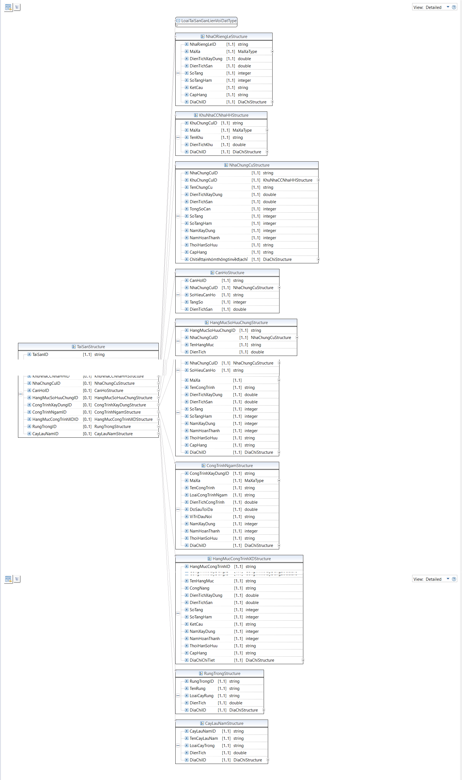

Hình 1 Lược đồ mô tả cấu trúc dữ liệu của Tài sản và các cấu trúc, kiểu dữ liệu liên quan

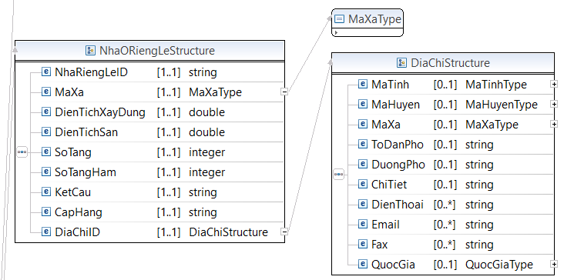

Hình 2 Lược đồ mô tả cấu trúc dữ liệu Nhà ở riêng lẻ và các cấu trúc, kiểu dữ liệu liên quan

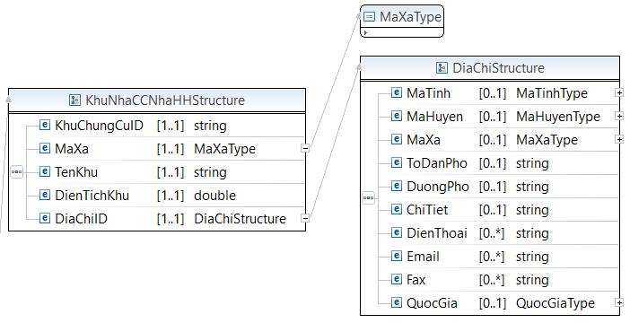

Hình 3 Lược đồ mô tả cấu trúc dữ liệu nhà chung cư, nhà hỗn hợp và các cấu trúc, kiểu dữ liệu liên quan

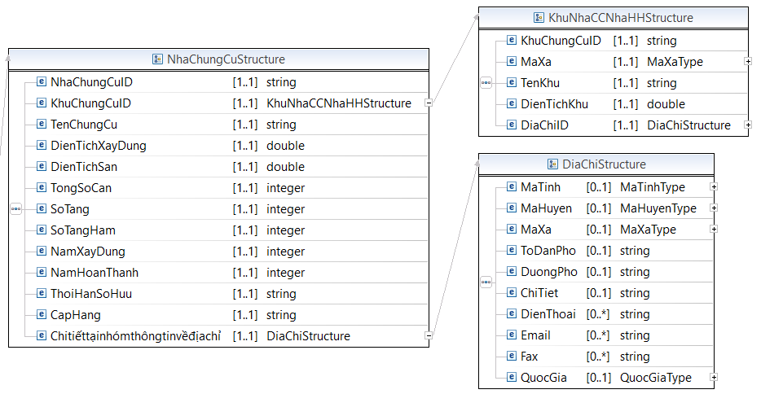

Hình 4 Lược đồ mô tả cấu trúc dữ liệu nhà chung cư và các cấu trúc, kiểu dữ liệu liên quan

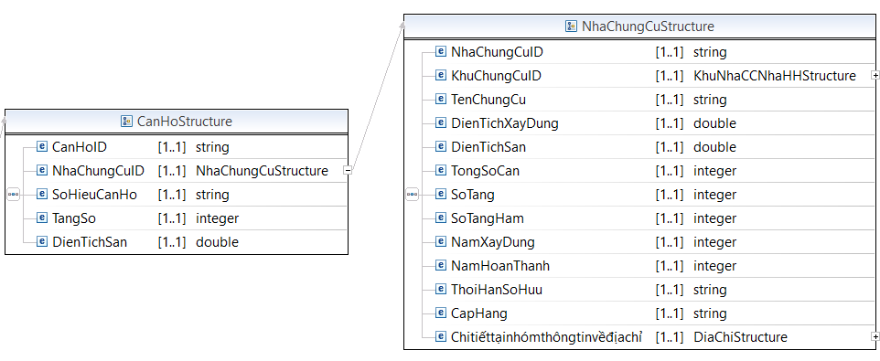

Hình 5 Lược đồ mô tả cấu trúc dữ liệu căn hộ và các cấu trúc, kiểu dữ liệu liên quan

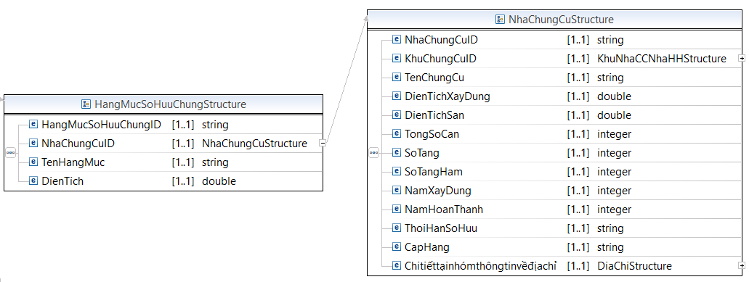

Hình 6 Lược đồ mô tả cấu trúc dữ liệu hạng mục sở hữu chung và các cấu trúc, kiểu dữ liệu liên quan

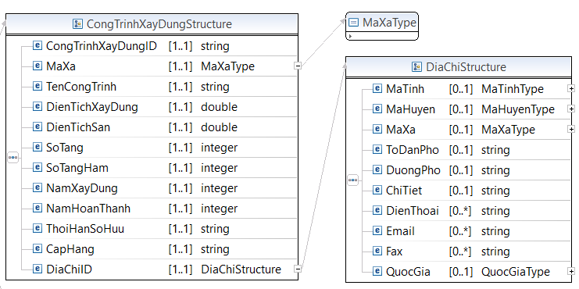

Hình 7 Lược đồ mô tả cấu trúc dữ liệu công trình xây dựng và các cấu trúc, kiểu dữ liệu liên quan

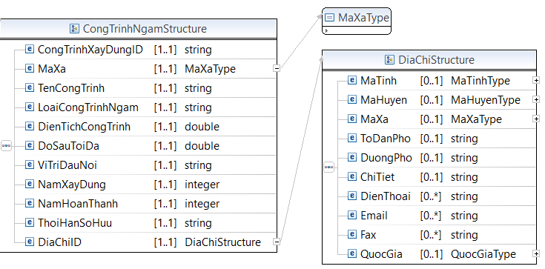

Hình 8 Lược đồ mô tả cấu trúc dữ liệu công trình ngầm và các cấu trúc, kiểu dữ liệu liên quan

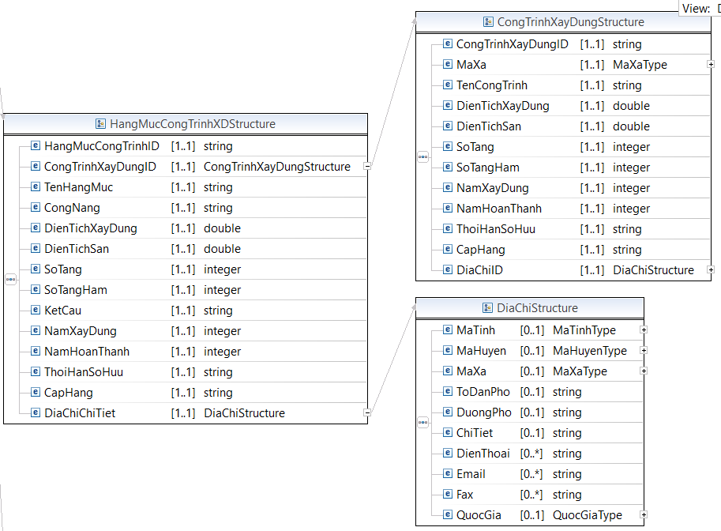

Hình 9 Lược đồ mô tả cấu trúc dữ liệu hạng mục công trình xây dựng và các cấu trúc, kiểu dữ liệu liên quan

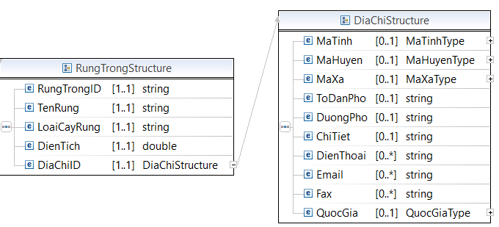

Hình 10 Lược đồ mô tả cấu trúc dữ liệu rừng trồng và các cấu trúc, kiểu dữ liệu liên quan

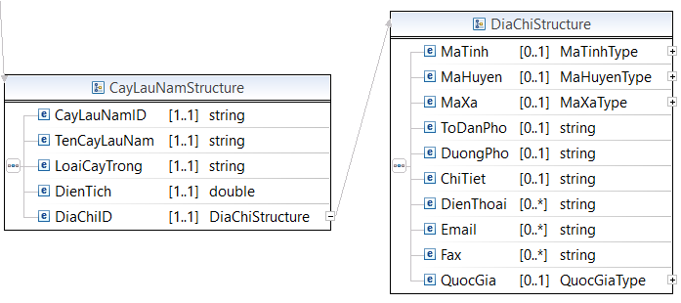

Hình 11 Lược đồ mô tả cấu trúc dữ liệu cây lâu năm và các cấu trúc, kiểu dữ liệu liên quan

**Mã nguồn lược đồ chứa các cấu trúc thông tin của lược đồ dữ liệu tài sản (TaiSan_core.xsd)**

<?xml version=*“1.1”* encoding=*"UTF-8"*?>

<xsd:schema xmlns:xsd=*"http://www.w3.org/2001/XMLSchema"* xmlns:TTDLQG=*"..."* targetNamespace=*"..."* version=*“1.1”* elementFormDefault=*"qualified"*>

<!-- <xsd:include schemaLocation="BaseEnumType.xsd" /> -->

<xsd:annotation>

<xsd:documentation></xsd:documentation>

</xsd:annotation>

<xsd:complexType name=*"ChuSoHuuTaiSanStructure"*>

<xsd:annotation>

<xsd:documentation>Mô tả cấu trúc thông tin phân nhóm dữ liệu Chủ sở hữu tài sản.</xsd:documentation>

</xsd:annotation>

<xsd:sequence>

<xsd:element name=*"SoDinhDanh "* type=*"xsd:integer"* minOccurs=*"0"* maxOccurs=*"1 "* />

<xsd:element name=*"SoDinhDanhHoGD "* type=*"xsd:string"* minOccurs=*"0"* maxOccurs=*"1 "* />

<xsd:element name=*"SoDinhDanhToChuc "* type=*"xsd:string"* minOccurs=*"0"* maxOccurs=*"1 "* />

</xsd:sequence>

</xsd:complexType>

<xsd:complexType name=*"QuyenSoHuuTaiSanStructure"*>

<xsd:annotation>

<xsd:documentation>Mô tả cấu trúc thông tin phân nhóm dữ liệu: Quyền sở hữu tài sản.</xsd:documentation>

</xsd:annotation>

<xsd:sequence>

<xsd:element name=*"SoHuuTaiSan "* type=*"TTDLQG:ChuSoHuuTaiSanStructure"* minOccurs=*"1"* maxOccurs=*"1"* />

<xsd:element name=*"NhomDLTaiSan "* type=*"TTDLQG:TaiSanStructure"* minOccurs=*"1"* maxOccurs=*"1"* />

<xsd:element name=*"NghiaVuTaiChinhID "* type=*"TTDLQG:NghiaVuTaiChinhStructure"* minOccurs=*"1"* maxOccurs=*"1"* />

<xsd:element name=*"HanCheQuyenSoHuuID "* type=*"TTDLQG:HanCheQuyenSoHuuStructure"* minOccurs=*"1"* maxOccurs=*"1"* />

<xsd:element name=*" GiayChungNhanID "* type=*"TTDLQG:GiayChungNhanStructure"* minOccurs=*"1"* maxOccurs=*"1"* />

</xsd:sequence>

</xsd:complexType>

<xsd:complexType name=*"NghiaVuTaiChinhStructure"*>

<xsd:annotation>

<xsd:documentation>Mô tả cấu trúc thông tin phân nhóm dữ liệu: Nghĩa vụ tài chính</xsd:documentation>

</xsd:annotation>

<xsd:sequence>

<xsd:element name=*"NghiaVuTaiChinhlD "* type=*"xsd:string"* minOccurs=*"1"* maxOccurs=*"1"* />

<xsd:element name=*"LoaiNghiaVuTaiChinh "* type=*"xsd:string"* minOccurs=*"1"* maxOccurs=*"1"* />

<xsd:element name=*"TongSoTien "* type=*"xsd:integer"* minOccurs=*"1"* maxOccurs=*"1"* />

<xsd:element name=*"TongSoTienMienGiam "* type=*"xsd:integer"* minOccurs=*"1"* maxOccurs=*"1"* />

<xsd:element name=*"TongSoTienNo "* type=*"xsd:integer"* minOccurs=*"1"* maxOccurs=*"1"* />

<xsd:element name=*"ngayBatDau "* type=*"TTDLQG:ThoiGianStructure"* minOccurs=*"1"* maxOccurs=*"1"* />

<xsd:element name=*"HoanThanh "* type=*"xsd:boolean"* minOccurs=*"1"* maxOccurs=*"1"* />

<xsd:element name=*"MienGiamNVTaiChinhID "* type=*"TTDLQG:MienGiamNVTaiChinhStructure"* minOccurs=*"1"* maxOccurs=*"1"* />

<xsd:element name=*"NoNVTaiChinhID "* type=*"TTDLQG:NoNVTaiChinhStructure"* minOccurs=*"1"* maxOccurs=*"1"* />

</xsd:sequence>

</xsd:complexType>

<xsd:complexType name=*"MienGiamNVTaiChinhStructure"*>

<xsd:annotation>

<xsd:documentation>Mô tả cấu trúc thông tin phân nhóm dữ liệu: Miễn giảm nghĩa vụ tài chính</xsd:documentation>

</xsd:annotation>

<xsd:sequence>

<xsd:element name=*"MienGiamNghiaVuTaiChinhlD "* type=*"xsd:string"* minOccurs=*"1"* maxOccurs=*"1"* />

<xsd:element name=*"MghiaVuTaiChinhlD "* type=*"TTDLQG:NghiaVuTaiChinhStructure"* minOccurs=*"1"* maxOccurs=*"1"* />

<xsd:element name=*"LoaiCheDoMienGiamlD "* type=*"xsd:integer"* minOccurs=*"1"* maxOccurs=*"1"* />

<xsd:element name=*"SoTienMienGiam "* type=*"xsd:integer"* minOccurs=*"1"* maxOccurs=*"1"* />

<xsd:element name=*"SoQuyetDinhMienGiam "* type=*"xsd:string"* minOccurs=*"1"* maxOccurs=*"1"* />

<xsd:element name=*"NgayRaQuyetDinhMienGiam "* type=*"TTDLQG:ThoiGianStructure"* minOccurs=*"1"* maxOccurs=*"1"* />

<xsd:element name=*"CoQuanRaQuyetDinhMienGiam "* type=*"xsd:string"* minOccurs=*"1"* maxOccurs=*"1"* />

</xsd:sequence>

</xsd:complexType>

<xsd:complexType name=*"NoNVTaiChinhStructure"*>

<xsd:annotation>

<xsd:documentation>Mô tả cấu trúc thông tin phân nhóm dữ liệu: Nợ nghĩa vụ tài chính</xsd:documentation>

</xsd:annotation>

<xsd:sequence>

<xsd:element name=*"NoNghiaVuTaiChinhlD "* type=*"xsd:string"* minOccurs=*"1"* maxOccurs=*"1"* />

<xsd:element name=*"NghiaVuTaiChinhlD "* type=*"TTDLQG:NghiaVuTaiChinhStructure"* minOccurs=*"1"* maxOccurs=*"1"* />

<xsd:element name=*"LoaiCheDoMienGiamlD "* type=*"xsd:integer"* minOccurs=*"1"* maxOccurs=*"1"* />

<xsd:element name=*"SoTienNo "* type=*"xsd:integer"* minOccurs=*"1"* maxOccurs=*"1"* />

<xsd:element name=*"SoQuyetDinhNo "* type=*"xsd:string"* minOccurs=*"1"* maxOccurs=*"1"* />

<xsd:element name=*"NgayRaQuyetDinhN0 "* type=*"TTDLQG:ThoiGianStructure"* minOccurs=*"1"* maxOccurs=*"1"* />

<xsd:element name=*"CoQuanRaQuyetDinhNo "* type=*"xsd:string"* minOccurs=*"1"* maxOccurs=*"1"* />

</xsd:sequence>

</xsd:complexType>

<xsd:complexType name=*"HanCheQuyenSoHuuStructure"*>

<xsd:annotation>

<xsd:documentation>Mô tả cấu trúc thông tin phân nhóm dữ liệu: Hạn chế quyền sở hữu</xsd:documentation>

</xsd:annotation>

<xsd:sequence>

<xsd:element name=*"HanChelD "* type=*"xsd:string"* minOccurs=*"1"* maxOccurs=*"1"* />

<xsd:element name=*"LoaiHanChe "* type=*"xsd:integer"* minOccurs=*"1"* maxOccurs=*"1"* />

<xsd:element name=*"DienTich "* type=*"xsd:double"* minOccurs=*"1"* maxOccurs=*"1"* />

<xsd:element name=*"NoiDungHanChe "* type=*"xsd:string"* minOccurs=*"1"* maxOccurs=*"1"* />

<xsd:element name=*"HanCheMotPhan "* type=*"xsd:boolean"* minOccurs=*"1"* maxOccurs=*"1"* />

<xsd:element name=*"SoDoRanhGioiHanChe "* type=*"TTDLQG:base64Binary"* minOccurs=*"1"* maxOccurs=*"1"* />

<xsd:element name=*"SoVanBan "* type=*"xsd:string"* minOccurs=*"1"* maxOccurs=*"1"* />

<xsd:element name=*"NgayBanHanh "* type=*"TTDLQG:ThoiGianStructure"* minOccurs=*"1"* maxOccurs=*"1"* />

<xsd:element name=*"CoQuanBanHanh "* type=*"xsd:string"* minOccurs=*"1"* maxOccurs=*"1"* />

<xsd:element name=*"BanQuet "* type=*""* minOccurs=*"1"* maxOccurs=*"1"* />

</xsd:sequence>

</xsd:complexType>

<xsd:complexType name=*"GiayChungNhanStructure"*>

<xsd:annotation>

<xsd:documentation>Mô tả cấu trúc thông tin phân nhóm dữ liệu: Giấy chứng nhận</xsd:documentation>

</xsd:annotation>

<xsd:sequence>

<xsd:element name=*"GiayChungNhanlD "* type=*"xsd:string"* minOccurs=*"1"* maxOccurs=*"1"* />

<xsd:element name=*"SoVaoSo "* type=*"xsd:string"* minOccurs=*"1"* maxOccurs=*"1"* />

<xsd:element name=*"SoPhatHanh "* type=*"xsd:string"* minOccurs=*"1"* maxOccurs=*"1"* />

<xsd:element name=*"MaVach "* type=*"xsd:string"* minOccurs=*"1"* maxOccurs=*"1"* />

<xsd:element name=*"NgayCap "* type=*"TTDLQG:ThoiGianStructure"* minOccurs=*"1"* maxOccurs=*"1"* />

<xsd:element name=*"BanQuet "* type=*"TTDLQG:base64Binary"* minOccurs=*"1"* maxOccurs=*"1"* />

<xsd:element name=*"SoDinhDanh "* type=*"xsd:integer"* minOccurs=*"1"* maxOccurs=*"1"* />

</xsd:sequence>

</xsd:complexType>

<xsd:complexType name=*"TaiSanStructure"*>

<xsd:annotation>

<xsd:documentation>Mô tả cấu trúc thông tin nhóm dữ liệu: Tài sản</xsd:documentation>

</xsd:annotation>

<xsd:sequence>

<xsd:element name=*"TaiSanID "* type=*"xsd:string"* minOccurs=*"1"* maxOccurs=*"1"* />

<xsd:element name=*"LoaiTaiSanGanLienVoiDat "* type=*"TTDLQG:LoaiTaiSanGanLienVoiDatType"* minOccurs=*"1"* maxOccurs=*"1"* />

<xsd:element name=*"nhaRiengLelD "* type=*"TTDLQG:NhaORiengLeStructure"* minOccurs=*"0"* maxOccurs=*"1 "* />

<xsd:element name=*"KhuNhaCCNhaHHID "* type=*"TTDLQG:KhuNhaCCNhaHHStructure"* minOccurs=*"0"* maxOccurs=*"1 "* />

<xsd:element name=*"NhaChungCuID "* type=*"TTDLQG:NhaChungCuStructure"* minOccurs=*"0"* maxOccurs=*"1 "* />

<xsd:element name=*"CanHoID "* type=*"TTDLQG:CanHoStructure"* minOccurs=*"0"* maxOccurs=*"1 "* />

<xsd:element name=*"HangMucSoHuuChungID "* type=*"TTDLQG:HangMucSoHuuChungStructure"* minOccurs=*"0"* maxOccurs=*"1 "* />

<xsd:element name=*"CongTrinhXayDungID "* type=*"TTDLQG:CongTrinhXayDungStructure"* minOccurs=*"0"* maxOccurs=*"1 "* />

<xsd:element name=*"CongTrinhNgamID "* type=*"TTDLQG:CongTrinhNgamStructure"* minOccurs=*"0"* maxOccurs=*"1 "* />

<xsd:element name=*"HangMucCongTrinhXDlD "* type=*"TTDLQG:HangMucCongTrinhXDStructure"* minOccurs=*"0"* maxOccurs=*"1 "* />

<xsd:element name=*"RungTronglD "* type=*"TTDLQG:RungTrongStructure"* minOccurs=*"0"* maxOccurs=*"1 "* />

<xsd:element name=*"CayLauNamlD "* type=*"TTDLQG:CayLauNamStructure"* minOccurs=*"0"* maxOccurs=*"1 "* />

</xsd:sequence>

</xsd:complexType>

<xsd:complexType name=*"NhaORiengLeStructure"*>

<xsd:annotation>

<xsd:documentation>Mô tả cấu trúc thông tin phân nhóm dữ liệu: Nhà ở riêng lẻ</xsd:documentation>

</xsd:annotation>

<xsd:sequence>

<xsd:element name=*"NhaRiengLelD "* type=*"xsd:string"* minOccurs=*"1"* maxOccurs=*"1"* />

<xsd:element name=*"MaXa "* type=*"TTDLQG:MaXaType"* minOccurs=*"1"* maxOccurs=*"1"* />

<xsd:element name=*"DienTichXayDung "* type=*"xsd:double"* minOccurs=*"1"* maxOccurs=*"1"* />

<xsd:element name=*"DienTichSan "* type=*"xsd:double"* minOccurs=*"1"* maxOccurs=*"1"* />

<xsd:element name=*"SoTang "* type=*"xsd:integer"* minOccurs=*"1"* maxOccurs=*"1"* />

<xsd:element name=*"SoTangHam "* type=*"xsd:integer"* minOccurs=*"1"* maxOccurs=*"1"* />

<xsd:element name=*"KetCau "* type=*"xsd:string"* minOccurs=*"1"* maxOccurs=*"1"* />

<xsd:element name=*"CapHang "* type=*"xsd:string"* minOccurs=*"1"* maxOccurs=*"1"* />

<xsd:element name=*"DiaChiID "* type=*"TTDLQG:DiaChiStructure"* minOccurs=*"1"* maxOccurs=*"1"* />

</xsd:sequence>

</xsd:complexType>

<xsd:complexType name=*"KhuNhaCCNhaHHStructure"*>

<xsd:annotation>

<xsd:documentation>Mô tả cấu trúc thông tin phân nhóm dữ liệu: Khu nhà chung cư, nhà hỗn hợp</xsd:documentation>

</xsd:annotation>

<xsd:sequence>

<xsd:element name=*"KhuChungCuID "* type=*"xsd:string"* minOccurs=*"1"* maxOccurs=*"1"* />

<xsd:element name=*"MaXa "* type=*"TTDLQG:MaXaType"* minOccurs=*"1"* maxOccurs=*"1"* />

<xsd:element name=*"TenKhu "* type=*"xsd:string"* minOccurs=*"1"* maxOccurs=*"1"* />

<xsd:element name=*"DienTichKhu "* type=*"xsd:double"* minOccurs=*"1"* maxOccurs=*"1"* />

<xsd:element name=*"DiaChiID "* type=*"TTDLQG:DiaChiStructure"* minOccurs=*"1"* maxOccurs=*"1"* />

</xsd:sequence>

</xsd:complexType>

<xsd:complexType name=*"NhaChungCuStructure"*>

<xsd:annotation>

<xsd:documentation>Mô tả cấu trúc thông tin phân nhóm dữ liệu: Khu nhà chung cư, nhà hỗn hợp</xsd:documentation>

</xsd:annotation>

<xsd:sequence>

<xsd:element name=*"NhaChungCuID "* type=*"xsd:string"* minOccurs=*"1"* maxOccurs=*"1"* />

<xsd:element name=*"KhuChungCuID "* type=*"TTDLQG:KhuNhaCCNhaHHStructure"* minOccurs=*"1"* maxOccurs=*"1"* />

<xsd:element name=*"TenChungCu "* type=*"xsd:string"* minOccurs=*"1"* maxOccurs=*"1"* />

<xsd:element name=*"DienTichXayDung "* type=*"xsd:double"* minOccurs=*"1"* maxOccurs=*"1"* />

<xsd:element name=*"DienTichSan "* type=*"xsd:double"* minOccurs=*"1"* maxOccurs=*"1"* />

<xsd:element name=*"TongSoCan "* type=*"xsd:integer"* minOccurs=*"1"* maxOccurs=*"1"* />

<xsd:element name=*"SoTang "* type=*"xsd:integer"* minOccurs=*"1"* maxOccurs=*"1"* />

<xsd:element name=*"SoTangHam "* type=*"xsd:integer"* minOccurs=*"1"* maxOccurs=*"1"* />

<xsd:element name=*"NamXayDung "* type=*"xsd:integer"* minOccurs=*"1"* maxOccurs=*"1"* />

<xsd:element name=*"NamHoanThanh "* type=*"xsd:integer"* minOccurs=*"1"* maxOccurs=*"1"* />

<xsd:element name=*"ThoiHanSoHuu "* type=*"xsd:string"* minOccurs=*"1"* maxOccurs=*"1"* />

<xsd:element name=*"CapHang "* type=*"xsd:string"* minOccurs=*"1"* maxOccurs=*"1"* />

<xsd:element name=*"Chitiếttạinhómthôngtinvềđịachỉ "* type=*"TTDLQG:DiaChiStructure"* minOccurs=*"1"* maxOccurs=*"1"* />

</xsd:sequence>

</xsd:complexType>

<xsd:complexType name=*"CanHoStructure"*>

<xsd:annotation>

<xsd:documentation>Mô tả cấu trúc thông tin phân nhóm dữ liệu: Căn hộ</xsd:documentation>

</xsd:annotation>

<xsd:sequence>

<xsd:element name=*"CanHoID "* type=*"xsd:string"* minOccurs=*"1"* maxOccurs=*"1"* />

<xsd:element name=*"NhaChungCuID "* type=*"TTDLQG:NhaChungCuStructure"* minOccurs=*"1"* maxOccurs=*"1"* />

<xsd:element name=*"SoHieuCanHo "* type=*"xsd:string"* minOccurs=*"1"* maxOccurs=*"1"* />

<xsd:element name=*"TangSo "* type=*"xsd:integer"* minOccurs=*"1"* maxOccurs=*"1"* />

<xsd:element name=*"DienTichSan "* type=*"xsd:double"* minOccurs=*"1"* maxOccurs=*"1"* />

</xsd:sequence>

</xsd:complexType>

<xsd:complexType name=*"HangMucSoHuuChungStructure"*>

<xsd:annotation>

<xsd:documentation>Mô tả cấu trúc thông tin phân nhóm dữ liệu: Hạng mục sở hữu chung</xsd:documentation>

</xsd:annotation>

<xsd:sequence>

<xsd:element name=*"HangMucSoHuuChunglD "* type=*"xsd:string"* minOccurs=*"1"* maxOccurs=*"1"* />

<xsd:element name=*"NhaChungCuID "* type=*"TTDLQG:NhaChungCuStructure"* minOccurs=*"1"* maxOccurs=*"1"* />

<xsd:element name=*"TenHangMuc "* type=*"xsd:string"* minOccurs=*"1"* maxOccurs=*"1"* />

<xsd:element name=*"DienTich "* type=*"xsd:double"* minOccurs=*"1"* maxOccurs=*"1"* />

</xsd:sequence>

</xsd:complexType>

<xsd:complexType name=*"CongTrinhXayDungStructure"*>

<xsd:annotation>

<xsd:documentation>Mô tả cấu trúc thông tin phân nhóm dữ liệu: Công trình xây dựng</xsd:documentation>

</xsd:annotation>

<xsd:sequence>

<xsd:element name=*"CongTrinhXayDunglD "* type=*"xsd:string"* minOccurs=*"1"* maxOccurs=*"1"* />

<xsd:element name=*"MaXa "* type=*"TTDLQG:MaXaType"* minOccurs=*"1"* maxOccurs=*"1"* />

<xsd:element name=*"TenCongTrinh "* type=*"xsd:string"* minOccurs=*"1"* maxOccurs=*"1"* />

<xsd:element name=*"DienTichXayDung "* type=*"xsd:double"* minOccurs=*"1"* maxOccurs=*"1"* />

<xsd:element name=*"DienTichSan "* type=*"xsd:double"* minOccurs=*"1"* maxOccurs=*"1"* />

<xsd:element name=*"SoTang "* type=*"xsd:integer"* minOccurs=*"1"* maxOccurs=*"1"* />

<xsd:element name=*"SoTangHam "* type=*"xsd:integer"* minOccurs=*"1"* maxOccurs=*"1"* />

<xsd:element name=*"NamXayDung "* type=*"xsd:integer"* minOccurs=*"1"* maxOccurs=*"1"* />

<xsd:element name=*"NamHoanThanh "* type=*"xsd:integer"* minOccurs=*"1"* maxOccurs=*"1"* />

<xsd:element name=*"ThoiHanSoHuu "* type=*"xsd:string"* minOccurs=*"1"* maxOccurs=*"1"* />

<xsd:element name=*"CapHang "* type=*"xsd:string"* minOccurs=*"1"* maxOccurs=*"1"* />

<xsd:element name=*"DiaChiID "* type=*"TTDLQG:DiaChiStructure"* minOccurs=*"1"* maxOccurs=*"1"* />

</xsd:sequence>

</xsd:complexType>

<xsd:complexType name=*"CongTrinhNgamStructure"*>

<xsd:annotation>

<xsd:documentation>Mô tả cấu trúc thông tin phân nhóm dữ liệu: Công trình ngầm</xsd:documentation>

</xsd:annotation>

<xsd:sequence>

<xsd:element name=*"CongTrinhXayDunglD "* type=*"xsd:string"* minOccurs=*"1"* maxOccurs=*"1"* />

<xsd:element name=*"MaXa "* type=*"TTDLQG:MaXaType"* minOccurs=*"1"* maxOccurs=*"1"* />

<xsd:element name=*"TenCongTrinh "* type=*"xsd:string"* minOccurs=*"1"* maxOccurs=*"1"* />

<xsd:element name=*"LoaiCongTrinhNgam "* type=*"xsd:string"* minOccurs=*"1"* maxOccurs=*"1"* />

<xsd:element name=*"DienTichCongTrinh "* type=*"xsd:double"* minOccurs=*"1"* maxOccurs=*"1"* />

<xsd:element name=*"DoSauToiDa "* type=*"xsd:double"* minOccurs=*"1"* maxOccurs=*"1"* />

<xsd:element name=*"ViTriDauNoi "* type=*"xsd:string"* minOccurs=*"1"* maxOccurs=*"1"* />

<xsd:element name=*"NamXayDung "* type=*"xsd:integer"* minOccurs=*"1"* maxOccurs=*"1"* />

<xsd:element name=*"NamHoanThanh "* type=*"xsd:integer"* minOccurs=*"1"* maxOccurs=*"1"* />

<xsd:element name=*"ThoiHanSoHuu "* type=*"xsd:string"* minOccurs=*"1"* maxOccurs=*"1"* />

<xsd:element name=*"DiaChiID "* type=*"TTDLQG:DiaChiStructure"* minOccurs=*"1"* maxOccurs=*"1"* />

</xsd:sequence>

</xsd:complexType>

<xsd:complexType name=*"HangMucCongTrinhXDStructure"*>

<xsd:annotation>

<xsd:documentation>Mô tả cấu trúc thông tin phân nhóm dữ liệu: Hạng mục công trình xây dựng</xsd:documentation>

</xsd:annotation>

<xsd:sequence>

<xsd:element name=*"HangMucCongTrinhlD "* type=*"xsd:string"* minOccurs=*"1"* maxOccurs=*"1"* />

<xsd:element name=*"CongTrinhXayDungID "* type=*"TTDLQG:CongTrinhXayDungStructure"* minOccurs=*"1"* maxOccurs=*"1"* />

<xsd:element name=*"TenHangMuc "* type=*"xsd:string"* minOccurs=*"1"* maxOccurs=*"1"* />

<xsd:element name=*"CongNang "* type=*"xsd:string"* minOccurs=*"1"* maxOccurs=*"1"* />

<xsd:element name=*"DienTichXayDung "* type=*"xsd:double"* minOccurs=*"1"* maxOccurs=*"1"* />

<xsd:element name=*"DienTichSan "* type=*"xsd:double"* minOccurs=*"1"* maxOccurs=*"1"* />

<xsd:element name=*"SoTang "* type=*"xsd:integer"* minOccurs=*"1"* maxOccurs=*"1"* />

<xsd:element name=*"SoTangHam "* type=*"xsd:integer"* minOccurs=*"1"* maxOccurs=*"1"* />

<xsd:element name=*"KetCau "* type=*"xsd:string"* minOccurs=*"1"* maxOccurs=*"1"* />

<xsd:element name=*"NamXayDung "* type=*"xsd:integer"* minOccurs=*"1"* maxOccurs=*"1"* />

<xsd:element name=*"NamHoanThanh "* type=*"xsd:integer"* minOccurs=*"1"* maxOccurs=*"1"* />

<xsd:element name=*"ThoiHanSoHuu "* type=*"xsd:string"* minOccurs=*"1"* maxOccurs=*"1"* />

<xsd:element name=*"CapHang "* type=*"xsd:string"* minOccurs=*"1"* maxOccurs=*"1"* />

<xsd:element name=*"DiaChiChiTiet "* type=*"TTDLQG:DiaChiStructure"* minOccurs=*"1"* maxOccurs=*"1"* />

</xsd:sequence>

</xsd:complexType>

<xsd:complexType name=*"RungTrongStructure"*>

<xsd:annotation>

<xsd:documentation>Mô tả cấu trúc thông tin phân nhóm dữ liệu: Rừng sản xuất là rừng trồng</xsd:documentation>

</xsd:annotation>

<xsd:sequence>

<xsd:element name=*"RungTronglD "* type=*"xsd:string"* minOccurs=*"1"* maxOccurs=*"1"* />

<xsd:element name=*"TenRung "* type=*"xsd:string"* minOccurs=*"1"* maxOccurs=*"1"* />

<xsd:element name=*"LoaiCayRung "* type=*"xsd:string"* minOccurs=*"1"* maxOccurs=*"1"* />

<xsd:element name=*"DienTich "* type=*"xsd:double"* minOccurs=*"1"* maxOccurs=*"1"* />

<xsd:element name=*"DiaChiID "* type=*"TTDLQG:DiaChiStructure"* minOccurs=*"1"* maxOccurs=*"1"* />

</xsd:sequence>

</xsd:complexType>

<xsd:complexType name=*"CayLauNamStructure"*>

<xsd:annotation>

<xsd:documentation>Mô tả cấu trúc thông tin phân nhóm dữ liệu: Cây lâu năm</xsd:documentation>

</xsd:annotation>

<xsd:sequence>

<xsd:element name=*"CayLauNamlD "* type=*"xsd:string"* minOccurs=*"1"* maxOccurs=*"1"* />

<xsd:element name=*"TenCayLauNam "* type=*"xsd:string"* minOccurs=*"1"* maxOccurs=*"1"* />

<xsd:element name=*"LoaiCayTrong "* type=*"xsd:string"* minOccurs=*"1"* maxOccurs=*"1"* />

<xsd:element name=*"DienTich "* type=*"xsd:double"* minOccurs=*"1"* maxOccurs=*"1"* />

<xsd:element name=*"DiaChiID "* type=*"TTDLQG:DiaChiStructure"* minOccurs=*"1"* maxOccurs=*"1"* />

</xsd:sequence>

</xsd:complexType>

<xsd:complexType name=*"GiaThuaDatStructure"*>

<xsd:annotation>

<xsd:documentation>Mô tả cấu trúc thông tin phân nhóm dữ liệu: Giá đất xác định đến từng thửa đất</xsd:documentation>

</xsd:annotation>

<xsd:sequence>

<xsd:element name=*"GiaDatlD "* type=*"xsd:string"* minOccurs=*"1"* maxOccurs=*"1"* />

<xsd:element name=*"ThuaDatlD "* type=*"ThongTinThuaDatStructure"* minOccurs=*"1"* maxOccurs=*"1"* />

<xsd:element name=*"BangGiaDatID "* type=*"TTDLQG:BangGiaDatStructure"* minOccurs=*"1"* maxOccurs=*"1"* />

<xsd:element name=*"GiaDatCuTheID "* type=*"TTDLQG:GiaDatCuTheStructure"* minOccurs=*"1"* maxOccurs=*"1"* />

<xsd:element name=*"GiaDatChuyenNhuongID "* type=*"xsd:integer"* minOccurs=*"1"* maxOccurs=*"1"* />

</xsd:sequence>

</xsd:complexType>

<xsd:complexType name=*"KhungGiaDatStructure"*>

<xsd:annotation>

<xsd:documentation>Mô tả cấu trúc thông tin phân nhóm dữ liệu: Khung giá đất</xsd:documentation>

</xsd:annotation>

<xsd:sequence>

<xsd:element name=*"KhungGiaDatlD "* type=*"xsd:string"* minOccurs=*"1"* maxOccurs=*"1"* />

<xsd:element name=*"GiaDatToiThieu "* type=*"xsd:integer"* minOccurs=*"1"* maxOccurs=*"1"* />

<xsd:element name=*"GiaDatToiDa "* type=*"xsd:integer"* minOccurs=*"1"* maxOccurs=*"1"* />

<xsd:element name=*"NgayHieuLuc "* type=*"TTDLQG:ThoiGianStructure"* minOccurs=*"1"* maxOccurs=*"1"* />

<xsd:element name=*"NghiDinhBanHanh "* type=*"TTDLQG:base64Binary"* minOccurs=*"1"* maxOccurs=*"1"* />

</xsd:sequence>

</xsd:complexType>

<xsd:complexType name=*"BangGiaDatStructure"*>

<xsd:annotation>

<xsd:documentation>Mô tả cấu trúc thông tin phân nhóm dữ liệu: Bảng giá đất</xsd:documentation>

</xsd:annotation>

<xsd:sequence>

<xsd:element name=*"BangGiaDatlD "* type=*"xsd:string"* minOccurs=*"1"* maxOccurs=*"1"* />

<xsd:element name=*"NgayBanHanh "* type=*"TTDLQG:ThoiGianStructure"* minOccurs=*"1"* maxOccurs=*"1"* />

<xsd:element name=*"GiaDatTheoBangGia "* type=*"xsd:integer"* minOccurs=*"1"* maxOccurs=*"1"* />

<xsd:element name=*"ViTriDat "* type=*"xsd:integer"* minOccurs=*"1"* maxOccurs=*"1"* />

<xsd:element name=*"KhuVucDat "* type=*"xsd:integer"* minOccurs=*"1"* maxOccurs=*"1"* />

<xsd:element name=*"NgayHieuLuc "* type=*"TTDLQG:ThoiGianStructure"* minOccurs=*"1"* maxOccurs=*"1"* />

<xsd:element name=*"QuyetDinhBanHanh "* type=*"TTDLQG:base64Binary"* minOccurs=*"1"* maxOccurs=*"1"* />

</xsd:sequence>

</xsd:complexType>

<xsd:complexType name=*"HeSoDieuChinhStructure"*>

<xsd:annotation>

<xsd:documentation>Mô tả cấu trúc thông tin phân nhóm dữ liệu: Hệ số điều chỉnh</xsd:documentation>

</xsd:annotation>

<xsd:sequence>

<xsd:element name=*"HeSoDieuChinhlD "* type=*"xsd:string"* minOccurs=*"1"* maxOccurs=*"1"* />

<xsd:element name=*"HeSoDieuChinh "* type=*"xsd:double"* minOccurs=*"1"* maxOccurs=*"1"* />

<xsd:element name=*"NgayHieuLuc "* type=*"TTDLQG:ThoiGianStructure"* minOccurs=*"1"* maxOccurs=*"1"* />

<xsd:element name=*"QuyetDinhBanHanh "* type=*"TTDLQG:base64Binary"* minOccurs=*"1"* maxOccurs=*"1"* />

</xsd:sequence>

</xsd:complexType>

<xsd:complexType name=*"GiaDatCuTheStructure"*>

<xsd:annotation>

<xsd:documentation>Mô tả cấu trúc thông tin phân nhóm dữ liệu: Giá đất cụ thể</xsd:documentation>

</xsd:annotation>

<xsd:sequence>

<xsd:element name=*"GiaCuThelD "* type=*"xsd:string"* minOccurs=*"1"* maxOccurs=*"1"* />

<xsd:element name=*"GiaDatTheoHeSo "* type=*"xsd:integer"* minOccurs=*"1"* maxOccurs=*"1"* />

<xsd:element name=*"GiaDatCuThe "* type=*"xsd:integer"* minOccurs=*"1"* maxOccurs=*"1"* />

<xsd:element name=*"ThoiDiemQuyetDinhGiaDatCuThe "* type=*"TTDLQG:ThoiGianStructure"* minOccurs=*"1"* maxOccurs=*"1"* />

<xsd:element name=*"CanCuPhapLy "* type=*"xsd:string"* minOccurs=*"1"* maxOccurs=*"1"* />

</xsd:sequence>

</xsd:complexType>

<xsd:complexType name=*"GiaThiTruongStructure"*>

<xsd:annotation>

<xsd:documentation>Mô tả cấu trúc thông tin phân nhóm dữ liệu: Giá thị trường</xsd:documentation>

</xsd:annotation>

<xsd:sequence>

<xsd:element name=*"GiaThiTruonglD "* type=*"xsd:string"* minOccurs=*"1"* maxOccurs=*"1"* />

<xsd:element name=*"GiaTheoHopDong "* type=*"xsd:integer"* minOccurs=*"1"* maxOccurs=*"1"* />

<xsd:element name=*"ThoiDiemChuyenNhuongHopDong "* type=*"TTDLQG:ThoiGianStructure"* minOccurs=*"1"* maxOccurs=*"1"* />

<xsd:element name=*"GiaDatTrungDauGia "* type=*"xsd:integer"* minOccurs=*"1"* maxOccurs=*"1"* />

<xsd:element name=*"ThoiDiemTrungDauGia "* type=*"TTDLQG:ThoiGianStructure"* minOccurs=*"1"* maxOccurs=*"1"* />

<xsd:element name=*"GiaDatChuyenNhuongThiTruong "* type=*"xsd:integer"* minOccurs=*"1"* maxOccurs=*"1"* />

<xsd:element name=*"ThoiDiemChuyenNhuongThiTruong "* type=*"TTDLQG:ThoiGianStructure"* minOccurs=*"1"* maxOccurs=*"1"* />

</xsd:sequence>

</xsd:complexType>

<xsd:complexType name=*"DiaChiStructure"*>

<xsd:annotation>

<xsd:documentation>DiaChi</xsd:documentation>

</xsd:annotation>

<xsd:sequence>

<xsd:element name=*"MaTinh"* type=*"TTDLQG:MaTinhType"* minOccurs=*"0"* maxOccurs=*"1"* />

<xsd:element name=*"MaHuyen"* type=*"TTDLQG:MaHuyenType"* minOccurs=*"0"* maxOccurs=*"1"* />

<xsd:element name=*"MaXa"* type=*"TTDLQG:MaXaType"* minOccurs=*"0"* maxOccurs=*"1"* />

<xsd:element name=*"ToDanPho"* type=*"xsd:string"* minOccurs=*"0"* maxOccurs=*"1"* />

<xsd:element name=*"DuongPho"* type=*"xsd:string"* minOccurs=*"0"* maxOccurs=*"1"* />

<xsd:element name=*"ChiTiet"* type=*"xsd:string"* minOccurs=*"0"* maxOccurs=*"1"* />

<xsd:element name=*"DienThoai"* type=*"xsd:string"* minOccurs=*"0"* maxOccurs=*"unbounded"* />

<xsd:element name=*"Email"* type=*"xsd:string"* minOccurs=*"0"* maxOccurs=*"unbounded"* />

<xsd:element name=*"Fax"* type=*"xsd:string"* minOccurs=*"0"* maxOccurs=*"unbounded"* />

<xsd:element name=*"QuocGia"* type=*"TTDLQG:QuocGiaType"* minOccurs=*"0"* maxOccurs=*"1"* />

</xsd:sequence>

</xsd:complexType>

<xsd:complexType name=*"ThoiGianStructure"*>

<xsd:annotation>

<xsd:documentation>Mô tả cấu trúc các trường thông tin sử dụng liên quan đến thời gian</xsd:documentation>

</xsd:annotation>

<xsd:sequence>

<xsd:element name=*"Nam"* type=*"TTDLQG:NamType"* minOccurs=*"1 "* maxOccurs=*"1 "* />

<xsd:element name=*"ThangNam"* type=*"TTDLQG:ThangNamType"* minOccurs=*"1 "* maxOccurs=*"1 "* />

<xsd:element name=*"NgayThangNam"* type=*"TTDLQG:NgayThangNamType"* minOccurs=*"1 "* maxOccurs=*"1 "* />

</xsd:sequence>

</xsd:complexType>

<xsd:complexType name=*"ThongTinThuaDatStructure"*>

<xsd:annotation>

<xsd:documentation>Mô tả cấu trúc thông tin về thửa đất</xsd:documentation>

</xsd:annotation>

<xsd:sequence>

<xsd:element name=*"ThuaDatlD"* type=*"xsd:string"* minOccurs=*"1"* maxOccurs=*"1"* />

<xsd:element name=*"Xa"* type=*"TTDLQG:MaXaType"* minOccurs=*"1"* maxOccurs=*"1"* />

<xsd:element name=*"SoHieuToBanDo"* type=*"xsd:integer"* minOccurs=*"1"* maxOccurs=*"1"* />

<xsd:element name=*"SoThuaDat"* type=*"xsd:integer"* minOccurs=*"1"* maxOccurs=*"1"* />

<xsd:element name=*"SoHieuToBanDoCu"* type=*"xsd:integer"* minOccurs=*"1"* maxOccurs=*"1"* />

<xsd:element name=*"SoThuaDatCu"* type=*"xsd:integer"* minOccurs=*"1"* maxOccurs=*"1"* />

<xsd:element name=*"MucDichSuDungDat"* type=*"TTDLQG:MucDichSuDungStructure"* minOccurs=*"1"* maxOccurs=*"unbounded"* />

<xsd:element name=*"NguonGoclD"* type=*"TTDLQG:NguonGocSuDungStructure"* minOccurs=*"1"* maxOccurs=*"1"* />

<xsd:element name=*"DienTich"* type=*"xsd:double"* minOccurs=*"1"* maxOccurs=*"1"* />

<xsd:element name=*"DenTichPhapLy"* type=*"xsd:double"* minOccurs=*"0"* maxOccurs=*"unbounded"* />

<xsd:element name=*"TaiLieuDoDaclD"* type=*"TTDLQG:TaiLieuDoDacStructure"* minOccurs=*"1"* maxOccurs=*"1"* />

<xsd:element name=*"LaDoiTuongChiemDat"* type=*"xsd:boolean"* minOccurs=*"0"* maxOccurs=*"1"* />

<xsd:element name=*"QuyenQuanLy"* type=*"TTDLQG:QuyenQuanLyStructure"* minOccurs=*"0"* maxOccurs=*"1"* />

<xsd:element name=*"QuyenSuDung"* type=*"TTDLQG:QuyenSuDungStructure"* minOccurs=*"0"* maxOccurs=*"unbounded"* />

<xsd:element name=*"ThayDoiTrongQuaTrinhSDD"* type=*"TTDLQG:ThayDoiTrongQuaTrinhSDDStructure"* minOccurs=*"0"* maxOccurs=*"unbounded"* />

<xsd:element name=*"DiaChi"* type=*"TTDLQG:DiaChiStructure"* minOccurs=*"1"* maxOccurs=*"1"* />

</xsd:sequence>

</xsd:complexType>

<xsd:complexType name=*"MucDichSuDungStructure"*>

<xsd:annotation>

<xsd:documentation>Mô tả mục đích sử dụng đất</xsd:documentation>

</xsd:annotation>

<xsd:sequence>

<xsd:element name=*"MucDichSuDungDatlD"* type=*"xsd:string"* minOccurs=*"1"* maxOccurs=*"1"* />

<xsd:element name=*"ThuaDatlD"* type=*"xsd:string"* minOccurs=*"1"* maxOccurs=*"1"* />

<xsd:element name=*"SoThuTuMDSD"* type=*"xsd:integer"* minOccurs=*"1"* maxOccurs=*"1"* />

<xsd:element name=*"MaMDSD"* type=*"TTDLQG:MaMDSDType"* minOccurs=*"1"* maxOccurs=*"1"* />

<xsd:element name=*"MaMDSDQH"* type=*"TTDLQG:MaMDSDQHType"* minOccurs=*"1"* maxOccurs=*"1"* />

<xsd:element name=*"DienTich"* type=*"xsd:double"* minOccurs=*"1"* maxOccurs=*"1"* />

<xsd:element name=*"SuDungChung"* type=*"xsd:boolean"* minOccurs=*"1"* maxOccurs=*"1"* />

<xsd:element name=*"ThoiHanSuDung"* type=*"TTDLQG:ThoiGianStructure"* minOccurs=*"1"* maxOccurs=*"1"* />

</xsd:sequence>

</xsd:complexType>

<xsd:complexType name=*"NguonGocSuDungStructure"*>

<xsd:annotation>

<xsd:documentation>Nguồn gốc sử dụng thửa đất</xsd:documentation>

</xsd:annotation>

<xsd:sequence>

<xsd:element name=*"SoDinhDanh"* type=*"xsd:integer"* minOccurs=*"0"* maxOccurs=*"1"* />

<xsd:element name=*"MaHoGiaDinh"* type=*"xsd:string"* minOccurs=*"0"* maxOccurs=*"1"* />

<xsd:element name=*"SoDinhDanhDienTuToChuc"* type=*"xsd:string"* minOccurs=*"0"* maxOccurs=*"1"* />

</xsd:sequence>

</xsd:complexType>

<xsd:complexType name=*"TaiLieuDoDacStructure"*>

<xsd:annotation>

<xsd:documentation>Mô tả cấu trúc thông tin về thửa đất</xsd:documentation>

</xsd:annotation>

<xsd:sequence>

<xsd:element name=*"TaiLieuDoDaclD"* type=*"xsd:string"* minOccurs=*"1"* maxOccurs=*"1"* />

<xsd:element name=*"MaXa"* type=*"TTDLQG:MaXaType"* minOccurs=*"1"* maxOccurs=*"1"* />

<xsd:element name=*"LoaiBanDoDiaChinh"* type=*"TTDLQG:LoaiBanDoDiaChinhType"* minOccurs=*"1"* maxOccurs=*"1"* />

<xsd:element name=*"DonViDoDac"* type=*"xsd:string"* minOccurs=*"1"* maxOccurs=*"1"* />

<xsd:element name=*"PhuongPhapDo"* type=*"xsd:string"* minOccurs=*"1"* maxOccurs=*"1"* />

<xsd:element name=*"MucDoChinhXac"* type=*"xsd:string"* minOccurs=*"1"* maxOccurs=*"1"* />

<xsd:element name=*"TyLeDoDac"* type=*"xsd:string"* minOccurs=*"1"* maxOccurs=*"1"* />

<xsd:element name=*"NgayHoanThanh"* type=*"TTDLQG:ThoiGianStructure"* minOccurs=*"1"* maxOccurs=*"1"* />

</xsd:sequence>

</xsd:complexType>

<xsd:complexType name=*"QuyenQuanLyStructure"*>

<xsd:annotation>

<xsd:documentation>Quyền quản lý đất</xsd:documentation>

</xsd:annotation>

<xsd:sequence>

<xsd:element name=*"QuyenQuanLylD"* type=*"xsd:string"* minOccurs=*"1"* maxOccurs=*"1"* />

<xsd:element name=*"NguoiSuDungQuanLy"* type=*"TTDLQG:NguoiSuDungQuanLyStructure"* minOccurs=*"1"* maxOccurs=*"1"* />

<xsd:element name=*"ThongTinThuaDat"* type=*"ThongTinThuaDatStructure"* minOccurs=*"1"* maxOccurs=*"1"* />

<xsd:element name=*"MaMDSD"* type=*"TTDLQG:MaMDSDType"* minOccurs=*"1"* maxOccurs=*"unbounded"* />

</xsd:sequence>

</xsd:complexType>

<xsd:complexType name=*"QuyenSuDungStructure"*>

<xsd:annotation>

<xsd:documentation>Quyền sử dụng đất</xsd:documentation>

</xsd:annotation>

<xsd:sequence>

<xsd:element name=*"QuyenSuDunglD"* type=*"xsd:string"* minOccurs=*"1"* maxOccurs=*"1"* />

<xsd:element name=*"NguoiSuDungQuanLy"* type=*"TTDLQG:NguoiSuDungQuanLyStructure"* minOccurs=*"0"* maxOccurs=*"unbounded"* />

<xsd:element name=*"ThongTinThuaDat"* type=*"ThongTinThuaDatStructure"* minOccurs=*"1"* maxOccurs=*"1"* />

<xsd:element name=*"MucDichSuDung"* type=*"xsd:string"* minOccurs=*"1"* maxOccurs=*"1"* />

<xsd:element name=*"NghiaVuTaiChinh"* type=*"TTDLQG:NghiaVuTaiChinhStructure"* minOccurs=*"1"* maxOccurs=*"unbounded"* />

<xsd:element name=*"HanCheQuyenSuDung"* type=*"xsd:string"* minOccurs=*"0"* maxOccurs=*"unbounded"* />

<xsd:element name=*"GiayChungNhan"* type=*"TTDLQG:GiayChungNhanStructure"* minOccurs=*"0"* maxOccurs=*"unbounded"* />

</xsd:sequence>

</xsd:complexType>

<xsd:complexType name=*"ThayDoiTrongQuaTrinhSDDStructure"*>

<xsd:annotation>

<xsd:documentation>Thay đổi trong quá trình sử dụng đất</xsd:documentation>

</xsd:annotation>

<xsd:sequence>

<xsd:element name=*"BienDongID"* type=*"xsd:string"* minOccurs=*"1"* maxOccurs=*"1"* />

<xsd:element name=*"LoaiGiaoDichBienDong"* type=*"xsd:string"* minOccurs=*"1"* maxOccurs=*"1"* />

<xsd:element name=*"NoiDungBienDong"* type=*"xsd:string"* minOccurs=*"1"* maxOccurs=*"1"* />

<xsd:element name=*"NguoiThamGiaVaoQuaTrinhBienDong"* type=*"xsd:integer"* minOccurs=*"0"* maxOccurs=*"unbounded"* />

</xsd:sequence>

</xsd:complexType>

<xsd:complexType name=*"NguoiSuDungQuanLyStructure"*>

<xsd:annotation>

<xsd:documentation>Người sử dụng quản lý</xsd:documentation>

</xsd:annotation>

<xsd:sequence>

<xsd:element name=*"Tên"* type=*"xsd:string"* minOccurs=*"1"* maxOccurs=*"1"* />

</xsd:sequence>

</xsd:complexType>

<xsd:simpleType name=*"LoaiTaiSanGanLienVoiDatType"*>

<xsd:annotation>

<xsd:documentation>Lọai tài sản gắn liền với đất</xsd:documentation>

</xsd:annotation>

<xsd:restriction base=*"xsd:token"*>

<xsd:enumeration value=*"Loại1"*><xsd:annotation><xsd:documentation>xsd:string</xsd:documentation></xsd:annotation></xsd:enumeration>

</xsd:restriction>

</xsd:simpleType>

<xsd:simpleType name=*"MaXaType"*>

<xsd:annotation>

<xsd:documentation>Mã xã</xsd:documentation>

</xsd:annotation>

<xsd:restriction base=*"xsd:token"*>

<xsd:enumeration value=*"1"*><xsd:annotation><xsd:documentation>xsd:string</xsd:documentation></xsd:annotation></xsd:enumeration>

</xsd:restriction>

</xsd:simpleType>

<xsd:simpleType name=*"MaTinhType"*>

<xsd:annotation>

<xsd:documentation>Mã tỉnh</xsd:documentation>

</xsd:annotation>

<xsd:restriction base=*"xsd:token"*>

<xsd:enumeration value=*"1"*><xsd:annotation><xsd:documentation>xsd:string</xsd:documentation></xsd:annotation></xsd:enumeration>

</xsd:restriction>

</xsd:simpleType>

<xsd:simpleType name=*"MaHuyenType"*>

<xsd:annotation>

<xsd:documentation>Mã huyện</xsd:documentation>

</xsd:annotation>

<xsd:restriction base=*"xsd:token"*>

<xsd:enumeration value=*"1"*><xsd:annotation><xsd:documentation>xsd:string</xsd:documentation></xsd:annotation></xsd:enumeration>

</xsd:restriction>

</xsd:simpleType>

<xsd:simpleType name=*"QuocGiaType"*>

<xsd:annotation>

<xsd:documentation>Quốc gia</xsd:documentation>

</xsd:annotation>

<xsd:restriction base=*"xsd:token"*>

<xsd:enumeration value=*"VN"*><xsd:annotation><xsd:documentation>xsd:string</xsd:documentation></xsd:annotation></xsd:enumeration>

</xsd:restriction>

</xsd:simpleType>

<xsd:simpleType name=*"NamType"*>

<xsd:annotation>

<xsd:documentation>Năm</xsd:documentation>

</xsd:annotation>

<xsd:restriction base=*"xsd:token"*>

<xsd:enumeration value=*"2023"*><xsd:annotation><xsd:documentation>xsd:string</xsd:documentation></xsd:annotation></xsd:enumeration>

</xsd:restriction>

</xsd:simpleType>

<xsd:simpleType name=*"ThangNamType"*>

<xsd:annotation>

<xsd:documentation>Tháng năm</xsd:documentation>

</xsd:annotation>

<xsd:restriction base=*"xsd:token"*>

<xsd:enumeration value=*"mm/yyyy"*><xsd:annotation><xsd:documentation>xsd:string</xsd:documentation></xsd:annotation></xsd:enumeration>

</xsd:restriction>

</xsd:simpleType>

<xsd:simpleType name=*"NgayThangNamType"*>

<xsd:annotation>

<xsd:documentation>Loại ngày tháng năm</xsd:documentation>

</xsd:annotation>

<xsd:restriction base=*"xsd:token"*>

<xsd:enumeration value=*"mm/dd/yyyy"*><xsd:annotation><xsd:documentation>xsd:string</xsd:documentation></xsd:annotation></xsd:enumeration>

</xsd:restriction>

</xsd:simpleType>

<xsd:simpleType name=*"MaMDSDType"*>

<xsd:annotation>

<xsd:documentation>Mã mục đích sử dụng</xsd:documentation>

</xsd:annotation>

<xsd:restriction base=*"xsd:token"*>

<xsd:enumeration value=*"ONT"*><xsd:annotation><xsd:documentation>xsd:string</xsd:documentation></xsd:annotation></xsd:enumeration>

</xsd:restriction>

</xsd:simpleType>

<xsd:simpleType name=*"MaMDSDQHType"*>

<xsd:annotation>

<xsd:documentation>Mã mục đích sử dụng quy hoạch</xsd:documentation>

</xsd:annotation>

<xsd:restriction base=*"xsd:token"*>

<xsd:enumeration value=*"LUA"*><xsd:annotation><xsd:documentation>xsd:string</xsd:documentation></xsd:annotation></xsd:enumeration>

</xsd:restriction>

</xsd:simpleType>

</xsd:schema>

# PHỤ LỤC C.4. Lược đồ dữ liệu địa chính

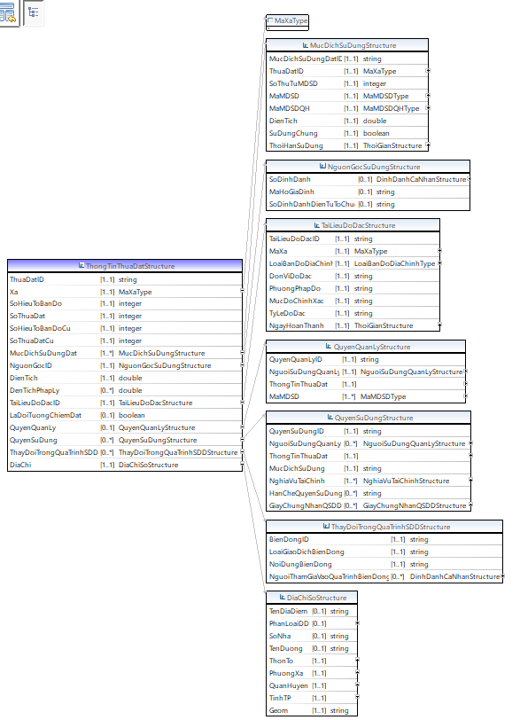

**Hình 5.1 - Lược đồ dữ liệu địa chính mô tả cấu trúc dữ liệu của ThongTinThuaDat và các cấu trúc, kiểu dữ liệu liên quan**

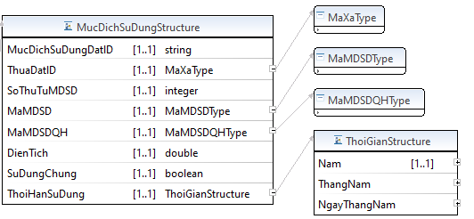

**Hình 5.2 - Lược đồ dữ liệu địa chính mô tả cấu trúc dữ liệu của MucDichSuDung và các cấu trúc, kiểu dữ liệu liên quan**

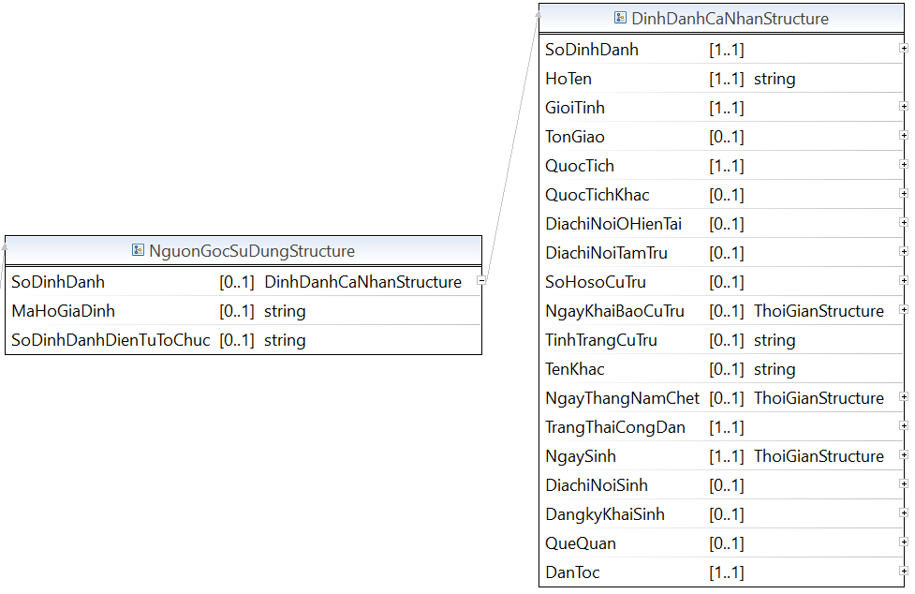

**Hình 5.3 - Lược đồ dữ liệu địa chính mô tả cấu trúc dữ liệu của NguonGocSuDung và các cấu trúc, kiểu dữ liệu liên quan**

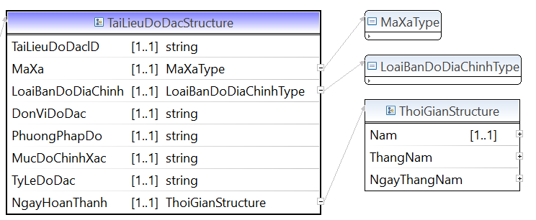

**Hình 5.4 - Lược đồ dữ liệu địa chính mô tả cấu trúc dữ liệu của TaiLieuDoDac và các cấu trúc, kiểu dữ liệu liên quan**

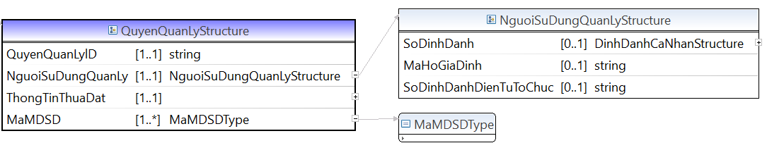

**Hình 5.5 - Lược đồ dữ liệu địa chính mô tả cấu trúc dữ liệu của QuyenQuanLy và các cấu trúc, kiểu dữ liệu liên quan**

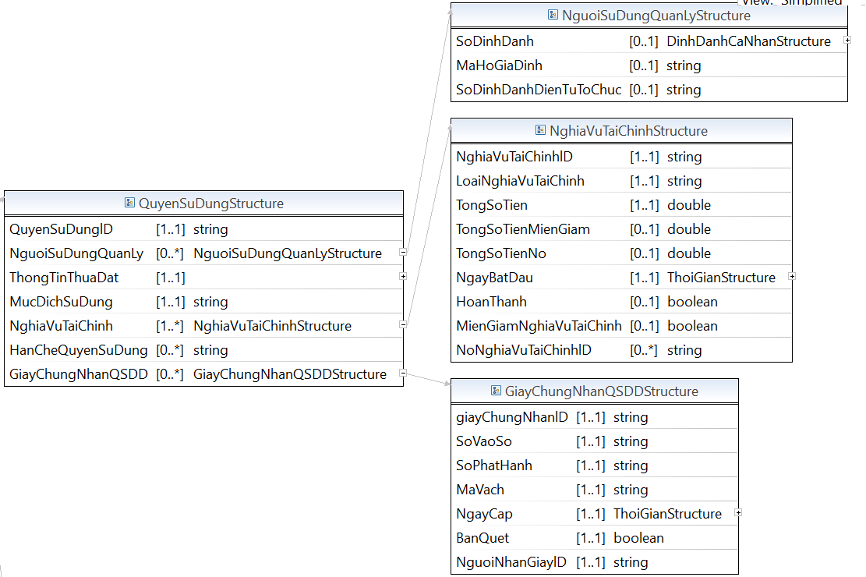

**Hình 5.6 - Lược đồ dữ liệu địa chính mô tả cấu trúc dữ liệu của QuyenSuDung và các cấu trúc, kiểu dữ liệu liên quan**

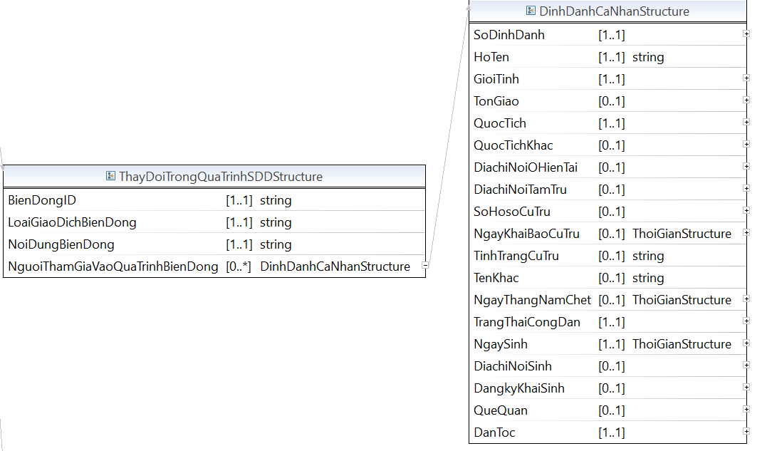

**Hình 5.7 - Lược đồ dữ liệu địa chính mô tả cấu trúc dữ liệu của ThayDoiTrongQuaTrinhSDD và các cấu trúc, kiểu dữ liệu liên quan**

**Mã nguồn lược đồ chứa các cấu trúc thông tin của lược đồ dữ liệu địa chính (DiaChinh_core.xsd)**

<?xml version=*“1.1”* encoding=*"UTF-8"*?>

<xsd:schema xmlns:xsd=*"http://www.w3.org/2001/XMLSchema"* xmlns:TTDLQG=*"..."* targetNamespace=*"..."* version=*“1.1”* elementFormDefault=*"qualified"*>

<!-- <xsd:include schemaLocation="BaseEnumType.xsd" /> -->

<xsd:annotation>

<xsd:documentation></xsd:documentation>

</xsd:annotation>

<xsd:complexType name=*"ThongTinKhacLienQuanThuaDatStructure"*>

<xsd:annotation>

<xsd:documentation>Mô tả cấu trúc thông tin về thửa đất</xsd:documentation>

</xsd:annotation>

<xsd:sequence>

<xsd:element name=*"MaThongTinKhac"* type=*"xsd:string"* minOccurs=*"1"* maxOccurs=*"1"* />

<xsd:element name=*"ThongTinThuaDat"* type=*"ThongTinThuaDatStructure"* minOccurs=*"1"* maxOccurs=*"1"* />

<xsd:element name=*"NoiDungDuLieu"* type=*"xsd:string"* minOccurs=*"1"* maxOccurs=*"unbounded"* />

</xsd:sequence>

</xsd:complexType>

<xsd:complexType name=*"ThongTinThuaDatStructure"*>

<xsd:annotation>

<xsd:documentation>Mô tả cấu trúc thông tin về thửa đất</xsd:documentation>

</xsd:annotation>

<xsd:sequence>

<xsd:element name=*"ThuaDatlD"* type=*"xsd:string"* minOccurs=*"1"* maxOccurs=*"1"* />

<xsd:element name=*"Xa"* type=*"TTDLQG:MaXaType"* minOccurs=*"1"* maxOccurs=*"1"* />

<xsd:element name=*"SoHieuToBanDo"* type=*"xsd:integer"* minOccurs=*"1"* maxOccurs=*"1"* />

<xsd:element name=*"SoThuaDat"* type=*"xsd:integer"* minOccurs=*"1"* maxOccurs=*"1"* />

<xsd:element name=*"SoHieuToBanDoCu"* type=*"xsd:integer"* minOccurs=*"1"* maxOccurs=*"1"* />

<xsd:element name=*"SoThuaDatCu"* type=*"xsd:integer"* minOccurs=*"1"* maxOccurs=*"1"* />

<xsd:element name=*"MucDichSuDungDat"* type=*"TTDLQG:MucDichSuDungStructure"* minOccurs=*"1"* maxOccurs=*"unbounded"* />

<xsd:element name=*"NguonGoclD"* type=*"TTDLQG:NguonGocSuDungStructure"* minOccurs=*"1"* maxOccurs=*"1"* />

<xsd:element name=*"DienTich"* type=*"xsd:double"* minOccurs=*"1"* maxOccurs=*"1"* />

<xsd:element name=*"DenTichPhapLy"* type=*"xsd:double"* minOccurs=*"0"* maxOccurs=*"unbounded"* />

<xsd:element name=*"TaiLieuDoDaclD"* type=*"TTDLQG:TaiLieuDoDacStructure"* minOccurs=*"1"* maxOccurs=*"1"* />

<xsd:element name=*"LaDoiTuongChiemDat"* type=*"xsd:boolean"* minOccurs=*"0"* maxOccurs=*"1"* />

<xsd:element name=*"QuyenQuanLy"* type=*"TTDLQG:QuyenQuanLyStructure"* minOccurs=*"0"* maxOccurs=*"1"* />

<xsd:element name=*"QuyenSuDung"* type=*"TTDLQG:QuyenSuDungStructure"* minOccurs=*"0"* maxOccurs=*"unbounded"* />

<xsd:element name=*"ThayDoiTrongQuaTrinhSDD"* type=*"TTDLQG:ThayDoiTrongQuaTrinhSDDStructure"* minOccurs=*"0"* maxOccurs=*"unbounded"* />

<xsd:element name=*"DiaChi"* type=*"TTDLQG:DiaChiSoStructure"* minOccurs=*"1"* maxOccurs=*"1"* />

</xsd:sequence>

</xsd:complexType>

<xsd:complexType name=*"MucDichSuDungStructure"*>

<xsd:annotation>

<xsd:documentation>Mô tả mục đích sử dụng đất</xsd:documentation>

</xsd:annotation>

<xsd:sequence>

<xsd:element name=*"MucDichSuDungDatlD"* type=*"xsd:string"* minOccurs=*"1"* maxOccurs=*"1"* />

<xsd:element name=*"ThuaDatlD"* type=*"TTDLQG:MaXaType"* minOccurs=*"1"* maxOccurs=*"1"* />

<xsd:element name=*"SoThuTuMDSD"* type=*"xsd:integer"* minOccurs=*"1"* maxOccurs=*"1"* />

<xsd:element name=*"MaMDSD"* type=*"TTDLQG:MaMDSDType"* minOccurs=*"1"* maxOccurs=*"1"* />

<xsd:element name=*"MaMDSDQH"* type=*"TTDLQG:MaMDSDQHType"* minOccurs=*"1"* maxOccurs=*"1"* />

<xsd:element name=*"DienTich"* type=*"xsd:double"* minOccurs=*"1"* maxOccurs=*"1"* />

<xsd:element name=*"SuDungChung"* type=*"xsd:boolean"* minOccurs=*"1"* maxOccurs=*"1"* />

<xsd:element name=*"ThoiHanSuDung"* type=*"TTDLQG:ThoiGianStructure"* minOccurs=*"1"* maxOccurs=*"1"* />

</xsd:sequence>

</xsd:complexType>

<xsd:complexType name=*"NguonGocSuDungStructure"*>

<xsd:annotation>

<xsd:documentation>Nguồn gốc sử dụng thửa đất</xsd:documentation>

</xsd:annotation>

<xsd:sequence>

<xsd:element name=*"SoDinhDanh"* type=*"TTDLQG:DinhDanhCaNhanStructure"* minOccurs=*"0"* maxOccurs=*"1"* />

<xsd:element name=*"MaHoGiaDinh"* type=*"xsd:string"* minOccurs=*"0"* maxOccurs=*"1"* />

<xsd:element name=*"SoDinhDanhDienTuToChuc"* type=*"xsd:string"* minOccurs=*"0"* maxOccurs=*"1"* />

</xsd:sequence>

</xsd:complexType>

<xsd:complexType name=*"TaiLieuDoDacStructure"*>

<xsd:annotation>

<xsd:documentation>Mô tả cấu trúc thông tin về thửa đất</xsd:documentation>

</xsd:annotation>

<xsd:sequence>

<xsd:element name=*"TaiLieuDoDaclD"* type=*"xsd:string"* minOccurs=*"1"* maxOccurs=*"1"* />

<xsd:element name=*"MaXa"* type=*"TTDLQG:MaXaType"* minOccurs=*"1"* maxOccurs=*"1"* />

<xsd:element name=*"LoaiBanDoDiaChinh"* type=*"TTDLQG:LoaiBanDoDiaChinhType"* minOccurs=*"1"* maxOccurs=*"1"* />

<xsd:element name=*"DonViDoDac"* type=*"xsd:string"* minOccurs=*"1"* maxOccurs=*"1"* />

<xsd:element name=*"PhuongPhapDo"* type=*"xsd:string"* minOccurs=*"1"* maxOccurs=*"1"* />

<xsd:element name=*"MucDoChinhXac"* type=*"xsd:string"* minOccurs=*"1"* maxOccurs=*"1"* />

<xsd:element name=*"TyLeDoDac"* type=*"xsd:string"* minOccurs=*"1"* maxOccurs=*"1"* />

<xsd:element name=*"NgayHoanThanh"* type=*"TTDLQG:ThoiGianStructure"* minOccurs=*"1"* maxOccurs=*"1"* />

</xsd:sequence>

</xsd:complexType>

<xsd:complexType name=*"NguoiSuDungQuanLyStructure"*>

<xsd:annotation>

<xsd:documentation>Thông tin về người sử dụng quản lý đất</xsd:documentation>

</xsd:annotation>

<xsd:sequence>

<xsd:element name=*"SoDinhDanh"* type=*"TTDLQG:DinhDanhCaNhanStructure"* minOccurs=*"0"* maxOccurs=*"1"* />

<xsd:element name=*"MaHoGiaDinh"* type=*"xsd:string"* minOccurs=*"0"* maxOccurs=*"1"* />

<xsd:element name=*"SoDinhDanhDienTuToChuc"* type=*"xsd:string"* minOccurs=*"0"* maxOccurs=*"1"* />

</xsd:sequence>

</xsd:complexType>

<xsd:complexType name=*"QuyenSuDungStructure"*>

<xsd:annotation>

<xsd:documentation>Quyền sử dụng đất</xsd:documentation>

</xsd:annotation>

<xsd:sequence>

<xsd:element name=*"QuyenSuDunglD"* type=*"xsd:string"* minOccurs=*"1"* maxOccurs=*"1"* />

<xsd:element name=*"NguoiSuDungQuanLy"* type=*"TTDLQG:NguoiSuDungQuanLyStructure"* minOccurs=*"0"* maxOccurs=*"unbounded"* />

<xsd:element name=*"ThongTinThuaDat"* type=*"ThongTinThuaDatStructure"* minOccurs=*"1"* maxOccurs=*"1"* />

<xsd:element name=*"MucDichSuDung"* type=*"xsd:string"* minOccurs=*"1"* maxOccurs=*"1"* />

<xsd:element name=*"NghiaVuTaiChinh"* type=*"TTDLQG:NghiaVuTaiChinhStructure"* minOccurs=*"1"* maxOccurs=*"unbounded"* />

<xsd:element name=*"HanCheQuyenSuDung"* type=*"xsd:string"* minOccurs=*"0"* maxOccurs=*"unbounded"* />

<xsd:element name=*"GiayChungNhanQSDD"* type=*"TTDLQG:GiayChungNhanQSDDStructure"* minOccurs=*"0"* maxOccurs=*"unbounded"* />

</xsd:sequence>

</xsd:complexType>

<xsd:complexType name=*"QuyenQuanLyStructure"*>

<xsd:annotation>

<xsd:documentation>Quyền quản lý đất</xsd:documentation>

</xsd:annotation>

<xsd:sequence>

<xsd:element name=*"QuyenQuanLylD"* type=*"xsd:string"* minOccurs=*"1"* maxOccurs=*"1"* />

<xsd:element name=*"NguoiSuDungQuanLy"* type=*"TTDLQG:NguoiSuDungQuanLyStructure"* minOccurs=*"1"* maxOccurs=*"1"* />

<xsd:element name=*"ThongTinThuaDat"* type=*"ThongTinThuaDatStructure"* minOccurs=*"1"* maxOccurs=*"1"* />

<xsd:element name=*"MaMDSD"* type=*"TTDLQG:MaMDSDType"* minOccurs=*"1"* maxOccurs=*"unbounded"* />

</xsd:sequence>

</xsd:complexType>

<xsd:complexType name=*"NghiaVuTaiChinhStructure"*>

<xsd:annotation>

<xsd:documentation>Nghĩa vụ tài chình</xsd:documentation>

</xsd:annotation>

<xsd:sequence>

<xsd:element name=*"NghiaVuTaiChinhlD"* type=*"xsd:string"* minOccurs=*"1"* maxOccurs=*"1"* />

<xsd:element name=*"LoaiNghiaVuTaiChinh"* type=*"xsd:string"* minOccurs=*"1"* maxOccurs=*"1"* />

<xsd:element name=*"TongSoTien"* type=*"xsd:double"* minOccurs=*"1"* maxOccurs=*"1"* />

<xsd:element name=*"TongSoTienMienGiam"* type=*"xsd:double"* minOccurs=*"0"* maxOccurs=*"1"* />

<xsd:element name=*"TongSoTienNo"* type=*"xsd:double"* minOccurs=*"0"* maxOccurs=*"1"* />

<xsd:element name=*"NgayBatDau"* type=*"TTDLQG:ThoiGianStructure"* minOccurs=*"1"* maxOccurs=*"1"* />

<xsd:element name=*"HoanThanh"* type=*"xsd:boolean"* minOccurs=*"0"* maxOccurs=*"1"* />

<xsd:element name=*"MienGiamNghiaVuTaiChinh"* type=*"xsd:boolean"* minOccurs=*"0"* maxOccurs=*"1"* />

<xsd:element name=*"NoNghiaVuTaiChinhlD"* type=*"xsd:string"* minOccurs=*"0"* maxOccurs=*"unbounded"* />

</xsd:sequence>

</xsd:complexType>

<xsd:complexType name=*"GiayChungNhanQSDDStructure"*>

<xsd:annotation>

<xsd:documentation>Giấy chứng nhận quyền sử dụng đất</xsd:documentation>

</xsd:annotation>

<xsd:sequence>

<xsd:element name=*"giayChungNhanlD"* type=*"xsd:string"* minOccurs=*"1"* maxOccurs=*"1"* />

<xsd:element name=*"SoVaoSo"* type=*"xsd:string"* minOccurs=*"1"* maxOccurs=*"1"* />

<xsd:element name=*"SoPhatHanh"* type=*"xsd:string"* minOccurs=*"1"* maxOccurs=*"1"* />

<xsd:element name=*"MaVach"* type=*"xsd:string"* minOccurs=*"1"* maxOccurs=*"1"* />

<xsd:element name=*"NgayCap"* type=*"TTDLQG:ThoiGianStructure"* minOccurs=*"1"* maxOccurs=*"1"* />

<xsd:element name=*"BanQuet"* type=*"xsd:boolean"* minOccurs=*"1"* maxOccurs=*"1"* />

<xsd:element name=*"NguoiNhanGiaylD"* type=*"xsd:string"* minOccurs=*"1"* maxOccurs=*"1"* />

</xsd:sequence>

</xsd:complexType>

<xsd:complexType name=*"TinhTrangPhapLyQSDStructure"*>

<xsd:annotation>

<xsd:documentation>Tình trạng pháp lý về quyền sử dụng, quản lý đất</xsd:documentation>

</xsd:annotation>

<xsd:sequence>

<xsd:element name=*"TinhHinhDangKylD"* type=*"xsd:string"* minOccurs=*"1"* maxOccurs=*"1"* />

<xsd:element name=*"NgayTiepNhan"* type=*"xsd:string"* minOccurs=*"1"* maxOccurs=*"1"* />

<xsd:element name=*"ThoiDiemDangKy"* type=*"xsd:string"* minOccurs=*"1"* maxOccurs=*"1"* />

<xsd:element name=*"SoThuTu"* type=*"xsd:integer"* minOccurs=*"1"* maxOccurs=*"1"* />

<xsd:element name=*"NguoiUyQuyen"* type=*"TTDLQG:DinhDanhCaNhanStructure"* minOccurs=*"0"* maxOccurs=*"1"* />

<xsd:element name=*"CoQuyenSuDung"* type=*"xsd:boolean"* minOccurs=*"1"* maxOccurs=*"1"* />

<xsd:element name=*"CoQuyenSoHuu"* type=*"xsd:boolean"* minOccurs=*"1"* maxOccurs=*"1"* />

<xsd:element name=*"CoQuyenQuanLy"* type=*"xsd:boolean"* minOccurs=*"1"* maxOccurs=*"1"* />

<xsd:element name=*"CacLoaiGiayToPhapLy"* type=*"xsd:string"* minOccurs=*"1"* maxOccurs=*"unbounded"* />

</xsd:sequence>

</xsd:complexType>

<xsd:complexType name=*"ThayDoiTrongQuaTrinhSDDStructure"*>

<xsd:annotation>

<xsd:documentation>Thay đổi trong quá trình sử dụng đất</xsd:documentation>

</xsd:annotation>

<xsd:sequence>

<xsd:element name=*"BienDongID"* type=*"xsd:string"* minOccurs=*"1"* maxOccurs=*"1"* />

<xsd:element name=*"LoaiGiaoDichBienDong"* type=*"xsd:string"* minOccurs=*"1"* maxOccurs=*"1"* />

<xsd:element name=*"NoiDungBienDong"* type=*"xsd:string"* minOccurs=*"1"* maxOccurs=*"1"* />

<xsd:element name=*"NguoiThamGiaVaoQuaTrinhBienDong"* type=*"TTDLQG:DinhDanhCaNhanStructure"* minOccurs=*"0"* maxOccurs=*"unbounded"* />

</xsd:sequence>

</xsd:complexType>

<xsd:complexType name=*"DiaChiSoStructure"*>

<xsd:annotation>

<xsd:documentation>Thông tin về địa chỉ</xsd:documentation>

</xsd:annotation>

<xsd:sequence>

<xsd:element name=*"TenDiaDiem"* type=*"xsd:string"* minOccurs=*"0"* maxOccurs=*"1"* />

<xsd:element name=*"PhanLoaiDD"* type=*"TTDLQG:PhanLoaiDiaChiStructure"* minOccurs=*"0"* maxOccurs=*"1"* />

<xsd:element name=*"SoNha"* type=*"xsd:string"* minOccurs=*"0"* maxOccurs=*"1"* />

<xsd:element name=*"TenDuong"* type=*"xsd:string"* minOccurs=*"0"* maxOccurs=*"1"* />

<xsd:element name=*"ThonTo"* type=*"TTDLQG:MaThonToStructure"* minOccurs=*"1"* maxOccurs=*"1"* />

<xsd:element name=*"PhuongXa"* type=*"TTDLQG:MaBCPhuongXaStructure"* minOccurs=*"1"* maxOccurs=*"1"* />

<xsd:element name=*"QuanHuyen"* type=*"TTDLQG:MaBCQuanHuyenStructure"* minOccurs=*"1"* maxOccurs=*"1"* />

<xsd:element name=*"TinhTP"* type=*"TTDLQG:MaBCTinhTPStructure"* minOccurs=*"1"* maxOccurs=*"1"* />

<xsd:element name=*"Geom"* type=*"xsd:string"* minOccurs=*"1"* maxOccurs=*"1"* />

</xsd:sequence>

</xsd:complexType>

<xsd:simpleType name=*"MaMDSDType"*>

<xsd:annotation>

<xsd:documentation>Mã mục đích sử dụng</xsd:documentation>

</xsd:annotation>

<xsd:restriction base=*"xsd:token"*>

<xsd:enumeration value=*"ONT"*><xsd:annotation><xsd:documentation>xsd:string</xsd:documentation></xsd:annotation></xsd:enumeration>

</xsd:restriction>

</xsd:simpleType>

<xsd:simpleType name=*"MaXaType"*>

<xsd:annotation>

<xsd:documentation>Mã xã</xsd:documentation>

</xsd:annotation>

<xsd:restriction base=*"xsd:token"*>

<xsd:enumeration value=*"TD"*><xsd:annotation><xsd:documentation>xsd:string</xsd:documentation></xsd:annotation></xsd:enumeration>

</xsd:restriction>

</xsd:simpleType>

<xsd:simpleType name=*"MaMDSDQHType"*>

<xsd:annotation>

<xsd:documentation>Mã mục đích sử dụng quy hoạch</xsd:documentation>

</xsd:annotation>

<xsd:restriction base=*"xsd:token"*>

<xsd:enumeration value=*"LUA"*><xsd:annotation><xsd:documentation>xsd:string</xsd:documentation></xsd:annotation></xsd:enumeration>

</xsd:restriction>

</xsd:simpleType>

<xsd:simpleType name=*"LoaiBanDoDiaChinhType"*>

<xsd:annotation>

<xsd:documentation>Loại bản đồ địa chính</xsd:documentation>

</xsd:annotation>

<xsd:restriction base=*"xsd:token"*>

<xsd:enumeration value=*"1:10000"*><xsd:annotation><xsd:documentation>xsd:string</xsd:documentation></xsd:annotation></xsd:enumeration>

</xsd:restriction>

</xsd:simpleType>

<xsd:complexType name=*"ThoiGianStructure"*>

<xsd:annotation>

<xsd:documentation>Mô tả cấu trúc các trường thông tin sử dụng liên quan đến thời gian</xsd:documentation>

</xsd:annotation>

<xsd:sequence>

<xsd:element name=*"Nam"* type=*"TTDLQG:NamType"* minOccurs=*"1"* maxOccurs=*"1"* />

<xsd:element name=*"ThangNam"* type=*"TTDLQG:ThangNamType"* minOccurs=*" "* maxOccurs=*" "* />

<xsd:element name=*"NgayThangNam"* type=*"TTDLQG:NgayThangNamType"* minOccurs=*""* maxOccurs=*""* />

</xsd:sequence>

</xsd:complexType>

<xsd:complexType name=*"DinhDanhCaNhanStructure"*>

<xsd:annotation>

<xsd:documentation>Người sử dụng quản lý</xsd:documentation>

</xsd:annotation>

<xsd:sequence>

<xsd:element name=*"SoDinhDanh"* type=*"TTDLQG:SoDinhDanhType"* minOccurs=*"1"* maxOccurs=*"1"* />

<xsd:element name=*"HoTen"* type=*"xsd:string"* minOccurs=*"1"* maxOccurs=*"1"* />

<xsd:element name=*"GioiTinh"* type=*"TTDLQG:GioiTinhType"* minOccurs=*"1"* maxOccurs=*"1"* />

<xsd:element name=*"TonGiao"* type=*"TTDLQG:TonGiaoStructure"* minOccurs=*"0"* maxOccurs=*"1"* />

<xsd:element name=*"QuocTich"* type=*"TTDLQG:QuocGiaType"* minOccurs=*"1"* maxOccurs=*"1"* />

<xsd:element name=*"QuocTichKhac"* type=*"TTDLQG:QuocGiaType"* minOccurs=*"0"* maxOccurs=*"1"* />

<xsd:element name=*"DiachiNoiOHienTai"* type=*"TTDLQG:DiaChiStructure"* minOccurs=*"0"* maxOccurs=*"1"* />

<xsd:element name=*"DiachiNoiTamTru"* type=*"TTDLQG:DiaChiStructure"* minOccurs=*"0"* maxOccurs=*"1"* />

<xsd:element name=*"SoHosoCuTru"* type=*"TTDLQG:Chuỗi ký tựType"* minOccurs=*"0"* maxOccurs=*"1"* />

<xsd:element name=*"NgayKhaiBaoCuTru"* type=*"TTDLQG:ThoiGianStructure"* minOccurs=*"0"* maxOccurs=*"1"* />

<xsd:element name=*"TinhTrangCuTru"* type=*"xsd:string"* minOccurs=*"0"* maxOccurs=*"1"* />

<xsd:element name=*"TenKhac"* type=*"xsd:string"* minOccurs=*"0"* maxOccurs=*"1"* />

<xsd:element name=*"NgayThangNamChet"* type=*"TTDLQG:ThoiGianStructure"* minOccurs=*"0"* maxOccurs=*"1"* />

<xsd:element name=*"TrangThaiCongDan"* type=*"TTDLQG:TrangThaiCongDanType"* minOccurs=*"1"* maxOccurs=*"1"* />

<xsd:element name=*"NgaySinh"* type=*"TTDLQG:ThoiGianStructure"* minOccurs=*"1"* maxOccurs=*"1"* />

<xsd:element name=*"DiachiNoiSinh"* type=*"TTDLQG:DiaChiStructure"* minOccurs=*"0"* maxOccurs=*"1"* />

<xsd:element name=*"DangkyKhaiSinh"* type=*"TTDLQG:DiaChiStructure"* minOccurs=*"0"* maxOccurs=*"1"* />

<xsd:element name=*"QueQuan"* type=*"TTDLQG:DiaChiStructure"* minOccurs=*"0"* maxOccurs=*"1"* />

<xsd:element name=*"DanToc"* type=*"TTDLQG:DanTocStructure"* minOccurs=*"1"* maxOccurs=*"1"* />

</xsd:sequence>

</xsd:complexType>

</xsd:schema>

# PHỤ LỤC C.5. Lược đồ dữ liệu nền địa lý

## C5.1. Biên giới, địa giới

* Lược đồ XML cấu trúc dữ liệu Đường biên giới quốc gia

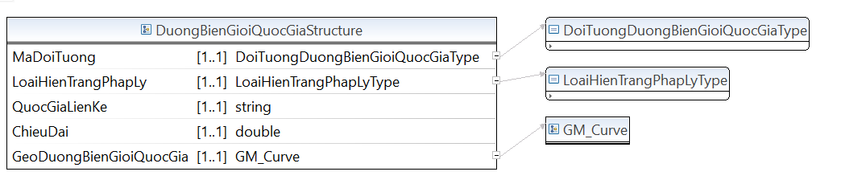

* Lược đồ XML cấu trúc dữ liệu Mốc quốc giới

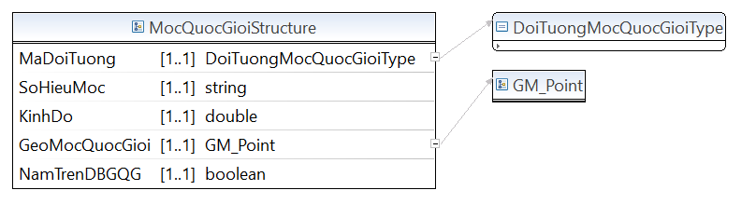

* Lược đồ XML cấu trúc dữ liệu Đường địa giới

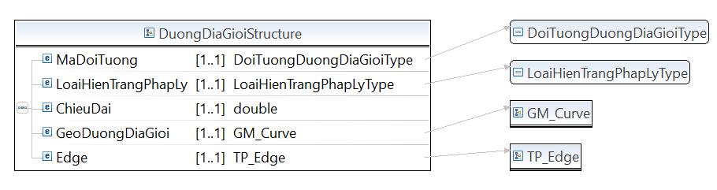

* Lược đồ XML cấu trúc dữ liệu Mốc địa giới

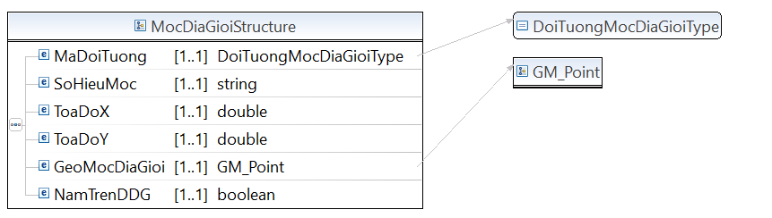

* Lược đồ XML cấu trúc dữ liệu Địa phận

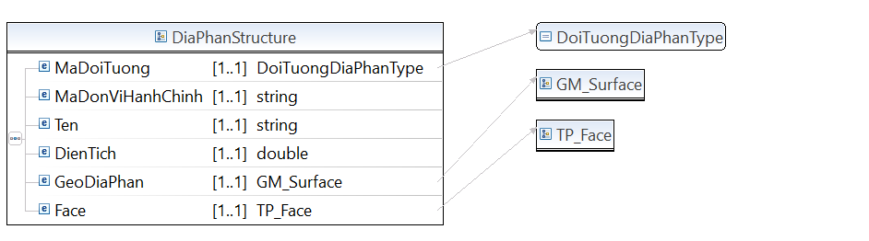

* Lược đồ XML cấu trúc dữ liệu Đường cơ sở lãnh hải

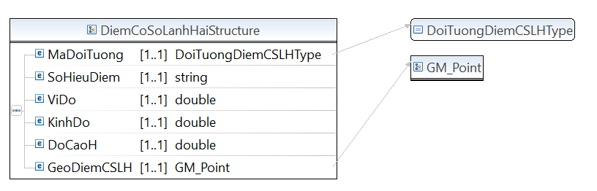

* Lược đồ XML cấu trúc dữ liệu Điểm cơ sở lãnh hải

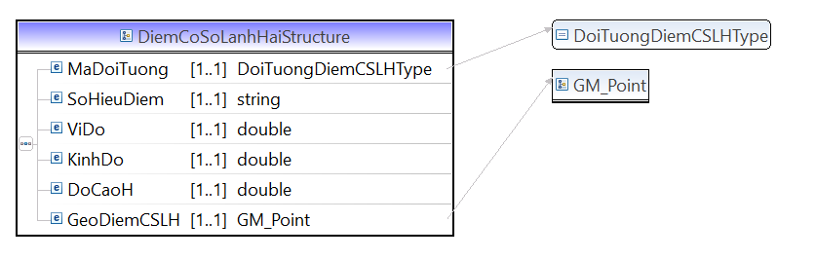

* Lược đồ XML cấu trúc dữ liệu Vùng biển

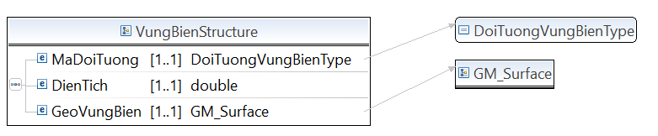

**Mã nguồn lược đồ chứa các cấu trúc thông tin của lược đồ dữ liệu nền địa lý – nhóm biên giới, địa giới (BienGioiDiaGioi.xsd)**

<?xml version=*“1.1”* encoding=*"UTF-8"*?>

<xsd:schema xmlns:xsd=*"…."* xmlns:TTDLQG=*"..."* targetNamespace=*"..."* version=*“1.1”* elementFormDefault=*"qualified"*>

<!-- <xsd:include schemaLocation="BaseEnumType.xsd" /> -->

<xsd:annotation>

<xsd:documentation></xsd:documentation>

</xsd:annotation>

<xsd:complexType name=*"DuongBienGioiQuocGiaStructure"*>

<xsd:annotation>

<xsd:documentation>Đường biên giới quốc gia trên đất liền và trên biển</xsd:documentation>

</xsd:annotation>

<xsd:sequence>

<xsd:element name=*"MaDoiTuong"* type=*"TTDLQG:DoiTuongDuongBienGioiQuocGiaType"* minOccurs=*"1"* maxOccurs=*"1"* />

<xsd:element name=*"LoaiHienTrangPhapLy"* type=*"TTDLQG:LoaiHienTrangPhapLyType"* minOccurs=*"1"* maxOccurs=*"1"* />

<xsd:element name=*"QuocGiaLienKe"* type=*"xsd:string"* minOccurs=*"1"* maxOccurs=*"1"* />

<xsd:element name=*"ChieuDai"* type=*"xsd:double"* minOccurs=*"1"* maxOccurs=*"1"* />

<xsd:element name=*"GeoDuongBienGioiQuocGia"* type=*"TTDLQG:GM_Curve"* minOccurs=*"1"* maxOccurs=*"1"* />

</xsd:sequence>

</xsd:complexType>

<xsd:complexType name=*"MocQuocGioiStructure"*>

<xsd:annotation>

<xsd:documentation>Mốc đánh dấu vị trí đường biên giới quốc gia trên đất liền</xsd:documentation>

</xsd:annotation>

<xsd:sequence>

<xsd:element name=*"MaDoiTuong"* type=*"TTDLQG:DoiTuongMocQuocGioiType"* minOccurs=*"1"* maxOccurs=*"1"* />

<xsd:element name=*"SoHieuMoc"* type=*"xsd:string"* minOccurs=*"1"* maxOccurs=*"1"* />

<xsd:element name=*"KinhDo"* type=*"xsd:double"* minOccurs=*"1"* maxOccurs=*"1"* />

<xsd:element name=*"GeoMocQuocGioi"* type=*"GM_Point"* minOccurs=*"1"* maxOccurs=*"1"* />

<xsd:element name=*"NamTrenDBGQG"* type=*"xsd:boolean"* minOccurs=*"1"* maxOccurs=*"1"* />

</xsd:sequence>

</xsd:complexType>

<xsd:complexType name=*"DuongDiaGioiStructure"*>

<xsd:annotation>

<xsd:documentation>Đường địa giới hành chính các cấp</xsd:documentation>

</xsd:annotation>

<xsd:sequence>

<xsd:element name=*"MaDoiTuong"* type=*"TTDLQG:DoiTuongDuongDiaGioiType"* minOccurs=*"1"* maxOccurs=*"1"* />

<xsd:element name=*"LoaiHienTrangPhapLy"* type=*"TTDLQG:LoaiHienTrangPhapLyType"* minOccurs=*"1"* maxOccurs=*"1"* />

<xsd:element name=*"ChieuDai"* type=*"xsd:double"* minOccurs=*"1"* maxOccurs=*"1"* />

<xsd:element name=*"GeoDuongDiaGioi"* type=*"TTDLQG:GM_Curve"* minOccurs=*"1"* maxOccurs=*"1"* />

<xsd:element name=*"Edge"* type=*"TTDLQG:TP_Edge"* minOccurs=*"1"* maxOccurs=*"1"* />

</xsd:sequence>

</xsd:complexType>

<xsd:complexType name=*"MocDiaGioiStructure"*>

<xsd:annotation>

<xsd:documentation>Là dấu hiệu bằng vật thể dùng để đánh dấu đường ĐGHC giữa các đơn vị hành chính với nhau. Mốc ĐGHC các cấp bao gồm: mốc ĐGHC cấp tỉnh, mốc ĐGHC cấp huyện, mốc ĐGHC cấp xã</xsd:documentation>

</xsd:annotation>

<xsd:sequence>

<xsd:element name=*"MaDoiTuong"* type=*"TTDLQG:DoiTuongMocDiaGioiType"* minOccurs=*"1"* maxOccurs=*"1"* />

<xsd:element name=*"SoHieuMoc"* type=*"xsd:string"* minOccurs=*"1"* maxOccurs=*"1"* />

<xsd:element name=*"ToaDoX"* type=*"xsd:double"* minOccurs=*"1"* maxOccurs=*"1"* />

<xsd:element name=*"ToaDoY"* type=*"xsd:double"* minOccurs=*"1"* maxOccurs=*"1"* />

<xsd:element name=*"GeoMocDiaGioi"* type=*"GM_Point"* minOccurs=*"1"* maxOccurs=*"1"* />

<xsd:element name=*"NamTrenDDG"* type=*"xsd:boolean"* minOccurs=*"1"* maxOccurs=*"1"* />

</xsd:sequence>

</xsd:complexType>

<xsd:complexType name=*"DiaPhanStructure"*>

<xsd:annotation>

<xsd:documentation>Địa phận hành chính các cấp</xsd:documentation>

</xsd:annotation>

<xsd:sequence>

<xsd:element name=*"MaDoiTuong"* type=*"TTDLQG:DoiTuongDiaPhanType"* minOccurs=*"1"* maxOccurs=*"1"* />

<xsd:element name=*"MaDonViHanhChinh"* type=*"xsd:string"* minOccurs=*"1"* maxOccurs=*"1"* />

<xsd:element name=*"Ten"* type=*"xsd:string"* minOccurs=*"1"* maxOccurs=*"1"* />

<xsd:element name=*"DienTich"* type=*"xsd:double"* minOccurs=*"1"* maxOccurs=*"1"* />

<xsd:element name=*"GeoDiaPhan"* type=*"TTDLQG:GM_Surface"* minOccurs=*"1"* maxOccurs=*"1"* />

<xsd:element name=*"Face"* type=*"TTDLQG:TP_Face"* minOccurs=*"1"* maxOccurs=*"1"* />

</xsd:sequence>

</xsd:complexType>

<xsd:complexType name=*"DuongCoSoLanhHaiStructure"*>

<xsd:annotation>

<xsd:documentation>Đường gấp khúc nối liền các điểm cơ sở lãnh hải</xsd:documentation>

</xsd:annotation>

<xsd:sequence>

<xsd:element name=*"MaDoiTuong"* type=*"TTDLQG:DoiTuongDCSLHType"* minOccurs=*"1"* maxOccurs=*"1"* />

<xsd:element name=*"ChieuDai"* type=*"xsd:double"* minOccurs=*"1"* maxOccurs=*"1"* />

<xsd:element name=*"GeoDCSLH"* type=*"TTDLQG:GM_Curve"* minOccurs=*"1"* maxOccurs=*"1"* />

</xsd:sequence>

</xsd:complexType>

<xsd:complexType name=*"DiemCoSoLanhHaiStructure"*>

<xsd:annotation>

<xsd:documentation>Điểm ngoài cùng nhất nhô ra biển tại mức nước thủy triều thấp nhất trung bình nhiều năm</xsd:documentation>

</xsd:annotation>

<xsd:sequence>

<xsd:element name=*"MaDoiTuong"* type=*"TTDLQG:DoiTuongDiemCSLHType"* minOccurs=*"1"* maxOccurs=*"1"* />

<xsd:element name=*"SoHieuDiem"* type=*"xsd:string"* minOccurs=*"1"* maxOccurs=*"1"* />

<xsd:element name=*"ViDo"* type=*"xsd:double"* minOccurs=*"1"* maxOccurs=*"1"* />

<xsd:element name=*"KinhDo"* type=*"xsd:double"* minOccurs=*"1"* maxOccurs=*"1"* />

<xsd:element name=*"DoCaoH"* type=*"xsd:double"* minOccurs=*"1"* maxOccurs=*"1"* />

<xsd:element name=*"GeoDiemCSLH"* type=*"GM_Point"* minOccurs=*"1"* maxOccurs=*"1"* />

</xsd:sequence>

</xsd:complexType>

<xsd:complexType name=*"VungBienStructure"*>

<xsd:annotation>

<xsd:documentation>Vùng biển bao gồm các đối tượng: vùng nội thủy, lãnh hải, vùng tiếp giáp lãnh hải, vùng nước lịch sử.</xsd:documentation>

</xsd:annotation>

<xsd:sequence>

<xsd:element name=*"MaDoiTuong"* type=*"TTDLQG:DoiTuongVungBienType"* minOccurs=*"1"* maxOccurs=*"1"* />

<xsd:element name=*"DienTich"* type=*"xsd:double"* minOccurs=*"1"* maxOccurs=*"1"* />

<xsd:element name=*"GeoVungBien"* type=*"TTDLQG:GM_Surface"* minOccurs=*"1"* maxOccurs=*"1"* />

</xsd:sequence>

</xsd:complexType>

<xsd:simpleType name=*"DoiTuongDuongBienGioiQuocGiaType"*>

<xsd:annotation>

<xsd:documentation>Mã đối tượng đường biên giới quốc gia</xsd:documentation>

</xsd:annotation>

<xsd:restriction base=*"xsd:token"*>

<xsd:enumeration value=*"AA01"*><xsd:annotation><xsd:documentation>xsd:string</xsd:documentation></xsd:annotation></xsd:enumeration>

<xsd:enumeration value=*"AA02"*><xsd:annotation><xsd:documentation>xsd:string</xsd:documentation></xsd:annotation></xsd:enumeration>

</xsd:restriction>

</xsd:simpleType>

<xsd:simpleType name=*"DoiTuongMocQuocGioiType"*>

<xsd:annotation>

<xsd:documentation>Mã xã</xsd:documentation>

</xsd:annotation>

<xsd:restriction base=*"xsd:token"*>

<xsd:enumeration value=*"AG02"*><xsd:annotation><xsd:documentation>xsd:string</xsd:documentation></xsd:annotation></xsd:enumeration>

</xsd:restriction>

</xsd:simpleType>

<xsd:simpleType name=*"DoiTuongDuongDiaGioiType"*>

<xsd:annotation>

<xsd:documentation>Mã đối tượng đường địa giới</xsd:documentation>

</xsd:annotation>

<xsd:restriction base=*"xsd:token"*>

<xsd:enumeration value=*"AC01"*><xsd:annotation><xsd:documentation>xsd:string</xsd:documentation></xsd:annotation></xsd:enumeration>

<xsd:enumeration value=*"AC02"*><xsd:annotation><xsd:documentation>xsd:string</xsd:documentation></xsd:annotation></xsd:enumeration>

<xsd:enumeration value=*"AC03"*><xsd:annotation><xsd:documentation>xsd:string</xsd:documentation></xsd:annotation></xsd:enumeration>

</xsd:restriction>

</xsd:simpleType>

<xsd:simpleType name=*"DoiTuongMocDiaGioiType"*>

<xsd:annotation>

<xsd:documentation>Mã đối tượng mốc địa giới</xsd:documentation>

</xsd:annotation>

<xsd:restriction base=*"xsd:token"*>

<xsd:enumeration value=*"AG03"*><xsd:annotation><xsd:documentation>xsd:string</xsd:documentation></xsd:annotation></xsd:enumeration>

<xsd:enumeration value=*"AG04"*><xsd:annotation><xsd:documentation>xsd:string</xsd:documentation></xsd:annotation></xsd:enumeration>

<xsd:enumeration value=*"AG05"*><xsd:annotation><xsd:documentation>xsd:string</xsd:documentation></xsd:annotation></xsd:enumeration>

</xsd:restriction>

</xsd:simpleType>

<xsd:simpleType name=*"DoiTuongDiaPhanType"*>

<xsd:annotation>

<xsd:documentation>Mã đối tượng địa phận</xsd:documentation>

</xsd:annotation>

<xsd:restriction base=*"xsd:token"*>

<xsd:enumeration value=*"AD01"*><xsd:annotation><xsd:documentation>xsd:string</xsd:documentation></xsd:annotation></xsd:enumeration>

<xsd:enumeration value=*"AD02"*><xsd:annotation><xsd:documentation>xsd:string</xsd:documentation></xsd:annotation></xsd:enumeration>

<xsd:enumeration value=*"AD03"*><xsd:annotation><xsd:documentation>xsd:string</xsd:documentation></xsd:annotation></xsd:enumeration>

</xsd:restriction>

</xsd:simpleType>

<xsd:simpleType name=*"DoiTuongDCSLHType"*>

<xsd:annotation>

<xsd:documentation>Mã đối tượng đường cơ sở lãnh hải</xsd:documentation>

</xsd:annotation>

<xsd:restriction base=*"xsd:token"*>

<xsd:enumeration value=*"AB01"*><xsd:annotation><xsd:documentation>xsd:string</xsd:documentation></xsd:annotation></xsd:enumeration>

</xsd:restriction>

</xsd:simpleType>

<xsd:simpleType name=*"DoiTuongDiemCSLHType"*>

<xsd:annotation>

<xsd:documentation>Mã đối tượng điểm cơ sở lãnh hải</xsd:documentation>

</xsd:annotation>

<xsd:restriction base=*"xsd:token"*>

<xsd:enumeration value=*"AB01"*><xsd:annotation><xsd:documentation>xsd:string</xsd:documentation></xsd:annotation></xsd:enumeration>

</xsd:restriction>

</xsd:simpleType>

<xsd:simpleType name=*"DoiTuongVungBienType"*>

<xsd:annotation>

<xsd:documentation>Mã đối tượng vùng biển</xsd:documentation>

</xsd:annotation>

<xsd:restriction base=*"xsd:token"*>

<xsd:enumeration value=*"AE01"*><xsd:annotation><xsd:documentation>xsd:string</xsd:documentation></xsd:annotation></xsd:enumeration>

<xsd:enumeration value=*"AE02"*><xsd:annotation><xsd:documentation>xsd:string</xsd:documentation></xsd:annotation></xsd:enumeration>

<xsd:enumeration value=*"AE03"*><xsd:annotation><xsd:documentation>xsd:string</xsd:documentation></xsd:annotation></xsd:enumeration>

<xsd:enumeration value=*"AE06"*><xsd:annotation><xsd:documentation>xsd:string</xsd:documentation></xsd:annotation></xsd:enumeration>

</xsd:restriction>

</xsd:simpleType>

<xsd:simpleType name=*"LoaiHienTrangPhapLyType"*>

<xsd:annotation>

<xsd:documentation>Loại hiện trạng pháp lý</xsd:documentation>

</xsd:annotation>

<xsd:restriction base=*"xsd:token"*>

<xsd:enumeration value=*"1"*><xsd:annotation><xsd:documentation>xsd:string</xsd:documentation></xsd:annotation></xsd:enumeration>

<xsd:enumeration value=*"2"*><xsd:annotation><xsd:documentation>xsd:string</xsd:documentation></xsd:annotation></xsd:enumeration>

</xsd:restriction>

</xsd:simpleType>

</xsd:schema>

## C5.2. Dân cư

* Lược đồ XML cấu trúc dữ liệu Điểm dân cư

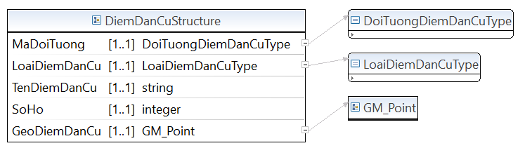

* Lược đồ XML cấu trúc dữ liệu Nhà

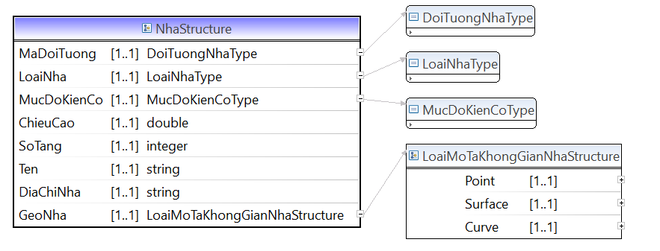

* Lược đồ XML cấu trúc dữ liệu Công trình phụ trợ

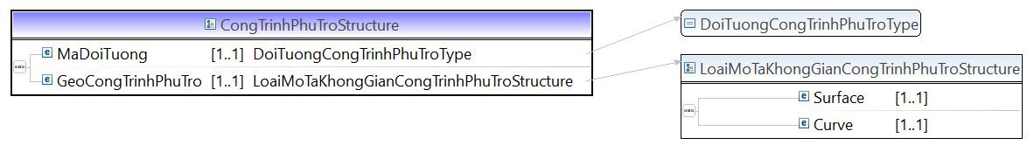

* Lược đồ XML cấu trúc dữ liệu Hạ tầng kỹ thuật khác

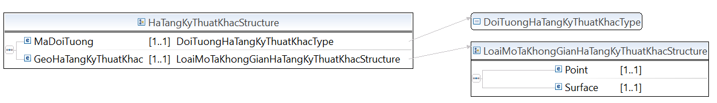

* Lược đồ XML cấu trúc dữ liệu Công trình cấp nước

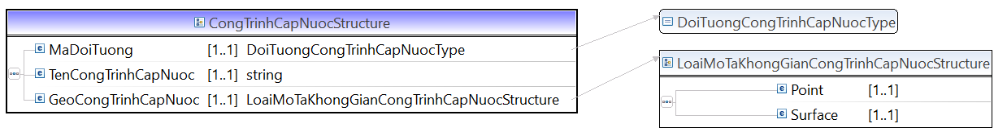

* Lược đồ XML cấu trúc dữ liệu Trạm quan trắc

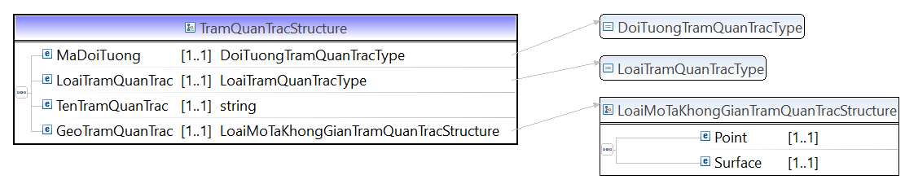

* Lược đồ XML cấu trúc dữ liệu Đường dây tải điện

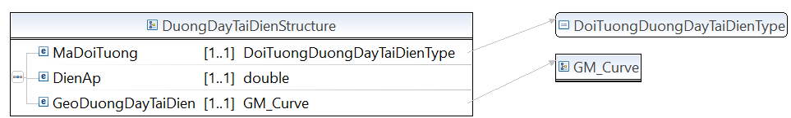

* Lược đồ XML cấu trúc dữ liệu Ranh giới

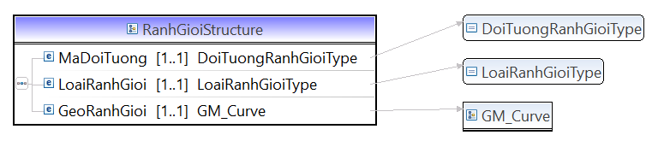

* Lược đồ XML cấu trúc dữ liệu Thành lũy

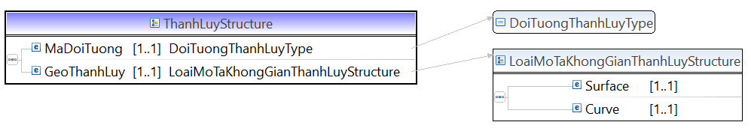

* Lược đồ XML cấu trúc dữ liệu Hàng rào

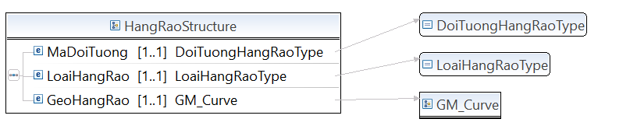

* Lược đồ XML cấu trúc dữ liệu công trình y tế

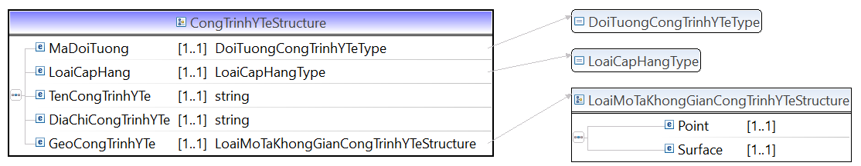

* Lược đồ XML cấu trúc dữ liệu công trình giáo dục:

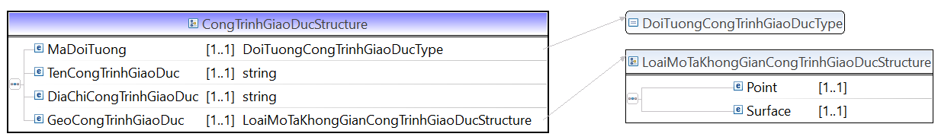

* Lược đồ XML cấu trúc dữ liệu công trình thể thao:

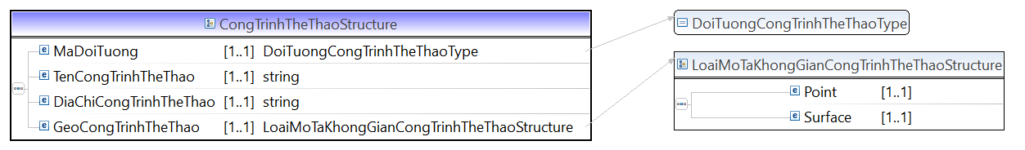

* Lược đồ XML cấu trúc dữ liệu công trình văn hóa:

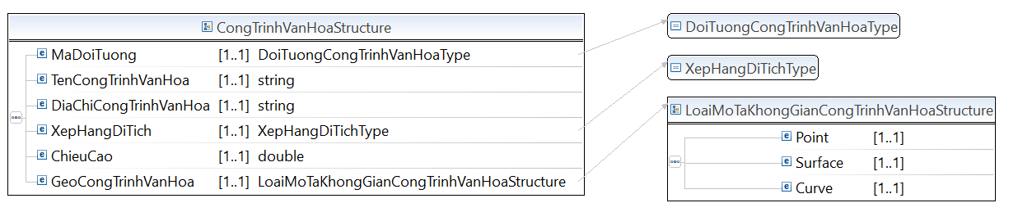

* Lược đồ XML cấu trúc dữ liệu công trình thương mại dịch vụ và trụ sở làm việc

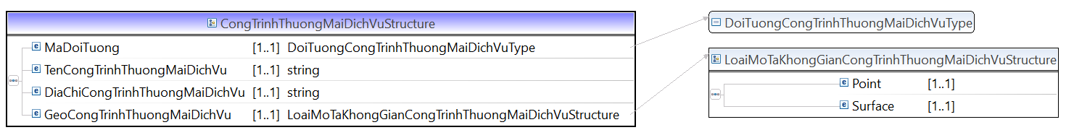

* Lược đồ XML cấu trúc dữ liệu công trình tôn giáo, tín ngưỡng:

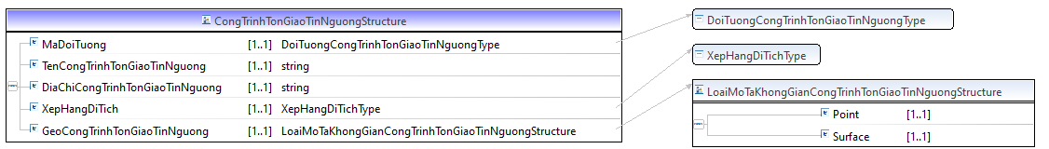

* Lược đồ XML cấu trúc dữ liệu Trụ sở cơ quan nhà nước:

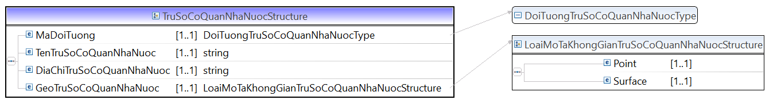

* Lược đồ XML cấu trúc dữ liệu công trình công nghiệp:

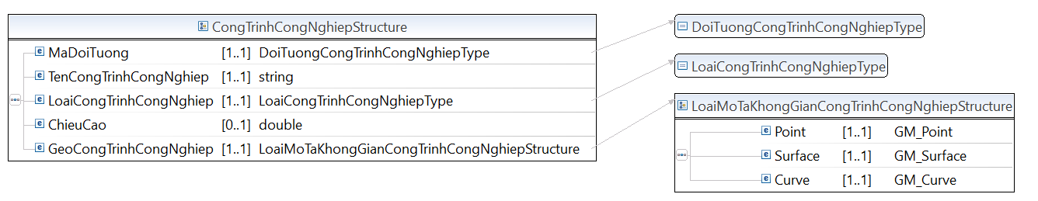

* Lược đồ XML cấu trúc dữ liệu công trình đang xây dựng:

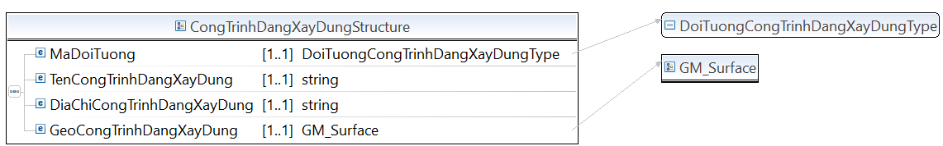

* Lược đồ XML cấu trúc dữ liệu Cơ sở sản xuất nông lâm nghiệp:

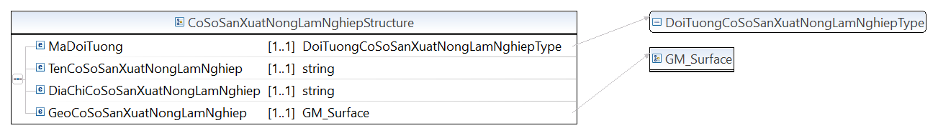

* Lược đồ XML cấu trúc dữ liệu Khu chức năng đặc thù:

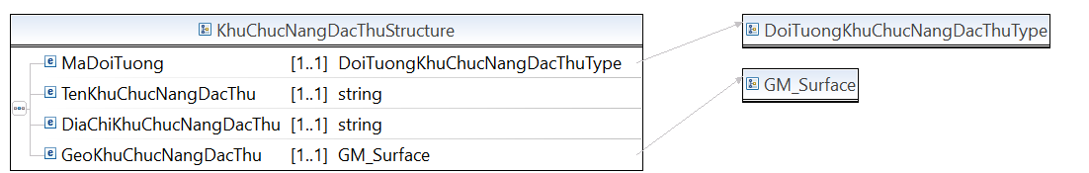

* Lược đồ XML cấu trúc dữ liệu Công trình xử lý chất thải:

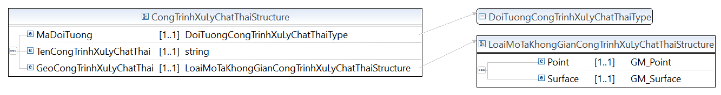

* Lược đồ XML cấu trúc dữ liệu Công trình an ninh

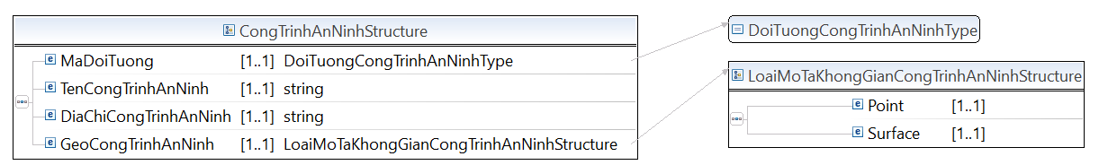

* Lược đồ XML cấu trúc dữ liệu Công trình quốc phòng

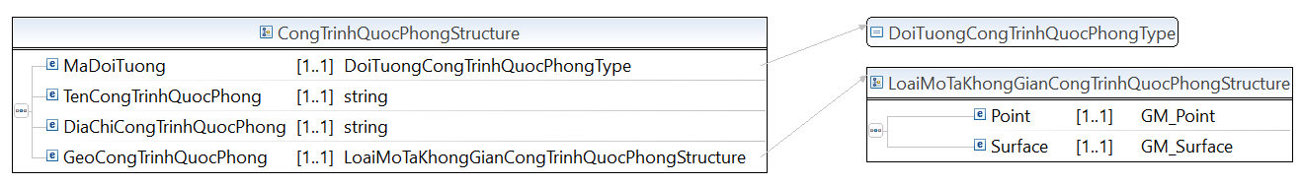

**Mã nguồn lược đồ chứa các cấu trúc thông tin của lược đồ dữ liệu nền địa lý – nhóm dân cư (TTDLQG.xsd)**

<?xml version=*“1.1”* encoding=*"UTF-8"*?>

<xsd:schema xmlns:xsd=*"http://www.w3.org/2001/XMLSchema"* xmlns:TTDLQG=*"..."* targetNamespace=*"..."* version=*“1.1”* elementFormDefault=*"qualified"*>

<!-- <xsd:include schemaLocation="BaseEnumType.xsd" /> -->

<xsd:annotation>

<xsd:documentation></xsd:documentation>

</xsd:annotation>

<xsd:complexType name=*"DiemTTDLQGStructure"*>

<xsd:annotation>

<xsd:documentation>Nơi cư trú của một cộng đồng dân cư</xsd:documentation>

</xsd:annotation>

<xsd:sequence>

<xsd:element name=*"MaDoiTuong"* type=*"TTDLQG:DoiTuongDiemTTDLQGType"* minOccurs=*"1"* maxOccurs=*"1"* />

<xsd:element name=*"LoaiDiemTTDLQG"* type=*"TTDLQG:LoaiDiemTTDLQGType"* minOccurs=*"1"* maxOccurs=*"1"* />

<xsd:element name=*"TenDiemTTDLQG"* type=*"xsd:string"* minOccurs=*"1"* maxOccurs=*"1"* />

<xsd:element name=*"SoHo"* type=*"xsd:integer"* minOccurs=*"1"* maxOccurs=*"1"* />

<xsd:element name=*"GeoDiemTTDLQG"* type=*"GM_Point"* minOccurs=*"1"* maxOccurs=*"1"* />

</xsd:sequence>

</xsd:complexType>

<xsd:complexType name=*"NhaStructure"*>

<xsd:annotation>

<xsd:documentation>Nhà là công trình xây dựng có chức năng chính là bảo vệ, che chắn cho người và vật bên trong</xsd:documentation>

</xsd:annotation>

<xsd:sequence>

<xsd:element name=*"MaDoiTuong"* type=*"TTDLQG:DoiTuongNhaType"* minOccurs=*"1"* maxOccurs=*"1"* />

<xsd:element name=*"LoaiNha"* type=*"TTDLQG:LoaiNhaType"* minOccurs=*"1"* maxOccurs=*"1"* />

<xsd:element name=*"MucDoKienCo"* type=*"TTDLQG:MucDoKienCoType"* minOccurs=*"1"* maxOccurs=*"1"* />

<xsd:element name=*"ChieuCao"* type=*"xsd:double"* minOccurs=*"1"* maxOccurs=*"1"* />

<xsd:element name=*"SoTang"* type=*"xsd:integer"* minOccurs=*"1"* maxOccurs=*"1"* />

<xsd:element name=*"Ten"* type=*"xsd:string"* minOccurs=*"1"* maxOccurs=*"1"* />

<xsd:element name=*"DiaChiNha"* type=*"xsd:string"* minOccurs=*"1"* maxOccurs=*"1"* />

<xsd:element name=*"GeoNha"* type=*"TTDLQG:LoaiMoTaKhongGianNhaStructure"* minOccurs=*"1"* maxOccurs=*"1"* />

</xsd:sequence>

</xsd:complexType>

<xsd:complexType name=*"CongTrinhPhuTroStructure"*>

<xsd:annotation>

<xsd:documentation>Gồm bậc lên xuống các công trình xây dựng; Cầu thang lên xuống ở ngoài trời; Phần đường dốc dẫn lên, xuống tầng hầm của các công trình xây dựng; Lối đi có mái che nối các công trình xây dựng</xsd:documentation>

</xsd:annotation>

<xsd:sequence>

<xsd:element name=*"MaDoiTuong"* type=*"TTDLQG:DoiTuongCongTrinhPhuTroType"* minOccurs=*"1"* maxOccurs=*"1"* />

<xsd:element name=*"GeoCongTrinhPhuTro"* type=*"TTDLQG:LoaiMoTaKhongGianCongTrinhPhuTroStructure"* minOccurs=*"1"* maxOccurs=*"1"* />

</xsd:sequence>

</xsd:complexType>

<xsd:complexType name=*"HaTangKyThuatKhacStructure"*>

<xsd:annotation>

<xsd:documentation>Phạm vi xây dựng công trình hạ tầng kỹ thuật khác</xsd:documentation>

</xsd:annotation>

<xsd:sequence>

<xsd:element name=*"MaDoiTuong"* type=*"TTDLQG:DoiTuongHaTangKyThuatKhacType"* minOccurs=*"1"* maxOccurs=*"1"* />

<xsd:element name=*"GeoHaTangKyThuatKhac"* type=*"TTDLQG:LoaiMoTaKhongGianHaTangKyThuatKhacStructure"* minOccurs=*"1"* maxOccurs=*"1"* />

</xsd:sequence>

</xsd:complexType>

<xsd:complexType name=*"CongTrinhCapNuocStructure"*>

<xsd:annotation>

<xsd:documentation>Phạm vi xây dựng các công trình cấp nước</xsd:documentation>

</xsd:annotation>

<xsd:sequence>

<xsd:element name=*"MaDoiTuong"* type=*"TTDLQG:DoiTuongCongTrinhCapNuocType"* minOccurs=*"1"* maxOccurs=*"1"* />

<xsd:element name=*"TenCongTrinhCapNuoc"* type=*"xsd:string"* minOccurs=*"1"* maxOccurs=*"1"* />

<xsd:element name=*"GeoCongTrinhCapNuoc"* type=*"TTDLQG:LoaiMoTaKhongGianCongTrinhCapNuocStructure"* minOccurs=*"1"* maxOccurs=*"1"* />

</xsd:sequence>

</xsd:complexType>

<xsd:complexType name=*"TramQuanTracStructure"*>

<xsd:annotation>

<xsd:documentation>Nơi có công trình quan trắc về tài nguyên và môi trường</xsd:documentation>

</xsd:annotation>

<xsd:sequence>

<xsd:element name=*"MaDoiTuong"* type=*"TTDLQG:DoiTuongTramQuanTracType"* minOccurs=*"1"* maxOccurs=*"1"* />

<xsd:element name=*"LoaiTramQuanTrac"* type=*"TTDLQG:LoaiTramQuanTracType"* minOccurs=*"1"* maxOccurs=*"1"* />

<xsd:element name=*"TenTramQuanTrac"* type=*"xsd:string"* minOccurs=*"1"* maxOccurs=*"1"* />

<xsd:element name=*"GeoTramQuanTrac"* type=*"TTDLQG:LoaiMoTaKhongGianTramQuanTracStructure"* minOccurs=*"1"* maxOccurs=*"1"* />

</xsd:sequence>

</xsd:complexType>

<xsd:complexType name=*"DuongDayTaiDienStructure"*>

<xsd:annotation>

<xsd:documentation>Hệ thống đường dây để truyền tải và phân phối điện</xsd:documentation>

</xsd:annotation>

<xsd:sequence>

<xsd:element name=*"MaDoiTuong"* type=*"TTDLQG:DoiTuongDuongDayTaiDienType"* minOccurs=*"1"* maxOccurs=*"1"* />

<xsd:element name=*"DienAp"* type=*"xsd:double"* minOccurs=*"1"* maxOccurs=*"1"* />

<xsd:element name=*"GeoDuongDayTaiDien"* type=*"TTDLQG:GM_Curve"* minOccurs=*"1"* maxOccurs=*"1"* />

</xsd:sequence>

</xsd:complexType>

<xsd:complexType name=*"DuongOngDanStructure"*>

<xsd:annotation>

<xsd:documentation>Nơi có đường ống dẫn chuyển (nước, khí, dầu)</xsd:documentation>

</xsd:annotation>

<xsd:sequence>

<xsd:element name=*"MaDoiTuong"* type=*"TTDLQG:DoiTuongDuongOngDanType"* minOccurs=*"1"* maxOccurs=*"1"* />

<xsd:element name=*"LoaiOngDan"* type=*"TTDLQG:LoaiOngDanType"* minOccurs=*"1"* maxOccurs=*"1"* />

<xsd:element name=*"GeoDuongOngDan"* type=*"TTDLQG:GM_Curve"* minOccurs=*"1"* maxOccurs=*"1"* />

</xsd:sequence>

</xsd:complexType>

<xsd:complexType name=*"RanhGioiStructure"*>

<xsd:annotation>

<xsd:documentation>Ranh giới</xsd:documentation>

</xsd:annotation>

<xsd:sequence>

<xsd:element name=*"MaDoiTuong"* type=*"TTDLQG:DoiTuongRanhGioiType"* minOccurs=*"1"* maxOccurs=*"1"* />

<xsd:element name=*"LoaiRanhGioi"* type=*"TTDLQG:LoaiRanhGioiType"* minOccurs=*"1"* maxOccurs=*"1"* />

<xsd:element name=*"GeoRanhGioi"* type=*"TTDLQG:GM_Curve"* minOccurs=*"1"* maxOccurs=*"1"* />

</xsd:sequence>

</xsd:complexType>

<xsd:complexType name=*"ThanhLuyStructure"*>

<xsd:annotation>

<xsd:documentation>Đối tượng tồn tại ổn định, kiên cố trên thực địa để phân định đồ hình khu chức năng</xsd:documentation>

</xsd:annotation>

<xsd:sequence>

<xsd:element name=*"MaDoiTuong"* type=*"TTDLQG:DoiTuongThanhLuyType"* minOccurs=*"1"* maxOccurs=*"1"* />

<xsd:element name=*"GeoThanhLuy"* type=*"TTDLQG:LoaiMoTaKhongGianThanhLuyStructure"* minOccurs=*"1"* maxOccurs=*"1"* />

</xsd:sequence>

</xsd:complexType>

<xsd:complexType name=*"HangRaoStructure"*>

<xsd:annotation>

<xsd:documentation>Đường ranh giới để nhận dạng đồ hình, khuôn viên của các cơ sở có khuôn viên cố định</xsd:documentation>

</xsd:annotation>

<xsd:sequence>

<xsd:element name=*"MaDoiTuong"* type=*"TTDLQG:DoiTuongHangRaoType"* minOccurs=*"1"* maxOccurs=*"1"* />

<xsd:element name=*"LoaiHangRao"* type=*"TTDLQG:LoaiHangRaoType"* minOccurs=*"1"* maxOccurs=*"1"* />

<xsd:element name=*"GeoHangRao"* type=*"TTDLQG:GM_Curve"* minOccurs=*"1"* maxOccurs=*"1"* />

</xsd:sequence>

</xsd:complexType>

<xsd:complexType name=*"CongTrinhYTeStructure"*>

<xsd:annotation>

<xsd:documentation>Phạm vi khu vực xây dựng công trình y tế</xsd:documentation>

</xsd:annotation>

<xsd:sequence>

<xsd:element name=*"MaDoiTuong"* type=*"TTDLQG:DoiTuongCongTrinhYTeType"* minOccurs=*"1"* maxOccurs=*"1"* />

<xsd:element name=*"LoaiCapHang"* type=*"TTDLQG:LoaiCapHangType"* minOccurs=*"1"* maxOccurs=*"1"* />

<xsd:element name=*"TenCongTrinhYTe"* type=*"xsd:string"* minOccurs=*"1"* maxOccurs=*"1"* />

<xsd:element name=*"DiaChiCongTrinhYTe"* type=*"xsd:string"* minOccurs=*"1"* maxOccurs=*"1"* />

<xsd:element name=*"GeoCongTrinhYTe"* type=*"TTDLQG:LoaiMoTaKhongGianCongTrinhYTeStructure"* minOccurs=*"1"* maxOccurs=*"1"* />

</xsd:sequence>

</xsd:complexType>

<xsd:complexType name=*"CongTrinhGiaoDucStructure"*>

<xsd:annotation>

<xsd:documentation>Phạm vi khu vực xây dựng công giáo dục</xsd:documentation>

</xsd:annotation>

<xsd:sequence>

<xsd:element name=*"MaDoiTuong"* type=*"TTDLQG:DoiTuongCongTrinhGiaoDucType"* minOccurs=*"1"* maxOccurs=*"1"* />

<xsd:element name=*"TenCongTrinhGiaoDuc"* type=*"xsd:string"* minOccurs=*"1"* maxOccurs=*"1"* />

<xsd:element name=*"DiaChiCongTrinhGiaoDuc"* type=*"xsd:string"* minOccurs=*"1"* maxOccurs=*"1"* />

<xsd:element name=*"GeoCongTrinhGiaoDuc"* type=*"TTDLQG:LoaiMoTaKhongGianCongTrinhGiaoDucStructure"* minOccurs=*"1"* maxOccurs=*"1"* />

</xsd:sequence>

</xsd:complexType>

<xsd:complexType name=*"CongTrinhTheThaoStructure"*>

<xsd:annotation>

<xsd:documentation>Phạm vi khu vực xây dựng công trình thể thao</xsd:documentation>

</xsd:annotation>

<xsd:sequence>

<xsd:element name=*"MaDoiTuong"* type=*"TTDLQG:DoiTuongCongTrinhTheThaoType"* minOccurs=*"1"* maxOccurs=*"1"* />

<xsd:element name=*"TenCongTrinhTheThao"* type=*"xsd:string"* minOccurs=*"1"* maxOccurs=*"1"* />

<xsd:element name=*"DiaChiCongTrinhTheThao"* type=*"xsd:string"* minOccurs=*"1"* maxOccurs=*"1"* />

<xsd:element name=*"GeoCongTrinhTheThao"* type=*"TTDLQG:LoaiMoTaKhongGianCongTrinhTheThaoStructure"* minOccurs=*"1"* maxOccurs=*"1"* />

</xsd:sequence>

</xsd:complexType>

<xsd:complexType name=*"CongTrinhVanHoaStructure"*>

<xsd:annotation>

<xsd:documentation>Phạm vi khu vực xây dựng công trình văn hóa</xsd:documentation>

</xsd:annotation>

<xsd:sequence>

<xsd:element name=*"MaDoiTuong"* type=*"TTDLQG:DoiTuongCongTrinhVanHoaType"* minOccurs=*"1"* maxOccurs=*"1"* />

<xsd:element name=*"TenCongTrinhVanHoa"* type=*"xsd:string"* minOccurs=*"1"* maxOccurs=*"1"* />

<xsd:element name=*"DiaChiCongTrinhVanHoa"* type=*"xsd:string"* minOccurs=*"1"* maxOccurs=*"1"* />

<xsd:element name=*"XepHangDiTich"* type=*"TTDLQG:XepHangDiTichType"* minOccurs=*"1"* maxOccurs=*"1"* />

<xsd:element name=*"ChieuCao"* type=*"xsd:double"* minOccurs=*"1"* maxOccurs=*"1"* />

<xsd:element name=*"GeoCongTrinhVanHoa"* type=*"TTDLQG:LoaiMoTaKhongGianCongTrinhVanHoaStructure"* minOccurs=*"1"* maxOccurs=*"1"* />

</xsd:sequence>

</xsd:complexType>

<xsd:complexType name=*"CongTrinhThuongMaiDichVuStructure"*>

<xsd:annotation>

<xsd:documentation>Phạm vi khu vực công trình thương mại dịch vụ và trụ sở làm việc</xsd:documentation>

</xsd:annotation>

<xsd:sequence>

<xsd:element name=*"MaDoiTuong"* type=*"TTDLQG:DoiTuongCongTrinhThuongMaiDichVuType"* minOccurs=*"1"* maxOccurs=*"1"* />

<xsd:element name=*"TenCongTrinhThuongMaiDichVu"* type=*"xsd:string"* minOccurs=*"1"* maxOccurs=*"1"* />

<xsd:element name=*"DiaChiCongTrinhThuongMaiDichVu"* type=*"xsd:string"* minOccurs=*"1"* maxOccurs=*"1"* />

<xsd:element name=*"GeoCongTrinhThuongMaiDichVu"* type=*"TTDLQG:LoaiMoTaKhongGianCongTrinhThuongMaiDichVuStructure"* minOccurs=*"1"* maxOccurs=*"1"* />

</xsd:sequence>

</xsd:complexType>

<xsd:complexType name=*"CongTrinhTonGiaoTinNguongStructure"*>

<xsd:annotation>

<xsd:documentation>Phạm vi xây dựng công trình tôn giáo, tín ngưỡng</xsd:documentation>

</xsd:annotation>

<xsd:sequence>

<xsd:element name=*"MaDoiTuong"* type=*"TTDLQG:DoiTuongCongTrinhTonGiaoTinNguongType"* minOccurs=*"1"* maxOccurs=*"1"* />

<xsd:element name=*"TenCongTrinhTonGiaoTinNguong"* type=*"xsd:string"* minOccurs=*"1"* maxOccurs=*"1"* />

<xsd:element name=*"DiaChiCongTrinhTonGiaoTinNguong"* type=*"xsd:string"* minOccurs=*"1"* maxOccurs=*"1"* />

<xsd:element name=*"XepHangDiTich"* type=*"TTDLQG:XepHangDiTichType"* minOccurs=*"1"* maxOccurs=*"1"* />

<xsd:element name=*"GeoCongTrinhTonGiaoTinNguong"* type=*"TTDLQG:LoaiMoTaKhongGianCongTrinhTonGiaoTinNguongStructure"* minOccurs=*"1"* maxOccurs=*"1"* />

</xsd:sequence>

</xsd:complexType>

<xsd:complexType name=*"TruSoCoQuanNhaNuocStructure"*>

<xsd:annotation>

<xsd:documentation>Phạm vi xây dựng Trụ sở cơ quan nhà nước</xsd:documentation>

</xsd:annotation>

<xsd:sequence>

<xsd:element name=*"MaDoiTuong"* type=*"TTDLQG:DoiTuongTruSoCoQuanNhaNuocType"* minOccurs=*"1"* maxOccurs=*"1"* />

<xsd:element name=*"TenTruSoCoQuanNhaNuoc"* type=*"xsd:string"* minOccurs=*"1"* maxOccurs=*"1"* />

<xsd:element name=*"DiaChiTruSoCoQuanNhaNuoc"* type=*"xsd:string"* minOccurs=*"1"* maxOccurs=*"1"* />

<xsd:element name=*"GeoTruSoCoQuanNhaNuoc"* type=*"TTDLQG:LoaiMoTaKhongGianTruSoCoQuanNhaNuocStructure"* minOccurs=*"1"* maxOccurs=*"1"* />

</xsd:sequence>

</xsd:complexType>

<xsd:complexType name=*"CongTrinhCongNghiepStructure"*>

<xsd:annotation>

<xsd:documentation>Phạm vi xây dựng công trình công nghiệp</xsd:documentation>

</xsd:annotation>

<xsd:sequence>

<xsd:element name=*"MaDoiTuong"* type=*"TTDLQG:DoiTuongCongTrinhCongNghiepType"* minOccurs=*"1"* maxOccurs=*"1"* />

<xsd:element name=*"TenCongTrinhCongNghiep"* type=*"xsd:string"* minOccurs=*"1"* maxOccurs=*"1"* />

<xsd:element name=*"LoaiCongTrinhCongNghiep"* type=*"TTDLQG:LoaiCongTrinhCongNghiepType"* minOccurs=*"1"* maxOccurs=*"1"* />

<xsd:element name=*"ChieuCao"* type=*"xsd:double"* minOccurs=*"0"* maxOccurs=*"1"* />

<xsd:element name=*"GeoCongTrinhCongNghiep"* type=*"TTDLQG:LoaiMoTaKhongGianCongTrinhCongNghiepStructure"* minOccurs=*"1"* maxOccurs=*"1"* />

</xsd:sequence>

</xsd:complexType>

<xsd:complexType name=*"CongTrinhDangXayDungStructure"*>

<xsd:annotation>

<xsd:documentation>Phạm vi xây dựng công trình công nghiệp</xsd:documentation>

</xsd:annotation>

<xsd:sequence>

<xsd:element name=*"MaDoiTuong"* type=*"TTDLQG:DoiTuongCongTrinhDangXayDungType"* minOccurs=*"1"* maxOccurs=*"1"* />

<xsd:element name=*"TenCongTrinhDangXayDung"* type=*"xsd:string"* minOccurs=*"1"* maxOccurs=*"1"* />

<xsd:element name=*"DiaChiCongTrinhDangXayDung"* type=*"xsd:string"* minOccurs=*"1"* maxOccurs=*"1"* />

<xsd:element name=*"GeoCongTrinhDangXayDung"* type=*"TTDLQG:GM_Surface"* minOccurs=*"1"* maxOccurs=*"1"* />

</xsd:sequence>

</xsd:complexType>

<xsd:complexType name=*"CoSoSanXuatNongLamNghiepStructure"*>

<xsd:annotation>

<xsd:documentation>Khu vực đất sản xuất, kinh doanh nông nghiệp, lâm nghiệp và có các đối tượng địa lý liên quan đến nông, lâm nghiệp</xsd:documentation>

</xsd:annotation>

<xsd:sequence>

<xsd:element name=*"MaDoiTuong"* type=*"TTDLQG:DoiTuongCoSoSanXuatNongLamNghiepType"* minOccurs=*"1"* maxOccurs=*"1"* />

<xsd:element name=*"TenCoSoSanXuatNongLamNghiep"* type=*"xsd:string"* minOccurs=*"1"* maxOccurs=*"1"* />

<xsd:element name=*"DiaChiCoSoSanXuatNongLamNghiep"* type=*"xsd:string"* minOccurs=*"1"* maxOccurs=*"1"* />

<xsd:element name=*"GeoCoSoSanXuatNongLamNghiep"* type=*"TTDLQG:GM_ Surface"* minOccurs=*"1"* maxOccurs=*"1"* />

</xsd:sequence>

</xsd:complexType>

<xsd:complexType name=*"KhuChucNangDacThuStructure"*>

<xsd:annotation>

<xsd:documentation>Khu vực phát triển theo các chức năng chuyên biệt hoặc hỗn hợp</xsd:documentation>

</xsd:annotation>

<xsd:sequence>

<xsd:element name=*"MaDoiTuong"* type=*"TTDLQG:DoiTuongKhuChucNangDacThuType"* minOccurs=*"1"* maxOccurs=*"1"* />

<xsd:element name=*"TenKhuChucNangDacThu"* type=*"xsd:string"* minOccurs=*"1"* maxOccurs=*"1"* />

<xsd:element name=*"DiaChiKhuChucNangDacThu"* type=*"xsd:string"* minOccurs=*"1"* maxOccurs=*"1"* />

<xsd:element name=*"GeoKhuChucNangDacThu"* type=*"TTDLQG:GM_ Surface"* minOccurs=*"1"* maxOccurs=*"1"* />

</xsd:sequence>

</xsd:complexType>

<xsd:complexType name=*"CongTrinhXuLyChatThaiStructure"*>

<xsd:annotation>

<xsd:documentation>Khu vực phát triển theo các chức năng chuyên biệt hoặc hỗn hợp</xsd:documentation>

</xsd:annotation>

<xsd:sequence>

<xsd:element name=*"MaDoiTuong"* type=*"TTDLQG:DoiTuongCongTrinhXuLyChatThaiType"* minOccurs=*"1"* maxOccurs=*"1"* />

<xsd:element name=*"TenCongTrinhXuLyChatThai"* type=*"xsd:string"* minOccurs=*"1"* maxOccurs=*"1"* />

<xsd:element name=*"GeoCongTrinhXuLyChatThai"* type=*"TTDLQG:LoaiMoTaKhongGianCongTrinhXuLyChatThaiStructure"* minOccurs=*"1"* maxOccurs=*"1"* />

</xsd:sequence>

</xsd:complexType>

<xsd:complexType name=*"CongTrinhAnNinhStructure"*>

<xsd:annotation>

<xsd:documentation>Phạm vi xây dựng công trình an ninh</xsd:documentation>

</xsd:annotation>

<xsd:sequence>

<xsd:element name=*"MaDoiTuong"* type=*"TTDLQG:DoiTuongCongTrinhAnNinhType"* minOccurs=*"1"* maxOccurs=*"1"* />

<xsd:element name=*"TenCongTrinhAnNinh"* type=*"xsd:string"* minOccurs=*"1"* maxOccurs=*"1"* />

<xsd:element name=*"DiaChiCongTrinhAnNinh"* type=*"xsd:string"* minOccurs=*"1"* maxOccurs=*"1"* />

<xsd:element name=*"GeoCongTrinhAnNinh"* type=*"TTDLQG:LoaiMoTaKhongGianCongTrinhAnNinhStructure"* minOccurs=*"1"* maxOccurs=*"1"* />

</xsd:sequence>

</xsd:complexType>

<xsd:complexType name=*"CongTrinhQuocPhongStructure"*>

<xsd:annotation>

<xsd:documentation>Phạm vi xây dựng công trình quốc phòng</xsd:documentation>

</xsd:annotation>

<xsd:sequence>

<xsd:element name=*"MaDoiTuong"* type=*"TTDLQG:DoiTuongCongTrinhQuocPhongType"* minOccurs=*"1"* maxOccurs=*"1"* />

<xsd:element name=*"TenCongTrinhQuocPhong"* type=*"xsd:string"* minOccurs=*"1"* maxOccurs=*"1"* />

<xsd:element name=*"DiaChiCongTrinhQuocPhong"* type=*"xsd:string"* minOccurs=*"1"* maxOccurs=*"1"* />

<xsd:element name=*"GeoCongTrinhQuocPhong"* type=*"TTDLQG:LoaiMoTaKhongGianCongTrinhQuocPhongStructure"* minOccurs=*"1"* maxOccurs=*"1"* />

</xsd:sequence>

</xsd:complexType>

<xsd:complexType name=*"LoaiMoTaKhongGianNhaStructure"*>

<xsd:annotation>

<xsd:documentation>Loại mô tả không gian nhà</xsd:documentation>

</xsd:annotation>

<xsd:sequence>

<xsd:element name=*"Point"* type=*"GM_PointType"* minOccurs=*"1"* maxOccurs=*"1"* />

<xsd:element name=*"Surface"* type=*"TTDLQG:GM_SurfaceType"* minOccurs=*"1"* maxOccurs=*"1"* />

<xsd:element name=*"Curve"* type=*"TTDLQG:GM_CurveType"* minOccurs=*"1"* maxOccurs=*"1"* />

</xsd:sequence>

</xsd:complexType>

<xsd:complexType name=*"LoaiMoTaKhongGianCongTrinhPhuTroStructure"*>

<xsd:annotation>

<xsd:documentation>Loại mô tả không gian công trình phụ trợ</xsd:documentation>

</xsd:annotation>

<xsd:sequence>

<xsd:element name=*"Surface"* type=*"TTDLQG:GM_SurfaceType"* minOccurs=*"1"* maxOccurs=*"1"* />

<xsd:element name=*"Curve"* type=*"TTDLQG:GM_CurveType"* minOccurs=*"1"* maxOccurs=*"1"* />

</xsd:sequence>

</xsd:complexType>

<xsd:complexType name=*"LoaiMoTaKhongGianHaTangKyThuatKhacStructure"*>

<xsd:annotation>

<xsd:documentation>Loại mô tả không gian hạ tầng kỹ thuật khác</xsd:documentation>

</xsd:annotation>

<xsd:sequence>

<xsd:element name=*"Point"* type=*"GM_PointType"* minOccurs=*"1"* maxOccurs=*"1"* />

<xsd:element name=*"Surface"* type=*"TTDLQG:GM_SurfaceType"* minOccurs=*"1"* maxOccurs=*"1"* />

</xsd:sequence>

</xsd:complexType>

<xsd:complexType name=*"LoaiMoTaKhongGianCongTrinhCapNuocStructure"*>

<xsd:annotation>

<xsd:documentation>Loại mô tả không gian công trình cấp nước</xsd:documentation>

</xsd:annotation>

<xsd:sequence>

<xsd:element name=*"Point"* type=*"GM_PointType"* minOccurs=*"1"* maxOccurs=*"1"* />

<xsd:element name=*"Surface"* type=*"TTDLQG:GM_SurfaceType"* minOccurs=*"1"* maxOccurs=*"1"* />

</xsd:sequence>

</xsd:complexType>

<xsd:complexType name=*"LoaiMoTaKhongGianTramQuanTracStructure"*>

<xsd:annotation>

<xsd:documentation>Loại mô tả không gian không gian của trạm quan trắc</xsd:documentation>

</xsd:annotation>

<xsd:sequence>

<xsd:element name=*"Point"* type=*"GM_PointType"* minOccurs=*"1"* maxOccurs=*"1"* />

<xsd:element name=*"Surface"* type=*"TTDLQG:GM_SurfaceType"* minOccurs=*"1"* maxOccurs=*"1"* />

</xsd:sequence>

</xsd:complexType>

<xsd:complexType name=*"LoaiMoTaKhongGianThanhLuyStructure"*>

<xsd:annotation>

<xsd:documentation>Loại mô tả không gian không gian thành lũy</xsd:documentation>

</xsd:annotation>

<xsd:sequence>

<xsd:element name=*"Surface"* type=*"TTDLQG:GM_SurfaceType"* minOccurs=*"1"* maxOccurs=*"1"* />

<xsd:element name=*"Curve"* type=*"TTDLQG:GM_CurveType"* minOccurs=*"1"* maxOccurs=*"1"* />

</xsd:sequence>

</xsd:complexType>

<xsd:complexType name=*"LoaiMoTaKhongGianCongTrinhYTeStructure"*>

<xsd:annotation>

<xsd:documentation>Loại mô tả không gian không gian công trình y tế</xsd:documentation>

</xsd:annotation>

<xsd:sequence>

<xsd:element name=*"Point"* type=*"GM_PointType"* minOccurs=*"1"* maxOccurs=*"1"* />

<xsd:element name=*"Surface"* type=*"TTDLQG:GM_SurfaceType"* minOccurs=*"1"* maxOccurs=*"1"* />

</xsd:sequence>

</xsd:complexType>

<xsd:complexType name=*"LoaiMoTaKhongGianCongTrinhGiaoDucStructure"*>

<xsd:annotation>

<xsd:documentation>Loại mô tả không gian không gian công trình giáo dục</xsd:documentation>

</xsd:annotation>

<xsd:sequence>

<xsd:element name=*"Point"* type=*"GM_PointType"* minOccurs=*"1"* maxOccurs=*"1"* />

<xsd:element name=*"Surface"* type=*"TTDLQG:GM_SurfaceType"* minOccurs=*"1"* maxOccurs=*"1"* />

</xsd:sequence>

</xsd:complexType>

<xsd:complexType name=*"LoaiMoTaKhongGianCongTrinhVanHoaStructure"*>

<xsd:annotation>

<xsd:documentation>Loại mô tả không gian không gian công trình văn hóa</xsd:documentation>

</xsd:annotation>

<xsd:sequence>

<xsd:element name=*"Point"* type=*"GM_PointType"* minOccurs=*"1"* maxOccurs=*"1"* />

<xsd:element name=*"Surface"* type=*"TTDLQG:GM_SurfaceType"* minOccurs=*"1"* maxOccurs=*"1"* />

<xsd:element name=*"Curve"* type=*"TTDLQG:GM_CurveType"* minOccurs=*"1"* maxOccurs=*"1"* />

</xsd:sequence>

</xsd:complexType>

<xsd:complexType name=*"LoaiMoTaKhongGianCongTrinhThuongMaiDichVuStructure"*>

<xsd:annotation>

<xsd:documentation>Loại mô tả không gian công trình thương mại dịch vụ</xsd:documentation>

</xsd:annotation>

<xsd:sequence>

<xsd:element name=*"Point"* type=*"GM_PointType"* minOccurs=*"1"* maxOccurs=*"1"* />

<xsd:element name=*"Surface"* type=*"TTDLQG:GM_SurfaceType"* minOccurs=*"1"* maxOccurs=*"1"* />

</xsd:sequence>

</xsd:complexType>

<xsd:complexType name=*"LoaiMoTaKhongGianCongTrinhTheThaoStructure"*>

<xsd:annotation>

<xsd:documentation>Loại mô tả không gian công trình thể thao</xsd:documentation>

</xsd:annotation>

<xsd:sequence>

<xsd:element name=*"Point"* type=*"GM_PointType"* minOccurs=*"1"* maxOccurs=*"1"* />

<xsd:element name=*"Surface"* type=*"TTDLQG:GM_SurfaceType"* minOccurs=*"1"* maxOccurs=*"1"* />

</xsd:sequence>

</xsd:complexType>

<xsd:complexType name=*"LoaiMoTaKhongGianTruSoCoQuanNhaNuocStructure"*>

<xsd:annotation>

<xsd:documentation>Loại mô tả không gian của trụ sở cơ quan nhà nước</xsd:documentation>

</xsd:annotation>

<xsd:sequence>

<xsd:element name=*"Point"* type=*"GM_PointType"* minOccurs=*"1"* maxOccurs=*"1"* />

<xsd:element name=*"Surface"* type=*"TTDLQG:GM_SurfaceType"* minOccurs=*"1"* maxOccurs=*"1"* />

</xsd:sequence>

</xsd:complexType>

<xsd:complexType name=*"LoaiMoTaKhongGianCongTrinhTonGiaoTinNguongStructure"*>

<xsd:annotation>

<xsd:documentation>Loại mô tả không gian của công trình tôn giáo, tín ngưỡng</xsd:documentation>

</xsd:annotation>

<xsd:sequence>

<xsd:element name=*"Point"* type=*"GM_PointType"* minOccurs=*"1"* maxOccurs=*"1"* />

<xsd:element name=*"Surface"* type=*"TTDLQG:GM_SurfaceType"* minOccurs=*"1"* maxOccurs=*"1"* />

</xsd:sequence>

</xsd:complexType>

<xsd:complexType name=*"LoaiMoTaKhongGianCongTrinhCongNghiepStructure"*>

<xsd:annotation>

<xsd:documentation>Loại mô tả không gian của công trình công nghiệp</xsd:documentation>

</xsd:annotation>

<xsd:sequence>

<xsd:element name=*"Point"* type=*"GM_PointType"* minOccurs=*"1"* maxOccurs=*"1"* />

<xsd:element name=*"Surface"* type=*"TTDLQG:GM_SurfaceType"* minOccurs=*"1"* maxOccurs=*"1"* />

<xsd:element name=*"Curve"* type=*"TTDLQG:GM_CurveType"* minOccurs=*"1"* maxOccurs=*"1"* />

</xsd:sequence>

</xsd:complexType>

<xsd:complexType name=*"LoaiMoTaKhongGianCongTrinhXuLyChatThaiStructure"*>

<xsd:annotation>

<xsd:documentation>Loại mô tả không gian công trình xử lý chất thải</xsd:documentation>

</xsd:annotation>

<xsd:sequence>

<xsd:element name=*"Point"* type=*"TTDLQG:GM_Point"* minOccurs=*"1"* maxOccurs=*"1"* />

<xsd:element name=*"Surface"* type=*"TTDLQG:GM_Surface"* minOccurs=*"1"* maxOccurs=*"1"* />

</xsd:sequence>

</xsd:complexType>

<xsd:complexType name=*"LoaiMoTaKhongGianCongTrinhAnNinhStructure"*>

<xsd:annotation>

<xsd:documentation>Loại mô tả không gian công trình an ninh</xsd:documentation>

</xsd:annotation>

<xsd:sequence>

<xsd:element name=*"Point"* type=*"GM_PointType"* minOccurs=*"1"* maxOccurs=*"1"* />

<xsd:element name=*"Surface"* type=*"TTDLQG:GM_SurfaceType"* minOccurs=*"1"* maxOccurs=*"1"* />

</xsd:sequence>

</xsd:complexType>

<xsd:complexType name=*"LoaiMoTaKhongGianCongTrinhQuocPhongStructure"*>

<xsd:annotation>

<xsd:documentation>Loại mô tả không gian công trình quốc phòng</xsd:documentation>

</xsd:annotation>

<xsd:sequence>

<xsd:element name=*"Point"* type=*"TTDLQG:GM_Point"* minOccurs=*"1"* maxOccurs=*"1"* />

<xsd:element name=*"Surface"* type=*"TTDLQG:GM_Surface"* minOccurs=*"1"* maxOccurs=*"1"* />

</xsd:sequence>

</xsd:complexType>

<xsd:simpleType name=*"DoiTuongDiemTTDLQGType"*>

<xsd:annotation>

<xsd:documentation>Đối tượng điểm dân cư</xsd:documentation>

</xsd:annotation>

<xsd:restriction base=*"xsd:token"*>

<xsd:enumeration value=*"CB02"*><xsd:annotation><xsd:documentation>xsd:string</xsd:documentation></xsd:annotation></xsd:enumeration>

</xsd:restriction>

</xsd:simpleType>

<xsd:simpleType name=*"LoaiDiemTTDLQGType"*>

<xsd:annotation>

<xsd:documentation>Loại điểm dân cư</xsd:documentation>

</xsd:annotation>

<xsd:restriction base=*"xsd:token"*>

<xsd:enumeration value=*"1"*><xsd:annotation><xsd:documentation>xsd:string</xsd:documentation></xsd:annotation></xsd:enumeration>

<xsd:enumeration value=*"2"*><xsd:annotation><xsd:documentation>xsd:string</xsd:documentation></xsd:annotation></xsd:enumeration>

</xsd:restriction>

</xsd:simpleType>

<xsd:simpleType name=*"DoiTuongNhaType"*>

<xsd:annotation>

<xsd:documentation>Đối tượng nhà</xsd:documentation>

</xsd:annotation>

<xsd:restriction base=*"xsd:token"*>

<xsd:enumeration value=*"CA01"*><xsd:annotation><xsd:documentation>xsd:string</xsd:documentation></xsd:annotation></xsd:enumeration>

</xsd:restriction>

</xsd:simpleType>

<xsd:simpleType name=*"LoaiNhaType"*>

<xsd:annotation>

<xsd:documentation>Loại nhà</xsd:documentation>

</xsd:annotation>

<xsd:restriction base=*"xsd:token"*>

<xsd:enumeration value=*"1"*><xsd:annotation><xsd:documentation>xsd:string</xsd:documentation></xsd:annotation></xsd:enumeration>

<xsd:enumeration value=*"2"*><xsd:annotation><xsd:documentation>xsd:string</xsd:documentation></xsd:annotation></xsd:enumeration>

<xsd:enumeration value=*"3"*><xsd:annotation><xsd:documentation>xsd:string</xsd:documentation></xsd:annotation></xsd:enumeration>

<xsd:enumeration value=*"4"*><xsd:annotation><xsd:documentation>xsd:string</xsd:documentation></xsd:annotation></xsd:enumeration>

<xsd:enumeration value=*"5"*><xsd:annotation><xsd:documentation>xsd:string</xsd:documentation></xsd:annotation></xsd:enumeration>

<xsd:enumeration value=*"6"*><xsd:annotation><xsd:documentation>xsd:string</xsd:documentation></xsd:annotation></xsd:enumeration>

<xsd:enumeration value=*"7"*><xsd:annotation><xsd:documentation>xsd:string</xsd:documentation></xsd:annotation></xsd:enumeration>

<xsd:enumeration value=*"8"*><xsd:annotation><xsd:documentation>xsd:string</xsd:documentation></xsd:annotation></xsd:enumeration>

</xsd:restriction>

</xsd:simpleType>

<xsd:simpleType name=*"MucDoKienCoType"*>

<xsd:annotation>

<xsd:documentation>Mức độ kiên cố</xsd:documentation>

</xsd:annotation>

<xsd:restriction base=*"xsd:token"*>

<xsd:enumeration value=*"1"*><xsd:annotation><xsd:documentation>xsd:string</xsd:documentation></xsd:annotation></xsd:enumeration>

<xsd:enumeration value=*"2"*><xsd:annotation><xsd:documentation>xsd:string</xsd:documentation></xsd:annotation></xsd:enumeration>

<xsd:enumeration value=*"3"*><xsd:annotation><xsd:documentation>xsd:string</xsd:documentation></xsd:annotation></xsd:enumeration>

</xsd:restriction>

</xsd:simpleType>

<xsd:simpleType name=*"DoiTuongCongTrinhPhuTroType"*>

<xsd:annotation>

<xsd:documentation>Công trình phụ trợ</xsd:documentation>

</xsd:annotation>

<xsd:restriction base=*"xsd:token"*>

<xsd:enumeration value=*"CD01"*><xsd:annotation><xsd:documentation>xsd:string</xsd:documentation></xsd:annotation></xsd:enumeration>

<xsd:enumeration value=*"CD02"*><xsd:annotation><xsd:documentation>xsd:string</xsd:documentation></xsd:annotation></xsd:enumeration>

<xsd:enumeration value=*"CD03"*><xsd:annotation><xsd:documentation>xsd:string</xsd:documentation></xsd:annotation></xsd:enumeration>

<xsd:enumeration value=*"CD04"*><xsd:annotation><xsd:documentation>xsd:string</xsd:documentation></xsd:annotation></xsd:enumeration>

</xsd:restriction>

</xsd:simpleType>

<xsd:simpleType name=*"DoiTuongHaTangKyThuatKhacType"*>

<xsd:annotation>

<xsd:documentation>Hạ tầng kỹ thuật khác</xsd:documentation>

</xsd:annotation>

<xsd:restriction base=*"xsd:token"*>

<xsd:enumeration value=*"BA01"*><xsd:annotation><xsd:documentation>xsd:string</xsd:documentation></xsd:annotation></xsd:enumeration>

<xsd:enumeration value=*"BA02"*><xsd:annotation><xsd:documentation>xsd:string</xsd:documentation></xsd:annotation></xsd:enumeration>

<xsd:enumeration value=*"BA04"*><xsd:annotation><xsd:documentation>xsd:string</xsd:documentation></xsd:annotation></xsd:enumeration>

<xsd:enumeration value=*"BB04"*><xsd:annotation><xsd:documentation>xsd:string</xsd:documentation></xsd:annotation></xsd:enumeration>

<xsd:enumeration value=*"BB05"*><xsd:annotation><xsd:documentation>xsd:string</xsd:documentation></xsd:annotation></xsd:enumeration>

<xsd:enumeration value=*"BC03"*><xsd:annotation><xsd:documentation>xsd:string</xsd:documentation></xsd:annotation></xsd:enumeration>

<xsd:enumeration value=*"BV01"*><xsd:annotation><xsd:documentation>xsd:string</xsd:documentation></xsd:annotation></xsd:enumeration>

<xsd:enumeration value=*"BV03"*><xsd:annotation><xsd:documentation>xsd:string</xsd:documentation></xsd:annotation></xsd:enumeration>

<xsd:enumeration value=*"BV10"*><xsd:annotation><xsd:documentation>xsd:string</xsd:documentation></xsd:annotation></xsd:enumeration>

<xsd:enumeration value=*"BV11"*><xsd:annotation><xsd:documentation>xsd:string</xsd:documentation></xsd:annotation></xsd:enumeration>

<xsd:enumeration value=*"BV12"*><xsd:annotation><xsd:documentation>xsd:string</xsd:documentation></xsd:annotation></xsd:enumeration>

<xsd:enumeration value=*"BV13"*><xsd:annotation><xsd:documentation>xsd:string</xsd:documentation></xsd:annotation></xsd:enumeration>

</xsd:restriction>

</xsd:simpleType>

<xsd:simpleType name=*"DoiTuongCongTrinhCapNuocType"*>

<xsd:annotation>

<xsd:documentation>Công trình cấp nước</xsd:documentation>

</xsd:annotation>

<xsd:restriction base=*"xsd:token"*>

<xsd:enumeration value=*"BU03"*><xsd:annotation><xsd:documentation>xsd:string</xsd:documentation></xsd:annotation></xsd:enumeration>

<xsd:enumeration value=*"BU05"*><xsd:annotation><xsd:documentation>xsd:string</xsd:documentation></xsd:annotation></xsd:enumeration>

</xsd:restriction>

</xsd:simpleType>

<xsd:simpleType name=*"DoiTuongTramQuanTracType"*>

<xsd:annotation>

<xsd:documentation>Trạm quan trắc</xsd:documentation>

</xsd:annotation>

<xsd:restriction base=*"xsd:token"*>

<xsd:enumeration value=*"BI04"*><xsd:annotation><xsd:documentation>xsd:string</xsd:documentation></xsd:annotation></xsd:enumeration>

</xsd:restriction>

</xsd:simpleType>

<xsd:simpleType name=*"LoaiTramQuanTracType"*>

<xsd:annotation>

<xsd:documentation>Loại trạm quan trắc</xsd:documentation>

</xsd:annotation>

<xsd:restriction base=*"xsd:token"*>

<xsd:enumeration value=*"1"*><xsd:annotation><xsd:documentation>xsd:string</xsd:documentation></xsd:annotation></xsd:enumeration>

<xsd:enumeration value=*"2"*><xsd:annotation><xsd:documentation>xsd:string</xsd:documentation></xsd:annotation></xsd:enumeration>

<xsd:enumeration value=*"3"*><xsd:annotation><xsd:documentation>xsd:string</xsd:documentation></xsd:annotation></xsd:enumeration>

<xsd:enumeration value=*"4"*><xsd:annotation><xsd:documentation>xsd:string</xsd:documentation></xsd:annotation></xsd:enumeration>

<xsd:enumeration value=*"5"*><xsd:annotation><xsd:documentation>xsd:string</xsd:documentation></xsd:annotation></xsd:enumeration>

<xsd:enumeration value=*"6"*><xsd:annotation><xsd:documentation>xsd:string</xsd:documentation></xsd:annotation></xsd:enumeration>

</xsd:restriction>

</xsd:simpleType>

<xsd:simpleType name=*"DoiTuongDuongDayTaiDienType"*>

<xsd:annotation>

<xsd:documentation>Đường dây tải điện</xsd:documentation>

</xsd:annotation>

<xsd:restriction base=*"xsd:token"*>

<xsd:enumeration value=*"BA03"*><xsd:annotation><xsd:documentation>xsd:string</xsd:documentation></xsd:annotation></xsd:enumeration>

</xsd:restriction>

</xsd:simpleType>

<xsd:simpleType name=*"DoiTuongDuongOngDanType"*>

<xsd:annotation>

<xsd:documentation>Đường ống dẫn</xsd:documentation>

</xsd:annotation>

<xsd:restriction base=*"xsd:token"*>

<xsd:enumeration value=*"BU02"*><xsd:annotation><xsd:documentation>xsd:string</xsd:documentation></xsd:annotation></xsd:enumeration>

</xsd:restriction>

</xsd:simpleType>

<xsd:simpleType name=*"LoaiOngDanType"*>

<xsd:annotation>

<xsd:documentation>Loại ống dẫn</xsd:documentation>

</xsd:annotation>

<xsd:restriction base=*"xsd:token"*>

<xsd:enumeration value=*"1"*><xsd:annotation><xsd:documentation>xsd:string</xsd:documentation></xsd:annotation></xsd:enumeration>

<xsd:enumeration value=*"2"*><xsd:annotation><xsd:documentation>xsd:string</xsd:documentation></xsd:annotation></xsd:enumeration>

<xsd:enumeration value=*"3"*><xsd:annotation><xsd:documentation>xsd:string</xsd:documentation></xsd:annotation></xsd:enumeration>

</xsd:restriction>

</xsd:simpleType>

<xsd:simpleType name=*"DoiTuongRanhGioiType"*>

<xsd:annotation>

<xsd:documentation>Đối tượng Ranh giới</xsd:documentation>

</xsd:annotation>

<xsd:restriction base=*"xsd:token"*>

<xsd:enumeration value=*"KB03"*><xsd:annotation><xsd:documentation>xsd:string</xsd:documentation></xsd:annotation></xsd:enumeration>

</xsd:restriction>

</xsd:simpleType>

<xsd:simpleType name=*"LoaiRanhGioiType"*>

<xsd:annotation>

<xsd:documentation>Loại Ranh giới</xsd:documentation>

</xsd:annotation>

<xsd:restriction base=*"xsd:token"*>

<xsd:enumeration value=*"1"*><xsd:annotation><xsd:documentation>xsd:string</xsd:documentation></xsd:annotation></xsd:enumeration>

<xsd:enumeration value=*"2"*><xsd:annotation><xsd:documentation>xsd:string</xsd:documentation></xsd:annotation></xsd:enumeration>

</xsd:restriction>

</xsd:simpleType>

<xsd:simpleType name=*"DoiTuongThanhLuyType"*>

<xsd:annotation>

<xsd:documentation>Đối tượng Thành lũy</xsd:documentation>

</xsd:annotation>

<xsd:restriction base=*"xsd:token"*>

<xsd:enumeration value=*"KB01"*><xsd:annotation><xsd:documentation>xsd:string</xsd:documentation></xsd:annotation></xsd:enumeration>

</xsd:restriction>

</xsd:simpleType>

<xsd:simpleType name=*"DoiTuongHangRaoType"*>

<xsd:annotation>

<xsd:documentation>Đối tượng Hàng rào</xsd:documentation>

</xsd:annotation>

<xsd:restriction base=*"xsd:token"*>

<xsd:enumeration value=*"KB04"*><xsd:annotation><xsd:documentation>xsd:string</xsd:documentation></xsd:annotation></xsd:enumeration>

</xsd:restriction>

</xsd:simpleType>

<xsd:simpleType name=*"LoaiHangRaoType"*>

<xsd:annotation>

<xsd:documentation>Loại hàng rào</xsd:documentation>

</xsd:annotation>

<xsd:restriction base=*"xsd:token"*>

<xsd:enumeration value=*"1"*><xsd:annotation><xsd:documentation>xsd:string</xsd:documentation></xsd:annotation></xsd:enumeration>

<xsd:enumeration value=*"2"*><xsd:annotation><xsd:documentation>xsd:string</xsd:documentation></xsd:annotation></xsd:enumeration>

</xsd:restriction>

</xsd:simpleType>

<xsd:simpleType name=*"DoiTuongCongTrinhYTeType"*>

<xsd:annotation>

<xsd:documentation>Đối tượng Công trình y tế</xsd:documentation>

</xsd:annotation>

<xsd:restriction base=*"xsd:token"*>

<xsd:enumeration value=*"BR02"*><xsd:annotation><xsd:documentation>xsd:string</xsd:documentation></xsd:annotation></xsd:enumeration>

<xsd:enumeration value=*"BR03"*><xsd:annotation><xsd:documentation>xsd:string</xsd:documentation></xsd:annotation></xsd:enumeration>

<xsd:enumeration value=*"BR04"*><xsd:annotation><xsd:documentation>xsd:string</xsd:documentation></xsd:annotation></xsd:enumeration>

<xsd:enumeration value=*"BR05"*><xsd:annotation><xsd:documentation>xsd:string</xsd:documentation></xsd:annotation></xsd:enumeration>

<xsd:enumeration value=*"BR06"*><xsd:annotation><xsd:documentation>xsd:string</xsd:documentation></xsd:annotation></xsd:enumeration>

<xsd:enumeration value=*"BR07"*><xsd:annotation><xsd:documentation>xsd:string</xsd:documentation></xsd:annotation></xsd:enumeration>

<xsd:enumeration value=*"BR08"*><xsd:annotation><xsd:documentation>xsd:string</xsd:documentation></xsd:annotation></xsd:enumeration>

<xsd:enumeration value=*"BR09"*><xsd:annotation><xsd:documentation>xsd:string</xsd:documentation></xsd:annotation></xsd:enumeration>

</xsd:restriction>

</xsd:simpleType>

<xsd:simpleType name=*"LoaiCapHangType"*>

<xsd:annotation>

<xsd:documentation>Phân loại cấp hạng theo quyết định của cơ quan có thẩm quyền công nhận</xsd:documentation>

</xsd:annotation>

<xsd:restriction base=*"xsd:token"*>

<xsd:enumeration value=*"1"*><xsd:annotation><xsd:documentation>xsd:string</xsd:documentation></xsd:annotation></xsd:enumeration>

<xsd:enumeration value=*"2"*><xsd:annotation><xsd:documentation>xsd:string</xsd:documentation></xsd:annotation></xsd:enumeration>

<xsd:enumeration value=*"3"*><xsd:annotation><xsd:documentation>xsd:string</xsd:documentation></xsd:annotation></xsd:enumeration>

<xsd:enumeration value=*"4"*><xsd:annotation><xsd:documentation>xsd:string</xsd:documentation></xsd:annotation></xsd:enumeration>

<xsd:enumeration value=*"5"*><xsd:annotation><xsd:documentation>xsd:string</xsd:documentation></xsd:annotation></xsd:enumeration>

</xsd:restriction>

</xsd:simpleType>

<xsd:simpleType name=*"DoiTuongCongTrinhGiaoDucType"*>

<xsd:annotation>

<xsd:documentation>Đối tượng công trình giáo dục</xsd:documentation>

</xsd:annotation>

<xsd:restriction base=*"xsd:token"*>

<xsd:enumeration value=*"BG02"*><xsd:annotation><xsd:documentation>xsd:string</xsd:documentation></xsd:annotation></xsd:enumeration>

<xsd:enumeration value=*"BG03"*><xsd:annotation><xsd:documentation>xsd:string</xsd:documentation></xsd:annotation></xsd:enumeration>

<xsd:enumeration value=*"BG04"*><xsd:annotation><xsd:documentation>xsd:string</xsd:documentation></xsd:annotation></xsd:enumeration>

<xsd:enumeration value=*"BG05"*><xsd:annotation><xsd:documentation>xsd:string</xsd:documentation></xsd:annotation></xsd:enumeration>

<xsd:enumeration value=*"BG06"*><xsd:annotation><xsd:documentation>xsd:string</xsd:documentation></xsd:annotation></xsd:enumeration>

<xsd:enumeration value=*"BG07"*><xsd:annotation><xsd:documentation>xsd:string</xsd:documentation></xsd:annotation></xsd:enumeration>

<xsd:enumeration value=*"BG08"*><xsd:annotation><xsd:documentation>xsd:string</xsd:documentation></xsd:annotation></xsd:enumeration>

<xsd:enumeration value=*"BG09"*><xsd:annotation><xsd:documentation>xsd:string</xsd:documentation></xsd:annotation></xsd:enumeration>

<xsd:enumeration value=*"BG10"*><xsd:annotation><xsd:documentation>xsd:string</xsd:documentation></xsd:annotation></xsd:enumeration>

<xsd:enumeration value=*"BG11"*><xsd:annotation><xsd:documentation>xsd:string</xsd:documentation></xsd:annotation></xsd:enumeration>

<xsd:enumeration value=*"BG12"*><xsd:annotation><xsd:documentation>xsd:string</xsd:documentation></xsd:annotation></xsd:enumeration>

<xsd:enumeration value=*"BG13"*><xsd:annotation><xsd:documentation>xsd:string</xsd:documentation></xsd:annotation></xsd:enumeration>

<xsd:enumeration value=*"BG14"*><xsd:annotation><xsd:documentation>xsd:string</xsd:documentation></xsd:annotation></xsd:enumeration>

</xsd:restriction>

</xsd:simpleType>

<xsd:simpleType name=*"DoiTuongCongTrinhTheThaoType"*>

<xsd:annotation>

<xsd:documentation>Đối tượng công trình thể thao</xsd:documentation>

</xsd:annotation>

<xsd:restriction base=*"xsd:token"*>

<xsd:enumeration value=*"BM02"*><xsd:annotation><xsd:documentation>xsd:string</xsd:documentation></xsd:annotation></xsd:enumeration>

<xsd:enumeration value=*"BM03"*><xsd:annotation><xsd:documentation>xsd:string</xsd:documentation></xsd:annotation></xsd:enumeration>

<xsd:enumeration value=*"BM04"*><xsd:annotation><xsd:documentation>xsd:string</xsd:documentation></xsd:annotation></xsd:enumeration>

<xsd:enumeration value=*"BM05"*><xsd:annotation><xsd:documentation>xsd:string</xsd:documentation></xsd:annotation></xsd:enumeration>

<xsd:enumeration value=*"BM06"*><xsd:annotation><xsd:documentation>xsd:string</xsd:documentation></xsd:annotation></xsd:enumeration>

<xsd:enumeration value=*"BM07"*><xsd:annotation><xsd:documentation>xsd:string</xsd:documentation></xsd:annotation></xsd:enumeration>

<xsd:enumeration value=*"BM08"*><xsd:annotation><xsd:documentation>xsd:string</xsd:documentation></xsd:annotation></xsd:enumeration>

</xsd:restriction>

</xsd:simpleType>

<xsd:simpleType name=*"DoiTuongCongTrinhVanHoaType"*>

<xsd:annotation>

<xsd:documentation>Đối tượng công trình văn hóa</xsd:documentation>

</xsd:annotation>

<xsd:restriction base=*"xsd:token"*>

<xsd:enumeration value=*"BT02"*><xsd:annotation><xsd:documentation>xsd:string</xsd:documentation></xsd:annotation></xsd:enumeration>

<xsd:enumeration value=*"BQ03"*><xsd:annotation><xsd:documentation>xsd:string</xsd:documentation></xsd:annotation></xsd:enumeration>

<xsd:enumeration value=*"BQ04"*><xsd:annotation><xsd:documentation>xsd:string</xsd:documentation></xsd:annotation></xsd:enumeration>

<xsd:enumeration value=*"BQ05"*><xsd:annotation><xsd:documentation>xsd:string</xsd:documentation></xsd:annotation></xsd:enumeration>

<xsd:enumeration value=*"BQ06"*><xsd:annotation><xsd:documentation>xsd:string</xsd:documentation></xsd:annotation></xsd:enumeration>

<xsd:enumeration value=*"BQ07"*><xsd:annotation><xsd:documentation>xsd:string</xsd:documentation></xsd:annotation></xsd:enumeration>

<xsd:enumeration value=*"BQ08"*><xsd:annotation><xsd:documentation>xsd:string</xsd:documentation></xsd:annotation></xsd:enumeration>

<xsd:enumeration value=*"BQ09"*><xsd:annotation><xsd:documentation>xsd:string</xsd:documentation></xsd:annotation></xsd:enumeration>

<xsd:enumeration value=*"BQ10"*><xsd:annotation><xsd:documentation>xsd:string</xsd:documentation></xsd:annotation></xsd:enumeration>

<xsd:enumeration value=*"BQ11"*><xsd:annotation><xsd:documentation>xsd:string</xsd:documentation></xsd:annotation></xsd:enumeration>

<xsd:enumeration value=*"BQ12"*><xsd:annotation><xsd:documentation>xsd:string</xsd:documentation></xsd:annotation></xsd:enumeration>

<xsd:enumeration value=*"BQ13"*><xsd:annotation><xsd:documentation>xsd:string</xsd:documentation></xsd:annotation></xsd:enumeration>

<xsd:enumeration value=*"BQ15"*><xsd:annotation><xsd:documentation>xsd:string</xsd:documentation></xsd:annotation></xsd:enumeration>

<xsd:enumeration value=*"BQ16"*><xsd:annotation><xsd:documentation>xsd:string</xsd:documentation></xsd:annotation></xsd:enumeration>

<xsd:enumeration value=*"BQ17"*><xsd:annotation><xsd:documentation>xsd:string</xsd:documentation></xsd:annotation></xsd:enumeration>

<xsd:enumeration value=*"BQ18"*><xsd:annotation><xsd:documentation>xsd:string</xsd:documentation></xsd:annotation></xsd:enumeration>

<xsd:enumeration value=*"BQ19"*><xsd:annotation><xsd:documentation>xsd:string</xsd:documentation></xsd:annotation></xsd:enumeration>

<xsd:enumeration value=*"BQ20"*><xsd:annotation><xsd:documentation>xsd:string</xsd:documentation></xsd:annotation></xsd:enumeration>

<xsd:enumeration value=*"BQ21"*><xsd:annotation><xsd:documentation>xsd:string</xsd:documentation></xsd:annotation></xsd:enumeration>

<xsd:enumeration value=*"BQ22"*><xsd:annotation><xsd:documentation>xsd:string</xsd:documentation></xsd:annotation></xsd:enumeration>

<xsd:enumeration value=*"BQ23"*><xsd:annotation><xsd:documentation>xsd:string</xsd:documentation></xsd:annotation></xsd:enumeration>

<xsd:enumeration value=*"BQ24"*><xsd:annotation><xsd:documentation>xsd:string</xsd:documentation></xsd:annotation></xsd:enumeration>

</xsd:restriction>

</xsd:simpleType>

<xsd:simpleType name=*"XepHangDiTichType"*>

<xsd:annotation>

<xsd:documentation>Xếp hạng di tích</xsd:documentation>

</xsd:annotation>

<xsd:restriction base=*"xsd:token"*>

<xsd:enumeration value=*"1"*><xsd:annotation><xsd:documentation>xsd:string</xsd:documentation></xsd:annotation></xsd:enumeration>

<xsd:enumeration value=*"2"*><xsd:annotation><xsd:documentation>xsd:string</xsd:documentation></xsd:annotation></xsd:enumeration>

<xsd:enumeration value=*"3"*><xsd:annotation><xsd:documentation>xsd:string</xsd:documentation></xsd:annotation></xsd:enumeration>

<xsd:enumeration value=*"4"*><xsd:annotation><xsd:documentation>xsd:string</xsd:documentation></xsd:annotation></xsd:enumeration>

</xsd:restriction>

</xsd:simpleType>

<xsd:simpleType name=*"DoiTuongCongTrinhThuongMaiDichVuType"*>

<xsd:annotation>

<xsd:documentation>Đối tượng công trình thương mại dịch vụ</xsd:documentation>

</xsd:annotation>

<xsd:restriction base=*"xsd:token"*>

<xsd:enumeration value=*"BN02"*><xsd:annotation><xsd:documentation>xsd:string</xsd:documentation></xsd:annotation></xsd:enumeration>

<xsd:enumeration value=*"BN14"*><xsd:annotation><xsd:documentation>xsd:string</xsd:documentation></xsd:annotation></xsd:enumeration>

<xsd:enumeration value=*"BN15"*><xsd:annotation><xsd:documentation>xsd:string</xsd:documentation></xsd:annotation></xsd:enumeration>

<xsd:enumeration value=*"BN03"*><xsd:annotation><xsd:documentation>xsd:string</xsd:documentation></xsd:annotation></xsd:enumeration>

<xsd:enumeration value=*"BN04"*><xsd:annotation><xsd:documentation>xsd:string</xsd:documentation></xsd:annotation></xsd:enumeration>

<xsd:enumeration value=*"BN16"*><xsd:annotation><xsd:documentation>xsd:string</xsd:documentation></xsd:annotation></xsd:enumeration>

<xsd:enumeration value=*"BN05"*><xsd:annotation><xsd:documentation>xsd:string</xsd:documentation></xsd:annotation></xsd:enumeration>

<xsd:enumeration value=*"BN06"*><xsd:annotation><xsd:documentation>xsd:string</xsd:documentation></xsd:annotation></xsd:enumeration>

<xsd:enumeration value=*"BN07"*><xsd:annotation><xsd:documentation>xsd:string</xsd:documentation></xsd:annotation></xsd:enumeration>

<xsd:enumeration value=*"BN08"*><xsd:annotation><xsd:documentation>xsd:string</xsd:documentation></xsd:annotation></xsd:enumeration>

<xsd:enumeration value=*"BN09"*><xsd:annotation><xsd:documentation>xsd:string</xsd:documentation></xsd:annotation></xsd:enumeration>

<xsd:enumeration value=*"BN10"*><xsd:annotation><xsd:documentation>xsd:string</xsd:documentation></xsd:annotation></xsd:enumeration>

<xsd:enumeration value=*"BN12"*><xsd:annotation><xsd:documentation>xsd:string</xsd:documentation></xsd:annotation></xsd:enumeration>

<xsd:enumeration value=*"BN13"*><xsd:annotation><xsd:documentation>xsd:string</xsd:documentation></xsd:annotation></xsd:enumeration>

<xsd:enumeration value=*"BH03"*><xsd:annotation><xsd:documentation>xsd:string</xsd:documentation></xsd:annotation></xsd:enumeration>

<xsd:enumeration value=*"BE09"*><xsd:annotation><xsd:documentation>xsd:string</xsd:documentation></xsd:annotation></xsd:enumeration>

<xsd:enumeration value=*"BE10"*><xsd:annotation><xsd:documentation>xsd:string</xsd:documentation></xsd:annotation></xsd:enumeration>

<xsd:enumeration value=*"BE11"*><xsd:annotation><xsd:documentation>xsd:string</xsd:documentation></xsd:annotation></xsd:enumeration>

<xsd:enumeration value=*"BE12"*><xsd:annotation><xsd:documentation>xsd:string</xsd:documentation></xsd:annotation></xsd:enumeration>

<xsd:enumeration value=*"BI02"*><xsd:annotation><xsd:documentation>xsd:string</xsd:documentation></xsd:annotation></xsd:enumeration>

<xsd:enumeration value=*"BI03"*><xsd:annotation><xsd:documentation>xsd:string</xsd:documentation></xsd:annotation></xsd:enumeration>

</xsd:restriction>

</xsd:simpleType>

<xsd:simpleType name=*"DoiTuongTruSoCoQuanNhaNuocType"*>

<xsd:annotation>

<xsd:documentation>Đối tượng trụ sở cơ quan nhà nước</xsd:documentation>

</xsd:annotation>

<xsd:restriction base=*"xsd:token"*>

<xsd:enumeration value=*"BE13"*><xsd:annotation><xsd:documentation>xsd:string</xsd:documentation></xsd:annotation></xsd:enumeration>

<xsd:enumeration value=*"BE14"*><xsd:annotation><xsd:documentation>xsd:string</xsd:documentation></xsd:annotation></xsd:enumeration>

<xsd:enumeration value=*"BE15"*><xsd:annotation><xsd:documentation>xsd:string</xsd:documentation></xsd:annotation></xsd:enumeration>

<xsd:enumeration value=*"BE16"*><xsd:annotation><xsd:documentation>xsd:string</xsd:documentation></xsd:annotation></xsd:enumeration>

<xsd:enumeration value=*"BE17"*><xsd:annotation><xsd:documentation>xsd:string</xsd:documentation></xsd:annotation></xsd:enumeration>

<xsd:enumeration value=*"BE02"*><xsd:annotation><xsd:documentation>xsd:string</xsd:documentation></xsd:annotation></xsd:enumeration>

<xsd:enumeration value=*"BE04"*><xsd:annotation><xsd:documentation>xsd:string</xsd:documentation></xsd:annotation></xsd:enumeration>

<xsd:enumeration value=*"BE05"*><xsd:annotation><xsd:documentation>xsd:string</xsd:documentation></xsd:annotation></xsd:enumeration>

<xsd:enumeration value=*"BE06"*><xsd:annotation><xsd:documentation>xsd:string</xsd:documentation></xsd:annotation></xsd:enumeration>

<xsd:enumeration value=*"BE07"*><xsd:annotation><xsd:documentation>xsd:string</xsd:documentation></xsd:annotation></xsd:enumeration>

</xsd:restriction>

</xsd:simpleType>

<xsd:simpleType name=*"DoiTuongCongTrinhTonGiaoTinNguongType"*>

<xsd:annotation>

<xsd:documentation>Đối tượng công trình tôn giáo tín ngưỡng</xsd:documentation>

</xsd:annotation>

<xsd:restriction base=*"xsd:token"*>

<xsd:enumeration value=*"BO03"*><xsd:annotation><xsd:documentation>xsd:string</xsd:documentation></xsd:annotation></xsd:enumeration>

<xsd:enumeration value=*"BO04"*><xsd:annotation><xsd:documentation>xsd:string</xsd:documentation></xsd:annotation></xsd:enumeration>

<xsd:enumeration value=*"BO05"*><xsd:annotation><xsd:documentation>xsd:string</xsd:documentation></xsd:annotation></xsd:enumeration>

<xsd:enumeration value=*"BO06"*><xsd:annotation><xsd:documentation>xsd:string</xsd:documentation></xsd:annotation></xsd:enumeration>

<xsd:enumeration value=*"BO07"*><xsd:annotation><xsd:documentation>xsd:string</xsd:documentation></xsd:annotation></xsd:enumeration>

<xsd:enumeration value=*"BO08"*><xsd:annotation><xsd:documentation>xsd:string</xsd:documentation></xsd:annotation></xsd:enumeration>

<xsd:enumeration value=*"BO09"*><xsd:annotation><xsd:documentation>xsd:string</xsd:documentation></xsd:annotation></xsd:enumeration>

<xsd:enumeration value=*"BO10"*><xsd:annotation><xsd:documentation>xsd:string</xsd:documentation></xsd:annotation></xsd:enumeration>

<xsd:enumeration value=*"BP02"*><xsd:annotation><xsd:documentation>xsd:string</xsd:documentation></xsd:annotation></xsd:enumeration>

<xsd:enumeration value=*"BP03"*><xsd:annotation><xsd:documentation>xsd:string</xsd:documentation></xsd:annotation></xsd:enumeration>

<xsd:enumeration value=*"BP04"*><xsd:annotation><xsd:documentation>xsd:string</xsd:documentation></xsd:annotation></xsd:enumeration>

<xsd:enumeration value=*"BP05"*><xsd:annotation><xsd:documentation>xsd:string</xsd:documentation></xsd:annotation></xsd:enumeration>

<xsd:enumeration value=*"BP06"*><xsd:annotation><xsd:documentation>xsd:string</xsd:documentation></xsd:annotation></xsd:enumeration>

<xsd:enumeration value=*"BP07"*><xsd:annotation><xsd:documentation>xsd:string</xsd:documentation></xsd:annotation></xsd:enumeration>

</xsd:restriction>

</xsd:simpleType>

<xsd:simpleType name=*"DoiTuongCongTrinhDangXayDungType"*>

<xsd:annotation>

<xsd:documentation>Đối tượng công trình đang xây dựng</xsd:documentation>

</xsd:annotation>

<xsd:restriction base=*"xsd:token"*>

<xsd:enumeration value=*"IA05"*><xsd:annotation><xsd:documentation>xsd:string</xsd:documentation></xsd:annotation></xsd:enumeration>

</xsd:restriction>

</xsd:simpleType>

<xsd:simpleType name=*"DoiTuongCongTrinhCongNghiepType"*>

<xsd:annotation>

<xsd:documentation>Đối tượng công trình công nghiệp</xsd:documentation>

</xsd:annotation>

<xsd:restriction base=*"xsd:token"*>

<xsd:enumeration value=*"BL04"*><xsd:annotation><xsd:documentation>xsd:string</xsd:documentation></xsd:annotation></xsd:enumeration>

<xsd:enumeration value=*"BL05"*><xsd:annotation><xsd:documentation>xsd:string</xsd:documentation></xsd:annotation></xsd:enumeration>

<xsd:enumeration value=*"BL07"*><xsd:annotation><xsd:documentation>xsd:string</xsd:documentation></xsd:annotation></xsd:enumeration>

<xsd:enumeration value=*"BL12"*><xsd:annotation><xsd:documentation>xsd:string</xsd:documentation></xsd:annotation></xsd:enumeration>

<xsd:enumeration value=*"BL16"*><xsd:annotation><xsd:documentation>xsd:string</xsd:documentation></xsd:annotation></xsd:enumeration>

<xsd:enumeration value=*"BL17"*><xsd:annotation><xsd:documentation>xsd:string</xsd:documentation></xsd:annotation></xsd:enumeration>

<xsd:enumeration value=*"BL18"*><xsd:annotation><xsd:documentation>xsd:string</xsd:documentation></xsd:annotation></xsd:enumeration>

<xsd:enumeration value=*"BL19"*><xsd:annotation><xsd:documentation>xsd:string</xsd:documentation></xsd:annotation></xsd:enumeration>

<xsd:enumeration value=*"BN18"*><xsd:annotation><xsd:documentation>xsd:string</xsd:documentation></xsd:annotation></xsd:enumeration>

<xsd:enumeration value=*"BN19"*><xsd:annotation><xsd:documentation>xsd:string</xsd:documentation></xsd:annotation></xsd:enumeration>

<xsd:enumeration value=*"BN16"*><xsd:annotation><xsd:documentation>xsd:string</xsd:documentation></xsd:annotation></xsd:enumeration>

<xsd:enumeration value=*"BA05"*><xsd:annotation><xsd:documentation>xsd:string</xsd:documentation></xsd:annotation></xsd:enumeration>

</xsd:restriction>

</xsd:simpleType>

<xsd:simpleType name=*"LoaiCongTrinhCongNghiepType"*>

<xsd:annotation>

<xsd:documentation>Loại công trình công nghiệp</xsd:documentation>

</xsd:annotation>

<xsd:restriction base=*"xsd:token"*>

<xsd:enumeration value=*"1"*><xsd:annotation><xsd:documentation>xsd:string</xsd:documentation></xsd:annotation></xsd:enumeration>

<xsd:enumeration value=*"2"*><xsd:annotation><xsd:documentation>xsd:string</xsd:documentation></xsd:annotation></xsd:enumeration>

<xsd:enumeration value=*"3"*><xsd:annotation><xsd:documentation>xsd:string</xsd:documentation></xsd:annotation></xsd:enumeration>

<xsd:enumeration value=*"4"*><xsd:annotation><xsd:documentation>xsd:string</xsd:documentation></xsd:annotation></xsd:enumeration>

<xsd:enumeration value=*"5"*><xsd:annotation><xsd:documentation>xsd:string</xsd:documentation></xsd:annotation></xsd:enumeration>

<xsd:enumeration value=*"6"*><xsd:annotation><xsd:documentation>xsd:string</xsd:documentation></xsd:annotation></xsd:enumeration>

<xsd:enumeration value=*"7"*><xsd:annotation><xsd:documentation>xsd:string</xsd:documentation></xsd:annotation></xsd:enumeration>

<xsd:enumeration value=*"8"*><xsd:annotation><xsd:documentation>xsd:string</xsd:documentation></xsd:annotation></xsd:enumeration>

<xsd:enumeration value=*"9"*><xsd:annotation><xsd:documentation>xsd:string</xsd:documentation></xsd:annotation></xsd:enumeration>

</xsd:restriction>

</xsd:simpleType>

<xsd:simpleType name=*"DoiTuongCoSoSanXuatNongLamNghiepType"*>

<xsd:annotation>

<xsd:documentation>Đối tượng cơ sở sản xuất nông, lâm nghiệp</xsd:documentation>

</xsd:annotation>

<xsd:restriction base=*"xsd:token"*>

<xsd:enumeration value=*"BL06"*><xsd:annotation><xsd:documentation>xsd:string</xsd:documentation></xsd:annotation></xsd:enumeration>

<xsd:enumeration value=*"BL08"*><xsd:annotation><xsd:documentation>xsd:string</xsd:documentation></xsd:annotation></xsd:enumeration>

<xsd:enumeration value=*"BL09"*><xsd:annotation><xsd:documentation>xsd:string</xsd:documentation></xsd:annotation></xsd:enumeration>

<xsd:enumeration value=*"BL11"*><xsd:annotation><xsd:documentation>xsd:string</xsd:documentation></xsd:annotation></xsd:enumeration>

<xsd:enumeration value=*"BL13"*><xsd:annotation><xsd:documentation>xsd:string</xsd:documentation></xsd:annotation></xsd:enumeration>

<xsd:enumeration value=*"BL14"*><xsd:annotation><xsd:documentation>xsd:string</xsd:documentation></xsd:annotation></xsd:enumeration>

<xsd:enumeration value=*"BL25"*><xsd:annotation><xsd:documentation>xsd:string</xsd:documentation></xsd:annotation></xsd:enumeration>

</xsd:restriction>

</xsd:simpleType>

<xsd:simpleType name=*"DoiTuong KhuChucNangDacThuType"*>

<xsd:annotation>

<xsd:documentation>Đối tượng khu chức năng đặc thù</xsd:documentation>

</xsd:annotation>

<xsd:restriction base=*"xsd:token"*>

<xsd:enumeration value=*"BL03"*><xsd:annotation><xsd:documentation>xsd:string</xsd:documentation></xsd:annotation></xsd:enumeration>

<xsd:enumeration value=*"BL02"*><xsd:annotation><xsd:documentation>xsd:string</xsd:documentation></xsd:annotation></xsd:enumeration>

<xsd:enumeration value=*"BL15"*><xsd:annotation><xsd:documentation>xsd:string</xsd:documentation></xsd:annotation></xsd:enumeration>

<xsd:enumeration value=*"BL22"*><xsd:annotation><xsd:documentation>xsd:string</xsd:documentation></xsd:annotation></xsd:enumeration>

<xsd:enumeration value=*"BH02"*><xsd:annotation><xsd:documentation>xsd:string</xsd:documentation></xsd:annotation></xsd:enumeration>

<xsd:enumeration value=*"BL23"*><xsd:annotation><xsd:documentation>xsd:string</xsd:documentation></xsd:annotation></xsd:enumeration>

<xsd:enumeration value=*"BL24"*><xsd:annotation><xsd:documentation>xsd:string</xsd:documentation></xsd:annotation></xsd:enumeration>

</xsd:restriction>

</xsd:simpleType>

<xsd:simpleType name=*"DoiTuongCongTrinhXuLyChatThaiType"*>

<xsd:annotation>

<xsd:documentation>Đối tượng công trình xử lý chất thải</xsd:documentation>

</xsd:annotation>

<xsd:restriction base=*"xsd:token"*>

<xsd:enumeration value=*"BV07"*><xsd:annotation><xsd:documentation>xsd:string</xsd:documentation></xsd:annotation></xsd:enumeration>

<xsd:enumeration value=*"BV08"*><xsd:annotation><xsd:documentation>xsd:string</xsd:documentation></xsd:annotation></xsd:enumeration>

<xsd:enumeration value=*"BV09"*><xsd:annotation><xsd:documentation>xsd:string</xsd:documentation></xsd:annotation></xsd:enumeration>

<xsd:enumeration value=*"BV10"*><xsd:annotation><xsd:documentation>xsd:string</xsd:documentation></xsd:annotation></xsd:enumeration>

</xsd:restriction>

</xsd:simpleType>

<xsd:simpleType name=*"DoiTuongCongTrinhAnNinhType"*>

<xsd:annotation>

<xsd:documentation>Đối tượng công trình an ninh</xsd:documentation>

</xsd:annotation>

<xsd:restriction base=*"xsd:token"*>

<xsd:enumeration value=*"BD01"*><xsd:annotation><xsd:documentation>xsd:string</xsd:documentation></xsd:annotation></xsd:enumeration>

<xsd:enumeration value=*"BD02"*><xsd:annotation><xsd:documentation>xsd:string</xsd:documentation></xsd:annotation></xsd:enumeration>

<xsd:enumeration value=*"BD03"*><xsd:annotation><xsd:documentation>xsd:string</xsd:documentation></xsd:annotation></xsd:enumeration>

<xsd:enumeration value=*"BD04"*><xsd:annotation><xsd:documentation>xsd:string</xsd:documentation></xsd:annotation></xsd:enumeration>

</xsd:restriction>

</xsd:simpleType>

<xsd:simpleType name=*"DoiTuongCongTrinhQuocPhongType"*>

<xsd:annotation>

<xsd:documentation>Đối tượng công trình quốc phòng</xsd:documentation>

</xsd:annotation>

<xsd:restriction base=*"xsd:token"*>

<xsd:enumeration value=*"BK02"*><xsd:annotation><xsd:documentation>xsd:string</xsd:documentation></xsd:annotation></xsd:enumeration>

<xsd:enumeration value=*"BK03"*><xsd:annotation><xsd:documentation>xsd:string</xsd:documentation></xsd:annotation></xsd:enumeration>

<xsd:enumeration value=*"BK04"*><xsd:annotation><xsd:documentation>xsd:string</xsd:documentation></xsd:annotation></xsd:enumeration>

</xsd:restriction>

</xsd:simpleType>

<xsd:complexType name=*"GM_Point"*></xsd:complexType>

<xsd:complexType name=*"GM_Surface"*></xsd:complexType>

</xsd:schema>

## C5.3.Giao thông

* Lược đồ XML cấu trúc dữ liệu Âu tàu

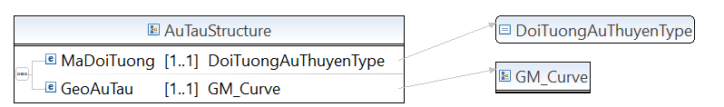

* Lược đồ XML cấu trúc dữ liệu Bãi đáp trực thăng:

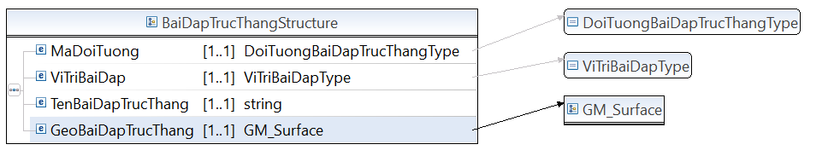

* Lược đồ XML cấu trúc dữ liệu Bến bãi:

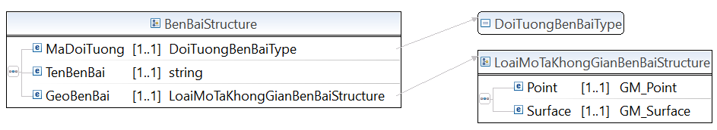

* Lược đồ XML cấu trúc dữ liệu Cảng hàng không:

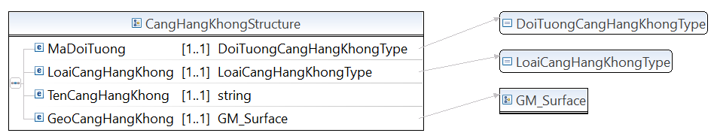

* Lược đồ XML cấu trúc dữ liệu Cầu giao thông:

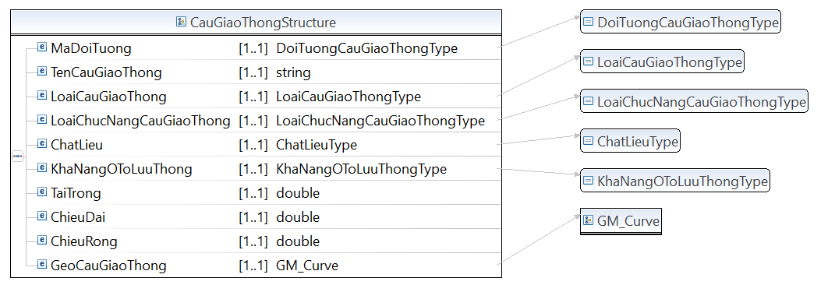

* Lược đồ XML cấu trúc dữ liệu Cầu tàu:

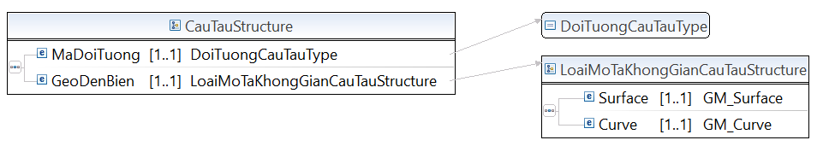

* Lược đồ XML cấu trúc dữ liệu Cột tín hiệu:

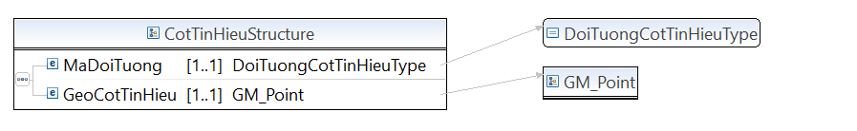

* Lược đồ XML cấu trúc dữ liệu Đèn biển:

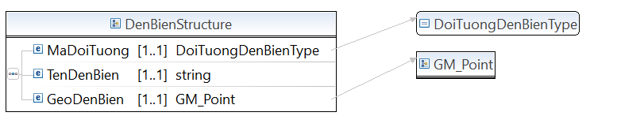

* Lược đồ XML cấu trúc dữ liệu Đèo:

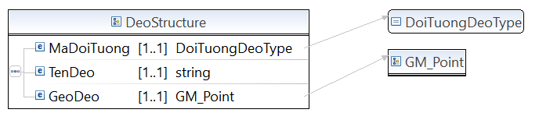

* Lược đồ XML cấu trúc dữ liệu Đoạn tim đường bộ:

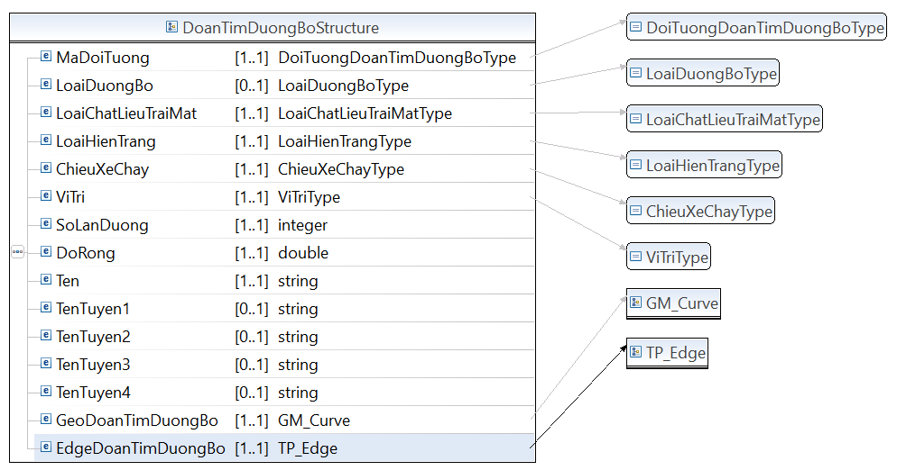

* Lược đồ XML cấu trúc dữ liệu Đoạn vượt sông suối:

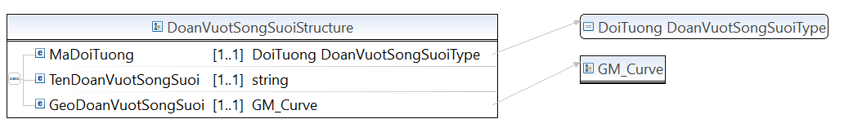

* Lược đồ XML cấu trúc dữ liệu Đường bang:

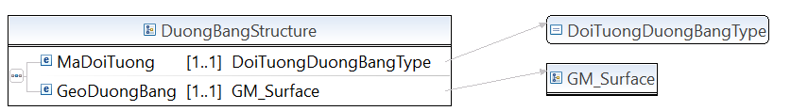

* Lược đồ XML cấu trúc dữ liệu Đường bờ vùng bờ thửa:

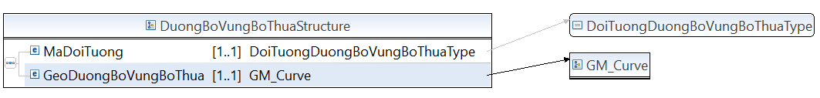

* Lược đồ XML cấu trúc dữ liệu Đường cáp treo:

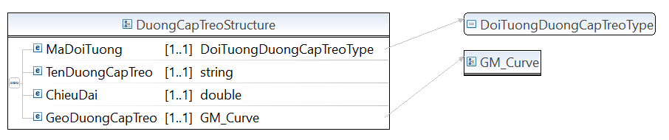

* Lược đồ XML cấu trúc dữ liệu Đường lên cao có bậc xây

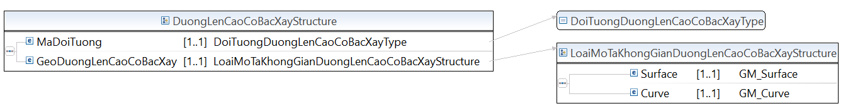

* Lược đồ XML cấu trúc dữ liệu Đường mòn:

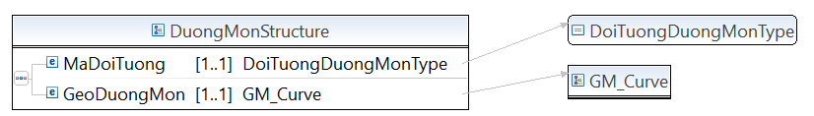

* Lược đồ XML cấu trúc dữ liệu Đường sắt:

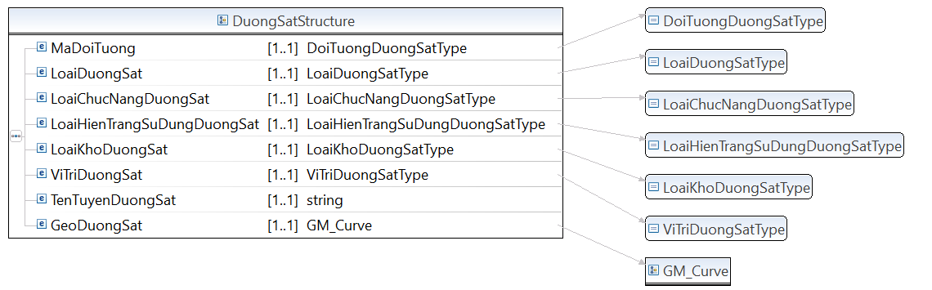

* Lược đồ XML cấu trúc dữ liệu Ga đường sắt:

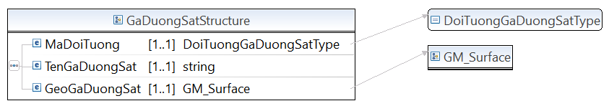

* Lược đồ XML cấu trúc dữ liệu Giao đường sắt và đường bộ:

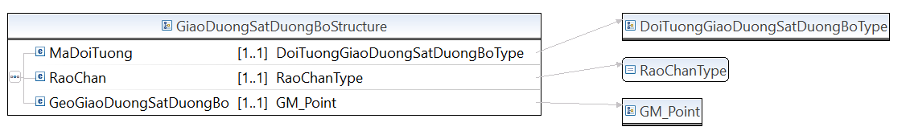

* Lược đồ XML cấu trúc dữ liệu Hầm giao thông:

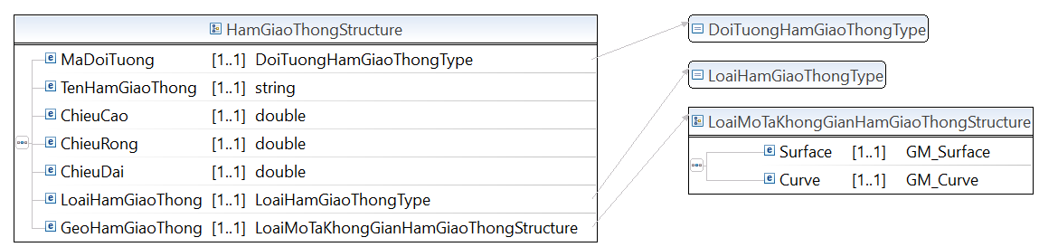

* Lược đồ XML cấu trúc dữ liệu Lối đi bộ sang đường:

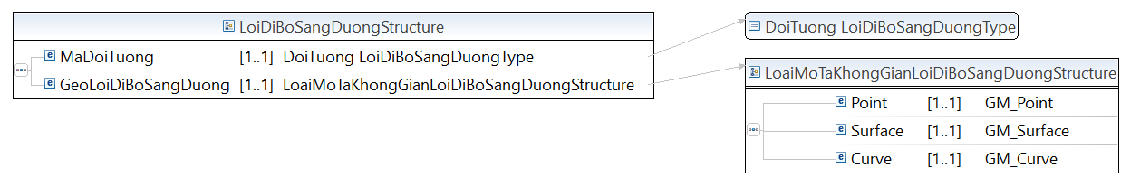

* Lược đồ XML cấu trúc dữ liệu Mặt đường bộ:

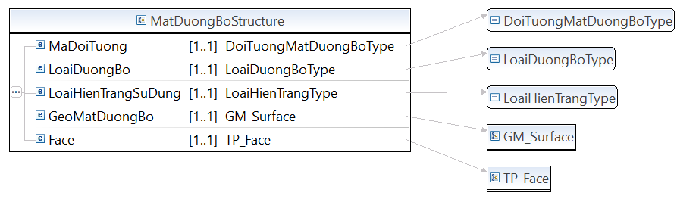

* Lược đồ XML cấu trúc dữ liệu Nhà ga hàng không:

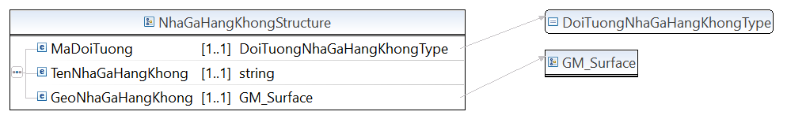

* Lược đồ XML cấu trúc dữ liệu Nơi neo đậu tàu thuyền:

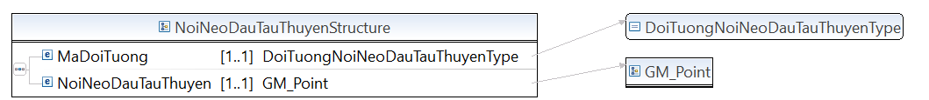

* Lược đồ XML cấu trúc dữ liệu Nút đường sắt

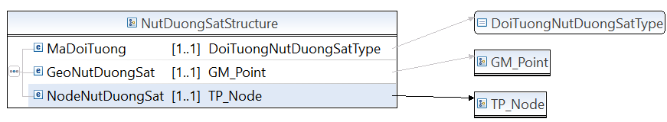

* Lược đồ XML cấu trúc dữ liệu Nút mạng đường bộ

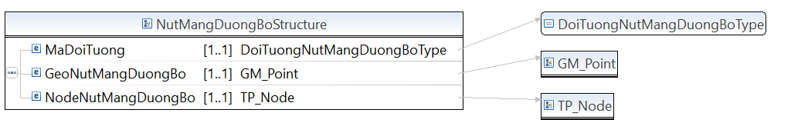

* Lược đồ XML cấu trúc dữ liệu Ranh giới đường bộ

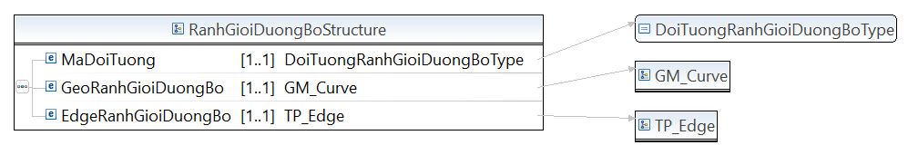

* Lược đồ XML cấu trúc dữ liệu Rào chắn đường sắt

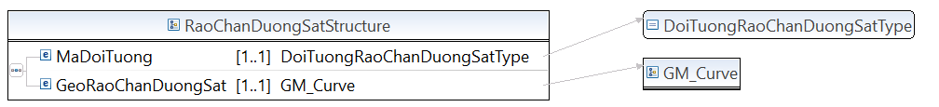

* Lược đồ XML cấu trúc dữ liệu Taluy giao thông

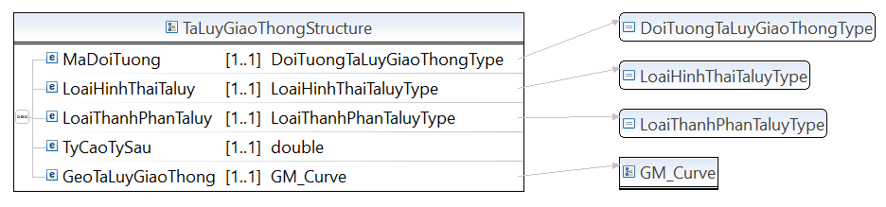

* Lược đồ XML cấu trúc dữ liệu Trụ đường cáp treo

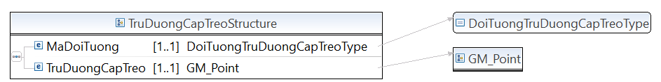

**Mã nguồn lược đồ chứa các cấu trúc thông tin của lược đồ dữ liệu nền địa lý – nhóm giao thông (GiaoThong.xsd)**

<?xml version=*“1.1”* encoding=*"UTF-8"*?>

<xsd:schema xmlns:xsd=*"http://www.w3.org/2001/XMLSchema"* xmlns:TTDLQG=*"..."* targetNamespace=*"..."* version=*“1.1”* elementFormDefault=*"qualified"*>

<!-- <xsd:include schemaLocation="BaseEnumType.xsd" /> -->

<xsd:annotation>

<xsd:documentation></xsd:documentation>

</xsd:annotation>

<xsd:complexType name=*"DoanTimDuongBoStructure"*>

<xsd:annotation>

<xsd:documentation>Thể hiện trung tuyến của phần đường dành cho các phương tiện giao thông lưu thông</xsd:documentation>

</xsd:annotation>

<xsd:sequence>

<xsd:element name=*"MaDoiTuong"* type=*"TTDLQG:DoiTuongDoanTimDuongBoType"* minOccurs=*"1"* maxOccurs=*"1"* />

<xsd:element name=*"LoaiDuongBo"* type=*"TTDLQG:LoaiDuongBoType"* minOccurs=*"0"* maxOccurs=*"1"* />

<xsd:element name=*"LoaiChatLieuTraiMat"* type=*"TTDLQG:LoaiChatLieuTraiMatType"* minOccurs=*"1"* maxOccurs=*"1"* />

<xsd:element name=*"LoaiHienTrang"* type=*"TTDLQG:LoaiHienTrangType"* minOccurs=*"1"* maxOccurs=*"1"* />

<xsd:element name=*"ChieuXeChay"* type=*"TTDLQG:ChieuXeChayType"* minOccurs=*"1"* maxOccurs=*"1"* />

<xsd:element name=*"ViTri"* type=*"TTDLQG:ViTriType"* minOccurs=*"1"* maxOccurs=*"1"* />

<xsd:element name=*"SoLanDuong"* type=*"xsd:integer"* minOccurs=*"1"* maxOccurs=*"1"* />

<xsd:element name=*"DoRong"* type=*"xsd:double"* minOccurs=*"1"* maxOccurs=*"1"* />

<xsd:element name=*"Ten"* type=*"xsd:string"* minOccurs=*"1"* maxOccurs=*"1"* />

<xsd:element name=*"TenTuyen1"* type=*"xsd:string"* minOccurs=*"0"* maxOccurs=*"1"* />

<xsd:element name=*"TenTuyen2"* type=*"xsd:string"* minOccurs=*"0"* maxOccurs=*"1"* />

<xsd:element name=*"TenTuyen3"* type=*"xsd:string"* minOccurs=*"0"* maxOccurs=*"1"* />

<xsd:element name=*"TenTuyen4"* type=*"xsd:string"* minOccurs=*"0"* maxOccurs=*"1"* />

<xsd:element name=*"GeoDoanTimDuongBo"* type=*"TTDLQG:GM_Curve"* minOccurs=*"1"* maxOccurs=*"1"* />

<xsd:element name=*"EdgeDoanTimDuongBo"* type=*"TTDLQG:TP_Edge"* minOccurs=*"1"* maxOccurs=*"1"* />

</xsd:sequence>

</xsd:complexType>

<xsd:complexType name=*"NutMangDuongBoStructure"*>

<xsd:annotation>

<xsd:documentation>Nút mạng đường bộ</xsd:documentation>

</xsd:annotation>

<xsd:sequence>

<xsd:element name=*"MaDoiTuong"* type=*"TTDLQG:DoiTuongNutMangDuongBoType"* minOccurs=*"1"* maxOccurs=*"1"* />

<xsd:element name=*"GeoNutMangDuongBo"* type=*"TTDLQG:GM_Point"* minOccurs=*"1"* maxOccurs=*"1"* />

<xsd:element name=*"NodeNutMangDuongBo"* type=*"TTDLQG:TP_Node"* minOccurs=*"1"* maxOccurs=*"1"* />

</xsd:sequence>

</xsd:complexType>

<xsd:complexType name=*"DoanVuotSongSuoiStructure"*>

<xsd:annotation>

<xsd:documentation>Áp dụng biểu thị đoạn đường bộ vượt sông suối không có cầu</xsd:documentation>

</xsd:annotation>

<xsd:sequence>

<xsd:element name=*"MaDoiTuong"* type=*"TTDLQG:DoiTuong DoanVuotSongSuoiType"* minOccurs=*"1"* maxOccurs=*"1"* />

<xsd:element name=*"TenDoanVuotSongSuoi"* type=*"xsd:string"* minOccurs=*"1"* maxOccurs=*"1"* />

<xsd:element name=*"GeoDoanVuotSongSuoi"* type=*"TTDLQG:GM_Curve"* minOccurs=*"1"* maxOccurs=*"1"* />

</xsd:sequence>

</xsd:complexType>

<xsd:complexType name=*"CauGiaoThongStructure"*>

<xsd:annotation>

<xsd:documentation>Là phương tiện nối liền 2 hay nhiều điểm khác nhau, giúp việc di chuyển giữa các điểm đó được dễ dàng hơn</xsd:documentation>

</xsd:annotation>

<xsd:sequence>

<xsd:element name=*"MaDoiTuong"* type=*"TTDLQG:DoiTuongCauGiaoThongType"* minOccurs=*"1"* maxOccurs=*"1"* />

<xsd:element name=*"TenCauGiaoThong"* type=*"xsd:string"* minOccurs=*"1"* maxOccurs=*"1"* />

<xsd:element name=*"LoaiCauGiaoThong"* type=*"TTDLQG:LoaiCauGiaoThongType"* minOccurs=*"1"* maxOccurs=*"1"* />

<xsd:element name=*"LoaiChucNangCauGiaoThong"* type=*"TTDLQG:LoaiChucNangCauGiaoThongType"* minOccurs=*"1"* maxOccurs=*"1"* />

<xsd:element name=*"ChatLieu"* type=*"TTDLQG:ChatLieuType"* minOccurs=*"1"* maxOccurs=*"1"* />

<xsd:element name=*"KhaNangOToLuuThong"* type=*"TTDLQG:KhaNangOToLuuThongType"* minOccurs=*"1"* maxOccurs=*"1"* />

<xsd:element name=*"TaiTrong"* type=*"xsd:double"* minOccurs=*"1"* maxOccurs=*"1"* />

<xsd:element name=*"ChieuDai"* type=*"xsd:double"* minOccurs=*"1"* maxOccurs=*"1"* />

<xsd:element name=*"ChieuRong"* type=*"xsd:double"* minOccurs=*"1"* maxOccurs=*"1"* />

<xsd:element name=*"GeoCauGiaoThong"* type=*"TTDLQG:GM_Curve"* minOccurs=*"1"* maxOccurs=*"1"* />

</xsd:sequence>

</xsd:complexType>

<xsd:complexType name=*"HamGiaoThongStructure"*>

<xsd:annotation>

<xsd:documentation>Hầm giao thông là một loại công trình ngầm nhằm mục đích vượt qua các địa hình bằng cách chui qua nó</xsd:documentation>

</xsd:annotation>

<xsd:sequence>

<xsd:element name=*"MaDoiTuong"* type=*"TTDLQG:DoiTuongHamGiaoThongType"* minOccurs=*"1"* maxOccurs=*"1"* />

<xsd:element name=*"TenHamGiaoThong"* type=*"xsd:string"* minOccurs=*"1"* maxOccurs=*"1"* />

<xsd:element name=*"ChieuCao"* type=*"xsd:double"* minOccurs=*"1"* maxOccurs=*"1"* />

<xsd:element name=*"ChieuRong"* type=*"xsd:double"* minOccurs=*"1"* maxOccurs=*"1"* />

<xsd:element name=*"ChieuDai"* type=*"xsd:double"* minOccurs=*"1"* maxOccurs=*"1"* />

<xsd:element name=*"LoaiHamGiaoThong"* type=*"TTDLQG:LoaiHamGiaoThongType"* minOccurs=*"1"* maxOccurs=*"1"* />

<xsd:element name=*"GeoHamGiaoThong"* type=*"TTDLQG:LoaiMoTaKhongGianHamGiaoThongStructure"* minOccurs=*"1"* maxOccurs=*"1"* />

</xsd:sequence>

</xsd:complexType>

<xsd:complexType name=*"LoiDiBoSangDuongStructure"*>

<xsd:annotation>

<xsd:documentation>Là lối dành cho người đi bộ sang đường</xsd:documentation>

</xsd:annotation>

<xsd:sequence>

<xsd:element name=*"MaDoiTuong"* type=*"TTDLQG:DoiTuong LoiDiBoSangDuongType"* minOccurs=*"1"* maxOccurs=*"1"* />

<xsd:element name=*"GeoLoiDiBoSangDuong"* type=*"TTDLQG:LoaiMoTaKhongGianLoiDiBoSangDuongStructure"* minOccurs=*"1"* maxOccurs=*"1"* />

</xsd:sequence>

</xsd:complexType>

<xsd:complexType name=*"TaLuyGiaoThongStructure"*>

<xsd:annotation>

<xsd:documentation>Đối tượng địa lý mô tả sự biến đổi địa hình do sự đào đắp các công trình giao thông</xsd:documentation>

</xsd:annotation>

<xsd:sequence>

<xsd:element name=*"MaDoiTuong"* type=*"TTDLQG:DoiTuongTaLuyGiaoThongType"* minOccurs=*"1"* maxOccurs=*"1"* />

<xsd:element name=*"LoaiHinhThaiTaluy"* type=*"TTDLQG:LoaiHinhThaiTaluyType"* minOccurs=*"1"* maxOccurs=*"1"* />

<xsd:element name=*"LoaiThanhPhanTaluy"* type=*"TTDLQG:LoaiThanhPhanTaluyType"* minOccurs=*"1"* maxOccurs=*"1"* />

<xsd:element name=*"TyCaoTySau"* type=*"xsd:double"* minOccurs=*"1"* maxOccurs=*"1"* />

<xsd:element name=*"GeoTaLuyGiaoThong"* type=*"TTDLQG:GM_Curve"* minOccurs=*"1"* maxOccurs=*"1"* />

</xsd:sequence>

</xsd:complexType>

<xsd:complexType name=*"MatDuongBoStructure"*>

<xsd:annotation>

<xsd:documentation>Là kiểu đối tượng địa lý gồm các đối tượng biểu thị các thành phần của mặt đường bộ gồm: Nền đường, giải phân cách, đảo giao thông</xsd:documentation>

</xsd:annotation>

<xsd:sequence>

<xsd:element name=*"MaDoiTuong"* type=*"TTDLQG:DoiTuongMatDuongBoType"* minOccurs=*"1"* maxOccurs=*"1"* />

<xsd:element name=*"LoaiDuongBo"* type=*"TTDLQG:LoaiDuongBoType"* minOccurs=*"1"* maxOccurs=*"1"* />

<xsd:element name=*"LoaiHienTrangSuDung"* type=*"TTDLQG:LoaiHienTrangType"* minOccurs=*"1"* maxOccurs=*"1"* />

<xsd:element name=*"GeoMatDuongBo"* type=*"TTDLQG:GM_Surface"* minOccurs=*"1"* maxOccurs=*"1"* />

<xsd:element name=*"Face"* type=*"TTDLQG:TP_Face"* minOccurs=*"1"* maxOccurs=*"1"* />

</xsd:sequence>

</xsd:complexType>

<xsd:complexType name=*"RanhGioiDuongBoStructure"*>

<xsd:annotation>

<xsd:documentation>Là kiểu đối tượng địa lý gồm các đối tượng biểu thị các thành phần ranh giới của đường bộ gồm: Mép lòng đường, mép đường, mép đường qua cầu, chia nhánh đường quy ước</xsd:documentation>

</xsd:annotation>

<xsd:sequence>

<xsd:element name=*"MaDoiTuong"* type=*"TTDLQG:DoiTuongRanhGioiDuongBoType"* minOccurs=*"1"* maxOccurs=*"1"* />

<xsd:element name=*"GeoRanhGioiDuongBo"* type=*"TTDLQG:GM_Curve"* minOccurs=*"1"* maxOccurs=*"1"* />

<xsd:element name=*"EdgeRanhGioiDuongBo"* type=*"TTDLQG:TP_Edge"* minOccurs=*"1"* maxOccurs=*"1"* />

</xsd:sequence>

</xsd:complexType>

<xsd:complexType name=*"DuongMonStructure"*>

<xsd:annotation>

<xsd:documentation>Là đường do vết chân người đi lại nhiều mà thành (thường ở các vùng rừng, núi)</xsd:documentation>

</xsd:annotation>

<xsd:sequence>

<xsd:element name=*"MaDoiTuong"* type=*"TTDLQG:DoiTuongDuongMonType"* minOccurs=*"1"* maxOccurs=*"1"* />

<xsd:element name=*"GeoDuongMon"* type=*"TTDLQG:GM_Curve"* minOccurs=*"1"* maxOccurs=*"1"* />

</xsd:sequence>

</xsd:complexType>

<xsd:complexType name=*"DuongBoVungBoThuaStructure"*>

<xsd:annotation>

<xsd:documentation>Là bờ bao quanh một thửa ruộng để giữ hoặc tháo nước</xsd:documentation>

</xsd:annotation>

<xsd:sequence>

<xsd:element name=*"MaDoiTuong"* type=*"TTDLQG:DoiTuongDuongBoVungBoThuaType"* minOccurs=*"1"* maxOccurs=*"1"* />

<xsd:element name=*"GeoDuongBoVungBoThua"* type=*"TTDLQG:GM_Curve"* minOccurs=*"1"* maxOccurs=*"1"* />

</xsd:sequence>

</xsd:complexType>

<xsd:complexType name=*"DuongLenCaoCoBacXayStructure"*>

<xsd:annotation>

<xsd:documentation>Cấu trúc đường lên cao có bậc xây</xsd:documentation>

</xsd:annotation>

<xsd:sequence>

<xsd:element name=*"MaDoiTuong"* type=*"TTDLQG:DoiTuongDuongLenCaoCoBacXayType"* minOccurs=*"1"* maxOccurs=*"1"* />

<xsd:element name=*"GeoDuongLenCaoCoBacXay"* type=*"TTDLQG:LoaiMoTaKhongGianDuongLenCaoCoBacXayStructure"* minOccurs=*"1"* maxOccurs=*"1"* />

</xsd:sequence>

</xsd:complexType>

<xsd:complexType name=*"DuongSatStructure"*>

<xsd:annotation>

<xsd:documentation>Cấu trúc đường sắt</xsd:documentation>

</xsd:annotation>

<xsd:sequence>

<xsd:element name=*"MaDoiTuong"* type=*"TTDLQG:DoiTuongDuongSatType"* minOccurs=*"1"* maxOccurs=*"1"* />

<xsd:element name=*"LoaiDuongSat"* type=*"TTDLQG:LoaiDuongSatType"* minOccurs=*"1"* maxOccurs=*"1"* />

<xsd:element name=*"LoaiChucNangDuongSat"* type=*"TTDLQG:LoaiChucNangDuongSatType"* minOccurs=*"1"* maxOccurs=*"1"* />

<xsd:element name=*"LoaiHienTrangSuDungDuongSat"* type=*"TTDLQG:LoaiHienTrangSuDungDuongSatType"* minOccurs=*"1"* maxOccurs=*"1"* />

<xsd:element name=*"LoaiKhoDuongSat"* type=*"TTDLQG:LoaiKhoDuongSatType"* minOccurs=*"1"* maxOccurs=*"1"* />

<xsd:element name=*"ViTriDuongSat"* type=*"TTDLQG:ViTriDuongSatType"* minOccurs=*"1"* maxOccurs=*"1"* />

<xsd:element name=*"TenTuyenDuongSat"* type=*"xsd:string"* minOccurs=*"1"* maxOccurs=*"1"* />

<xsd:element name=*"GeoDuongSat"* type=*"TTDLQG:GM_Curve"* minOccurs=*"1"* maxOccurs=*"1"* />

</xsd:sequence>

</xsd:complexType>

<xsd:complexType name=*"NutDuongSatStructure"*>

<xsd:annotation>

<xsd:documentation>Giao cắt giữa các đoạn đường sắt cùng cấp</xsd:documentation>

</xsd:annotation>

<xsd:sequence>

<xsd:element name=*"MaDoiTuong"* type=*"TTDLQG:DoiTuongNutDuongSatType"* minOccurs=*"1"* maxOccurs=*"1"* />

<xsd:element name=*"GeoNutDuongSat"* type=*"TTDLQG:GM_Point"* minOccurs=*"1"* maxOccurs=*"1"* />

<xsd:element name=*"NodeNutDuongSat"* type=*"TTDLQG:TP_Node"* minOccurs=*"1"* maxOccurs=*"1"* />

</xsd:sequence>

</xsd:complexType>

<xsd:complexType name=*"GaDuongSatStructure"*>

<xsd:annotation>

<xsd:documentation>Ga đường sắt là nơi để phương tiện giao thông đường sắt dừng, tránh, vượt, xếp, dỡ hàng hoá, đón trả khách, thực hiện tác nghiệp kỹ thuật và các dịch vụ khác. Ga đường sắt có nhà ga, quảng trường, kho, bãi hàng, ke ga, tường rào, khu dịch vụ, trang thiết bị cần thiết và các công trình đường sắt khác</xsd:documentation>

</xsd:annotation>

<xsd:sequence>

<xsd:element name=*"MaDoiTuong"* type=*"TTDLQG:DoiTuongGaDuongSatType"* minOccurs=*"1"* maxOccurs=*"1"* />

<xsd:element name=*"TenGaDuongSat"* type=*"xsd:string"* minOccurs=*"1"* maxOccurs=*"1"* />

<xsd:element name=*"GeoGaDuongSat"* type=*"TTDLQG:GM_Surface"* minOccurs=*"1"* maxOccurs=*"1"* />

</xsd:sequence>

</xsd:complexType>

<xsd:complexType name=*"RaoChanDuongSatStructure"*>

<xsd:annotation>

<xsd:documentation>Thể hiện vị trí rào chắn đường sắt</xsd:documentation>

</xsd:annotation>

<xsd:sequence>

<xsd:element name=*"MaDoiTuong"* type=*"TTDLQG:DoiTuongRaoChanDuongSatType"* minOccurs=*"1"* maxOccurs=*"1"* />

<xsd:element name=*"GeoRaoChanDuongSat"* type=*"TTDLQG:GM_Curve"* minOccurs=*"1"* maxOccurs=*"1"* />

</xsd:sequence>

</xsd:complexType>

<xsd:complexType name=*"GiaoDuongSatDuongBoStructure"*>

<xsd:annotation>

<xsd:documentation>Chỗ giao trên mặt đất giữa đường sắt và đường bộ</xsd:documentation>

</xsd:annotation>

<xsd:sequence>

<xsd:element name=*"MaDoiTuong"* type=*"TTDLQG:DoiTuongGiaoDuongSatDuongBoType"* minOccurs=*"1"* maxOccurs=*"1"* />

<xsd:element name=*"RaoChan"* type=*"TTDLQG:RaoChanType"* minOccurs=*"1"* maxOccurs=*"1"* />

<xsd:element name=*"GeoGiaoDuongSatDuongBo"* type=*"TTDLQG:GM_Point"* minOccurs=*"1"* maxOccurs=*"1"* />

</xsd:sequence>

</xsd:complexType>

<xsd:complexType name=*"DuongBangStructure"*>

<xsd:annotation>

<xsd:documentation>Các đường cất hạ cánh, đường lăn chính, đường lăn phụ, đường tắt (đường lăn cao tốc, đường lăn nối) và sân chuẩn bị cất cánh, hạ cánh của máy bay.</xsd:documentation>

</xsd:annotation>

<xsd:sequence>

<xsd:element name=*"MaDoiTuong"* type=*"TTDLQG:DoiTuongDuongBangType"* minOccurs=*"1"* maxOccurs=*"1"* />

<xsd:element name=*"GeoDuongBang"* type=*"TTDLQG:GM_Surface"* minOccurs=*"1"* maxOccurs=*"1"* />

</xsd:sequence>

</xsd:complexType>

<xsd:complexType name=*"CangHangKhongStructure"*>

<xsd:annotation>

<xsd:documentation>Cảng hàng không là khu vực xác định, bao gồm sân bay, nhà ga và trang bị, thiết bị, công trình cần thiết khác được sử dụng cho tàu bay đi, đến và thực hiện vận chuyển hàng không Quốc tế và Nội địa.</xsd:documentation>

</xsd:annotation>

<xsd:sequence>

<xsd:element name=*"MaDoiTuong"* type=*"TTDLQG:DoiTuongCangHangKhongType"* minOccurs=*"1"* maxOccurs=*"1"* />

<xsd:element name=*"LoaiCangHangKhong"* type=*"TTDLQG:LoaiCangHangKhongType"* minOccurs=*"1"* maxOccurs=*"1"* />

<xsd:element name=*"TenCangHangKhong"* type=*"xsd:string"* minOccurs=*"1"* maxOccurs=*"1"* />

<xsd:element name=*"GeoCangHangKhong"* type=*"TTDLQG:GM_Surface"* minOccurs=*"1"* maxOccurs=*"1"* />

</xsd:sequence>

</xsd:complexType>

<xsd:complexType name=*"NhaGaHangKhongStructure"*>

<xsd:annotation>

<xsd:documentation>Cấu trúc nhà ga hang không</xsd:documentation>

</xsd:annotation>

<xsd:sequence>

<xsd:element name=*"MaDoiTuong"* type=*"TTDLQG:DoiTuongNhaGaHangKhongType"* minOccurs=*"1"* maxOccurs=*"1"* />

<xsd:element name=*"TenNhaGaHangKhong"* type=*"xsd:string"* minOccurs=*"1"* maxOccurs=*"1"* />

<xsd:element name=*"GeoNhaGaHangKhong"* type=*"TTDLQG:GM_Surface"* minOccurs=*"1"* maxOccurs=*"1"* />

</xsd:sequence>

</xsd:complexType>

<xsd:complexType name=*"BaiDapTrucThangStructure"*>

<xsd:annotation>

<xsd:documentation>Cấu trúc của bãi đáp trực thăng</xsd:documentation>

</xsd:annotation>

<xsd:sequence>

<xsd:element name=*"MaDoiTuong"* type=*"TTDLQG:DoiTuongBaiDapTrucThangType"* minOccurs=*"1"* maxOccurs=*"1"* />

<xsd:element name=*"ViTriBaiDap"* type=*"TTDLQG:ViTriBaiDapType"* minOccurs=*"1"* maxOccurs=*"1"* />

<xsd:element name=*"TenBaiDapTrucThang"* type=*"xsd:string"* minOccurs=*"1"* maxOccurs=*"1"* />

<xsd:element name=*"GeoBaiDapTrucThang"* type=*"TTDLQG:GM_Surface"* minOccurs=*"1"* maxOccurs=*"1"* />

</xsd:sequence>

</xsd:complexType>

<xsd:complexType name=*"DuongCapTreoStructure"*>

<xsd:annotation>

<xsd:documentation>Đường cáp treo là loại phương tiện di chuyển trên không thông qua các cabin di chuyển trên dây cáp được nối giữa các cột cao, giúp hành khách có điều kiện di chuyển nhanh chóng, thuận tiện</xsd:documentation>

</xsd:annotation>

<xsd:sequence>

<xsd:element name=*"MaDoiTuong"* type=*"TTDLQG:DoiTuongDuongCapTreoType"* minOccurs=*"1"* maxOccurs=*"1"* />

<xsd:element name=*"TenDuongCapTreo"* type=*"xsd:string"* minOccurs=*"1"* maxOccurs=*"1"* />

<xsd:element name=*"ChieuDai"* type=*"xsd:double"* minOccurs=*"1"* maxOccurs=*"1"* />

<xsd:element name=*"GeoDuongCapTreo"* type=*"TTDLQG:GM_Curve"* minOccurs=*"1"* maxOccurs=*"1"* />

</xsd:sequence>

</xsd:complexType>

<xsd:complexType name=*"TruDuongCapTreoStructure"*>

<xsd:annotation>

<xsd:documentation>Cấu trúc của trụ đường cáp treo</xsd:documentation>

</xsd:annotation>

<xsd:sequence>

<xsd:element name=*"MaDoiTuong"* type=*"TTDLQG:DoiTuongTruDuongCapTreoType"* minOccurs=*"1"* maxOccurs=*"1"* />

<xsd:element name=*"TruDuongCapTreo"* type=*"TTDLQG:GM_Point"* minOccurs=*"1"* maxOccurs=*"1"* />

</xsd:sequence>

</xsd:complexType>

<xsd:complexType name=*"BenBaiStructure"*>

<xsd:annotation>

<xsd:documentation>Nơi dành cho những hoạt động dừng, đỗ, bảo trì máy móc hoặc thực hiện các dịch vụ chuyên chở hàng hoá, hành khách của các loại phương tiện giao thông</xsd:documentation>

</xsd:annotation>

<xsd:sequence>

<xsd:element name=*"MaDoiTuong"* type=*"TTDLQG:DoiTuongBenBaiType"* minOccurs=*"1"* maxOccurs=*"1"* />

<xsd:element name=*"TenBenBai"* type=*"xsd:string"* minOccurs=*"1"* maxOccurs=*"1"* />

<xsd:element name=*"GeoBenBai"* type=*"TTDLQG:LoaiMoTaKhongGianBenBaiStructure"* minOccurs=*"1"* maxOccurs=*"1"* />

</xsd:sequence>

</xsd:complexType>

<xsd:complexType name=*"DeoStructure"*>

<xsd:annotation>

<xsd:documentation>Đèo là một đoạn tuyến đường vượt qua một dãy núi hoặc trên một sườn núi. Thể hiện đèo bằng điểm cao nhất của đường đèo</xsd:documentation>

</xsd:annotation>

<xsd:sequence>

<xsd:element name=*"MaDoiTuong"* type=*"TTDLQG:DoiTuongDeoType"* minOccurs=*"1"* maxOccurs=*"1"* />

<xsd:element name=*"TenDeo"* type=*"xsd:string"* minOccurs=*"1"* maxOccurs=*"1"* />

<xsd:element name=*"GeoDeo"* type=*"TTDLQG:GM_Point"* minOccurs=*"1"* maxOccurs=*"1"* />

</xsd:sequence>

</xsd:complexType>

<xsd:complexType name=*"DenBienStructure"*>

<xsd:annotation>

<xsd:documentation>Đèn biển là báo hiệu hàng hải được thiết lập cố định tại các vị trí cần thiết ven bờ biển, trong vùng nước cảng biển và vùng biển Việt Nam</xsd:documentation>

</xsd:annotation>

<xsd:sequence>

<xsd:element name=*"MaDoiTuong"* type=*"TTDLQG:DoiTuongDenBienType"* minOccurs=*"1"* maxOccurs=*"1"* />

<xsd:element name=*"TenDenBien"* type=*"xsd:string"* minOccurs=*"1"* maxOccurs=*"1"* />

<xsd:element name=*"GeoDenBien"* type=*"TTDLQG:GM_Point"* minOccurs=*"1"* maxOccurs=*"1"* />

</xsd:sequence>

</xsd:complexType>

<xsd:complexType name=*"CauTauStructure"*>

<xsd:annotation>

<xsd:documentation>Công trình xây dựng ở bến cảng để tàu thuyền, sà lan,... cập bến xếp dỡ hàng hoá hoặc để hành khách lên xuống</xsd:documentation>

</xsd:annotation>

<xsd:sequence>

<xsd:element name=*"MaDoiTuong"* type=*"TTDLQG:DoiTuongCauTauType"* minOccurs=*"1"* maxOccurs=*"1"* />

<xsd:element name=*"GeoDenBien"* type=*"TTDLQG:LoaiMoTaKhongGianCauTauStructure"* minOccurs=*"1"* maxOccurs=*"1"* />

</xsd:sequence>

</xsd:complexType>

<xsd:complexType name=*"CotTinHieuStructure"*>

<xsd:annotation>

<xsd:documentation>Là các cột báo hiệu giao thông dọc bờ sông</xsd:documentation>

</xsd:annotation>

<xsd:sequence>

<xsd:element name=*"MaDoiTuong"* type=*"TTDLQG:DoiTuongCotTinHieuType"* minOccurs=*"1"* maxOccurs=*"1"* />

<xsd:element name=*"GeoCotTinHieu"* type=*"TTDLQG:GM_Point"* minOccurs=*"1"* maxOccurs=*"1"* />

</xsd:sequence>

</xsd:complexType>

<xsd:complexType name=*"NoiNeoDauTauThuyenStructure"*>

<xsd:annotation>

<xsd:documentation>Là vị trí neo đậu tàu, thuyền</xsd:documentation>

</xsd:annotation>

<xsd:sequence>

<xsd:element name=*"MaDoiTuong"* type=*"TTDLQG:DoiTuongNoiNeoDauTauThuyenType"* minOccurs=*"1"* maxOccurs=*"1"* />

<xsd:element name=*"NoiNeoDauTauThuyen"* type=*"TTDLQG:GM_Point"* minOccurs=*"1"* maxOccurs=*"1"* />

</xsd:sequence>

</xsd:complexType>

<xsd:complexType name=*"AuTauStructure"*>

<xsd:annotation>

<xsd:documentation>Nơi có công trình dâng nước, hạ nước để đưa phương tiện giao thông thủy vượt qua mực nước chênh lệch</xsd:documentation>

</xsd:annotation>

<xsd:sequence>

<xsd:element name=*"MaDoiTuong"* type=*"TTDLQG:DoiTuongAuThuyenType"* minOccurs=*"1"* maxOccurs=*"1"* />

<xsd:element name=*"GeoAuTau"* type=*"TTDLQG:GM_Curve"* minOccurs=*"1"* maxOccurs=*"1"* />

</xsd:sequence>

</xsd:complexType>

<xsd:simpleType name=*"DoiTuongDoanTimDuongBoType"*>

<xsd:annotation>

<xsd:documentation>Đối tượng đoạn tim đường bộ</xsd:documentation>

</xsd:annotation>

<xsd:restriction base=*"xsd:token"*>

<xsd:enumeration value=*"HA13"*><xsd:annotation><xsd:documentation>xsd:string</xsd:documentation></xsd:annotation></xsd:enumeration>

</xsd:restriction>

</xsd:simpleType>

<xsd:simpleType name=*"LoaiDuongBoType"*>

<xsd:annotation>

<xsd:documentation>Lọai đường bộ</xsd:documentation>

</xsd:annotation>

<xsd:restriction base=*"xsd:token"*>

<xsd:enumeration value=*"1"*><xsd:annotation><xsd:documentation>xsd:string</xsd:documentation></xsd:annotation></xsd:enumeration>

<xsd:enumeration value=*"2"*><xsd:annotation><xsd:documentation>xsd:string</xsd:documentation></xsd:annotation></xsd:enumeration>

<xsd:enumeration value=*"3"*><xsd:annotation><xsd:documentation>xsd:string</xsd:documentation></xsd:annotation></xsd:enumeration>

<xsd:enumeration value=*"4"*><xsd:annotation><xsd:documentation>xsd:string</xsd:documentation></xsd:annotation></xsd:enumeration>

<xsd:enumeration value=*"5"*><xsd:annotation><xsd:documentation>xsd:string</xsd:documentation></xsd:annotation></xsd:enumeration>

<xsd:enumeration value=*"6"*><xsd:annotation><xsd:documentation>xsd:string</xsd:documentation></xsd:annotation></xsd:enumeration>

<xsd:enumeration value=*"7"*><xsd:annotation><xsd:documentation>xsd:string</xsd:documentation></xsd:annotation></xsd:enumeration>

<xsd:enumeration value=*"8"*><xsd:annotation><xsd:documentation>xsd:string</xsd:documentation></xsd:annotation></xsd:enumeration>

<xsd:enumeration value=*"9"*><xsd:annotation><xsd:documentation>xsd:string</xsd:documentation></xsd:annotation></xsd:enumeration>

</xsd:restriction>

</xsd:simpleType>

<xsd:simpleType name=*"LoaiChatLieuTraiMatType"*>

<xsd:annotation>

<xsd:documentation>Lọai chất liệu trải mặt</xsd:documentation>

</xsd:annotation>

<xsd:restriction base=*"xsd:token"*>

<xsd:enumeration value=*"1"*><xsd:annotation><xsd:documentation>xsd:string</xsd:documentation></xsd:annotation></xsd:enumeration>

<xsd:enumeration value=*"2"*><xsd:annotation><xsd:documentation>xsd:string</xsd:documentation></xsd:annotation></xsd:enumeration>

<xsd:enumeration value=*"3"*><xsd:annotation><xsd:documentation>xsd:string</xsd:documentation></xsd:annotation></xsd:enumeration>

<xsd:enumeration value=*"4"*><xsd:annotation><xsd:documentation>xsd:string</xsd:documentation></xsd:annotation></xsd:enumeration>

<xsd:enumeration value=*"5"*><xsd:annotation><xsd:documentation>xsd:string</xsd:documentation></xsd:annotation></xsd:enumeration>

<xsd:enumeration value=*"6"*><xsd:annotation><xsd:documentation>xsd:string</xsd:documentation></xsd:annotation></xsd:enumeration>

</xsd:restriction>

</xsd:simpleType>

<xsd:simpleType name=*"LoaiHienTrangType"*>

<xsd:annotation>

<xsd:documentation>Lọai hiện trạng</xsd:documentation>

</xsd:annotation>

<xsd:restriction base=*"xsd:token"*>

<xsd:enumeration value=*"1"*><xsd:annotation><xsd:documentation>xsd:string</xsd:documentation></xsd:annotation></xsd:enumeration>

<xsd:enumeration value=*"2"*><xsd:annotation><xsd:documentation>xsd:string</xsd:documentation></xsd:annotation></xsd:enumeration>

</xsd:restriction>

</xsd:simpleType>

<xsd:simpleType name=*"ChieuXeChayType"*>

<xsd:annotation>

<xsd:documentation>Chiều xe chạy</xsd:documentation>

</xsd:annotation>

<xsd:restriction base=*"xsd:token"*>

<xsd:enumeration value=*"1"*><xsd:annotation><xsd:documentation>xsd:string</xsd:documentation></xsd:annotation></xsd:enumeration>

<xsd:enumeration value=*"2"*><xsd:annotation><xsd:documentation>xsd:string</xsd:documentation></xsd:annotation></xsd:enumeration>

</xsd:restriction>

</xsd:simpleType>

<xsd:simpleType name=*"ViTriType"*>

<xsd:annotation>

<xsd:documentation>Vị trí</xsd:documentation>

</xsd:annotation>

<xsd:restriction base=*"xsd:token"*>

<xsd:enumeration value=*"1"*><xsd:annotation><xsd:documentation>xsd:string</xsd:documentation></xsd:annotation></xsd:enumeration>

<xsd:enumeration value=*"2"*><xsd:annotation><xsd:documentation>xsd:string</xsd:documentation></xsd:annotation></xsd:enumeration>

<xsd:enumeration value=*"3"*><xsd:annotation><xsd:documentation>xsd:string</xsd:documentation></xsd:annotation></xsd:enumeration>

<xsd:enumeration value=*"4"*><xsd:annotation><xsd:documentation>xsd:string</xsd:documentation></xsd:annotation></xsd:enumeration>

<xsd:enumeration value=*"5"*><xsd:annotation><xsd:documentation>xsd:string</xsd:documentation></xsd:annotation></xsd:enumeration>

<xsd:enumeration value=*"6"*><xsd:annotation><xsd:documentation>xsd:string</xsd:documentation></xsd:annotation></xsd:enumeration>

<xsd:enumeration value=*"7"*><xsd:annotation><xsd:documentation>xsd:string</xsd:documentation></xsd:annotation></xsd:enumeration>

<xsd:enumeration value=*"8"*><xsd:annotation><xsd:documentation>xsd:string</xsd:documentation></xsd:annotation></xsd:enumeration>

</xsd:restriction>

</xsd:simpleType>

<xsd:simpleType name=*"DoiTuongNutMangDuongBoType"*>

<xsd:annotation>

<xsd:documentation>Đối tượng nút mạng đường bộ</xsd:documentation>

</xsd:annotation>

<xsd:restriction base=*"xsd:token"*>

<xsd:enumeration value=*"HA10"*><xsd:annotation><xsd:documentation>xsd:string</xsd:documentation></xsd:annotation></xsd:enumeration>

</xsd:restriction>

</xsd:simpleType>

<xsd:simpleType name=*"DoiTuong DoanVuotSongSuoiType"*>

<xsd:annotation>

<xsd:documentation>Đối tượng đoạn vượt sông suối</xsd:documentation>

</xsd:annotation>

<xsd:restriction base=*"xsd:token"*>

<xsd:enumeration value=*"HA16"*><xsd:annotation><xsd:documentation>xsd:string</xsd:documentation></xsd:annotation></xsd:enumeration>

<xsd:enumeration value=*"HA17"*><xsd:annotation><xsd:documentation>xsd:string</xsd:documentation></xsd:annotation></xsd:enumeration>

<xsd:enumeration value=*"HA18"*><xsd:annotation><xsd:documentation>xsd:string</xsd:documentation></xsd:annotation></xsd:enumeration>

<xsd:enumeration value=*"HA19"*><xsd:annotation><xsd:documentation>xsd:string</xsd:documentation></xsd:annotation></xsd:enumeration>

</xsd:restriction>

</xsd:simpleType>

<xsd:simpleType name=*"DoiTuongCauGiaoThongType"*>

<xsd:annotation>

<xsd:documentation>Đối tượng cầu giao thông</xsd:documentation>

</xsd:annotation>

<xsd:restriction base=*"xsd:token"*>

<xsd:enumeration value=*"HG02"*><xsd:annotation><xsd:documentation>xsd:string</xsd:documentation></xsd:annotation></xsd:enumeration>

</xsd:restriction>

</xsd:simpleType>

<xsd:simpleType name=*"LoaiCauGiaoThongType"*>

<xsd:annotation>

<xsd:documentation>Loại cầu giao thông</xsd:documentation>

</xsd:annotation>

<xsd:restriction base=*"xsd:token"*>

<xsd:enumeration value=*"1"*><xsd:annotation><xsd:documentation>xsd:string</xsd:documentation></xsd:annotation></xsd:enumeration>

<xsd:enumeration value=*"2"*><xsd:annotation><xsd:documentation>xsd:string</xsd:documentation></xsd:annotation></xsd:enumeration>

<xsd:enumeration value=*"3"*><xsd:annotation><xsd:documentation>xsd:string</xsd:documentation></xsd:annotation></xsd:enumeration>

<xsd:enumeration value=*"4"*><xsd:annotation><xsd:documentation>xsd:string</xsd:documentation></xsd:annotation></xsd:enumeration>

<xsd:enumeration value=*"5"*><xsd:annotation><xsd:documentation>xsd:string</xsd:documentation></xsd:annotation></xsd:enumeration>

<xsd:enumeration value=*"6"*><xsd:annotation><xsd:documentation>xsd:string</xsd:documentation></xsd:annotation></xsd:enumeration>

</xsd:restriction>

</xsd:simpleType>

<xsd:simpleType name=*"LoaiChucNangCauGiaoThongType"*>

<xsd:annotation>

<xsd:documentation>Loại chức năng cầu giao thông</xsd:documentation>

</xsd:annotation>

<xsd:restriction base=*"xsd:token"*>

<xsd:enumeration value=*"1"*><xsd:annotation><xsd:documentation>xsd:string</xsd:documentation></xsd:annotation></xsd:enumeration>

<xsd:enumeration value=*"2"*><xsd:annotation><xsd:documentation>xsd:string</xsd:documentation></xsd:annotation></xsd:enumeration>

<xsd:enumeration value=*"3"*><xsd:annotation><xsd:documentation>xsd:string</xsd:documentation></xsd:annotation></xsd:enumeration>

<xsd:enumeration value=*"4"*><xsd:annotation><xsd:documentation>xsd:string</xsd:documentation></xsd:annotation></xsd:enumeration>

</xsd:restriction>

</xsd:simpleType>

<xsd:simpleType name=*"ChatLieuType"*>

<xsd:annotation>

<xsd:documentation>Chất liệu</xsd:documentation>

</xsd:annotation>

<xsd:restriction base=*"xsd:token"*>

<xsd:enumeration value=*"1"*><xsd:annotation><xsd:documentation>xsd:string</xsd:documentation></xsd:annotation></xsd:enumeration>

<xsd:enumeration value=*"2"*><xsd:annotation><xsd:documentation>xsd:string</xsd:documentation></xsd:annotation></xsd:enumeration>

<xsd:enumeration value=*"3"*><xsd:annotation><xsd:documentation>xsd:string</xsd:documentation></xsd:annotation></xsd:enumeration>

</xsd:restriction>

</xsd:simpleType>

<xsd:simpleType name=*"KhaNangOToLuuThongType"*>

<xsd:annotation>

<xsd:documentation>KhaNangOToLuuThong</xsd:documentation>

</xsd:annotation>

<xsd:restriction base=*"xsd:token"*>

<xsd:enumeration value=*"1"*><xsd:annotation><xsd:documentation>xsd:string</xsd:documentation></xsd:annotation></xsd:enumeration>

<xsd:enumeration value=*"2"*><xsd:annotation><xsd:documentation>xsd:string</xsd:documentation></xsd:annotation></xsd:enumeration>

</xsd:restriction>

</xsd:simpleType>

<xsd:simpleType name=*"DoiTuongHamGiaoThongType"*>

<xsd:annotation>

<xsd:documentation>Hầm giao thông</xsd:documentation>

</xsd:annotation>

<xsd:restriction base=*"xsd:token"*>

<xsd:enumeration value=*"HG05"*><xsd:annotation><xsd:documentation>xsd:string</xsd:documentation></xsd:annotation></xsd:enumeration>

</xsd:restriction>

</xsd:simpleType>

<xsd:simpleType name=*"LoaiHamGiaoThongType"*>

<xsd:annotation>

<xsd:documentation>Loại hầm giao thông</xsd:documentation>

</xsd:annotation>

<xsd:restriction base=*"xsd:token"*>

<xsd:enumeration value=*"1"*><xsd:annotation><xsd:documentation>xsd:string</xsd:documentation></xsd:annotation></xsd:enumeration>

<xsd:enumeration value=*"2"*><xsd:annotation><xsd:documentation>xsd:string</xsd:documentation></xsd:annotation></xsd:enumeration>

</xsd:restriction>

</xsd:simpleType>

<xsd:complexType name=*"LoaiMoTaKhongGianHamGiaoThongStructure"*>

<xsd:annotation>

<xsd:documentation>LoaiMoTaKhongGianHamGiaoThong</xsd:documentation>

</xsd:annotation>

<xsd:sequence>

<xsd:element name=*"Surface"* type=*"TTDLQG:GM_Surface"* minOccurs=*"1"* maxOccurs=*"1"* />

<xsd:element name=*"Curve"* type=*"TTDLQG:GM_Curve"* minOccurs=*"1"* maxOccurs=*"1"* />

</xsd:sequence>

</xsd:complexType>

<xsd:simpleType name=*"DoiTuong LoiDiBoSangDuongType"*>

<xsd:annotation>

<xsd:documentation>Lối đi bộ sang đường</xsd:documentation>

</xsd:annotation>

<xsd:restriction base=*"xsd:token"*>

<xsd:enumeration value=*"HG09"*><xsd:annotation><xsd:documentation>xsd:string</xsd:documentation></xsd:annotation></xsd:enumeration>

<xsd:enumeration value=*"HG10"*><xsd:annotation><xsd:documentation>xsd:string</xsd:documentation></xsd:annotation></xsd:enumeration>

</xsd:restriction>

</xsd:simpleType>

<xsd:complexType name=*"LoaiMoTaKhongGianLoiDiBoSangDuongStructure"*>

<xsd:annotation>

<xsd:documentation>LoaiMoTaKhongGianLoiDiBoSangDuong</xsd:documentation>

</xsd:annotation>

<xsd:sequence>

<xsd:element name=*"Point"* type=*"TTDLQG:GM_Point"* minOccurs=*"1"* maxOccurs=*"1"* />

<xsd:element name=*"Surface"* type=*"TTDLQG:GM_Surface"* minOccurs=*"1"* maxOccurs=*"1"* />

<xsd:element name=*"Curve"* type=*"TTDLQG:GM_Curve"* minOccurs=*"1"* maxOccurs=*"1"* />

</xsd:sequence>

</xsd:complexType>

<xsd:simpleType name=*"DoiTuongTaLuyGiaoThongType"*>

<xsd:annotation>

<xsd:documentation>TaLuy giao thông</xsd:documentation>

</xsd:annotation>

<xsd:restriction base=*"xsd:token"*>

<xsd:enumeration value=*"TaLuygiaothông"*><xsd:annotation><xsd:documentation>xsd:string</xsd:documentation></xsd:annotation></xsd:enumeration>

</xsd:restriction>

</xsd:simpleType>

<xsd:simpleType name=*"LoaiHinhThaiTaluyType"*>

<xsd:annotation>

<xsd:documentation>Loại hình Taluy</xsd:documentation>

</xsd:annotation>

<xsd:restriction base=*"xsd:token"*>

<xsd:enumeration value=*"1"*><xsd:annotation><xsd:documentation>xsd:string</xsd:documentation></xsd:annotation></xsd:enumeration>

<xsd:enumeration value=*"2"*><xsd:annotation><xsd:documentation>xsd:string</xsd:documentation></xsd:annotation></xsd:enumeration>

</xsd:restriction>

</xsd:simpleType>

<xsd:simpleType name=*"LoaiThanhPhanTaluyType"*>

<xsd:annotation>

<xsd:documentation>Loại thành phần Taluy</xsd:documentation>

</xsd:annotation>

<xsd:restriction base=*"xsd:token"*>

<xsd:enumeration value=*"1"*><xsd:annotation><xsd:documentation>xsd:string</xsd:documentation></xsd:annotation></xsd:enumeration>

<xsd:enumeration value=*"2"*><xsd:annotation><xsd:documentation>xsd:string</xsd:documentation></xsd:annotation></xsd:enumeration>

</xsd:restriction>

</xsd:simpleType>

<xsd:simpleType name=*"DoiTuongMatDuongBoType"*>

<xsd:annotation>

<xsd:documentation>Mặt đường bộ</xsd:documentation>

</xsd:annotation>

<xsd:restriction base=*"xsd:token"*>

<xsd:enumeration value=*"HA04"*><xsd:annotation><xsd:documentation>xsd:string</xsd:documentation></xsd:annotation></xsd:enumeration>

<xsd:enumeration value=*"HA05"*><xsd:annotation><xsd:documentation>xsd:string</xsd:documentation></xsd:annotation></xsd:enumeration>

<xsd:enumeration value=*"HA11"*><xsd:annotation><xsd:documentation>xsd:string</xsd:documentation></xsd:annotation></xsd:enumeration>

<xsd:enumeration value=*"HA07"*><xsd:annotation><xsd:documentation>xsd:string</xsd:documentation></xsd:annotation></xsd:enumeration>

<xsd:enumeration value=*"HA23"*><xsd:annotation><xsd:documentation>xsd:string</xsd:documentation></xsd:annotation></xsd:enumeration>

</xsd:restriction>

</xsd:simpleType>

<xsd:simpleType name=*"DoiTuongRanhGioiDuongBoType"*>

<xsd:annotation>

<xsd:documentation>Ranh giới đường bộ</xsd:documentation>

</xsd:annotation>

<xsd:restriction base=*"xsd:token"*>

<xsd:enumeration value=*"HA08"*><xsd:annotation><xsd:documentation>xsd:string</xsd:documentation></xsd:annotation></xsd:enumeration>

<xsd:enumeration value=*"HA15"*><xsd:annotation><xsd:documentation>xsd:string</xsd:documentation></xsd:annotation></xsd:enumeration>

<xsd:enumeration value=*"HA21"*><xsd:annotation><xsd:documentation>xsd:string</xsd:documentation></xsd:annotation></xsd:enumeration>

<xsd:enumeration value=*"HA22"*><xsd:annotation><xsd:documentation>xsd:string</xsd:documentation></xsd:annotation></xsd:enumeration>

</xsd:restriction>

</xsd:simpleType>

<xsd:simpleType name=*"DoiTuongDuongMonType"*>

<xsd:annotation>

<xsd:documentation>Đường mòn</xsd:documentation>

</xsd:annotation>

<xsd:restriction base=*"xsd:token"*>

<xsd:enumeration value=*"HA26"*><xsd:annotation><xsd:documentation>xsd:string</xsd:documentation></xsd:annotation></xsd:enumeration>

</xsd:restriction>

</xsd:simpleType>

<xsd:simpleType name=*"DoiTuongDuongBoVungBoThuaType"*>

<xsd:annotation>

<xsd:documentation>Đường bờ vùng bờ thửa</xsd:documentation>

</xsd:annotation>

<xsd:restriction base=*"xsd:token"*>

<xsd:enumeration value=*"HA27"*><xsd:annotation><xsd:documentation>xsd:string</xsd:documentation></xsd:annotation></xsd:enumeration>

</xsd:restriction>

</xsd:simpleType>

<xsd:simpleType name=*"DoiTuongDuongLenCaoCoBacXayType"*>

<xsd:annotation>

<xsd:documentation>Đường lên cao có bậc xây</xsd:documentation>

</xsd:annotation>

<xsd:restriction base=*"xsd:token"*>

<xsd:enumeration value=*"HG11"*><xsd:annotation><xsd:documentation>xsd:string</xsd:documentation></xsd:annotation></xsd:enumeration>

</xsd:restriction>

</xsd:simpleType>

<xsd:complexType name=*"LoaiMoTaKhongGianDuongLenCaoCoBacXayStructure"*>

<xsd:annotation>

<xsd:documentation>Mô tả không gian đường lên cao có bậc xây</xsd:documentation>

</xsd:annotation>

<xsd:sequence>

<xsd:element name=*"Surface"* type=*"TTDLQG:GM_Surface"* minOccurs=*"1"* maxOccurs=*"1"* />

<xsd:element name=*"Curve"* type=*"TTDLQG:GM_Curve"* minOccurs=*"1"* maxOccurs=*"1"* />

</xsd:sequence>

</xsd:complexType>

<xsd:simpleType name=*"DoiTuongDuongSatType"*>

<xsd:annotation>

<xsd:documentation>Đường sắt</xsd:documentation>

</xsd:annotation>

<xsd:restriction base=*"xsd:token"*>

<xsd:enumeration value=*"HB01"*><xsd:annotation><xsd:documentation>xsd:string</xsd:documentation></xsd:annotation></xsd:enumeration>

</xsd:restriction>

</xsd:simpleType>

<xsd:simpleType name=*"LoaiDuongSatType"*>

<xsd:annotation>

<xsd:documentation>Loại Đường sắt</xsd:documentation>

</xsd:annotation>

<xsd:restriction base=*"xsd:token"*>

<xsd:enumeration value=*"1"*><xsd:annotation><xsd:documentation>xsd:string</xsd:documentation></xsd:annotation></xsd:enumeration>

<xsd:enumeration value=*"2"*><xsd:annotation><xsd:documentation>xsd:string</xsd:documentation></xsd:annotation></xsd:enumeration>

</xsd:restriction>

</xsd:simpleType>

<xsd:simpleType name=*"LoaiChucNangDuongSatType"*>

<xsd:annotation>

<xsd:documentation>Loại chức năng đường sắt</xsd:documentation>

</xsd:annotation>

<xsd:restriction base=*"xsd:token"*>

<xsd:enumeration value=*"1"*><xsd:annotation><xsd:documentation>xsd:string</xsd:documentation></xsd:annotation></xsd:enumeration>

<xsd:enumeration value=*"2"*><xsd:annotation><xsd:documentation>xsd:string</xsd:documentation></xsd:annotation></xsd:enumeration>

<xsd:enumeration value=*"3"*><xsd:annotation><xsd:documentation>xsd:string</xsd:documentation></xsd:annotation></xsd:enumeration>

</xsd:restriction>

</xsd:simpleType>

<xsd:simpleType name=*"LoaiHienTrangSuDungDuongSatType"*>

<xsd:annotation>

<xsd:documentation>Loại hiện trạng sử dụng đường sắt</xsd:documentation>

</xsd:annotation>

<xsd:restriction base=*"xsd:token"*>

<xsd:enumeration value=*"1"*><xsd:annotation><xsd:documentation>xsd:string</xsd:documentation></xsd:annotation></xsd:enumeration>

<xsd:enumeration value=*"2"*><xsd:annotation><xsd:documentation>xsd:string</xsd:documentation></xsd:annotation></xsd:enumeration>

</xsd:restriction>

</xsd:simpleType>

<xsd:simpleType name=*"LoaiKhoDuongSatType"*>

<xsd:annotation>

<xsd:documentation>Loại khổ đường sắt</xsd:documentation>

</xsd:annotation>

<xsd:restriction base=*"xsd:token"*>

<xsd:enumeration value=*"1"*><xsd:annotation><xsd:documentation>xsd:string</xsd:documentation></xsd:annotation></xsd:enumeration>

<xsd:enumeration value=*"2"*><xsd:annotation><xsd:documentation>xsd:string</xsd:documentation></xsd:annotation></xsd:enumeration>

<xsd:enumeration value=*"3"*><xsd:annotation><xsd:documentation>xsd:string</xsd:documentation></xsd:annotation></xsd:enumeration>

</xsd:restriction>

</xsd:simpleType>

<xsd:simpleType name=*"ViTriDuongSatType"*>

<xsd:annotation>

<xsd:documentation>Vị trí đường sắt</xsd:documentation>

</xsd:annotation>

<xsd:restriction base=*"xsd:token"*>

<xsd:enumeration value=*"1"*><xsd:annotation><xsd:documentation>xsd:string</xsd:documentation></xsd:annotation></xsd:enumeration>

<xsd:enumeration value=*"2"*><xsd:annotation><xsd:documentation>xsd:string</xsd:documentation></xsd:annotation></xsd:enumeration>

<xsd:enumeration value=*"3"*><xsd:annotation><xsd:documentation>xsd:string</xsd:documentation></xsd:annotation></xsd:enumeration>

<xsd:enumeration value=*"4"*><xsd:annotation><xsd:documentation>xsd:string</xsd:documentation></xsd:annotation></xsd:enumeration>

</xsd:restriction>

</xsd:simpleType>

<xsd:simpleType name=*"DoiTuongNutDuongSatType"*>

<xsd:annotation>

<xsd:documentation>Nút đường sắt</xsd:documentation>

</xsd:annotation>

<xsd:restriction base=*"xsd:token"*>

<xsd:enumeration value=*"HB05"*><xsd:annotation><xsd:documentation>xsd:string</xsd:documentation></xsd:annotation></xsd:enumeration>

</xsd:restriction>

</xsd:simpleType>

<xsd:simpleType name=*"DoiTuongGaDuongSatType"*>

<xsd:annotation>

<xsd:documentation>Ga đường sắt</xsd:documentation>

</xsd:annotation>

<xsd:restriction base=*"xsd:token"*>

<xsd:enumeration value=*"HB02"*><xsd:annotation><xsd:documentation>xsd:string</xsd:documentation></xsd:annotation></xsd:enumeration>

</xsd:restriction>

</xsd:simpleType>

<xsd:simpleType name=*"DoiTuongRaoChanDuongSatType"*>

<xsd:annotation>

<xsd:documentation>Rào chắn đường sắt</xsd:documentation>

</xsd:annotation>

<xsd:restriction base=*"xsd:token"*>

<xsd:enumeration value=*"HA12"*><xsd:annotation><xsd:documentation>xsd:string</xsd:documentation></xsd:annotation></xsd:enumeration>

</xsd:restriction>

</xsd:simpleType>

<xsd:simpleType name=*"RaoChanType"*>

<xsd:annotation>

<xsd:documentation>Rào chắn</xsd:documentation>

</xsd:annotation>

<xsd:restriction base=*"xsd:token"*>

<xsd:enumeration value=*"1"*><xsd:annotation><xsd:documentation>xsd:string</xsd:documentation></xsd:annotation></xsd:enumeration>

<xsd:enumeration value=*"2"*><xsd:annotation><xsd:documentation>xsd:string</xsd:documentation></xsd:annotation></xsd:enumeration>

</xsd:restriction>

</xsd:simpleType>

<xsd:simpleType name=*"DoiTuongDuongBangType"*>

<xsd:annotation>

<xsd:documentation>Đường băng</xsd:documentation>

</xsd:annotation>

<xsd:restriction base=*"xsd:token"*>

<xsd:enumeration value=*"HD04"*><xsd:annotation><xsd:documentation>xsd:string</xsd:documentation></xsd:annotation></xsd:enumeration>

</xsd:restriction>

</xsd:simpleType>

<xsd:simpleType name=*"DoiTuongCangHangKhongType"*>

<xsd:annotation>

<xsd:documentation>Cảng hàng không</xsd:documentation>

</xsd:annotation>

<xsd:restriction base=*"xsd:token"*>

<xsd:enumeration value=*"HD01"*><xsd:annotation><xsd:documentation>xsd:string</xsd:documentation></xsd:annotation></xsd:enumeration>

</xsd:restriction>

</xsd:simpleType>

<xsd:simpleType name=*"LoaiCangHangKhongType"*>

<xsd:annotation>

<xsd:documentation>Loại cảng hàng không</xsd:documentation>

</xsd:annotation>

<xsd:restriction base=*"xsd:token"*>

<xsd:enumeration value=*"1"*><xsd:annotation><xsd:documentation>xsd:string</xsd:documentation></xsd:annotation></xsd:enumeration>

<xsd:enumeration value=*"2"*><xsd:annotation><xsd:documentation>xsd:string</xsd:documentation></xsd:annotation></xsd:enumeration>

</xsd:restriction>

</xsd:simpleType>

<xsd:simpleType name=*"DoiTuongNhaGaHangKhongType"*>

<xsd:annotation>

<xsd:documentation>Nhà ga hàng không</xsd:documentation>

</xsd:annotation>

<xsd:restriction base=*"xsd:token"*>

<xsd:enumeration value=*"HD05"*><xsd:annotation><xsd:documentation>xsd:string</xsd:documentation></xsd:annotation></xsd:enumeration>

</xsd:restriction>

</xsd:simpleType>

<xsd:simpleType name=*"DoiTuongBaiDapTrucThangType"*>

<xsd:annotation>

<xsd:documentation>Bãi đáp trực thăng</xsd:documentation>

</xsd:annotation>

<xsd:restriction base=*"xsd:token"*>

<xsd:enumeration value=*"HD06"*><xsd:annotation><xsd:documentation>xsd:string</xsd:documentation></xsd:annotation></xsd:enumeration>

</xsd:restriction>

</xsd:simpleType>

<xsd:simpleType name=*"ViTriBaiDapType"*>

<xsd:annotation>

<xsd:documentation>Vị trí bãi đáp</xsd:documentation>

</xsd:annotation>

<xsd:restriction base=*"xsd:token"*>

<xsd:enumeration value=*"1"*><xsd:annotation><xsd:documentation>xsd:string</xsd:documentation></xsd:annotation></xsd:enumeration>

<xsd:enumeration value=*"2"*><xsd:annotation><xsd:documentation>xsd:string</xsd:documentation></xsd:annotation></xsd:enumeration>

</xsd:restriction>

</xsd:simpleType>

<xsd:simpleType name=*"DoiTuongDuongCapTreoType"*>

<xsd:annotation>

<xsd:documentation>Đường cáp treo</xsd:documentation>

</xsd:annotation>

<xsd:restriction base=*"xsd:token"*>

<xsd:enumeration value=*"HE01"*><xsd:annotation><xsd:documentation>xsd:string</xsd:documentation></xsd:annotation></xsd:enumeration>

</xsd:restriction>

</xsd:simpleType>

<xsd:simpleType name=*"DoiTuongTruDuongCapTreoType"*>

<xsd:annotation>

<xsd:documentation>Trụ đường cáp treo</xsd:documentation>

</xsd:annotation>

<xsd:restriction base=*"xsd:token"*>

<xsd:enumeration value=*"HE03"*><xsd:annotation><xsd:documentation>xsd:string</xsd:documentation></xsd:annotation></xsd:enumeration>

</xsd:restriction>

</xsd:simpleType>

<xsd:simpleType name=*"DoiTuongBenBaiType"*>

<xsd:annotation>

<xsd:documentation>Bến bãi</xsd:documentation>

</xsd:annotation>

<xsd:restriction base=*"xsd:token"*>

<xsd:enumeration value=*"HA01"*><xsd:annotation><xsd:documentation>xsd:string</xsd:documentation></xsd:annotation></xsd:enumeration>

<xsd:enumeration value=*"HA02"*><xsd:annotation><xsd:documentation>xsd:string</xsd:documentation></xsd:annotation></xsd:enumeration>

<xsd:enumeration value=*"HA03"*><xsd:annotation><xsd:documentation>xsd:string</xsd:documentation></xsd:annotation></xsd:enumeration>

<xsd:enumeration value=*"HA20"*><xsd:annotation><xsd:documentation>xsd:string</xsd:documentation></xsd:annotation></xsd:enumeration>

<xsd:enumeration value=*"HA28"*><xsd:annotation><xsd:documentation>xsd:string</xsd:documentation></xsd:annotation></xsd:enumeration>

<xsd:enumeration value=*"HA14"*><xsd:annotation><xsd:documentation>xsd:string</xsd:documentation></xsd:annotation></xsd:enumeration>

<xsd:enumeration value=*"HC02"*><xsd:annotation><xsd:documentation>xsd:string</xsd:documentation></xsd:annotation></xsd:enumeration>

<xsd:enumeration value=*"HC03"*><xsd:annotation><xsd:documentation>xsd:string</xsd:documentation></xsd:annotation></xsd:enumeration>

<xsd:enumeration value=*"HC04"*><xsd:annotation><xsd:documentation>xsd:string</xsd:documentation></xsd:annotation></xsd:enumeration>

<xsd:enumeration value=*"HE02"*><xsd:annotation><xsd:documentation>xsd:string</xsd:documentation></xsd:annotation></xsd:enumeration>

</xsd:restriction>

</xsd:simpleType>

<xsd:complexType name=*"LoaiMoTaKhongGianBenBaiStructure"*>

<xsd:annotation>

<xsd:documentation>Mô tả không gian bến bãi</xsd:documentation>

</xsd:annotation>

<xsd:sequence>

<xsd:element name=*"Point"* type=*"TTDLQG:GM_Point"* minOccurs=*"1"* maxOccurs=*"1"* />

<xsd:element name=*"Surface"* type=*"TTDLQG:GM_Surface"* minOccurs=*"1"* maxOccurs=*"1"* />

</xsd:sequence>

</xsd:complexType>

<xsd:simpleType name=*"DoiTuongDeoType"*>

<xsd:annotation>

<xsd:documentation>Đèo</xsd:documentation>

</xsd:annotation>

<xsd:restriction base=*"xsd:token"*>

<xsd:enumeration value=*"HG04"*><xsd:annotation><xsd:documentation>xsd:string</xsd:documentation></xsd:annotation></xsd:enumeration>

</xsd:restriction>

</xsd:simpleType>

<xsd:simpleType name=*"DoiTuongDenBienType"*>

<xsd:annotation>

<xsd:documentation>Đèn biển</xsd:documentation>

</xsd:annotation>

<xsd:restriction base=*"xsd:token"*>

<xsd:enumeration value=*"HH02"*><xsd:annotation><xsd:documentation>xsd:string</xsd:documentation></xsd:annotation></xsd:enumeration>

</xsd:restriction>

</xsd:simpleType>

<xsd:simpleType name=*"DoiTuongCauTauType"*>

<xsd:annotation>

<xsd:documentation>Cầu tàu</xsd:documentation>

</xsd:annotation>

<xsd:restriction base=*"xsd:token"*>

<xsd:enumeration value=*"Cầutàu"*><xsd:annotation><xsd:documentation>xsd:string</xsd:documentation></xsd:annotation></xsd:enumeration>

</xsd:restriction>

</xsd:simpleType>

<xsd:complexType name=*"LoaiMoTaKhongGianCauTauStructure"*>

<xsd:annotation>

<xsd:documentation>Mô tả không gian cầu tàu</xsd:documentation>

</xsd:annotation>

<xsd:sequence>

<xsd:element name=*"Surface"* type=*"TTDLQG:GM_Surface"* minOccurs=*"1"* maxOccurs=*"1"* />

<xsd:element name=*"Curve"* type=*"TTDLQG:GM_Curve"* minOccurs=*"1"* maxOccurs=*"1"* />

</xsd:sequence>

</xsd:complexType>

<xsd:simpleType name=*"DoiTuongCotTinHieuType"*>

<xsd:annotation>

<xsd:documentation>Cột tín hiệu</xsd:documentation>

</xsd:annotation>

<xsd:restriction base=*"xsd:token"*>

<xsd:enumeration value=*"HH04"*><xsd:annotation><xsd:documentation>xsd:string</xsd:documentation></xsd:annotation></xsd:enumeration>

</xsd:restriction>

</xsd:simpleType>

<xsd:simpleType name=*"DoiTuongNoiNeoDauTauThuyenType"*>

<xsd:annotation>

<xsd:documentation>Nơi neo đậu tàu thuyền</xsd:documentation>

</xsd:annotation>

<xsd:restriction base=*"xsd:token"*>

<xsd:enumeration value=*"HC08"*><xsd:annotation><xsd:documentation>xsd:string</xsd:documentation></xsd:annotation></xsd:enumeration>

</xsd:restriction>

</xsd:simpleType>

<xsd:simpleType name=*"DoiTuongAuThuyenType"*>

<xsd:annotation>

<xsd:documentation>Âu thuyền</xsd:documentation>

</xsd:annotation>

<xsd:restriction base=*"xsd:token"*>

<xsd:enumeration value=*"HC01"*><xsd:annotation><xsd:documentation>xsd:string</xsd:documentation></xsd:annotation></xsd:enumeration>

<xsd:enumeration value=*"HC09"*><xsd:annotation><xsd:documentation>xsd:string</xsd:documentation></xsd:annotation></xsd:enumeration>

</xsd:restriction>

</xsd:simpleType>

<xsd:complexType name=*"GM_Curve"*></xsd:complexType>

<xsd:complexType name=*"GM_Surface"*></xsd:complexType>

<xsd:complexType name=*"GM_Point"*></xsd:complexType>

<xsd:complexType name=*"TP_Edge"*></xsd:complexType>

<xsd:complexType name=*"DoiTuongGiaoDuongSatDuongBoType"*></xsd:complexType>

<xsd:complexType name=*"TP_Face"*></xsd:complexType>

<xsd:complexType name=*"TP_Node"*></xsd:complexType>

</xsd:schema>

## C5.4.Thủy văn

* Lược đồ XML cấu trúc dữ liệu Bãi bồi

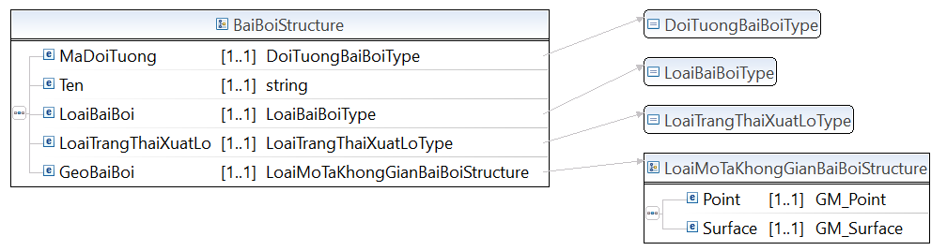

* Lược đồ XML cấu trúc dữ liệu Bãi đá dưới nước

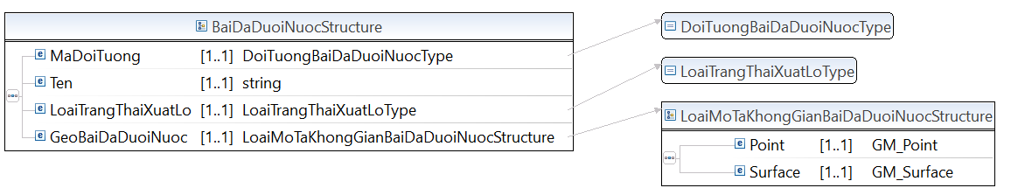

* Lược đồ XML cấu trúc dữ liệu Biển

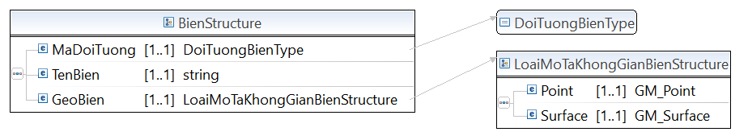

* Lược đồ XML cấu trúc dữ liệu Bờ kè, bờ cạp

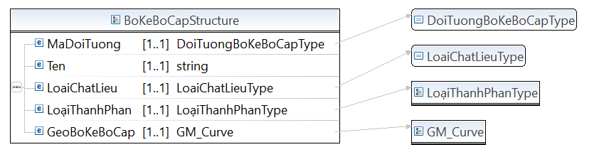

* Lược đồ XML cấu trúc dữ liệu Cống

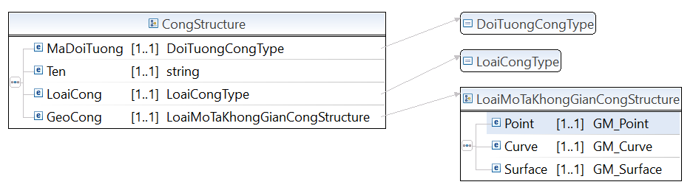

* Lược đồ XML cấu trúc dữ liệu Công trình trên đê

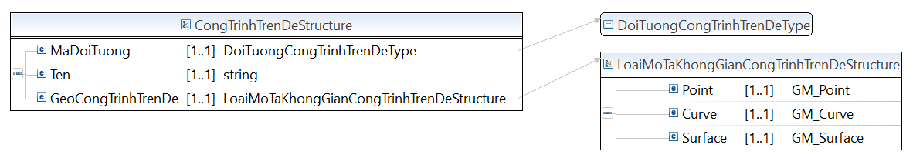

* Lược đồ XML cấu trúc dữ liệu Cột đo nước

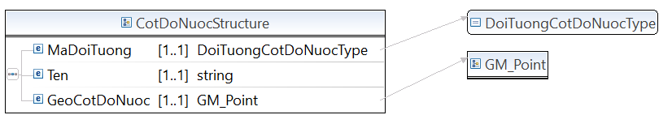

* Lược đồ XML cấu trúc dữ liệu Đầm lầy

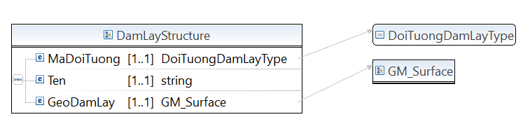

* Lược đồ XML cấu trúc dữ liệu Đảo

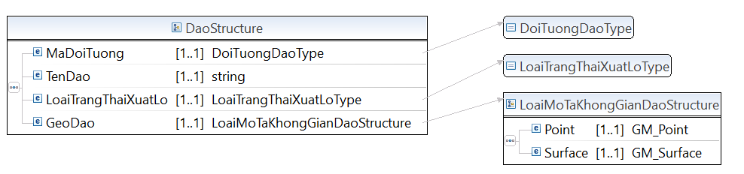

* Lược đồ XML cấu trúc dữ liệu Đập

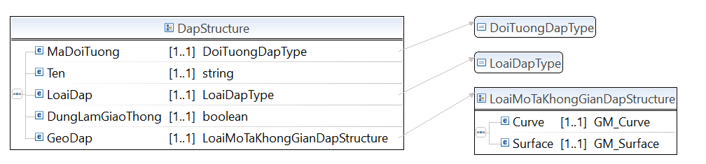

* Lược đồ XML cấu trúc dữ liệu Đê

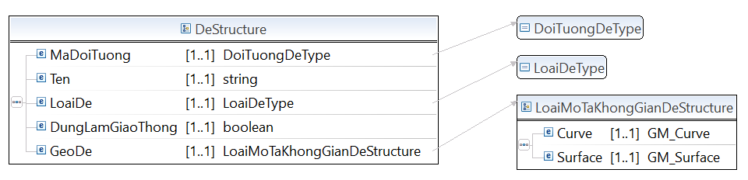

* Lược đồ XML cấu trúc dữ liệu Điểm sông suối mất tích

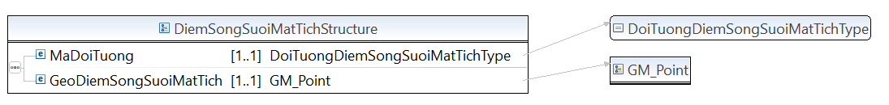

* Lược đồ XML cấu trúc dữ liệu Đường bờ nước

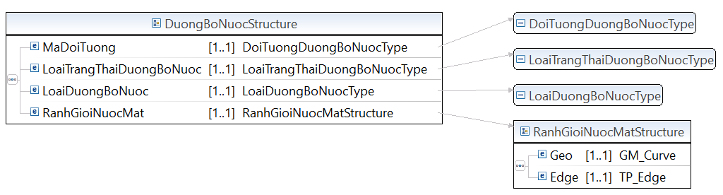

* Lược đồ XML cấu trúc dữ liệu Đường mép nước

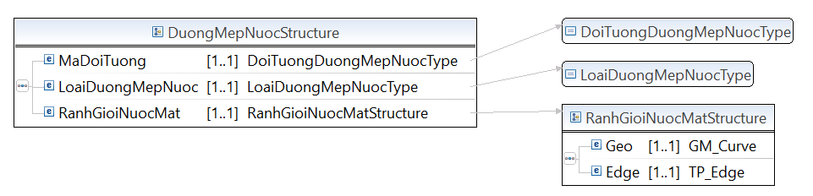

* Lược đồ XML cấu trúc dữ liệu Ghềnh

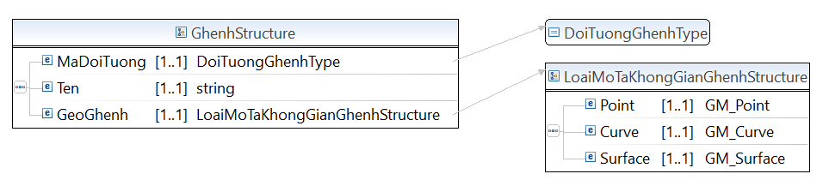

* Lược đồ XML cấu trúc dữ liệu Kênh mương

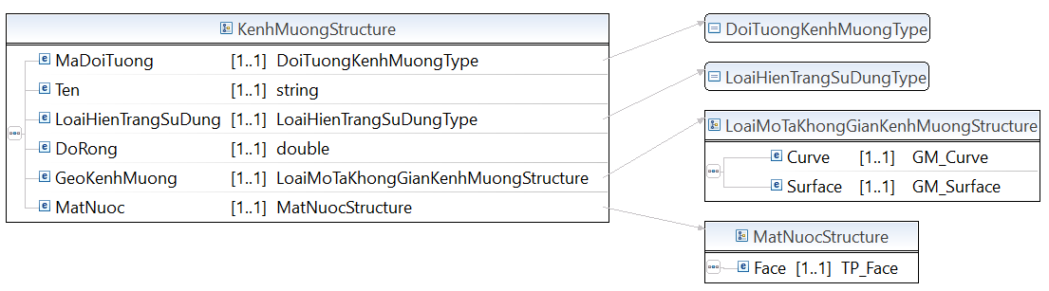

* Lược đồ XML cấu trúc dữ liệu Máng dẫn nước

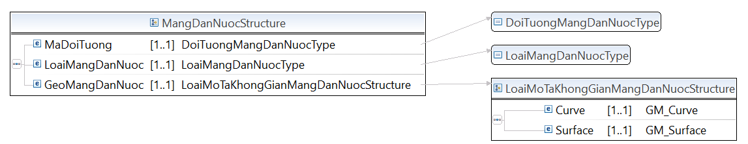

* Lược đồ XML cấu trúc dữ liệu Mặt bờ kênh mương

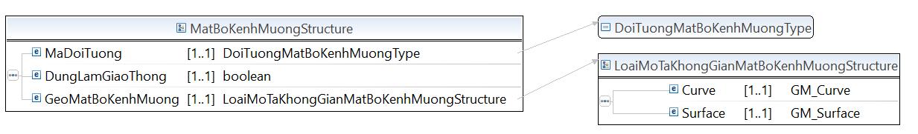

* Lược đồ XML cấu trúc dữ liệu Mặt nước

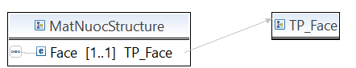

* Lược đồ XML cấu trúc dữ liệu Mặt nước sông suối

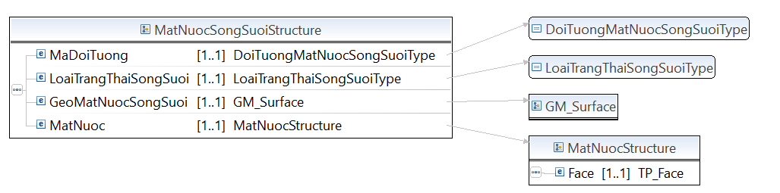

* Lược đồ XML cấu trúc dữ liệu Mặt nước tĩnh

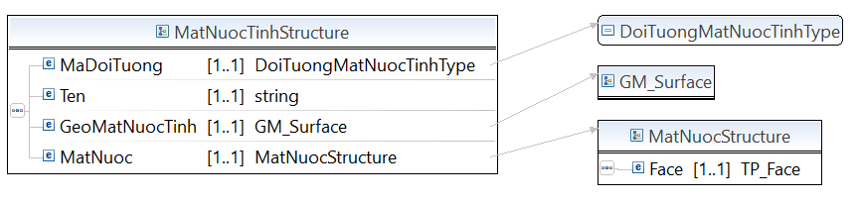

* Lược đồ XML cấu trúc dữ liệu Nguồn nước

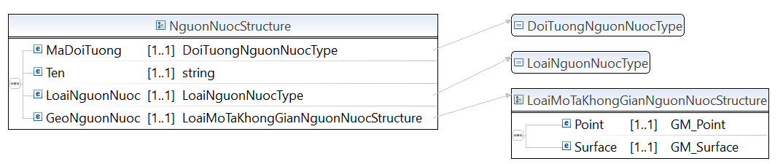

* Lược đồ XML cấu trúc dữ liệu Nút mạng dòng chảy

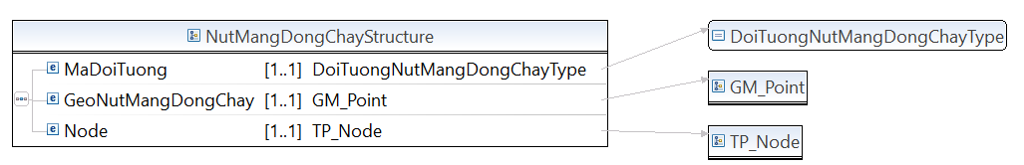

* Lược đồ XML cấu trúc dữ liệu Rạn san hô

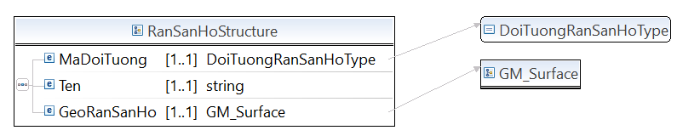

* Lược đồ XML cấu trúc dữ liệu Ranh giới nước mặt

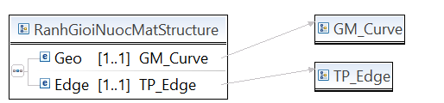

* Lược đồ XML cấu trúc dữ liệu Ranh giới nước mặt quy ước

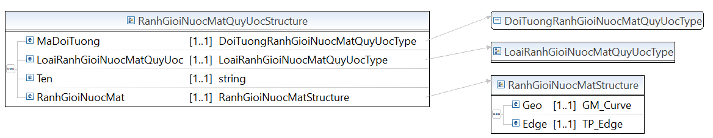

* Lược đồ XML cấu trúc dữ liệu Taluy công trình thủy lợi

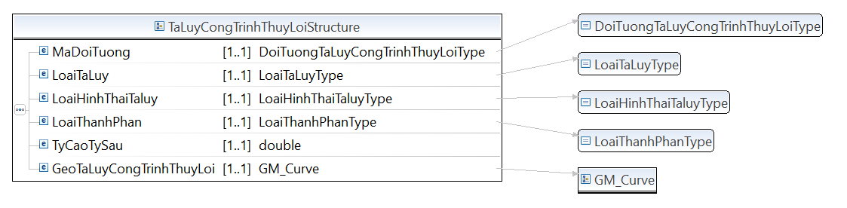

* Lược đồ XML cấu trúc dữ liệu Thác

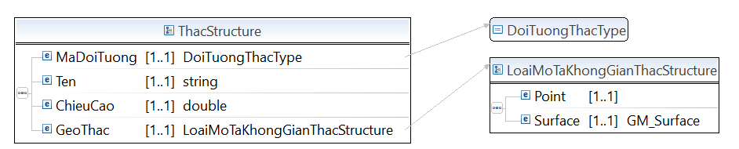

* Lược đồ XML cấu trúc dữ liệu Tim dòng chảy

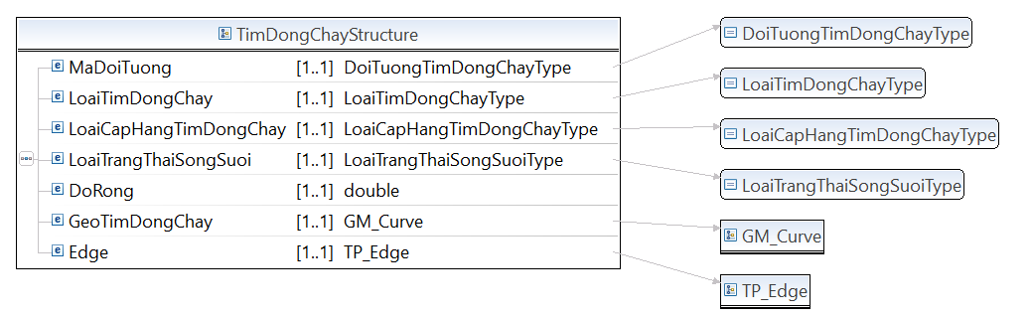

* Lược đồ XML cấu trúc dữ liệu Trạm bơm

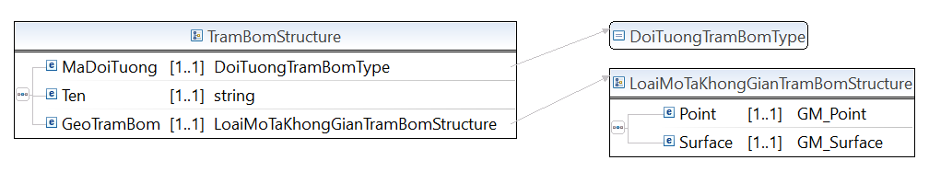

**Mã nguồn lược đồ chứa các cấu trúc thông tin của lược đồ dữ liệu nền địa lý – nhóm Thủy văn (ThuyVan.xsd)**

<?xml version=*“1.1”* encoding=*"UTF-8"*?>

<xsd:schema xmlns:xsd=*"http://www.w3.org/2001/XMLSchema"* xmlns:TTDLQG=*"..."* targetNamespace=*"..."* version=*“1.1”* elementFormDefault=*"qualified"*>

<!-- <xsd:include schemaLocation="BaseEnumType.xsd" /> -->

<xsd:annotation>

<xsd:documentation></xsd:documentation>

</xsd:annotation>

<xsd:complexType name=*"BienStructure"*>

<xsd:annotation>

<xsd:documentation>Vùng biển bao gồm cả vịnh, vũng thuộc phạm vi xây dựng dữ liệu</xsd:documentation>

</xsd:annotation>

<xsd:sequence>

<xsd:element name=*"MaDoiTuong"* type=*"TTDLQG:DoiTuongBienType"* minOccurs=*"1"* maxOccurs=*"1"* />

<xsd:element name=*"TenBien"* type=*"xsd:string"* minOccurs=*"1"* maxOccurs=*"1"* />

<xsd:element name=*"GeoBien"* type=*"TTDLQG:LoaiMoTaKhongGianBienStructure"* minOccurs=*"1"* maxOccurs=*"1"* />

</xsd:sequence>

</xsd:complexType>

<xsd:complexType name=*"DaoStructure"*>

<xsd:annotation>

<xsd:documentation>Là vùng đất tự nhiên có nước bao bọc, khi thủy triều lên vùng đất này vẫn ở trên mặt nước</xsd:documentation>

</xsd:annotation>

<xsd:sequence>

<xsd:element name=*"MaDoiTuong"* type=*"TTDLQG:DoiTuongDaoType"* minOccurs=*"1"* maxOccurs=*"1"* />

<xsd:element name=*"TenDao"* type=*"xsd:string"* minOccurs=*"1"* maxOccurs=*"1"* />

<xsd:element name=*"LoaiTrangThaiXuatLo"* type=*"TTDLQG:LoaiTrangThaiXuatLoType"* minOccurs=*"1"* maxOccurs=*"1"* />

<xsd:element name=*"GeoDao"* type=*"TTDLQG:LoaiMoTaKhongGianDaoStructure"* minOccurs=*"1"* maxOccurs=*"1"* />

</xsd:sequence>

</xsd:complexType>

<xsd:complexType name=*"NguonNuocStructure"*>

<xsd:annotation>

<xsd:documentation>Nguồn nước</xsd:documentation>

</xsd:annotation>

<xsd:sequence>

<xsd:element name=*"MaDoiTuong"* type=*"TTDLQG:DoiTuongNguonNuocType"* minOccurs=*"1"* maxOccurs=*"1"* />

<xsd:element name=*"Ten"* type=*"xsd:string"* minOccurs=*"1"* maxOccurs=*"1"* />

<xsd:element name=*"LoaiNguonNuoc"* type=*"TTDLQG:LoaiNguonNuocType"* minOccurs=*"1"* maxOccurs=*"1"* />

<xsd:element name=*"GeoNguonNuoc"* type=*"TTDLQG:LoaiMoTaKhongGianNguonNuocStructure"* minOccurs=*"1"* maxOccurs=*"1"* />

</xsd:sequence>

</xsd:complexType>

<xsd:complexType name=*"BaiBoiStructure"*>

<xsd:annotation>

<xsd:documentation>Bãi được hình thành do quá trình bồi lắng tự nhiên</xsd:documentation>

</xsd:annotation>

<xsd:sequence>

<xsd:element name=*"MaDoiTuong"* type=*"TTDLQG:DoiTuongBaiBoiType"* minOccurs=*"1"* maxOccurs=*"1"* />

<xsd:element name=*"Ten"* type=*"xsd:string"* minOccurs=*"1"* maxOccurs=*"1"* />

<xsd:element name=*"LoaiBaiBoi"* type=*"TTDLQG:LoaiBaiBoiType"* minOccurs=*"1"* maxOccurs=*"1"* />

<xsd:element name=*"LoaiTrangThaiXuatLo"* type=*"TTDLQG:LoaiTrangThaiXuatLoType"* minOccurs=*"1"* maxOccurs=*"1"* />

<xsd:element name=*"GeoBaiBoi"* type=*"TTDLQG:LoaiMoTaKhongGianBaiBoiStructure"* minOccurs=*"1"* maxOccurs=*"1"* />

</xsd:sequence>

</xsd:complexType>

<xsd:complexType name=*"BaiDaDuoiNuocStructure"*>

<xsd:annotation>

<xsd:documentation>Là các đối tượng đá trên sông, suối, biển</xsd:documentation>

</xsd:annotation>

<xsd:sequence>

<xsd:element name=*"MaDoiTuong"* type=*"TTDLQG:DoiTuongBaiDaDuoiNuocType"* minOccurs=*"1"* maxOccurs=*"1"* />

<xsd:element name=*"Ten"* type=*"xsd:string"* minOccurs=*"1"* maxOccurs=*"1"* />

<xsd:element name=*"LoaiTrangThaiXuatLo"* type=*"TTDLQG:LoaiTrangThaiXuatLoType"* minOccurs=*"1"* maxOccurs=*"1"* />

<xsd:element name=*"GeoBaiDaDuoiNuoc"* type=*"TTDLQG:LoaiMoTaKhongGianBaiDaDuoiNuocStructure"* minOccurs=*"1"* maxOccurs=*"1"* />

</xsd:sequence>

</xsd:complexType>

<xsd:complexType name=*"GhenhStructure"*>

<xsd:annotation>

<xsd:documentation>Là đối tượng trên sông suối làm thay đổi dòng chảy tự nhiên</xsd:documentation>

</xsd:annotation>

<xsd:sequence>

<xsd:element name=*"MaDoiTuong"* type=*"TTDLQG:DoiTuongGhenhType"* minOccurs=*"1"* maxOccurs=*"1"* />

<xsd:element name=*"Ten"* type=*"xsd:string"* minOccurs=*"1"* maxOccurs=*"1"* />

<xsd:element name=*"GeoGhenh"* type=*"TTDLQG:LoaiMoTaKhongGianGhenhStructure"* minOccurs=*"1"* maxOccurs=*"1"* />

</xsd:sequence>

</xsd:complexType>

<xsd:complexType name=*"ThacStructure"*>

<xsd:annotation>

<xsd:documentation>Là đối tượng trên sông suối làm thay đổi dòng chảy tự nhiên</xsd:documentation>

</xsd:annotation>

<xsd:sequence>

<xsd:element name=*"MaDoiTuong"* type=*"TTDLQG:DoiTuongThacType"* minOccurs=*"1"* maxOccurs=*"1"* />

<xsd:element name=*"Ten"* type=*"xsd:string"* minOccurs=*"1"* maxOccurs=*"1"* />

<xsd:element name=*"ChieuCao"* type=*"xsd:double"* minOccurs=*"1"* maxOccurs=*"1"* />

<xsd:element name=*"GeoThac"* type=*"TTDLQG:LoaiMoTaKhongGianThacStructure"* minOccurs=*"1"* maxOccurs=*"1"* />

</xsd:sequence>

</xsd:complexType>

<xsd:complexType name=*"DiemSongSuoiMatTichStructure"*>

<xsd:annotation>

<xsd:documentation>Là điểm mất tích và điểm xuất hiện trở lại của hệ thống sông suối.</xsd:documentation>

</xsd:annotation>

<xsd:sequence>

<xsd:element name=*"MaDoiTuong"* type=*"TTDLQG:DoiTuongDiemSongSuoiMatTichType"* minOccurs=*"1"* maxOccurs=*"1"* />

<xsd:element name=*"GeoDiemSongSuoiMatTich"* type=*"GM_Point"* minOccurs=*"1"* maxOccurs=*"1"* />

</xsd:sequence>

</xsd:complexType>

<xsd:complexType name=*"MatNuocStructure"*>

<xsd:annotation>

<xsd:documentation>Mô tả các đặc tính chung của các kiểu đối tượng MatNuocTinh, MatNuocSongSuoi, KenhMuong được xác định theo khả năng điều tra, đo đạc và hiện trạng nước mặt tại thời điểm thu nhận thông tin</xsd:documentation>

</xsd:annotation>

<xsd:sequence>

<xsd:element name=*"Face"* type=*"TTDLQG:TP_Face"* minOccurs=*"1"* maxOccurs=*"1"* />

</xsd:sequence>

</xsd:complexType>

<xsd:complexType name=*"MatNuocSongSuoiStructure"*>

<xsd:annotation>

<xsd:documentation>Là thành phần dạng bề mặt của các kiểu đối tượng SongSuoi</xsd:documentation>

</xsd:annotation>

<xsd:sequence>

<xsd:element name=*"MaDoiTuong"* type=*"TTDLQG:DoiTuongMatNuocSongSuoiType"* minOccurs=*"1"* maxOccurs=*"1"* />

<xsd:element name=*"LoaiTrangThaiSongSuoi"* type=*"TTDLQG:LoaiTrangThaiSongSuoiType"* minOccurs=*"1"* maxOccurs=*"1"* />

<xsd:element name=*"GeoMatNuocSongSuoi"* type=*"TTDLQG:GM_Surface"* minOccurs=*"1"* maxOccurs=*"1"* />

<xsd:element name=*"MatNuoc"* type=*"TTDLQG:MatNuocStructure"* minOccurs=*"1"* maxOccurs=*"1"* />

</xsd:sequence>

</xsd:complexType>

<xsd:complexType name=*"MatNuocSongSuoiStructure"*>

<xsd:annotation>

<xsd:documentation>Là thành phần dạng bề mặt của các kiểu đối tượng SongSuoi</xsd:documentation>

</xsd:annotation>

<xsd:sequence>

<xsd:element name=*"MaDoiTuong"* type=*"TTDLQG:DoiTuongMatNuocSongSuoiType"* minOccurs=*"1"* maxOccurs=*"1"* />

<xsd:element name=*"LoaiTrangThaiSongSuoi"* type=*"TTDLQG:LoaiTrangThaiSongSuoiType"* minOccurs=*"1"* maxOccurs=*"1"* />

<xsd:element name=*"GeoMatNuocSongSuoi"* type=*"TTDLQG:GM_Surface"* minOccurs=*"1"* maxOccurs=*"1"* />

<xsd:element name=*"MatNuoc"* type=*"TTDLQG:MatNuocStructure"* minOccurs=*"1"* maxOccurs=*"1"* />

</xsd:sequence>

</xsd:complexType>

<xsd:complexType name=*"MatNuocTinhStructure"*>

<xsd:annotation>

<xsd:documentation>Là vùng mặt nước tĩnh của các đối tượng ao, hồ, đầm; hồ chứa</xsd:documentation>

</xsd:annotation>

<xsd:sequence>

<xsd:element name=*"MaDoiTuong"* type=*"TTDLQG:DoiTuongMatNuocTinhType"* minOccurs=*"1"* maxOccurs=*"1"* />

<xsd:element name=*"Ten"* type=*"xsd:string"* minOccurs=*"1"* maxOccurs=*"1"* />

<xsd:element name=*"GeoMatNuocTinh"* type=*"TTDLQG:GM_Surface"* minOccurs=*"1"* maxOccurs=*"1"* />

<xsd:element name=*"MatNuoc"* type=*"TTDLQG:MatNuocStructure"* minOccurs=*"1"* maxOccurs=*"1"* />

</xsd:sequence>

</xsd:complexType>

<xsd:complexType name=*"KenhMuongStructure"*>

<xsd:annotation>

<xsd:documentation>Dòng chảy nhân tạo của nước mặt</xsd:documentation>

</xsd:annotation>

<xsd:sequence>

<xsd:element name=*"MaDoiTuong"* type=*"TTDLQG:DoiTuongKenhMuongType"* minOccurs=*"1"* maxOccurs=*"1"* />

<xsd:element name=*"Ten"* type=*"xsd:string"* minOccurs=*"1"* maxOccurs=*"1"* />

<xsd:element name=*"LoaiHienTrangSuDung"* type=*"TTDLQG:LoaiHienTrangSuDungType"* minOccurs=*"1"* maxOccurs=*"1"* />

<xsd:element name=*"DoRong"* type=*"xsd:double"* minOccurs=*"1"* maxOccurs=*"1"* />

<xsd:element name=*"GeoKenhMuong"* type=*"TTDLQG:LoaiMoTaKhongGianKenhMuongStructure"* minOccurs=*"1"* maxOccurs=*"1"* />

<xsd:element name=*"MatNuoc"* type=*"TTDLQG:MatNuocStructure"* minOccurs=*"1"* maxOccurs=*"1"* />

</xsd:sequence>

</xsd:complexType>

<xsd:complexType name=*"RanhGioiNuocMatStructure"*>

<xsd:annotation>

<xsd:documentation>Các đặc tính chung của các kiểu đối tượng: DuongBoNuoc, DuongMepNuoc, RanhGioiNuocMatQuyUoc. Áp dụng để biểu thị đường phân định giữa phần mặt nước với mặt đất hoặc với các phần mặt nước kề cận không cùng loại</xsd:documentation>

</xsd:annotation>

<xsd:sequence>

<xsd:element name=*"Geo"* type=*"TTDLQG:GM_Curve"* minOccurs=*"1"* maxOccurs=*"1"* />

<xsd:element name=*"Edge"* type=*"TTDLQG:TP_Edge"* minOccurs=*"1"* maxOccurs=*"1"* />

</xsd:sequence>

</xsd:complexType>

<xsd:complexType name=*"DuongBoNuocStructure"*>

<xsd:annotation>

<xsd:documentation>Mép bờ của sông, suối, kênh, rạch là ranh giới giữa mái dốc tự nhiên của bờ biển, sông, suối, kênh, rạch với mặt đất tự nhiên theo chiều ngang. Trường hợp sông, suối, kênh, rạch đã được kè bờ thì mép bờ là đỉnh của bờ kè. Mép bờ của đầm, phá, ao, hồ tự nhiên, hồ nhân tạo không phải là hồ chứa thủy điện, thủy lợi do cơ quan lập phương án cắm mốc xác định trên cơ sở mực nước cao nhất. Đường bờ biển là đường mép nước biển cao nhất trung bình nhiều năm. Đường bờ biển khi được kè bờ thì mép bờ là đỉnh của bờ kè.</xsd:documentation>

</xsd:annotation>

<xsd:sequence>

<xsd:element name=*"MaDoiTuong"* type=*"TTDLQG:DoiTuongDuongBoNuocType"* minOccurs=*"1"* maxOccurs=*"1"* />

<xsd:element name=*"LoaiTrangThaiDuongBoNuoc"* type=*"TTDLQG:LoaiTrangThaiDuongBoNuocType"* minOccurs=*"1"* maxOccurs=*"1"* />

<xsd:element name=*"LoaiDuongBoNuoc"* type=*"TTDLQG:LoaiDuongBoNuocType"* minOccurs=*"1"* maxOccurs=*"1"* />

<xsd:element name=*"RanhGioiNuocMat"* type=*"TTDLQG:RanhGioiNuocMatStructure"* minOccurs=*"1"* maxOccurs=*"1"* />

</xsd:sequence>

</xsd:complexType>

<xsd:complexType name=*"DuongMepNuocStructure"*>

<xsd:annotation>

<xsd:documentation>Đường mép nước sông, suối, hồ, ao, đầm, phá là đường mực nước của sông, suối, hồ, ao, đầm, phá tại thời điểm thu nhận thông tin. Đường mép nước biển là đường mực nước của biển tại thời điểm thu nhận thông tin</xsd:documentation>

</xsd:annotation>

<xsd:sequence>

<xsd:element name=*"MaDoiTuong"* type=*"TTDLQG:DoiTuongDuongMepNuocType"* minOccurs=*"1"* maxOccurs=*"1"* />

<xsd:element name=*"LoaiDuongMepNuoc"* type=*"TTDLQG:LoaiDuongMepNuocType"* minOccurs=*"1"* maxOccurs=*"1"* />

<xsd:element name=*"RanhGioiNuocMat"* type=*"TTDLQG:RanhGioiNuocMatStructure"* minOccurs=*"1"* maxOccurs=*"1"* />

</xsd:sequence>

</xsd:complexType>

<xsd:complexType name=*"RanhGioiNuocMatQuyUocStructure"*>

<xsd:annotation>

<xsd:documentation>Đường ranh giới phân chia tương đối giữa các phần nước mặt của đầm, phá, ao, hồ, sông, suối, kênh, mương, biển; các đường khép vùng cho từng nhánh nước mặt của các dòng chảy</xsd:documentation>

</xsd:annotation>

<xsd:sequence>

<xsd:element name=*"MaDoiTuong"* type=*"TTDLQG:DoiTuongRanhGioiNuocMatQuyUocType"* minOccurs=*"1"* maxOccurs=*"1"* />

<xsd:element name=*"LoaiRanhGioiNuocMatQuyUoc"* type=*"TTDLQG:LoaiRanhGioiNuocMatQuyUocType"* minOccurs=*"1"* maxOccurs=*"1"* />

<xsd:element name=*"Ten"* type=*"TTDLQG:Chuỗi ký tựType"* minOccurs=*"1"* maxOccurs=*"1"* />

<xsd:element name=*"RanhGioiNuocMat"* type=*"TTDLQG:RanhGioiNuocMatStructure"* minOccurs=*"1"* maxOccurs=*"1"* />

</xsd:sequence>

</xsd:complexType>

<xsd:complexType name=*"BoKeBoCapStructure"*>

<xsd:annotation>

<xsd:documentation>Công trình xây dựng nhằm chống sạt lở để bảo vệ bờ</xsd:documentation>

</xsd:annotation>

<xsd:sequence>

<xsd:element name=*"MaDoiTuong"* type=*"TTDLQG:DoiTuongBoKeBoCapType"* minOccurs=*"1"* maxOccurs=*"1"* />

<xsd:element name=*"Ten"* type=*"xsd:string"* minOccurs=*"1"* maxOccurs=*"1"* />

<xsd:element name=*"LoaiChatLieu"* type=*"TTDLQG:LoaiChatLieuType"* minOccurs=*"1"* maxOccurs=*"1"* />

<xsd:element name=*"LoạiThanhPhan"* type=*"TTDLQG:LoạiThanhPhanType"* minOccurs=*"1"* maxOccurs=*"1"* />

<xsd:element name=*"GeoBoKeBoCap"* type=*"TTDLQG:GM_Curve"* minOccurs=*"1"* maxOccurs=*"1"* />

</xsd:sequence>

</xsd:complexType>

<xsd:complexType name=*"CongStructure"*>

<xsd:annotation>

<xsd:documentation>Công trình xây dựng dùng để cấp nước, thoát nước hoặc kết hợp giao thông thủy.</xsd:documentation>

</xsd:annotation>

<xsd:sequence>

<xsd:element name=*"MaDoiTuong"* type=*"TTDLQG:DoiTuongCongType"* minOccurs=*"1"* maxOccurs=*"1"* />

<xsd:element name=*"Ten"* type=*"xsd:string"* minOccurs=*"1"* maxOccurs=*"1"* />

<xsd:element name=*"LoaiCong"* type=*"TTDLQG:LoaiCongType"* minOccurs=*"1"* maxOccurs=*"1"* />

<xsd:element name=*"GeoCong"* type=*"TTDLQG:LoaiMoTaKhongGianCongStructure"* minOccurs=*"1"* maxOccurs=*"1"* />

</xsd:sequence>

</xsd:complexType>

<xsd:complexType name=*"CongTrinhTrenDeStructure"*>

<xsd:annotation>

<xsd:documentation>Công trình xây dựng có liên quan đến đê</xsd:documentation>

</xsd:annotation>

<xsd:sequence>

<xsd:element name=*"MaDoiTuong"* type=*"TTDLQG:DoiTuongCongTrinhTrenDeType"* minOccurs=*"1"* maxOccurs=*"1"* />

<xsd:element name=*"Ten"* type=*"xsd:string"* minOccurs=*"1"* maxOccurs=*"1"* />

<xsd:element name=*"GeoCongTrinhTrenDe"* type=*"TTDLQG:LoaiMoTaKhongGianCongTrinhTrenDeStructure"* minOccurs=*"1"* maxOccurs=*"1"* />

</xsd:sequence>

</xsd:complexType>

<xsd:complexType name=*"DeStructure"*>

<xsd:annotation>

<xsd:documentation>Là công trình ngăn nước lũ của sông hoặc ngăn nước biển, được cơ quan nhà nước có thẩm quyền phân loại, phân cấp theo quy định của pháp luật</xsd:documentation>

</xsd:annotation>

<xsd:sequence>

<xsd:element name=*"MaDoiTuong"* type=*"TTDLQG:DoiTuongDeType"* minOccurs=*"1"* maxOccurs=*"1"* />

<xsd:element name=*"Ten"* type=*"xsd:string"* minOccurs=*"1"* maxOccurs=*"1"* />

<xsd:element name=*"LoaiDe"* type=*"TTDLQG:LoaiDeType"* minOccurs=*"1"* maxOccurs=*"1"* />

<xsd:element name=*"DungLamGiaoThong"* type=*"xsd:boolean"* minOccurs=*"1"* maxOccurs=*"1"* />

<xsd:element name=*"GeoDe"* type=*"TTDLQG:LoaiMoTaKhongGianDeStructure"* minOccurs=*"1"* maxOccurs=*"1"* />

</xsd:sequence>

</xsd:complexType>

<xsd:complexType name=*"DapStructure"*>

<xsd:annotation>

<xsd:documentation>Công trình thủy lợi, thủy điện để ngăn nước hoặc chắn song</xsd:documentation>

</xsd:annotation>

<xsd:sequence>

<xsd:element name=*"MaDoiTuong"* type=*"TTDLQG:DoiTuongDapType"* minOccurs=*"1"* maxOccurs=*"1"* />

<xsd:element name=*"Ten"* type=*"xsd:string"* minOccurs=*"1"* maxOccurs=*"1"* />

<xsd:element name=*"LoaiDap"* type=*"TTDLQG:LoaiDapType"* minOccurs=*"1"* maxOccurs=*"1"* />

<xsd:element name=*"DungLamGiaoThong"* type=*"xsd:boolean"* minOccurs=*"1"* maxOccurs=*"1"* />

<xsd:element name=*"GeoDap"* type=*"TTDLQG:LoaiMoTaKhongGianDapStructure"* minOccurs=*"1"* maxOccurs=*"1"* />

</xsd:sequence>

</xsd:complexType>

<xsd:complexType name=*"DamLayStructure"*>

<xsd:annotation>

<xsd:documentation>Các vùng đất lầy, than bùn bị ngập nước thường xuyên hay tạm thời</xsd:documentation>

</xsd:annotation>

<xsd:sequence>

<xsd:element name=*"MaDoiTuong"* type=*"TTDLQG:DoiTuongDamLay (T)"* minOccurs=*"1"* maxOccurs=*"1"* />

<xsd:element name=*"Ten"* type=*"xsd:string"* minOccurs=*"1"* maxOccurs=*"1"* />

<xsd:element name=*"GeoDamLay"* type=*"TTDLQG:GM_Surface (T)"* minOccurs=*"1"* maxOccurs=*"1"* />

</xsd:sequence>

</xsd:complexType>

<xsd:complexType name=*"MangDanNuocStructure"*>

<xsd:annotation>

<xsd:documentation>Là công trình để dẫn nước từ nguồn nước đến nơi sử dụng</xsd:documentation>

</xsd:annotation>

<xsd:sequence>

<xsd:element name=*"MaDoiTuong"* type=*"TTDLQG:DoiTuongMangDanNuocType"* minOccurs=*"1"* maxOccurs=*"1"* />

<xsd:element name=*"LoaiMangDanNuoc"* type=*"TTDLQG:LoaiMangDanNuocType"* minOccurs=*"1"* maxOccurs=*"1"* />

<xsd:element name=*"GeoMangDanNuoc"* type=*"TTDLQG:LoaiMoTaKhongGianMangDanNuocStructure"* minOccurs=*"1"* maxOccurs=*"1"* />

</xsd:sequence>

</xsd:complexType>

<xsd:complexType name=*"MatBoKenhMuongStructure"*>

<xsd:annotation>

<xsd:documentation>Mặt bờ kênh mương ở một bên hoặc hai bên đường bờ nước được hình thành trong quá trình đào kênh, mương</xsd:documentation>

</xsd:annotation>

<xsd:sequence>

<xsd:element name=*"MaDoiTuong"* type=*"TTDLQG:DoiTuongMatBoKenhMuongType"* minOccurs=*"1"* maxOccurs=*"1"* />

<xsd:element name=*"DungLamGiaoThong"* type=*"xsd:boolean"* minOccurs=*"1"* maxOccurs=*"1"* />

<xsd:element name=*"GeoMatBoKenhMuong"* type=*"TTDLQG:LoaiMoTaKhongGianMatBoKenhMuongStructure"* minOccurs=*"1"* maxOccurs=*"1"* />

</xsd:sequence>

</xsd:complexType>

<xsd:complexType name=*"TramBomStructure"*>

<xsd:annotation>

<xsd:documentation>Tập hợp các công trình và các thiết bị bơm</xsd:documentation>

</xsd:annotation>

<xsd:sequence>

<xsd:element name=*"MaDoiTuong"* type=*"TTDLQG:DoiTuongTramBomType"* minOccurs=*"1"* maxOccurs=*"1"* />

<xsd:element name=*"Ten"* type=*"xsd:string"* minOccurs=*"1"* maxOccurs=*"1"* />

<xsd:element name=*"GeoTramBom"* type=*"TTDLQG:LoaiMoTaKhongGianTramBomStructure"* minOccurs=*"1"* maxOccurs=*"1"* />

</xsd:sequence>

</xsd:complexType>

<xsd:complexType name=*"CotDoNuocStructure"*>

<xsd:annotation>

<xsd:documentation>Là công cụ dùng để đo mực nước</xsd:documentation>

</xsd:annotation>

<xsd:sequence>

<xsd:element name=*"MaDoiTuong"* type=*"TTDLQG:DoiTuongCotDoNuocType"* minOccurs=*"1"* maxOccurs=*"1"* />

<xsd:element name=*"Ten"* type=*"xsd:string"* minOccurs=*"1"* maxOccurs=*"1"* />

<xsd:element name=*"GeoCotDoNuoc"* type=*"TTDLQG:GM_Point"* minOccurs=*"1"* maxOccurs=*"1"* />

</xsd:sequence>

</xsd:complexType>

<xsd:complexType name=*"RanSanHoStructure"*>

<xsd:annotation>

<xsd:documentation>Khu vực được hình thành từ các quần thể san hô</xsd:documentation>

</xsd:annotation>

<xsd:sequence>

<xsd:element name=*"MaDoiTuong"* type=*"TTDLQG:DoiTuongRanSanHoType"* minOccurs=*"1"* maxOccurs=*"1"* />

<xsd:element name=*"Ten"* type=*"xsd:string"* minOccurs=*"1"* maxOccurs=*"1"* />

<xsd:element name=*"GeoRanSanHo"* type=*"TTDLQG:GM_Surface"* minOccurs=*"1"* maxOccurs=*"1"* />

</xsd:sequence>

</xsd:complexType>

<xsd:complexType name=*"TaLuyCongTrinhThuyLoiStructure"*>

<xsd:annotation>

<xsd:documentation>Đối tượng địa lý mô tả sự biến đổi địa hình do sự đào đắp các công trình thuỷ lợi, là phần mái dốc của các công trình thủy lợi</xsd:documentation>

</xsd:annotation>

<xsd:sequence>

<xsd:element name=*"MaDoiTuong"* type=*"TTDLQG:DoiTuongTaLuyCongTrinhThuyLoiType"* minOccurs=*"1"* maxOccurs=*"1"* />

<xsd:element name=*"LoaiTaLuy"* type=*"TTDLQG:LoaiTaLuyType"* minOccurs=*"1"* maxOccurs=*"1"* />

<xsd:element name=*"LoaiHinhThaiTaluy"* type=*"TTDLQG:LoaiHinhThaiTaluyType"* minOccurs=*"1"* maxOccurs=*"1"* />

<xsd:element name=*"LoaiThanhPhan"* type=*"TTDLQG:LoaiThanhPhanType"* minOccurs=*"1"* maxOccurs=*"1"* />

<xsd:element name=*"TyCaoTySau"* type=*"xsd:double"* minOccurs=*"1"* maxOccurs=*"1"* />

<xsd:element name=*"GeoTaLuyCongTrinhThuyLoi"* type=*"TTDLQG:GM_Curve"* minOccurs=*"1"* maxOccurs=*"1"* />

</xsd:sequence>

</xsd:complexType>

<xsd:complexType name=*"NutMangDongChayStructure"*>

<xsd:annotation>

<xsd:documentation>Vị trí hợp lưu, phân lưu của sông suối</xsd:documentation>

</xsd:annotation>

<xsd:sequence>

<xsd:element name=*"MaDoiTuong"* type=*"TTDLQG:DoiTuongNutMangDongChayType"* minOccurs=*"1"* maxOccurs=*"1"* />

<xsd:element name=*"GeoNutMangDongChay"* type=*"GM_Point"* minOccurs=*"1"* maxOccurs=*"1"* />

<xsd:element name=*"Node"* type=*"TTDLQG:TP_Node"* minOccurs=*"1"* maxOccurs=*"1"* />

</xsd:sequence>

</xsd:complexType>

<xsd:complexType name=*"TimDongChayStructure"*>

<xsd:annotation>

<xsd:documentation>Trung tuyến dòng chảy tự nhiên, dòng chảy nhân tạo</xsd:documentation>

</xsd:annotation>

<xsd:sequence>

<xsd:element name=*"MaDoiTuong"* type=*"TTDLQG:DoiTuongTimDongChayType"* minOccurs=*"1"* maxOccurs=*"1"* />

<xsd:element name=*"LoaiTimDongChay"* type=*"TTDLQG:LoaiTimDongChayType"* minOccurs=*"1"* maxOccurs=*"1"* />

<xsd:element name=*"LoaiCapHangTimDongChay"* type=*"TTDLQG:LoaiCapHangTimDongChayType"* minOccurs=*"1"* maxOccurs=*"1"* />

<xsd:element name=*"LoaiTrangThaiSongSuoi"* type=*"TTDLQG:LoaiTrangThaiSongSuoiType"* minOccurs=*"1"* maxOccurs=*"1"* />

<xsd:element name=*"DoRong"* type=*"xsd:double"* minOccurs=*"1"* maxOccurs=*"1"* />

<xsd:element name=*"GeoTimDongChay"* type=*"TTDLQG:GM_Curve"* minOccurs=*"1"* maxOccurs=*"1"* />

<xsd:element name=*"Edge"* type=*"TTDLQG:TP_Edge"* minOccurs=*"1"* maxOccurs=*"1"* />

</xsd:sequence>

</xsd:complexType>

<xsd:simpleType name=*"DoiTuongBienType"*>

<xsd:annotation>

<xsd:documentation>Biển</xsd:documentation>

</xsd:annotation>

<xsd:restriction base=*"xsd:token"*>

<xsd:enumeration value=*"LC03"*><xsd:annotation><xsd:documentation>xsd:string</xsd:documentation></xsd:annotation></xsd:enumeration>

<xsd:enumeration value=*"LC06"*><xsd:annotation><xsd:documentation>xsd:string</xsd:documentation></xsd:annotation></xsd:enumeration>

<xsd:enumeration value=*"LB02"*><xsd:annotation><xsd:documentation>xsd:string</xsd:documentation></xsd:annotation></xsd:enumeration>

</xsd:restriction>

</xsd:simpleType>

<xsd:complexType name=*"LoaiMoTaKhongGianBienStructure"*>

<xsd:annotation>

<xsd:documentation>Cấu trúc không gian biển</xsd:documentation>

</xsd:annotation>

<xsd:sequence>

<xsd:element name=*"Point"* type=*"TTDLQG:GM_Point"* minOccurs=*"1"* maxOccurs=*"1"* />

<xsd:element name=*"Surface"* type=*"TTDLQG:GM_Surface"* minOccurs=*"1"* maxOccurs=*"1"* />

</xsd:sequence>

</xsd:complexType>

<xsd:simpleType name=*"DoiTuongDaoType"*>

<xsd:annotation>

<xsd:documentation>Đảo</xsd:documentation>

</xsd:annotation>

<xsd:restriction base=*"xsd:token"*>

<xsd:enumeration value=*"LC04"*><xsd:annotation><xsd:documentation>xsd:string</xsd:documentation></xsd:annotation></xsd:enumeration>

</xsd:restriction>

</xsd:simpleType>

<xsd:simpleType name=*"LoaiTrangThaiXuatLoType"*>

<xsd:annotation>

<xsd:documentation>Loại trạng thái xuất lộ</xsd:documentation>

</xsd:annotation>

<xsd:restriction base=*"xsd:token"*>

<xsd:enumeration value=*"1"*><xsd:annotation><xsd:documentation>xsd:string</xsd:documentation></xsd:annotation></xsd:enumeration>

<xsd:enumeration value=*"2"*><xsd:annotation><xsd:documentation>xsd:string</xsd:documentation></xsd:annotation></xsd:enumeration>

<xsd:enumeration value=*"3"*><xsd:annotation><xsd:documentation>xsd:string</xsd:documentation></xsd:annotation></xsd:enumeration>

</xsd:restriction>

</xsd:simpleType>

<xsd:complexType name=*"LoaiMoTaKhongGianDaoStructure"*>

<xsd:annotation>

<xsd:documentation>Cấu trúc không gian đảo</xsd:documentation>

</xsd:annotation>

<xsd:sequence>

<xsd:element name=*"Point"* type=*"GM_Point"* minOccurs=*"1"* maxOccurs=*"1"* />

<xsd:element name=*"Surface"* type=*"TTDLQG:GM_Surface"* minOccurs=*"1"* maxOccurs=*"1"* />

</xsd:sequence>

</xsd:complexType>

<xsd:simpleType name=*"DoiTuongNguonNuocType"*>

<xsd:annotation>

<xsd:documentation>Nguồn nước</xsd:documentation>

</xsd:annotation>

<xsd:restriction base=*"xsd:token"*>

<xsd:enumeration value=*"LA03"*><xsd:annotation><xsd:documentation>xsd:string</xsd:documentation></xsd:annotation></xsd:enumeration>

<xsd:enumeration value=*"LA05"*><xsd:annotation><xsd:documentation>xsd:string</xsd:documentation></xsd:annotation></xsd:enumeration>

</xsd:restriction>

</xsd:simpleType>

<xsd:simpleType name=*"LoaiNguonNuocType"*>

<xsd:annotation>

<xsd:documentation>Loại nguồn nước</xsd:documentation>

</xsd:annotation>

<xsd:restriction base=*"xsd:token"*>

<xsd:enumeration value=*"1"*><xsd:annotation><xsd:documentation>xsd:string</xsd:documentation></xsd:annotation></xsd:enumeration>

<xsd:enumeration value=*"2"*><xsd:annotation><xsd:documentation>xsd:string</xsd:documentation></xsd:annotation></xsd:enumeration>

<xsd:enumeration value=*"3"*><xsd:annotation><xsd:documentation>xsd:string</xsd:documentation></xsd:annotation></xsd:enumeration>

</xsd:restriction>

</xsd:simpleType>

<xsd:complexType name=*"LoaiMoTaKhongGianNguonNuocStructure"*>

<xsd:annotation>

<xsd:documentation>Cấu trúc không gian nguồn nước</xsd:documentation>

</xsd:annotation>

<xsd:sequence>

<xsd:element name=*"Point"* type=*"GM_Point"* minOccurs=*"1"* maxOccurs=*"1"* />

<xsd:element name=*"Surface"* type=*"TTDLQG:GM_Surface"* minOccurs=*"1"* maxOccurs=*"1"* />

</xsd:sequence>

</xsd:complexType>

<xsd:simpleType name=*"DoiTuongBaiBoiType"*>

<xsd:annotation>

<xsd:documentation>Bãi bồi</xsd:documentation>

</xsd:annotation>

<xsd:restriction base=*"xsd:token"*>

<xsd:enumeration value=*"LD01"*><xsd:annotation><xsd:documentation>xsd:string</xsd:documentation></xsd:annotation></xsd:enumeration>

</xsd:restriction>

</xsd:simpleType>

<xsd:simpleType name=*"LoaiBaiBoiType"*>

<xsd:annotation>

<xsd:documentation>Loại bãi bồi</xsd:documentation>

</xsd:annotation>

<xsd:restriction base=*"xsd:token"*>

<xsd:enumeration value=*"1"*><xsd:annotation><xsd:documentation>xsd:string</xsd:documentation></xsd:annotation></xsd:enumeration>

<xsd:enumeration value=*"2"*><xsd:annotation><xsd:documentation>xsd:string</xsd:documentation></xsd:annotation></xsd:enumeration>

<xsd:enumeration value=*"3"*><xsd:annotation><xsd:documentation>xsd:string</xsd:documentation></xsd:annotation></xsd:enumeration>

</xsd:restriction>

</xsd:simpleType>

<xsd:complexType name=*"LoaiMoTaKhongGianBaiBoiStructure"*>

<xsd:annotation>

<xsd:documentation>Cấu trúc không gian bãi bồi</xsd:documentation>

</xsd:annotation>

<xsd:sequence>

<xsd:element name=*"Point"* type=*"TTDLQG:GM_Point"* minOccurs=*"1"* maxOccurs=*"1"* />

<xsd:element name=*"Surface"* type=*"TTDLQG:GM_Surface"* minOccurs=*"1"* maxOccurs=*"1"* />

</xsd:sequence>

</xsd:complexType>

<xsd:simpleType name=*"DoiTuongBaiDaDuoiNuocType"*>

<xsd:annotation>

<xsd:documentation>Bãi đá dưới nước</xsd:documentation>

</xsd:annotation>

<xsd:restriction base=*"xsd:token"*>

<xsd:enumeration value=*"LC01"*><xsd:annotation><xsd:documentation>xsd:string</xsd:documentation></xsd:annotation></xsd:enumeration>

<xsd:enumeration value=*"LC08"*><xsd:annotation><xsd:documentation>xsd:string</xsd:documentation></xsd:annotation></xsd:enumeration>

</xsd:restriction>

</xsd:simpleType>

<xsd:complexType name=*"LoaiMoTaKhongGianBaiDaDuoiNuocStructure"*>

<xsd:annotation>

<xsd:documentation>Cấu trúc không gian bãi đá dưới nước</xsd:documentation>

</xsd:annotation>

<xsd:sequence>

<xsd:element name=*"Point"* type=*"TTDLQG:GM_Point"* minOccurs=*"1"* maxOccurs=*"1"* />

<xsd:element name=*"Surface"* type=*"TTDLQG:GM_Surface"* minOccurs=*"1"* maxOccurs=*"1"* />

</xsd:sequence>

</xsd:complexType>

<xsd:simpleType name=*"DoiTuongGhenhType"*>

<xsd:annotation>

<xsd:documentation>Ghềnh</xsd:documentation>

</xsd:annotation>

<xsd:restriction base=*"xsd:token"*>

<xsd:enumeration value=*"LD02"*><xsd:annotation><xsd:documentation>xsd:string</xsd:documentation></xsd:annotation></xsd:enumeration>

</xsd:restriction>

</xsd:simpleType>

<xsd:complexType name=*"LoaiMoTaKhongGianGhenhStructure"*>

<xsd:annotation>

<xsd:documentation>Cấu trúc không gian ghềnh</xsd:documentation>

</xsd:annotation>

<xsd:sequence>

<xsd:element name=*"Point"* type=*"GM_Point"* minOccurs=*"1"* maxOccurs=*"1"* />

<xsd:element name=*"Curve"* type=*"TTDLQG:GM_Curve"* minOccurs=*"1"* maxOccurs=*"1"* />

<xsd:element name=*"Surface"* type=*"TTDLQG:GM_Surface"* minOccurs=*"1"* maxOccurs=*"1"* />

</xsd:sequence>

</xsd:complexType>

<xsd:simpleType name=*"DoiTuongThacType"*>

<xsd:annotation>

<xsd:documentation>Thác</xsd:documentation>

</xsd:annotation>

<xsd:restriction base=*"xsd:token"*>

<xsd:enumeration value=*"LD03"*><xsd:annotation><xsd:documentation>xsd:string</xsd:documentation></xsd:annotation></xsd:enumeration>

</xsd:restriction>

</xsd:simpleType>

<xsd:complexType name=*"LoaiMoTaKhongGianThacStructure"*>

<xsd:annotation>

<xsd:documentation>Cấu trúc không gian thác</xsd:documentation>

</xsd:annotation>

<xsd:sequence>

<xsd:element name=*"Point"* type=*"GM_Point"* minOccurs=*"1"* maxOccurs=*"1"* />

<xsd:element name=*"Surface"* type=*"TTDLQG:GM_Surface"* minOccurs=*"1"* maxOccurs=*"1"* />

</xsd:sequence>

</xsd:complexType>

<xsd:simpleType name=*"DoiTuongDiemSongSuoiMatTichType"*>

<xsd:annotation>

<xsd:documentation>Điểm sông, điểm suối mất tích</xsd:documentation>

</xsd:annotation>

<xsd:restriction base=*"xsd:token"*>

<xsd:enumeration value=*"LA09"*><xsd:annotation><xsd:documentation>xsd:string</xsd:documentation></xsd:annotation></xsd:enumeration>

</xsd:restriction>

</xsd:simpleType>

<xsd:simpleType name=*"DoiTuongMatNuocSongSuoiType"*>

<xsd:annotation>

<xsd:documentation>Mặt nước sông suối</xsd:documentation>

</xsd:annotation>

<xsd:restriction base=*"xsd:token"*>

<xsd:enumeration value=*"LA10"*><xsd:annotation><xsd:documentation>xsd:string</xsd:documentation></xsd:annotation></xsd:enumeration>

</xsd:restriction>

</xsd:simpleType>

<xsd:simpleType name=*"LoaiTrangThaiSongSuoiType"*>

<xsd:annotation>

<xsd:documentation>Loại trạng thái sông suối</xsd:documentation>

</xsd:annotation>

<xsd:restriction base=*"xsd:token"*>

<xsd:enumeration value=*"1"*><xsd:annotation><xsd:documentation>xsd:string</xsd:documentation></xsd:annotation></xsd:enumeration>

<xsd:enumeration value=*"2"*><xsd:annotation><xsd:documentation>xsd:string</xsd:documentation></xsd:annotation></xsd:enumeration>

</xsd:restriction>

</xsd:simpleType>

<xsd:simpleType name=*"DoiTuongMatNuocTinhType"*>

<xsd:annotation>

<xsd:documentation>Mặt nước tĩnh</xsd:documentation>

</xsd:annotation>

<xsd:restriction base=*"xsd:token"*>

<xsd:enumeration value=*"LB01"*><xsd:annotation><xsd:documentation>xsd:string</xsd:documentation></xsd:annotation></xsd:enumeration>

<xsd:enumeration value=*"LB03"*><xsd:annotation><xsd:documentation>xsd:string</xsd:documentation></xsd:annotation></xsd:enumeration>

</xsd:restriction>

</xsd:simpleType>

<xsd:simpleType name=*"DoiTuongKenhMuongType"*>

<xsd:annotation>

<xsd:documentation>Kênh mương</xsd:documentation>

</xsd:annotation>

<xsd:restriction base=*"xsd:token"*>

<xsd:enumeration value=*"LA04"*><xsd:annotation><xsd:documentation>xsd:string</xsd:documentation></xsd:annotation></xsd:enumeration>

</xsd:restriction>

</xsd:simpleType>

<xsd:simpleType name=*"LoaiHienTrangSuDungType"*>

<xsd:annotation>

<xsd:documentation>Loại hiện trạng sử dụng</xsd:documentation>

</xsd:annotation>

<xsd:restriction base=*"xsd:token"*>

<xsd:enumeration value=*"1"*><xsd:annotation><xsd:documentation>xsd:string</xsd:documentation></xsd:annotation></xsd:enumeration>

<xsd:enumeration value=*"2"*><xsd:annotation><xsd:documentation>xsd:string</xsd:documentation></xsd:annotation></xsd:enumeration>

</xsd:restriction>

</xsd:simpleType>

<xsd:complexType name=*"LoaiMoTaKhongGianKenhMuongStructure"*>

<xsd:annotation>

<xsd:documentation>Cấu trúc không gian kênh mương</xsd:documentation>

</xsd:annotation>

<xsd:sequence>

<xsd:element name=*"Curve"* type=*"TTDLQG:GM_Curve"* minOccurs=*"1"* maxOccurs=*"1"* />

<xsd:element name=*"Surface"* type=*"TTDLQG:GM_Surface"* minOccurs=*"1"* maxOccurs=*"1"* />

</xsd:sequence>

</xsd:complexType>

<xsd:simpleType name=*"DoiTuongDuongBoNuocType"*>

<xsd:annotation>

<xsd:documentation>Đường bờ nước</xsd:documentation>

</xsd:annotation>

<xsd:restriction base=*"xsd:token"*>

<xsd:enumeration value=*"LG01"*><xsd:annotation><xsd:documentation>xsd:string</xsd:documentation></xsd:annotation></xsd:enumeration>

</xsd:restriction>

</xsd:simpleType>

<xsd:simpleType name=*"LoaiTrangThaiDuongBoNuocType"*>

<xsd:annotation>

<xsd:documentation>Loại trạng thái Đường bờ nước</xsd:documentation>

</xsd:annotation>

<xsd:restriction base=*"xsd:token"*>

<xsd:enumeration value=*"1"*><xsd:annotation><xsd:documentation>xsd:string</xsd:documentation></xsd:annotation></xsd:enumeration>

<xsd:enumeration value=*"2"*><xsd:annotation><xsd:documentation>xsd:string</xsd:documentation></xsd:annotation></xsd:enumeration>

<xsd:enumeration value=*"3"*><xsd:annotation><xsd:documentation>xsd:string</xsd:documentation></xsd:annotation></xsd:enumeration>

</xsd:restriction>

</xsd:simpleType>

<xsd:simpleType name=*"LoaiDuongBoNuocType"*>

<xsd:annotation>

<xsd:documentation>Loại Đường bờ nước</xsd:documentation>

</xsd:annotation>

<xsd:restriction base=*"xsd:token"*>

<xsd:enumeration value=*"1"*><xsd:annotation><xsd:documentation>xsd:string</xsd:documentation></xsd:annotation></xsd:enumeration>

<xsd:enumeration value=*"2"*><xsd:annotation><xsd:documentation>xsd:string</xsd:documentation></xsd:annotation></xsd:enumeration>

<xsd:enumeration value=*"3"*><xsd:annotation><xsd:documentation>xsd:string</xsd:documentation></xsd:annotation></xsd:enumeration>

<xsd:enumeration value=*"4"*><xsd:annotation><xsd:documentation>xsd:string</xsd:documentation></xsd:annotation></xsd:enumeration>

<xsd:enumeration value=*"5"*><xsd:annotation><xsd:documentation>xsd:string</xsd:documentation></xsd:annotation></xsd:enumeration>

<xsd:enumeration value=*"6"*><xsd:annotation><xsd:documentation>xsd:string</xsd:documentation></xsd:annotation></xsd:enumeration>

</xsd:restriction>

</xsd:simpleType>

<xsd:simpleType name=*"DoiTuongDuongMepNuocType"*>

<xsd:annotation>

<xsd:documentation>Đường mép nước</xsd:documentation>

</xsd:annotation>

<xsd:restriction base=*"xsd:token"*>

<xsd:enumeration value=*"LG02"*><xsd:annotation><xsd:documentation>xsd:string</xsd:documentation></xsd:annotation></xsd:enumeration>

</xsd:restriction>

</xsd:simpleType>

<xsd:simpleType name=*"LoaiDuongMepNuocType"*>

<xsd:annotation>

<xsd:documentation>Loại Đường mép nước</xsd:documentation>

</xsd:annotation>

<xsd:restriction base=*"xsd:token"*>

<xsd:enumeration value=*"1"*><xsd:annotation><xsd:documentation>xsd:string</xsd:documentation></xsd:annotation></xsd:enumeration>

<xsd:enumeration value=*"2"*><xsd:annotation><xsd:documentation>xsd:string</xsd:documentation></xsd:annotation></xsd:enumeration>

<xsd:enumeration value=*"3"*><xsd:annotation><xsd:documentation>xsd:string</xsd:documentation></xsd:annotation></xsd:enumeration>

<xsd:enumeration value=*"4"*><xsd:annotation><xsd:documentation>xsd:string</xsd:documentation></xsd:annotation></xsd:enumeration>

<xsd:enumeration value=*"5"*><xsd:annotation><xsd:documentation>xsd:string</xsd:documentation></xsd:annotation></xsd:enumeration>

<xsd:enumeration value=*"6"*><xsd:annotation><xsd:documentation>xsd:string</xsd:documentation></xsd:annotation></xsd:enumeration>

<xsd:enumeration value=*"7"*><xsd:annotation><xsd:documentation>xsd:string</xsd:documentation></xsd:annotation></xsd:enumeration>

</xsd:restriction>

</xsd:simpleType>

<xsd:simpleType name=*"DoiTuongRanhGioiNuocMatQuyUocType"*>

<xsd:annotation>

<xsd:documentation>Đường ranh giới nước mặt quy ước</xsd:documentation>

</xsd:annotation>

<xsd:restriction base=*"xsd:token"*>

<xsd:enumeration value=*"1"*><xsd:annotation><xsd:documentation>xsd:string</xsd:documentation></xsd:annotation></xsd:enumeration>

<xsd:enumeration value=*"2"*><xsd:annotation><xsd:documentation>xsd:string</xsd:documentation></xsd:annotation></xsd:enumeration>

</xsd:restriction>

</xsd:simpleType>

<xsd:simpleType name=*"DoiTuongBoKeBoCapType"*>

<xsd:annotation>

<xsd:documentation>Bờ kè bờ cạp</xsd:documentation>

</xsd:annotation>

<xsd:restriction base=*"xsd:token"*>

<xsd:enumeration value=*"LE03"*><xsd:annotation><xsd:documentation>xsd:string</xsd:documentation></xsd:annotation></xsd:enumeration>

</xsd:restriction>

</xsd:simpleType>

<xsd:simpleType name=*"LoaiChatLieuType"*>

<xsd:annotation>

<xsd:documentation>Loai chất liệu</xsd:documentation>

</xsd:annotation>

<xsd:restriction base=*"xsd:token"*>

<xsd:enumeration value=*"1"*><xsd:annotation><xsd:documentation>xsd:string</xsd:documentation></xsd:annotation></xsd:enumeration>

<xsd:enumeration value=*"2"*><xsd:annotation><xsd:documentation>xsd:string</xsd:documentation></xsd:annotation></xsd:enumeration>

<xsd:enumeration value=*"3"*><xsd:annotation><xsd:documentation>xsd:string</xsd:documentation></xsd:annotation></xsd:enumeration>

</xsd:restriction>

</xsd:simpleType>

<xsd:simpleType name=*"DoiTuongCongType"*>

<xsd:annotation>

<xsd:documentation>Cống</xsd:documentation>

</xsd:annotation>

<xsd:restriction base=*"xsd:token"*>

<xsd:enumeration value=*"LE01"*><xsd:annotation><xsd:documentation>xsd:string</xsd:documentation></xsd:annotation></xsd:enumeration>

</xsd:restriction>

</xsd:simpleType>

<xsd:simpleType name=*"LoaiCongType"*>

<xsd:annotation>

<xsd:documentation>Loại cống</xsd:documentation>

</xsd:annotation>

<xsd:restriction base=*"xsd:token"*>

<xsd:enumeration value=*"1"*><xsd:annotation><xsd:documentation>xsd:string</xsd:documentation></xsd:annotation></xsd:enumeration>

<xsd:enumeration value=*"2"*><xsd:annotation><xsd:documentation>xsd:string</xsd:documentation></xsd:annotation></xsd:enumeration>

<xsd:enumeration value=*"3"*><xsd:annotation><xsd:documentation>xsd:string</xsd:documentation></xsd:annotation></xsd:enumeration>

</xsd:restriction>

</xsd:simpleType>

<xsd:complexType name=*"LoaiMoTaKhongGianCongStructure"*>

<xsd:annotation>

<xsd:documentation>Cấu trúc không gian cống</xsd:documentation>

</xsd:annotation>

<xsd:sequence>

<xsd:element name=*"Point"* type=*"TTDLQG:GM_Point"* minOccurs=*"1"* maxOccurs=*"1"* />

<xsd:element name=*"Curve"* type=*"TTDLQG:GM_Curve"* minOccurs=*"1"* maxOccurs=*"1"* />

<xsd:element name=*"Surface"* type=*"TTDLQG:GM_Surface"* minOccurs=*"1"* maxOccurs=*"1"* />

</xsd:sequence>

</xsd:complexType>

<xsd:simpleType name=*"DoiTuongCongTrinhTrenDeType"*>

<xsd:annotation>

<xsd:documentation>Công trình trên đê</xsd:documentation>

</xsd:annotation>

<xsd:restriction base=*"xsd:token"*>

<xsd:enumeration value=*"LE02"*><xsd:annotation><xsd:documentation>xsd:string</xsd:documentation></xsd:annotation></xsd:enumeration>

<xsd:enumeration value=*"LE06"*><xsd:annotation><xsd:documentation>xsd:string</xsd:documentation></xsd:annotation></xsd:enumeration>

</xsd:restriction>

</xsd:simpleType>

<xsd:complexType name=*"LoaiMoTaKhongGianCongTrinhTrenDeStructure"*>

<xsd:annotation>

<xsd:documentation>Cấu trúc không gian công trình trên đê</xsd:documentation>

</xsd:annotation>

<xsd:sequence>

<xsd:element name=*"Point"* type=*"TTDLQG:GM_Point"* minOccurs=*"1"* maxOccurs=*"1"* />

<xsd:element name=*"Curve"* type=*"TTDLQG:GM_Curve"* minOccurs=*"1"* maxOccurs=*"1"* />

<xsd:element name=*"Surface"* type=*"TTDLQG:GM_Surface"* minOccurs=*"1"* maxOccurs=*"1"* />

</xsd:sequence>

</xsd:complexType>

<xsd:simpleType name=*"DoiTuongDeType"*>

<xsd:annotation>

<xsd:documentation>Đê</xsd:documentation>

</xsd:annotation>

<xsd:restriction base=*"xsd:token"*>

<xsd:enumeration value=*"LE05"*><xsd:annotation><xsd:documentation>xsd:string</xsd:documentation></xsd:annotation></xsd:enumeration>

</xsd:restriction>

</xsd:simpleType>

<xsd:simpleType name=*"LoaiDeType"*>

<xsd:annotation>

<xsd:documentation>Loại đê</xsd:documentation>

</xsd:annotation>

<xsd:restriction base=*"xsd:token"*>

<xsd:enumeration value=*"1"*><xsd:annotation><xsd:documentation>xsd:string</xsd:documentation></xsd:annotation></xsd:enumeration>

<xsd:enumeration value=*"2"*><xsd:annotation><xsd:documentation>xsd:string</xsd:documentation></xsd:annotation></xsd:enumeration>

<xsd:enumeration value=*"3"*><xsd:annotation><xsd:documentation>xsd:string</xsd:documentation></xsd:annotation></xsd:enumeration>

<xsd:enumeration value=*"4"*><xsd:annotation><xsd:documentation>xsd:string</xsd:documentation></xsd:annotation></xsd:enumeration>

<xsd:enumeration value=*"5"*><xsd:annotation><xsd:documentation>xsd:string</xsd:documentation></xsd:annotation></xsd:enumeration>

</xsd:restriction>

</xsd:simpleType>

<xsd:complexType name=*"LoaiMoTaKhongGianDeStructure"*>

<xsd:annotation>

<xsd:documentation>Cấu trúc không gian đê</xsd:documentation>

</xsd:annotation>

<xsd:sequence>

<xsd:element name=*"Curve"* type=*"TTDLQG:GM_Curve"* minOccurs=*"1"* maxOccurs=*"1"* />

<xsd:element name=*"Surface"* type=*"TTDLQG:GM_Surface"* minOccurs=*"1"* maxOccurs=*"1"* />

</xsd:sequence>

</xsd:complexType>

<xsd:simpleType name=*"DoiTuongDapType"*>

<xsd:annotation>

<xsd:documentation>Đập</xsd:documentation>

</xsd:annotation>

<xsd:restriction base=*"xsd:token"*>

<xsd:enumeration value=*"LE04"*><xsd:annotation><xsd:documentation>xsd:string</xsd:documentation></xsd:annotation></xsd:enumeration>

</xsd:restriction>

</xsd:simpleType>

<xsd:simpleType name=*"LoaiDapType"*>

<xsd:annotation>

<xsd:documentation>Loại đập</xsd:documentation>

</xsd:annotation>

<xsd:restriction base=*"xsd:token"*>

<xsd:enumeration value=*"1"*><xsd:annotation><xsd:documentation>xsd:string</xsd:documentation></xsd:annotation></xsd:enumeration>

<xsd:enumeration value=*"2"*><xsd:annotation><xsd:documentation>xsd:string</xsd:documentation></xsd:annotation></xsd:enumeration>

<xsd:enumeration value=*"3"*><xsd:annotation><xsd:documentation>xsd:string</xsd:documentation></xsd:annotation></xsd:enumeration>

</xsd:restriction>

</xsd:simpleType>

<xsd:complexType name=*"LoaiMoTaKhongGianDapStructure"*>

<xsd:annotation>

<xsd:documentation>Cấu trúc không gian đập</xsd:documentation>

</xsd:annotation>

<xsd:sequence>

<xsd:element name=*"Curve"* type=*"TTDLQG:GM_Curve"* minOccurs=*"1"* maxOccurs=*"1"* />

<xsd:element name=*"Surface"* type=*"TTDLQG:GM_Surface"* minOccurs=*"1"* maxOccurs=*"1"* />

</xsd:sequence>

</xsd:complexType>

<xsd:simpleType name=*"DoiTuongDamLayType"*>

<xsd:annotation>

<xsd:documentation>Đầm lầy</xsd:documentation>

</xsd:annotation>

<xsd:restriction base=*"xsd:token"*>

<xsd:enumeration value=*"LH01"*><xsd:annotation><xsd:documentation>xsd:string</xsd:documentation></xsd:annotation></xsd:enumeration>

</xsd:restriction>

</xsd:simpleType>

<xsd:simpleType name=*"DoiTuongMangDanNuocType"*>

<xsd:annotation>

<xsd:documentation>Máng dẫn nước</xsd:documentation>

</xsd:annotation>

<xsd:restriction base=*"xsd:token"*>

<xsd:enumeration value=*"LE07"*><xsd:annotation><xsd:documentation>xsd:string</xsd:documentation></xsd:annotation></xsd:enumeration>

</xsd:restriction>

</xsd:simpleType>

<xsd:simpleType name=*"LoaiMangDanNuocType"*>

<xsd:annotation>

<xsd:documentation>Loại máng dẫn nước</xsd:documentation>

</xsd:annotation>

<xsd:restriction base=*"xsd:token"*>

<xsd:enumeration value=*"1"*><xsd:annotation><xsd:documentation>xsd:string</xsd:documentation></xsd:annotation></xsd:enumeration>

<xsd:enumeration value=*"2"*><xsd:annotation><xsd:documentation>xsd:string</xsd:documentation></xsd:annotation></xsd:enumeration>

</xsd:restriction>

</xsd:simpleType>

<xsd:complexType name=*"LoaiMoTaKhongGianMangDanNuocStructure"*>

<xsd:annotation>

<xsd:documentation>Cấu trúc không gian máng dẫn nước</xsd:documentation>

</xsd:annotation>

<xsd:sequence>

<xsd:element name=*"Curve"* type=*"TTDLQG:GM_Curve"* minOccurs=*"1"* maxOccurs=*"1"* />

<xsd:element name=*"Surface"* type=*"TTDLQG:GM_Surface"* minOccurs=*"1"* maxOccurs=*"1"* />

</xsd:sequence>

</xsd:complexType>

<xsd:simpleType name=*"DoiTuongMatBoKenhMuongType"*>

<xsd:annotation>

<xsd:documentation>Mặt bờ kênh mương</xsd:documentation>

</xsd:annotation>

<xsd:restriction base=*"xsd:token"*>

<xsd:enumeration value=*"LE08"*><xsd:annotation><xsd:documentation>xsd:string</xsd:documentation></xsd:annotation></xsd:enumeration>

</xsd:restriction>

</xsd:simpleType>

<xsd:complexType name=*"LoaiMoTaKhongGianMatBoKenhMuongStructure"*>

<xsd:annotation>

<xsd:documentation>Cấu trúc không gian mặt bờ kênh mương</xsd:documentation>

</xsd:annotation>

<xsd:sequence>

<xsd:element name=*"Curve"* type=*"TTDLQG:GM_Curve"* minOccurs=*"1"* maxOccurs=*"1"* />

<xsd:element name=*"Surface"* type=*"TTDLQG:GM_Surface"* minOccurs=*"1"* maxOccurs=*"1"* />

</xsd:sequence>

</xsd:complexType>

<xsd:simpleType name=*"DoiTuongTramBomType"*>

<xsd:annotation>

<xsd:documentation>Trạm bơm</xsd:documentation>

</xsd:annotation>

<xsd:restriction base=*"xsd:token"*>

<xsd:enumeration value=*"LE10"*><xsd:annotation><xsd:documentation>xsd:string</xsd:documentation></xsd:annotation></xsd:enumeration>

</xsd:restriction>

</xsd:simpleType>

<xsd:complexType name=*"LoaiMoTaKhongGianTramBomStructure"*>

<xsd:annotation>

<xsd:documentation>Cấu trúc không gian trạm bơm</xsd:documentation>

</xsd:annotation>

<xsd:sequence>

<xsd:element name=*"Point"* type=*"GM_Point"* minOccurs=*"1"* maxOccurs=*"1"* />

<xsd:element name=*"Surface"* type=*"TTDLQG:GM_Surface"* minOccurs=*"1"* maxOccurs=*"1"* />

</xsd:sequence>

</xsd:complexType>

<xsd:simpleType name=*"DoiTuongCotDoNuocType"*>

<xsd:annotation>

<xsd:documentation>Cột đo nước</xsd:documentation>

</xsd:annotation>

<xsd:restriction base=*"xsd:token"*>

<xsd:enumeration value=*"LE11"*><xsd:annotation><xsd:documentation>xsd:string</xsd:documentation></xsd:annotation></xsd:enumeration>

</xsd:restriction>

</xsd:simpleType>

<xsd:simpleType name=*"DoiTuongRanSanHoType"*>

<xsd:annotation>

<xsd:documentation>Rạn san hô</xsd:documentation>

</xsd:annotation>

<xsd:restriction base=*"xsd:token"*>

<xsd:enumeration value=*"LC07"*><xsd:annotation><xsd:documentation>xsd:string</xsd:documentation></xsd:annotation></xsd:enumeration>

</xsd:restriction>

</xsd:simpleType>

<xsd:simpleType name=*"DoiTuongTaLuyCongTrinhThuyLoiType"*>

<xsd:annotation>

<xsd:documentation>Ta luy công trình thủy lợi</xsd:documentation>

</xsd:annotation>

<xsd:restriction base=*"xsd:token"*>

<xsd:enumeration value=*"LE09"*><xsd:annotation><xsd:documentation>xsd:string</xsd:documentation></xsd:annotation></xsd:enumeration>

</xsd:restriction>

</xsd:simpleType>

<xsd:simpleType name=*"LoaiTaLuyType"*>

<xsd:annotation>

<xsd:documentation>Loại Ta luy</xsd:documentation>

</xsd:annotation>

<xsd:restriction base=*"xsd:token"*>

<xsd:enumeration value=*"1"*><xsd:annotation><xsd:documentation>xsd:string</xsd:documentation></xsd:annotation></xsd:enumeration>

<xsd:enumeration value=*"2"*><xsd:annotation><xsd:documentation>xsd:string</xsd:documentation></xsd:annotation></xsd:enumeration>

<xsd:enumeration value=*"3"*><xsd:annotation><xsd:documentation>xsd:string</xsd:documentation></xsd:annotation></xsd:enumeration>

<xsd:enumeration value=*"4"*><xsd:annotation><xsd:documentation>xsd:string</xsd:documentation></xsd:annotation></xsd:enumeration>

</xsd:restriction>

</xsd:simpleType>

<xsd:simpleType name=*"LoaiHinhThaiTaluyType"*>

<xsd:annotation>

<xsd:documentation>Loại hình Ta luy</xsd:documentation>

</xsd:annotation>

<xsd:restriction base=*"xsd:token"*>

<xsd:enumeration value=*"1"*><xsd:annotation><xsd:documentation>xsd:string</xsd:documentation></xsd:annotation></xsd:enumeration>

<xsd:enumeration value=*"2"*><xsd:annotation><xsd:documentation>xsd:string</xsd:documentation></xsd:annotation></xsd:enumeration>

</xsd:restriction>

</xsd:simpleType>

<xsd:simpleType name=*"LoaiThanhPhanType"*>

<xsd:annotation>

<xsd:documentation>Loai thành phần</xsd:documentation>

</xsd:annotation>

<xsd:restriction base=*"xsd:token"*>

<xsd:enumeration value=*"1"*><xsd:annotation><xsd:documentation>xsd:string</xsd:documentation></xsd:annotation></xsd:enumeration>

<xsd:enumeration value=*"2"*><xsd:annotation><xsd:documentation>xsd:string</xsd:documentation></xsd:annotation></xsd:enumeration>

</xsd:restriction>

</xsd:simpleType>

<xsd:simpleType name=*"DoiTuongTimDongChayType"*>

<xsd:annotation>

<xsd:documentation>Tim dòng chảy</xsd:documentation>

</xsd:annotation>

<xsd:restriction base=*"xsd:token"*>

<xsd:enumeration value=*"LA06"*><xsd:annotation><xsd:documentation>xsd:string</xsd:documentation></xsd:annotation></xsd:enumeration>

</xsd:restriction>

</xsd:simpleType>

<xsd:simpleType name=*"DoiTuongNutMangDongChayType"*>

<xsd:annotation>

<xsd:documentation>Nút mạng dòng chảy</xsd:documentation>

</xsd:annotation>

<xsd:restriction base=*"xsd:token"*>

<xsd:enumeration value=*"LA08"*><xsd:annotation><xsd:documentation>xsd:string</xsd:documentation></xsd:annotation></xsd:enumeration>

</xsd:restriction>

</xsd:simpleType>

<xsd:simpleType name=*"LoaiTimDongChayType"*>

<xsd:annotation>

<xsd:documentation>Nút mạng dòng chảy</xsd:documentation>

</xsd:annotation>

<xsd:restriction base=*"xsd:token"*>

<xsd:enumeration value=*"1"*><xsd:annotation><xsd:documentation>xsd:string</xsd:documentation></xsd:annotation></xsd:enumeration>

<xsd:enumeration value=*"2"*><xsd:annotation><xsd:documentation>xsd:string</xsd:documentation></xsd:annotation></xsd:enumeration>

<xsd:enumeration value=*"3"*><xsd:annotation><xsd:documentation>xsd:string</xsd:documentation></xsd:annotation></xsd:enumeration>

</xsd:restriction>

</xsd:simpleType>

<xsd:simpleType name=*"LoaiCapHangTimDongChayType"*>

<xsd:annotation>

<xsd:documentation>Loại cấp hạng tim dòng chảy</xsd:documentation>

</xsd:annotation>

<xsd:restriction base=*"xsd:token"*>

<xsd:enumeration value=*"1"*><xsd:annotation><xsd:documentation>xsd:string</xsd:documentation></xsd:annotation></xsd:enumeration>

<xsd:enumeration value=*"2"*><xsd:annotation><xsd:documentation>xsd:string</xsd:documentation></xsd:annotation></xsd:enumeration>

<xsd:enumeration value=*"3"*><xsd:annotation><xsd:documentation>xsd:string</xsd:documentation></xsd:annotation></xsd:enumeration>

<xsd:enumeration value=*"4"*><xsd:annotation><xsd:documentation>xsd:string</xsd:documentation></xsd:annotation></xsd:enumeration>

<xsd:enumeration value=*"5"*><xsd:annotation><xsd:documentation>xsd:string</xsd:documentation></xsd:annotation></xsd:enumeration>

<xsd:enumeration value=*"6"*><xsd:annotation><xsd:documentation>xsd:string</xsd:documentation></xsd:annotation></xsd:enumeration>

<xsd:enumeration value=*"7"*><xsd:annotation><xsd:documentation>xsd:string</xsd:documentation></xsd:annotation></xsd:enumeration>

</xsd:restriction>

</xsd:simpleType>

<xsd:simpleType name=*"LoaiTrangThaiSongSuoiType"*>

<xsd:annotation>

<xsd:documentation>Loại trạng thái sông suối</xsd:documentation>

</xsd:annotation>

<xsd:restriction base=*"xsd:token"*>

<xsd:enumeration value=*"1"*><xsd:annotation><xsd:documentation>xsd:string</xsd:documentation></xsd:annotation></xsd:enumeration>

<xsd:enumeration value=*"2"*><xsd:annotation><xsd:documentation>xsd:string</xsd:documentation></xsd:annotation></xsd:enumeration>

</xsd:restriction>

</xsd:simpleType>

<xsd:complexType name=*"GM_Point"*></xsd:complexType>

<xsd:complexType name=*"GM_Surface"*></xsd:complexType>

<xsd:complexType name=*"LoạiThanhPhanType"*></xsd:complexType>

<xsd:complexType name=*"GM_Curve"*></xsd:complexType>

</xsd:schema>

# PHỤ LỤC C.6. Lược đồ dữ liệu địa chỉ

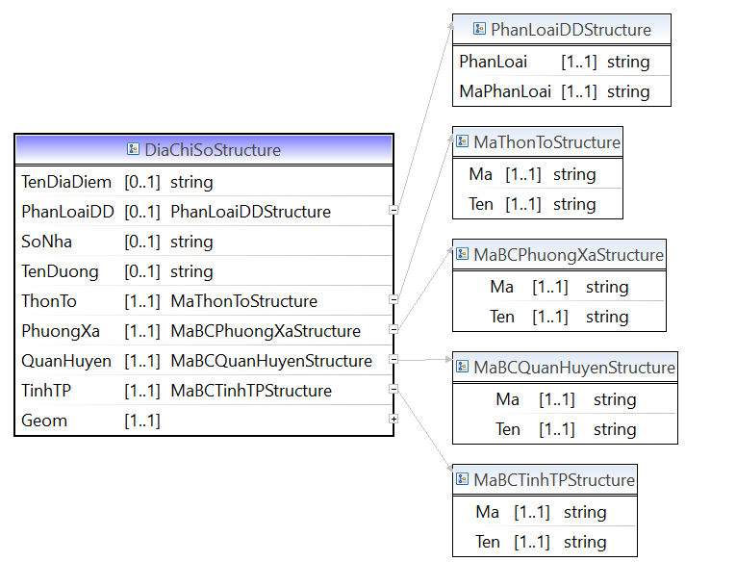

**Hình 7.1 - Lược đồ dữ liệu địa chỉ mô tả cấu trúc dữ liệu của DiaChiSo và các cấu trúc, kiểu dữ liệu liên quan**

**Mã nguồn lược đồ chứa các cấu trúc thông tin của lược đồ dữ liệu địa chỉ (DiaChi_core.xsd)**

<?xml version=*“1.1”* encoding=*"UTF-8"*?>

<xsd:schema xmlns:xsd=*"http://www.w3.org/2001/XMLSchema"* xmlns:TTDLQG=*"..."* targetNamespace=*"..."* version=*“1.1”* elementFormDefault=*"qualified"*>

<!-- <xsd:include schemaLocation="BaseEnumType.xsd" /> -->

<xsd:annotation>

<xsd:documentation></xsd:documentation>

</xsd:annotation>

<xsd:complexType name=*"DiaChiSoStructure"*>

<xsd:annotation>

<xsd:documentation>Mô tả cấu trúc thông tin về địa chỉ số</xsd:documentation>

</xsd:annotation>

<xsd:sequence>

<xsd:element name=*"TenDiaDiem"* type=*"xsd:string"* minOccurs=*"0"* maxOccurs=*"1"* />

<xsd:element name=*"PhanLoaiDD"* type=*"TTDLQG:PhanLoaiDDStructure"* minOccurs=*"0"* maxOccurs=*"1"* />

<xsd:element name=*"SoNha"* type=*"xsd:string"* minOccurs=*"0"* maxOccurs=*"1"* />

<xsd:element name=*"TenDuong"* type=*"xsd:string"* minOccurs=*"0"* maxOccurs=*"1"* />

<xsd:element name=*"ThonTo"* type=*"TTDLQG:MaThonToStructure"* minOccurs=*"1"* maxOccurs=*"1"* />

<xsd:element name=*"PhuongXa"* type=*"TTDLQG:MaBCPhuongXaStructure"* minOccurs=*"1"* maxOccurs=*"1"* />

<xsd:element name=*"QuanHuyen"* type=*"TTDLQG:MaBCQuanHuyenStructure"* minOccurs=*"1"* maxOccurs=*"1"* />

<xsd:element name=*"TinhTP"* type=*"TTDLQG:MaBCTinhTPStructure"* minOccurs=*"1"* maxOccurs=*"1"* />

<xsd:element name=*"Geom"* type=*"GMPointType"* minOccurs=*"1"* maxOccurs=*"1"* />

</xsd:sequence>

</xsd:complexType>

<xsd:complexType name=*"CanHoStructure"*>

<xsd:annotation>

<xsd:documentation>Mô tả cấu trúc thông tin về căn hộ</xsd:documentation>

</xsd:annotation>

<xsd:sequence>

<xsd:element name=*"ChungCu"* type=*"xsd:string"* minOccurs=*"0"* maxOccurs=*"1"* />

<xsd:element name=*"ToaNha"* type=*"xsd:string"* minOccurs=*"0"* maxOccurs=*"1"* />

<xsd:element name=*"Tang"* type=*"TTDLQG:Number"* minOccurs=*"1"* maxOccurs=*"1"* />

<xsd:element name=*"Phong"* type=*"xsd:string"* minOccurs=*"1"* maxOccurs=*"1"* />

<xsd:element name=*"DiaChiSo"* type=*"TTDLQG:DiaChiSoStructure"* minOccurs=*"1"* maxOccurs=*"1"* />

</xsd:sequence>

</xsd:complexType>

<xsd:complexType name=*"MaBCTinhTPStructure"*>

<xsd:annotation>

<xsd:documentation>Mô tả cấu trúc thông tin mã bưu chính tỉnh, thành phố</xsd:documentation>

</xsd:annotation>

<xsd:sequence>

<xsd:element name=*"Ma"* type=*"xsd:string"* minOccurs=*"1"* maxOccurs=*"1"* />

<xsd:element name=*"Ten"* type=*"xsd:string"* minOccurs=*"1"* maxOccurs=*"1"* />

</xsd:sequence>

</xsd:complexType>

<xsd:complexType name=*"MaBCQuanHuyenStructure"*>

<xsd:annotation>

<xsd:documentation>Mô tả cấu trúc thông tin mã bưu chính quận, huyện</xsd:documentation>

</xsd:annotation>

<xsd:sequence>

<xsd:element name=*"Ma"* type=*"xsd:string"* minOccurs=*"1"* maxOccurs=*"1"* />

<xsd:element name=*"Ten"* type=*"xsd:string"* minOccurs=*"1"* maxOccurs=*"1"* />

</xsd:sequence>

</xsd:complexType>

<xsd:complexType name=*"MaBCPhuongXaStructure"*>

<xsd:annotation>

<xsd:documentation>Mô tả cấu trúc thông tin mã bưu chính phường, xã</xsd:documentation>

</xsd:annotation>

<xsd:sequence>

<xsd:element name=*"Ma"* type=*"xsd:string"* minOccurs=*"1"* maxOccurs=*"1"* />

<xsd:element name=*"Ten"* type=*"xsd:string"* minOccurs=*"1"* maxOccurs=*"1"* />

</xsd:sequence>

</xsd:complexType>

<xsd:complexType name=*"MaThonToStructure"*>

<xsd:annotation>

<xsd:documentation>Mô tả cấu trúc thông tin mã bưu chính thôn, tổ</xsd:documentation>

</xsd:annotation>

<xsd:sequence>

<xsd:element name=*"Ma"* type=*"xsd:string"* minOccurs=*"1"* maxOccurs=*"1"* />

<xsd:element name=*"Ten"* type=*"xsd:string"* minOccurs=*"1"* maxOccurs=*"1"* />

</xsd:sequence>

</xsd:complexType>

<xsd:complexType name=*"PhanLoaiDDStructure"*>

<xsd:annotation>

<xsd:documentation>Mô tả cấu trúc thông tin mã bưu chính thôn, tổ</xsd:documentation>

</xsd:annotation>

<xsd:sequence>

<xsd:element name=*"PhanLoai"* type=*"xsd:string"* minOccurs=*"1"* maxOccurs=*"1"* />

<xsd:element name=*"MaPhanLoai"* type=*"xsd:string"* minOccurs=*"1"* maxOccurs=*"1"* />

</xsd:sequence>

</xsd:complexType>

<xsd:simpleType name=*"GMPointType"*>

<xsd:annotation>

<xsd:documentation>Tọa độ không gian điểm</xsd:documentation>

</xsd:annotation>

<xsd:restriction base=*"xsd:token"*>

<xsd:enumeration value=*"1"*><xsd:annotation><xsd:documentation>xsd:string</xsd:documentation></xsd:annotation></xsd:enumeration>

</xsd:restriction>

</xsd:simpleType>

</xsd:schema>